HIT Solar Cells with n-Type Low-Cost Metallurgical Si

AUTHOR NAMES (Word Style “BB_Author_Name”)

AUTHOR ADDRESS(Word Style “BC_Author_Address”)

ABSTRACT. In this study, a conversion efficiency of 20.23% was obtained in a heterojunction with intrinsic thin layer (HIT) solar cell with a metallurgical Si wafer (156 mm × 156 mm). This was comparable to the conversion efficiencies of the existing HIT solar cells. The impurity concentration and compensation levels and their effect on the performance of this HIT solar cell were investigated using the AFORS-HET simulation software. While the cell performance was drastically affected beyond a certain impurity concentration, it was hardly affected by compensation. It was revealed that a small amount of impurity in metallurgical Si materials did not hamper the solar cell properties.

**Introduction**

The photovoltaic industry is continuously striving to achieve high conversion efficiencies in a cost-effective manner. Heterojunction with intrinsic thin layer (HIT) solar cells enable a high open-circuit voltage and, therefore, a high conversion efficiency, owing to the hydrogen-rich a-Si passivation layer on the n-type Si wafer. The highest HIT conversion efficiency of 25.6% has been achieved by Panasonic (formerly Sanyo), a multinational electronics company.1 However, the manufacturing cost of HIT solar cells is remarkably high (∼$ 0.5/w), and lowering this cost is a challenge for further capacity expansion. Currently, solar-grade Si (SOGSi) is mainly fabricated using an improved Siemens method. However, this method involves high energy consumption and high cost and also causes pollution. Si purification using metallurgical methods has drawn significant attention in the past decade due to its cost-effectiveness, low energy consumption, and low pollution. Further, n-Type Si prepared using metallurgical methods (metallurgical Si) does not require phosphorus removal by electron beam refining, which is an expensive process. Consequently, the manufacturing cost with this method is only 40% of that with the Siemens method. An et al.2 investigated the main solar cell performance using Si prepared by both the Siemens method and metallurgical methods, and a conversion efficiency of 18.3% was obtained for regular monocrystalline metallurgical Si. Further, Einhaus et al.3 reported a cell efficiency of 19% for mono-c UMG n-type Si on a 149 cm2 cell in the first trial using the heterojunction solar cell technology. The automat for simulation of heterostructures (AFORS-HET) simulation software was developed specifically for heterojunction solar cells, and any type of semiconductor tandem materials with random combinations can be simulated using this software. Researchers have investigated the HIT solar cell performance using AFORS-HET simulation, and the results are significant.4–6 In this study too, the AFORS-HET simulation was employed to investigate the properties of the HIT solar cell fabricated with metallurgical Si. For comparison, HIT solar cells were also fabricated using Si prepared by the Siemens method (Siemens Si). Despite the slightly poorer electrical properties of metallurgical Si, HIT solar cells fabricated with metallurgical Si have a significant potential in large-scale industrial manufacturing.

**Materials and Methods**

*HIT solar cell fabrication*

HIT solar cells were fabricated using both Siemens Si and metallurgical Si (n-type Si wafers; 156 × 156 mm2) by ULVAC plasma-enhanced chemical vapor deposition for 5–10 nm a-Si films. A transparent conductive oxide (TCO) was prepared by Sumitomo reactive plasma deposition. Finally, screen printing was applied to form a silver metal contact to extract the light-generated current. The fabricated HIT solar cells had a bifacial structure with four bus bars (Figure 1(a)). The temperature for the entire HIT solar cell fabrication process was less than 250 °C. *I–V* parameters were characterized with a Kopel steady-state IV tester.

|  |
| --- |
| TCO  TCO  a  -  (  Si  i  )  a  -  (  Si  p  +  )  a  (  Si  -  i  )  c-  Si  (  )  n  a  -  (  Si  n  +  )  (a) (b)  Figure 1: (a) Front face of the fabricated HIT solar cell. (b) Schematic of the HIT solar cell structure.    Figure 2: Defect state distribution of the different types of a-Si:H layers obtained by simulation. |

*s*

Si materials produced by metallurgical methods exhibit the impurity compensation effect, such as coexistence of B and P. They also have higher concentrations of metal impurities such as Fe and Cu impurities. The Fe and Cu concentrations in the Si prepared by the Siemens method are negligible. The metallurgical Si wafers used in this work had a resistivity of 2.0 Ω⋅cm, minority-carrier lifetime of 30 𝜇s, and Fe concentration of 0.005 ppb. The tested parameters of the Si wafers were inputted into the AFORS-HET software to simulate the HIT solar cell. Furthermore, the effect of metal impurity and B and P compensation on the cell properties were investigated. In the AFORS-HET simulation, the doping concentrations of both B and P can be used, and the impurity level can be easily adjusted, which is beneficial for conducting research on compensated HIT solar cells. The HIT solar cell for this simulation has a p+-a-Si/i-aSi:H/c-Si/i-a-Si:H/n+-a-Si structure (Figure 1(b)). The simulation parameters were obtained from previous reports7–10 and are listed in Table 1. Owing to the reduction in thickness upon acid etching, the Si substrate (170 𝜇m) used in this simulation was smaller than the bare Si wafer (190 𝜇m). Surface recombination at the a-Si/c-Si interface was 1.0 × 107 cms−1. The defect state6 settings for p+-a-Si, i-a-Si, and n+-a-Si are shown in Figure 2. Light trapping can occur on both front and back surfaces. Both front and back electrodes were in ohmic contact. The reflectivities for the front and back surfaces were 0.1 and 1, respectively. The simulated light soaking conditions were AM1.5 and 100 mW/cm2, and the effective wavelength range was 0.38–1.1 𝜇m.

|  |  |  |  |  |  |  |  |  |  |  |  |  |  |  |  |  |  |  |  |  |  |  |  |  |  |  |  |  |  |  |  |  |  |  |  |  |  |  |  |  |  |  |  |  |  |  |  |  |  |  |  |  |  |  |  |  |  |  |  |  |  |  |  |  |  |  |  |  |  |  |  |  |  |  |  |  |  |  |  |  |  |  |  |  |  |  |  |  |  |  |  |  |  |  |  |  |  |  |  |  |  |  |  |  |  |  |  |  |  |  |  |  |  |  |  |  |  |  |  |  |  |  |  |  |  |  |  |  |  |  |  |  |
| --- | --- | --- | --- | --- | --- | --- | --- | --- | --- | --- | --- | --- | --- | --- | --- | --- | --- | --- | --- | --- | --- | --- | --- | --- | --- | --- | --- | --- | --- | --- | --- | --- | --- | --- | --- | --- | --- | --- | --- | --- | --- | --- | --- | --- | --- | --- | --- | --- | --- | --- | --- | --- | --- | --- | --- | --- | --- | --- | --- | --- | --- | --- | --- | --- | --- | --- | --- | --- | --- | --- | --- | --- | --- | --- | --- | --- | --- | --- | --- | --- | --- | --- | --- | --- | --- | --- | --- | --- | --- | --- | --- | --- | --- | --- | --- | --- | --- | --- | --- | --- | --- | --- | --- | --- | --- | --- | --- | --- | --- | --- | --- | --- | --- | --- | --- | --- | --- | --- | --- | --- | --- | --- | --- | --- | --- | --- | --- | --- | --- | --- | --- | --- |
| Table 1: Input parameters for AFORS-HET simulation.   |  |  |  |  |  |  | | --- | --- | --- | --- | --- | --- | | Parameters | a-Si:H(p) | | a-Si:H(i) | c-Si(n) | a-Si:H(n+) | | Thickness (nm) | 5 | | 5 | 1.7×105 | 5 | | Dielectric constant | 11.9 | | 11.9 | 11.9 | 11.9 | | Electron affinity (eV) | 3.8 | | 3.8 | 4.05 | 3.8 | | Band gap (eV) | 1.70 | | 1.74 | 1.12 | 1.70 | | Effective conduction band density (cm−3) | 1.0×1020 | | 1.0×1020 | 2.8×1019 | 1.0×1020 | | Effective valence band density (cm−3) | 1.0×1020 | | 1.0×1020 | 1.04×1019 | 1.0×1020 | | Electron mobility (cm2 V−1s−1) | 10 | | 20 | 1040 | 10 | | Hole mobility (cm2 V−1s−1) | 1 | | 2 | 412 | 1 | | Acceptor concentration (cm−3) | 1.0×1019 | | 0 | 5×1015 | 0 | | Donor concentration (cm−3) | 0 | | 0 | 7.03×1015 | 1.0×1019 | | Thermal velocity of electrons (cm/s) | 1.0×107 | | 1.0×107 | 1.0×107 | 1.0×107 | | Thermal velocity of holes (cm/s) | 1.0×107 | | 1.0×107 | 1.0×107 | 1.0×107 | | Layer density (g cm−3) | 2.328 | | 2.328 | 2.328 | 2.328 | | Band tail density of states (cm−3 eV−1) | 2.0×1021 | | 2.0×1021 |  | 2.0×1021 | | Characteristic energy (eV) for donors, acceptors | 0.045, 0.037 | | 0.045, 0.02 |  | 0.06, 0.037 | | Capture cross-section for donor states, e, h (cm2) | 1.0×10−15, 1.0×10−17 | 1.0×10−15, 1.0×10−17 | |  | 1.0×10−15, 1.0×10−17 | | Capture cross-section for acceptor states, e, h (cm2) | 1.0×10−17, 1.0×10−15 | 1.0×10−17, 1.0×10−15 | |  | 1.0×10−17, 1.0×10−15 | | Defect density of states at Gaussian peak energy (eV) | 1.0×1017–6.0×1019 | 1.0×1016–1.0×1019 | |  | 8.0×1017–1.0×1020 | | Standard deviation (eV) | 1.10, 1.35 | 0.725, 1.025 | |  | 0.40, 0.65 | | Capture cross-section for donor states, e, h (cm2) | 1.0×10−14, 1.0×10−15 | 1.0×10−14, 1.0×10−15 | |  | 1.0×10−14, 1.0×10−15 | | Capture cross-section for acceptor states, e, h (cm2) | 1.0×10−15, 1.0×10−14 | 1.0×10−15, 1.0×10−14 | |  | 1.0×10−15, 1.0×10−14 | |

**Results and Discussion**

*Influence of deep energy-level impurity on solar cell properties*

Si purification by metallurgical methods can be realized through gas blowing, slagging boron removal, phosphorus removal by electron beam refining, acid leaching, and unidirectional removal of solidification metals. The repeated processes were applied to remove the metal impurities in Si and meet the requirements for SOG. metal impurities in the Siemens Si were higher. The presence of metal impurities (Fe, Cu, and Ni impurities) decrease the minority-carrier lifetime and reduce the light-generated current. In the AFORS-HET simulations, defects can be deliberately added to c-Si for simulating the impact of metal impurities on the solar cell properties. In this work, only Fe and Cu were considered to be the two main metal impurities. Owing to the directional solidification of the Fe residues, electron beam processing with copper electrodes can be introduced. The Fe and Cu energy levels in Si were 0.4 and 0.24 eV, respectively. The electron capture cross-sections for Fe and Cu were 4.5 × 10−14 and 1 × 10−14 cm−2, respectively,10 while the hole capture cross-sections for Fe and Cu were 6.91 × 10−17 and 1.8 × 10−17 cm−2, respectively. First, we considered only the Fe impurities and set the concentration range as 1 × 1010–1 × 1015 cm−3. The variation in the solar cell properties as a function of the defect density is shown in Figure 3(a). It is evident that the density of defect states should be less than 1012 cm−3 to achieve a good performance. When it is higher than 1012 cm−3, the cell properties are drastically affected by the defect density, and the conversion efficiency drops below 20%. Meanwhile, the short-circuit current density (𝐽sc) and open-circuit voltage (𝑉oc) decrease. For instance, when the Fe impurities increase up to 1015 cm−3, 𝑉oc decreases to 468 mV, 𝐽sc 2 drops to 24.21 mA/cm, and the conversion efficiency is only 8.07%. Figure 3(b) shows the simulation results in the presence of both the Fe and Cu impurities. During the simulation, the concentration of the Fe impurity was fixed at 1012 cm−3, while the concentration of the Cu impurity was varied from 1 × 1010 to 1 × 1015 cm−3. Consequently, when the Cu concentration was higher than 1012 cm−3, the conversion efficiency (𝜂) dropped to less than 20%. The cell performance deteriorated with increasing concentrations of Cu impurities. The data in Figures 3(a) and 3(b) suggest that the effects of an individual impurity are added to each other when there are multiple impurities. The main impurities in the metallurgical Si material are Fe and Cu. In the present study, the Fe and Cu concentrations measured by glow discharge mass spectrometry (GDMS) were 2.6 × 1012 and 6.5 × 1011 cm−3,respectively. Using the measured impurity data as inputs in the AFORS-HET software, the simulated 𝑉oc, 𝐽sc, fill factor (FF), and 𝜂 were determined to be ~2684.1 mV, ∼ 39.89 mA/cm, ∼75.08%, and ∼19.58%, respectively.

*Influence of compensation level on solar cell properties*

In metallurgical n-type Si wafers, there is a certain amount of B doping in addition to P doping. This is a well-known compensation phenomenon, and the compensation is proportional to the B concentration. In the AFORS-HET simulation, donor concentration 𝑁𝐷 and acceptor concentration 𝑁𝐴 can be inputted simultaneously. The carrier mobility is inputted manually as a fixed parameter, as the carrier mobility at different doping concentrations is different. At room temperature, the carrier mobility in Si can be described using the following set of equations:11

(1)

|  |
| --- |
| (a) Fe (b) Fe+Cu  Figure 3: Effect of (a) Fe impurities and (b) Fe and Cu impurities on the cell properties. |

Equation (1) reflects the concentration of donor and acceptor impurities at room temperature. To simulate the compensation effect on the cell properties more accurately, the difference between 𝑁𝐷 and 𝑁𝐴 was calculated and found to be 2.03 × 1015 cm−3. The acceptor concentration, 𝑁𝐴,varies from 1 × 10 to 2 × 10 cm. 𝑁𝐴 for metallurgical Si, as measured by GDMS, was found to be 1.368 × 1015 cm−3. Electron mobility and hole mobility were calculated using the MATLAB software and inputted into the AFORS-HET software for simulation. The simulated results are shown in Figure 4, and it is evident that the influence of compensation on the cell properties was minor. Nonetheless, higher the compensation, poorer were the cell properties.

*Comparison of simulated and measured solar cell properties*

In this work, 156 mm × 156 mm metallurgical Si wafers were used to fabricate HIT solar cells in a pilot line at the Shanghai Institute of Micro-System and Information Technology, Chinese Academy of Sciences. For comparison, the same process was used to fabricate a batch of Siemens Si HIT solar cells. The *I–V* curves of both the types of HIT solar cell are shown in Figure 5.

The measured parameters of metallurgical Si were introduced into the AFORS-HET software for simulating the HIT solar cells. Table 2 shows the simulated and measured cell properties for comparison. The measured and simulated 𝑉oc, 𝐽sc, FF, and 𝜂 values for the HIT solar cells were similar. However, the simulated temperature coefficient (TC) of the photoelectric conversion efficiency was lower than the measured value. With AFORS-HET software optimization, 𝜂 of the HIT solar cell with metallurgical Si increased up to 21.17% when the density of defect states was 1012 cm−3 and the concentration of B was zero. Table 2 also shows a comparison of the performance of the cells fabricated using metallurgical Si and Siemens Si in the same batch. The electrical properties of the former were slightly poorer than those of the latter. However, due to the significantly low cost of metallurgical Si materials, the performance to cost ratio for the metallurgical Si HIT solar cells would be higher than that of Siemens Si solar cells. This suggests that the metallurgical Si HIT solar cells have a significant potential for large-scale industrial manufacturing.

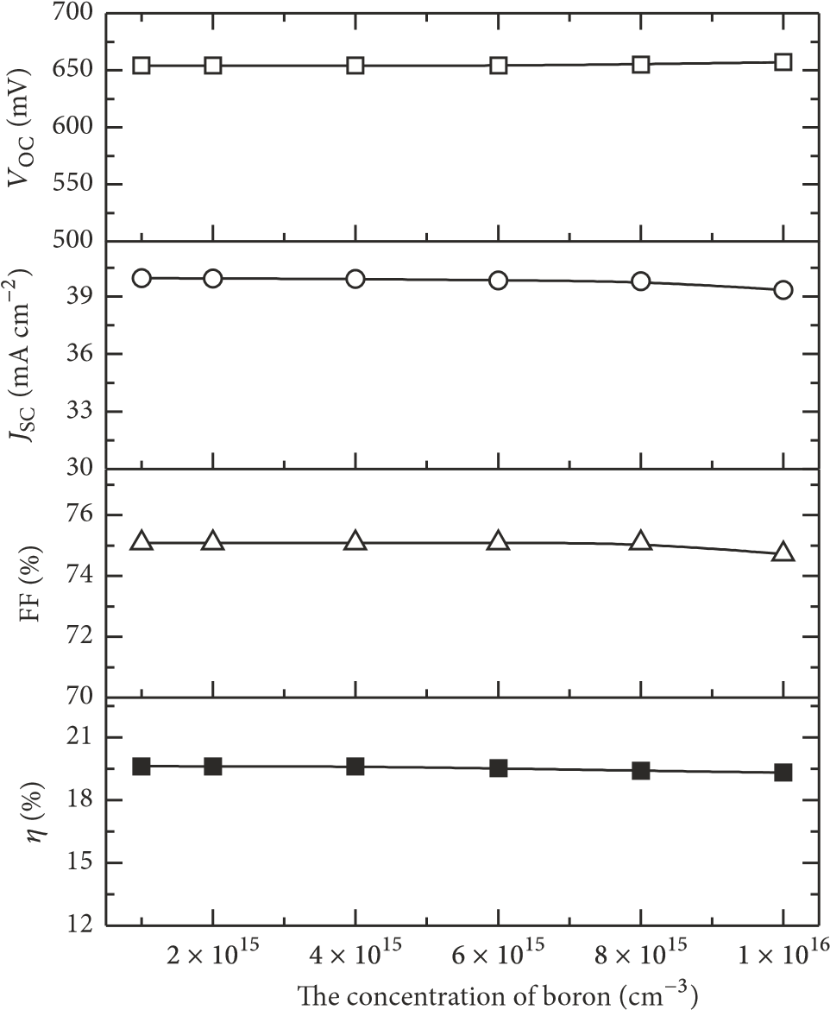

Figure 4: Influence of compensation level on the solar cell properties.

|  |  |  |  |  |  |  |  |  |  |  |  |  |  |  |  |  |  |  |  |  |  |  |  |  |  |  |  |  |  |  |
| --- | --- | --- | --- | --- | --- | --- | --- | --- | --- | --- | --- | --- | --- | --- | --- | --- | --- | --- | --- | --- | --- | --- | --- | --- | --- | --- | --- | --- | --- | --- |
| Table 2: Comparison of HIT solar cell properties with metallurgical Si and Siemens Si.   |  |  |  |  |  | | --- | --- | --- | --- | --- | | Cell parameters | Siemens Si | Metallurgical Si | Simulated data | Optimized data | | 𝑉oc (V) | 0.7294 | 0.6949 | 0.6841 | 0.7061 | | 𝐽sc (mA/cm2) | 38.918 | 37.564 | 37.656 | 39.641 | | FF (%) | 78.37 | 77.48 | 75.08 | 81.08 | | 𝜂 (%) | 22.25 | 20.23 | 19.58 | 21.17 | | TC (%/∘C) | −0.225 | −0.3043 | −0.2000 | −0.2000 | |

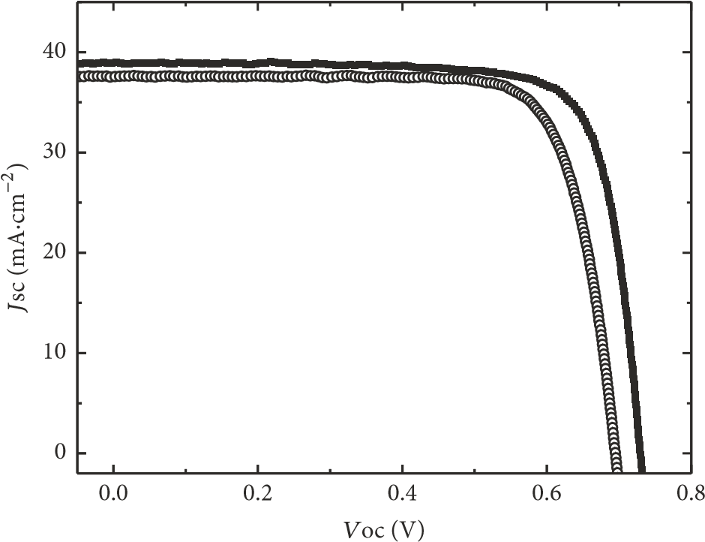

Metallurgical Si

Siemens Si

Figure 5: *I–V* curves of HIT solar cells fabricated using metallurgical Si and Siemens Si.

**Conclusions**

In summary, it can be concluded that despite the marginally poorer material quality of metallurgical Si compared to that of Siemens Si, HIT solar cells with competitive performance can be fabricated using the former. The best performance of the metallurgical Si HIT solar cell corresponded to 𝑉oc, 𝐽sc, FF, 𝜂, and TC of ∼694.9 mV, ∼37.564 mA/cm2, FF ∼77.48%, ∼20.23%, and ∼ −0.3043%/∘C, respectively. AFORS-HET simulation studies revealed that a small amount of impurity in metallurgical Si materials did not hamper the solar cell properties.

ASSOCIATED CONTENT

(Word Style “TE_Supporting_Information”). **Supporting Information**. A listing of the contents of each file supplied as Supporting Information should be included. For instructions on what should be included in the Supporting Information as well as how to prepare this material for publications, refer to the journal’s Instructions for Authors.  
The following files are available free of charge.  
brief description (file type, i.e., PDF)  
brief description (file type, i.e., PDF)

AUTHOR INFORMATION

Corresponding Author

*(Word Style “FA_Corresponding_Author_Footnote”). * (Word Style “FA_Corresponding_Author_Footnote”). Give contact information for the author(s) to whom correspondence should be addressed.

Present Addresses

†If an author’s address is different than the one given in the affiliation line, this information may be included here.

Author Contributions

The manuscript was written through contributions of all authors. All authors have given approval to the final version of the manuscript. ‡These authors contributed equally. (match statement to author names with a symbol)

Funding Sources

Any funds used to support the research of the manuscript should be placed here (per journal style).

Notes

The authors declare that they have no conflicts of interest.

ACKNOWLEDGMENT

The authors thank the financial sponsorship from Fujian Industrial Guidance Project (No. 2017H0038). They also thank Ningxia Power Group Co., Ltd., China, for providing n-type monocrystalline SOG silicon rods purified by the metallurgical method.

REFERENCES

K. Masuko, M. Shigematsu, T. Hashiguchi et al., “Achievement of more than 25% conversion efficiency with crystalline silicon heterojunction solar cell,” *IEEE Journal of Photovoltaics*, vol. 4, no. 6, pp. 1433–1435, 2014.

B. An J, J. Yank, and X. Zhou, “Electrical performance comparison of mono-crystalline silicon solar cell with wafer purified by metallurgical Siemens method,” *ActaEnergiae Solaris Sinica*, vol. 36, pp. 2325–2328, 2015.

R. Einhaus, J. Kraiem, J. Degoulange et al., “19% efficiency heterojunction solar cells on Cz wafers from non-blended Upgraded Metallurgical Silicon,” in *Proceedings of the 2012 IEEE*

*38th Photovoltaic Specialists Conference (PVSC)*, pp. 003234– 003237, Austin, TX, USA, June 2012.

B. Ren, Y. Zhang, B. Guo et al., “Computer simulation of asi:H/c-Si heterjuntion solar cells on n-type silicon,” *ActaEnergiae Solaris Sinica*, vol. 29, pp. 1112–1116, 2008.

X. Cheng, F. Meng, J. Wang, X. Li, and J. Huang, “Simulation of heterojunction solar cells based on p-type silicon wafer,” *Acta Energiae Solaris Sinica*, vol. 33, no. 9, pp. 1474–1479, 2012.

X. Wen, X. Zeng, W. Liao, Q. Lei, and S. Yin, “An approach for improving the carriers transport properties of a-Si: H/c-Si heterojunction solar cells with efficiency of more than 27%,” *Solar Energy*, vol. 96, pp. 168–176, 2013.

K. Patel, M. Katiyar, B. Mazhari et al., “Simulation studies on heterojunction and HIT solar cells,” in *Proceedings of the 16th International Workshop on Physics of Semiconductor Devices*, p. 85490E, Kanpur, India.

J. Liu, S. Huang, and L. He, “Simulation of a high-efficiency silicon-based heterojunction solar cell,” *Journal of Semiconductors*, vol. 36, no. 4, pp. 0440101–0440108, 2015.

N. Dwivedi, S. Kumar, A. Bisht, K. Patel, and S. Sudhakar, “Simulation approach for optimization of device structure and thickness of HIT solar cells to achieve ∼27% efficiency,” *Solar Energy*, vol. 88, pp. 31–41, 2013.

L. Zhao, H. L. Li, C. L. Zhou, H. W. Diao, and W. J. Wang, “Optimized resistivity of p-type Si substrate for HIT solar cell with Al back surface field by computer simulation,” *Solar Energy*, vol. 83, no. 6, pp. 812–816, 2009.

Z. Chen and J. Wang, *Basic Material Physics for Semiconductor Devices*, Science Press, 2013.