**Expression Patterns of Galectins-1, -3, and -7 are Prognostic for Overall Survival in Ovarian Cancer**

Alice Author1,*, Bob Author2, Christine Author1,2,+, and Derek Author2,+

1Affiliation, department, city, postcode, country

2Affiliation, department, city, postcode, country

*corresponding.author@email.example

+these authors contributed equally to this work

**Abstract:** There is a considerable need for the development of new prognostic factors in ovarian cancer. Galectins are carbohydrate-binding proteins that have been suggested to serve as prognostic factors for various cancer types. In this study, the expression of galectin (Gal)-1, -3, and -7 was investigated in 156 ovarian cancer specimens using immunohistochemical staining. Overall patient survival was compared among groups stratified by galectin expression. Gal-1 and -3 staining was observed in the peritumoural stroma as well as the nucleus and cytoplasm of tumour cells, while Gal-7 was only present in the cytoplasm. Patients with Gal-1 expression in the cytoplasm or high Gal-1 expression in the peritumoural stroma showed reduced overall survival. Nuclear Gal-3 staining correlated with better clinical outcomes. Cases with high Gal-7 expression exhibited significantly reduced overall survival, while Gal-7-negative cases exhibited improved survival. Our results indicate that tumour and stromal staining of Gal-1 and cytoplasmic staining of Gal-7 serve as negative prognostic factors for ovarian cancer, while nuclear Gal-3 staining may represent a new positive prognosticator for ovarian cancer.

**Introduction**

Ovarian cancer is the most lethal gynecological malignancy, ranking fifth in estimated cancer deaths among women in the USA1. First-line treatment consists of primary debulking surgery followed by platinum and paclitaxel chemotherapy2. Despite these treatments, the 5-year relative survival rate for epithelial ovarian cancer patients remains below 50%3. A lack of screening methods and frequent presentation with advanced stage disease are considered the main reasons for the poor outcomes of ovarian cancer patients.

Prognosticators in ovarian cancer include disease stage at diagnosis, extent of residual disease after surgery, histological subtype, and the volume of ascites4. Numerous studies have aimed to identify new biological prognostic factors in ovarian cancer. Recently, the carbohydrate stem cell marker TF1 has been proposed as a negative prognostic marker in ovarian cancer displaying wild-type p53, while estrogen receptor promoter methylation predicts overall survival in low-grade ovarian carcinoma patients5,6. Although the prognostic value independent of clinical parameters has been demonstrated for these and various other molecules, to date, with the exception of breast cancer gene (*BRCA*) status, no biological marker is commonly accepted4. Further specification of anti-cancer therapies necessitates an improvement in the biological prognostic markers for ovarian cancer.

Galectins belong to a family of proteins sharing two main characteristics: binding affinity for β-galactosides and significant similarity in the carbohydrate-recognition domain (CRD)7. The first member of this family to be described was galectin (Gal)-1, which can be isolated as a homodimer comprising two identical CRD subunits8. Since then, a growing number of galectin family members have been identified, but Gal-1–4, Gal-7–10, Gal-12, and Gal-13 are known to be present in humans9. Similar to Gal-1, Gal-7 typically occurs as a homodimer, while Gal-3 is the only galectin characterized as a chimeric protein that is known to form higher order oligomers10,11. In several types of cancer, galectins are known to affect tumour growth, metastasis, angiogenesis, cell migration, invasiveness, and progression, and they are therefore good candidates for proteins with prognostic value for patient survival9,12.

The role of Gal-1 in cancer has been studied by various groups. In patient sera and ovarian cancer tissues, it has been shown that a combination of CA-125 and Gal-1 serves as a possible two-marker combination for the preoperative discrimination of benign and malignant ovarian masses13. In addition, patients suffering from metastatic epithelial ovarian cancer were observed to exhibit higher serum Gal-1 levels than those with non-metastatic cancer. Elevated Gal-1 staining of the peritumoural stroma was shown to occur in advanced stages of epithelial ovarian cancer and is also associated with reduced progression-free survival in univariate analysis14. However, these results have not yet been reproduced for overall survival or confirmed by multivariate analysis15. Thus, the potential of Gal-1 as an independent prognostic marker in ovarian cancer requires further investigation.

High cytoplasmic Gal-3 expression has been suggested as a negative prognostic factor, as it was shown to correlate with reduced progression-free survival in ovarian cancer16. However, in another study, Gal-3 expression did not correlate with reduced overall survival, though a cytoplasmic staining pattern was associated with poor outcome when compared to patterns including nuclear staining17. Although Gal-3 staining has been observed in the nucleus and stroma, its influence on overall survival remains unclear.

Finally, Gal-7 has been proposed by two independent groups to serve as a negative prognostic factor in ovarian cancer. In both studies, its influence on progression-free survival and overall survival was confirmed by univariate and multivariate analysis16,18. However, disagreement remains regarding whether Gal-7 staining occurs predominantly in the nucleus or the cytoplasm. In addition, it is currently unknown whether the expressions of different galectins are correlated in ovarian cancer, and there is a critical need for a comprehensive study of various galectins in a representative ovarian cancer panel. Therefore, in this study, we investigated the prognostic value of Gal-1, -3, and -7 in patients with epithelial ovarian cancer and analysed correlations among the expression patterns of the three proteins as well as with clinical and pathological parameters. Our results suggest that Gal-1, -3, and -7 are localization-dependent prognostic factors for overall survival in ovarian cancer patients.

**Results**

*Gal-1 tumour and stromal staining is a negative prognostic indicator of overall survival*

Gal-1 staining was conducted in 150 ovarian cancer specimens. Gal-1 was present in the cytoplasms and the nuclei of ovarian cancer cells, as well as in the peritumoural stromae (Fig. 1). In 102 cases (68.0%), the tumour cell cytoplasm was positive for Gal-1, with a median Remmele immunoreactive (IR) score of 3. The peritumoural stroma was positive for Gal-1 in 148 cases (98.0%), with a median IR score of 8. Gal-1 expression was significantly correlated with several clinical and pathological factors (Table 1).

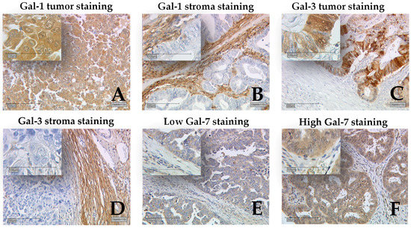

**Figure 1.** Detection of galectins by immunohistochemistry. Representative photomicrographs are shown. Gal-1 was present in the cytoplasm and the nucleus of ovarian cancer cells (**A**) as well as the peritumoural stroma (**B**). Gal-3 staining was observed in the nucleus, cytoplasm (**C**), and stroma (**D**). Staining for Gal-7 was mainly observed in the cytoplasm (**E**), with only a few individual cases showing nuclear staining (**F**). Scale bars, 200 μm (10× magnification) in main images, 100 μm (50× magnification) in insets.

**Table 1.** Correlations between Gal-1 staining and clinical and pathological factors.

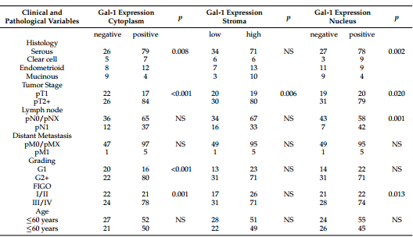

TNM staging was performed according to the standards of the Union for International Cancer Control (UICC); pT1 = tumour stage 1; pT2+ = tumour stage 2 or higher; pN0 = lymph node stage 0; pNX = lymph node stage not evaluated; pN1 = lymph node stage 1; pM0 = distant metastasis stage 0; pMX = distant metastasis not evaluated; pM1 = distant metastasis stage 1; G1 = grade 1; G2+ = grade 2 or higher; FIGO = Fédération Internationale de Gynécologie et d’Obstétrique; NS = Not significant (*p* > 0.05)

Gal-1 staining in the cytoplasm and nucleus differed among several histological subtypes (*p* = 0.008 and *p* = 0.002, respectively). Cytoplasmic Gal-1 staining was significantly stronger in serous, clear cell, or endometrioid subtypes, while for the mucinous subtype, we observed more negative cases. In addition, more cases with serous and clear cell subtypes exhibited Gal-1-positive nuclei, while the endometrioid and mucinous subtypes exhibited weaker nuclear Gal-1 staining. Furthermore, Gal-1 staining in the nucleus, cytoplasm, and stroma was significantly higher in cases with advanced tumour stage (*p* < 0.001, *p* = 0.006, and *p* = 0.02, respectively). Gal-1 expression in the cytoplasm was significantly higher in cases with higher grading (*p* < 0.001) and advanced FIGO (Fédération Internationale de Gynécologie et d’Obstétrique) stage (*p* = 0.001). The IR scores of nuclear Gal-1 staining were higher in lymph node-positive cases (*p* = 0.001) and those with advanced FIGO stage (*p* = 0.013).

The survival times of groups characterized by their Gal-1 expression in the nucleus, cytoplasm, and stroma were compared (Fig. 2). Cases with Gal-1 expression in the cytoplasm showed significantly reduced overall survival compared to cases without any Gal-1 expression in the cytoplasm (*p* = 0.029) Moreover, cases displaying high Gal-1 expression in the stroma showed significantly poorer outcomes than those with low Gal-1 expression in the stroma (*p* = 0.045). A comparison of cases negative and positive for Gal-1 expression in the nucleus did not reveal any difference in terms of overall survival. However, based on multivariate analysis, only Gal-1 stromal staining serves as an independent prognostic factor (Table 2).

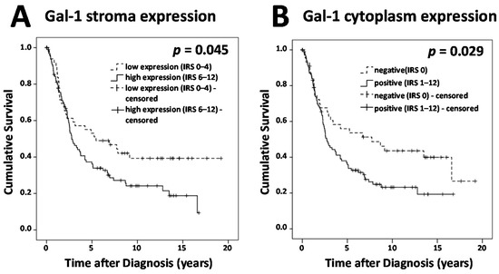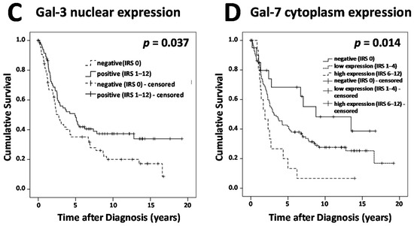

**Figure 2.** Survival times were plotted as Kaplan-Meier graphs. Percentage of living patients (vertical axis) was plotted against time (horizontal axis). Patients without an observed event (death) who exited the study before the observation period ended have been censored, as indicated in the graphs. Survival times of different groups stratified by galectin expression are compared. (**A**) Cases displaying high Gal-1 expression in the stroma showed significantly reduced survival compared to cases with low Gal-1 expression in the stroma. (**B**) Cases with Gal-1 expression in the cytoplasm showed significantly reduced overall survival compared to cases without Gal-1 expression in the cytoplasm. (**C**) Cases without Gal-3 expression in the nucleus showed significantly reduced overall survival compared to cases with nuclear Gal-3 expression. (**D**) Cases with high Gal-7 expression showed significantly reduced overall survival and Gal-7-negative cases showed better overall survival when compared to cases with low expression of Gal-7. Galectin expression was determined in cytoplasm, nucleus, and stroma using Remmele immunoreactive scores.

**Table 2.** Multivariate analysis of prognostic factors for overall survival in ovarian cancer.

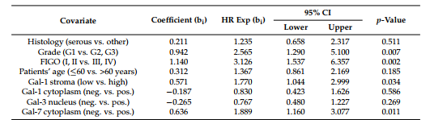

HR = hazard ratio; CI = confidence interval

*Presence of Gal-3 in the nucleus is a positive prognostic indicator in ovarian cancer*

Gal-3-positive nuclei were observed in 83 (55%) out of 151 cases, while 96 cases (63.6%) showed cytoplasmic Gal-3 staining and 85 cases (56.3%) presented with Gal-3-positive peritumoural stromae (Fig. 1). Median IR scores for Gal-3 in the nucleus, cytoplasm, and stroma were 1, 2, and 1, respectively. Gal-3 staining was correlated with clinical and pathological variables (Table 3). Gal-3 expression in the stroma and nucleus differed among different histological subtypes (*p* = 0.008 and *p* = 0.013, respectively). Gal-3 stromal staining was stronger in the serous and clear cell subtypes but weaker in the endometrioid and mucinous subtypes, while nuclear Gal-3 staining was stronger in the serous, clear cell, and mucinous subtypes but weaker in the endometrioid subtype. Tumours rated as pT1 presented with significantly stronger nuclear Gal-3 staining than those rated pT2 or higher (*p* = 0.042). We observed correlations between Gal-3 staining in the nucleus and cytoplasm with patient age (*p* = 0.022 and *p* = 0.013, respectively), observing higher IR scores for patients younger than 60. In our study panel, Gal-3 overexpression in the cytoplasm was not correlated with poorer outcomes in ovarian cancer patients. Similarly, Gal-3 staining in the peritumoural stroma was not observed to be a prognostic factor. In contrast, nuclear Gal-3 expression could serve as a positive prognostic factor (Fig. 2). Cases without Gal-3 expression in the nucleus showed significantly reduced overall survival compared to cases with nuclear Gal-3 expression (*p* = 0.034). According to the results of multivariate analysis, however, nuclear Gal-3 staining was not an independent prognostic factor, probably due to its strong correlations with patient age, tumour stage, and histology (Table 2).

**Table 3.** Correlations between Gal-3 staining and clinical and pathological factors.

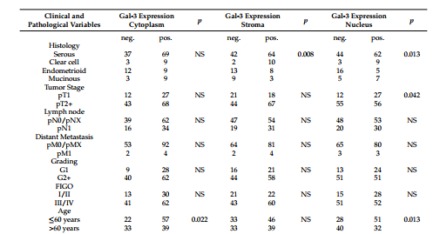

TNM staging was performed according to the standards of the UICC; pT1 = tumour stage 1; pT2+ = tumour stage 2 or higher; pN0 = lymph node stage 0; pNX = lymph node stage not evaluated; pN1 = lymph node stage 1; pM0 = distant metastasis stage 0; pMX = distant metastasis not evaluated; pM1 = distant metastasis stage 1; G1 = grade 1; G2+ = grade 2 or higher; NS = Not significant (*p* > 0.05).

*Gal-7 expression levels predict overall survival in ovarian cancer*

Staining for Gal-7 was mainly observed in the cytoplasm; only a few individual cases showed nuclear staining (Fig. 1). Cytoplasmic Gal-7 staining was present in 129 (86.6%) out of 149 specimens, with a median IR score of 3. In total, 20 cases were negative for Gal-7, while 114 cases showed low and 15 cases showed high expression of Gal-7. Gal-7 expression appeared to differ among different histological subtypes (*p* = 0.026). The strongest Gal-7 staining was found in the serous subtype, and the weakest in the endometrioid subtype (Table 4). No other correlations between Gal-7 staining and pathological data were found. Survival times of Gal-7-negative cases and those with high Gal-7 expression were compared to those with low Gal-7 expression (Fig. 2). We observed significantly reduced overall survival for cases with high Gal-7 expression and improved survival for Gal-7-negative cases compared to that of cases with low expression of Gal-7 (*p* = 0.014). In addition, according to the results of multivariate analysis, Gal-7 expression can be confirmed as an independent prognostic factor for overall survival in ovarian cancer (Table 2).

**Table 4.** Correlations between Gal-7 staining and clinical and pathological factors.

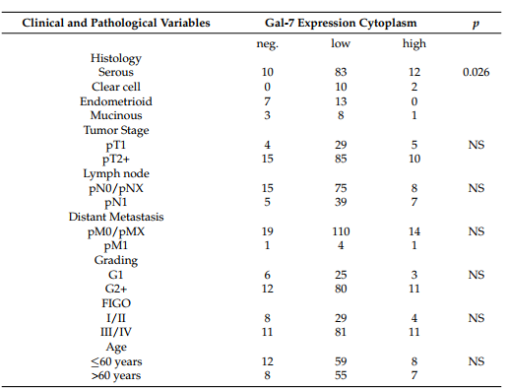

TNM staging was performed according to the standards of the UICC; pT1 = tumour stage 1; pT2+ = tumour stage 2 or higher; pN0 = lymph node stage 0; pNX = lymph node stage not evaluated; pN1 = lymph node stage 1; pM0 = distant metastasis stage 0; pMX = distant metastasis not evaluated; pM1 = distant metastasis stage 1; G1 = grade 1; G2+ = grade 2 or higher; NS = Not significant (*p* > 0.05).

*Correlations among galectin expression patterns*

Results of the analysis of the correlations among galectin expression patterns are shown in Table 5. For Gal-1 staining, we observed positive correlations among staining results in the cytoplasm, nucleus, and stroma. Similarly, the staining results of Gal-3 in the cytoplasm, nucleus, and stroma were positively correlated with each other. Furthermore, we observed correlations between Gal-1 and -3 staining in the nucleus, cytoplasm, and stroma. Gal-7 staining was positively correlated with Gal-1 staining in the cytoplasm and nucleus and all types of Gal-3 staining.

**Table 5.** Correlation analysis of galectin expression patterns.

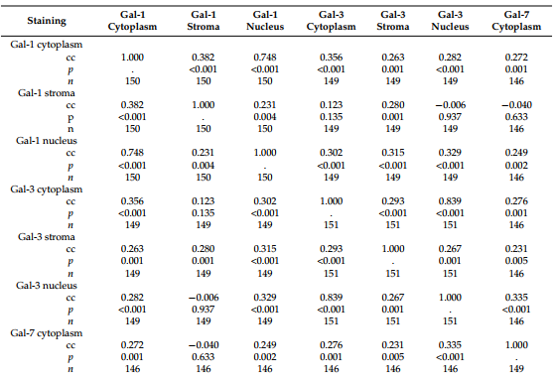

Correlations among IR scores of Gal-1, -3, and -7 staining in different compartments were assessed using Spearman’s correlation analysis. cc = correlation coefficient, *p* = two-tailed significance, *n* = number of patients.

**Discussion**

According to our data, Gal-1 staining in the cytoplasm and stroma predicts poor overall survival in ovarian cancer. Consistent with this, *in vitro* experiments have shown that the overexpression of Gal-1 significantly increases migration and invasion behaviours in ovarian cancer cells19. Furthermore, Gal-1 knockdown experiments in ovarian cancer cells result in reductions in cell growth, migration, and invasion. Possible mechanisms for this include the interaction of Gal-1 with H-Ras to activate the Raf/extracellular signal-regulated kinase (ERK) pathway, as well as downregulate matrix metalloproteinase-9 (MMP-9) and c-Jun. Moreover, Gal-1 overexpression may significantly decrease the sensitivity of ovarian cancer cells to cisplatin, reflecting a possible explanation for the reduced survival of ovarian cancer patients with increased Gal-1 expression14. Thus, Gal-1 represents a promising new target for ovarian cancer therapy, and several compounds targeting Gal-1 have been introduced20. OTX008, for instance, is a new compound able to bind non-covalently to Gal-1 on the side back face, inhibiting the proliferation and invasion of various cancer cells lines21. The anti-proliferative effects of OTX008 correlated with Gal-1 expression across a large panel of cell lines. Moreover, OTX008 efficiently inhibited the growth of ovarian cancer xenografts *in vivo*22.

According to the results of multivariate analysis in this study, only Gal-1 stromal staining serves as an independent prognostic factor for overall survival. The accumulation of Gal-1 in the peritumoural stroma has been described for various other tumour entities23-25. Some groups have investigated the mechanisms responsible for this phenomenon. *In situ* hybridization experiments showed that fibroblasts adjacent to malignant cells express *GAL1* mRNA, suggesting a possible explanation for peritumoural Gal-1 accumulation. In addition, it was demonstrated that ovarian cancer cells produce Gal-1 and release it into the medium. Furthermore, conditioned medium obtained from ovarian carcinoma cells induces elevated Gal-1 expression in fibroblasts. These experiments suggest that ovarian cancer cells may be primarily responsible for stromal Gal-1 expression26. Our findings regarding the positive correlation between Gal-1 staining in the peritumoural stroma and malignant cells is consistent with this hypothesis. However, further investigations are required to explain cases of Gal-1 expression in the stroma but not in cancer cells, and *vice versa*.

Several groups have suggested that higher Gal-3 expression is associated with reduced progression-free survival in ovarian cancer17,27. However, in these studies, detection of Gal-3 expression was limited to the cytoplasm, and the prognostic value of nuclear Gal-3 staining has not been further studied. We could not confirm a negative influence of cytoplasmic Gal-3 overexpression on overall survival in our study panel. On the contrary, nuclear Gal-3 staining served as a positive prognostic factor, although it was not independent of the influence of clinical and pathological parameters. Thus, it is apparently nuclear and not cytoplasmic Gal-3 expression that has a major influence on patients’ outcomes. In line with this, Gal-3 has been observed to play an important role in nuclear physiology, as it is involved in the processes of pre-mRNA splicing and mRNA transport28,29. Furthermore, cell culture experiments using human cervix adenocarcinoma (HeLa) cells demonstrated delayed activation of the DNA damage repair response and a decrease in G2/M cell cycle checkpoint arrest in the absence of Gal-330. A similar mechanism is conceivable in ovarian cancer, predisposing cells for further mutations in the absence of nuclear Gal-3. To our knowledge, reduced Gal-3 expression as an indicator of poor prognosis has only been observed in gastric cancer thus far31. In cholangiocarcinoma, Gal-3 expression is associated with a poorly differentiated type, while *in vitro* experiments show significantly increased cell migration and invasion after suppression of Gal-3 expression32. However, for ovarian cancer, *in vitro* experiments have shown that knockdown of Gal-3 inhibits migration and invasion of cancer cells, while increasing apoptosis and sensitivity to carboplatin33. Moreover, paclitaxel and additional treatment with a Gal-3 inhibitor resulted in synergistic cytotoxic effects and increased apoptosis in an ovarian cancer cell line34. Due to the discrepancies in previous research and to the fact that our data are not consistent with either previous studies on progression-free survival or recent *in vitro* research, further investigation into the prognostic role of Gal-3 in ovarian cancer is required.

As recently proposed by other groups, we were able to confirm Gal-7 as a negative prognosticator for overall survival in ovarian cancer according to both uni- and multivariate analyses. Cell culture experiments have demonstrated that Gal-7 expression is induced by a mutant form of p53. In addition, Gal-7 was shown to increase the proliferation16, invasiveness, and motility of ovarian cancer cells, while acting as an immunosuppressant by killing Jurkat T cells and human peripheral T cells18. Together, these investigations confirm Gal-7 as a promising new target for specific therapeutic treatment of epithelial ovarian cancer.

We observed a variety of positive correlations among the expression patterns of Gal-1, -3, and -7. This observation, along with the fact that galectins share binding affinities and exhibit similarities in protein structure, suggests that galectins might also share common functions in ovarian cancer molecular biology. However, as these observations are rather descriptive, further investigations into the biological characteristics and functions of different galectins are required to determine their similarities and differences, specifically in regards to their role(s) in ovarian cancer.

**Methods**

*Patients*

Formalin-fixed, paraffin-embedded (FFPE) ovarian cancer samples from 156 female patients who underwent surgery at the Department of Obstetrics and Gynecology, Ludwig-Maximilians-University (LMU) of Munich, Germany between 1990 and 2002 were analysed in this study. Women diagnosed with benign or borderline tumours of the ovary were excluded, and no patient had received neo-adjuvant chemotherapy. Tumour grading [G1 (*n* = 38), G2 (*n* = 53), G3 (*n* = 53)], and histological characterization [serous (*n* = 110), endometrioid (*n* = 21), clear cell (*n* = 12), mucinous (*n* = 13)] were performed by a gynecological pathologist. Tumour staging was performed using FIGO classifications [I (*n* = 35), II (*n* = 10), III (*n* = 103), IV (*n* = 3)]. TNM classification was performed according to the UICC. Data on the extension of the primary tumour were available in 155 cases [T1 (*n* = 40), T2 (*n* = 18), T3 (*n* = 93), T4 (*n* = 4)], data on lymph node involvement were available in 95 cases [N0 (*n* = 43), N1 (*n* = 52)], and data on the presence of distant metastasis were available in 9 cases [M0 (*n* = 3), M1 (*n* = 6)]. Clinical data were retrieved from patients’ charts, and follow-up data were requested from the Munich Cancer Registry. Patient age at surgery ranged from 31 to 88 years, with a median age of 62 ±12 years. Mean overall survival was 3.2 ± 3.0 years, and 104 deaths were observed in total. The mean follow-up period was 5.1 ± 4.8 years.

*Immunohistochemistry*

Resected ovarian cancer tissue samples were fixed in formalin and embedded in paraffin after surgery. For histopathological investigations, sections were dewaxed in xylol for 20 min and immersed in 3% hydrogen peroxide (Merck, Darmstadt, Germany) to quench endogenous peroxidase. Then, slides were rehydrated in a descending series of alcohol (100%, 75%, and 50%) and cooked in a pressure cooker for 5 min in sodium citrate buffer (0.1 mol/L citric acid, 0.1 mol/L sodium citrate, pH 6.0) to ensure epitope retrieval. Afterwards, slides were washed in distilled water and phosphate-buffered saline (PBS), followed by a specific procedure for staining each galectin. For Gal-1 staining, slides were blocked using Power Block (BioGenex, San Ramon, CA, USA) for 3 min at room temperature and incubated with anti-Gal-1 primary antibody (goat, polyclonal; R&D Systems, Minneapolis, MN, USA) at a final concentration of 0.033 µg/mL in Power Block for 16 h at 4 °C. Gal-3 staining was performed by blocking specimens with 1.5% horse serum (Vector Laboratories, Burlingame, CA, USA) for 30 min at room temperature and incubating with anti-Gal-3 primary antibody (mouse, monoclonal; Novocastra Reagents, Leica Biosystems, Wetzlar, Germany) at a final concentration of 4.6 µg/mL in PBS for 16 h at 4 °C. For Gal-7 staining, specimens were blocked with Blocking Solution [Reagent 1, ZytoChem Plus HRP Polymer System (Mouse/Rabbit); Zytomed Systems GmbH, Berlin, Germany] for 5 min at room temperature. Slides were then incubated with anti-Gal-7 (rabbit, polyclonal; Abcam, Cambridge, UK) at a final concentration of 2.5 µg/mL in PBS for 16 h at 4 °C. Afterwards, for Gal-1 and -3 staining, slides were incubated with isotype-matched anti-goat/mouse IgG secondary antibody and avidin-biotin-peroxidase complex, both for 30 min at room temperature, according to the instructions of the ABC Vectastain kit (Vector Laboratories). For Gal-7 staining, specimens were incubated in Post-Block reagent (Reagent 2, Zytomed Systems GmbH) and HRP-Polymer (Reagent 3, Zytomed Systems GmbH) for 30 min at room temperature, according to the manufacturer’s protocol for the ZytoChem Plus HRP Polymer System (Mouse/Rabbit) (Zytomed Systems GmbH). All slides were washed twice in PBS for 2 min after every incubation step. For visualization, specimens were stained with 3,3′-diaminobenzidine chromogen (DAB; Dako, Glostrup, Denmark). The reaction was stopped after 30 s–2 min with tap water, and specimens were counterstained in Mayer acidic hematoxylin, dehydrated in an ascending series of alcohol followed by xylol, and covered with Consul Mount (Thermo Shandon, Pittsburgh, PA, USA). Tissue sections that had been previously incubated with isotype-matched rabbit-/mouse-/goat- IgG (Dako) instead of the primary antibody served as negative controls. For positive controls, tissue slides of placental (Gal-1, -3) or breast cancer (Gal-7) tissues were used. Primary antibodies were chosen due to the high expected staining specificities according to the results of positive-control staining, as well as descriptions and example pictures on the manufacturers’ homepages. The semi-quantitative Remmele IR score was determined by two independent observers in consensus to obtain staining results. For this purpose, the predominant staining intensity (0 = negative, 1 = low, 2 = moderate, and 3 = strong) and the percentage of stained cells (0 = 0%, 1 = 1–10%, 2 = 11–50%, 3 = 51–80%, and 4 = 81–100% stained cells) are multiplied, resulting in values from 0 to 12. Staining intensity was measured in the cytoplasm and the nucleus of cancer cells and in the peritumoural stroma. Cut-off points for IR scores were chosen specifically for each staining with regard to the distribution pattern of IR scores in the collective sample. For Gal-1 staining in the cytoplasm and nucleus of cancer cells, an IR score = 0 was considered negative and an IR score ≥ 1 as positive. For stromal staining, Gal-1 groups with low expression (IR score < 5) and high expression (IR score ≥ 5) were compared. For analysis of Gal-3 staining, negative cases with an IR score = 0 were compared to positive cases with an IR score ≥ 1. Gal-7 expression was grouped as negative (IRS = 0), low (1 ≤ IRS ≤ 4), and high (IRS ≥ 6).

*Statistical analysis*

Statistical analyses were performed using SPSS 23.0 (IBM, Armonk, NY, USA) Distributions of clinicopathological variables were tested with chi-square tests. Mann-Whitney *U*-tests were used to compare the IR scores of galectins among different clinical and pathological subgroups. Correlations among immunohistochemical staining results were calculated using Spearman’s correlation analysis. Kaplan-Meier curves and log-rank tests (Mantel-Cox) were used to compare survival times among different groups. Data are presented as the mean ± standard deviation. Values of *p* < 0.05 were considered significant.

*Ethics statement*

All tissue samples used for this study were left-over material from the archives of the LMU Munich Department of Gynecology and Obstetrics, which were initially collected for histopathological diagnostics. All diagnostic procedures had already been fully completed at the time the histopathological investigations for the current study were performed. Patients’ data were fully anonymized. The study was approved by the Ethics Committee of LMU Munich. All experiments were performed according to the standards set forth in the Declaration of Helsinki, 1975.

**Conclusions**

In this study, we showed that expression of galectins and theirits impacts on overall survival in ovarian cancer patients are strongly dependent onf itstheir cellular localization in the nucleus or cytoplasm of tumour cells or the peritumoural stroma. We found that Gal-1 tumour and stromal staining and Gal-7 staining in the cytoplasm serves as negative prognostic factors for overall survival in ovarian cancer, while nuclear Gal-3 staining may serve as a positive prognostic factor. According to the results of multivariate analysis, Gal-1 stromal staining and Gal-7 staining are prognostic factors that are independent of clinical and pathological parameters.

**References**

s;;; a

**Competing Financial Interests**

*Source:* [*Galectins-1, -3, and -7 Are Prognostic Markers for Survival of Ovarian Cancer Patients*](https://doaj.org/article/8157f6db55a04e9eb5ce56e81cc541da) *by H. Schulz, E. Schmoeckel, C. Kuhn*[*, et al.*](https://doaj.org/article/701adfbb1df44e7793e127cfe239d56f)*, used under*[*CC-BY*](https://creativecommons.org/licenses/by/4.0/)