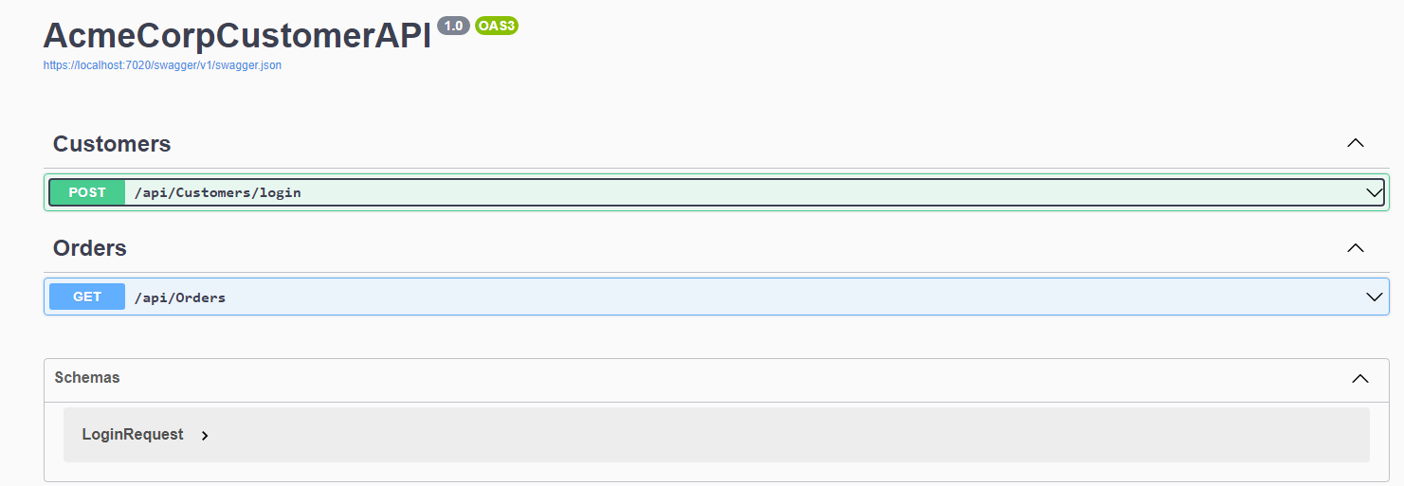

/api/Customers/login

Customers can log in and get the JWT Token. The login endpoint will check against the [Customer] table in DB and return their claims if any

/api/Orders

Only customer who has already authenticated and with Admin role in their claims can access this endpoint.

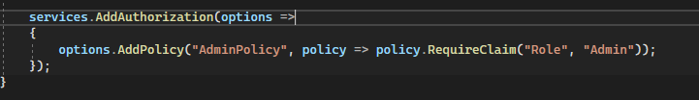

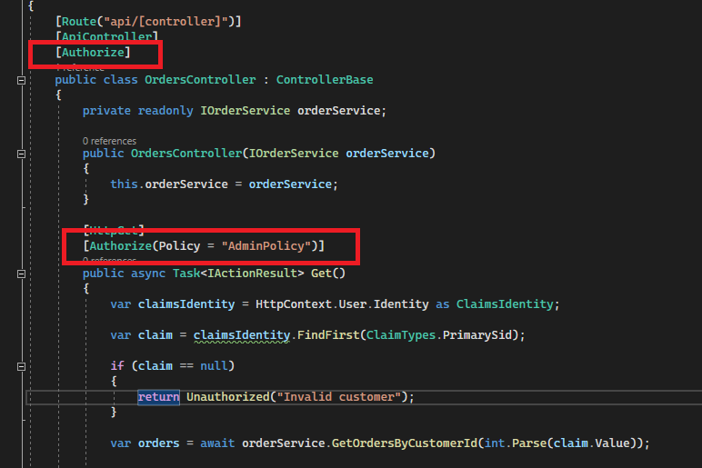

Service also try to apply DB migration when start up – only for DEV enviroment

