1. Building_basic Table.

This table doesn’t include building name or title.

1. Users table

This table doesn’t include plan_id to know user’s plan & subscription.

1. Tasks table

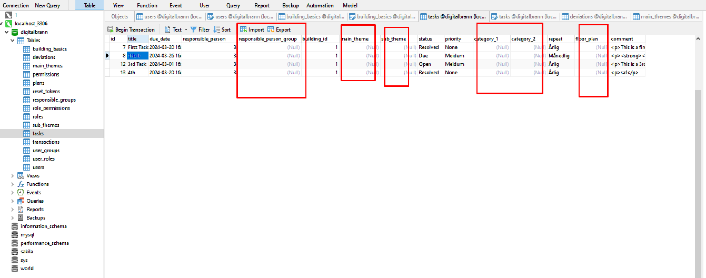

As shown above, this table contains unused entries.

So please let me know meaning of these entries.