**Swarms of Oil Sensing Robots in a Simulated Environment**

**By Dave Cavaletto**



**Design**

The overall program includes three main parts each containing the latter and implemented as a class using C#: the environment, the swarm, and the robots.  The environment is the space the robots live in, holds the background image of the oil spill, and defines the boundaries of space.  The swarm is the collective for the individual robot. Its content is dictated by the total number of robots within it.  The swarm works within the environment and organizes each robot. All entities within the swarm do not communicate with one another.  Last, is the robot.  Each robot, upon initial creation, is given a calculated value based on the overall size of the environment and the total number of robots within the swarm.  This value is used to mandate the distance each robot is to keep between its self and local robots.  As the system is currently implemented, the effective communication range between robots is linearly related to the previously calculated distance value between robots. In other words, the communication range is equal to the distance plus some constant.

As currently implemented the system loops through every robot in the swarm repeatedly.  Every iteration the current robot (this robot) polls every other robot (that robot) in the swarm to determine if that robot is within this robot’s communication range.  There are three general outcome possibilities for polling the distance from this robot to that robot, that robot is out of this robot’s communication range, that robot is in this robot’s communication range, and finally that robot is in this robot’s space.  The first two cases produce the same result, no change is made to this robot’s position.  The third case results in this robot changing its heading to move away from that robot.  This robot will not update its position until it has polled every other robot in the swarm.  The result is this robot moves away from every other robot within its space.

**Introduction**

This paper is to present my work on creating a simulation of a swarm of robots that can be dispatched in a decentralized way to detect oil in an ocean environment.  I hope to show that using a swarm is an effective and inexpensive way to monitor and identify oil slicks in the ocean.

Swarm behavior implies that each member of the swarm operates independently. Each robot moves, communicates, and coordinates only with the robots within its communication field. Those outside its field are ignored. With the limited radius of communication (ignoring a "base station" at the shore line or buoy in the water, or a satellite), the complexity of the robot is allowed to remain minimal and they can be a less powerful (read expensive) tool.

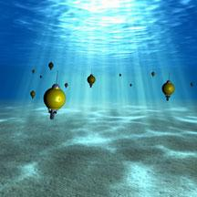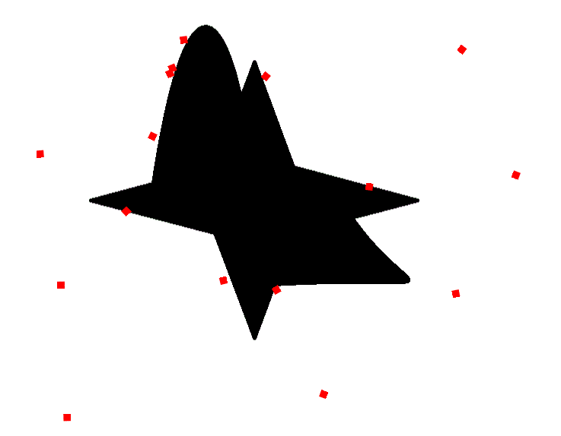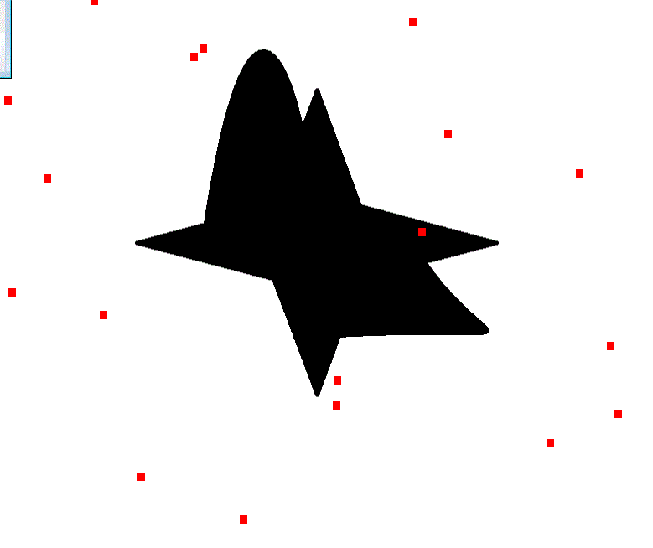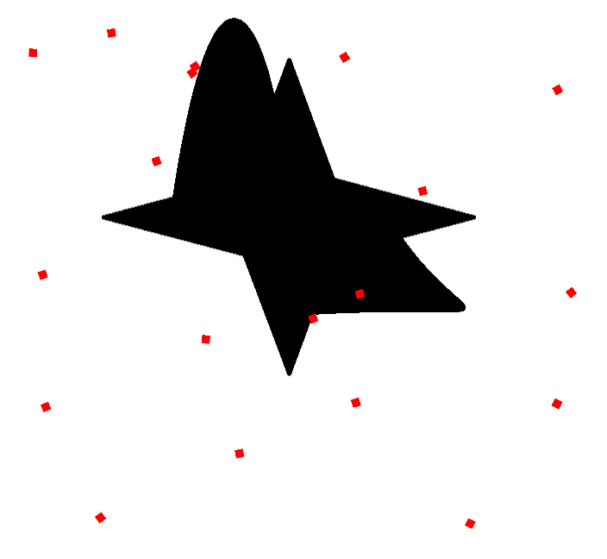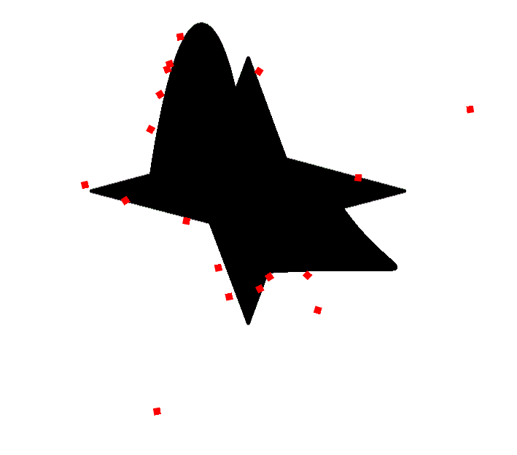

# 1. *Marine oil spill detection, statistics and mapping with ERS SAR imagery in south-east Asia.* Lu, J. 15, Ipswich : International Journal Of Remote Sensing, 2003, Vol. 24.

2. *Oil Spill Monitoring In The Croatian Adriatic Waters: Needs And Possibilities.* **MOROVIĆ, Mira, and Andrei IVANOV.** 1, Ipswich : Acta Adriatica, 2011, Vol. 52.

**Conclusion**

The implementation of a swarm of robots to track oil pollutants in the ocean could have far reaching affects.  Being able to monitor shipping lanes and areas around likely oil producing structures would allow for quick responses to such disasters.  I’ve shown that it is possible to distribute a group of robots without a central control and have them spread evenly over a given area.

Swarms of robots that can operate independently have other possibilities as well.  Robots that are designed to sample the ocean water and find oil spills could also be used to monitor and discover how the ocean and its inhabitants exist.  These robots would have far reaching implications on our knowledge of how the ocean and its inhabitants live (6).

**Background**

Current technology tracks oil spills using satellite imagery, aerial photographs, and aircraft onsite of the oil spill. Aircraft cover limited areas and come with high overhead operational costs (2).  Space-borne Synthetic Aperture Radar (SAR) detection, which is available through a number of satellites owned by various countries, produces images that are not available daily and are affected by cloud cover and wind speed.  While these methods cover large areas of ocean, they cannot always discriminate between oil slicks and naturally occurring phenomenon such as algae blooms and other surface anomalies (1).  All of these methods require a technician to inspect data to determine size, location, direction and size of a spill.  The methods using images from satellites only provide a static image of the spill, no information about where it is moving is given.

Artist rendition of a robot swarm controlled by algorithms developed by engineers at UC San Diego. Image credit: Scripps Institution of Oceanography at UC San Diego.

<http://www.jacobsschool.ucsd.edu/news/news_releases/release.sfe?id=901>

**Stills taken from the simulation show robots slowly finding the oil spill and maintaining distance from each other as they move in open ‘ocean’.**