**NFL.com 2025 Mock Draft Screenshots**

Complete NFL.com Mock Drafts - June 08, 2025

7 Authors • 231 Screenshots • Top 32 Picks Each • Analysis Included

# Bucky Brooks - 2025 Mock Draft

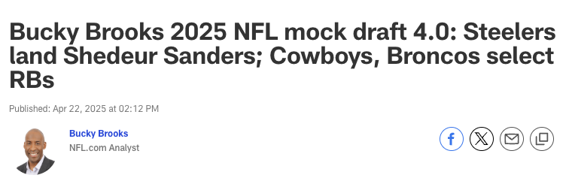

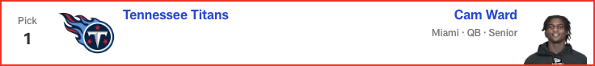

*📝 Analysis: As the Titans’ new franchise QB1, Ward would add the kind of talent, toughness and tenacity the franchise has lacked since Steve “Air” McNair was under center in Tennessee.*

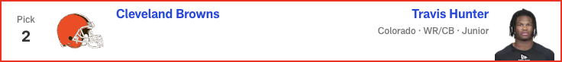

*📝 Analysis: The two-way standout is a superstar in the making as a big-play pass catcher and shutdown corner. Hunter’s unique skills would give Kevin Stefanski a Shohei Ohtani-esque weapon to utilize on offense and defense.*

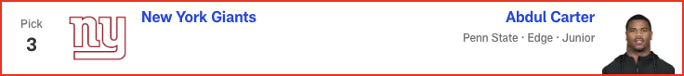

*📝 Analysis: Bypassing a chance to land a potential franchise quarterback is risky, but the Giants could take a disruptive playmaker to enhance a pass rush that features three quarterback hunters (Brian Burns, Dexter Lawrence and Kayvon Thibodeaux) on the front line.*

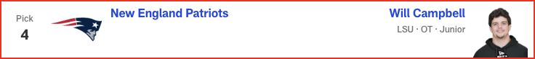

*📝 Analysis: Protecting Drake Maye is a top priority for a front office that wants to see the franchise quarterback flourish in Year 2.*

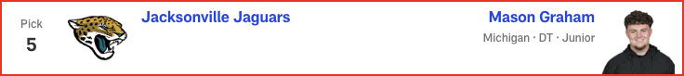

*📝 Analysis: The safest pick in the draft would give the Jaguars a blue-chip defender in the middle of a defensive line that needs more “hard hat and lunch pail” guys.*

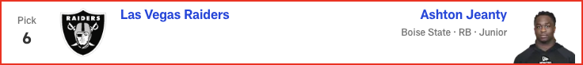

*📝 Analysis: Pete Carroll’s apparent desire to feature a dominant rushing attack makes the Boise State standout the sensible pick to serve as his lead back.*

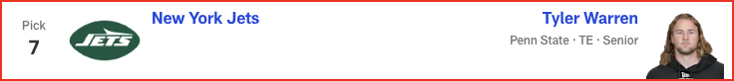

*📝 Analysis: Adding a big-bodied pass-catcher between the hashes would help Justin Fields settle in as a passer in an offense rooted in play-action concepts. Warren is a versatile playmaker with the route-running ability and ball skills to move the chains consistently with a ball-control approach.*

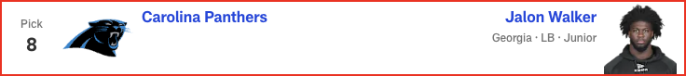

*📝 Analysis: Upgrading the defensive front with a hybrid linebacker who boasts pass-rushing skills could help the Panthers create more chaos at the point of attack.*

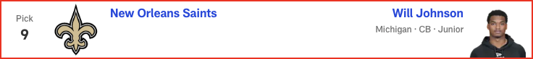

*📝 Analysis: The talented technician would give the Saints a blue-chip CB1 to feature in a zone-based system that places a premium on “vision-and-break” playmakers.*

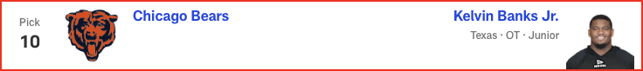

*📝 Analysis: New head coach Ben Johnson’s experience with a dominant line while running the offense for division-rival Detroit could prompt him to add more resources to the Bears’ front, even after it was fortified in free agency. Banks is a natural left tackle with the athleticism and shadowboxing skills to protect Caleb Williams’ blind side.*

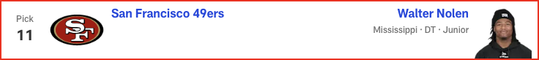

*📝 Analysis: Adding more talent and athleticism to the defensive front will enable Nick Bosa and Co. to get back to their disruptive ways at the line of scrimmage under DC Robert Saleh.*

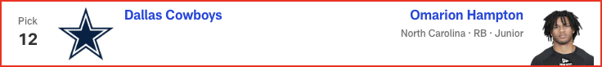

*📝 Analysis: The team needs a true RB1 to steady an offense that is always better when it operates with a run-first premise.*

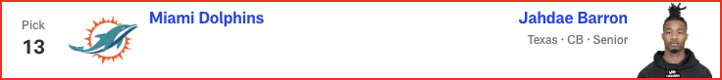

*📝 Analysis: Jalen Ramsey’s potential imminent departure could lead Barron to fill two spots as a CB/nickel defender.*

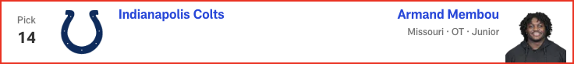

*📝 Analysis: With 29-year-old Braden Smith entering Year 8 of his career, the Colts could acquire their right tackle of the future here. As a big-bodied edge blocker with twinkle toes and heavy hands, Membou has the star power general manager Chris Ballard tends to covet in a top prospect.*

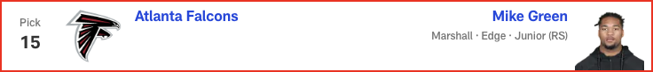

*📝 Analysis: The team’s desperation for an elite pass rusher could make Green the pick here. The Marshall standout possesses the first-step quickness and explosiveness to harass quarterbacks off the edge.*

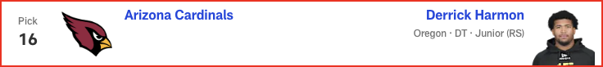

*📝 Analysis: The hard-nosed interior force would be a nice fit in Arizona's D-line as a disruptive defender with heavy hands and a high-revving motor.*

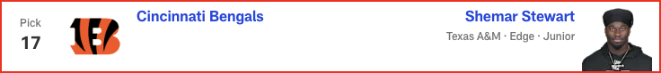

*📝 Analysis: Stewart still needs some development, but he's athletic and could generate strong sack numbers, especially if Trey Hendrickson sticks around, setting the rookie up to feed off the veteran's presence.*

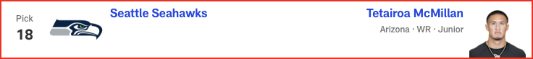

*📝 Analysis: After trading away DK Metcalf and releasing Tyler Lockett this offseason, the Seahawks could add a big-bodied pass-catcher to occupy the role of red-zone weapon.*

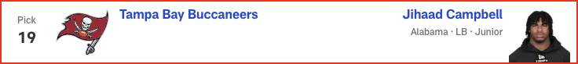

*📝 Analysis: Lavonte David is back for Year 14 -- but Todd Bowles could pick the 35-year-old linebacker's successor here. Presuming his recovery from a torn labrum goes smoothly, Campbell’s versatility would give the Buccaneers a second-level defender with playmaking and pass-rush potential.*

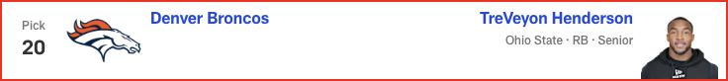

*📝 Analysis: Sean Payton wants a feature back with big-play potential in the rotation. Henderson’s speed and explosiveness could give the Super Bowl-winning coach Alvin Kamara vibes when he's contemplating how to utilize the Ohio State standout.*

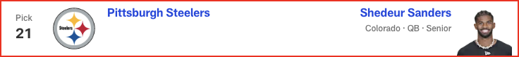

*📝 Analysis: Mike Tomlin could view Sanders as the perfect quarterback for his squad. With his confidence, moxie and pinpoint passing skills, the Colorado star might ignite a dormant offense that has already added some star power this offseason.*

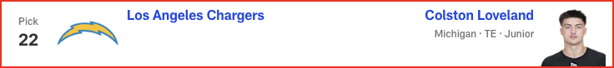

*📝 Analysis: Surrounding Justin Herbert with more playmakers should be a top priority for the Chargers. As a flex tight end with sticky hands and wide receiver-like route-running skills, Loveland could create mismatches in the passing game.*

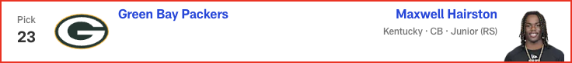

*📝 Analysis: The playmaking cover corner is the ideal ballhawk to play in Jeff Hafley’s system. Hairston excels as a “see ball, get ball” defender with superb instincts, awareness and diagnostic skills.*

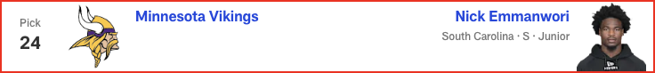

*📝 Analysis: Emmanwori can learn from Harrison Smith, who has been in the Vikings' backfield for 13 seasons, before sliding in as the next potential fixture at safety in Minnesota.*

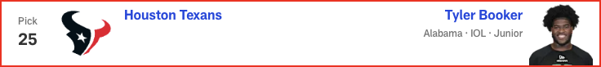

*📝 Analysis: The 300-plus-pound bully is a tone-setter at the point of attack. Booker mauls defenders as a heavy-handed blocker with a violent approach.*

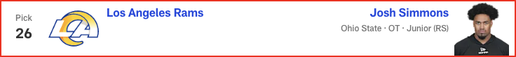

*📝 Analysis: The talented edge blocker might be too talented to bypass at this selection. Simmons’ athleticism and movement skills could make him a star early in his career.*

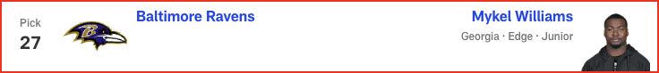

*📝 Analysis: GM Eric DeCosta and head coach John Harbaugh have a knack for finding quality players at the end of the first round. With his athleticism and pass-rushing potential, Williams could flourish in the Ravens’ aggressive defense.*

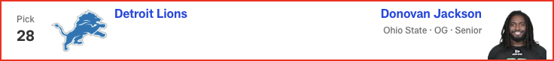

*📝 Analysis: In terms of temperament and physicality, Jackson is perfectly suited to help the Lions continue to dominate up front from the jump.*

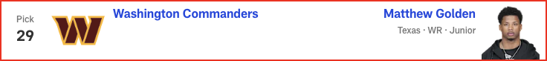

*📝 Analysis: What do the Commanders do to help Jayden Daniels take another step forward? Use a first-round pick on Golden, who led Texas in both receiving yards (987) and scoring grabs (nine) last season.*

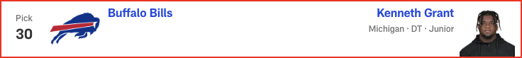

*📝 Analysis: Buffalo's depth chart features plenty of pass-rushing talent; the 6-foot-4, 331-pound Grant's presence up front could help shore up a run defense that ranked 19th in the NFL in yards allowed per rush attempt in 2024.*

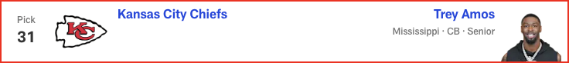

*📝 Analysis: Adding an outside corner would enable the Chiefs to move Trent McDuffie back to his natural nickel spot. Amos’ length, instincts and bump-and-run skills mesh well with the team’s defensive scheme.*

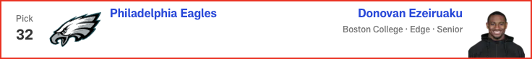

*📝 Analysis: The relentless, energetic Ezeiruaku knows how to harass the passer, based on his 16.5 sacks (second-most in the FBS) last season. He's an ideal match for the Eagles.*

# Daniel Jeremiah - 2025 Mock Draft

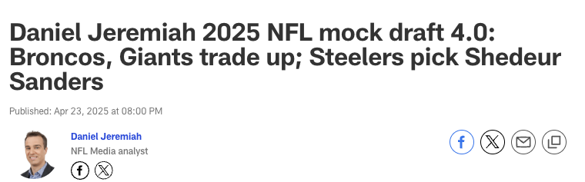



*📝 Analysis: It sounds like the cat could be out of the bag with this pick, based on Titans GM Mike Borgonzi’s comments this week. It’s time to bring some excitement to Tennessee, and Ward has a very enticing skill set.*

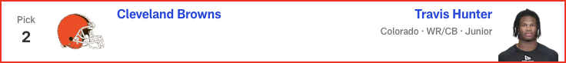

*📝 Analysis: At the end of the day, the Browns decide they can’t bypass all that Hunter brings to the table. GM Andrew Berry has said he views the two-way star as a wide receiver first and then a cornerback. Cleveland will have a fun duo at receiver with Hunter and Jerry Jeudy.*

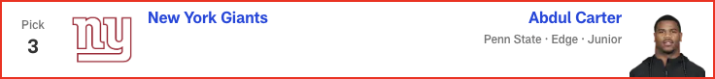

*📝 Analysis: There’s been chatter about the Giants potentially trading out of this pick, but if they stay put, I think they address the defensive line. Carter could take their front from good to great.*



*📝 Analysis: The Patriots must upgrade the left tackle position heading into Year 2 for Drake Maye. Campbell fits the bill. He’ll be a long-term starter for New England.*

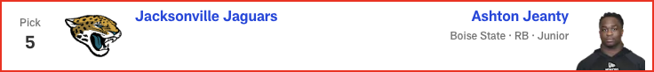

*📝 Analysis: Based on everything I’ve heard from talking to people around the league, the expectation is the Jaguars will pick either Jeanty or Arizona WR Tetairoa McMillan here. I’ll go with the higher-rated player on my board.*

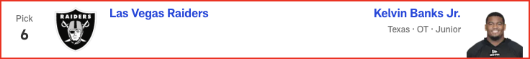

*📝 Analysis: With Jeanty unavailable, the Raiders decide to continue building at the line of scrimmage. I would assume Texas coach Steve Sarkisian gave his former boss, Pete Carroll, a strong recommendation on Banks. With Kolton Miller seeking a new contract, Banks gives Las Vegas insurance at left tackle. In the meantime, he could play guard if needed.*

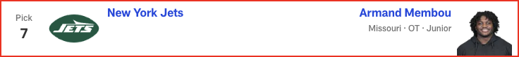

*📝 Analysis: I think this pick comes down to Membou versus Penn State TE Tyler Warren for new GM Darren Mougey and head coach Aaron Glenn. They choose Membou, who slides into the right tackle spot as potentially the final piece to the Jets’ offensive line overhaul of the last few years.*

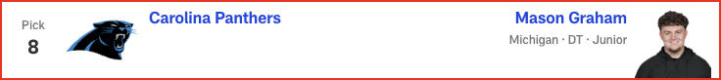

*📝 Analysis: Carolina took a big swing at Milton Williams in free agency and missed. They did end up signing defensive tackles, but none of the additions are of Graham’s caliber.*

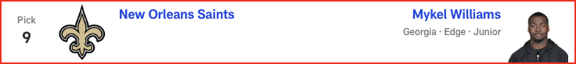

*📝 Analysis: There’s a lot of talk about the Saints drafting a quarterback at No. 9, but I think they’ll address that position in the second round. They have an affinity for long, physical edge rushers -- Williams fits that mold.*

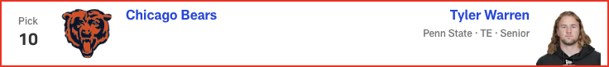

*📝 Analysis: With the top offensive linemen and Jeanty off the board, Warren becomes a very attractive piece for Ben Johnson’s offense. The Bears will be living in 12 personnel with Warren, Cole Kmet, DJ Moore and Rome Odunze on the field. That’s a group to be excited about.*

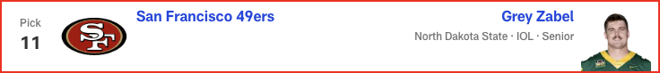

*📝 Analysis: The 49ers’ offensive line needs an influx of young talent with Trent Williams approaching his age-37 season, Aaron Banks departing in free agency and Brock Purdy getting set to sign a massive extension. Zabel can step in and start at guard from Day 1.*

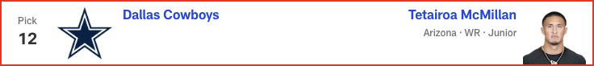

*📝 Analysis: I could see the Cowboys trying to trade out of this pick, but if they stay at No. 12, they could be choosing between the top remaining wide receivers, North Carolina RB Omarion Hampton and Alabama OG Tyler Booker. In this case, they go with a big target to complement CeeDee Lamb.*

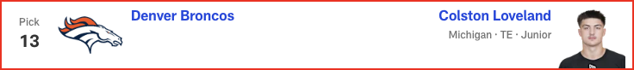

*📝 Analysis: I believe Loveland is highly coveted by a bunch of teams, and it seems like the Dolphins would like to add more draft capital. Sean Payton has never been shy about being aggressive -- the Saints traded up in the first round four times during his tenure as head coach. If he wants something, he usually goes and gets it. The signing of Evan Engram would not preclude Denver from making an aggressive move for Loveland.*

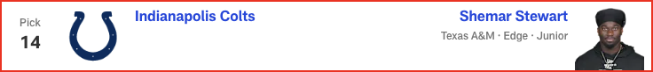

*📝 Analysis: Colts GM Chris Ballard has always placed a premium on athletic traits, and Stewart offers those in a big way. This feels very similar to the selection of Kwity Paye when he was coming out of college in 2021. Indianapolis drafts an edge rusher in the first round for the second year in a row (Laiatu Latu in 2024) after losing Dayo Odeyingbo in free agency.*

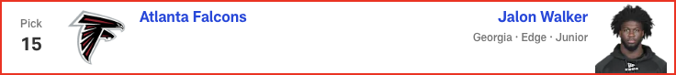

*📝 Analysis: I think this is the year Atlanta addresses the pass rush in Round 1. There’s a lot of chatter about James Pearce Jr. going to the Falcons, but in this scenario, Walker falls into their lap. He can rush off the edge -- on passing downs, at the minimum -- and play off the ball, too.*

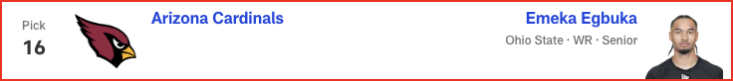

*📝 Analysis: Arizona reunites Egbuka with Ohio State teammate Marvin Harrison Jr. to give Kyler Murray a dynamic tandem at receiver. Egbuka fills a need, and he can help bring the best out of Harrison.*

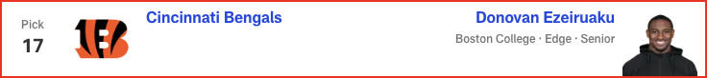

*📝 Analysis: Ezeiruaku is a skilled pass rusher with some similarities to Bengals DE Trey Hendrickson, whose future with the team remains murky.*

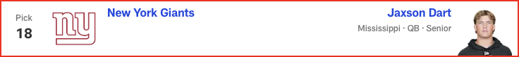

*📝 Analysis: The Giants and Browns are both candidates to trade back into the first round, with the goal of moving ahead of the QB-needy Steelers. I’ve heard talk about the Seahawks looking to trade out of Round 1, so this pairing makes sense. New York would get its QB and Seattle GM John Schneider would be armed with a boatload of Day 2 picks after this trade. There’s a belief in league circles that the Giants view Dart as a better fit than Shedeur Sanders.*

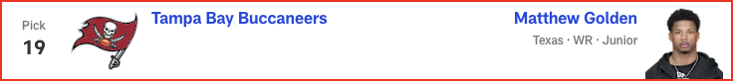

*📝 Analysis: It would not be a surprise to see Alabama LB Jihaad Campbell go to Tampa Bay at No. 19, but with Mike Evans heading into his 12th season, the Bucs opt to add another pass catcher. Golden would team up with 2024 third-round pick Jalen McMillan to give them two good, young wideouts to complement veterans Evans and Chris Godwin.*

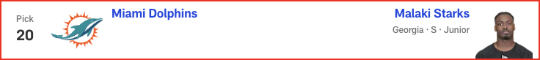

*📝 Analysis: PROJECTED TRADE WITH DENVER BRONCOS*

*I could see the Dolphins taking Starks at No. 13, but in this case, they trade back and still get him. Starks is a perfect fit for Miami, which lost Jevon Holland and could be on the verge of parting with Jalen Ramsey. Starks has the versatility to start at nickelback or safety.﻿﻿*

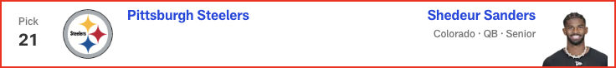

*📝 Analysis: I’m not convinced the Steelers will take Sanders if he’s available, but if he doesn’t go here, I’m not sure where he ends up. Mason Rudolph can provide a little bit of a bridge until Sanders is ready to go. This pick is a classic case of need meeting value.*

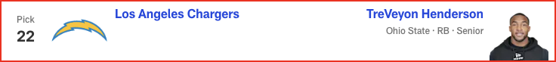

*📝 Analysis: It certainly would raise some eyebrows if Jim Harbaugh were to pass on two of his former Michigan pupils (DT Kenneth Grant and CB Will Johnson) to take an Ohio State product. That said, Henderson might just be too enticing here. He would be the lightning to Najee Harris' thunder, giving the Chargers an explosive running game.*



*📝 Analysis: The Packers love SEC defensive players, and Hairston can really run. He battled through injury in 2024, but his 2023 tape is exceptional. With Jaire Alexander potentially on the move, Green Bay adds help at cornerback.*

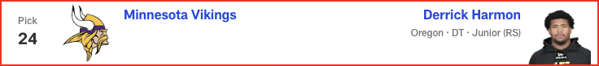

*📝 Analysis: The expectation is the Vikings will address either the offensive or defensive line here, even after making additions at those spots through free agency. Harmon can learn from Jonathan Allen and Javon Hargrave before becoming a full-time starter.*

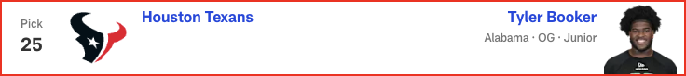

*📝 Analysis: The Texans are intent on changing the culture of their offensive line room, and Booker’s intangibles are as highly regarded as any I’ve come across in my time scouting offensive linemen.*

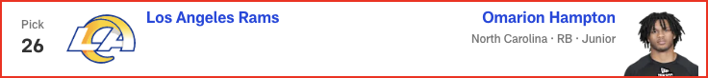

*📝 Analysis: On the surface, this might be puzzling, given the presence of Kyren Williams. But Williams is in the final year of his contract and had only one carry of 30-plus yards last season. In comparison, Saquon Barkley had 13 such runs, including the playoffs. Hampton provides a more explosive element to the Rams’ run game and can eventually take over as RB1.*

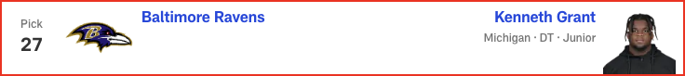

*📝 Analysis: This one is pretty simple: The Ravens are well connected at Michigan, and they have a need on the interior defensive line after Michael Pierce’s retirement.*



*📝 Analysis: The Lions have done a lot of homework on interior offensive linemen in this draft class. Jackson has been a riser throughout the evaluation process and would be the replacement for Kevin Zeitler. Jackson might not even make it to this pick, though.*

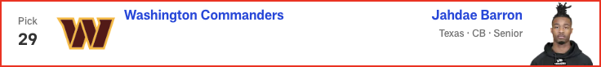

*📝 Analysis: This is a case of a team staying put and watching a value pick fall to it. I have Barron much higher in my rankings. He and 2024 second-round pick Mike Sainristil are two guys Washington could move all over the field.*

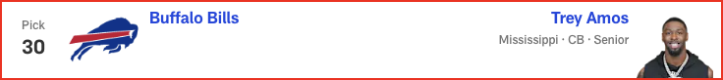

*📝 Analysis: I wouldn’t rule out a defensive tackle here, but the Bills need to add a cornerback with one of their early picks. Amos has the ability to match up with big, physical receivers.*

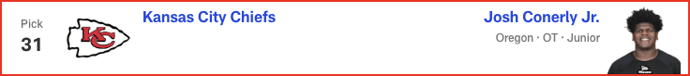

*📝 Analysis: It feels like the Chiefs will be taking the best available offensive tackle, even after signing Jaylon Moore. Their tackle play has cost them in both of their Super Bowl losses during the Patrick Mahomes era. They continue to invest at the position.*

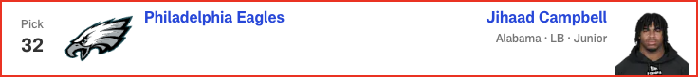

*📝 Analysis: The rules are simple with the Eagles: They take the best Alabama or Georgia player who falls into their lap. Campbell is my No. 12 player in the draft, so he would be a tremendous value at the end of Round 1. If not for the shoulder surgery he’s recovering from, he'd be a lock to go much higher.*

# Charles Davis - 2025 Mock Draft

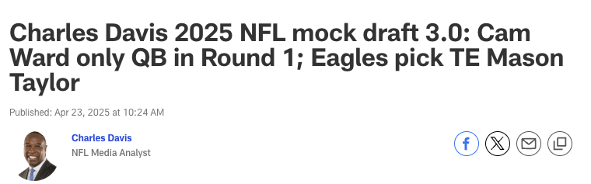



*📝 Analysis: The Titans thought they had their QB1 for the future in Will Levis, but it hasn’t worked out the way they hoped. They begin again with this mobile, big-armed QB who's eager for the challenge.*

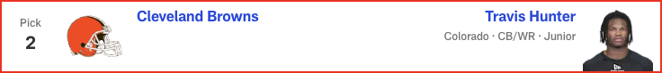

*📝 Analysis: Quarterback will be a strong consideration here, but the Browns opt for the Heisman Trophy winner. Hunter is the best player in the draft. Cleveland will begin by using him mainly on offense as the team’s WR1 -- and yes, he will play some defense, too.*



*📝 Analysis: Could this be the spot for Shedeur Sanders? After weighing their options, the Giants take an elite edge rusher to pump up the defense.*



*📝 Analysis: This could be a pick where the crowd in Green Bay lets out a roar of surprise if New England takes RB Ashton Jeanty. The Patriots might think about it, but ultimately, they pick a polished offensive lineman who will be the starting left tackle from the moment Commissioner Roger Goodell announces the selection.*



*📝 Analysis: OK, this is where we hear the surprised roar. New head coach Liam Coen gets an elite weapon to help him unlock all of QB Trevor Lawrence's potential.*

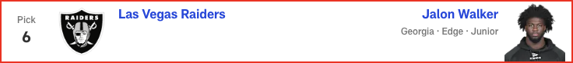

*📝 Analysis: Former first-round edge rusher Tyree Wilson has not panned out yet, so first-year GM John Spytek selects a new running mate for perennial Pro Bowler Maxx Crosby.*



*📝 Analysis: The Jets had a chance to draft TE Brock Bowers last year but passed on him before he landed with the Raiders and ultimately earned first-team All-Pro honors as a rookie. New York’s new brain trust doesn't miss the opportunity to land a potential star tight end this time around, and new QB1 Justin Fields is thrilled.*

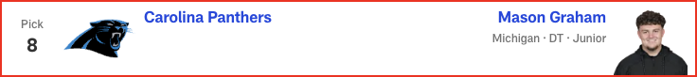

*📝 Analysis: The Panthers are desperate to get their defense back on track after a dismal 2024 season. The All-American from Michigan fits nicely next to Pro Bowl DT Derrick Brown, who is on his way back after missing all but one game last season due to injury.*

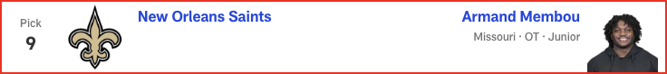

*📝 Analysis: This could easily be where QB Shedeur Sanders goes. I’ve already said I would be pounding the table for him in the draft room. Instead, though, the Saints tap Membou to take over at right tackle.*

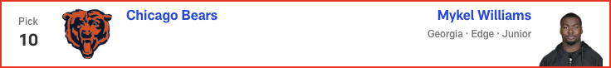

*📝 Analysis: Size, speed, explosiveness -- Williams has the traits teams are looking for in an edge rusher. The Bears' Montez Sweat welcomes the help.*

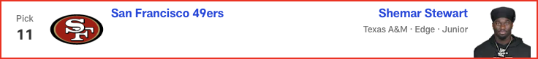

*📝 Analysis: There has been a lot of talk this offseason about the 49ers’ need for pass-rush help opposite Nick Bosa. In this projection, San Francisco takes a chance on a player with great talent but very limited production (4.5 sacks in three years at Texas A&M) to show for it.*



*📝 Analysis: With great size and strength, not to mention good hands, McMillan is the perfect complement to all-star WR1 CeeDee Lamb.*

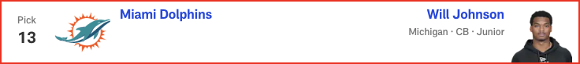

*📝 Analysis: The news that the Dolphins and CB Jalen Ramsey have mutually agreed to explore a trade hastens this selection. Johnson's dimensions are different from Ramsey's, but his aggressive nature attacking the ball is much like the veteran's.*

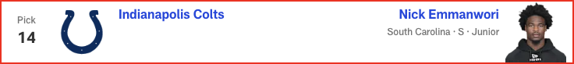

*📝 Analysis: There will be heavy consideration for Michigan TE Colston Loveland here, but new DC Lou Anarumo will be psyched when GM Chris Ballard calls this choice in. Expect Emmanwori to make an early impact.*

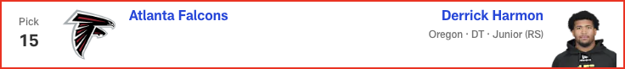

*📝 Analysis: Falcons fans annually clamor for a top edge rusher to be selected, but with longtime defensive tackle Grady Jarrett off to Chicago, Harmon brings his youthful energy to Georgia's capital city.*

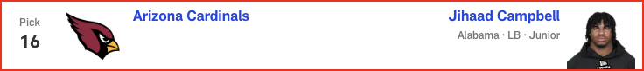

*📝 Analysis: Cardinals head coach Jonathan Gannon and defensive coordinator Nick Rallis will immediately implement schemes that allow Campbell to find the ball quickly. He will pursue the QB in obvious passing situations, too.*

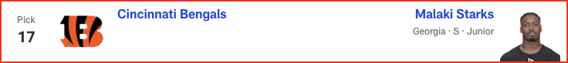

*📝 Analysis: When the Bengals were playing their best on defense in recent years, they were strong down the middle. Starks is a sideline-to-sideline playmaker from center field.*

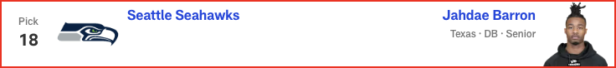

*📝 Analysis: This do-it-all defensive back will fit perfectly in head coach Mike Macdonald's schemes. Barron will allow big-play DB Devon Witherspoon to attack offenses with even more gusto.*

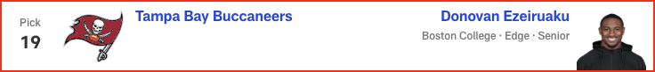

*📝 Analysis: The Bucs are all about disrupting the opposing QB, and the 2024 Ted Hendricks Award winner (best DE in the country) has a full arsenal of moves that make things bumpy for passers.*

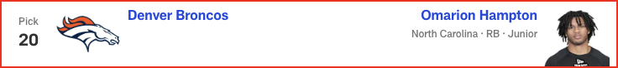

*📝 Analysis: Sometimes the fit is just right. Denver craves a lead RB, and Hampton is available.*

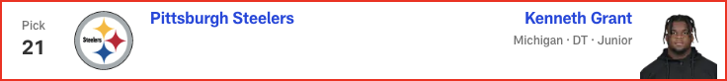

*📝 Analysis: Pittsburgh is another potential landing spot for Shedeur Sanders or one of the draft's other QB prospects. But in this case, the defensive front is prioritized by the Steelers, who select All-Pro DT Cam Heyward's eventual replacement.*



*📝 Analysis: Chargers GM Joe Hortiz and head coach Jim Harbaugh covet great players, and it doesn’t hurt that Harbaugh already knows Loveland quite well from their time together at Michigan. Another Wolverine heads west and helps QB Justin Herbert move to a higher echelon.*

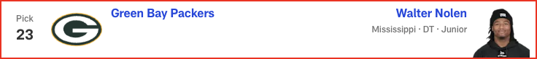

*📝 Analysis: The Packers add another interior pass rusher for DC Jeff Hafley as he seeks to cause a lot of turbulence for the opposition.*

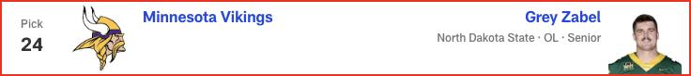

*📝 Analysis: Vikings GM Kwesi Adofo-Mensah continues to remake the offensive line. Zabel was a standout at NDSU and at the Senior Bowl. I think he's a plug-and-play starter at guard.*

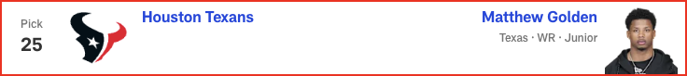

*📝 Analysis: Here’s a big decision for GM Nick Caserio. Does he help rising QB C.J. Stroud with a receiver or an offensive lineman? In this scenario, Golden’s speed and big-play ability make him the choice, but he could certainly be picked earlier in Round 1.*

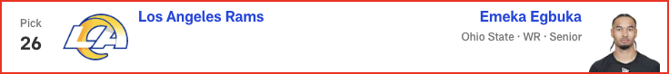

*📝 Analysis: A tremendous route runner and pass catcher, Egbuka is also up for the challenge of blocking in the run game, which is a must for receivers under head coach Sean McVay.*

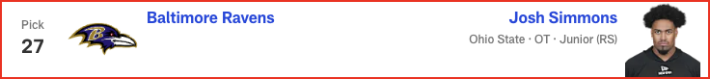

*📝 Analysis: Simmons has the potential to be a top-tier left tackle, but with Ronnie Stanley returning, the Ohio State/San Diego State product might begin his NFL career at guard, something Hall of Famer Jonathan Ogden did in his rookie season with Baltimore.*

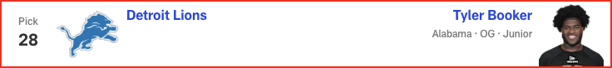

*📝 Analysis: The Lions continue to make the offensive line a priority. Booker steps in at guard to replace the departed Kevin Zeitler. Sonic and Knuckles will like this pick.*

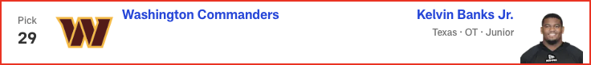

*📝 Analysis: It would not be a surprise to see Washington select a cornerback here -- Notre Dame’s Benjamin Morrison is my favorite CB in the draft -- but in this case, the Commanders fortify the offensive line with Banks, who can compete for the starting job at right tackle as a rookie.*

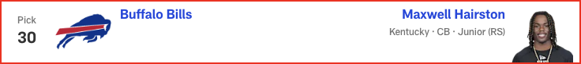

*📝 Analysis: The Bills always field a top defense, and they might want to be more aggressive in man coverage in 2025. If that's the case, the selection of "Mad Max" would be ideal for head coach Sean McDermott and defensive coordinator Bobby Babich.*

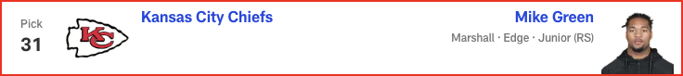

*📝 Analysis: Super Bowl LIX aside, Kansas City’s defense has been an absolute force in recent seasons. GM Brett Veach continues to give DC Steve Spagnuolo great resources.*

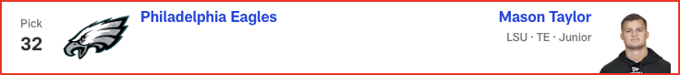

*📝 Analysis: GM Howie Roseman does a tremendous job of drafting players and getting them experience before they are needed as starters. Taylor, a smooth pass catcher, could be next in line.*

# Eric Edholm - 2025 Mock Draft

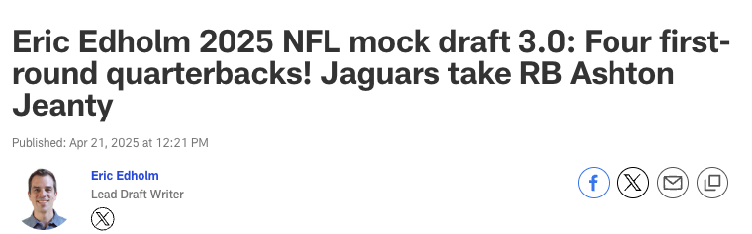

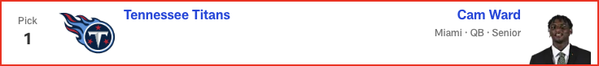

*📝 Analysis: This pick has felt locked in for weeks. Ward's almost certainly the new face of the Titans. This has allowed new GM Mike Borgonzi to start thinking about which receivers and edge rushers might be available when Tennessee comes on the clock early in Round 2.*



*📝 Analysis: I won't say Hunter's completely bust-proof, but it's hard to imagine the Heisman Trophy winner not helping out in a major way, either at receiver or corner -- or, as he prefers, at both spots.*



*📝 Analysis: The Giants still have a decision to make on Kayvon Thibodeaux's fifth-year option. Carter, my No. 1 overall prospect in this draft class, could be an absolute monster in time.*

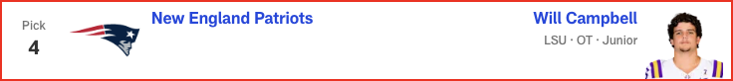

*📝 Analysis: Mike Vrabel knows he needs to protect Drake Maye, but the Patriots also need leaders and reliable building blocks. Campbell fills all of those voids.*

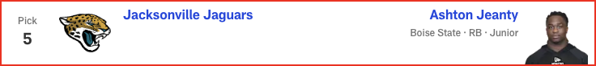

*📝 Analysis: I'm gonna flip it around. DT Mason Graham going here began to feel way too chalky for me recently. I just think Liam Coen will want to add a playmaker to his offense with the new regime's first pick.*

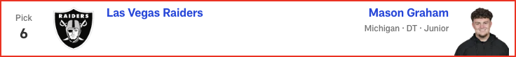

*📝 Analysis: With Ashton Jeanty off the board, the Raiders add another piece to a pretty strong defensive line. Las Vegas must continue to fortify that front in order to compete in the AFC West.*



*📝 Analysis: I considered Tyler Warren here, but the Jets can get a tight end later. They'd have less success attempting to find a starting right tackle with Membou's upside after this pick.*

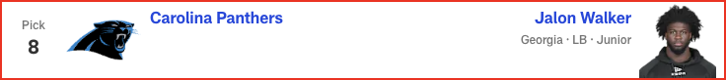

*📝 Analysis: Carolina is still a bit of a mystery, and there has been some trade chatter at this spot. But Walker's speed, pass-rush ability and QB-spy potential could add some juice to that defense.*

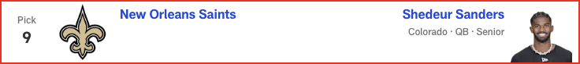

*📝 Analysis: I truly don't know where Sanders is going to end up or what the Saints think of him, but New Orleans needs a quarterback and this mock needs Sanders. (I think.)*



*📝 Analysis: With two picks coming early in Round 2, the Bears can afford to take a luxury pick -- a nice Tonka truck for Ben Johnson to play with -- and swing back later for the tackle.*

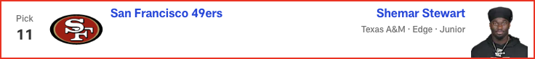

*📝 Analysis: The Niners feel capable of making some noise in this draft, and they can afford to take an early swing on Stewart's alluring skill set, with 10 more picks forthcoming.*

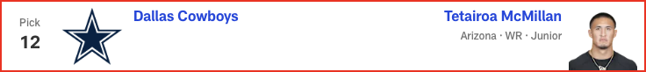

*📝 Analysis: CeeDee Lamb can't keep shouldering such an outsized portion of the load. McMillan gives Dallas a big perimeter wideout and red-zone target with great body control and chunk-play ability.*



*📝 Analysis: With Jalen Ramsey on the trade block, cornerback becomes a pretty urgent need in Miami. Barron is a versatile defender with playmaking chops who can help immediately.*

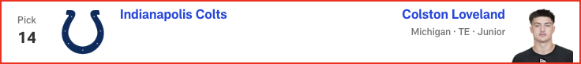

*📝 Analysis: When healthy last season, Loveland was a godsend for a Michigan team that struggled badly at QB. Daniel Jones and Anthony Richardson are battling for the Colts' starting job. Loveland is here to help -- once he's cleared for contact following shoulder surgery.*



*📝 Analysis: This pairing has been gaining some steam of late, and it makes sense -- just as the idea of Atlanta using a first-round pick on a pass rusher has for many years.*

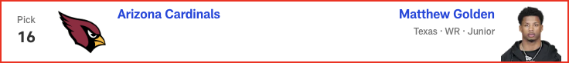

*📝 Analysis: This is another head-scratcher spot for me. Arizona could feel good enough about the DL/edge depth to wait on addressing that need. The Cardinals, however, might not be able to find the same caliber of receiver as Golden lower down.*

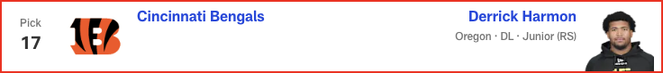

*📝 Analysis: There's a case to be made for taking more of an edge defender, but the Bengals need help inside. Harmon is a multi-technique DL who can disrupt from the interior.*

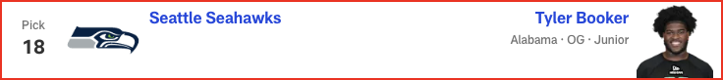

*📝 Analysis: The interior of Seattle's offensive line needs immediate help, and it was between Booker and North Dakota State's Grey Zabel here. Booker lacks Zabel's versatility, but the Alabama product can be a slobberknocker right away in the run game. There still should be a solid receiver available at 50 or 52.*



*📝 Analysis: I think an edge could tempt Tampa Bay here, but Campbell is such an explosive athlete and a perfect fit for the Bucs, assuming their medical evaluation of him is clean.*



*📝 Analysis: The Broncos quietly are creeping up on the NFL's big boys, and adding a three-down lead back speeds up that development. Hampton could be a big producer in Sean Payton's offense.*

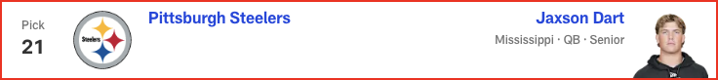

*📝 Analysis: The Steelers must have heard Aaron Rodgers waffling about his future on The Pat McAfee Show. Can they count on the 41-year-old? If Pittsburgh doesn't go QB here, what's the long-term plan at the game's most important position?*

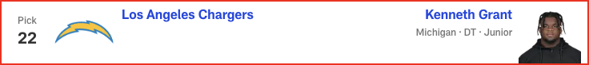

*📝 Analysis: Sure, the school connection helps for scouting purposes, but Grant really does fill the Chargers' nose tackle needs well. He'd step right into the Poona Ford-sized hole up front.*

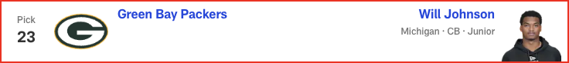

*📝 Analysis: Johnson has been a tricky player to place in mock drafts because of questions about his health and long speed. But at No. 23, the Packers absolutely can justify the risk for a highly pedigreed talent at a needed spot.*

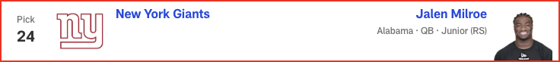

*📝 Analysis: PROJECTED TRADE WITH MINNESOTA VIKINGS*

*﻿﻿﻿﻿With Jaxson Dart off the board, the Giants can't hesitate to move up for a QB if they want one. Milroe makes sense for New York, even if he's a dice roll. The Vikings, with just four picks, might be an eager trade partner. In this scenario, Big Blue gives up Pick Nos. 34, 99 and 105 to select an explosive playmaker at 24.*

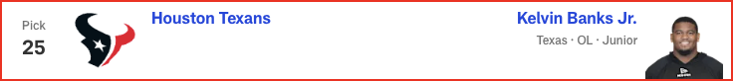

*📝 Analysis: I didn't imagine Banks falling this far, and I contemplated a receiver such as Emeka Egbuka here, but Houston can find a home for this Texas product right away, either at guard or tackle. He grew up just down the road from the Texans' facility.*

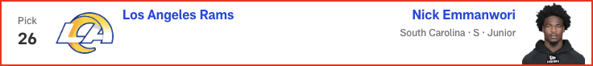

*📝 Analysis: The Rams were infatuated with Brock Bowers in last year's draft, so LSU TE Mason Taylor wouldn't shock me here. But Emmanwori could be a box safety/linebacker, adding another playmaker for this defense.*

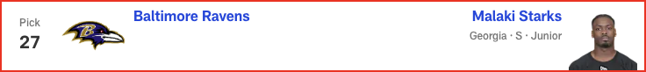

*📝 Analysis: Every year, it seems, a top-20 talent just falls into Baltimore's lap in this range, and we all just shrug. Starks could fill an immediate role in a thin secondary as a proven, three-year SEC starter.*

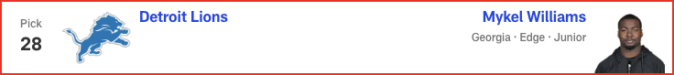

*📝 Analysis: I'm not fully convinced Williams makes it this far, but if he does, the Lions should be thrilled. He's exactly the type of ascending prospect and body type Detroit seems to want on the edge.*

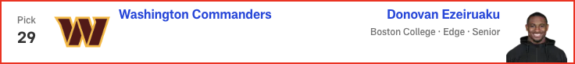

*📝 Analysis: I thought long and hard about a cornerback here, but Ezeiruaku's pass-rush upside might be too tempting to pass up here. He's also a mature player whose football character fits perfectly with Dan Quinn.*



*📝 Analysis: Maxwell Hairston's speed might be tempting, but Amos just feels like a better fit in Buffalo as a tackler, zone defender and general irritant with his size and play style. This secondary needs more length and skill.*

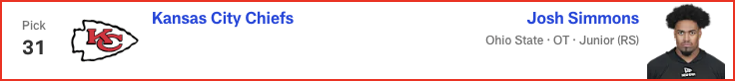

*📝 Analysis: Left tackle was such an issue last season, and the Chiefs can't assume free-agent addition Jaylon Moore will dominate and stay healthy. Simmons would be a smart value pick who can be brought along gradually.*

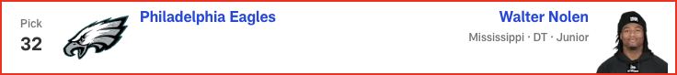

*📝 Analysis: The Eagles must replenish some lost depth up front, and Nolen could be perfect in their DL wave. He's a flash player who hasn't put it all together yet, but the ceiling is very high.*

# Dan Parr - 2025 Mock Draft

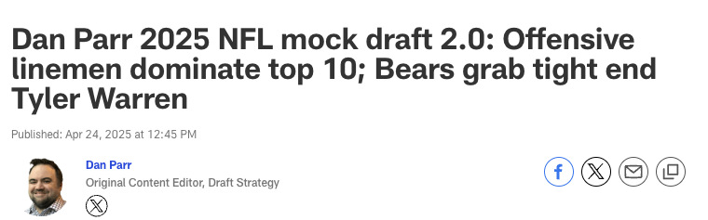

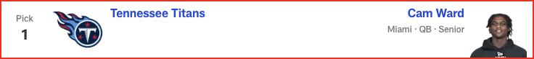

*📝 Analysis: The Titans use a top-10 pick on a quarterback for the fourth time in the last 20 years, hoping Ward and Brian Callahan can unlock some magic.*



*📝 Analysis: Cleveland doesn’t pass up a chance to select a potential once-in-a-lifetime player. Hunter immediately becomes a weapon on offense and can be used in certain packages on defense, as well.*



*📝 Analysis: While the long-term quarterback need looms large, the Giants don’t see value at the position that matches such a high pick. They select Carter and look to recreate the dominant pass rush that was critical to the team’s two Super Bowl wins in this century.*



*📝 Analysis: The Patriots don’t let the arm-length debate get in the way of their need to give Drake Maye a much-improved offensive line.*

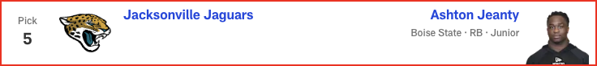

*📝 Analysis: As I’ve been saying since last month, the Jaguars should not turn down an opportunity to snag Jeanty, the best player available at No. 5. Based on the buzz of the last few days, I don't think they will.*



*📝 Analysis: With Jeanty off the board, the Raiders pivot to tightening up an offensive line that ranked near the bottom of the league last season.*



*📝 Analysis: The Jets have had a revolving door at right tackle for the past few seasons. In this simulation, they hope Membou and left tackle Olu Fashanu can bookend the offensive line for the next decade.*

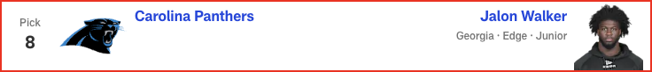

*📝 Analysis: The Panthers are coming off a historically bad season on defense. Drafting Walker is a big step back toward respectability on that side of the ball.*

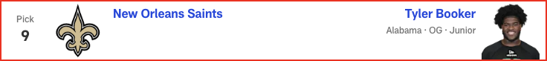

*📝 Analysis: The biggest stunner of the night comes at No. 9, with the Saints picking Booker earlier than most expected the hulking guard to come off the board. New Orleans could go in a number of directions here, including addressing the defensive line, but Kellen Moore looks for a building block on the offensive line first.*



*📝 Analysis: The board falls Ben Johnson’s way, giving him a chance to start his career as a head coach with a weapon who opens a lot of possibilities for the offense.*

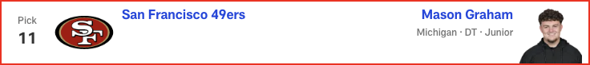

*📝 Analysis: We might see a party break out in the 49ers’ draft room if Graham -- NFL Network draft guru Daniel Jeremiah’s No. 4 overall prospect -- falls all the way to San Francisco at No. 11. That is, unless Ole Miss' Walter Nolen is the DT they prefer, as the most recent buzz has suggested.*

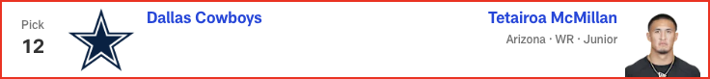

*📝 Analysis: The Cowboys relieve some of the stress on Dak Prescott by pairing CeeDee Lamb with McMillan, who has ball skills for days.*



*📝 Analysis: Miami could use a new alpha in the secondary with Jevon Holland gone and Jalen Ramsey potentially following him out the door. Barron fits the bill.*



*📝 Analysis: A popular trade-up candidate in mocks from my colleagues, the Colts stay put and still fill their biggest need in this scenario.*

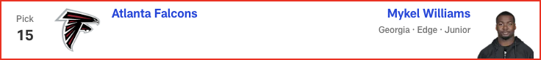

*📝 Analysis: If Raheem Morris can unlock Williams’ potential, the 20-year-old could become an elite NFL pass rusher, something the Falcons have sorely lacked for far too long.*

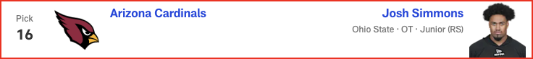

*📝 Analysis: For the third straight year, Arizona uses its top pick on an Ohio State product. Simmons joins Paris Johnson to give the Cardinals a pair of Buckeye bookends with long-term potential.*

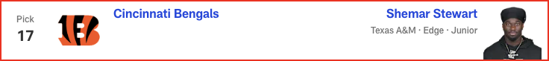

*📝 Analysis: The Bengals have to be on the lookout for someone who can either complement or replace Trey Hendrickson. New DC Al Golden’s task is to bring Stewart along from a production standpoint (just 4.5 sacks over three seasons at Texas A&M). He has the traits to be a monster off the edge.*

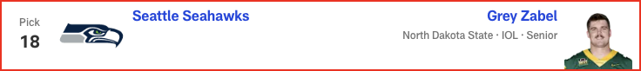

*📝 Analysis: If the Seahawks don’t trade out of this pick, this seems like a spot to shore up the offensive line. They go with Zabel, who can start at guard from the jump and has the versatility to fill in elsewhere on the line in a pinch.*



*📝 Analysis: "Best player available" vibes here. Campbell gets a chance to soak up wisdom from Lavonte David, one of the top off-ball linebackers of his era, before it’s his time to be the guy.*

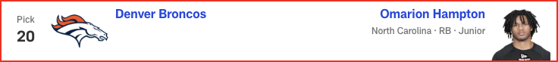

*📝 Analysis: Sean Payton finds the tone-setter the Broncos have been lacking in Hampton, who can take some pressure off Bo Nix’s shoulders.*

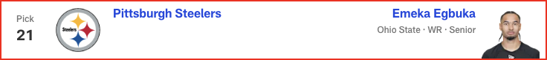

*📝 Analysis: Obviously, Shedeur Sanders has been the popular projection to Pittsburgh in the days leading up to the draft. If the Steelers decide to wait on taking a QB, the trio of DK Metcalf, George Pickens and Egbuka would be very enticing.*

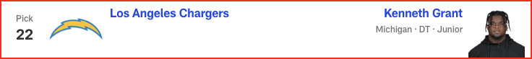

*📝 Analysis: Jim Harbaugh continues to build his team through the trenches, reconnecting with a fellow Michigan Man in the process.*

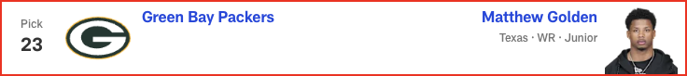

*📝 Analysis: Packers fans assembled at the draft site get to witness history for their franchise, as Green Bay selects a receiver in Round 1 for the first time in 23 years. Jordan Love approves!*

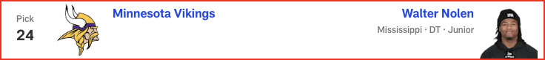

*📝 Analysis: Minnesota’s remaking of the defensive line continues. Nolen gets a chance to be tutored by Jonathan Allen and Javon Hargrave before it’s his time to be a leader on the interior.*

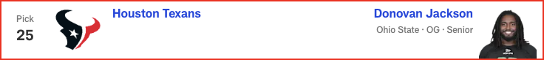

*📝 Analysis: GM Nick Caserio and head coach DeMeco Ryans continue their mission to rebuild the Texans’ offensive line, reuniting C.J. Stroud with his former Ohio State teammate.*

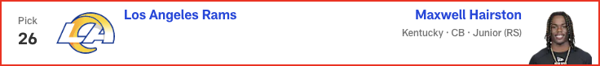

*📝 Analysis: It won't be a surprise if the Rams trade down in a deal with a team looking to move up for a quarterback. In this scenario, though, they bolster the secondary with a cornerback who has sub-4.3 speed and the ball skills to be a headache for offenses.*

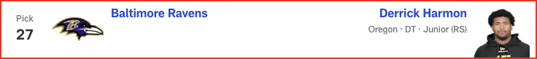

*📝 Analysis: With Harmon joining Nnamdi Madubuike, the Ravens are going to wreak havoc from the interior.*

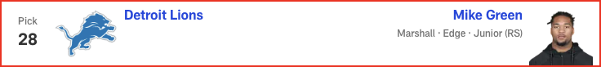

*📝 Analysis: The search for a pass-rushing complement to Aidan Hutchinson shifts to Green, who led the FBS with 17 sacks in 2024.*



*📝 Analysis: Washington fills its most pressing need with a player Dan Quinn could mold into a Pro Bowl-caliber pass rusher.*

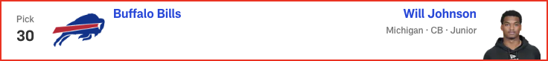

*📝 Analysis: Buffalo ends Johnson’s slide after injuries marred his 2024 season and pre-draft process. Cornerback is a spot the Bills must address, and the pedigreed cover man's value at No. 30 overrides potential concerns about him not running a 40-yard dash for teams.*

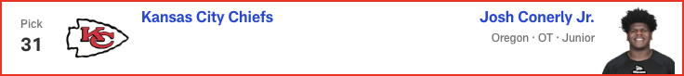

*📝 Analysis: Conerly offers the quality depth Kansas City should be building up front for Patrick Mahomes.*

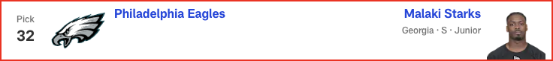

*📝 Analysis: Another year, another draft where one of the top defensive players in the class falls into the Eagles’ lap. DC Vic Fangio will love his options in the secondary.*

# Gennaro Filice - 2025 Mock Draft

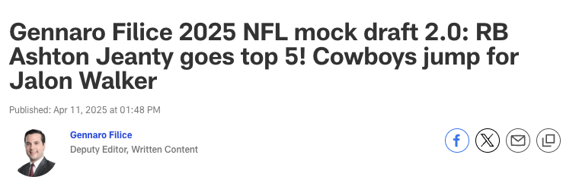

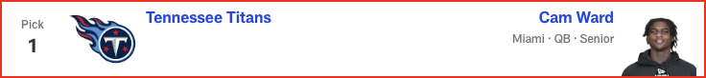

*📝 Analysis: At this juncture, mocking any other player in this draft slot would invite mockery. Ward appears destined to go No. 1 overall -- the only potential question is, who’s taking him? Theoretically, another quarterback-needy team could present the Titans with a Godfather offer. And yet, I still think they’d refuse. Reining in Ward’s devil-may-care playing style might be challenging, but who honestly thinks Brian Callahan would rather stick with the devil he knows, Will Levis?*

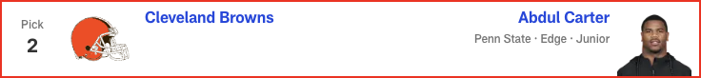

*📝 Analysis: The Draft Buzz-O-Meter [patent pending] has been shifting this pick to Travis Hunter. Understandable, especially given Cleveland’s dearth of offensive playmakers. But having Carter rush the passer opposite Myles Garrett for the rest of this decade is a five-year plan I can believe in. It doesn’t solve the franchise’s never-ending nightmare at quarterback, but think of the terror thrust upon opposing signal-callers. If you can’t beat ‘em, beat ‘em up!*

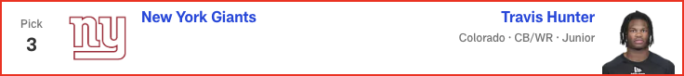

*📝 Analysis: When I last mocked Hunter to New York, longtime beat writer Paul Schwartz had just reported that the Giants see the two-way star as a cornerback. The New York Post scribe changed his tune this week, though, writing that the team’s evaluation remains fluid. The current state of the roster makes CB the bigger need, but a potential duo of Hunter and Malik Nabers makes WR the bigger splash. Maybe you can have your cake and eat it too, Big Blue!*

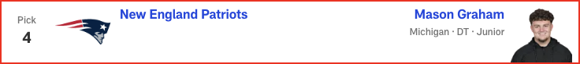

*📝 Analysis: New England just signed Milton Williams to a nine-figure deal, but fellow defensive tackle Christian Barmore remains an uncertainty due to recurring symptoms from blood clots. And regardless, does Mike Vrabel strike you as the kind of guy who’d be concerned about having too many disruptive D-linemen? Following a free agency spending spree that upgraded all three levels of the defense, the Patriots suddenly look like dark-horse contenders to field the league's best D in 2025. Adding an instant-impact leverage monster like Graham could push the unit over the top.*

*And not to fret, Drake Maye: I’ve got something up my sleeve to upgrade your protection in the back half of this mock.*



*📝 Analysis: Seemingly everyone -- including our resident prospect rankers in these parts, Daniel Jeremiah, Eric Edholm and Lance Zierlein -- has Jeanty as a top-five player in this class. So, what’s stopping him from being selected in the top five picks of this draft? Travis Etienne Jr.'s efficiency declined in 2023, and his production fell off a cliff in ’24. Tank Bigsby emerged as a rusher in Year 2, but he still seems ideally suited as a bruising RB2. Feels like a nice place to insert Jeanty, who just so happens to be a Jacksonville native. Trevor Lawrence has been supported by a top-20 ground game once, and in that 2022 season, he earned his lone Pro Bowl nod while the Jaguars took the AFC South and made noise in the playoffs. Seems relevant.*

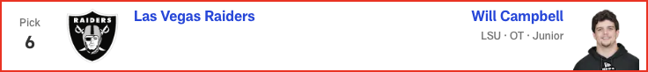

*📝 Analysis: Concerns about Campbell’s arm length spawned questions about the LSU product’s NFL position, but there’s no question the Raiders’ unsettled offensive line could use his fundamentally sound blocking in some capacity. Athletic, powerful and cerebral, Campbell overcame any length shortcomings to earn All-SEC recognition in each of his three college seasons -- and he added consensus All-America honors to the résumé this past fall.*

*Coincidentally, Pete Carroll’s first draft in Seattle began with the selection of an offensive tackle at No. 6 overall (Russell Okung).*

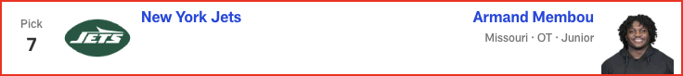

*📝 Analysis: The Jets have high hopes for last year’s first-round tackle, Olu Fashanu, as a "dancing bear" pass protector on the blind side. Here’s a perfect opportunity to complete the bookend set with an RT prospect who offers rare athleticism and bully spirit in a 332-pound frame.*

*Coincidentally, Aaron Glenn’s first draft in Detroit began with the selection of an offensive tackle at No. 7 overall (Penei Sewell).*

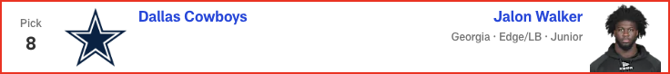

*📝 Analysis: PROJECTED TRADE WITH CAROLINA PANTHERS*

*Across the mockosphere, Walker often comes off the board at No. 8 overall -- typically, though, the Carolinas native is projected to land in Charlotte. But in this simulation, the Panthers trade the pick to the Cowboys, who scoop up Walker for themselves. Wait, doesn’t Dallas already have a twitchy LB/edge hybrid? Yeah, but why settle for one Micah Parsons when you can have two?! Alright, that comp’s aggressive, but the pairing would be undeniably fun. And Parsons is a well-documented fan of Walker’s game.*

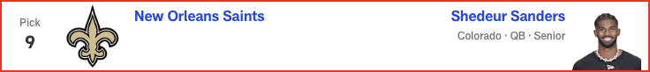

*📝 Analysis: With an aging roster pockmarked by restructured contracts and depth issues, New Orleans is no longer the land of bullish cap truthers. And with piles of dead presidents tied up in dead cap, the Saints could use the salary cheat code of a quarterback on a rookie contract. Sanders, like most first-year signal-callers, could benefit from a grace period before he’s expected to take the reins from the incumbent starter (Derek Carr). New head coach Kellen Moore has proven adept at working with young quarterbacks, particularly Dak Prescott and Jalen Hurts.*

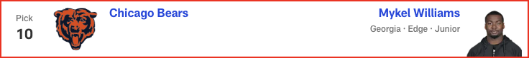

*📝 Analysis: Every draft cycle is a set of waves ... take waves, which typically swell after tentpole events like the NFL Scouting Combine, pro days, etc. And when it comes to placing individual prospects in a mock, the trick is figuring out which wave to ride.*

*Mykel Williams got a ton of early buzz in draftworld, but it feels like the hype train has slowed over the last month or so. With the full disclosure that I have no inside intel on the subject, I’m guessing that the early buzz was real and this late cooling period is a product of teams trying to hide their interest.*

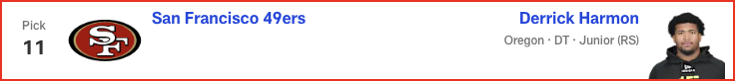

*📝 Analysis: Looking at San Francisco’s current depth chart, it’s shocking how unimposing the defensive line appears on paper. Yeah, the group is headlined by Nick Bosa, but beyond the perennial Defensive Player of the Year candidate, where’s the beef? The Niners are particularly thin on the interior. So let’s give them a scheme-versatile D-lineman out of Oregon -- remember Arik Armstead, 49er Faithful? -- who has drawn the kind of subtle-yet-consistent praise throughout the pre-draft process that makes me believe he could go surprisingly high.*

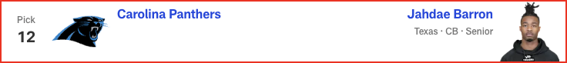

*📝 Analysis: PROJECTED TRADE WITH DALLAS COWBOYS*

*Alignment versatility’s all the rage among NFL pass catchers. Consequently, inside/outside ability’s never been more valuable to NFL defenses. And that’s exactly what Barron provides. Having just won the Jim Thorpe Award as college football’s top defensive back, the Texas product lined up all over the field as a starter for the last three seasons, deftly executing different techniques across myriad coverages. Then he put the cherry on top with a 4.39 40-yard dash in Indianapolis. Carolina just locked up CB1 Jaycee Horn through 2029. Jahdae can be the resourceful Robin to Jaycee’s Batman.*

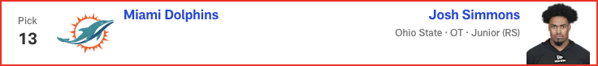

*📝 Analysis: I’m not a doctor and I don’t play one on the internet, so I won’t pretend to know how much the torn patellar tendon Simmons suffered in October will ultimately affect his draft position later this month. That said, his participation in Ohio State’s pro day last month -- albeit in a limited capacity -- was a positive sign, right? And a common sentiment among draftniks is that Simmons would have been OT1 in this class without the injury. So, Miami hops on the distressed asset as a long-term replacement for the recently retired Terron Armstead.*



*📝 Analysis: Many folks have the Colts taking a tight end, just usually not this one. Tyler Warren is the popular pick, but I’m bucking that trend with the belief that some teams could value Loveland’s route artistry at the position over Warren’s throwback skill set. Shoot, the Michigan product is running whip routes at nearly 6-foot-6 and 250 pounds!*

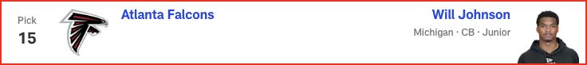

*📝 Analysis: At the Annual League Meeting, Arthur Blank let the cat out of the translucent bag:*

*"The emphasis on the draft will certainly be on the defensive side of the ball,” the Falcons owner said. “I think that's pretty obvious to everybody."*

*Atlanta could target an edge rusher here, but in this scenario, Johnson might be too good a value to pass on. If the pedigreed cover man does something at his long-awaited workout to quell lingering concerns about his long speed -- like run a 40 in the 4.4s -- he could fly up the draft board.*

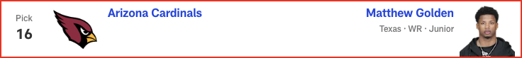

*📝 Analysis: With a pair of big-bodied wideouts in Marvin Harrison Jr. and Michael Wilson and a freshly PAID tight end in Trey McBride, the Cardinals could use a true “Z” to pop the top off the defense and create space underneath. Not that Golden’s strictly a vertical speed merchant. In fact, his 4.29 40 at the combine pleasantly caught everyone by surprise. But the three-level threat clearly has the juice to complement the existing pass catchers in Arizona, giving the Cards an alluring young receiving corps.*



*📝 Analysis: Cincinnati has struggled with safety play since letting Jessie Bates III walk in free agency. Starks offers pedigree (five-star recruit), high-level experience (three-year starter at Georgia) and versatility (significant snaps as a box defender, nickelback and single-high safety). He lacks supreme athletic testing, having posted underwhelming numbers in Indy. But don’t overthink it! The man’s play speed is undeniable, while his cerebral approach to the game is gold on the pre-draft interview circuit. It might be illegal with a prospect this accomplished, but I’m claiming Starks as MY GUY in the 2025 draft class.*

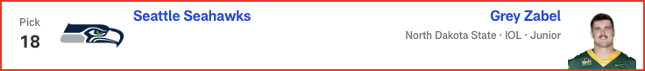

*📝 Analysis: To casual observers, this is a surprising selection. To draft sickos, this is the hottest name nobody knew a few months ago. Zabel started all across the offensive line at North Dakota State, but he’ll most likely man one of the three interior spots in the NFL. That’s an area where the Seahawks must improve. Zabel turned heads working as a center at the Senior Bowl and showcased exceptional athleticism at the combine. Seems like a fine fit in new offensive coordinator Klint Kubiak’s outside-zone scheme.*

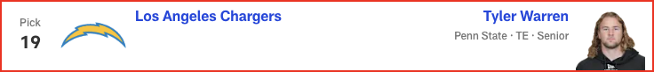

*📝 Analysis: PROJECTED TRADE WITH TAMPA BAY BUCCANEERS*

*The reason Warren goes a lot higher in most mocks: He could be a true “Y” tight end, a dying breed of player who’s equal parts blocker and receiver, offering real inline ability.*

*The reason Warren drops a bit in this mock: It feels like most modern offenses overwhelmingly value receiving ability over blocking prowess at TE1, typically preferring agile weapons who can route guys up.*

*That said, Jim Harbaugh loves tight ends of all shapes, sizes and play styles, so when Warren starts to slide in this exercise, he vaults right in front of the division-rival Broncos to claim this prize.*

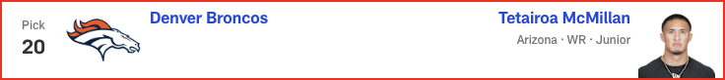

*📝 Analysis: With the possible exception of Shedeur Sanders, McMillan could have the widest draft range in this year’s mock madness. I had him going sixth overall in Version 1.0 and still can easily imagine him coming off the board in that area. But in today’s simulation, he falls right into Denver’s lap, giving Bo Nix another big-bodied target who can learn from (and eventually replace) Courtland Sutton.*

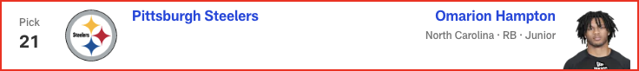

*📝 Analysis: Regardless of who ends up starting under center in Pittsburgh, you have to imagine this team will continue to pound the rock. The Steelers have ranked top 10 in rushing attempts in every season since Ben Roethlisberger’s retirement, vaulting to No. 4 in Arthur Smith’s maiden voyage as offensive coordinator last year. Smith remains at the controls, but Najee Harris -- who easily paced Pittsburgh in every major rushing category over each of the past four seasons -- departed in free agency. Hampton’s a true bell-cow back who could allow the Steelers to keep Jaylen Warren in the change-of-pace role that seems to suit him best.*

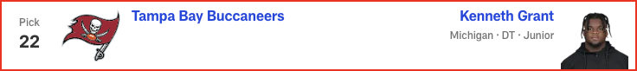

*📝 Analysis: PROJECTED TRADE WITH LOS ANGELES CHARGERS*

*Who wouldn’t like to see Grant line up alongside Vita Vea to block out the sun with 700 pounds of BEEF? Opposing offensive lines, presumably. Like Vea, Grant offers a rare blend of colossal size, raw power and eye-popping athleticism. With those two clogging run lanes, Calijah Kancey can do what he does best: rush the passer.*

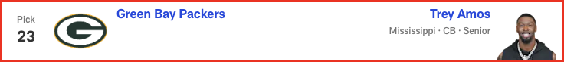

*📝 Analysis: The continuing uncertainty surrounding Jaire Alexander makes corner a need in Green Bay. Frankly, even if Alexander and the Packers are able to work things out and stay together in 2025 -- a possibility GM Brian Gutekunst recently raised -- the 28-year-old has missed double-digit games in three of the last four seasons, further underscoring the need to fortify the position. With good size and coverage versatility, Amos is the type of CB the Pack typically target. And his 4.43 40 in Indy alleviated any potential speed concerns.*

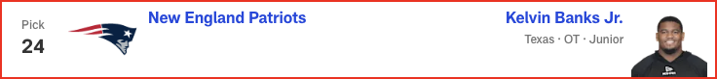

*📝 Analysis: PROJECTED TRADE WITH MINNESOTA VIKINGS*

*Told you I wouldn’t leave you high and dry, Drake!*

*After using the No. 4 overall pick to bolster the defensive line, the Patriots jump back into Round 1 to upgrade the O-line. Sending Minnesota its second-round pick (No. 38) and the higher of its two third-rounders (No. 69), New England leapfrogs a slew of tackle-needy teams to secure Banks. Having logged 42 starts at left tackle in his three years at Texas, Banks deserves the opportunity to man the blind side in the NFL, even if some project a move to the inside.*

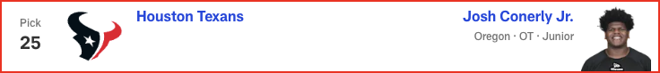

*📝 Analysis: Having just been beaten to the punch on the hometown tackle above, the Texans go west to grab an alluring Oregon prospect at the position. Conerly’s still developing his game, but the upside’s enticing. With the stopgap signing of veteran LT Cam Robinson, Houston can allow Conerly to ease into the NFL before hopefully becoming the long-term replacement for Laremy Tunsil.*

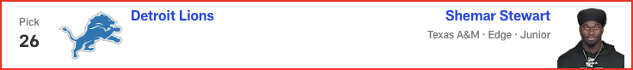

*📝 Analysis: PROJECTED TRADE WITH LOS ANGELES RAMS*

*﻿﻿﻿﻿﻿﻿Considering Stewart is an edge rusher who totaled 4.5 sacks in three years at Texas A&M, how should Lions-aligned readers feel about this projection? Well, two things can be true at the same time:*

*The meager sack production is highly concerning.*

*The meager sack production is the only reason he’s theoretically still available for Detroit in this range.*

*A former five-star recruit out of the Miami area, Stewart is a long, large, freak-show athlete who predictably blew up the combine. And despite the routinely-cited sack figures (exactly 1.5 in each of his three college seasons), he led a talented A&M D-line with 39 pressures last season, per Pro Football Focus.*

*All of which is to say, Stewart could be long gone by this point on April 24. So, in the here and now of this mock, Detroit jumps at the opportunity to land a traitsy running mate for Aidan Hutchinson.*

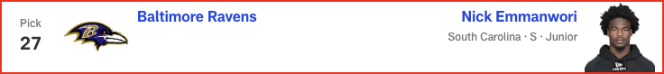

*📝 Analysis: FREAK-SHOW RUN!!! If Shemar Stewart made a splash at the combine, Nick Emmanwori performed a cannonball. Arriving in Indy at a chiseled 6-3 1/8 and 220 pounds, the South Carolina safety blazed the 40-yard dash in 4.38 seconds and nearly jumped out of Lucas Oil Stadium (43-inch vertical, 11-foot-6 broad). Emmanwori’s not just an Underwear Olympian, either; he started during all three of his seasons in the SEC, leading South Carolina in tackles during two of those campaigns and earning first-team All-America honors from The Associated Press in 2024.*

*And here’s the really amusing part: Imagine him playing alongside Swiss Army Knife safety Kyle Hamilton in Baltimore.*

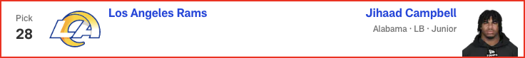

*📝 Analysis: PROJECTED TRADE WITH DETROIT LIONS*

*A first-team All-SEC linebacker with hybrid skills as a pass rusher, Campbell put on a show in Indianapolis. But post-combine shoulder surgery has created uncertainty around his draft stock. If he makes it all the way to Los Angeles, this could be a coup for the Rams. The only problem with this projection? Well, Les Snead hasn’t spent a top-100 pick on a linebacker since back when the Rams were in St. Louis (Alec Ogletree, No. 30 overall, 2013). But Campbell could be a monster in Chris Shula’s defense, extending the fun youth movement up front to the second level. So, I say EFF THEM PICK TENDENCIES!!*

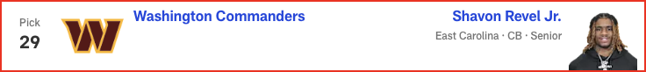

*📝 Analysis: An impressive physical specimen at a hair under 6-2 with pterodactyl length, Revel was poised to make a national name for himself in 2024. But then he tore his ACL during a practice in September, prematurely ending his final season at ECU and preventing him from showing his wares in the pre-draft process. Out of sight, but not out of mind. I anticipate a playoff team scooping him up in the back stretch of Round 1 as a long-term value pick with a potentially massive ROI. And a traitsy corner with serious press-man upside seems like something Dan Quinn could be interested in.*

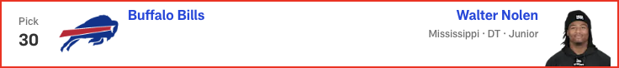

*📝 Analysis: Ranked by ESPN as the No. 1 overall recruit over Travis Hunter in the class of 2022, Nolen put it all together in his final college season, becoming the 14th consensus All-American in Ole Miss history. With a smaller defensive front that was overpowered in some big spots last season, Buffalo could opt for a heftier defensive tackle. (I gave them 334-pound beast Tyleik Williams in this space last time.) That said, Nolen has intoxicating potential as an explosive gap-shooter, and that could be tough to pass on if still available when the Bills come on the clock.*

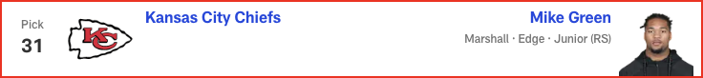

*📝 Analysis: Green’s a difficult prospect to project, given the off-field allegations he addressed at the combine. The on-field production speaks for itself, as Green just led the nation with 17 sacks. And although many of those came against Sun Belt competition, he tallied three sacks and a bunch of pressures in nonconference games against Virginia Tech and Ohio State. A twitched-up edge rusher whose motor always runs hot, Green could be a steal for K.C. if he falls this far and Andy Reid’s comfortable with his character.*



*📝 Analysis: Ezeiruaku fittingly comes off the board right after Mike Green, as the Boston College star fell a half-sack shy of his Marshall counterpart for last season's FBS crown in sacks, finishing with 16.5. He has an odd body type for an edge rusher: slightly undersized at 6-2 1/2 and 248 pounds, but with 34-inch vines for arms. Howie Roseman isn’t afraid to take a walk on the wild side, though. Remember when the Eagles selected Nolan Smith near the end of Round 1 two years ago despite concerns about his substandard dimensions? That move just paid serious dividends in Philadelphia’s second Lombardi Trophy run.*

# Marc Ross - 2025 Mock Draft

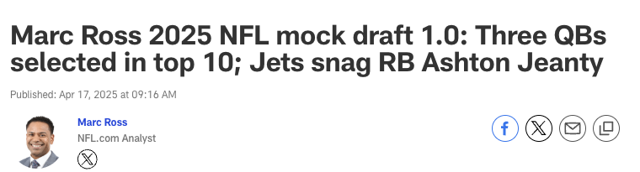



*📝 Analysis: Tennessee doesn't overthink this pick, selecting the player it has publicly praised throughout the pre-draft process. Ward is the only quarterback in this draft who has the playmaking ability required to swiftly transform a franchise; he could provide the Titans with the kind of instant impact we've seen from Jayden Daniels and C.J. Stroud over the past couple seasons.*



*📝 Analysis: The opportunity to pair Carter with perennial Pro Bowler Myles Garrett is too tempting to resist. Having these two on opposite sides of Jim Schwartz's defensive line ensures a terrorizing pass rush that will keep opposing quarterbacks uneasy in the pocket. Sure, Cleveland has plenty of questions surrounding its own QB situation, but outside of Cam Ward, I don't see another signal-caller in this class who truly upgrades the Browns offense.*

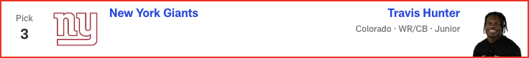

*📝 Analysis: New York could take a quarterback here despite having a trio of veterans on the roster. The team is hosting Shedeur Sanders for a private workout this week, but knowing the Giants' ownership and front office, I'm not sure they'll want to subject themselves to everything that comes with the polarizing prospect out of Colorado. Thus, Sanders' college teammate is the pick. Hunter was a two-way star at Colorado, but I think the reigning Heisman Trophy winner would add more value on offense as a complement to Malik Nabers. That said, he could also play spot duty on the back end of Shane Bowen's defense.*

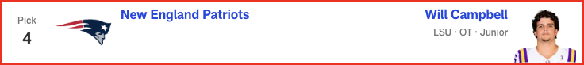

*📝 Analysis: This is too good a fit for a team that desperately needs to improve its offensive line. In my opinion, Campbell is the most polished and best lineman in this class. The highly productive prospect would do well under Mike Vrabel and Josh McDaniels.*

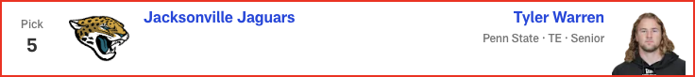

*📝 Analysis: The Jaguars must give Trevor Lawrence as many resources as possible to see if he truly is a franchise QB and the guy for Liam Coen's offense moving forward. Warren is the best tight end in this class. He'd find a ton of success working the middle of the field in Jacksonville, with second-year receiver Brian Thomas Jr. commanding the defense's attention deep.*

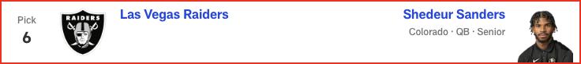

*📝 Analysis: Let's remember that Pete Carroll has doubled down on the quarterback position before, signing veteran Matt Flynn in Seattle before drafting Russell Wilson, who ultimately won the job as a rookie. So just because the Raiders traded for Geno Smith this offseason, it's not unthinkable for them to draft Sanders, who has a relationship with Las Vegas limited partner Tom Brady and wouldn't have to play immediately with Geno in tow.*

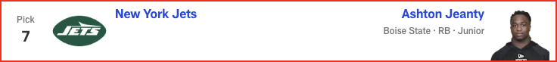

*📝 Analysis: With Justin Fields under center, it would be wise for the Jets to bulk up the ground game. Breece Hall has been OK, but pairing him with a future star in Jeanty would give new offensive coordinator Tanner Engstrand the kind of two-headed monster in the backfield that the assistant coach worked with in Detroit. A potent rushing attack is something that ultimately would fuel Fields' growth as a quarterback.*



*📝 Analysis: The Panthers are open to trading back, but their desperate need along the defensive line prompts them to stand pat in this exercise and select a polished/consistent DT to pair with Derrick Brown.*

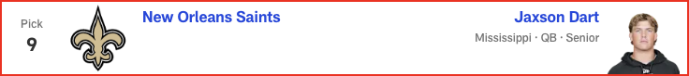

*📝 Analysis: With Derek Carr dealing with a shoulder injury that could threaten his availability for 2025, Kellen Moore drafts his own quarterback in an effort to revitalize the franchise. Projections for the work-in-progress Dart have been all over the board, but there is always QB desperation in the draft. If the Ole Miss passer lands here, he has a chance to reach his potential under Moore.*

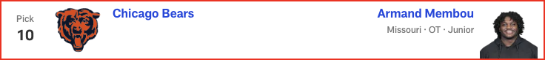

*📝 Analysis: New head coach Ben Johnson has brought the philosophy from his days in Detroit to Chicago, promptly rebuilding the Bears' offensive line upon arrival. He continues putting his stamp on the front by bringing in the powerful Membou -- just another step in making life as easy as possible for second-year QB Caleb Williams.*

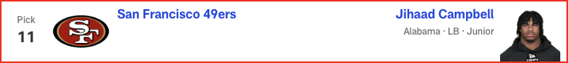

*📝 Analysis: After losing a number of key defensive players this offseason, including tone-setting linebacker Dre Greenlaw, the 49ers draft Campbell. The Alabama 'backer is my favorite player to watch in this entire draft class. He'd comprise a spectacular duo with Fred Warner.*



*📝 Analysis: To keep up with the Eagles and Commanders in the NFC East, the Cowboys need some impact players on offense outside of CeeDee Lamb. McMillan possesses the size and elite ball skills to perfectly complement Lamb as a deep-ball weapon in this passing attack.*

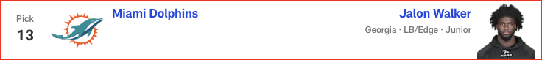

*📝 Analysis: The Dolphins could go a lot of ways here -- especially after the team and Jalen Ramsey mutually agreed to explore trade options for the star corner -- but boosting the pass rush should be Priority No. 1. Walker is at his best when getting after the quarterback and could find success alongside Chop Robinson and a healthy Jaelan Phillips.*



*📝 Analysis: The Colts have a ton of playmakers at receiver and running back, but tight end is the missing piece in the offensive weaponry. Consequently, Indy adds Loveland -- a big-time playmaker who has elite downfield speed and a big catch radius -- to give whoever ends up winning the quarterback competition the best chance to succeed.*



*📝 Analysis: Despite investing a lot of Day 2 draft capital in the defensive line in recent years, Atlanta continually struggles to take down the quarterback. Time to address the issue in Round 1 by scooping up a young, dynamic edge rusher with a Georgia connection.*



*📝 Analysis: Simmons offers good value here as the most athletic offensive lineman in this class. The Ohio State/San Diego State product has the potential to be a Pro Bowl-caliber player, but he's coming off a torn patellar tendon. Arizona could be patient with his recovery, already having veteran tackles Paris Johnson Jr. and Jonah Williams in place.*

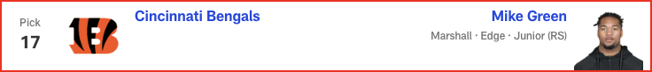

*📝 Analysis: The Bengals couldn't stop anyone last season, so even if reigning NFL sack king Trey Hendrickson ultimately remains in Cincinnati, this defense still needs help. Green is a productive pass rusher, having led the FBS with 17 sacks in 2024. His relentless pursuit of the quarterback and ability to stifle the run would improve a unit that ranked 25th in points and yards allowed last year.*

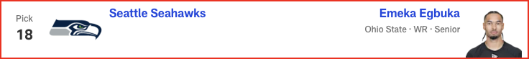

*📝 Analysis: Sam Darnold is at his best when he can distribute the ball to a great supporting cast. Adding Egbuka to a solid receiving corps could help Darnold replicate his 2024 breakout season in Minnesota. Egbuka plays similarly to Jaxon Smith-Njigba, his former Ohio State teammate who's already flourishing in Seattle.*

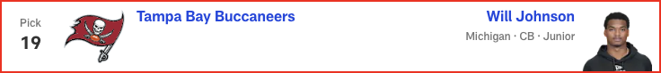

*📝 Analysis: Despite not running a pre-draft 40-yard dash, Johnson still feels like a top-10 talent in this class to me. He'd bring some much-needed playmaking ability to the back end of Todd Bowles' defense.*

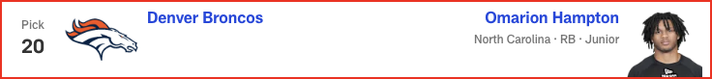

*📝 Analysis: Outside of the franchises lacking a starting quarterback, Denver might have the biggest need of any team entering the draft. The Broncos have struggled to run the ball under Sean Payton, so they finally solidify the ground game by adding this physical, bell-cow back.*

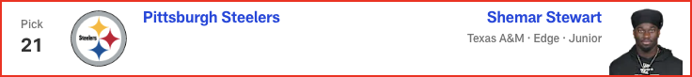

*📝 Analysis: With Cameron Heyward heading into Year 15 and T.J. Watt turning 31 in October, the Steelers must start thinking about the future of the defensive front. Despite his lack of sack production in college, Stewart feels built to play in the Steel City as a traitsy edge with dynamic upside.*

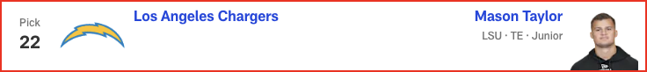

*📝 Analysis: Jim Harbaugh loves to utilize tight ends, so the Chargers fill a glaring need with a dependable and underrated prospect from an NFL family. (His dad is Hall of Fame DE Jason Taylor and his uncle is HOF LB Zach Thomas.) Plenty of upside in this well-rounded TE.*



*📝 Analysis: Jaire Alexander is at the forefront of trade discussions in Green Bay -- and he's missed double-digit games in three of the past four seasons. Bottom line: It's time for the Packers to invest in his replacement. Hairston has the skill set to step in as a starting cornerback.*

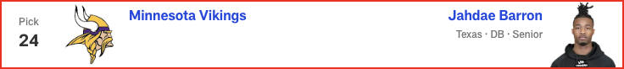

*📝 Analysis: The Vikings brought in a ton of upgrades for Brian Flores' defense last offseason and reaped the benefits in a 14-win campaign. After losing a number of key defensive playmakers in free agency this offseason, Minnesota gets a versatile defender who could play various positions in the secondary but would likely replace the departed Camryn Bynum.*

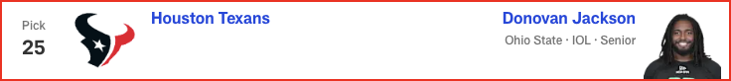

*📝 Analysis: The Texans continue overhauling their offensive line with this draft's best interior blocker. Jackson proved he could play left tackle as an injury replacement during Ohio State's national title run, but he projects as a Pro Bowl-caliber guard in the NFL.*

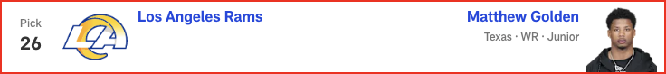

*📝 Analysis: The Rams aim to maximize Matthew Stafford's remaining shelf life by adding this speedster. Golden would give Los Angeles a better version of Tutu Atwell to complement Davante Adams and Puka Nacua in the pass game.*



*📝 Analysis: After seeing the success Kyle Hamilton has enjoyed in Baltimore, the Ravens bring in another playmaker whose best asset is his versatility. Having Hamilton and Starks next to one another in the secondary will be heaven for defensive coordinator Zach Orr.*

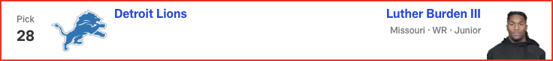

*📝 Analysis: General manager Brad Holmes isn't one to make the moves people expect, but he has built a great roster in Detroit. So while the Lions have bigger needs in the trenches, they snag Burden in an effort to offset the loss of OC Ben Johnson and maintain their offensive dominance. A standout in the SEC, Burden has a similar playing style to Amon-Ra St. Brown and can work underneath with Jameson Williams stretching the field.*

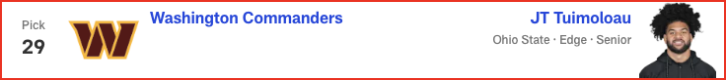

*📝 Analysis: Maybe the most underrated player in this draft class. Tuimoloau joins Dan Quinn's defensive front as a hard-nosed and productive talent. Filling a big need in Washington, JTT -- who registered 6.5 sacks and 11 tackles for loss during Ohio State's four-game playoff run -- could start immediately for the Commanders, whose DE depth chart is littered with NFL journeymen.*

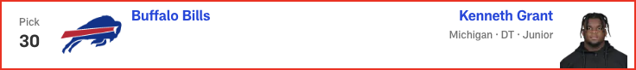

*📝 Analysis: Since drafting Josh Allen seventh overall in 2018, the Bills haven't truly hit on many early-round picks. (Former second-rounder James Cook, who has made the Pro Bowl in each of the last two seasons, is a notable exception.) Grant isn't the most consistent player, but he is talented, athletic and has the potential to be an impact player on Buffalo's defensive front. He'll get to learn and grow behind veteran DTs Ed Oliver and DaQuan Jones.*

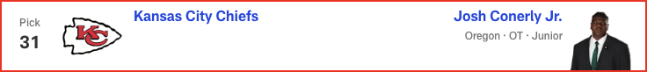

*📝 Analysis: Penalty magnet Jawaan Taylor has been a liability, and I'm not sold on free-agent signing Jaylon Moore curing all of Kansas City's OL ills. Conerly, who had his best game last season against Abdul Carter, has solid technique as a right or left tackle. He'd thrive under Andy Reid, who covets O-linemen with versatility.*

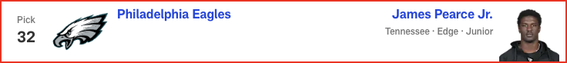

*📝 Analysis: With Josh Sweat departing in free agency and Nolan Smith coming off injury, the Eagles need pass-rush help to replicate their Super Bowl success. Pearce is an explosive player off the edge who can contribute immediately.*