**NFL 2025 Mock Draft Collection**

Complete NFL.com Mock Draft Screenshots - June 08, 2025

**🏈 Bucky Brooks**

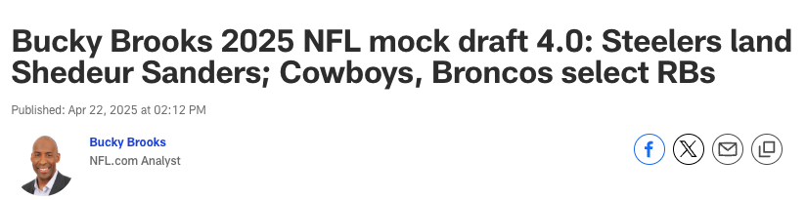









































**🏈 Daniel Jeremiah**

📸 21 screenshots captured from NFL.com

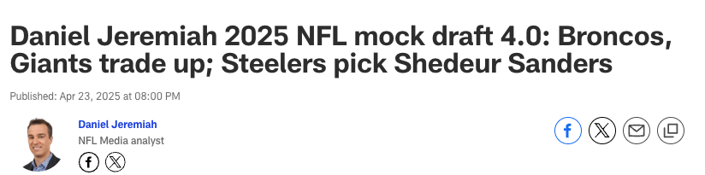









































**🏈 Lance Zierlein**

📸 21 screenshots captured from NFL.com

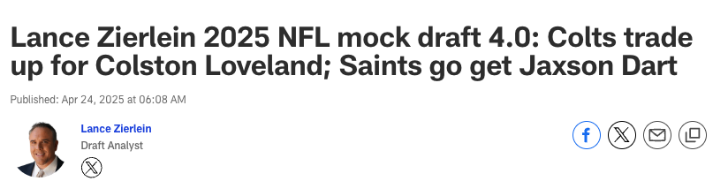









































**🏈 Charles Davis**

📸 21 screenshots captured from NFL.com

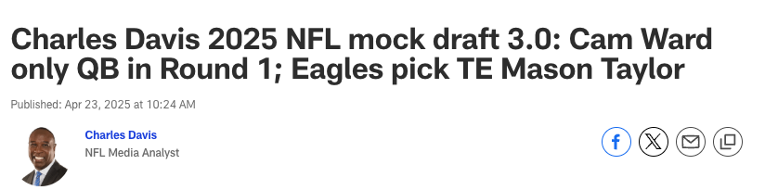









































**🏈 Eric Edholm**

📸 21 screenshots captured from NFL.com

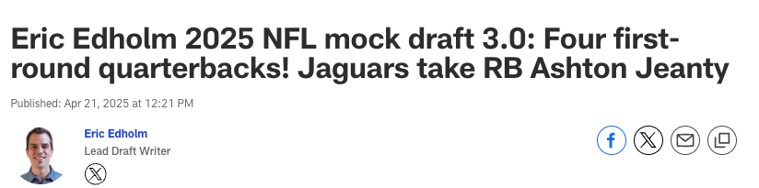









































**🏈 Dan Parr**

📸 21 screenshots captured from NFL.com

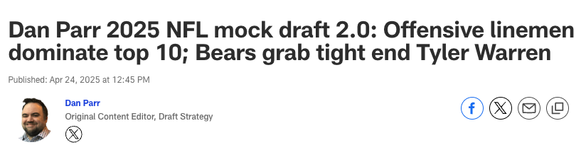









































**🏈 Chad Reuter**

📸 21 screenshots captured from NFL.com

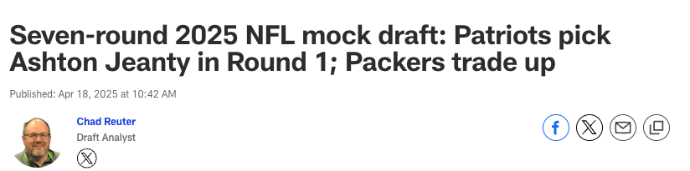









































**🏈 Gennaro Filice**

📸 21 screenshots captured from NFL.com

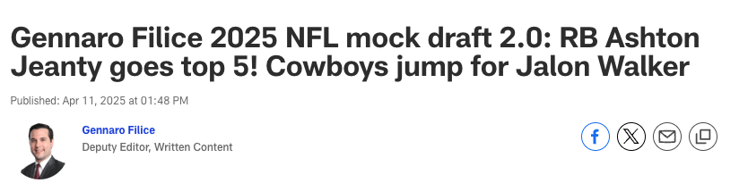









































**🏈 Marc Ross**

📸 21 screenshots captured from NFL.com

