NFL.com 2025 Mock Draft Screenshots

Complete NFL.com Mock Drafts - June 08, 2025

📊 7 Authors • 231 Screenshots • Top 32 Picks Each • Expert Analysis Included

# Bucky Brooks - 2025 Mock Draft

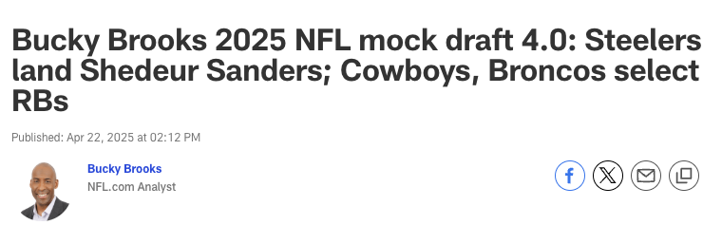

**Pick #1**

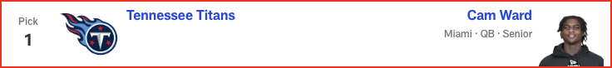

*📝 Analysis: Draft analysis for pick #1 by Bucky Brooks.*

**Pick #2**

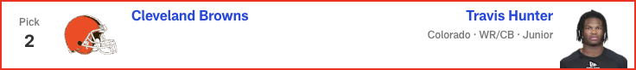

*📝 Analysis: Draft analysis for pick #2 by Bucky Brooks.*

**Pick #3**

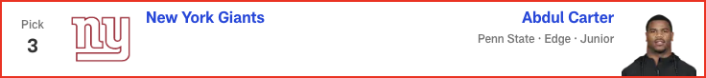

*📝 Analysis: Draft analysis for pick #3 by Bucky Brooks.*

**Pick #4**



*📝 Analysis: Draft analysis for pick #4 by Bucky Brooks.*

**Pick #5**

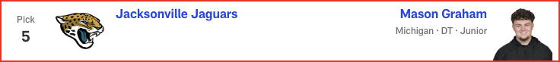

*📝 Analysis: Draft analysis for pick #5 by Bucky Brooks.*

**Pick #6**

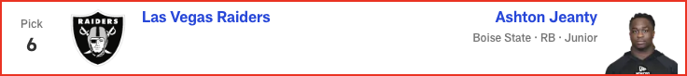

*📝 Analysis: Draft analysis for pick #6 by Bucky Brooks.*

**Pick #7**

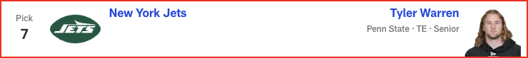

*📝 Analysis: Draft analysis for pick #7 by Bucky Brooks.*

**Pick #8**

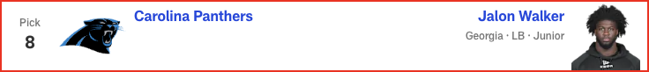

*📝 Analysis: Draft analysis for pick #8 by Bucky Brooks.*

**Pick #9**

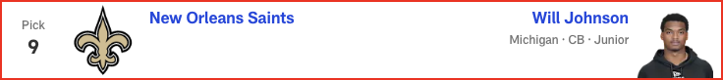

*📝 Analysis: Draft analysis for pick #9 by Bucky Brooks.*

**Pick #10**

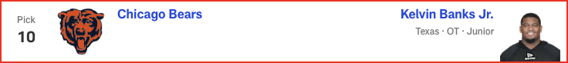

*📝 Analysis: Draft analysis for pick #10 by Bucky Brooks.*

**Pick #11**

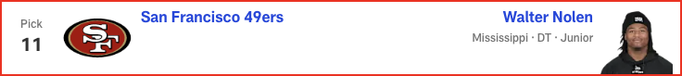

*📝 Analysis: Draft analysis for pick #11 by Bucky Brooks.*

**Pick #12**

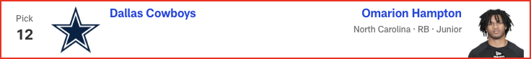

*📝 Analysis: Draft analysis for pick #12 by Bucky Brooks.*

**Pick #13**

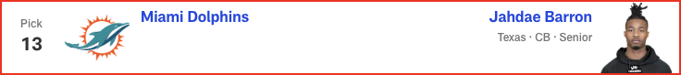

*📝 Analysis: Draft analysis for pick #13 by Bucky Brooks.*

**Pick #14**

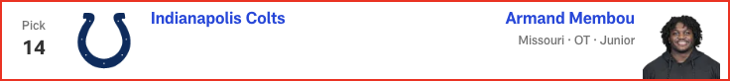

*📝 Analysis: Draft analysis for pick #14 by Bucky Brooks.*

**Pick #15**

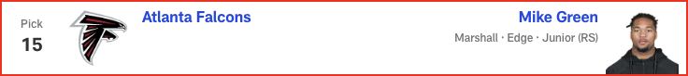

*📝 Analysis: Draft analysis for pick #15 by Bucky Brooks.*

**Pick #16**

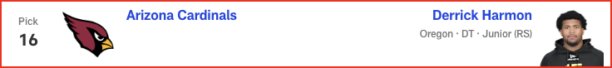

*📝 Analysis: Draft analysis for pick #16 by Bucky Brooks.*

**Pick #17**

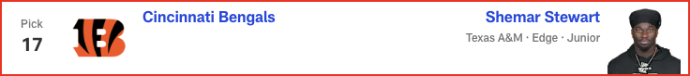

*📝 Analysis: Draft analysis for pick #17 by Bucky Brooks.*

**Pick #18**

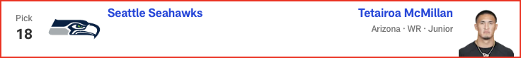

*📝 Analysis: Draft analysis for pick #18 by Bucky Brooks.*

**Pick #19**

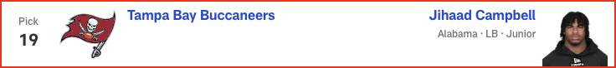

*📝 Analysis: Draft analysis for pick #19 by Bucky Brooks.*

**Pick #20**

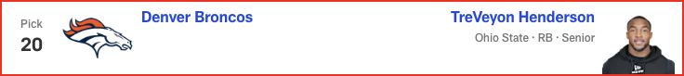

*📝 Analysis: Draft analysis for pick #20 by Bucky Brooks.*

**Pick #21**

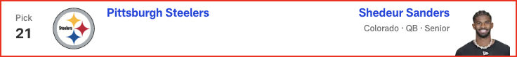

*📝 Analysis: Draft analysis for pick #21 by Bucky Brooks.*

**Pick #22**

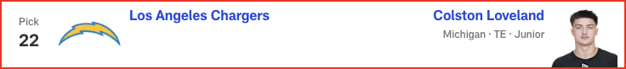

*📝 Analysis: Draft analysis for pick #22 by Bucky Brooks.*

**Pick #23**

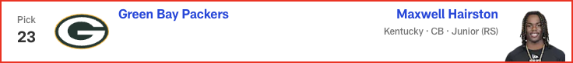

*📝 Analysis: Draft analysis for pick #23 by Bucky Brooks.*

**Pick #24**

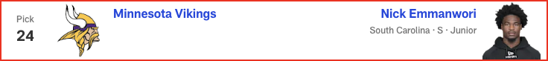

*📝 Analysis: Draft analysis for pick #24 by Bucky Brooks.*

**Pick #25**

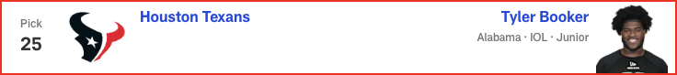

*📝 Analysis: Draft analysis for pick #25 by Bucky Brooks.*

**Pick #26**

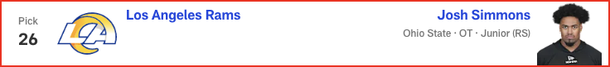

*📝 Analysis: Draft analysis for pick #26 by Bucky Brooks.*

**Pick #27**

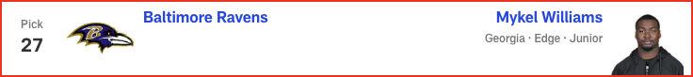

*📝 Analysis: Draft analysis for pick #27 by Bucky Brooks.*

**Pick #28**

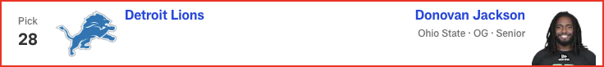

*📝 Analysis: Draft analysis for pick #28 by Bucky Brooks.*

**Pick #29**

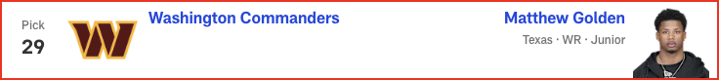

*📝 Analysis: Draft analysis for pick #29 by Bucky Brooks.*

**Pick #30**

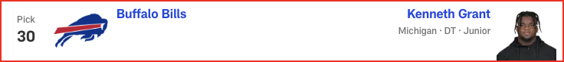

*📝 Analysis: Draft analysis for pick #30 by Bucky Brooks.*

**Pick #31**

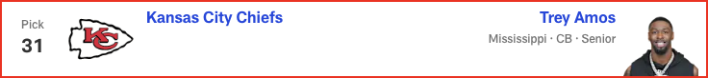

*📝 Analysis: Draft analysis for pick #31 by Bucky Brooks.*

**Pick #32**

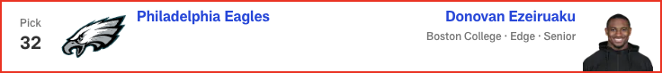

*📝 Analysis: Draft analysis for pick #32 by Bucky Brooks.*

# Daniel Jeremiah - 2025 Mock Draft

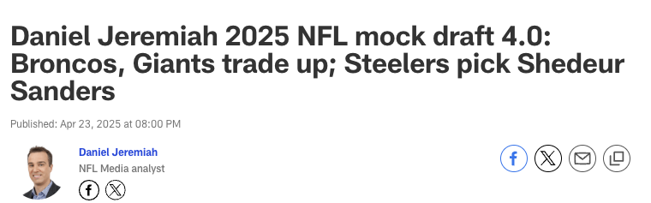

**Pick #1**

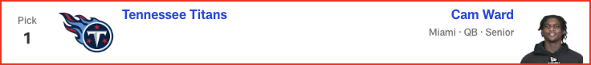

*📝 Analysis: Draft analysis for pick #1 by Daniel Jeremiah.*

**Pick #2**



*📝 Analysis: Draft analysis for pick #2 by Daniel Jeremiah.*

**Pick #3**

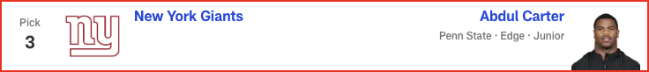

*📝 Analysis: Draft analysis for pick #3 by Daniel Jeremiah.*

**Pick #4**



*📝 Analysis: Draft analysis for pick #4 by Daniel Jeremiah.*

**Pick #5**

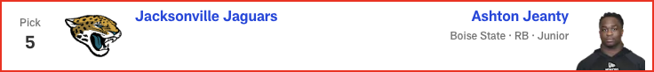

*📝 Analysis: Draft analysis for pick #5 by Daniel Jeremiah.*

**Pick #6**

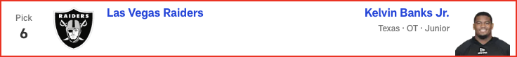

*📝 Analysis: Draft analysis for pick #6 by Daniel Jeremiah.*

**Pick #7**

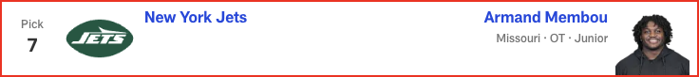

*📝 Analysis: Draft analysis for pick #7 by Daniel Jeremiah.*

**Pick #8**

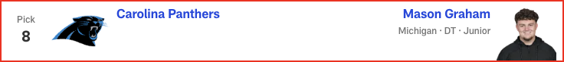

*📝 Analysis: Draft analysis for pick #8 by Daniel Jeremiah.*

**Pick #9**

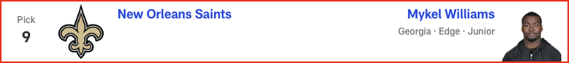

*📝 Analysis: Draft analysis for pick #9 by Daniel Jeremiah.*

**Pick #10**

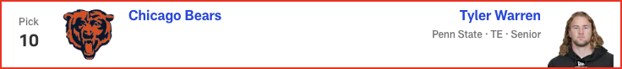

*📝 Analysis: Draft analysis for pick #10 by Daniel Jeremiah.*

**Pick #11**

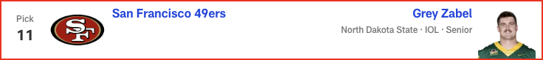

*📝 Analysis: Draft analysis for pick #11 by Daniel Jeremiah.*

**Pick #12**

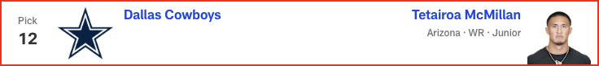

*📝 Analysis: Draft analysis for pick #12 by Daniel Jeremiah.*

**Pick #13**

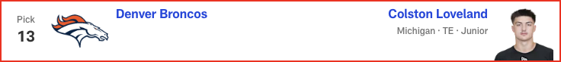

*📝 Analysis: Draft analysis for pick #13 by Daniel Jeremiah.*

**Pick #14**

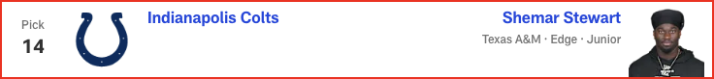

*📝 Analysis: Draft analysis for pick #14 by Daniel Jeremiah.*

**Pick #15**

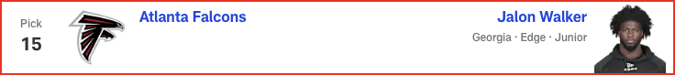

*📝 Analysis: Draft analysis for pick #15 by Daniel Jeremiah.*

**Pick #16**

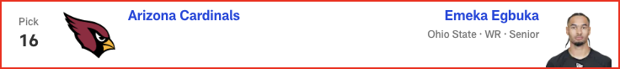

*📝 Analysis: Draft analysis for pick #16 by Daniel Jeremiah.*

**Pick #17**

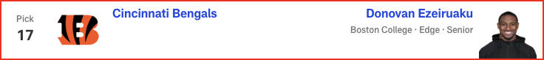

*📝 Analysis: Draft analysis for pick #17 by Daniel Jeremiah.*

**Pick #18**

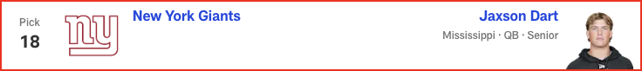

*📝 Analysis: Draft analysis for pick #18 by Daniel Jeremiah.*

**Pick #19**

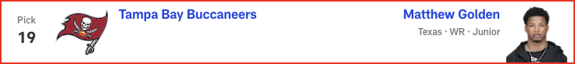

*📝 Analysis: Draft analysis for pick #19 by Daniel Jeremiah.*

**Pick #20**

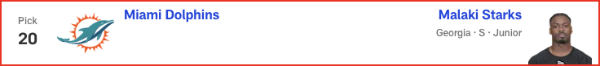

*📝 Analysis: Draft analysis for pick #20 by Daniel Jeremiah.*

**Pick #21**



*📝 Analysis: Draft analysis for pick #21 by Daniel Jeremiah.*

**Pick #22**

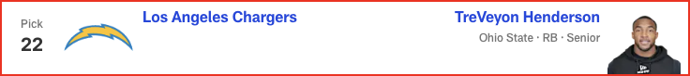

*📝 Analysis: Draft analysis for pick #22 by Daniel Jeremiah.*

**Pick #23**



*📝 Analysis: Draft analysis for pick #23 by Daniel Jeremiah.*

**Pick #24**

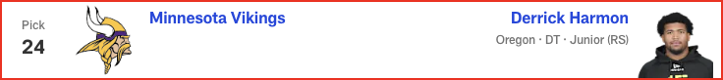

*📝 Analysis: Draft analysis for pick #24 by Daniel Jeremiah.*

**Pick #25**

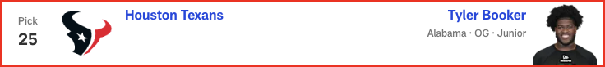

*📝 Analysis: Draft analysis for pick #25 by Daniel Jeremiah.*

**Pick #26**

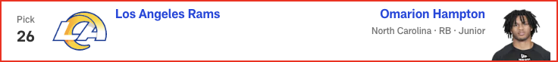

*📝 Analysis: Draft analysis for pick #26 by Daniel Jeremiah.*

**Pick #27**

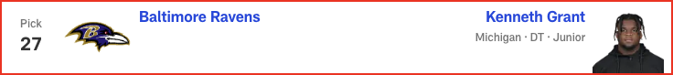

*📝 Analysis: Draft analysis for pick #27 by Daniel Jeremiah.*

**Pick #28**



*📝 Analysis: Draft analysis for pick #28 by Daniel Jeremiah.*

**Pick #29**

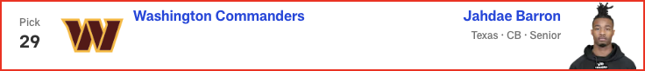

*📝 Analysis: Draft analysis for pick #29 by Daniel Jeremiah.*

**Pick #30**



*📝 Analysis: Draft analysis for pick #30 by Daniel Jeremiah.*

**Pick #31**

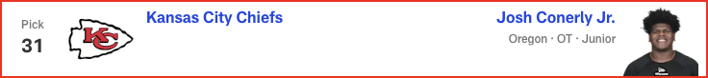

*📝 Analysis: Draft analysis for pick #31 by Daniel Jeremiah.*

**Pick #32**

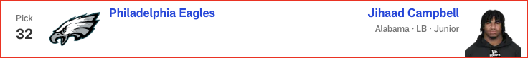

*📝 Analysis: Draft analysis for pick #32 by Daniel Jeremiah.*

# Charles Davis - 2025 Mock Draft

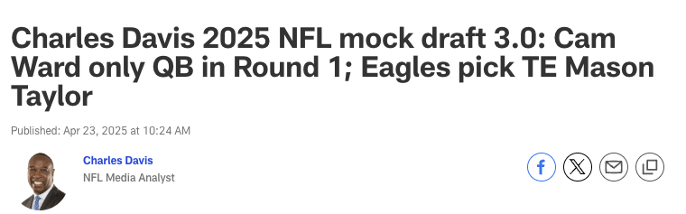

**Pick #1**



*📝 Analysis: Draft analysis for pick #1 by Charles Davis.*

**Pick #2**

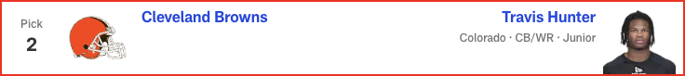

*📝 Analysis: Draft analysis for pick #2 by Charles Davis.*

**Pick #3**



*📝 Analysis: Draft analysis for pick #3 by Charles Davis.*

**Pick #4**



*📝 Analysis: Draft analysis for pick #4 by Charles Davis.*

**Pick #5**



*📝 Analysis: Draft analysis for pick #5 by Charles Davis.*

**Pick #6**

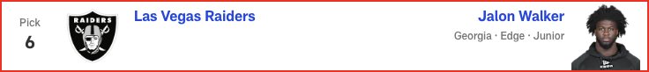

*📝 Analysis: Draft analysis for pick #6 by Charles Davis.*

**Pick #7**



*📝 Analysis: Draft analysis for pick #7 by Charles Davis.*

**Pick #8**

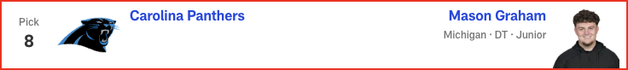

*📝 Analysis: Draft analysis for pick #8 by Charles Davis.*

**Pick #9**

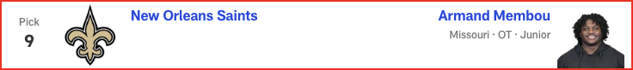

*📝 Analysis: Draft analysis for pick #9 by Charles Davis.*

**Pick #10**

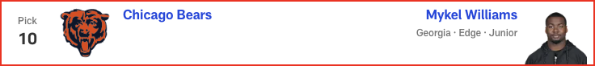

*📝 Analysis: Draft analysis for pick #10 by Charles Davis.*

**Pick #11**

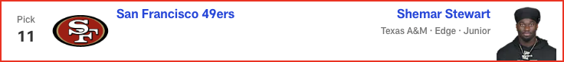

*📝 Analysis: Draft analysis for pick #11 by Charles Davis.*

**Pick #12**

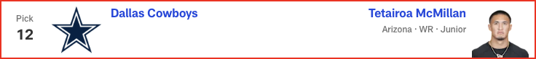

*📝 Analysis: Draft analysis for pick #12 by Charles Davis.*

**Pick #13**

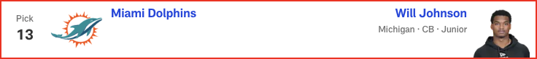

*📝 Analysis: Draft analysis for pick #13 by Charles Davis.*

**Pick #14**

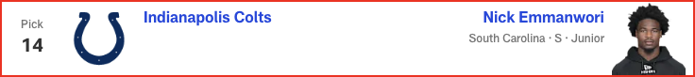

*📝 Analysis: Draft analysis for pick #14 by Charles Davis.*

**Pick #15**

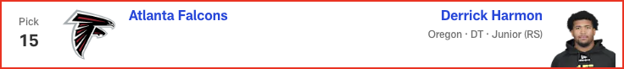

*📝 Analysis: Draft analysis for pick #15 by Charles Davis.*

**Pick #16**

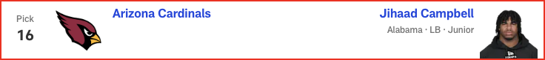

*📝 Analysis: Draft analysis for pick #16 by Charles Davis.*

**Pick #17**

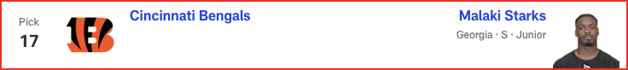

*📝 Analysis: Draft analysis for pick #17 by Charles Davis.*

**Pick #18**

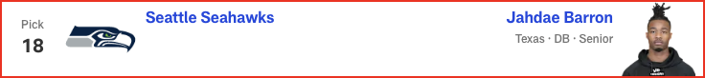

*📝 Analysis: Draft analysis for pick #18 by Charles Davis.*

**Pick #19**

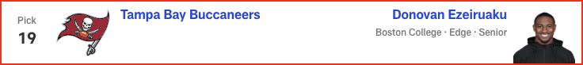

*📝 Analysis: Draft analysis for pick #19 by Charles Davis.*

**Pick #20**

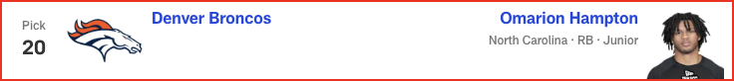

*📝 Analysis: Draft analysis for pick #20 by Charles Davis.*

**Pick #21**

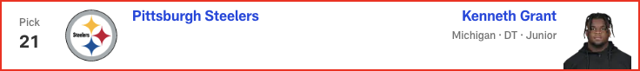

*📝 Analysis: Draft analysis for pick #21 by Charles Davis.*

**Pick #22**



*📝 Analysis: Draft analysis for pick #22 by Charles Davis.*

**Pick #23**

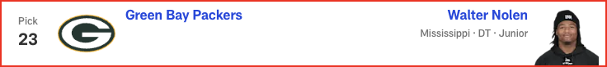

*📝 Analysis: Draft analysis for pick #23 by Charles Davis.*

**Pick #24**

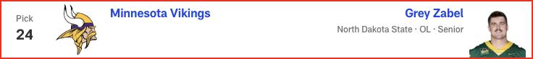

*📝 Analysis: Draft analysis for pick #24 by Charles Davis.*

**Pick #25**

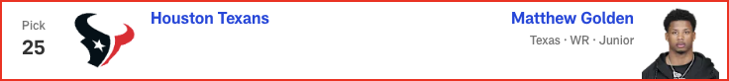

*📝 Analysis: Draft analysis for pick #25 by Charles Davis.*

**Pick #26**

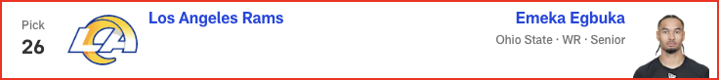

*📝 Analysis: Draft analysis for pick #26 by Charles Davis.*

**Pick #27**

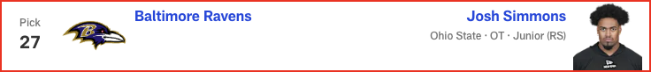

*📝 Analysis: Draft analysis for pick #27 by Charles Davis.*

**Pick #28**

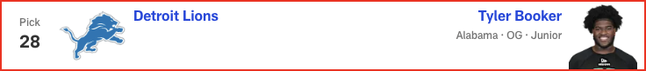

*📝 Analysis: Draft analysis for pick #28 by Charles Davis.*

**Pick #29**

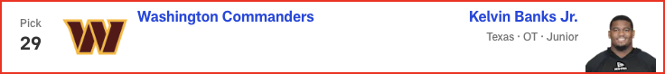

*📝 Analysis: Draft analysis for pick #29 by Charles Davis.*

**Pick #30**

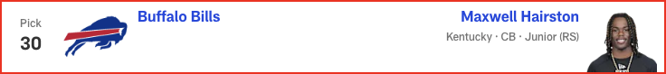

*📝 Analysis: Draft analysis for pick #30 by Charles Davis.*

**Pick #31**

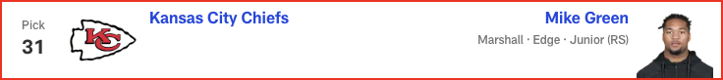

*📝 Analysis: Draft analysis for pick #31 by Charles Davis.*

**Pick #32**

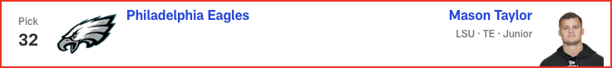

*📝 Analysis: Draft analysis for pick #32 by Charles Davis.*

# Eric Edholm - 2025 Mock Draft

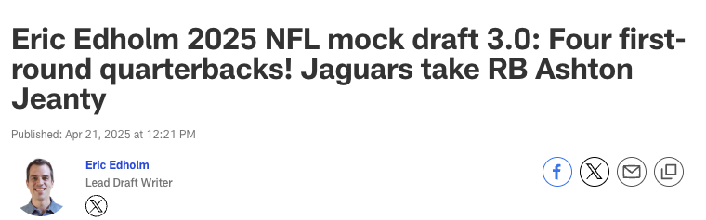

**Pick #1**

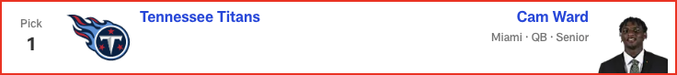

*📝 Analysis: Draft analysis for pick #1 by Eric Edholm.*

**Pick #2**



*📝 Analysis: Draft analysis for pick #2 by Eric Edholm.*

**Pick #3**



*📝 Analysis: Draft analysis for pick #3 by Eric Edholm.*

**Pick #4**

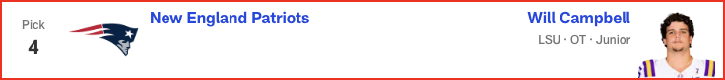

*📝 Analysis: Draft analysis for pick #4 by Eric Edholm.*

**Pick #5**

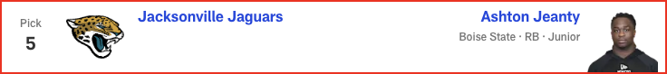

*📝 Analysis: Draft analysis for pick #5 by Eric Edholm.*

**Pick #6**

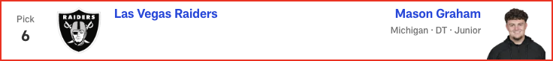

*📝 Analysis: Draft analysis for pick #6 by Eric Edholm.*

**Pick #7**

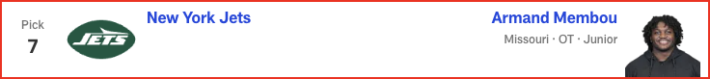

*📝 Analysis: Draft analysis for pick #7 by Eric Edholm.*

**Pick #8**



*📝 Analysis: Draft analysis for pick #8 by Eric Edholm.*

**Pick #9**

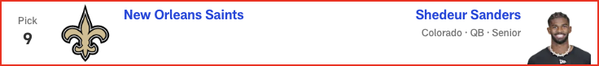

*📝 Analysis: Draft analysis for pick #9 by Eric Edholm.*

**Pick #10**

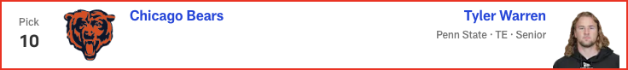

*📝 Analysis: Draft analysis for pick #10 by Eric Edholm.*

**Pick #11**

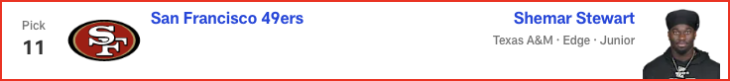

*📝 Analysis: Draft analysis for pick #11 by Eric Edholm.*

**Pick #12**



*📝 Analysis: Draft analysis for pick #12 by Eric Edholm.*

**Pick #13**

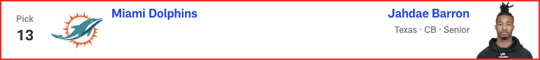

*📝 Analysis: Draft analysis for pick #13 by Eric Edholm.*

**Pick #14**

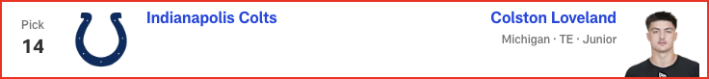

*📝 Analysis: Draft analysis for pick #14 by Eric Edholm.*

**Pick #15**

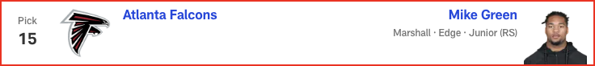

*📝 Analysis: Draft analysis for pick #15 by Eric Edholm.*

**Pick #16**

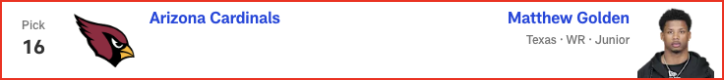

*📝 Analysis: Draft analysis for pick #16 by Eric Edholm.*

**Pick #17**

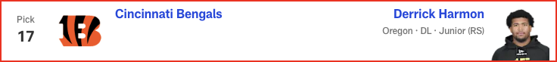

*📝 Analysis: Draft analysis for pick #17 by Eric Edholm.*

**Pick #18**

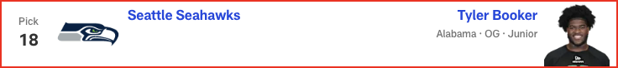

*📝 Analysis: Draft analysis for pick #18 by Eric Edholm.*

**Pick #19**



*📝 Analysis: Draft analysis for pick #19 by Eric Edholm.*

**Pick #20**



*📝 Analysis: Draft analysis for pick #20 by Eric Edholm.*

**Pick #21**

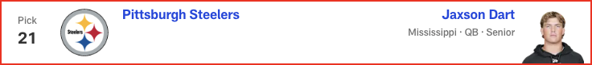

*📝 Analysis: Draft analysis for pick #21 by Eric Edholm.*

**Pick #22**

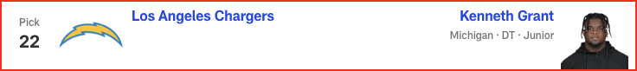

*📝 Analysis: Draft analysis for pick #22 by Eric Edholm.*

**Pick #23**

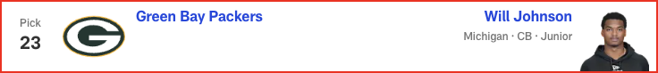

*📝 Analysis: Draft analysis for pick #23 by Eric Edholm.*

**Pick #24**

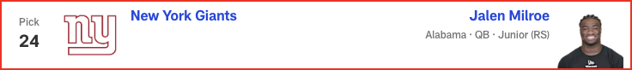

*📝 Analysis: Draft analysis for pick #24 by Eric Edholm.*

**Pick #25**

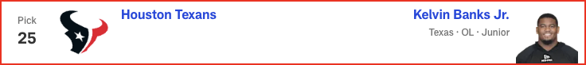

*📝 Analysis: Draft analysis for pick #25 by Eric Edholm.*

**Pick #26**

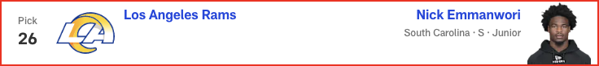

*📝 Analysis: Draft analysis for pick #26 by Eric Edholm.*

**Pick #27**

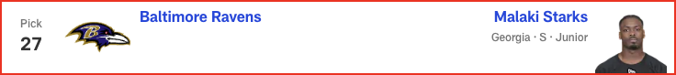

*📝 Analysis: Draft analysis for pick #27 by Eric Edholm.*

**Pick #28**

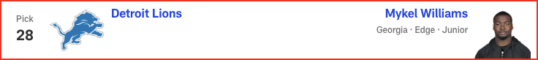

*📝 Analysis: Draft analysis for pick #28 by Eric Edholm.*

**Pick #29**

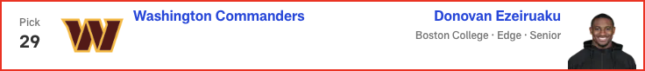

*📝 Analysis: Draft analysis for pick #29 by Eric Edholm.*

**Pick #30**



*📝 Analysis: Draft analysis for pick #30 by Eric Edholm.*

**Pick #31**

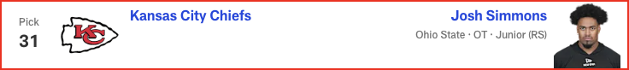

*📝 Analysis: Draft analysis for pick #31 by Eric Edholm.*

**Pick #32**

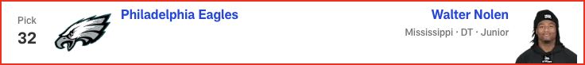

*📝 Analysis: Draft analysis for pick #32 by Eric Edholm.*

# Dan Parr - 2025 Mock Draft

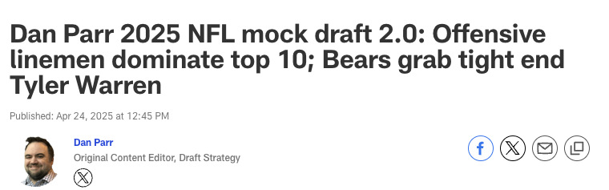

**Pick #1**

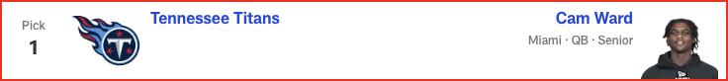

*📝 Analysis: Draft analysis for pick #1 by Dan Parr.*

**Pick #2**

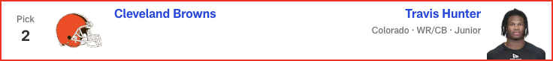

*📝 Analysis: Draft analysis for pick #2 by Dan Parr.*

**Pick #3**



*📝 Analysis: Draft analysis for pick #3 by Dan Parr.*

**Pick #4**



*📝 Analysis: Draft analysis for pick #4 by Dan Parr.*

**Pick #5**



*📝 Analysis: Draft analysis for pick #5 by Dan Parr.*

**Pick #6**



*📝 Analysis: Draft analysis for pick #6 by Dan Parr.*

**Pick #7**



*📝 Analysis: Draft analysis for pick #7 by Dan Parr.*

**Pick #8**

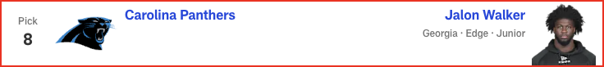

*📝 Analysis: Draft analysis for pick #8 by Dan Parr.*

**Pick #9**

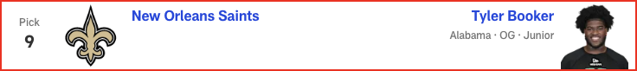

*📝 Analysis: Draft analysis for pick #9 by Dan Parr.*

**Pick #10**

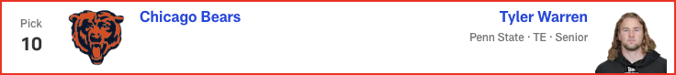

*📝 Analysis: Draft analysis for pick #10 by Dan Parr.*

**Pick #11**

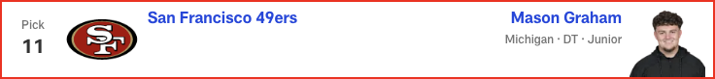

*📝 Analysis: Draft analysis for pick #11 by Dan Parr.*

**Pick #12**



*📝 Analysis: Draft analysis for pick #12 by Dan Parr.*

**Pick #13**



*📝 Analysis: Draft analysis for pick #13 by Dan Parr.*

**Pick #14**



*📝 Analysis: Draft analysis for pick #14 by Dan Parr.*

**Pick #15**

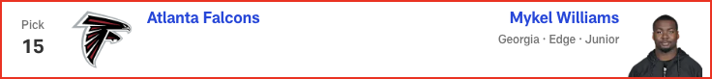

*📝 Analysis: Draft analysis for pick #15 by Dan Parr.*

**Pick #16**

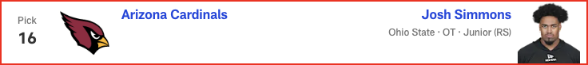

*📝 Analysis: Draft analysis for pick #16 by Dan Parr.*

**Pick #17**

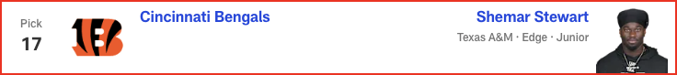

*📝 Analysis: Draft analysis for pick #17 by Dan Parr.*

**Pick #18**

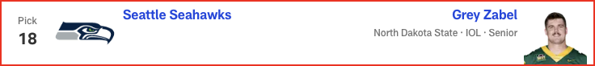

*📝 Analysis: Draft analysis for pick #18 by Dan Parr.*

**Pick #19**



*📝 Analysis: Draft analysis for pick #19 by Dan Parr.*

**Pick #20**



*📝 Analysis: Draft analysis for pick #20 by Dan Parr.*

**Pick #21**

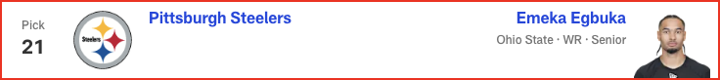

*📝 Analysis: Draft analysis for pick #21 by Dan Parr.*

**Pick #22**



*📝 Analysis: Draft analysis for pick #22 by Dan Parr.*

**Pick #23**

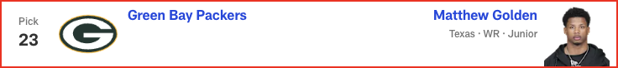

*📝 Analysis: Draft analysis for pick #23 by Dan Parr.*

**Pick #24**

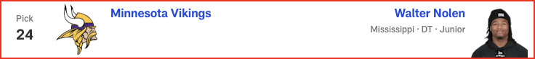

*📝 Analysis: Draft analysis for pick #24 by Dan Parr.*

**Pick #25**

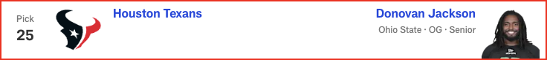

*📝 Analysis: Draft analysis for pick #25 by Dan Parr.*

**Pick #26**

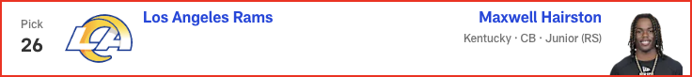

*📝 Analysis: Draft analysis for pick #26 by Dan Parr.*

**Pick #27**

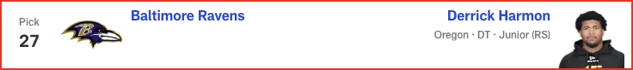

*📝 Analysis: Draft analysis for pick #27 by Dan Parr.*

**Pick #28**

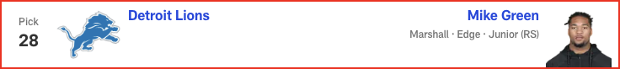

*📝 Analysis: Draft analysis for pick #28 by Dan Parr.*

**Pick #29**



*📝 Analysis: Draft analysis for pick #29 by Dan Parr.*

**Pick #30**

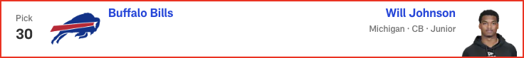

*📝 Analysis: Draft analysis for pick #30 by Dan Parr.*

**Pick #31**

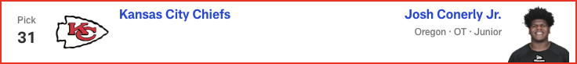

*📝 Analysis: Draft analysis for pick #31 by Dan Parr.*

**Pick #32**

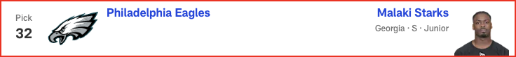

*📝 Analysis: Draft analysis for pick #32 by Dan Parr.*

# Gennaro Filice - 2025 Mock Draft

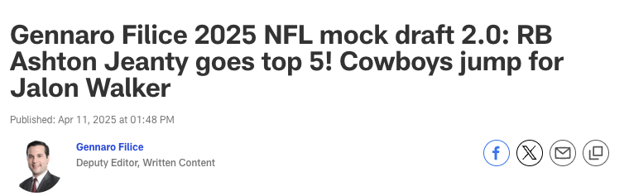

**Pick #1**



*📝 Analysis: Draft analysis for pick #1 by Gennaro Filice.*

**Pick #2**

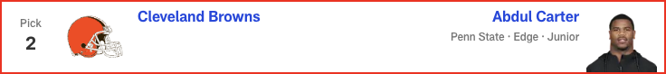

*📝 Analysis: Draft analysis for pick #2 by Gennaro Filice.*

**Pick #3**

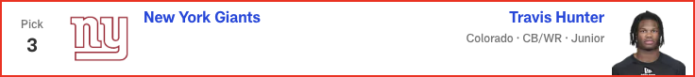

*📝 Analysis: Draft analysis for pick #3 by Gennaro Filice.*

**Pick #4**

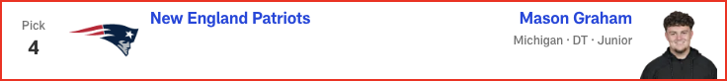

*📝 Analysis: Draft analysis for pick #4 by Gennaro Filice.*

**Pick #5**



*📝 Analysis: Draft analysis for pick #5 by Gennaro Filice.*

**Pick #6**



*📝 Analysis: Draft analysis for pick #6 by Gennaro Filice.*

**Pick #7**

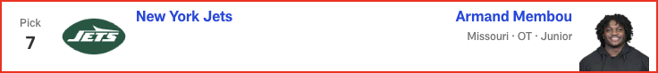

*📝 Analysis: Draft analysis for pick #7 by Gennaro Filice.*

**Pick #8**

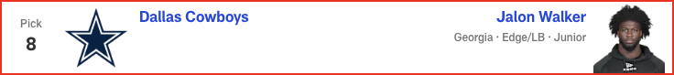

*📝 Analysis: Draft analysis for pick #8 by Gennaro Filice.*

**Pick #9**

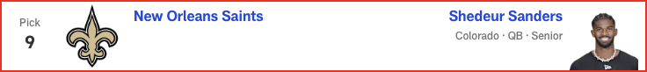

*📝 Analysis: Draft analysis for pick #9 by Gennaro Filice.*

**Pick #10**

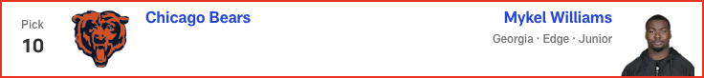

*📝 Analysis: Draft analysis for pick #10 by Gennaro Filice.*

**Pick #11**

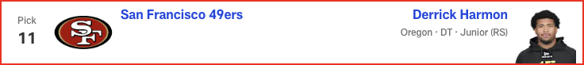

*📝 Analysis: Draft analysis for pick #11 by Gennaro Filice.*

**Pick #12**

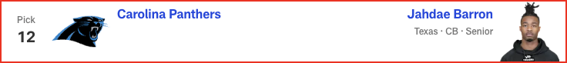

*📝 Analysis: Draft analysis for pick #12 by Gennaro Filice.*

**Pick #13**

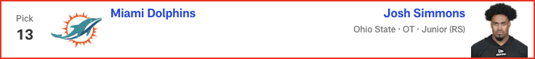

*📝 Analysis: Draft analysis for pick #13 by Gennaro Filice.*

**Pick #14**

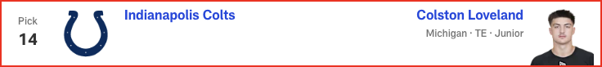

*📝 Analysis: Draft analysis for pick #14 by Gennaro Filice.*

**Pick #15**

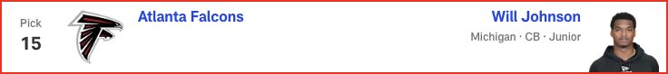

*📝 Analysis: Draft analysis for pick #15 by Gennaro Filice.*

**Pick #16**



*📝 Analysis: Draft analysis for pick #16 by Gennaro Filice.*

**Pick #17**



*📝 Analysis: Draft analysis for pick #17 by Gennaro Filice.*

**Pick #18**

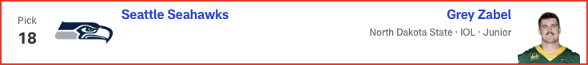

*📝 Analysis: Draft analysis for pick #18 by Gennaro Filice.*

**Pick #19**

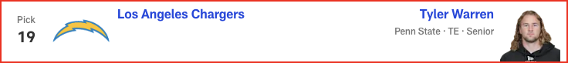

*📝 Analysis: Draft analysis for pick #19 by Gennaro Filice.*

**Pick #20**

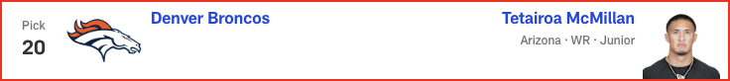

*📝 Analysis: Draft analysis for pick #20 by Gennaro Filice.*

**Pick #21**

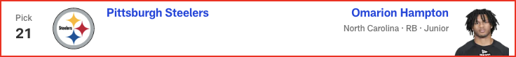

*📝 Analysis: Draft analysis for pick #21 by Gennaro Filice.*

**Pick #22**

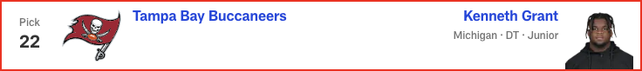

*📝 Analysis: Draft analysis for pick #22 by Gennaro Filice.*

**Pick #23**

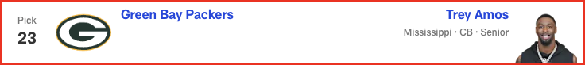

*📝 Analysis: Draft analysis for pick #23 by Gennaro Filice.*

**Pick #24**

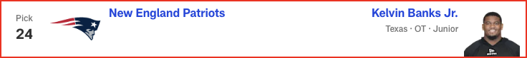

*📝 Analysis: Draft analysis for pick #24 by Gennaro Filice.*

**Pick #25**

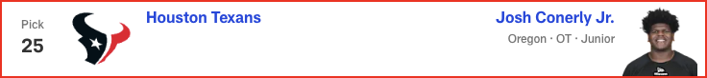

*📝 Analysis: Draft analysis for pick #25 by Gennaro Filice.*

**Pick #26**

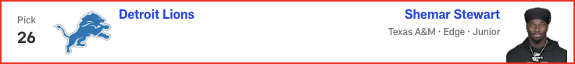

*📝 Analysis: Draft analysis for pick #26 by Gennaro Filice.*

**Pick #27**

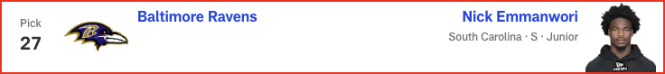

*📝 Analysis: Draft analysis for pick #27 by Gennaro Filice.*

**Pick #28**

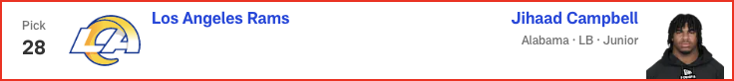

*📝 Analysis: Draft analysis for pick #28 by Gennaro Filice.*

**Pick #29**

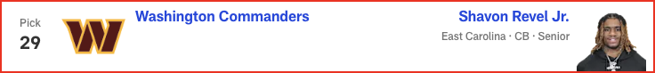

*📝 Analysis: Draft analysis for pick #29 by Gennaro Filice.*

**Pick #30**

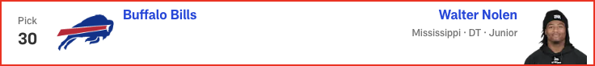

*📝 Analysis: Draft analysis for pick #30 by Gennaro Filice.*

**Pick #31**



*📝 Analysis: Draft analysis for pick #31 by Gennaro Filice.*

**Pick #32**



*📝 Analysis: Draft analysis for pick #32 by Gennaro Filice.*

# Marc Ross - 2025 Mock Draft

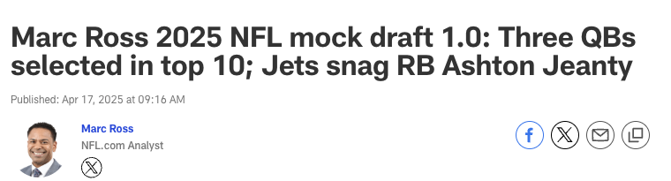

**Pick #1**

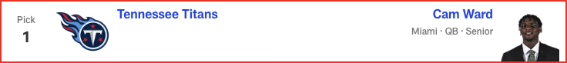

*📝 Analysis: Draft analysis for pick #1 by Marc Ross.*

**Pick #2**

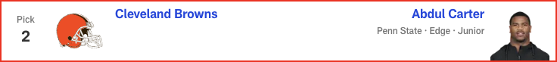

*📝 Analysis: Draft analysis for pick #2 by Marc Ross.*

**Pick #3**

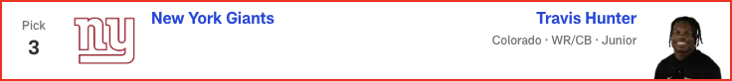

*📝 Analysis: Draft analysis for pick #3 by Marc Ross.*

**Pick #4**



*📝 Analysis: Draft analysis for pick #4 by Marc Ross.*

**Pick #5**

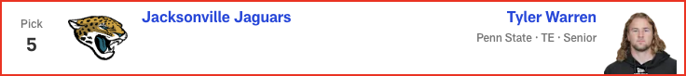

*📝 Analysis: Draft analysis for pick #5 by Marc Ross.*

**Pick #6**

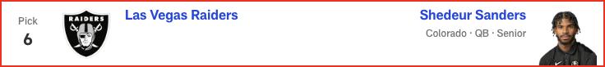

*📝 Analysis: Draft analysis for pick #6 by Marc Ross.*

**Pick #7**

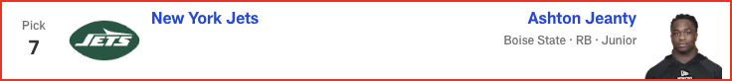

*📝 Analysis: Draft analysis for pick #7 by Marc Ross.*

**Pick #8**



*📝 Analysis: Draft analysis for pick #8 by Marc Ross.*

**Pick #9**

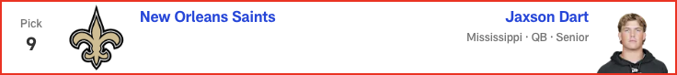

*📝 Analysis: Draft analysis for pick #9 by Marc Ross.*

**Pick #10**

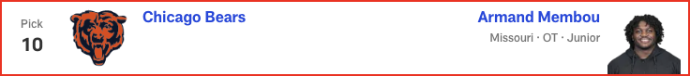

*📝 Analysis: Draft analysis for pick #10 by Marc Ross.*

**Pick #11**

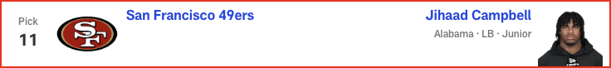

*📝 Analysis: Draft analysis for pick #11 by Marc Ross.*

**Pick #12**

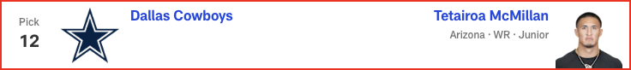

*📝 Analysis: Draft analysis for pick #12 by Marc Ross.*

**Pick #13**

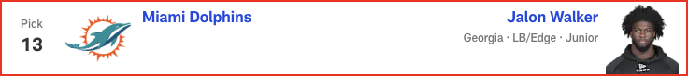

*📝 Analysis: Draft analysis for pick #13 by Marc Ross.*

**Pick #14**



*📝 Analysis: Draft analysis for pick #14 by Marc Ross.*

**Pick #15**



*📝 Analysis: Draft analysis for pick #15 by Marc Ross.*

**Pick #16**



*📝 Analysis: Draft analysis for pick #16 by Marc Ross.*

**Pick #17**

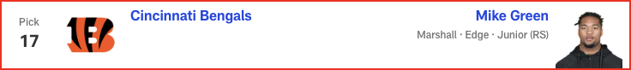

*📝 Analysis: Draft analysis for pick #17 by Marc Ross.*

**Pick #18**

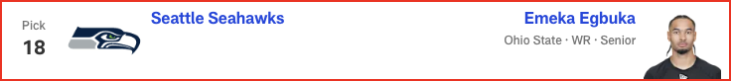

*📝 Analysis: Draft analysis for pick #18 by Marc Ross.*

**Pick #19**

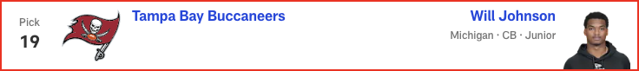

*📝 Analysis: Draft analysis for pick #19 by Marc Ross.*

**Pick #20**



*📝 Analysis: Draft analysis for pick #20 by Marc Ross.*

**Pick #21**

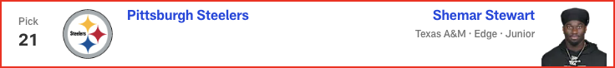

*📝 Analysis: Draft analysis for pick #21 by Marc Ross.*

**Pick #22**

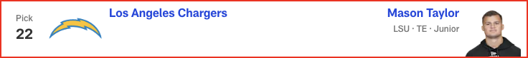

*📝 Analysis: Draft analysis for pick #22 by Marc Ross.*

**Pick #23**



*📝 Analysis: Draft analysis for pick #23 by Marc Ross.*

**Pick #24**

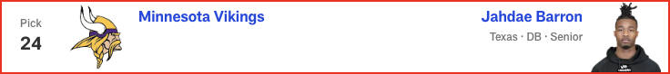

*📝 Analysis: Draft analysis for pick #24 by Marc Ross.*

**Pick #25**

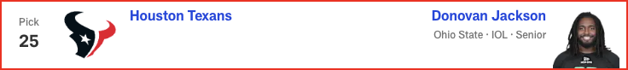

*📝 Analysis: Draft analysis for pick #25 by Marc Ross.*

**Pick #26**

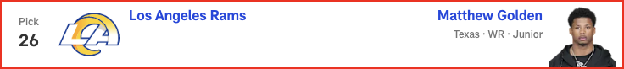

*📝 Analysis: Draft analysis for pick #26 by Marc Ross.*

**Pick #27**



*📝 Analysis: Draft analysis for pick #27 by Marc Ross.*

**Pick #28**

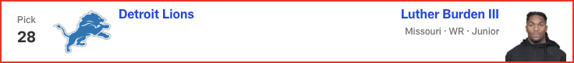

*📝 Analysis: Draft analysis for pick #28 by Marc Ross.*

**Pick #29**

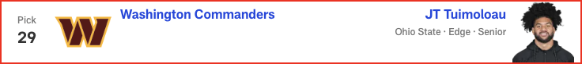

*📝 Analysis: Draft analysis for pick #29 by Marc Ross.*

**Pick #30**



*📝 Analysis: Draft analysis for pick #30 by Marc Ross.*

**Pick #31**

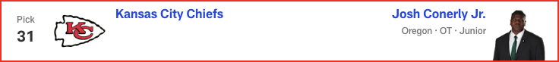

*📝 Analysis: Draft analysis for pick #31 by Marc Ross.*

**Pick #32**

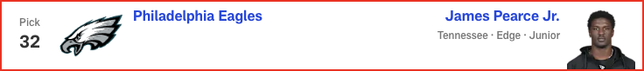

*📝 Analysis: Draft analysis for pick #32 by Marc Ross.*