NFL.com 2025 Mock Draft Screenshots

Complete NFL.com Mock Drafts - June 08, 2025

📊 7 Authors • 231 Screenshots • Top 32 Picks Each • Expert Analysis Included

# Bucky Brooks - 2025 Mock Draft

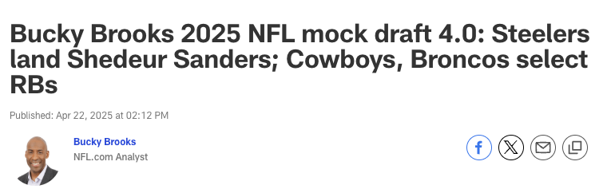

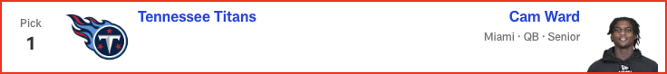

*📝 Analysis: Bypassing a chance to land a potential franchise quarterback is risky, but the Giants could take a disruptive playmaker to enhance a pass rush that features three quarterback hunters (Brian Burns, Dexter Lawrence and Kayvon Thibodeaux) on the front line.*

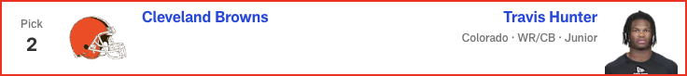

*📝 Analysis: Protecting Drake Maye is a top priority for a front office that wants to see the franchise quarterback flourish in Year 2.*

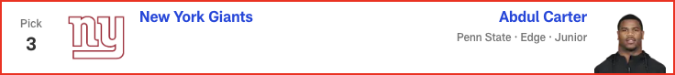

*📝 Analysis: The safest pick in the draft would give the Jaguars a blue-chip defender in the middle of a defensive line that needs more “hard hat and lunch pail” guys.*



*📝 Analysis: Pete Carroll’s apparent desire to feature a dominant rushing attack makes the Boise State standout the sensible pick to serve as his lead back.*

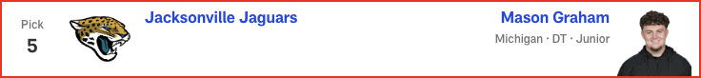

*📝 Analysis: Adding a big-bodied pass-catcher between the hashes would help Justin Fields settle in as a passer in an offense rooted in play-action concepts. Warren is a versatile playmaker with the route-running ability and ball skills to move the chains consistently with a ball-control approach.*

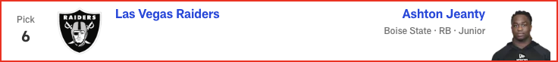

*📝 Analysis: In his third and final mock of the 2025 NFL Draft, Eric Edholm projects FOUR quarterbacks will hear their names called on Thursday night! Plus, running back Ashton Jeanty goes in the top five. See the full first-round projection, 1-32.*

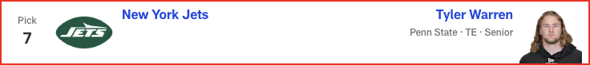

*📝 Analysis: The talented technician would give the Saints a blue-chip CB1 to feature in a zone-based system that places a premium on “vision-and-break” playmakers.*

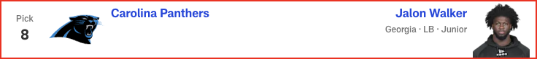

*📝 Analysis: New head coach Ben Johnson’s experience with a dominant line while running the offense for division-rival Detroit could prompt him to add more resources to the Bears’ front, even after it was fortified in free agency. Banks is a natural left tackle with the athleticism and shadowboxing skills to protect Caleb Williams’ blind side.*

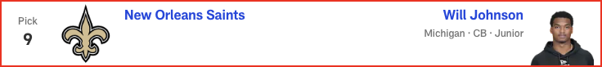

*📝 Analysis: With Round 1 of the 2025 NFL Draft in the books, Eric Edholm projects how Rounds 2 and 3 will play out on Friday night. Where do high-profile prospects like Michigan CB Will Johnson and Colorado QB Shedeur Sanders land? Check out the full Day 2 projection, 33 to 102.*

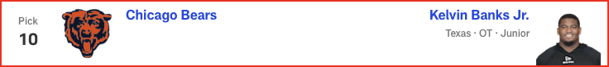

*📝 Analysis: The team needs a true RB1 to steady an offense that is always better when it operates with a run-first premise.*

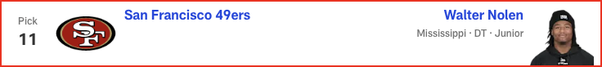

*📝 Analysis: Jalen Ramsey’s potential imminent departure could lead Barron to fill two spots as a CB/nickel defender.*

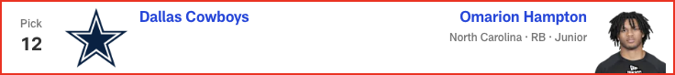

*📝 Analysis: The team’s desperation for an elite pass rusher could make Green the pick here. The Marshall standout possesses the first-step quickness and explosiveness to harass quarterbacks off the edge.*

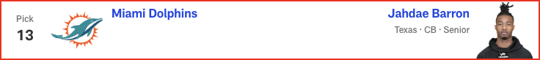

*📝 Analysis: Stewart still needs some development, but he's athletic and could generate strong sack numbers, especially if Trey Hendrickson sticks around, setting the rookie up to feed off the veteran's presence.*

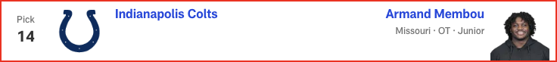

*📝 Analysis: After trading away DK Metcalf and releasing Tyler Lockett this offseason, the Seahawks could add a big-bodied pass-catcher to occupy the role of red-zone weapon.*

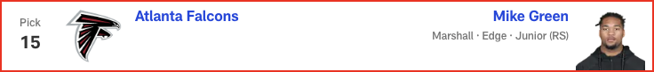

*📝 Analysis: Lavonte David is back for Year 14 -- but Todd Bowles could pick the 35-year-old linebacker's successor here. Presuming his recovery from a torn labrum goes smoothly, Campbell’s versatility would give the Buccaneers a second-level defender with playmaking and pass-rush potential.*

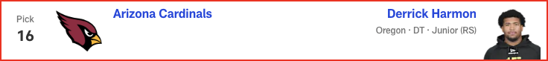

*📝 Analysis: Sean Payton wants a feature back with big-play potential in the rotation. Henderson’s speed and explosiveness could give the Super Bowl-winning coach Alvin Kamara vibes when he's contemplating how to utilize the Ohio State standout.*

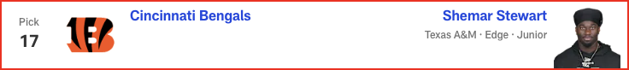

*📝 Analysis: Mike Tomlin could view Sanders as the perfect quarterback for his squad. With his confidence, moxie and pinpoint passing skills, the Colorado star might ignite a dormant offense that has already added some star power this offseason.*

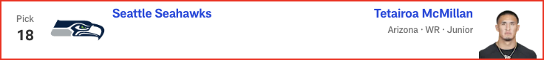

*📝 Analysis: Surrounding Justin Herbert with more playmakers should be a top priority for the Chargers. As a flex tight end with sticky hands and wide receiver-like route-running skills, Loveland could create mismatches in the passing game.*

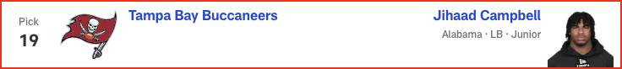

*📝 Analysis: The playmaking cover corner is the ideal ballhawk to play in Jeff Hafley’s system. Hairston excels as a “see ball, get ball” defender with superb instincts, awareness and diagnostic skills.*

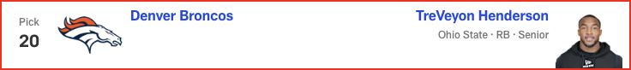

*📝 Analysis: Emmanwori can learn from Harrison Smith, who has been in the Vikings' backfield for 13 seasons, before sliding in as the next potential fixture at safety in Minnesota.*

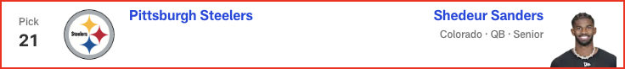

*📝 Analysis: With Round 1 of the 2025 NFL Draft in the books, Eric Edholm projects how Rounds 2 and 3 will play out on Friday night. Where do high-profile prospects like Michigan CB Will Johnson and Colorado QB Shedeur Sanders land? Check out the full Day 2 projection, 33 to 102.*

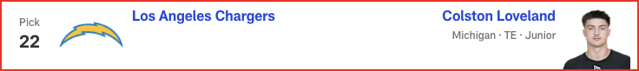

*📝 Analysis: GM Eric DeCosta and head coach John Harbaugh have a knack for finding quality players at the end of the first round. With his athleticism and pass-rushing potential, Williams could flourish in the Ravens’ aggressive defense.*

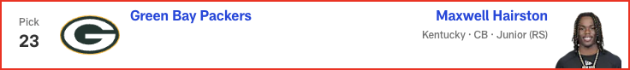

*📝 Analysis: What do the Commanders do to help Jayden Daniels take another step forward? Use a first-round pick on Golden, who led Texas in both receiving yards (987) and scoring grabs (nine) last season.*

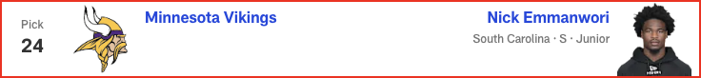

*📝 Analysis: Buffalo's depth chart features plenty of pass-rushing talent; the 6-foot-4, 331-pound Grant's presence up front could help shore up a run defense that ranked 19th in the NFL in yards allowed per rush attempt in 2024.*

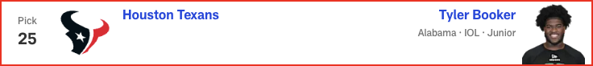

*📝 Analysis: Adding an outside corner would enable the Chiefs to move Trent McDuffie back to his natural nickel spot. Amos’ length, instincts and bump-and-run skills mesh well with the team’s defensive scheme.*

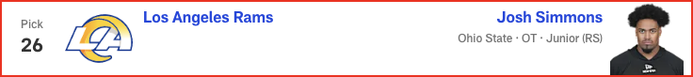

*📝 Analysis: The relentless, energetic Ezeiruaku knows how to harass the passer, based on his 16.5 sacks (second-most in the FBS) last season. He's an ideal match for the Eagles.*

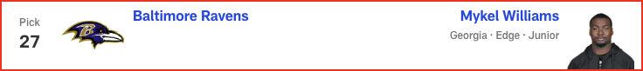

*📝 Analysis: With Round 1 of the 2025 NFL Draft in the books, Eric Edholm projects how Rounds 2 and 3 will play out on Friday night. Where do high-profile prospects like Michigan CB Will Johnson and Colorado QB Shedeur Sanders land? Check out the full Day 2 projection, 33 to 102.*

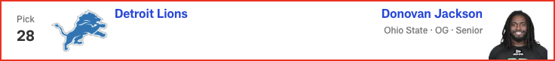

*📝 Analysis: With Round 1 of the 2025 NFL Draft in the books, Eric Edholm projects how Rounds 2 and 3 will play out on Friday night. Where do high-profile prospects like Michigan CB Will Johnson and Colorado QB Shedeur Sanders land? Check out the full Day 2 projection, 33 to 102.*

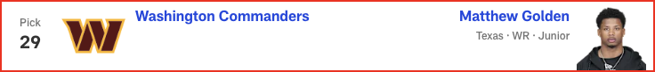

*📝 Analysis: In his second and final mock of the 2025 NFL Draft, Dan Parr predicts an early run on offensive linemen -- with one guard cracking the top 10! Plus, the 49ers and Eagles land steals on the defensive side of the ball. See the full first-round projection, 1-32.*

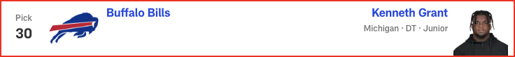

*📝 Analysis: In his final mock of the 2025 NFL Draft, Lance Zierlein has two tight ends coming off the board EARLY. Plus, the New Orleans Saints make a pair of trades and land a new quarterback. Check out the full first-round projection, 1-32.*

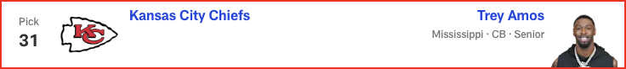

*📝 Analysis: In his fourth and final mock of the 2025 NFL Draft, Daniel Jeremiah predicts two teams will trade up for help on offense, including one squad that makes a move for a quarterback. See his full first-round projection, 1-32.*

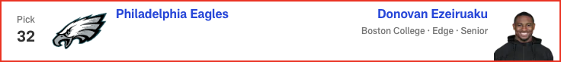

*📝 Analysis: In his final mock of the 2025 NFL Draft, Charles Davis projects only one quarterback coming off the board in Round 1. Plus, the Super Bowl champion Eagles select a tight end. Check out the full first-round projection, 1-32.*

# Daniel Jeremiah - 2025 Mock Draft

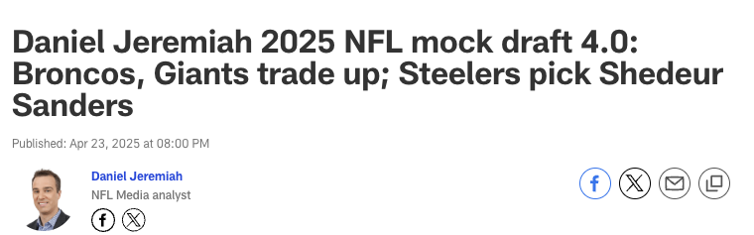



*📝 Analysis: There’s been chatter about the Giants potentially trading out of this pick, but if they stay put, I think they address the defensive line. Carter could take their front from good to great.*



*📝 Analysis: Based on everything I’ve heard from talking to people around the league, the expectation is the Jaguars will pick either Jeanty or Arizona WR Tetairoa McMillan here. I’ll go with the higher-rated player on my board.*



*📝 Analysis: I think this pick comes down to Membou versus Penn State TE Tyler Warren for new GM Darren Mougey and head coach Aaron Glenn. They choose Membou, who slides into the right tackle spot as potentially the final piece to the Jets’ offensive line overhaul of the last few years.*



*📝 Analysis: There’s a lot of talk about the Saints drafting a quarterback at No. 9, but I think they’ll address that position in the second round. They have an affinity for long, physical edge rushers -- Williams fits that mold.*

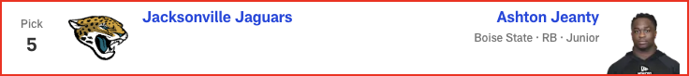

*📝 Analysis: In his third and final mock of the 2025 NFL Draft, Eric Edholm projects FOUR quarterbacks will hear their names called on Thursday night! Plus, running back Ashton Jeanty goes in the top five. See the full first-round projection, 1-32.*

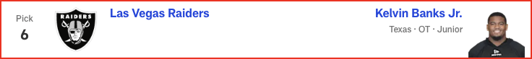

*📝 Analysis: The 49ers’ offensive line needs an influx of young talent with Trent Williams approaching his age-37 season, Aaron Banks departing in free agency and Brock Purdy getting set to sign a massive extension. Zabel can step in and start at guard from Day 1.*

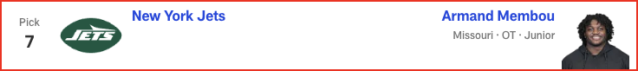

*📝 Analysis: I believe Loveland is highly coveted by a bunch of teams, and it seems like the Dolphins would like to add more draft capital. Sean Payton has never been shy about being aggressive -- the Saints traded up in the first round four times during his tenure as head coach. If he wants something, he usually goes and gets it. The signing of Evan Engram would not preclude Denver from making an aggressive m...*

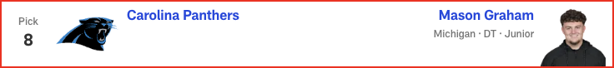

*📝 Analysis: Colts GM Chris Ballard has always placed a premium on athletic traits, and Stewart offers those in a big way. This feels very similar to the selection of Kwity Paye when he was coming out of college in 2021. Indianapolis drafts an edge rusher in the first round for the second year in a row (Laiatu Latu in 2024) after losing Dayo Odeyingbo in free agency.*

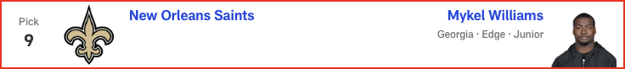

*📝 Analysis: I think this is the year Atlanta addresses the pass rush in Round 1. There’s a lot of chatter about James Pearce Jr. going to the Falcons, but in this scenario, Walker falls into their lap. He can rush off the edge -- on passing downs, at the minimum -- and play off the ball, too.*

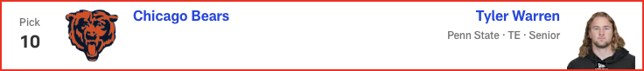

*📝 Analysis: Arizona reunites Egbuka with Ohio State teammate Marvin Harrison Jr. to give Kyler Murray a dynamic tandem at receiver. Egbuka fills a need, and he can help bring the best out of Harrison.*

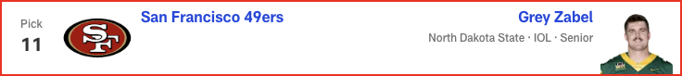

*📝 Analysis: Ezeiruaku is a skilled pass rusher with some similarities to Bengals DE Trey Hendrickson, whose future with the team remains murky.*

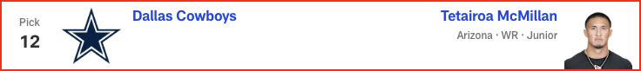

*📝 Analysis: Based on everything I’ve heard from talking to people around the league, the expectation is the Jaguars will pick either Jeanty or Arizona WR Tetairoa McMillan here. I’ll go with the higher-rated player on my board.*

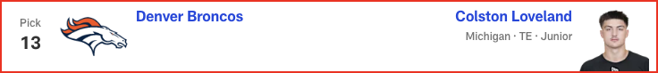

*📝 Analysis: The Packers love SEC defensive players, and Hairston can really run. He battled through injury in 2024, but his 2023 tape is exceptional. With Jaire Alexander potentially on the move, Green Bay adds help at cornerback.*

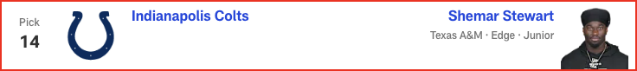

*📝 Analysis: On the surface, this might be puzzling, given the presence of Kyren Williams. But Williams is in the final year of his contract and had only one carry of 30-plus yards last season. In comparison, Saquon Barkley had 13 such runs, including the playoffs. Hampton provides a more explosive element to the Rams’ run game and can eventually take over as RB1.*

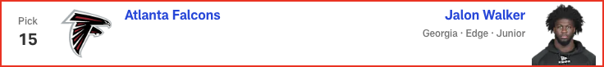

*📝 Analysis: The Lions have done a lot of homework on interior offensive linemen in this draft class. Jackson has been a riser throughout the evaluation process and would be the replacement for Kevin Zeitler. Jackson might not even make it to this pick, though.*

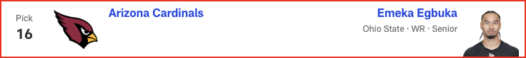

*📝 Analysis: This is a case of a team staying put and watching a value pick fall to it. I have Barron much higher in my rankings. He and 2024 second-round pick Mike Sainristil are two guys Washington could move all over the field.*

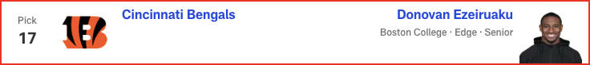

*📝 Analysis: The rules are simple with the Eagles: They take the best Alabama or Georgia player who falls into their lap. Campbell is my No. 12 player in the draft, so he would be a tremendous value at the end of Round 1. If not for the shoulder surgery he’s recovering from, he'd be a lock to go much higher.*

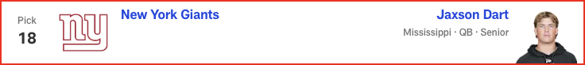

*📝 Analysis: With Round 1 of the 2025 NFL Draft in the books, Eric Edholm projects how Rounds 2 and 3 will play out on Friday night. Where do high-profile prospects like Michigan CB Will Johnson and Colorado QB Shedeur Sanders land? Check out the full Day 2 projection, 33 to 102.*

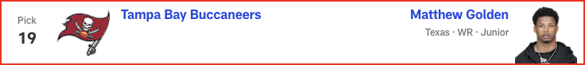

*📝 Analysis: With Round 1 of the 2025 NFL Draft in the books, Eric Edholm projects how Rounds 2 and 3 will play out on Friday night. Where do high-profile prospects like Michigan CB Will Johnson and Colorado QB Shedeur Sanders land? Check out the full Day 2 projection, 33 to 102.*

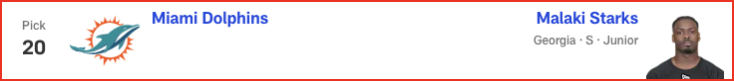

*📝 Analysis: In his second and final mock of the 2025 NFL Draft, Dan Parr predicts an early run on offensive linemen -- with one guard cracking the top 10! Plus, the 49ers and Eagles land steals on the defensive side of the ball. See the full first-round projection, 1-32.*



*📝 Analysis: With Round 1 of the 2025 NFL Draft in the books, Eric Edholm projects how Rounds 2 and 3 will play out on Friday night. Where do high-profile prospects like Michigan CB Will Johnson and Colorado QB Shedeur Sanders land? Check out the full Day 2 projection, 33 to 102.*

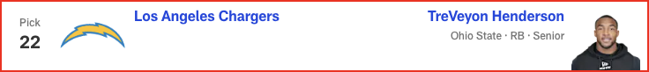

*📝 Analysis: In his final mock of the 2025 NFL Draft, Charles Davis projects only one quarterback coming off the board in Round 1. Plus, the Super Bowl champion Eagles select a tight end. Check out the full first-round projection, 1-32.*



*📝 Analysis: In his fourth and final mock of the 2025 NFL Draft, Bucky Brooks has the Pittsburgh Steelers drafting their quarterback of the future. Plus, the Cowboys and Broncos add backfield help. Check out the full first-round forecast, 1-32.*

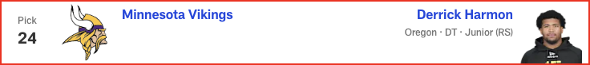

*📝 Analysis: In his third and final mock of the 2025 NFL Draft, Eric Edholm projects FOUR quarterbacks will hear their names called on Thursday night! Plus, running back Ashton Jeanty goes in the top five. See the full first-round projection, 1-32.*

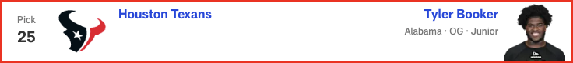

*📝 Analysis: In his first and only seven-round mock of the 2025 NFL Draft, Chad Reuter forecasts some big surprises in the top 10 and five first-round trades. See all of his projections, 1-257.*

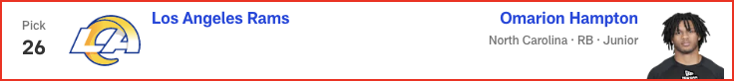

*📝 Analysis: In his first and only seven-round mock of the 2025 NFL Draft, Chad Reuter predicts two quarterbacks will come off the board in Round 2, while the Cowboys add a new running back.*

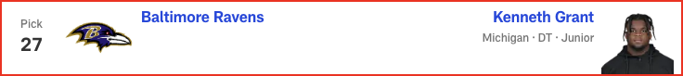

*📝 Analysis: In his first and only seven-round mock of the 2025 NFL Draft, Chad Reuter projects the Giants will spend both of their picks on offense in Round 3, while the Jets land a new quarterback.*

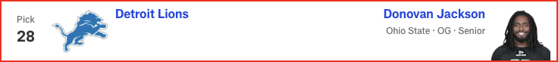

*📝 Analysis: In his first and only seven-round mock of the 2025 NFL Draft, Chad Reuter predicts a wide receiver run to start Round 4, with the Steelers finding a new quarterback later in the round.*

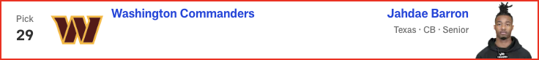

*📝 Analysis: Draft analysis for pick #29 by Daniel Jeremiah.*

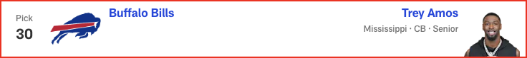

*📝 Analysis: Draft analysis for pick #30 by Daniel Jeremiah.*

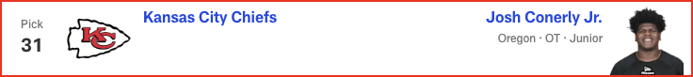

*📝 Analysis: Draft analysis for pick #31 by Daniel Jeremiah.*

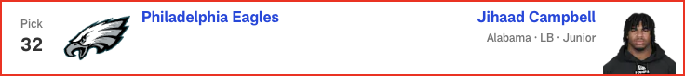

*📝 Analysis: It would not be a surprise to see Alabama LB Jihaad Campbell go to Tampa Bay at No. 19, but with Mike Evans heading into his 12th season, the Bucs opt to add another pass catcher. Golden would team up with 2024 third-round pick Jalen McMillan to give them two good, young wideouts to complement veterans Evans and Chris Godwin.*

# Charles Davis - 2025 Mock Draft

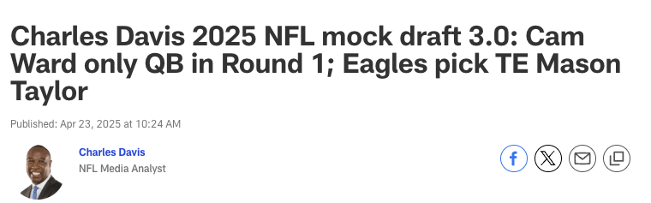

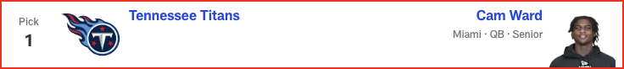

*📝 Analysis: OK, this is where we hear the surprised roar. New head coach Liam Coen gets an elite weapon to help him unlock all of QB Trevor Lawrence's potential.*

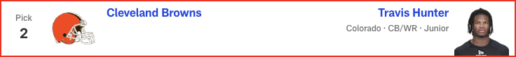

*📝 Analysis: The Jets had a chance to draft TE Brock Bowers last year but passed on him before he landed with the Raiders and ultimately earned first-team All-Pro honors as a rookie. New York’s new brain trust doesn't miss the opportunity to land a potential star tight end this time around, and new QB1 Justin Fields is thrilled.*



*📝 Analysis: The Panthers are desperate to get their defense back on track after a dismal 2024 season. The All-American from Michigan fits nicely next to Pro Bowl DT Derrick Brown, who is on his way back after missing all but one game last season due to injury.*



*📝 Analysis: This could easily be where QB Shedeur Sanders goes. I’ve already said I would be pounding the table for him in the draft room. Instead, though, the Saints tap Membou to take over at right tackle.*



*📝 Analysis: In his third and final mock of the 2025 NFL Draft, Eric Edholm projects FOUR quarterbacks will hear their names called on Thursday night! Plus, running back Ashton Jeanty goes in the top five. See the full first-round projection, 1-32.*

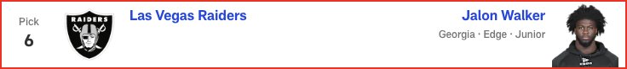

*📝 Analysis: There has been a lot of talk this offseason about the 49ers’ need for pass-rush help opposite Nick Bosa. In this projection, San Francisco takes a chance on a player with great talent but very limited production (4.5 sacks in three years at Texas A&M) to show for it.*



*📝 Analysis: Cardinals head coach Jonathan Gannon and defensive coordinator Nick Rallis will immediately implement schemes that allow Campbell to find the ball quickly. He will pursue the QB in obvious passing situations, too.*



*📝 Analysis: When the Bengals were playing their best on defense in recent years, they were strong down the middle. Starks is a sideline-to-sideline playmaker from center field.*

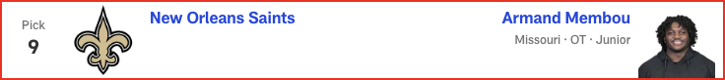

*📝 Analysis: This do-it-all defensive back will fit perfectly in head coach Mike Macdonald's schemes. Barron will allow big-play DB Devon Witherspoon to attack offenses with even more gusto.*

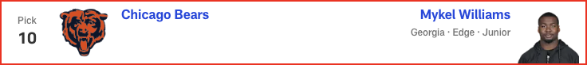

*📝 Analysis: Pittsburgh is another potential landing spot for Shedeur Sanders or one of the draft's other QB prospects. But in this case, the defensive front is prioritized by the Steelers, who select All-Pro DT Cam Heyward's eventual replacement.*

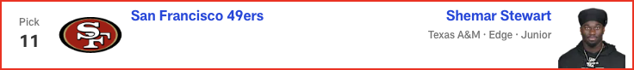

*📝 Analysis: Chargers GM Joe Hortiz and head coach Jim Harbaugh covet great players, and it doesn’t hurt that Harbaugh already knows Loveland quite well from their time together at Michigan. Another Wolverine heads west and helps QB Justin Herbert move to a higher echelon.*

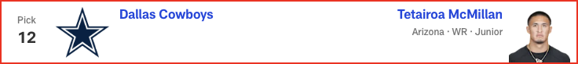

*📝 Analysis: Simmons has the potential to be a top-tier left tackle, but with Ronnie Stanley returning, the Ohio State/San Diego State product might begin his NFL career at guard, something Hall of Famer Jonathan Ogden did in his rookie season with Baltimore.*

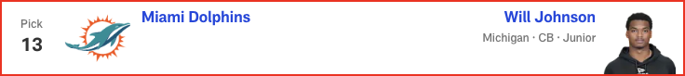

*📝 Analysis: With Round 1 of the 2025 NFL Draft in the books, Eric Edholm projects how Rounds 2 and 3 will play out on Friday night. Where do high-profile prospects like Michigan CB Will Johnson and Colorado QB Shedeur Sanders land? Check out the full Day 2 projection, 33 to 102.*

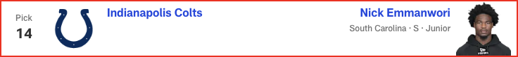

*📝 Analysis: The Bills always field a top defense, and they might want to be more aggressive in man coverage in 2025. If that's the case, the selection of "Mad Max" would be ideal for head coach Sean McDermott and defensive coordinator Bobby Babich.*

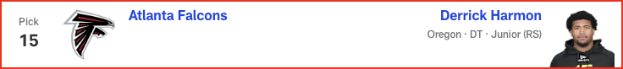

*📝 Analysis: Super Bowl LIX aside, Kansas City’s defense has been an absolute force in recent seasons. GM Brett Veach continues to give DC Steve Spagnuolo great resources.*

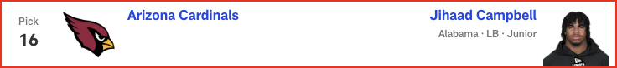

*📝 Analysis: GM Howie Roseman does a tremendous job of drafting players and getting them experience before they are needed as starters. Taylor, a smooth pass catcher, could be next in line.*

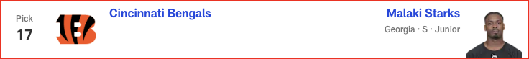

*📝 Analysis: With Round 1 of the 2025 NFL Draft in the books, Eric Edholm projects how Rounds 2 and 3 will play out on Friday night. Where do high-profile prospects like Michigan CB Will Johnson and Colorado QB Shedeur Sanders land? Check out the full Day 2 projection, 33 to 102.*

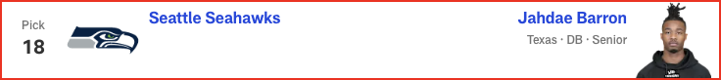

*📝 Analysis: With Round 1 of the 2025 NFL Draft in the books, Eric Edholm projects how Rounds 2 and 3 will play out on Friday night. Where do high-profile prospects like Michigan CB Will Johnson and Colorado QB Shedeur Sanders land? Check out the full Day 2 projection, 33 to 102.*

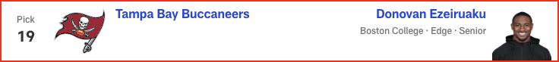

*📝 Analysis: In his second and final mock of the 2025 NFL Draft, Dan Parr predicts an early run on offensive linemen -- with one guard cracking the top 10! Plus, the 49ers and Eagles land steals on the defensive side of the ball. See the full first-round projection, 1-32.*

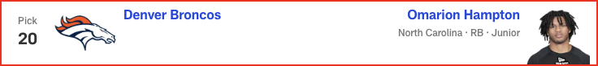

*📝 Analysis: In his final mock of the 2025 NFL Draft, Lance Zierlein has two tight ends coming off the board EARLY. Plus, the New Orleans Saints make a pair of trades and land a new quarterback. Check out the full first-round projection, 1-32.*

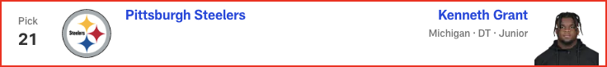

*📝 Analysis: In his fourth and final mock of the 2025 NFL Draft, Daniel Jeremiah predicts two teams will trade up for help on offense, including one squad that makes a move for a quarterback. See his full first-round projection, 1-32.*



*📝 Analysis: In his fourth and final mock of the 2025 NFL Draft, Bucky Brooks has the Pittsburgh Steelers drafting their quarterback of the future. Plus, the Cowboys and Broncos add backfield help. Check out the full first-round forecast, 1-32.*

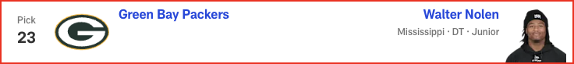

*📝 Analysis: In his third and final mock of the 2025 NFL Draft, Eric Edholm projects FOUR quarterbacks will hear their names called on Thursday night! Plus, running back Ashton Jeanty goes in the top five. See the full first-round projection, 1-32.*

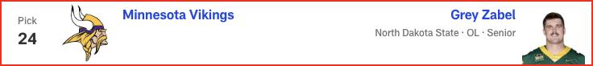

*📝 Analysis: In his first and only seven-round mock of the 2025 NFL Draft, Chad Reuter forecasts some big surprises in the top 10 and five first-round trades. See all of his projections, 1-257.*

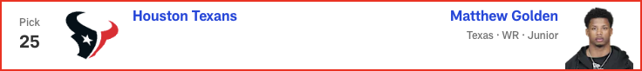

*📝 Analysis: In his first and only seven-round mock of the 2025 NFL Draft, Chad Reuter predicts two quarterbacks will come off the board in Round 2, while the Cowboys add a new running back.*

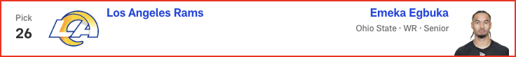

*📝 Analysis: In his first and only seven-round mock of the 2025 NFL Draft, Chad Reuter projects the Giants will spend both of their picks on offense in Round 3, while the Jets land a new quarterback.*

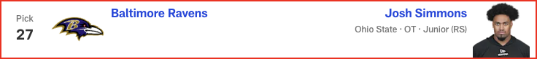

*📝 Analysis: In his first and only seven-round mock of the 2025 NFL Draft, Chad Reuter predicts a wide receiver run to start Round 4, with the Steelers finding a new quarterback later in the round.*

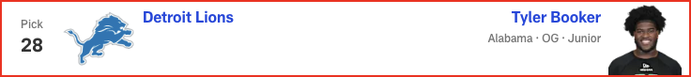

*📝 Analysis: Draft analysis for pick #28 by Charles Davis.*

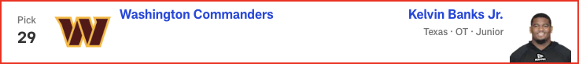

*📝 Analysis: Draft analysis for pick #29 by Charles Davis.*

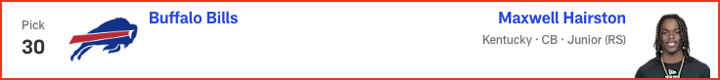

*📝 Analysis: Draft analysis for pick #30 by Charles Davis.*

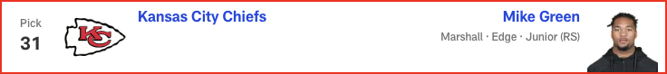

*📝 Analysis: Draft analysis for pick #31 by Charles Davis.*

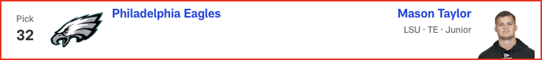

*📝 Analysis: Draft analysis for pick #32 by Charles Davis.*

# Eric Edholm - 2025 Mock Draft

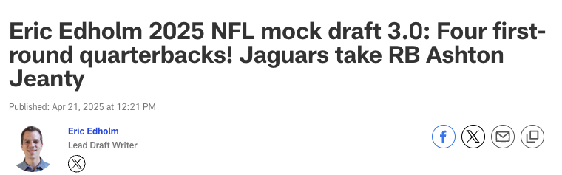

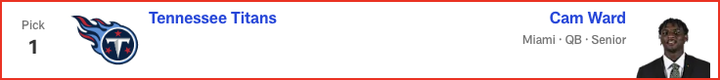

*📝 Analysis: The Giants still have a decision to make on Kayvon Thibodeaux's fifth-year option. Carter, my No. 1 overall prospect in this draft class, could be an absolute monster in time.*

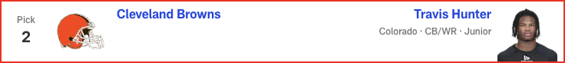

*📝 Analysis: Mike Vrabel knows he needs to protect Drake Maye, but the Patriots also need leaders and reliable building blocks. Campbell fills all of those voids.*



*📝 Analysis: I'm gonna flip it around. DT Mason Graham going here began to feel way too chalky for me recently. I just think Liam Coen will want to add a playmaker to his offense with the new regime's first pick.*

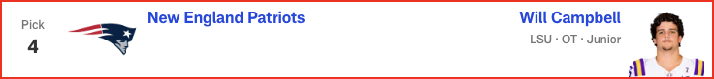

*📝 Analysis: Carolina is still a bit of a mystery, and there has been some trade chatter at this spot. But Walker's speed, pass-rush ability and QB-spy potential could add some juice to that defense.*



*📝 Analysis: I truly don't know where Sanders is going to end up or what the Saints think of him, but New Orleans needs a quarterback and this mock needs Sanders. (I think.)*

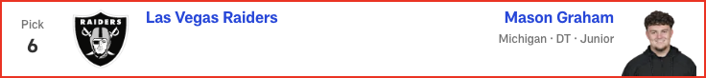

*📝 Analysis: I'm gonna flip it around. DT Mason Graham going here began to feel way too chalky for me recently. I just think Liam Coen will want to add a playmaker to his offense with the new regime's first pick.*

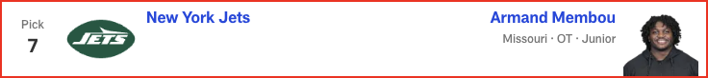

*📝 Analysis: When healthy last season, Loveland was a godsend for a Michigan team that struggled badly at QB. Daniel Jones and Anthony Richardson are battling for the Colts' starting job. Loveland is here to help -- once he's cleared for contact following shoulder surgery.*



*📝 Analysis: This pairing has been gaining some steam of late, and it makes sense -- just as the idea of Atlanta using a first-round pick on a pass rusher has for many years.*

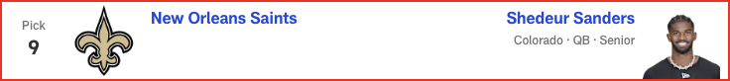

*📝 Analysis: With Round 1 of the 2025 NFL Draft in the books, Eric Edholm projects how Rounds 2 and 3 will play out on Friday night. Where do high-profile prospects like Michigan CB Will Johnson and Colorado QB Shedeur Sanders land? Check out the full Day 2 projection, 33 to 102.*



*📝 Analysis: The Broncos quietly are creeping up on the NFL's big boys, and adding a three-down lead back speeds up that development. Hampton could be a big producer in Sean Payton's offense.*

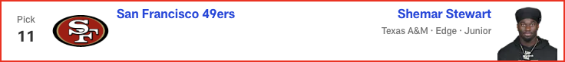

*📝 Analysis: Sure, the school connection helps for scouting purposes, but Grant really does fill the Chargers' nose tackle needs well. He'd step right into the Poona Ford-sized hole up front.*



*📝 Analysis: Johnson has been a tricky player to place in mock drafts because of questions about his health and long speed. But at No. 23, the Packers absolutely can justify the risk for a highly pedigreed talent at a needed spot.*

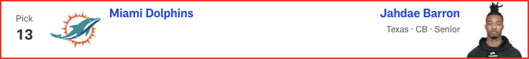

*📝 Analysis: The Rams were infatuated with Brock Bowers in last year's draft, so LSU TE Mason Taylor wouldn't shock me here. But Emmanwori could be a box safety/linebacker, adding another playmaker for this defense.*

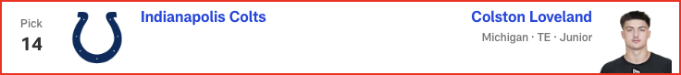

*📝 Analysis: Every year, it seems, a top-20 talent just falls into Baltimore's lap in this range, and we all just shrug. Starks could fill an immediate role in a thin secondary as a proven, three-year SEC starter.*



*📝 Analysis: I thought long and hard about a cornerback here, but Ezeiruaku's pass-rush upside might be too tempting to pass up here. He's also a mature player whose football character fits perfectly with Dan Quinn.*

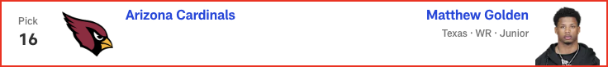

*📝 Analysis: Maxwell Hairston's speed might be tempting, but Amos just feels like a better fit in Buffalo as a tackler, zone defender and general irritant with his size and play style. This secondary needs more length and skill.*

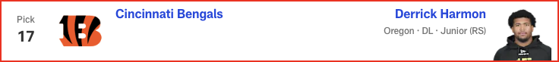

*📝 Analysis: Left tackle was such an issue last season, and the Chiefs can't assume free-agent addition Jaylon Moore will dominate and stay healthy. Simmons would be a smart value pick who can be brought along gradually.*

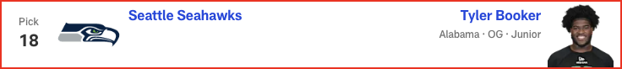

*📝 Analysis: The Eagles must replenish some lost depth up front, and Nolen could be perfect in their DL wave. He's a flash player who hasn't put it all together yet, but the ceiling is very high.*



*📝 Analysis: With Round 1 of the 2025 NFL Draft in the books, Eric Edholm projects how Rounds 2 and 3 will play out on Friday night. Where do high-profile prospects like Michigan CB Will Johnson and Colorado QB Shedeur Sanders land? Check out the full Day 2 projection, 33 to 102.*



*📝 Analysis: With Round 1 of the 2025 NFL Draft in the books, Eric Edholm projects how Rounds 2 and 3 will play out on Friday night. Where do high-profile prospects like Michigan CB Will Johnson and Colorado QB Shedeur Sanders land? Check out the full Day 2 projection, 33 to 102.*

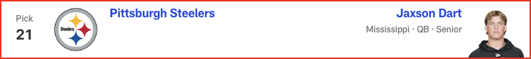

*📝 Analysis: In his second and final mock of the 2025 NFL Draft, Dan Parr predicts an early run on offensive linemen -- with one guard cracking the top 10! Plus, the 49ers and Eagles land steals on the defensive side of the ball. See the full first-round projection, 1-32.*

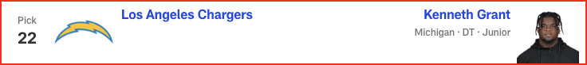

*📝 Analysis: In his final mock of the 2025 NFL Draft, Lance Zierlein has two tight ends coming off the board EARLY. Plus, the New Orleans Saints make a pair of trades and land a new quarterback. Check out the full first-round projection, 1-32.*

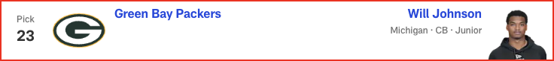

*📝 Analysis: With Round 1 of the 2025 NFL Draft in the books, Eric Edholm projects how Rounds 2 and 3 will play out on Friday night. Where do high-profile prospects like Michigan CB Will Johnson and Colorado QB Shedeur Sanders land? Check out the full Day 2 projection, 33 to 102.*

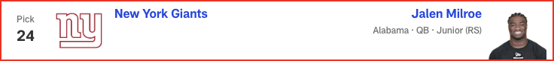

*📝 Analysis: In his final mock of the 2025 NFL Draft, Charles Davis projects only one quarterback coming off the board in Round 1. Plus, the Super Bowl champion Eagles select a tight end. Check out the full first-round projection, 1-32.*

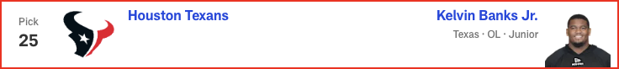

*📝 Analysis: In his fourth and final mock of the 2025 NFL Draft, Bucky Brooks has the Pittsburgh Steelers drafting their quarterback of the future. Plus, the Cowboys and Broncos add backfield help. Check out the full first-round forecast, 1-32.*

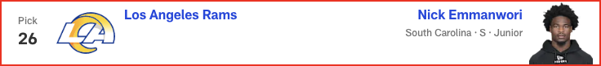

*📝 Analysis: In his first and only seven-round mock of the 2025 NFL Draft, Chad Reuter forecasts some big surprises in the top 10 and five first-round trades. See all of his projections, 1-257.*

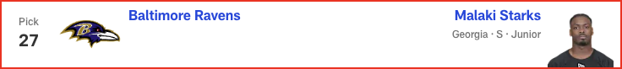

*📝 Analysis: In his first and only seven-round mock of the 2025 NFL Draft, Chad Reuter predicts two quarterbacks will come off the board in Round 2, while the Cowboys add a new running back.*

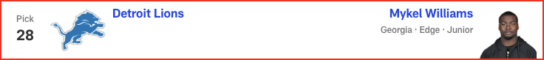

*📝 Analysis: In his first and only seven-round mock of the 2025 NFL Draft, Chad Reuter projects the Giants will spend both of their picks on offense in Round 3, while the Jets land a new quarterback.*

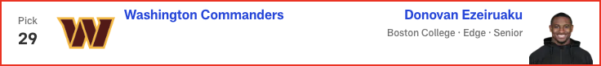

*📝 Analysis: In his first and only seven-round mock of the 2025 NFL Draft, Chad Reuter predicts a wide receiver run to start Round 4, with the Steelers finding a new quarterback later in the round.*



*📝 Analysis: Draft analysis for pick #30 by Eric Edholm.*

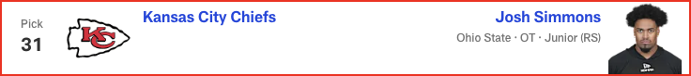

*📝 Analysis: Draft analysis for pick #31 by Eric Edholm.*

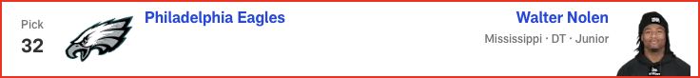

*📝 Analysis: Draft analysis for pick #32 by Eric Edholm.*

# Dan Parr - 2025 Mock Draft

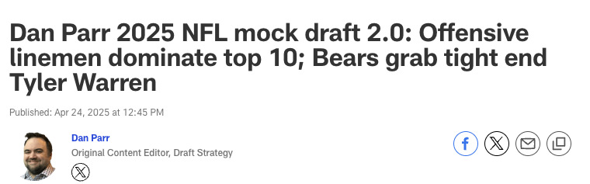



*📝 Analysis: Cleveland doesn’t pass up a chance to select a potential once-in-a-lifetime player. Hunter immediately becomes a weapon on offense and can be used in certain packages on defense, as well.*



*📝 Analysis: While the long-term quarterback need looms large, the Giants don’t see value at the position that matches such a high pick. They select Carter and look to recreate the dominant pass rush that was critical to the team’s two Super Bowl wins in this century.*



*📝 Analysis: As I’ve been saying since last month, the Jaguars should not turn down an opportunity to snag Jeanty, the best player available at No. 5. Based on the buzz of the last few days, I don't think they will.*



*📝 Analysis: With Jeanty off the board, the Raiders pivot to tightening up an offensive line that ranked near the bottom of the league last season.*

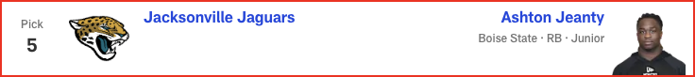

*📝 Analysis: In his third and final mock of the 2025 NFL Draft, Eric Edholm projects FOUR quarterbacks will hear their names called on Thursday night! Plus, running back Ashton Jeanty goes in the top five. See the full first-round projection, 1-32.*



*📝 Analysis: The Panthers are coming off a historically bad season on defense. Drafting Walker is a big step back toward respectability on that side of the ball.*



*📝 Analysis: The board falls Ben Johnson’s way, giving him a chance to start his career as a head coach with a weapon who opens a lot of possibilities for the offense.*

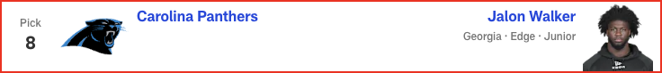

*📝 Analysis: We might see a party break out in the 49ers’ draft room if Graham -- NFL Network draft guru Daniel Jeremiah’s No. 4 overall prospect -- falls all the way to San Francisco at No. 11. That is, unless Ole Miss' Walter Nolen is the DT they prefer, as the most recent buzz has suggested.*

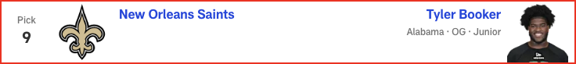

*📝 Analysis: The Cowboys relieve some of the stress on Dak Prescott by pairing CeeDee Lamb with McMillan, who has ball skills for days.*



*📝 Analysis: Miami could use a new alpha in the secondary with Jevon Holland gone and Jalen Ramsey potentially following him out the door. Barron fits the bill.*

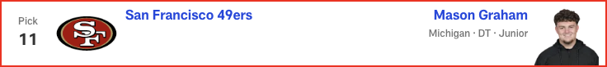

*📝 Analysis: If Raheem Morris can unlock Williams’ potential, the 20-year-old could become an elite NFL pass rusher, something the Falcons have sorely lacked for far too long.*



*📝 Analysis: For the third straight year, Arizona uses its top pick on an Ohio State product. Simmons joins Paris Johnson to give the Cardinals a pair of Buckeye bookends with long-term potential.*



*📝 Analysis: The Bengals have to be on the lookout for someone who can either complement or replace Trey Hendrickson. New DC Al Golden’s task is to bring Stewart along from a production standpoint (just 4.5 sacks over three seasons at Texas A&M). He has the traits to be a monster off the edge.*



*📝 Analysis: "Best player available" vibes here. Campbell gets a chance to soak up wisdom from Lavonte David, one of the top off-ball linebackers of his era, before it’s his time to be the guy.*

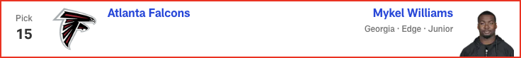

*📝 Analysis: Obviously, Shedeur Sanders has been the popular projection to Pittsburgh in the days leading up to the draft. If the Steelers decide to wait on taking a QB, the trio of DK Metcalf, George Pickens and Egbuka would be very enticing.*

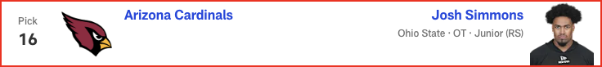

*📝 Analysis: Jim Harbaugh continues to build his team through the trenches, reconnecting with a fellow Michigan Man in the process.*

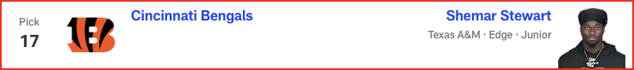

*📝 Analysis: Packers fans assembled at the draft site get to witness history for their franchise, as Green Bay selects a receiver in Round 1 for the first time in 23 years. Jordan Love approves!*

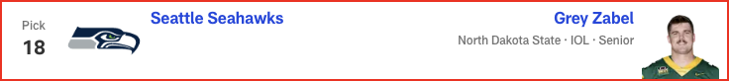

*📝 Analysis: GM Nick Caserio and head coach DeMeco Ryans continue their mission to rebuild the Texans’ offensive line, reuniting C.J. Stroud with his former Ohio State teammate.*



*📝 Analysis: It won't be a surprise if the Rams trade down in a deal with a team looking to move up for a quarterback. In this scenario, though, they bolster the secondary with a cornerback who has sub-4.3 speed and the ball skills to be a headache for offenses.*



*📝 Analysis: The search for a pass-rushing complement to Aidan Hutchinson shifts to Green, who led the FBS with 17 sacks in 2024.*

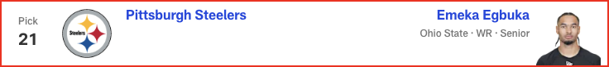

*📝 Analysis: Washington fills its most pressing need with a player Dan Quinn could mold into a Pro Bowl-caliber pass rusher.*



*📝 Analysis: Buffalo ends Johnson’s slide after injuries marred his 2024 season and pre-draft process. Cornerback is a spot the Bills must address, and the pedigreed cover man's value at No. 30 overrides potential concerns about him not running a 40-yard dash for teams.*

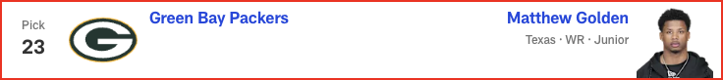

*📝 Analysis: Another year, another draft where one of the top defensive players in the class falls into the Eagles’ lap. DC Vic Fangio will love his options in the secondary.*

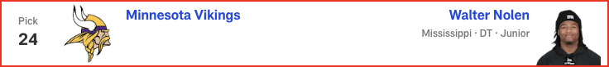

*📝 Analysis: We might see a party break out in the 49ers’ draft room if Graham -- NFL Network draft guru Daniel Jeremiah’s No. 4 overall prospect -- falls all the way to San Francisco at No. 11. That is, unless Ole Miss' Walter Nolen is the DT they prefer, as the most recent buzz has suggested.*

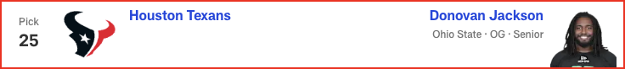

*📝 Analysis: With Round 1 of the 2025 NFL Draft in the books, Eric Edholm projects how Rounds 2 and 3 will play out on Friday night. Where do high-profile prospects like Michigan CB Will Johnson and Colorado QB Shedeur Sanders land? Check out the full Day 2 projection, 33 to 102.*

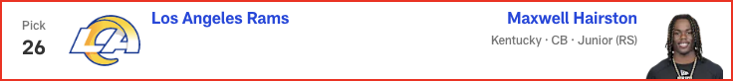

*📝 Analysis: In his final mock of the 2025 NFL Draft, Lance Zierlein has two tight ends coming off the board EARLY. Plus, the New Orleans Saints make a pair of trades and land a new quarterback. Check out the full first-round projection, 1-32.*

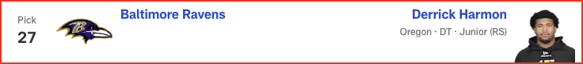

*📝 Analysis: In his fourth and final mock of the 2025 NFL Draft, Daniel Jeremiah predicts two teams will trade up for help on offense, including one squad that makes a move for a quarterback. See his full first-round projection, 1-32.*

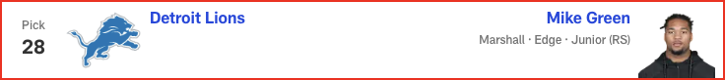

*📝 Analysis: In his final mock of the 2025 NFL Draft, Charles Davis projects only one quarterback coming off the board in Round 1. Plus, the Super Bowl champion Eagles select a tight end. Check out the full first-round projection, 1-32.*



*📝 Analysis: In his fourth and final mock of the 2025 NFL Draft, Bucky Brooks has the Pittsburgh Steelers drafting their quarterback of the future. Plus, the Cowboys and Broncos add backfield help. Check out the full first-round forecast, 1-32.*

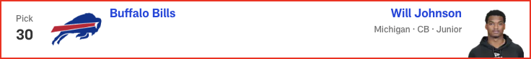

*📝 Analysis: With Round 1 of the 2025 NFL Draft in the books, Eric Edholm projects how Rounds 2 and 3 will play out on Friday night. Where do high-profile prospects like Michigan CB Will Johnson and Colorado QB Shedeur Sanders land? Check out the full Day 2 projection, 33 to 102.*

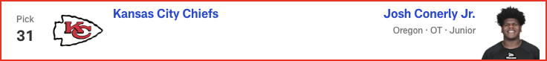

*📝 Analysis: In his first and only seven-round mock of the 2025 NFL Draft, Chad Reuter forecasts some big surprises in the top 10 and five first-round trades. See all of his projections, 1-257.*

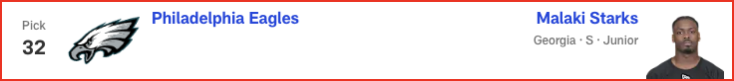

*📝 Analysis: In his first and only seven-round mock of the 2025 NFL Draft, Chad Reuter predicts two quarterbacks will come off the board in Round 2, while the Cowboys add a new running back.*

# Gennaro Filice - 2025 Mock Draft

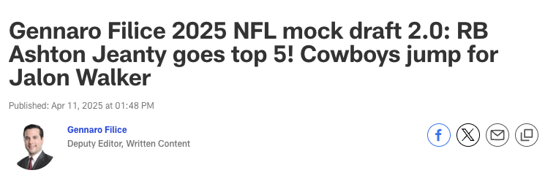



*📝 Analysis: When I last mocked Hunter to New York, longtime beat writer Paul Schwartz had just reported that the Giants see the two-way star as a cornerback. The New York Post scribe changed his tune this week, though, writing that the team’s evaluation remains fluid. The current state of the roster makes CB the bigger need, but a potential duo of Hunter and Malik Nabers makes WR the bigger splash. Maybe you ...*

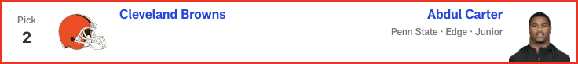

*📝 Analysis: New England just signed Milton Williams to a nine-figure deal, but fellow defensive tackle Christian Barmore remains an uncertainty due to recurring symptoms from blood clots. And regardless, does Mike Vrabel strike you as the kind of guy who’d be concerned about having too many disruptive D-linemen? Following a free agency spending spree that upgraded all three levels of the defense, the Patriots...*

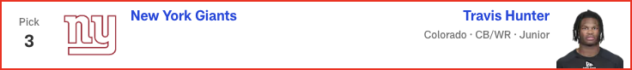

*📝 Analysis: The Draft Buzz-O-Meter [patent pending] has been shifting this pick to Travis Hunter. Understandable, especially given Cleveland’s dearth of offensive playmakers. But having Carter rush the passer opposite Myles Garrett for the rest of this decade is a five-year plan I can believe in. It doesn’t solve the franchise’s never-ending nightmare at quarterback, but think of the terror thrust upon opposi...*

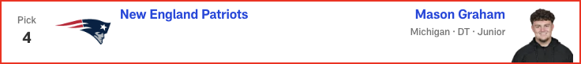

*📝 Analysis: Seemingly everyone -- including our resident prospect rankers in these parts, Daniel Jeremiah, Eric Edholm and Lance Zierlein -- has Jeanty as a top-five player in this class. So, what’s stopping him from being selected in the top five picks of this draft? Travis Etienne Jr.'s efficiency declined in 2023, and his production fell off a cliff in ’24. Tank Bigsby emerged as a rusher in Year 2, but he...*



*📝 Analysis: In his third and final mock of the 2025 NFL Draft, Eric Edholm projects FOUR quarterbacks will hear their names called on Thursday night! Plus, running back Ashton Jeanty goes in the top five. See the full first-round projection, 1-32.*



*📝 Analysis: Coincidentally, Pete Carroll’s first draft in Seattle began with the selection of an offensive tackle at No. 6 overall (Russell Okung).*



*📝 Analysis: Coincidentally, Aaron Glenn’s first draft in Detroit began with the selection of an offensive tackle at No. 7 overall (Penei Sewell).*

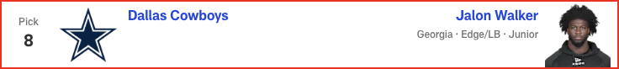

*📝 Analysis: With an aging roster pockmarked by restructured contracts and depth issues, New Orleans is no longer the land of bullish cap truthers. And with piles of dead presidents tied up in dead cap, the Saints could use the salary cheat code of a quarterback on a rookie contract. Sanders, like most first-year signal-callers, could benefit from a grace period before he’s expected to take the reins from the ...*



*📝 Analysis: With the possible exception of Shedeur Sanders, McMillan could have the widest draft range in this year’s mock madness. I had him going sixth overall in Version 1.0 and still can easily imagine him coming off the board in that area. But in today’s simulation, he falls right into Denver’s lap, giving Bo Nix another big-bodied target who can learn from (and eventually replace) Courtland Sutton.*



*📝 Analysis: Every draft cycle is a set of waves ... take waves, which typically swell after tentpole events like the NFL Scouting Combine, pro days, etc. And when it comes to placing individual prospects in a mock, the trick is figuring out which wave to ride.*

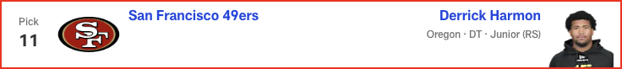

*📝 Analysis: Mykel Williams got a ton of early buzz in draftworld, but it feels like the hype train has slowed over the last month or so. With the full disclosure that I have no inside intel on the subject, I’m guessing that the early buzz was real and this late cooling period is a product of teams trying to hide their interest.*

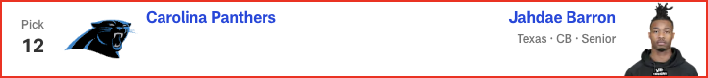

*📝 Analysis: Looking at San Francisco’s current depth chart, it’s shocking how unimposing the defensive line appears on paper. Yeah, the group is headlined by Nick Bosa, but beyond the perennial Defensive Player of the Year candidate, where’s the beef? The Niners are particularly thin on the interior. So let’s give them a scheme-versatile D-lineman out of Oregon -- remember Arik Armstead, 49er Faithful? -- who...*

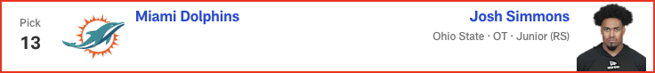

*📝 Analysis: Alignment versatility’s all the rage among NFL pass catchers. Consequently, inside/outside ability’s never been more valuable to NFL defenses. And that’s exactly what Barron provides. Having just won the Jim Thorpe Award as college football’s top defensive back, the Texas product lined up all over the field as a starter for the last three seasons, deftly executing different techniques across myria...*

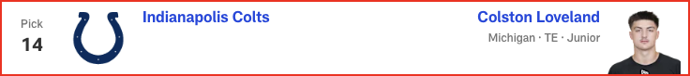

*📝 Analysis: I’m not a doctor and I don’t play one on the internet, so I won’t pretend to know how much the torn patellar tendon Simmons suffered in October will ultimately affect his draft position later this month. That said, his participation in Ohio State’s pro day last month -- albeit in a limited capacity -- was a positive sign, right? And a common sentiment among draftniks is that Simmons would have bee...*

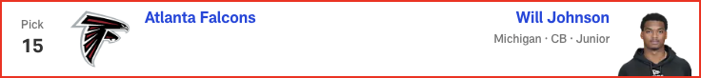

*📝 Analysis: With Round 1 of the 2025 NFL Draft in the books, Eric Edholm projects how Rounds 2 and 3 will play out on Friday night. Where do high-profile prospects like Michigan CB Will Johnson and Colorado QB Shedeur Sanders land? Check out the full Day 2 projection, 33 to 102.*



*📝 Analysis: "The emphasis on the draft will certainly be on the defensive side of the ball,” the Falcons owner said. “I think that's pretty obvious to everybody."*

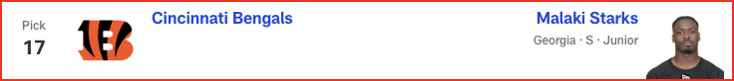

*📝 Analysis: Atlanta could target an edge rusher here, but in this scenario, Johnson might be too good a value to pass on. If the pedigreed cover man does something at his long-awaited workout to quell lingering concerns about his long speed -- like run a 40 in the 4.4s -- he could fly up the draft board.*

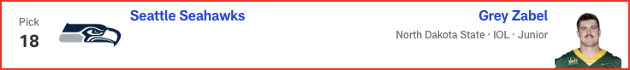

*📝 Analysis: With a pair of big-bodied wideouts in Marvin Harrison Jr. and Michael Wilson and a freshly PAID tight end in Trey McBride, the Cardinals could use a true “Z” to pop the top off the defense and create space underneath. Not that Golden’s strictly a vertical speed merchant. In fact, his 4.29 40 at the combine pleasantly caught everyone by surprise. But the three-level threat clearly has the juice to ...*

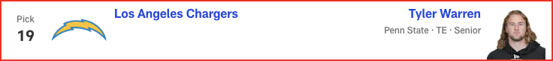

*📝 Analysis: Many folks have the Colts taking a tight end, just usually not this one. Tyler Warren is the popular pick, but I’m bucking that trend with the belief that some teams could value Loveland’s route artistry at the position over Warren’s throwback skill set. Shoot, the Michigan product is running whip routes at nearly 6-foot-6 and 250 pounds!*

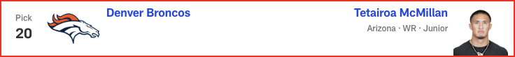

*📝 Analysis: To casual observers, this is a surprising selection. To draft sickos, this is the hottest name nobody knew a few months ago. Zabel started all across the offensive line at North Dakota State, but he’ll most likely man one of the three interior spots in the NFL. That’s an area where the Seahawks must improve. Zabel turned heads working as a center at the Senior Bowl and showcased exceptional athlet...*

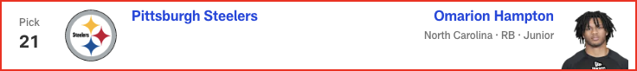

*📝 Analysis: The reason Warren goes a lot higher in most mocks: He could be a true “Y” tight end, a dying breed of player who’s equal parts blocker and receiver, offering real inline ability.*

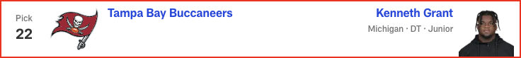

*📝 Analysis: The reason Warren drops a bit in this mock: It feels like most modern offenses overwhelmingly value receiving ability over blocking prowess at TE1, typically preferring agile weapons who can route guys up.*

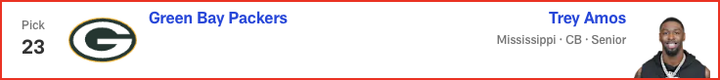

*📝 Analysis: With the possible exception of Shedeur Sanders, McMillan could have the widest draft range in this year’s mock madness. I had him going sixth overall in Version 1.0 and still can easily imagine him coming off the board in that area. But in today’s simulation, he falls right into Denver’s lap, giving Bo Nix another big-bodied target who can learn from (and eventually replace) Courtland Sutton.*

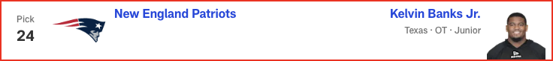

*📝 Analysis: Regardless of who ends up starting under center in Pittsburgh, you have to imagine this team will continue to pound the rock. The Steelers have ranked top 10 in rushing attempts in every season since Ben Roethlisberger’s retirement, vaulting to No. 4 in Arthur Smith’s maiden voyage as offensive coordinator last year. Smith remains at the controls, but Najee Harris -- who easily paced Pittsburgh in...*

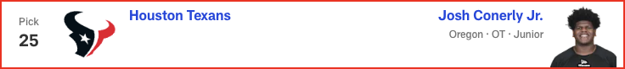

*📝 Analysis: The continuing uncertainty surrounding Jaire Alexander makes corner a need in Green Bay. Frankly, even if Alexander and the Packers are able to work things out and stay together in 2025 -- a possibility GM Brian Gutekunst recently raised -- the 28-year-old has missed double-digit games in three of the last four seasons, further underscoring the need to fortify the position. With good size and cove...*

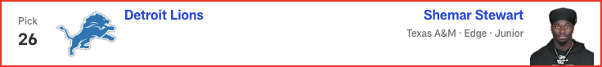

*📝 Analysis: FREAK-SHOW RUN!!! If Shemar Stewart made a splash at the combine, Nick Emmanwori performed a cannonball. Arriving in Indy at a chiseled 6-3 1/8 and 220 pounds, the South Carolina safety blazed the 40-yard dash in 4.38 seconds and nearly jumped out of Lucas Oil Stadium (43-inch vertical, 11-foot-6 broad). Emmanwori’s not just an Underwear Olympian, either; he started during all three of his seasons...*

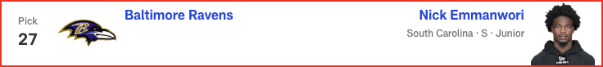

*📝 Analysis: A former five-star recruit out of the Miami area, Stewart is a long, large, freak-show athlete who predictably blew up the combine. And despite the routinely-cited sack figures (exactly 1.5 in each of his three college seasons), he led a talented A&M D-line with 39 pressures last season, per Pro Football Focus.*

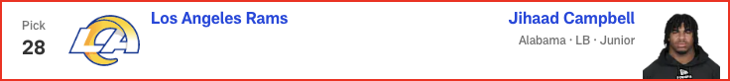

*📝 Analysis: FREAK-SHOW RUN!!! If Shemar Stewart made a splash at the combine, Nick Emmanwori performed a cannonball. Arriving in Indy at a chiseled 6-3 1/8 and 220 pounds, the South Carolina safety blazed the 40-yard dash in 4.38 seconds and nearly jumped out of Lucas Oil Stadium (43-inch vertical, 11-foot-6 broad). Emmanwori’s not just an Underwear Olympian, either; he started during all three of his seasons...*

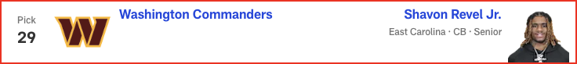

*📝 Analysis: A first-team All-SEC linebacker with hybrid skills as a pass rusher, Campbell put on a show in Indianapolis. But post-combine shoulder surgery has created uncertainty around his draft stock. If he makes it all the way to Los Angeles, this could be a coup for the Rams. The only problem with this projection? Well, Les Snead hasn’t spent a top-100 pick on a linebacker since back when the Rams were in...*

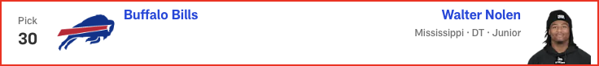

*📝 Analysis: An impressive physical specimen at a hair under 6-2 with pterodactyl length, Revel was poised to make a national name for himself in 2024. But then he tore his ACL during a practice in September, prematurely ending his final season at ECU and preventing him from showing his wares in the pre-draft process. Out of sight, but not out of mind. I anticipate a playoff team scooping him up in the back st...*



*📝 Analysis: Ezeiruaku fittingly comes off the board right after Mike Green, as the Boston College star fell a half-sack shy of his Marshall counterpart for last season's FBS crown in sacks, finishing with 16.5. He has an odd body type for an edge rusher: slightly undersized at 6-2 1/2 and 248 pounds, but with 34-inch vines for arms. Howie Roseman isn’t afraid to take a walk on the wild side, though. Remember ...*



*📝 Analysis: Ezeiruaku fittingly comes off the board right after Mike Green, as the Boston College star fell a half-sack shy of his Marshall counterpart for last season's FBS crown in sacks, finishing with 16.5. He has an odd body type for an edge rusher: slightly undersized at 6-2 1/2 and 248 pounds, but with 34-inch vines for arms. Howie Roseman isn’t afraid to take a walk on the wild side, though. Remember ...*

# Marc Ross - 2025 Mock Draft

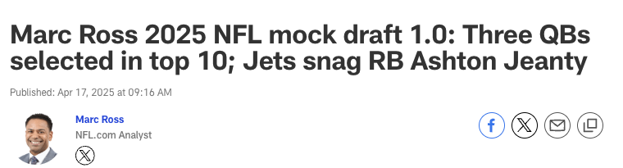



*📝 Analysis: The opportunity to pair Carter with perennial Pro Bowler Myles Garrett is too tempting to resist. Having these two on opposite sides of Jim Schwartz's defensive line ensures a terrorizing pass rush that will keep opposing quarterbacks uneasy in the pocket. Sure, Cleveland has plenty of questions surrounding its own QB situation, but outside of Cam Ward, I don't see another signal-caller in this cl...*

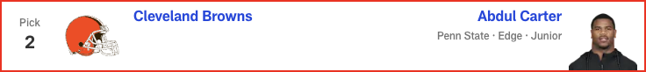

*📝 Analysis: Penalty magnet Jawaan Taylor has been a liability, and I'm not sold on free-agent signing Jaylon Moore curing all of Kansas City's OL ills. Conerly, who had his best game last season against Abdul Carter, has solid technique as a right or left tackle. He'd thrive under Andy Reid, who covets O-linemen with versatility.*

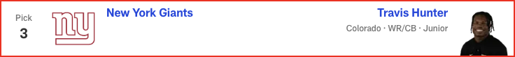

*📝 Analysis: The Jaguars must give Trevor Lawrence as many resources as possible to see if he truly is a franchise QB and the guy for Liam Coen's offense moving forward. Warren is the best tight end in this class. He'd find a ton of success working the middle of the field in Jacksonville, with second-year receiver Brian Thomas Jr. commanding the defense's attention deep.*

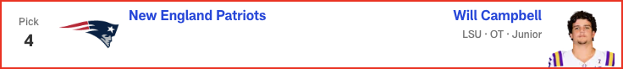

*📝 Analysis: Let's remember that Pete Carroll has doubled down on the quarterback position before, signing veteran Matt Flynn in Seattle before drafting Russell Wilson, who ultimately won the job as a rookie. So just because the Raiders traded for Geno Smith this offseason, it's not unthinkable for them to draft Sanders, who has a relationship with Las Vegas limited partner Tom Brady and wouldn't have to play ...*

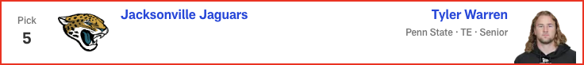

*📝 Analysis: With Justin Fields under center, it would be wise for the Jets to bulk up the ground game. Breece Hall has been OK, but pairing him with a future star in Jeanty would give new offensive coordinator Tanner Engstrand the kind of two-headed monster in the backfield that the assistant coach worked with in Detroit. A potent rushing attack is something that ultimately would fuel Fields' growth as a quar...*

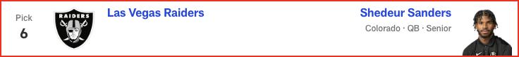

*📝 Analysis: New York could take a quarterback here despite having a trio of veterans on the roster. The team is hosting Shedeur Sanders for a private workout this week, but knowing the Giants' ownership and front office, I'm not sure they'll want to subject themselves to everything that comes with the polarizing prospect out of Colorado. Thus, Sanders' college teammate is the pick. Hunter was a two-way star a...*

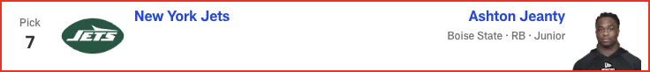

*📝 Analysis: In his third and final mock of the 2025 NFL Draft, Eric Edholm projects FOUR quarterbacks will hear their names called on Thursday night! Plus, running back Ashton Jeanty goes in the top five. See the full first-round projection, 1-32.*



*📝 Analysis: To keep up with the Eagles and Commanders in the NFC East, the Cowboys need some impact players on offense outside of CeeDee Lamb. McMillan possesses the size and elite ball skills to perfectly complement Lamb as a deep-ball weapon in this passing attack.*

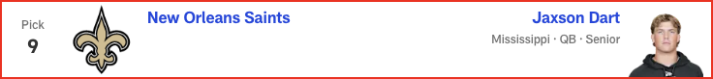

*📝 Analysis: The Dolphins could go a lot of ways here -- especially after the team and Jalen Ramsey mutually agreed to explore trade options for the star corner -- but boosting the pass rush should be Priority No. 1. Walker is at his best when getting after the quarterback and could find success alongside Chop Robinson and a healthy Jaelan Phillips.*

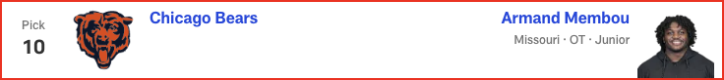

*📝 Analysis: The Colts have a ton of playmakers at receiver and running back, but tight end is the missing piece in the offensive weaponry. Consequently, Indy adds Loveland -- a big-time playmaker who has elite downfield speed and a big catch radius -- to give whoever ends up winning the quarterback competition the best chance to succeed.*

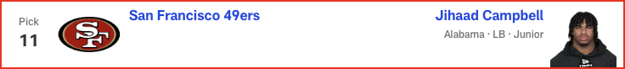

*📝 Analysis: Despite investing a lot of Day 2 draft capital in the defensive line in recent years, Atlanta continually struggles to take down the quarterback. Time to address the issue in Round 1 by scooping up a young, dynamic edge rusher with a Georgia connection.*



*📝 Analysis: Simmons offers good value here as the most athletic offensive lineman in this class. The Ohio State/San Diego State product has the potential to be a Pro Bowl-caliber player, but he's coming off a torn patellar tendon. Arizona could be patient with his recovery, already having veteran tackles Paris Johnson Jr. and Jonah Williams in place.*

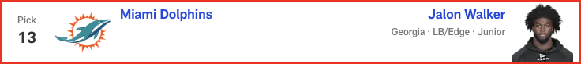

*📝 Analysis: The Bengals couldn't stop anyone last season, so even if reigning NFL sack king Trey Hendrickson ultimately remains in Cincinnati, this defense still needs help. Green is a productive pass rusher, having led the FBS with 17 sacks in 2024. His relentless pursuit of the quarterback and ability to stifle the run would improve a unit that ranked 25th in points and yards allowed last year.*



*📝 Analysis: Sam Darnold is at his best when he can distribute the ball to a great supporting cast. Adding Egbuka to a solid receiving corps could help Darnold replicate his 2024 breakout season in Minnesota. Egbuka plays similarly to Jaxon Smith-Njigba, his former Ohio State teammate who's already flourishing in Seattle.*



*📝 Analysis: Despite not running a pre-draft 40-yard dash, Johnson still feels like a top-10 talent in this class to me. He'd bring some much-needed playmaking ability to the back end of Todd Bowles' defense.*



*📝 Analysis: Outside of the franchises lacking a starting quarterback, Denver might have the biggest need of any team entering the draft. The Broncos have struggled to run the ball under Sean Payton, so they finally solidify the ground game by adding this physical, bell-cow back.*

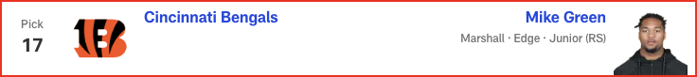

*📝 Analysis: Jaire Alexander is at the forefront of trade discussions in Green Bay -- and he's missed double-digit games in three of the past four seasons. Bottom line: It's time for the Packers to invest in his replacement. Hairston has the skill set to step in as a starting cornerback.*

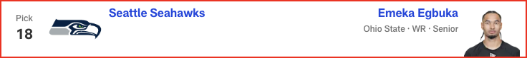

*📝 Analysis: The Vikings brought in a ton of upgrades for Brian Flores' defense last offseason and reaped the benefits in a 14-win campaign. After losing a number of key defensive playmakers in free agency this offseason, Minnesota gets a versatile defender who could play various positions in the secondary but would likely replace the departed Camryn Bynum.*

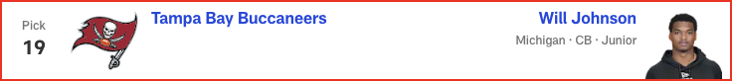

*📝 Analysis: With Round 1 of the 2025 NFL Draft in the books, Eric Edholm projects how Rounds 2 and 3 will play out on Friday night. Where do high-profile prospects like Michigan CB Will Johnson and Colorado QB Shedeur Sanders land? Check out the full Day 2 projection, 33 to 102.*



*📝 Analysis: General manager Brad Holmes isn't one to make the moves people expect, but he has built a great roster in Detroit. So while the Lions have bigger needs in the trenches, they snag Burden in an effort to offset the loss of OC Ben Johnson and maintain their offensive dominance. A standout in the SEC, Burden has a similar playing style to Amon-Ra St. Brown and can work underneath with Jameson Williams...*

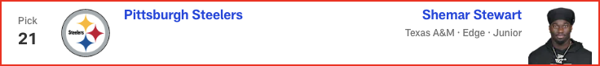

*📝 Analysis: Maybe the most underrated player in this draft class. Tuimoloau joins Dan Quinn's defensive front as a hard-nosed and productive talent. Filling a big need in Washington, JTT -- who registered 6.5 sacks and 11 tackles for loss during Ohio State's four-game playoff run -- could start immediately for the Commanders, whose DE depth chart is littered with NFL journeymen.*

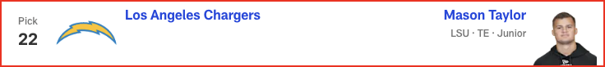

*📝 Analysis: Since drafting Josh Allen seventh overall in 2018, the Bills haven't truly hit on many early-round picks. (Former second-rounder James Cook, who has made the Pro Bowl in each of the last two seasons, is a notable exception.) Grant isn't the most consistent player, but he is talented, athletic and has the potential to be an impact player on Buffalo's defensive front. He'll get to learn and grow beh...*

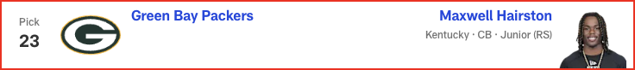

*📝 Analysis: Penalty magnet Jawaan Taylor has been a liability, and I'm not sold on free-agent signing Jaylon Moore curing all of Kansas City's OL ills. Conerly, who had his best game last season against Abdul Carter, has solid technique as a right or left tackle. He'd thrive under Andy Reid, who covets O-linemen with versatility.*

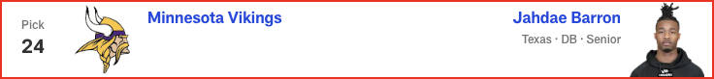

*📝 Analysis: With Josh Sweat departing in free agency and Nolan Smith coming off injury, the Eagles need pass-rush help to replicate their Super Bowl success. Pearce is an explosive player off the edge who can contribute immediately.*

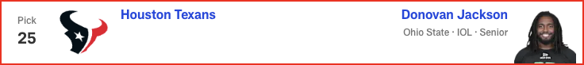

*📝 Analysis: With Round 1 of the 2025 NFL Draft in the books, Eric Edholm projects how Rounds 2 and 3 will play out on Friday night. Where do high-profile prospects like Michigan CB Will Johnson and Colorado QB Shedeur Sanders land? Check out the full Day 2 projection, 33 to 102.*

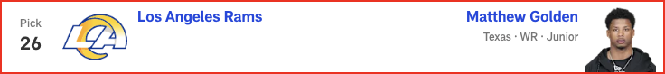

*📝 Analysis: With Round 1 of the 2025 NFL Draft in the books, Eric Edholm projects how Rounds 2 and 3 will play out on Friday night. Where do high-profile prospects like Michigan CB Will Johnson and Colorado QB Shedeur Sanders land? Check out the full Day 2 projection, 33 to 102.*



*📝 Analysis: In his second and final mock of the 2025 NFL Draft, Dan Parr predicts an early run on offensive linemen -- with one guard cracking the top 10! Plus, the 49ers and Eagles land steals on the defensive side of the ball. See the full first-round projection, 1-32.*

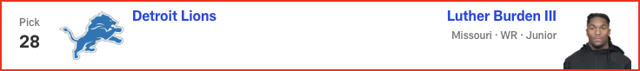

*📝 Analysis: In his final mock of the 2025 NFL Draft, Lance Zierlein has two tight ends coming off the board EARLY. Plus, the New Orleans Saints make a pair of trades and land a new quarterback. Check out the full first-round projection, 1-32.*

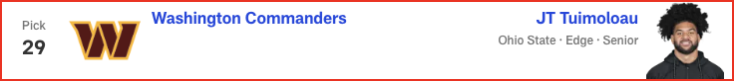

*📝 Analysis: In his fourth and final mock of the 2025 NFL Draft, Daniel Jeremiah predicts two teams will trade up for help on offense, including one squad that makes a move for a quarterback. See his full first-round projection, 1-32.*



*📝 Analysis: In his final mock of the 2025 NFL Draft, Charles Davis projects only one quarterback coming off the board in Round 1. Plus, the Super Bowl champion Eagles select a tight end. Check out the full first-round projection, 1-32.*

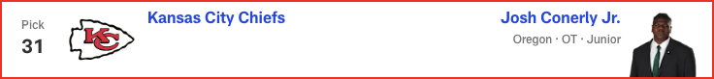

*📝 Analysis: In his fourth and final mock of the 2025 NFL Draft, Bucky Brooks has the Pittsburgh Steelers drafting their quarterback of the future. Plus, the Cowboys and Broncos add backfield help. Check out the full first-round forecast, 1-32.*

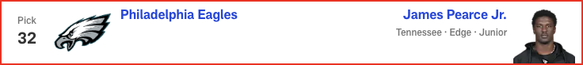

*📝 Analysis: In his third and final mock of the 2025 NFL Draft, Eric Edholm projects FOUR quarterbacks will hear their names called on Thursday night! Plus, running back Ashton Jeanty goes in the top five. See the full first-round projection, 1-32.*