NFL.com 2025 Mock Draft Screenshots

Complete NFL.com Mock Drafts - June 08, 2025

📊 7 Authors • 231 Screenshots • Top 32 Picks Each • Expert Analysis Included

# Bucky Brooks - 2025 Mock Draft

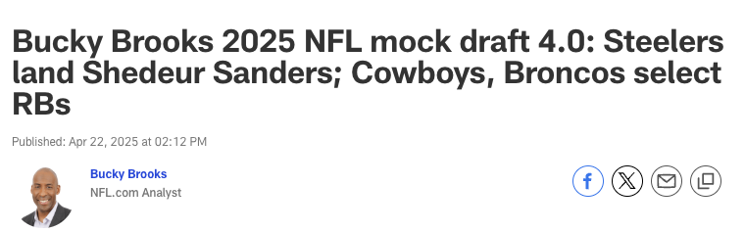

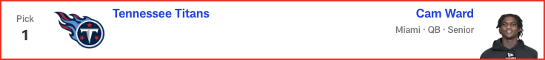

*📝 Analysis: As the Titans’ new franchise QB1, Ward would add the kind of talent, toughness and tenacity the franchise has lacked since Steve “Air” McNair was under center in Tennessee.*

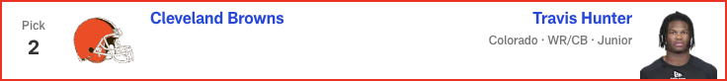

*📝 Analysis: The two-way standout is a superstar in the making as a big-play pass catcher and shutdown corner. Hunter’s unique skills would give Kevin Stefanski a Shohei Ohtani-esque weapon to utilize on offense and defense.*

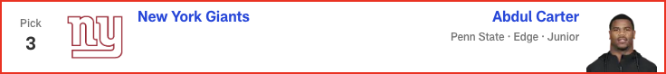

*📝 Analysis: Bypassing a chance to land a potential franchise quarterback is risky, but the Giants could take a disruptive playmaker to enhance a pass rush that features three quarterback hunters (Brian Burns, Dexter Lawrence and Kayvon Thibodeaux) on the front line.*



*📝 Analysis: Protecting Drake Maye is a top priority for a front office that wants to see the franchise quarterback flourish in Year 2.*

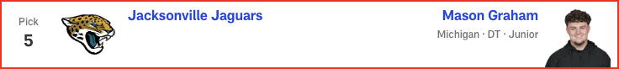

*📝 Analysis: The safest pick in the draft would give the Jaguars a blue-chip defender in the middle of a defensive line that needs more “hard hat and lunch pail” guys.*

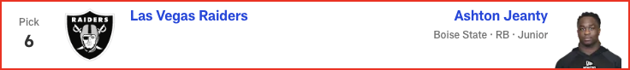

*📝 Analysis: Stewart still needs some development, but he's athletic and could generate strong sack numbers, especially if Trey Hendrickson sticks around, setting the rookie up to feed off the veteran's presence.*

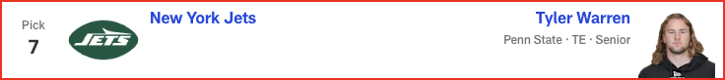

*📝 Analysis: After trading away DK Metcalf and releasing Tyler Lockett this offseason, the Seahawks could add a big-bodied pass-catcher to occupy the role of red-zone weapon.*

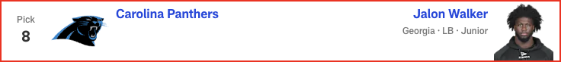

*📝 Analysis: Sean Payton wants a feature back with big-play potential in the rotation. Henderson’s speed and explosiveness could give the Super Bowl-winning coach Alvin Kamara vibes when he's contemplating how to utilize the Ohio State standout.*

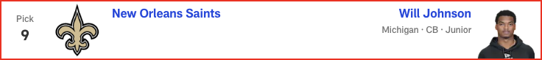

*📝 Analysis: Mike Tomlin could view Sanders as the perfect quarterback for his squad. With his confidence, moxie and pinpoint passing skills, the Colorado star might ignite a dormant offense that has already added some star power this offseason.*

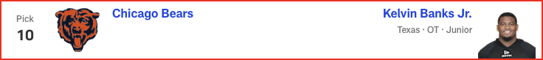

*📝 Analysis: Emmanwori can learn from Harrison Smith, who has been in the Vikings' backfield for 13 seasons, before sliding in as the next potential fixture at safety in Minnesota.*

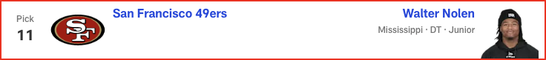

*📝 Analysis: What do the Commanders do to help Jayden Daniels take another step forward? Use a first-round pick on Golden, who led Texas in both receiving yards (987) and scoring grabs (nine) last season.*

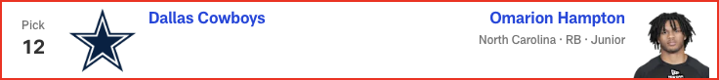

*📝 Analysis: Buffalo's depth chart features plenty of pass-rushing talent; the 6-foot-4, 331-pound Grant's presence up front could help shore up a run defense that ranked 19th in the NFL in yards allowed per rush attempt in 2024.*

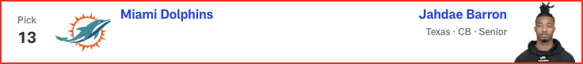

*📝 Analysis: The relentless, energetic Ezeiruaku knows how to harass the passer, based on his 16.5 sacks (second-most in the FBS) last season. He's an ideal match for the Eagles.*

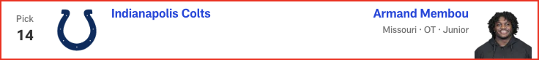

*📝 Analysis: With Round 1 of the 2025 NFL Draft in the books, Eric Edholm projects how Rounds 2 and 3 will play out on Friday night. Where do high-profile prospects like Michigan CB Will Johnson and Colorado QB Shedeur Sanders land? Check out the full Day 2 projection, 33 to 102.*

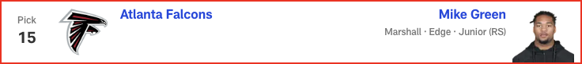

*📝 Analysis: In his second and final mock of the 2025 NFL Draft, Dan Parr predicts an early run on offensive linemen -- with one guard cracking the top 10! Plus, the 49ers and Eagles land steals on the defensive side of the ball. See the full first-round projection, 1-32.*

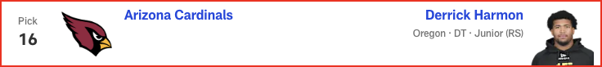

*📝 Analysis: In his final mock of the 2025 NFL Draft, Lance Zierlein has two tight ends coming off the board EARLY. Plus, the New Orleans Saints make a pair of trades and land a new quarterback. Check out the full first-round projection, 1-32.*

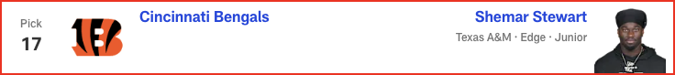

*📝 Analysis: In his final mock of the 2025 NFL Draft, Lance Zierlein has two tight ends coming off the board EARLY. Plus, the New Orleans Saints make a pair of trades and land a new quarterback. Check out the full first-round projection, 1-32.*

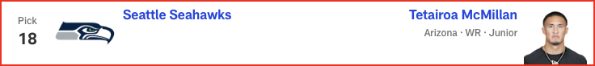

*📝 Analysis: In his final mock of the 2025 NFL Draft, Lance Zierlein has two tight ends coming off the board EARLY. Plus, the New Orleans Saints make a pair of trades and land a new quarterback. Check out the full first-round projection, 1-32.*

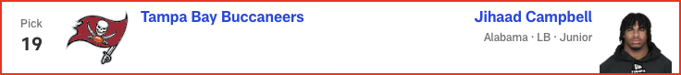

*📝 Analysis: In his final mock of the 2025 NFL Draft, Lance Zierlein has two tight ends coming off the board EARLY. Plus, the New Orleans Saints make a pair of trades and land a new quarterback. Check out the full first-round projection, 1-32.*

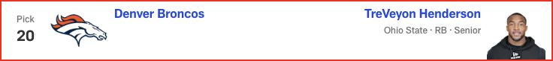

*📝 Analysis: In his final mock of the 2025 NFL Draft, Lance Zierlein has two tight ends coming off the board EARLY. Plus, the New Orleans Saints make a pair of trades and land a new quarterback. Check out the full first-round projection, 1-32.*

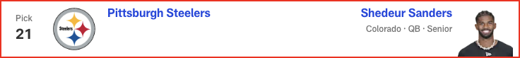

*📝 Analysis: In his final mock of the 2025 NFL Draft, Lance Zierlein has two tight ends coming off the board EARLY. Plus, the New Orleans Saints make a pair of trades and land a new quarterback. Check out the full first-round projection, 1-32.*

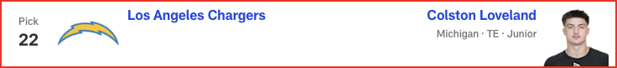

*📝 Analysis: In his final mock of the 2025 NFL Draft, Lance Zierlein has two tight ends coming off the board EARLY. Plus, the New Orleans Saints make a pair of trades and land a new quarterback. Check out the full first-round projection, 1-32.*

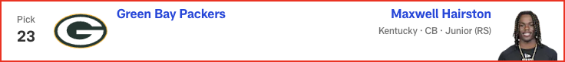

*📝 Analysis: In his final mock of the 2025 NFL Draft, Lance Zierlein has two tight ends coming off the board EARLY. Plus, the New Orleans Saints make a pair of trades and land a new quarterback. Check out the full first-round projection, 1-32.*

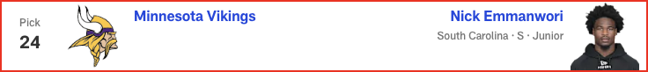

*📝 Analysis: In his final mock of the 2025 NFL Draft, Lance Zierlein has two tight ends coming off the board EARLY. Plus, the New Orleans Saints make a pair of trades and land a new quarterback. Check out the full first-round projection, 1-32.*

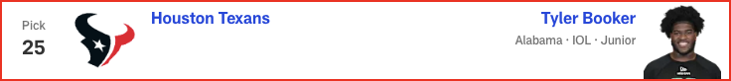

*📝 Analysis: In his final mock of the 2025 NFL Draft, Lance Zierlein has two tight ends coming off the board EARLY. Plus, the New Orleans Saints make a pair of trades and land a new quarterback. Check out the full first-round projection, 1-32.*

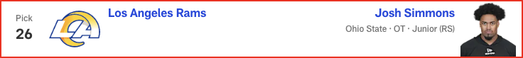

*📝 Analysis: In his final mock of the 2025 NFL Draft, Lance Zierlein has two tight ends coming off the board EARLY. Plus, the New Orleans Saints make a pair of trades and land a new quarterback. Check out the full first-round projection, 1-32.*

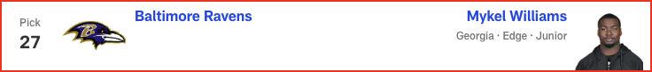

*📝 Analysis: In his final mock of the 2025 NFL Draft, Lance Zierlein has two tight ends coming off the board EARLY. Plus, the New Orleans Saints make a pair of trades and land a new quarterback. Check out the full first-round projection, 1-32.*

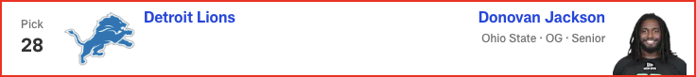

*📝 Analysis: In his final mock of the 2025 NFL Draft, Lance Zierlein has two tight ends coming off the board EARLY. Plus, the New Orleans Saints make a pair of trades and land a new quarterback. Check out the full first-round projection, 1-32.*

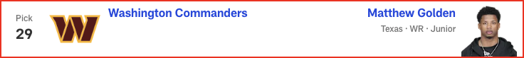

*📝 Analysis: In his final mock of the 2025 NFL Draft, Lance Zierlein has two tight ends coming off the board EARLY. Plus, the New Orleans Saints make a pair of trades and land a new quarterback. Check out the full first-round projection, 1-32.*

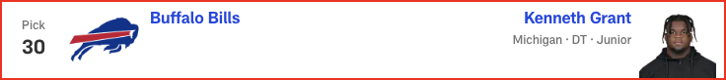

*📝 Analysis: In his final mock of the 2025 NFL Draft, Lance Zierlein has two tight ends coming off the board EARLY. Plus, the New Orleans Saints make a pair of trades and land a new quarterback. Check out the full first-round projection, 1-32.*

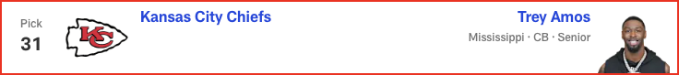

*📝 Analysis: In his final mock of the 2025 NFL Draft, Lance Zierlein has two tight ends coming off the board EARLY. Plus, the New Orleans Saints make a pair of trades and land a new quarterback. Check out the full first-round projection, 1-32.*

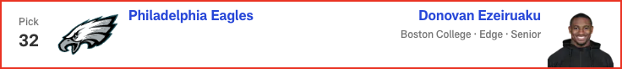

*📝 Analysis: In his first and only seven-round mock of the 2025 NFL Draft, Chad Reuter predicts a wide receiver run to start Round 4, with the Steelers finding a new quarterback later in the round.*

# Daniel Jeremiah - 2025 Mock Draft

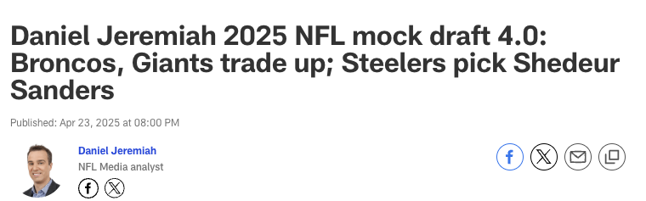

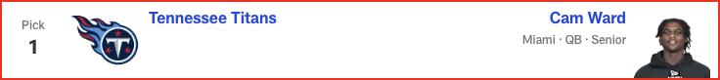

*📝 Analysis: There’s been chatter about the Giants potentially trading out of this pick, but if they stay put, I think they address the defensive line. Carter could take their front from good to great.*



*📝 Analysis: Based on everything I’ve heard from talking to people around the league, the expectation is the Jaguars will pick either Jeanty or Arizona WR Tetairoa McMillan here. I’ll go with the higher-rated player on my board.*

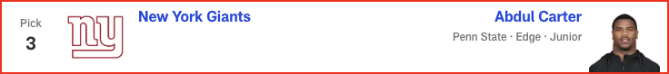

*📝 Analysis: There’s been chatter about the Giants potentially trading out of this pick, but if they stay put, I think they address the defensive line. Carter could take their front from good to great.*



*📝 Analysis: With the top offensive linemen and Jeanty off the board, Warren becomes a very attractive piece for Ben Johnson’s offense. The Bears will be living in 12 personnel with Warren, Cole Kmet, DJ Moore and Rome Odunze on the field. That’s a group to be excited about.*

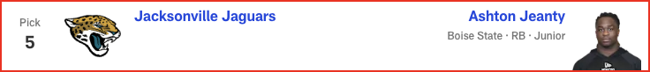

*📝 Analysis: Based on everything I’ve heard from talking to people around the league, the expectation is the Jaguars will pick either Jeanty or Arizona WR Tetairoa McMillan here. I’ll go with the higher-rated player on my board.*

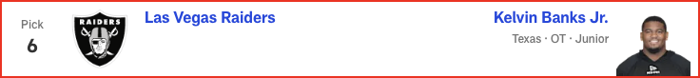

*📝 Analysis: Colts GM Chris Ballard has always placed a premium on athletic traits, and Stewart offers those in a big way. This feels very similar to the selection of Kwity Paye when he was coming out of college in 2021. Indianapolis drafts an edge rusher in the first round for the second year in a row (Laiatu Latu in 2024) after losing Dayo Odeyingbo in free agency.*

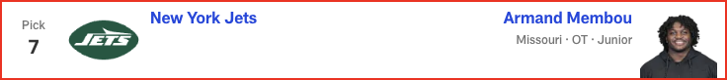

*📝 Analysis: Arizona reunites Egbuka with Ohio State teammate Marvin Harrison Jr. to give Kyler Murray a dynamic tandem at receiver. Egbuka fills a need, and he can help bring the best out of Harrison.*

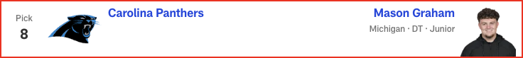

*📝 Analysis: It would not be a surprise to see Alabama LB Jihaad Campbell go to Tampa Bay at No. 19, but with Mike Evans heading into his 12th season, the Bucs opt to add another pass catcher. Golden would team up with 2024 third-round pick Jalen McMillan to give them two good, young wideouts to complement veterans Evans and Chris Godwin.*

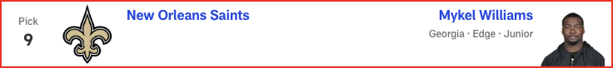

*📝 Analysis: The Packers love SEC defensive players, and Hairston can really run. He battled through injury in 2024, but his 2023 tape is exceptional. With Jaire Alexander potentially on the move, Green Bay adds help at cornerback.*

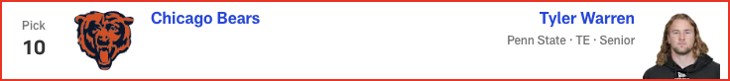

*📝 Analysis: The Lions have done a lot of homework on interior offensive linemen in this draft class. Jackson has been a riser throughout the evaluation process and would be the replacement for Kevin Zeitler. Jackson might not even make it to this pick, though.*

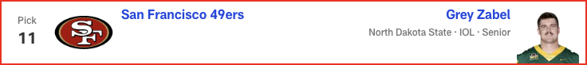

*📝 Analysis: The rules are simple with the Eagles: They take the best Alabama or Georgia player who falls into their lap. Campbell is my No. 12 player in the draft, so he would be a tremendous value at the end of Round 1. If not for the shoulder surgery he’s recovering from, he'd be a lock to go much higher.*

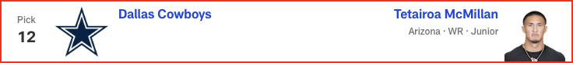

*📝 Analysis: With Round 1 of the 2025 NFL Draft in the books, Eric Edholm projects how Rounds 2 and 3 will play out on Friday night. Where do high-profile prospects like Michigan CB Will Johnson and Colorado QB Shedeur Sanders land? Check out the full Day 2 projection, 33 to 102.*

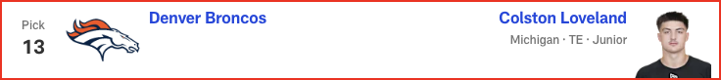

*📝 Analysis: In his second and final mock of the 2025 NFL Draft, Dan Parr predicts an early run on offensive linemen -- with one guard cracking the top 10! Plus, the 49ers and Eagles land steals on the defensive side of the ball. See the full first-round projection, 1-32.*

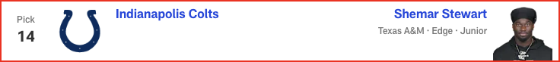

*📝 Analysis: In his final mock of the 2025 NFL Draft, Lance Zierlein has two tight ends coming off the board EARLY. Plus, the New Orleans Saints make a pair of trades and land a new quarterback. Check out the full first-round projection, 1-32.*

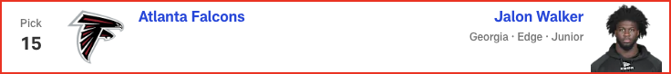

*📝 Analysis: In his final mock of the 2025 NFL Draft, Lance Zierlein has two tight ends coming off the board EARLY. Plus, the New Orleans Saints make a pair of trades and land a new quarterback. Check out the full first-round projection, 1-32.*

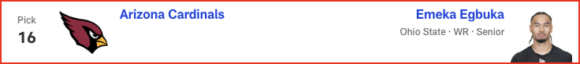

*📝 Analysis: In his final mock of the 2025 NFL Draft, Lance Zierlein has two tight ends coming off the board EARLY. Plus, the New Orleans Saints make a pair of trades and land a new quarterback. Check out the full first-round projection, 1-32.*

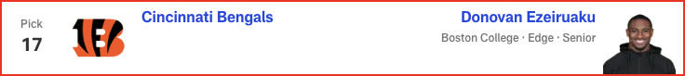

*📝 Analysis: In his final mock of the 2025 NFL Draft, Lance Zierlein has two tight ends coming off the board EARLY. Plus, the New Orleans Saints make a pair of trades and land a new quarterback. Check out the full first-round projection, 1-32.*

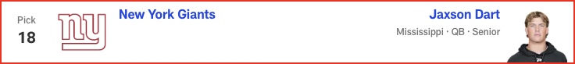

*📝 Analysis: In his final mock of the 2025 NFL Draft, Lance Zierlein has two tight ends coming off the board EARLY. Plus, the New Orleans Saints make a pair of trades and land a new quarterback. Check out the full first-round projection, 1-32.*

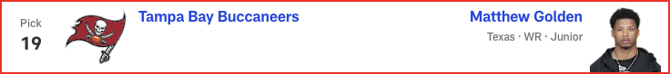

*📝 Analysis: In his final mock of the 2025 NFL Draft, Lance Zierlein has two tight ends coming off the board EARLY. Plus, the New Orleans Saints make a pair of trades and land a new quarterback. Check out the full first-round projection, 1-32.*



*📝 Analysis: In his final mock of the 2025 NFL Draft, Lance Zierlein has two tight ends coming off the board EARLY. Plus, the New Orleans Saints make a pair of trades and land a new quarterback. Check out the full first-round projection, 1-32.*

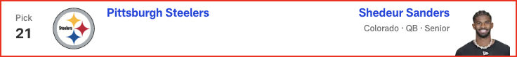

*📝 Analysis: In his final mock of the 2025 NFL Draft, Lance Zierlein has two tight ends coming off the board EARLY. Plus, the New Orleans Saints make a pair of trades and land a new quarterback. Check out the full first-round projection, 1-32.*

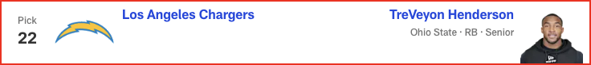

*📝 Analysis: In his final mock of the 2025 NFL Draft, Lance Zierlein has two tight ends coming off the board EARLY. Plus, the New Orleans Saints make a pair of trades and land a new quarterback. Check out the full first-round projection, 1-32.*



*📝 Analysis: In his final mock of the 2025 NFL Draft, Lance Zierlein has two tight ends coming off the board EARLY. Plus, the New Orleans Saints make a pair of trades and land a new quarterback. Check out the full first-round projection, 1-32.*

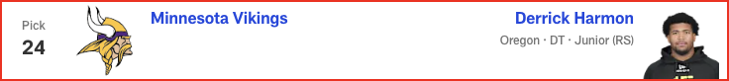

*📝 Analysis: In his final mock of the 2025 NFL Draft, Lance Zierlein has two tight ends coming off the board EARLY. Plus, the New Orleans Saints make a pair of trades and land a new quarterback. Check out the full first-round projection, 1-32.*

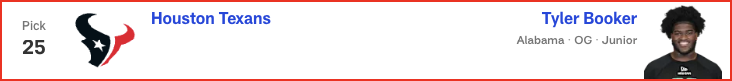

*📝 Analysis: In his final mock of the 2025 NFL Draft, Lance Zierlein has two tight ends coming off the board EARLY. Plus, the New Orleans Saints make a pair of trades and land a new quarterback. Check out the full first-round projection, 1-32.*

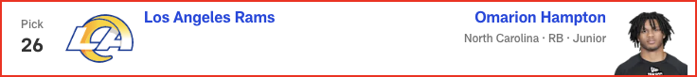

*📝 Analysis: In his final mock of the 2025 NFL Draft, Lance Zierlein has two tight ends coming off the board EARLY. Plus, the New Orleans Saints make a pair of trades and land a new quarterback. Check out the full first-round projection, 1-32.*

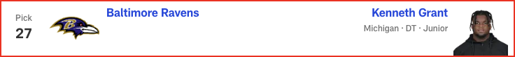

*📝 Analysis: In his final mock of the 2025 NFL Draft, Lance Zierlein has two tight ends coming off the board EARLY. Plus, the New Orleans Saints make a pair of trades and land a new quarterback. Check out the full first-round projection, 1-32.*



*📝 Analysis: In his final mock of the 2025 NFL Draft, Lance Zierlein has two tight ends coming off the board EARLY. Plus, the New Orleans Saints make a pair of trades and land a new quarterback. Check out the full first-round projection, 1-32.*

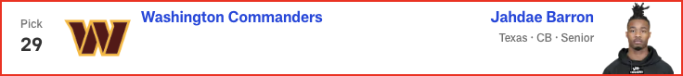

*📝 Analysis: In his final mock of the 2025 NFL Draft, Lance Zierlein has two tight ends coming off the board EARLY. Plus, the New Orleans Saints make a pair of trades and land a new quarterback. Check out the full first-round projection, 1-32.*

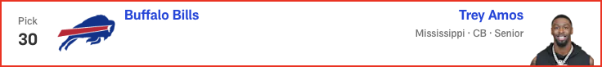

*📝 Analysis: In his final mock of the 2025 NFL Draft, Lance Zierlein has two tight ends coming off the board EARLY. Plus, the New Orleans Saints make a pair of trades and land a new quarterback. Check out the full first-round projection, 1-32.*

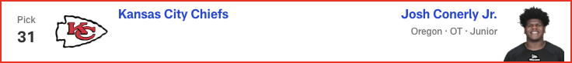

*📝 Analysis: In his final mock of the 2025 NFL Draft, Lance Zierlein has two tight ends coming off the board EARLY. Plus, the New Orleans Saints make a pair of trades and land a new quarterback. Check out the full first-round projection, 1-32.*

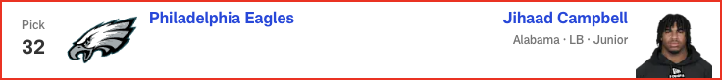

*📝 Analysis: In his first and only seven-round mock of the 2025 NFL Draft, Chad Reuter predicts a wide receiver run to start Round 4, with the Steelers finding a new quarterback later in the round.*

# Charles Davis - 2025 Mock Draft

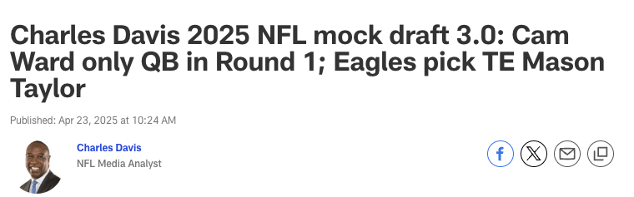



*📝 Analysis: Quarterback will be a strong consideration here, but the Browns opt for the Heisman Trophy winner. Hunter is the best player in the draft. Cleveland will begin by using him mainly on offense as the team’s WR1 -- and yes, he will play some defense, too.*

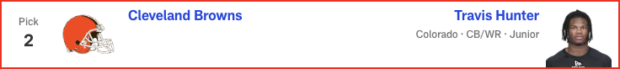

*📝 Analysis: Quarterback will be a strong consideration here, but the Browns opt for the Heisman Trophy winner. Hunter is the best player in the draft. Cleveland will begin by using him mainly on offense as the team’s WR1 -- and yes, he will play some defense, too.*

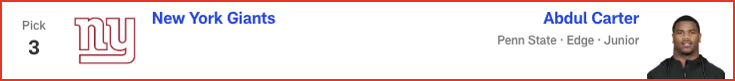

*📝 Analysis: Could this be the spot for Shedeur Sanders? After weighing their options, the Giants take an elite edge rusher to pump up the defense.*



*📝 Analysis: This could easily be where QB Shedeur Sanders goes. I’ve already said I would be pounding the table for him in the draft room. Instead, though, the Saints tap Membou to take over at right tackle.*



*📝 Analysis: OK, this is where we hear the surprised roar. New head coach Liam Coen gets an elite weapon to help him unlock all of QB Trevor Lawrence's potential.*

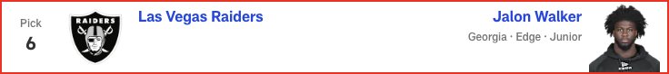

*📝 Analysis: When the Bengals were playing their best on defense in recent years, they were strong down the middle. Starks is a sideline-to-sideline playmaker from center field.*



*📝 Analysis: This do-it-all defensive back will fit perfectly in head coach Mike Macdonald's schemes. Barron will allow big-play DB Devon Witherspoon to attack offenses with even more gusto.*



*📝 Analysis: Chargers GM Joe Hortiz and head coach Jim Harbaugh covet great players, and it doesn’t hurt that Harbaugh already knows Loveland quite well from their time together at Michigan. Another Wolverine heads west and helps QB Justin Herbert move to a higher echelon.*

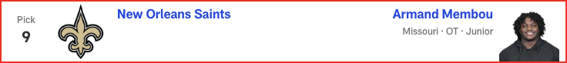

*📝 Analysis: It would not be a surprise to see Washington select a cornerback here -- Notre Dame’s Benjamin Morrison is my favorite CB in the draft -- but in this case, the Commanders fortify the offensive line with Banks, who can compete for the starting job at right tackle as a rookie.*

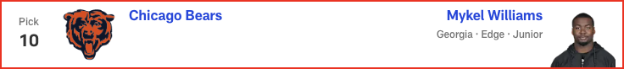

*📝 Analysis: Super Bowl LIX aside, Kansas City’s defense has been an absolute force in recent seasons. GM Brett Veach continues to give DC Steve Spagnuolo great resources.*

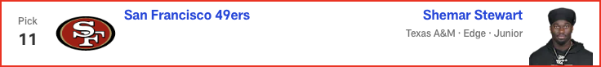

*📝 Analysis: With Round 1 of the 2025 NFL Draft in the books, Eric Edholm projects how Rounds 2 and 3 will play out on Friday night. Where do high-profile prospects like Michigan CB Will Johnson and Colorado QB Shedeur Sanders land? Check out the full Day 2 projection, 33 to 102.*

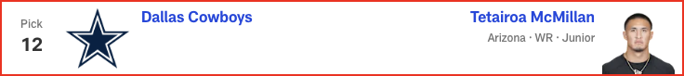

*📝 Analysis: In his second and final mock of the 2025 NFL Draft, Dan Parr predicts an early run on offensive linemen -- with one guard cracking the top 10! Plus, the 49ers and Eagles land steals on the defensive side of the ball. See the full first-round projection, 1-32.*

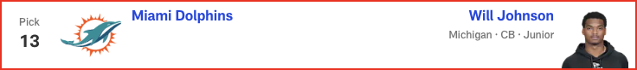

*📝 Analysis: In his final mock of the 2025 NFL Draft, Lance Zierlein has two tight ends coming off the board EARLY. Plus, the New Orleans Saints make a pair of trades and land a new quarterback. Check out the full first-round projection, 1-32.*

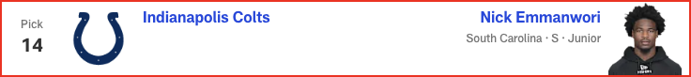

*📝 Analysis: In his final mock of the 2025 NFL Draft, Lance Zierlein has two tight ends coming off the board EARLY. Plus, the New Orleans Saints make a pair of trades and land a new quarterback. Check out the full first-round projection, 1-32.*

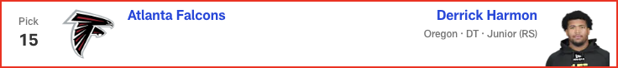

*📝 Analysis: In his final mock of the 2025 NFL Draft, Lance Zierlein has two tight ends coming off the board EARLY. Plus, the New Orleans Saints make a pair of trades and land a new quarterback. Check out the full first-round projection, 1-32.*

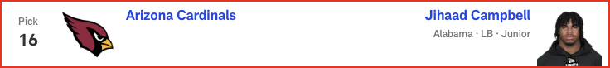

*📝 Analysis: In his final mock of the 2025 NFL Draft, Lance Zierlein has two tight ends coming off the board EARLY. Plus, the New Orleans Saints make a pair of trades and land a new quarterback. Check out the full first-round projection, 1-32.*

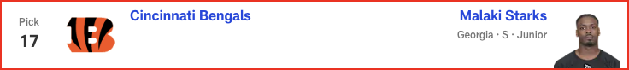

*📝 Analysis: In his final mock of the 2025 NFL Draft, Lance Zierlein has two tight ends coming off the board EARLY. Plus, the New Orleans Saints make a pair of trades and land a new quarterback. Check out the full first-round projection, 1-32.*

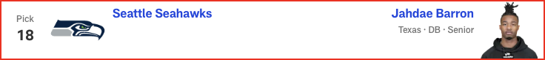

*📝 Analysis: In his final mock of the 2025 NFL Draft, Lance Zierlein has two tight ends coming off the board EARLY. Plus, the New Orleans Saints make a pair of trades and land a new quarterback. Check out the full first-round projection, 1-32.*

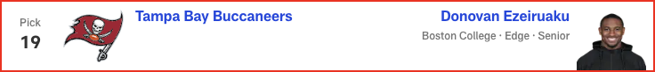

*📝 Analysis: In his final mock of the 2025 NFL Draft, Lance Zierlein has two tight ends coming off the board EARLY. Plus, the New Orleans Saints make a pair of trades and land a new quarterback. Check out the full first-round projection, 1-32.*

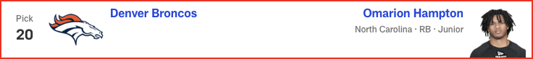

*📝 Analysis: In his final mock of the 2025 NFL Draft, Lance Zierlein has two tight ends coming off the board EARLY. Plus, the New Orleans Saints make a pair of trades and land a new quarterback. Check out the full first-round projection, 1-32.*

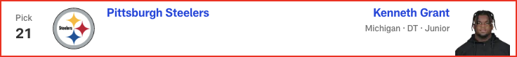

*📝 Analysis: In his final mock of the 2025 NFL Draft, Lance Zierlein has two tight ends coming off the board EARLY. Plus, the New Orleans Saints make a pair of trades and land a new quarterback. Check out the full first-round projection, 1-32.*

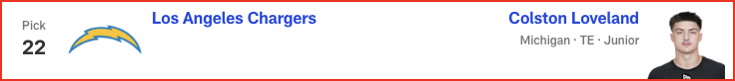

*📝 Analysis: In his final mock of the 2025 NFL Draft, Lance Zierlein has two tight ends coming off the board EARLY. Plus, the New Orleans Saints make a pair of trades and land a new quarterback. Check out the full first-round projection, 1-32.*

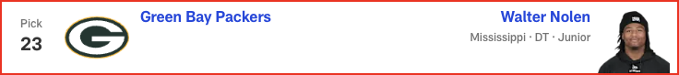

*📝 Analysis: In his final mock of the 2025 NFL Draft, Lance Zierlein has two tight ends coming off the board EARLY. Plus, the New Orleans Saints make a pair of trades and land a new quarterback. Check out the full first-round projection, 1-32.*

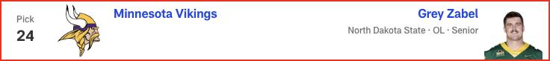

*📝 Analysis: In his final mock of the 2025 NFL Draft, Lance Zierlein has two tight ends coming off the board EARLY. Plus, the New Orleans Saints make a pair of trades and land a new quarterback. Check out the full first-round projection, 1-32.*

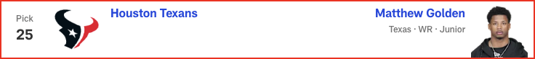

*📝 Analysis: In his final mock of the 2025 NFL Draft, Lance Zierlein has two tight ends coming off the board EARLY. Plus, the New Orleans Saints make a pair of trades and land a new quarterback. Check out the full first-round projection, 1-32.*

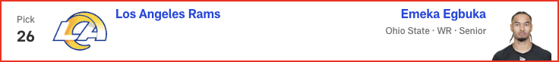

*📝 Analysis: In his final mock of the 2025 NFL Draft, Lance Zierlein has two tight ends coming off the board EARLY. Plus, the New Orleans Saints make a pair of trades and land a new quarterback. Check out the full first-round projection, 1-32.*

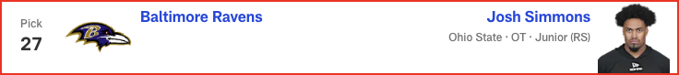

*📝 Analysis: In his final mock of the 2025 NFL Draft, Lance Zierlein has two tight ends coming off the board EARLY. Plus, the New Orleans Saints make a pair of trades and land a new quarterback. Check out the full first-round projection, 1-32.*

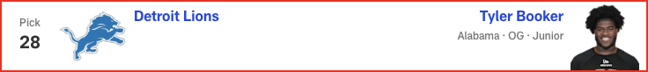

*📝 Analysis: In his final mock of the 2025 NFL Draft, Lance Zierlein has two tight ends coming off the board EARLY. Plus, the New Orleans Saints make a pair of trades and land a new quarterback. Check out the full first-round projection, 1-32.*

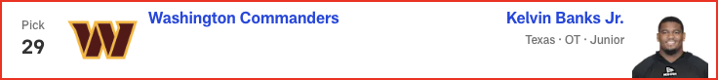

*📝 Analysis: In his final mock of the 2025 NFL Draft, Lance Zierlein has two tight ends coming off the board EARLY. Plus, the New Orleans Saints make a pair of trades and land a new quarterback. Check out the full first-round projection, 1-32.*

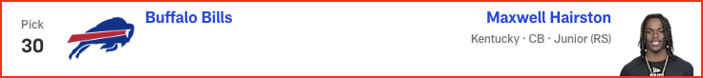

*📝 Analysis: In his final mock of the 2025 NFL Draft, Lance Zierlein has two tight ends coming off the board EARLY. Plus, the New Orleans Saints make a pair of trades and land a new quarterback. Check out the full first-round projection, 1-32.*

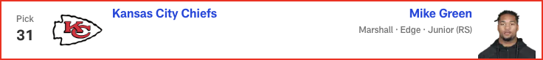

*📝 Analysis: In his final mock of the 2025 NFL Draft, Lance Zierlein has two tight ends coming off the board EARLY. Plus, the New Orleans Saints make a pair of trades and land a new quarterback. Check out the full first-round projection, 1-32.*

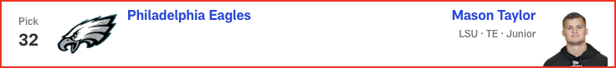

*📝 Analysis: In his first and only seven-round mock of the 2025 NFL Draft, Chad Reuter predicts a wide receiver run to start Round 4, with the Steelers finding a new quarterback later in the round.*

# Eric Edholm - 2025 Mock Draft

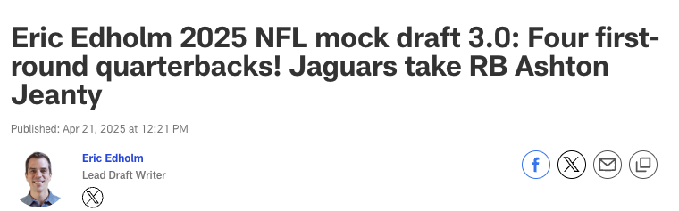

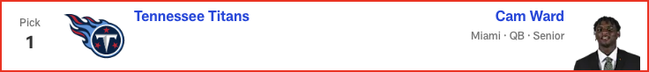

*📝 Analysis: The Giants still have a decision to make on Kayvon Thibodeaux's fifth-year option. Carter, my No. 1 overall prospect in this draft class, could be an absolute monster in time.*

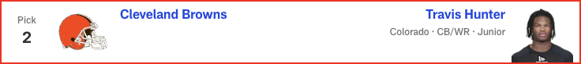

*📝 Analysis: Mike Vrabel knows he needs to protect Drake Maye, but the Patriots also need leaders and reliable building blocks. Campbell fills all of those voids.*



*📝 Analysis: The Giants still have a decision to make on Kayvon Thibodeaux's fifth-year option. Carter, my No. 1 overall prospect in this draft class, could be an absolute monster in time.*

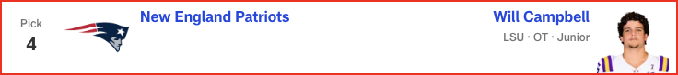

*📝 Analysis: Mike Vrabel knows he needs to protect Drake Maye, but the Patriots also need leaders and reliable building blocks. Campbell fills all of those voids.*



*📝 Analysis: When healthy last season, Loveland was a godsend for a Michigan team that struggled badly at QB. Daniel Jones and Anthony Richardson are battling for the Colts' starting job. Loveland is here to help -- once he's cleared for contact following shoulder surgery.*

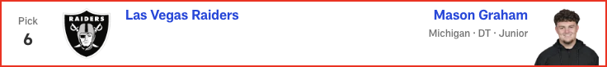

*📝 Analysis: The interior of Seattle's offensive line needs immediate help, and it was between Booker and North Dakota State's Grey Zabel here. Booker lacks Zabel's versatility, but the Alabama product can be a slobberknocker right away in the run game. There still should be a solid receiver available at 50 or 52.*



*📝 Analysis: The Broncos quietly are creeping up on the NFL's big boys, and adding a three-down lead back speeds up that development. Hampton could be a big producer in Sean Payton's offense.*



*📝 Analysis: Sure, the school connection helps for scouting purposes, but Grant really does fill the Chargers' nose tackle needs well. He'd step right into the Poona Ford-sized hole up front.*

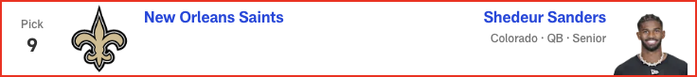

*📝 Analysis: The Rams were infatuated with Brock Bowers in last year's draft, so LSU TE Mason Taylor wouldn't shock me here. But Emmanwori could be a box safety/linebacker, adding another playmaker for this defense.*



*📝 Analysis: Maxwell Hairston's speed might be tempting, but Amos just feels like a better fit in Buffalo as a tackler, zone defender and general irritant with his size and play style. This secondary needs more length and skill.*



*📝 Analysis: Left tackle was such an issue last season, and the Chiefs can't assume free-agent addition Jaylon Moore will dominate and stay healthy. Simmons would be a smart value pick who can be brought along gradually.*



*📝 Analysis: With Round 1 of the 2025 NFL Draft in the books, Eric Edholm projects how Rounds 2 and 3 will play out on Friday night. Where do high-profile prospects like Michigan CB Will Johnson and Colorado QB Shedeur Sanders land? Check out the full Day 2 projection, 33 to 102.*



*📝 Analysis: With Round 1 of the 2025 NFL Draft in the books, Eric Edholm projects how Rounds 2 and 3 will play out on Friday night. Where do high-profile prospects like Michigan CB Will Johnson and Colorado QB Shedeur Sanders land? Check out the full Day 2 projection, 33 to 102.*

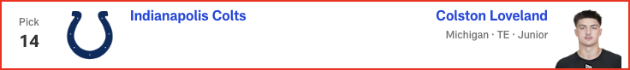

*📝 Analysis: In his second and final mock of the 2025 NFL Draft, Dan Parr predicts an early run on offensive linemen -- with one guard cracking the top 10! Plus, the 49ers and Eagles land steals on the defensive side of the ball. See the full first-round projection, 1-32.*



*📝 Analysis: In his final mock of the 2025 NFL Draft, Lance Zierlein has two tight ends coming off the board EARLY. Plus, the New Orleans Saints make a pair of trades and land a new quarterback. Check out the full first-round projection, 1-32.*

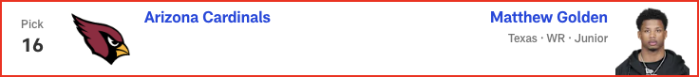

*📝 Analysis: In his final mock of the 2025 NFL Draft, Lance Zierlein has two tight ends coming off the board EARLY. Plus, the New Orleans Saints make a pair of trades and land a new quarterback. Check out the full first-round projection, 1-32.*

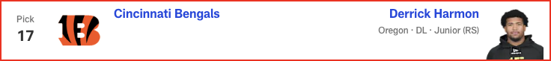

*📝 Analysis: In his final mock of the 2025 NFL Draft, Lance Zierlein has two tight ends coming off the board EARLY. Plus, the New Orleans Saints make a pair of trades and land a new quarterback. Check out the full first-round projection, 1-32.*

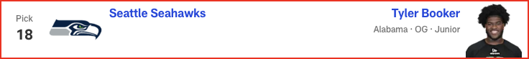

*📝 Analysis: In his final mock of the 2025 NFL Draft, Lance Zierlein has two tight ends coming off the board EARLY. Plus, the New Orleans Saints make a pair of trades and land a new quarterback. Check out the full first-round projection, 1-32.*

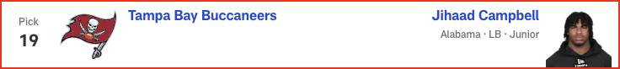

*📝 Analysis: In his final mock of the 2025 NFL Draft, Lance Zierlein has two tight ends coming off the board EARLY. Plus, the New Orleans Saints make a pair of trades and land a new quarterback. Check out the full first-round projection, 1-32.*

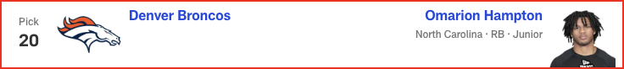

*📝 Analysis: In his final mock of the 2025 NFL Draft, Lance Zierlein has two tight ends coming off the board EARLY. Plus, the New Orleans Saints make a pair of trades and land a new quarterback. Check out the full first-round projection, 1-32.*

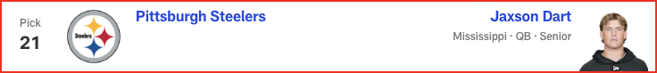

*📝 Analysis: In his final mock of the 2025 NFL Draft, Lance Zierlein has two tight ends coming off the board EARLY. Plus, the New Orleans Saints make a pair of trades and land a new quarterback. Check out the full first-round projection, 1-32.*

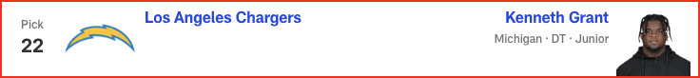

*📝 Analysis: In his final mock of the 2025 NFL Draft, Lance Zierlein has two tight ends coming off the board EARLY. Plus, the New Orleans Saints make a pair of trades and land a new quarterback. Check out the full first-round projection, 1-32.*

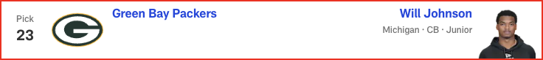

*📝 Analysis: In his final mock of the 2025 NFL Draft, Lance Zierlein has two tight ends coming off the board EARLY. Plus, the New Orleans Saints make a pair of trades and land a new quarterback. Check out the full first-round projection, 1-32.*

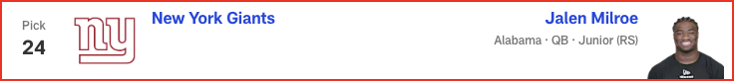

*📝 Analysis: In his final mock of the 2025 NFL Draft, Lance Zierlein has two tight ends coming off the board EARLY. Plus, the New Orleans Saints make a pair of trades and land a new quarterback. Check out the full first-round projection, 1-32.*

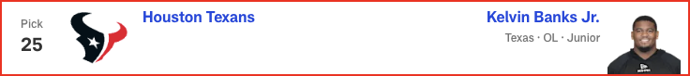

*📝 Analysis: In his final mock of the 2025 NFL Draft, Lance Zierlein has two tight ends coming off the board EARLY. Plus, the New Orleans Saints make a pair of trades and land a new quarterback. Check out the full first-round projection, 1-32.*

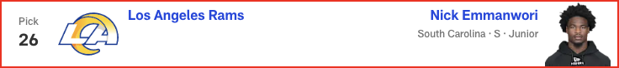

*📝 Analysis: In his final mock of the 2025 NFL Draft, Lance Zierlein has two tight ends coming off the board EARLY. Plus, the New Orleans Saints make a pair of trades and land a new quarterback. Check out the full first-round projection, 1-32.*

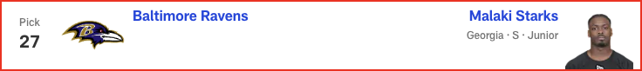

*📝 Analysis: In his final mock of the 2025 NFL Draft, Lance Zierlein has two tight ends coming off the board EARLY. Plus, the New Orleans Saints make a pair of trades and land a new quarterback. Check out the full first-round projection, 1-32.*

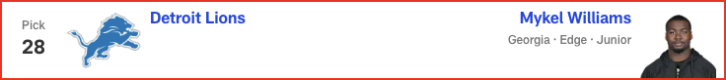

*📝 Analysis: In his final mock of the 2025 NFL Draft, Lance Zierlein has two tight ends coming off the board EARLY. Plus, the New Orleans Saints make a pair of trades and land a new quarterback. Check out the full first-round projection, 1-32.*

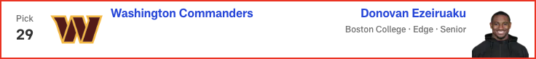

*📝 Analysis: In his final mock of the 2025 NFL Draft, Lance Zierlein has two tight ends coming off the board EARLY. Plus, the New Orleans Saints make a pair of trades and land a new quarterback. Check out the full first-round projection, 1-32.*

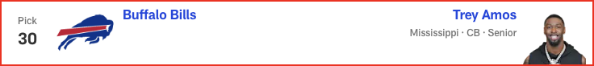

*📝 Analysis: In his final mock of the 2025 NFL Draft, Lance Zierlein has two tight ends coming off the board EARLY. Plus, the New Orleans Saints make a pair of trades and land a new quarterback. Check out the full first-round projection, 1-32.*

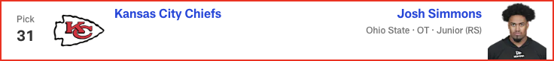

*📝 Analysis: In his first and only seven-round mock of the 2025 NFL Draft, Chad Reuter predicts a wide receiver run to start Round 4, with the Steelers finding a new quarterback later in the round.*

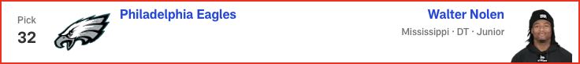

*📝 Analysis: In his first and only seven-round mock of the 2025 NFL Draft, Chad Reuter predicts a wide receiver run to start Round 4, with the Steelers finding a new quarterback later in the round.*

# Dan Parr - 2025 Mock Draft

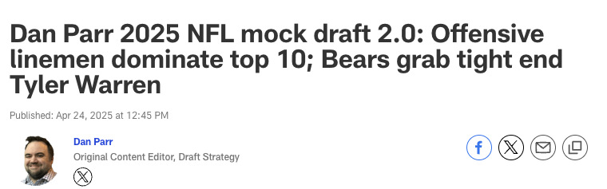



*📝 Analysis: The Titans use a top-10 pick on a quarterback for the fourth time in the last 20 years, hoping Ward and Brian Callahan can unlock some magic.*

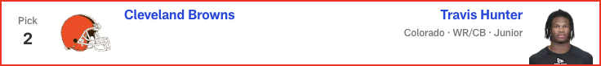

*📝 Analysis: Cleveland doesn’t pass up a chance to select a potential once-in-a-lifetime player. Hunter immediately becomes a weapon on offense and can be used in certain packages on defense, as well.*



*📝 Analysis: While the long-term quarterback need looms large, the Giants don’t see value at the position that matches such a high pick. They select Carter and look to recreate the dominant pass rush that was critical to the team’s two Super Bowl wins in this century.*



*📝 Analysis: The Panthers are coming off a historically bad season on defense. Drafting Walker is a big step back toward respectability on that side of the ball.*



*📝 Analysis: As I’ve been saying since last month, the Jaguars should not turn down an opportunity to snag Jeanty, the best player available at No. 5. Based on the buzz of the last few days, I don't think they will.*



*📝 Analysis: Miami could use a new alpha in the secondary with Jevon Holland gone and Jalen Ramsey potentially following him out the door. Barron fits the bill.*



*📝 Analysis: For the third straight year, Arizona uses its top pick on an Ohio State product. Simmons joins Paris Johnson to give the Cardinals a pair of Buckeye bookends with long-term potential.*

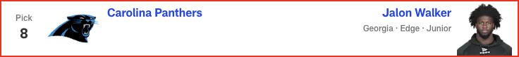

*📝 Analysis: "Best player available" vibes here. Campbell gets a chance to soak up wisdom from Lavonte David, one of the top off-ball linebackers of his era, before it’s his time to be the guy.*

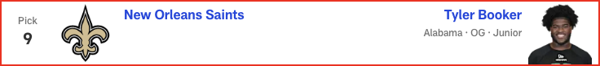

*📝 Analysis: Jim Harbaugh continues to build his team through the trenches, reconnecting with a fellow Michigan Man in the process.*



*📝 Analysis: Packers fans assembled at the draft site get to witness history for their franchise, as Green Bay selects a receiver in Round 1 for the first time in 23 years. Jordan Love approves!*

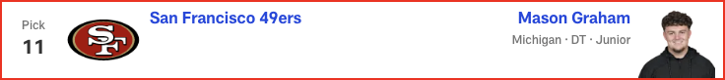

*📝 Analysis: It won't be a surprise if the Rams trade down in a deal with a team looking to move up for a quarterback. In this scenario, though, they bolster the secondary with a cornerback who has sub-4.3 speed and the ball skills to be a headache for offenses.*



*📝 Analysis: Buffalo ends Johnson’s slide after injuries marred his 2024 season and pre-draft process. Cornerback is a spot the Bills must address, and the pedigreed cover man's value at No. 30 overrides potential concerns about him not running a 40-yard dash for teams.*



*📝 Analysis: Another year, another draft where one of the top defensive players in the class falls into the Eagles’ lap. DC Vic Fangio will love his options in the secondary.*



*📝 Analysis: With Round 1 of the 2025 NFL Draft in the books, Eric Edholm projects how Rounds 2 and 3 will play out on Friday night. Where do high-profile prospects like Michigan CB Will Johnson and Colorado QB Shedeur Sanders land? Check out the full Day 2 projection, 33 to 102.*

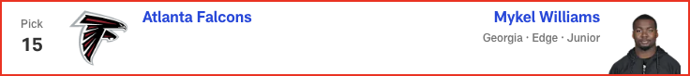

*📝 Analysis: In his final mock of the 2025 NFL Draft, Lance Zierlein has two tight ends coming off the board EARLY. Plus, the New Orleans Saints make a pair of trades and land a new quarterback. Check out the full first-round projection, 1-32.*

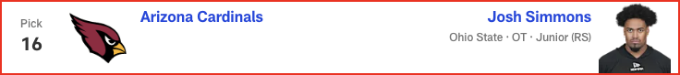

*📝 Analysis: In his fourth and final mock of the 2025 NFL Draft, Daniel Jeremiah predicts two teams will trade up for help on offense, including one squad that makes a move for a quarterback. See his full first-round projection, 1-32.*



*📝 Analysis: In his fourth and final mock of the 2025 NFL Draft, Daniel Jeremiah predicts two teams will trade up for help on offense, including one squad that makes a move for a quarterback. See his full first-round projection, 1-32.*

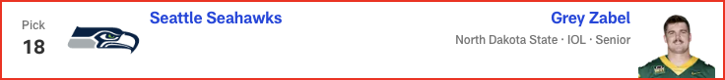

*📝 Analysis: In his fourth and final mock of the 2025 NFL Draft, Daniel Jeremiah predicts two teams will trade up for help on offense, including one squad that makes a move for a quarterback. See his full first-round projection, 1-32.*



*📝 Analysis: In his fourth and final mock of the 2025 NFL Draft, Daniel Jeremiah predicts two teams will trade up for help on offense, including one squad that makes a move for a quarterback. See his full first-round projection, 1-32.*



*📝 Analysis: In his fourth and final mock of the 2025 NFL Draft, Daniel Jeremiah predicts two teams will trade up for help on offense, including one squad that makes a move for a quarterback. See his full first-round projection, 1-32.*

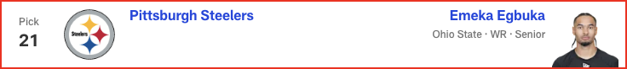

*📝 Analysis: In his fourth and final mock of the 2025 NFL Draft, Daniel Jeremiah predicts two teams will trade up for help on offense, including one squad that makes a move for a quarterback. See his full first-round projection, 1-32.*

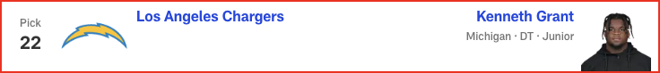

*📝 Analysis: In his fourth and final mock of the 2025 NFL Draft, Daniel Jeremiah predicts two teams will trade up for help on offense, including one squad that makes a move for a quarterback. See his full first-round projection, 1-32.*

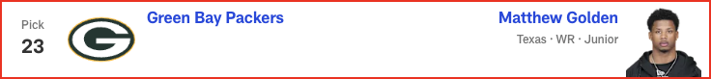

*📝 Analysis: In his fourth and final mock of the 2025 NFL Draft, Daniel Jeremiah predicts two teams will trade up for help on offense, including one squad that makes a move for a quarterback. See his full first-round projection, 1-32.*

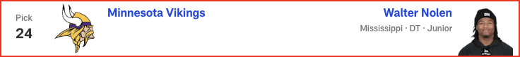

*📝 Analysis: In his fourth and final mock of the 2025 NFL Draft, Daniel Jeremiah predicts two teams will trade up for help on offense, including one squad that makes a move for a quarterback. See his full first-round projection, 1-32.*

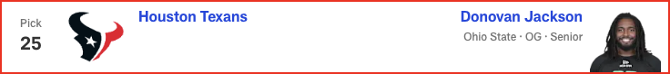

*📝 Analysis: In his fourth and final mock of the 2025 NFL Draft, Daniel Jeremiah predicts two teams will trade up for help on offense, including one squad that makes a move for a quarterback. See his full first-round projection, 1-32.*

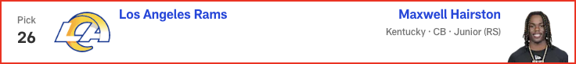

*📝 Analysis: In his fourth and final mock of the 2025 NFL Draft, Daniel Jeremiah predicts two teams will trade up for help on offense, including one squad that makes a move for a quarterback. See his full first-round projection, 1-32.*

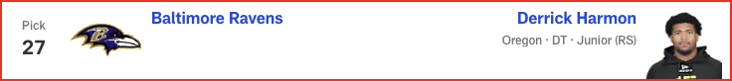

*📝 Analysis: In his fourth and final mock of the 2025 NFL Draft, Daniel Jeremiah predicts two teams will trade up for help on offense, including one squad that makes a move for a quarterback. See his full first-round projection, 1-32.*

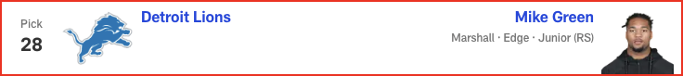

*📝 Analysis: In his fourth and final mock of the 2025 NFL Draft, Daniel Jeremiah predicts two teams will trade up for help on offense, including one squad that makes a move for a quarterback. See his full first-round projection, 1-32.*



*📝 Analysis: In his fourth and final mock of the 2025 NFL Draft, Daniel Jeremiah predicts two teams will trade up for help on offense, including one squad that makes a move for a quarterback. See his full first-round projection, 1-32.*

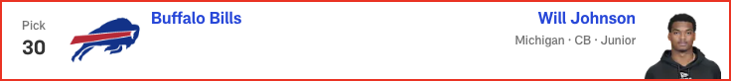

*📝 Analysis: With Round 1 of the 2025 NFL Draft in the books, Eric Edholm projects how Rounds 2 and 3 will play out on Friday night. Where do high-profile prospects like Michigan CB Will Johnson and Colorado QB Shedeur Sanders land? Check out the full Day 2 projection, 33 to 102.*



*📝 Analysis: In his first and only seven-round mock of the 2025 NFL Draft, Chad Reuter predicts a wide receiver run to start Round 4, with the Steelers finding a new quarterback later in the round.*

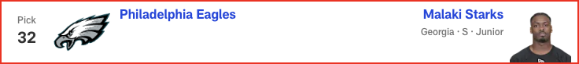

*📝 Analysis: In his first and only seven-round mock of the 2025 NFL Draft, Chad Reuter predicts a wide receiver run to start Round 4, with the Steelers finding a new quarterback later in the round.*

# Gennaro Filice - 2025 Mock Draft

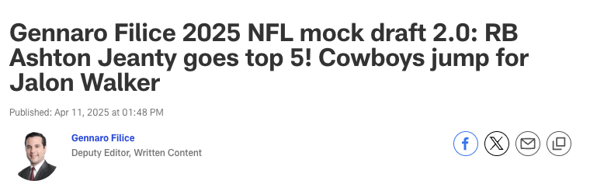



*📝 Analysis: At this juncture, mocking any other player in this draft slot would invite mockery. Ward appears destined to go No. 1 overall -- the only potential question is, who’s taking him? Theoretically, another quarterback-needy team could present the Titans with a Godfather offer. And yet, I still think they’d refuse. Reining in Ward’s devil-may-care playing style might be challenging, but who honestly th...*

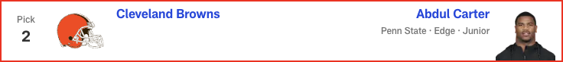

*📝 Analysis: The Draft Buzz-O-Meter [patent pending] has been shifting this pick to Travis Hunter. Understandable, especially given Cleveland’s dearth of offensive playmakers. But having Carter rush the passer opposite Myles Garrett for the rest of this decade is a five-year plan I can believe in. It doesn’t solve the franchise’s never-ending nightmare at quarterback, but think of the terror thrust upon opposi...*

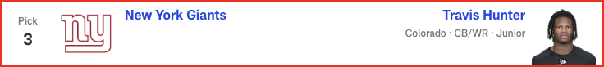

*📝 Analysis: When I last mocked Hunter to New York, longtime beat writer Paul Schwartz had just reported that the Giants see the two-way star as a cornerback. The New York Post scribe changed his tune this week, though, writing that the team’s evaluation remains fluid. The current state of the roster makes CB the bigger need, but a potential duo of Hunter and Malik Nabers makes WR the bigger splash. Maybe you ...*

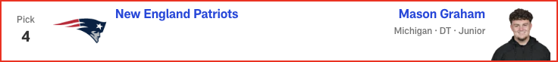

*📝 Analysis: New England just signed Milton Williams to a nine-figure deal, but fellow defensive tackle Christian Barmore remains an uncertainty due to recurring symptoms from blood clots. And regardless, does Mike Vrabel strike you as the kind of guy who’d be concerned about having too many disruptive D-linemen? Following a free agency spending spree that upgraded all three levels of the defense, the Patriots...*



*📝 Analysis: Seemingly everyone -- including our resident prospect rankers in these parts, Daniel Jeremiah, Eric Edholm and Lance Zierlein -- has Jeanty as a top-five player in this class. So, what’s stopping him from being selected in the top five picks of this draft? Travis Etienne Jr.'s efficiency declined in 2023, and his production fell off a cliff in ’24. Tank Bigsby emerged as a rusher in Year 2, but he...*



*📝 Analysis: Every draft cycle is a set of waves ... take waves, which typically swell after tentpole events like the NFL Scouting Combine, pro days, etc. And when it comes to placing individual prospects in a mock, the trick is figuring out which wave to ride.*



*📝 Analysis: Alignment versatility’s all the rage among NFL pass catchers. Consequently, inside/outside ability’s never been more valuable to NFL defenses. And that’s exactly what Barron provides. Having just won the Jim Thorpe Award as college football’s top defensive back, the Texas product lined up all over the field as a starter for the last three seasons, deftly executing different techniques across myria...*

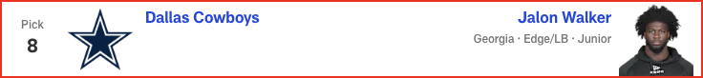

*📝 Analysis: Many folks have the Colts taking a tight end, just usually not this one. Tyler Warren is the popular pick, but I’m bucking that trend with the belief that some teams could value Loveland’s route artistry at the position over Warren’s throwback skill set. Shoot, the Michigan product is running whip routes at nearly 6-foot-6 and 250 pounds!*

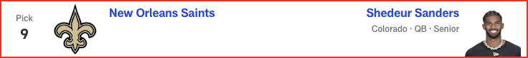

*📝 Analysis: "The emphasis on the draft will certainly be on the defensive side of the ball,” the Falcons owner said. “I think that's pretty obvious to everybody."*



*📝 Analysis: Cincinnati has struggled with safety play since letting Jessie Bates III walk in free agency. Starks offers pedigree (five-star recruit), high-level experience (three-year starter at Georgia) and versatility (significant snaps as a box defender, nickelback and single-high safety). He lacks supreme athletic testing, having posted underwhelming numbers in Indy. But don’t overthink it! The man’s play...*

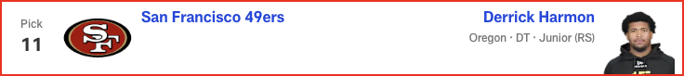

*📝 Analysis: The reason Warren drops a bit in this mock: It feels like most modern offenses overwhelmingly value receiving ability over blocking prowess at TE1, typically preferring agile weapons who can route guys up.*

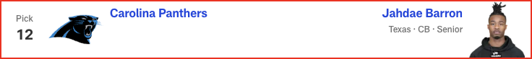

*📝 Analysis: Regardless of who ends up starting under center in Pittsburgh, you have to imagine this team will continue to pound the rock. The Steelers have ranked top 10 in rushing attempts in every season since Ben Roethlisberger’s retirement, vaulting to No. 4 in Arthur Smith’s maiden voyage as offensive coordinator last year. Smith remains at the controls, but Najee Harris -- who easily paced Pittsburgh in...*

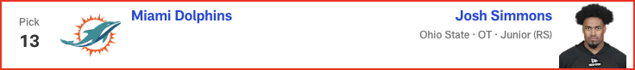

*📝 Analysis: After using the No. 4 overall pick to bolster the defensive line, the Patriots jump back into Round 1 to upgrade the O-line. Sending Minnesota its second-round pick (No. 38) and the higher of its two third-rounders (No. 69), New England leapfrogs a slew of tackle-needy teams to secure Banks. Having logged 42 starts at left tackle in his three years at Texas, Banks deserves the opportunity to man t...*

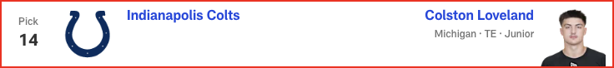

*📝 Analysis: FREAK-SHOW RUN!!! If Shemar Stewart made a splash at the combine, Nick Emmanwori performed a cannonball. Arriving in Indy at a chiseled 6-3 1/8 and 220 pounds, the South Carolina safety blazed the 40-yard dash in 4.38 seconds and nearly jumped out of Lucas Oil Stadium (43-inch vertical, 11-foot-6 broad). Emmanwori’s not just an Underwear Olympian, either; he started during all three of his seasons...*

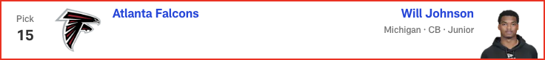

*📝 Analysis: An impressive physical specimen at a hair under 6-2 with pterodactyl length, Revel was poised to make a national name for himself in 2024. But then he tore his ACL during a practice in September, prematurely ending his final season at ECU and preventing him from showing his wares in the pre-draft process. Out of sight, but not out of mind. I anticipate a playoff team scooping him up in the back st...*



*📝 Analysis: With Round 1 of the 2025 NFL Draft in the books, Eric Edholm projects how Rounds 2 and 3 will play out on Friday night. Where do high-profile prospects like Michigan CB Will Johnson and Colorado QB Shedeur Sanders land? Check out the full Day 2 projection, 33 to 102.*

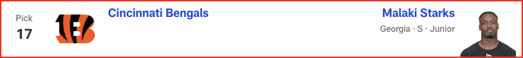

*📝 Analysis: In his second and final mock of the 2025 NFL Draft, Dan Parr predicts an early run on offensive linemen -- with one guard cracking the top 10! Plus, the 49ers and Eagles land steals on the defensive side of the ball. See the full first-round projection, 1-32.*

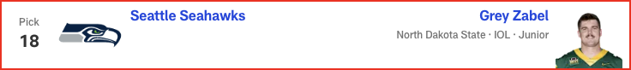

*📝 Analysis: In his final mock of the 2025 NFL Draft, Lance Zierlein has two tight ends coming off the board EARLY. Plus, the New Orleans Saints make a pair of trades and land a new quarterback. Check out the full first-round projection, 1-32.*

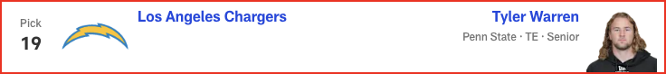

*📝 Analysis: In his final mock of the 2025 NFL Draft, Lance Zierlein has two tight ends coming off the board EARLY. Plus, the New Orleans Saints make a pair of trades and land a new quarterback. Check out the full first-round projection, 1-32.*

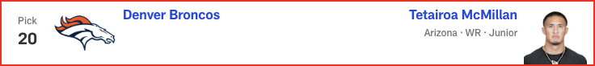

*📝 Analysis: In his final mock of the 2025 NFL Draft, Lance Zierlein has two tight ends coming off the board EARLY. Plus, the New Orleans Saints make a pair of trades and land a new quarterback. Check out the full first-round projection, 1-32.*

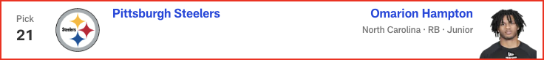

*📝 Analysis: In his final mock of the 2025 NFL Draft, Lance Zierlein has two tight ends coming off the board EARLY. Plus, the New Orleans Saints make a pair of trades and land a new quarterback. Check out the full first-round projection, 1-32.*

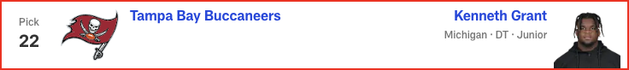

*📝 Analysis: In his final mock of the 2025 NFL Draft, Lance Zierlein has two tight ends coming off the board EARLY. Plus, the New Orleans Saints make a pair of trades and land a new quarterback. Check out the full first-round projection, 1-32.*

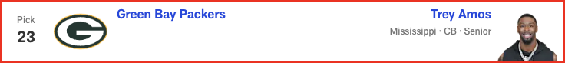

*📝 Analysis: In his final mock of the 2025 NFL Draft, Lance Zierlein has two tight ends coming off the board EARLY. Plus, the New Orleans Saints make a pair of trades and land a new quarterback. Check out the full first-round projection, 1-32.*

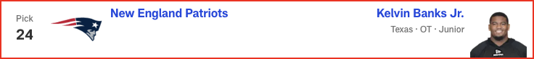

*📝 Analysis: After using the No. 4 overall pick to bolster the defensive line, the Patriots jump back into Round 1 to upgrade the O-line. Sending Minnesota its second-round pick (No. 38) and the higher of its two third-rounders (No. 69), New England leapfrogs a slew of tackle-needy teams to secure Banks. Having logged 42 starts at left tackle in his three years at Texas, Banks deserves the opportunity to man t...*

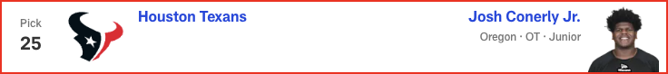

*📝 Analysis: In his final mock of the 2025 NFL Draft, Lance Zierlein has two tight ends coming off the board EARLY. Plus, the New Orleans Saints make a pair of trades and land a new quarterback. Check out the full first-round projection, 1-32.*

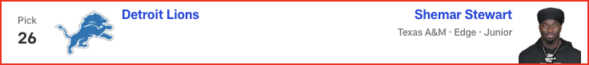

*📝 Analysis: FREAK-SHOW RUN!!! If Shemar Stewart made a splash at the combine, Nick Emmanwori performed a cannonball. Arriving in Indy at a chiseled 6-3 1/8 and 220 pounds, the South Carolina safety blazed the 40-yard dash in 4.38 seconds and nearly jumped out of Lucas Oil Stadium (43-inch vertical, 11-foot-6 broad). Emmanwori’s not just an Underwear Olympian, either; he started during all three of his seasons...*

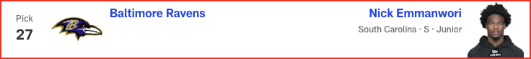

*📝 Analysis: In his final mock of the 2025 NFL Draft, Lance Zierlein has two tight ends coming off the board EARLY. Plus, the New Orleans Saints make a pair of trades and land a new quarterback. Check out the full first-round projection, 1-32.*

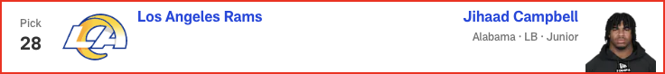

*📝 Analysis: In his final mock of the 2025 NFL Draft, Lance Zierlein has two tight ends coming off the board EARLY. Plus, the New Orleans Saints make a pair of trades and land a new quarterback. Check out the full first-round projection, 1-32.*

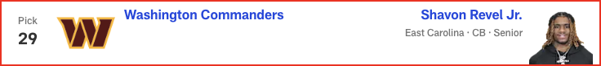

*📝 Analysis: In his final mock of the 2025 NFL Draft, Lance Zierlein has two tight ends coming off the board EARLY. Plus, the New Orleans Saints make a pair of trades and land a new quarterback. Check out the full first-round projection, 1-32.*

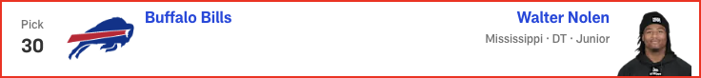

*📝 Analysis: In his final mock of the 2025 NFL Draft, Lance Zierlein has two tight ends coming off the board EARLY. Plus, the New Orleans Saints make a pair of trades and land a new quarterback. Check out the full first-round projection, 1-32.*

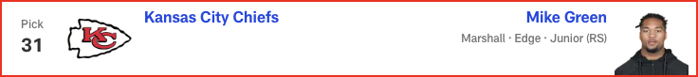

*📝 Analysis: Ezeiruaku fittingly comes off the board right after Mike Green, as the Boston College star fell a half-sack shy of his Marshall counterpart for last season's FBS crown in sacks, finishing with 16.5. He has an odd body type for an edge rusher: slightly undersized at 6-2 1/2 and 248 pounds, but with 34-inch vines for arms. Howie Roseman isn’t afraid to take a walk on the wild side, though. Remember ...*



*📝 Analysis: In his first and only seven-round mock of the 2025 NFL Draft, Chad Reuter predicts a wide receiver run to start Round 4, with the Steelers finding a new quarterback later in the round.*

# Marc Ross - 2025 Mock Draft

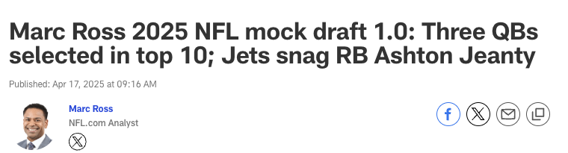



*📝 Analysis: Tennessee doesn't overthink this pick, selecting the player it has publicly praised throughout the pre-draft process. Ward is the only quarterback in this draft who has the playmaking ability required to swiftly transform a franchise; he could provide the Titans with the kind of instant impact we've seen from Jayden Daniels and C.J. Stroud over the past couple seasons.*

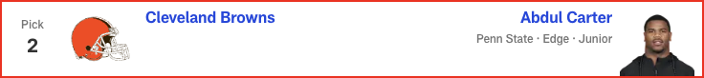

*📝 Analysis: The opportunity to pair Carter with perennial Pro Bowler Myles Garrett is too tempting to resist. Having these two on opposite sides of Jim Schwartz's defensive line ensures a terrorizing pass rush that will keep opposing quarterbacks uneasy in the pocket. Sure, Cleveland has plenty of questions surrounding its own QB situation, but outside of Cam Ward, I don't see another signal-caller in this cl...*

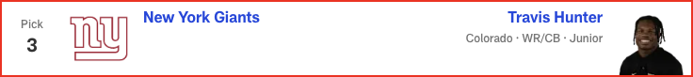

*📝 Analysis: New York could take a quarterback here despite having a trio of veterans on the roster. The team is hosting Shedeur Sanders for a private workout this week, but knowing the Giants' ownership and front office, I'm not sure they'll want to subject themselves to everything that comes with the polarizing prospect out of Colorado. Thus, Sanders' college teammate is the pick. Hunter was a two-way star a...*



*📝 Analysis: With Justin Fields under center, it would be wise for the Jets to bulk up the ground game. Breece Hall has been OK, but pairing him with a future star in Jeanty would give new offensive coordinator Tanner Engstrand the kind of two-headed monster in the backfield that the assistant coach worked with in Detroit. A potent rushing attack is something that ultimately would fuel Fields' growth as a quar...*

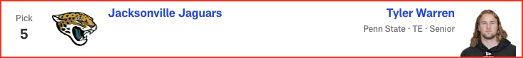

*📝 Analysis: The Jaguars must give Trevor Lawrence as many resources as possible to see if he truly is a franchise QB and the guy for Liam Coen's offense moving forward. Warren is the best tight end in this class. He'd find a ton of success working the middle of the field in Jacksonville, with second-year receiver Brian Thomas Jr. commanding the defense's attention deep.*

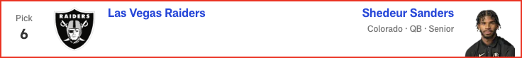

*📝 Analysis: The Dolphins could go a lot of ways here -- especially after the team and Jalen Ramsey mutually agreed to explore trade options for the star corner -- but boosting the pass rush should be Priority No. 1. Walker is at his best when getting after the quarterback and could find success alongside Chop Robinson and a healthy Jaelan Phillips.*

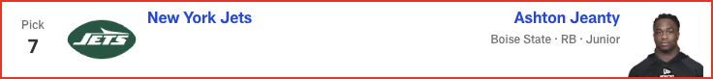

*📝 Analysis: Despite investing a lot of Day 2 draft capital in the defensive line in recent years, Atlanta continually struggles to take down the quarterback. Time to address the issue in Round 1 by scooping up a young, dynamic edge rusher with a Georgia connection.*

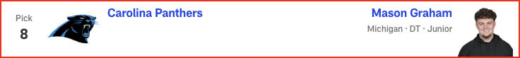

*📝 Analysis: The Bengals couldn't stop anyone last season, so even if reigning NFL sack king Trey Hendrickson ultimately remains in Cincinnati, this defense still needs help. Green is a productive pass rusher, having led the FBS with 17 sacks in 2024. His relentless pursuit of the quarterback and ability to stifle the run would improve a unit that ranked 25th in points and yards allowed last year.*

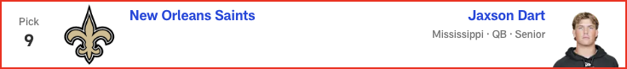

*📝 Analysis: Sam Darnold is at his best when he can distribute the ball to a great supporting cast. Adding Egbuka to a solid receiving corps could help Darnold replicate his 2024 breakout season in Minnesota. Egbuka plays similarly to Jaxon Smith-Njigba, his former Ohio State teammate who's already flourishing in Seattle.*

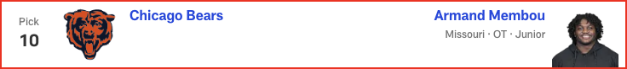

*📝 Analysis: Outside of the franchises lacking a starting quarterback, Denver might have the biggest need of any team entering the draft. The Broncos have struggled to run the ball under Sean Payton, so they finally solidify the ground game by adding this physical, bell-cow back.*

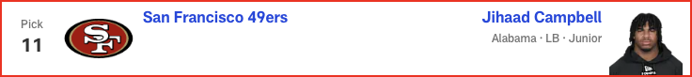

*📝 Analysis: Jaire Alexander is at the forefront of trade discussions in Green Bay -- and he's missed double-digit games in three of the past four seasons. Bottom line: It's time for the Packers to invest in his replacement. Hairston has the skill set to step in as a starting cornerback.*



*📝 Analysis: The Texans continue overhauling their offensive line with this draft's best interior blocker. Jackson proved he could play left tackle as an injury replacement during Ohio State's national title run, but he projects as a Pro Bowl-caliber guard in the NFL.*

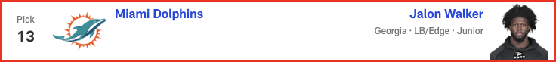

*📝 Analysis: Maybe the most underrated player in this draft class. Tuimoloau joins Dan Quinn's defensive front as a hard-nosed and productive talent. Filling a big need in Washington, JTT -- who registered 6.5 sacks and 11 tackles for loss during Ohio State's four-game playoff run -- could start immediately for the Commanders, whose DE depth chart is littered with NFL journeymen.*



*📝 Analysis: Penalty magnet Jawaan Taylor has been a liability, and I'm not sold on free-agent signing Jaylon Moore curing all of Kansas City's OL ills. Conerly, who had his best game last season against Abdul Carter, has solid technique as a right or left tackle. He'd thrive under Andy Reid, who covets O-linemen with versatility.*



*📝 Analysis: With Round 1 of the 2025 NFL Draft in the books, Eric Edholm projects how Rounds 2 and 3 will play out on Friday night. Where do high-profile prospects like Michigan CB Will Johnson and Colorado QB Shedeur Sanders land? Check out the full Day 2 projection, 33 to 102.*



*📝 Analysis: In his second and final mock of the 2025 NFL Draft, Dan Parr predicts an early run on offensive linemen -- with one guard cracking the top 10! Plus, the 49ers and Eagles land steals on the defensive side of the ball. See the full first-round projection, 1-32.*

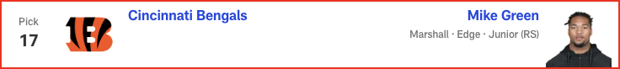

*📝 Analysis: In his final mock of the 2025 NFL Draft, Lance Zierlein has two tight ends coming off the board EARLY. Plus, the New Orleans Saints make a pair of trades and land a new quarterback. Check out the full first-round projection, 1-32.*

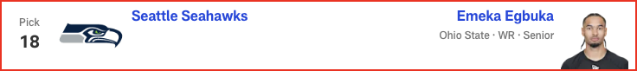

*📝 Analysis: In his final mock of the 2025 NFL Draft, Lance Zierlein has two tight ends coming off the board EARLY. Plus, the New Orleans Saints make a pair of trades and land a new quarterback. Check out the full first-round projection, 1-32.*

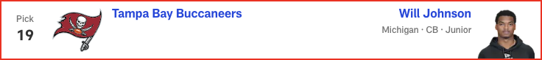

*📝 Analysis: In his final mock of the 2025 NFL Draft, Lance Zierlein has two tight ends coming off the board EARLY. Plus, the New Orleans Saints make a pair of trades and land a new quarterback. Check out the full first-round projection, 1-32.*



*📝 Analysis: In his final mock of the 2025 NFL Draft, Lance Zierlein has two tight ends coming off the board EARLY. Plus, the New Orleans Saints make a pair of trades and land a new quarterback. Check out the full first-round projection, 1-32.*

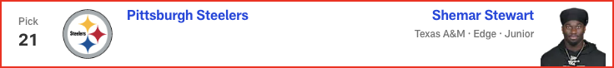

*📝 Analysis: In his final mock of the 2025 NFL Draft, Lance Zierlein has two tight ends coming off the board EARLY. Plus, the New Orleans Saints make a pair of trades and land a new quarterback. Check out the full first-round projection, 1-32.*

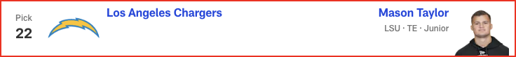

*📝 Analysis: In his final mock of the 2025 NFL Draft, Lance Zierlein has two tight ends coming off the board EARLY. Plus, the New Orleans Saints make a pair of trades and land a new quarterback. Check out the full first-round projection, 1-32.*



*📝 Analysis: In his final mock of the 2025 NFL Draft, Lance Zierlein has two tight ends coming off the board EARLY. Plus, the New Orleans Saints make a pair of trades and land a new quarterback. Check out the full first-round projection, 1-32.*

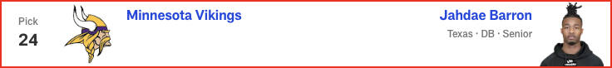

*📝 Analysis: In his final mock of the 2025 NFL Draft, Lance Zierlein has two tight ends coming off the board EARLY. Plus, the New Orleans Saints make a pair of trades and land a new quarterback. Check out the full first-round projection, 1-32.*

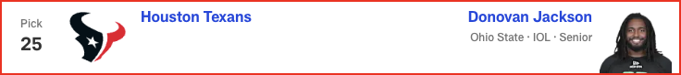

*📝 Analysis: In his final mock of the 2025 NFL Draft, Lance Zierlein has two tight ends coming off the board EARLY. Plus, the New Orleans Saints make a pair of trades and land a new quarterback. Check out the full first-round projection, 1-32.*

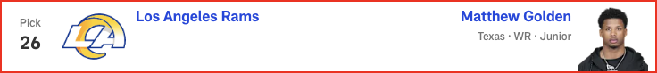

*📝 Analysis: In his final mock of the 2025 NFL Draft, Lance Zierlein has two tight ends coming off the board EARLY. Plus, the New Orleans Saints make a pair of trades and land a new quarterback. Check out the full first-round projection, 1-32.*



*📝 Analysis: In his final mock of the 2025 NFL Draft, Lance Zierlein has two tight ends coming off the board EARLY. Plus, the New Orleans Saints make a pair of trades and land a new quarterback. Check out the full first-round projection, 1-32.*

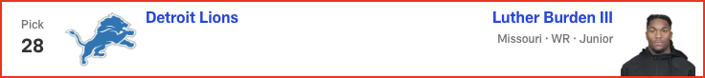

*📝 Analysis: In his final mock of the 2025 NFL Draft, Lance Zierlein has two tight ends coming off the board EARLY. Plus, the New Orleans Saints make a pair of trades and land a new quarterback. Check out the full first-round projection, 1-32.*

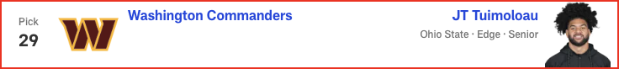

*📝 Analysis: In his final mock of the 2025 NFL Draft, Lance Zierlein has two tight ends coming off the board EARLY. Plus, the New Orleans Saints make a pair of trades and land a new quarterback. Check out the full first-round projection, 1-32.*



*📝 Analysis: In his final mock of the 2025 NFL Draft, Lance Zierlein has two tight ends coming off the board EARLY. Plus, the New Orleans Saints make a pair of trades and land a new quarterback. Check out the full first-round projection, 1-32.*

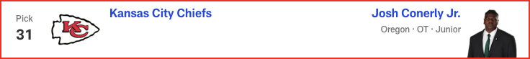

*📝 Analysis: In his final mock of the 2025 NFL Draft, Lance Zierlein has two tight ends coming off the board EARLY. Plus, the New Orleans Saints make a pair of trades and land a new quarterback. Check out the full first-round projection, 1-32.*

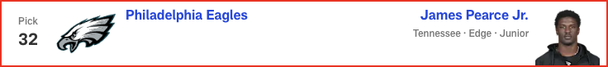

*📝 Analysis: In his first and only seven-round mock of the 2025 NFL Draft, Chad Reuter predicts a wide receiver run to start Round 4, with the Steelers finding a new quarterback later in the round.*