QUANTYZE
Limit Order Book Simulator — Full Technical Documentation
Cade McNelly · Nicolas Miranda Cantanhede · Sahand Samadirand
CSC111 Project 2 (Phase 2) — University of Toronto
Due: Monday March 30, 2026 — 1:00 PM Toronto Time

1. Project Overview

Project Name: Quantyze
Course: CSC111 — University of Toronto — Project 2 (Phase 2)
Due Date: Monday March 30, 2026, 1:00 PM Toronto Time
Maximum Extension: 3 days (grace credits cannot be used)
Team: Cade McNelly, Nicolas Miranda Cantanhede, Sahand Samadirand
Python Version: 3.13.5 (required)
Language Constraint: Pure Python only — no non-Python software or runtimes

1.1 Problem Statement
Amateur traders interact with financial markets through simplified chart interfaces that abstract away the underlying microstructure. This creates a dangerous misconception: the assumption that any quantity of an asset can be instantly purchased at the price shown on screen. In reality, execution is subject to order book depth, bid-ask spread, queue position, and available liquidity. The difference between expected and actual execution price is known as slippage, and it can be costly.
Quantyze addresses this gap by building a realistic, interactive limit order book simulator that exposes these hidden mechanics to the user, using BST and FIFO queue data structures as the core computational engine.

1.2 Project Goal (Bold per handout requirement)
To simulate a financial limit order book using tree-based data structures (BSTs), implement a price-time priority matching engine in pure Python, and visualize key market microstructure metrics (spread, depth, slippage, fill rate, P&L) interactively using Plotly.

1.3 Scope & Constraints
⚠ This project is implemented entirely in Python 3.13.5. No React.js, Flask, or any non-Python runtime is used. The frontend visualization is produced entirely via Plotly (Python) and/or a minimal static HTML file with only trivial JavaScript for display purposes, as permitted by the handout.
- All source files are at the top level of the submission — no subfolders
- Entry point is main.py; all modules are imported from the same directory
- Dataset is provided as a zip file (not fetched from external URLs at runtime)
- The program must run end-to-end in under 1 minute for the TA demo path

2. Submission Requirements (Phase 2 Handout)

This section documents exactly what the CSC111 Phase 2 handout requires. Every item here must be present in the final MarkUs submission.

2.1 Required Files on MarkUs
File | Description / Requirement
project_report.pdf | Final written report as PDF
project_report.tex | LaTeX source for the report
requirements.txt | All external Python libraries (pip-installable). No built-ins.
main.py | Entry point. Main block loads data, runs computation, produces output.
*.py (other modules) | All project Python modules at top level — no subfolders
Dataset zip | Via MarkUs (<10 MB), send.utoronto.ca, or UofT OneDrive link
ℹ Filenames must match exactly as listed above, using lowercase. MarkUs is case-sensitive.

2.2 requirements.txt Format
List only external libraries (those installed via pip, visible in PyCharm interpreter settings). Do not list built-in modules like doctest, math, random, csv, or statistics.
# Quantyze — CSC111 Project 2 requirements
python-ta
plotly
pytest
hypothesis
# Add any additional libraries used (e.g. pandas, numpy) here

2.3 Dataset Zip File Delivery
The TA will not download datasets from external URLs at runtime. The zip file must be provided via one of these three options:
- Uploaded directly to MarkUs (file size under 10 MB only)
- Shared via https://send.utoronto.ca — share with csc111-2026-01@cs.toronto.edu
- Uploaded to UofT OneDrive with a public access link (UTORid login is okay; no Google login)
⚠ Do NOT require the TA to fetch data from external URLs or APIs at runtime. All data must be in the zip file.

2.4 main.py Structure
The main.py main block must, in order:
- Load necessary files from the dataset zip
- Perform all computations (build order book, run matching engine, compute metrics)
- Produce output (Plotly visualization and/or interactive display)

main.py may be short and simply orchestrate the system setup and runtime flow. A reference-aligned structure is:
if __name__ == '__main__':
args = parse_args()
book, engine, stream, agent = build_system(args)
if args.train:
train_model(args.data)
else:
run_simulation(stream, agent, book)
start_flask(app, args.port)
print_summary(engine, agent)

2.5 Long-Running / Data Generation Note
If any part of the program takes over 1 minute, the handout requires two things:
- A short (under 1 minute) demo path that the TA can run to verify correctness
- A saved state (pre-computed result) included in the dataset zip, with instructions to load it
ℹ For Quantyze, the LOBSTER sample dataset (57,515 events) should process well within 1 minute in Python. If a ML training phase is added, pre-train and save the model to disk and load it in main.py.

3. Code Quality Standards (Handout Requirements)

3.1 Module Structure
Every Python file must have a module-level docstring with title, description, and copyright claim. No top-level statements or function calls are allowed outside of the main block.
"""
order_book.py

Defines the OrderBook class that coordinates BookTree instances for bids and asks, maintains the order index and trade log, and exposes market state to the matching engine and UI.

Copyright (c) 2026 Cade McNelly, Nicolas Miranda Cantanhede, Sahand Samadirand
"""

3.2 Functions and Classes
- Every function and class must have a full docstring (description, type annotations, preconditions, representation invariants where applicable)
- Naming must follow PEP 8: snake_case for functions/variables, PascalCase for classes
- Doctest examples are not required but strongly encouraged
- @check_contracts may be used during development but must be commented out for final submission
- Organize functions top-down: most important / public functions at the top, helpers below

3.3 python_ta and doctest in Every Module
Every module except main.py must have a main block that runs both doctest.testmod() and python_ta.check_all(). Adapt the config as needed per module.
if __name__ == '__main__':
import doctest
doctest.testmod()

import python_ta
python_ta.check_all(config={
'extra-imports': ['csv', 'collections'],
'allowed-io': ['load_lobster_messages'],
'max-line-length': 120
})

3.4 File Organization
Suggested module split for Quantyze (all at top level, no subfolders):
File | Responsibility
main.py | Entry point and orchestrator: parse args, build the system, train or simulate, start the API/UI, print summary output
orders.py | Defines Event and Order objects
price_level.py | Defines PriceLevel, the BST node that holds one price and a FIFO queue of Orders
book_tree.py | Defines BookTree, the BST of PriceLevels for one side of the order book
order_book.py | Defines OrderBook: bids tree, asks tree, order_index, and trade_log
matching_engine.py | Defines MatchingEngine: routes events, executes fills, computes slippage and metrics
data_loader.py | Defines DataLoader and helpers for CSV loading, validation, and synthetic event generation
event_stream.py | Defines EventStream and the Flask/API event pipeline
neural_net.py | Defines OrderBookNet, Trainer, and Agent for the optional ML extension
ui.js | Dashboard / frontend layer for book state, trades, and metrics
ℹ Do not use subfolders. All .py files must be submitted at the same level as main.py.

4. Domain Glossary

The following terms are used throughout the codebase, documentation, and agent prompts.

Term | Definition
Limit Order Book (LOB) | Central platform matching buyers and sellers. Maintains two-sided queue of resting orders organized by price.
Order | An instruction to buy or sell an asset at a given price and quantity.
Limit Order | An order specifying a max buy price or min sell price. Rests in the book if not immediately matchable.
Market Order | No specified price; executes immediately against best available opposite price.
Bid | Buy-side limit order. Best bid = highest price a buyer will pay.
Ask | Sell-side limit order. Best ask = lowest price a seller will accept.
Bid-Ask Spread | best_ask − best_bid. A tight spread indicates a liquid market.
Market Depth | Cumulative volume available at each price level.
Slippage | Difference between expected execution price and actual price due to depth limits.
Price-Time Priority | Orders at better prices fill first; ties broken by arrival time (FIFO).
Full Fill | Entire order quantity is matched and executed.
Partial Fill | Order is only partially matched; remainder rests in the book.
Cancellation | Removal of a resting order before it is matched.
P&L | Profit and Loss. Net financial outcome of simulated trading.
BST | Binary Search Tree. Organizes price levels for efficient best-bid/ask extraction.
FIFO Queue | First-In-First-Out queue enforcing time priority within a price level.
Fill Rate | Ratio of fully executed orders to total orders submitted.
Execution Cost | Total cost above mid-price across all trades, incorporating spread and slippage.

5. Dataset

5.1 Source
Dataset: LOBSTER (Limit Order Book System — The Efficient Reconstructor), Humboldt University Berlin / University of Vienna.
Source URL (for report reference only — TA will not fetch from this URL): https://lobsterdata.com
Sample file used: AMZN_2012-06-21_34200000_57600000 — Amazon Inc., June 21 2012, 9:30 AM – 4:00 PM, Level 1 (top of book)
⚠ The dataset zip file must be provided via MarkUs, send.utoronto.ca, or UofT OneDrive. The TA will not download it from lobsterdata.com at runtime.

5.2 Files in the Dataset
Filename | Description
AMZN_2012-06-21_..._message_1.csv | 57,515 order events. 6 columns: Time, Type, Order ID, Size, Price, Direction
AMZN_2012-06-21_..._orderbook_1.csv | 57,515 book snapshots. 4 columns per level: Ask Price, Ask Size, Bid Price, Bid Size
LOBSTER_SampleFiles_ReadMe.txt | Official format documentation from LOBSTER

5.3 Columns Used by the Program
Not all columns are used directly. The following table documents which columns are consumed and how:
File | Column | Name | Used For
message | 1 | Time | Event timestamp (seconds after midnight)
message | 2 | Type | Event classification (new order, cancel, execution, halt)
message | 3 | Order ID | Unique order reference for matching and cancellation
message | 4 | Size | Quantity of shares
message | 5 | Price | Price ÷ 10000 = USD price (e.g. 2238200 → $223.82)
message | 6 | Direction | 1 = buy, -1 = sell
orderbook | 1 | Ask Price 1 | Best ask price — used for spread and ground-truth validation
orderbook | 2 | Ask Size 1 | Best ask volume
orderbook | 3 | Bid Price 1 | Best bid price
orderbook | 4 | Bid Size 1 | Best bid volume

5.4 Dataset Statistics
Statistic | Value
Total events (message file) | 57,515
Trading day covered | AMZN, June 21 2012, 9:30 AM – 4:00 PM
New limit orders (Type 1) | 27,845 (48.4%)
Full deletions (Type 3) | 18,235 (31.7%)
Visible executions (Type 4) | 8,974 (15.6%)
Hidden executions (Type 5) | 2,445 (4.3%)
Partial cancels (Type 2) | 16 (<0.1%)
Trading halts (Type 7) | 0
Price range | $220.51 – $226.03 (range $5.52)
Median order size | 100 shares
Median bid-ask spread | $0.13
Median inter-event time | ~2 ms (genuine high-frequency data)
Sub-millisecond event pairs | 25,552

6. Data Architecture

6.1 Event Object Schema
Every row in the LOBSTER message file is parsed into a standard Event object. This is the atomic unit fed to the matching engine.

Field | Type | LOBSTER Source | Description
timestamp | datetime | Column 1 | Parsed into datetime from seconds after midnight
order_id | str | Column 3 | Unique reference. order_id='0' for hidden executions (Type 5).
side | str | Column 6 | 'buy' (direction=1) or 'sell' (direction=-1)
order_type | str | Column 2 | 'limit' (Type 1), 'cancel' (Type 2/3), 'execution' (Type 4/5), 'halt' (Type 7)
price | float | None | Column 5 ÷ 10000 | USD price. None for market orders or halts.
quantity | int | Column 4 | Number of shares. Must be > 0.

6.2 Validation Rules
- timestamp must be strictly non-decreasing across consecutive events
- price must be > 0 for limit orders; None for market orders and halts
- quantity must be > 0
- order_id must be unique across all active (non-cancelled, non-filled) orders
- Type 7 (halt) events: skip or flag — do not feed into matching engine
- Type 5 (hidden execution): log as external fill, order_id = '0', do not look up in book

6.3 Order Book Data Structure
The order book is implemented as two Binary Search Trees (BSTs) - one for bids and one for asks. In the reference architecture, PriceLevel is the BST node, BookTree manages one side of the market, and OrderBook coordinates both trees along with the order index and trade log.

PriceLevel Node
class PriceLevel:
price: float # The price this node represents
orders: deque[Order] # FIFO queue enforcing time priority
volume: float # Sum of remaining quantity at this level
left: PriceLevel | None # Lower-price child
right: PriceLevel | None # Higher-price child
⚠ CONFLICT: book_tree.py was deleted in an active merge. Resolve this conflict before final submission.
BookTree
class BookTree:
root: PriceLevel | None # Root of one bid-side or ask-side BST
side: str # "bid" or "ask"
size: int # Number of distinct price levels
⚠ Bug: order_book.py currently calls BookTree() with no arguments (self.bids = BookTree(); self.asks = BookTree()), but BookTree.__init__ requires a side parameter. This is an inconsistency that must be resolved.
OrderBook
- class OrderBook:
- bids: BookTree # Bid-side tree; best bid = maximum-price node
- asks: BookTree # Ask-side tree; best ask = minimum-price node
- order_index: dict[str, Order] # order_id -> Order for O(1) cancellation lookup
trade_log: list[dict] # Execution records flushed to log.json

6.3.1 System Framework Overview
The following diagram summarizes the module-level framework of the simulator. It shows how events, price levels, trees, the order book, matching engine, and UI fit together.
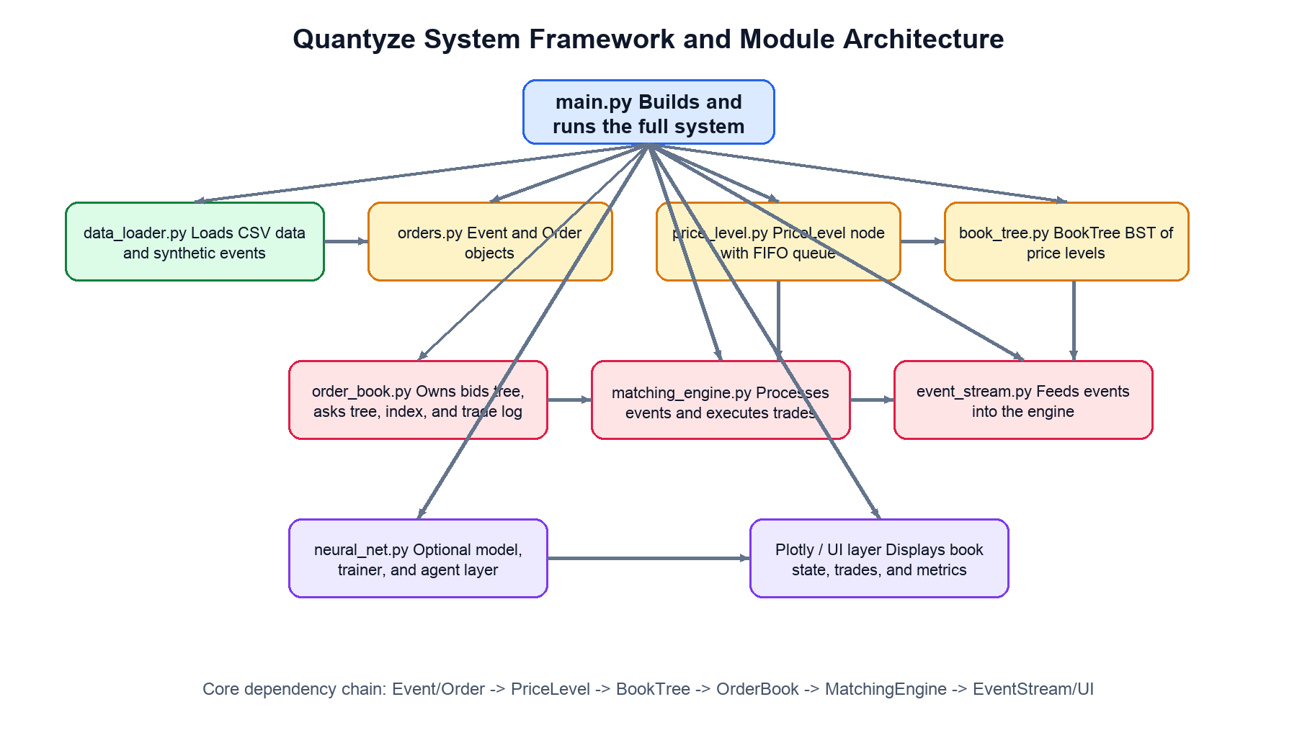
Figure 6.3.1. Module dependencies and top-level system framework.

6.3.2 Order Book Core Layout
The live order book owns two BookTree instances, one for bids and one for asks. In both trees, left means lower price and right means higher price. The only side-specific difference is which extreme counts as best: bids use the maximum-price node, while asks use the minimum-price node.
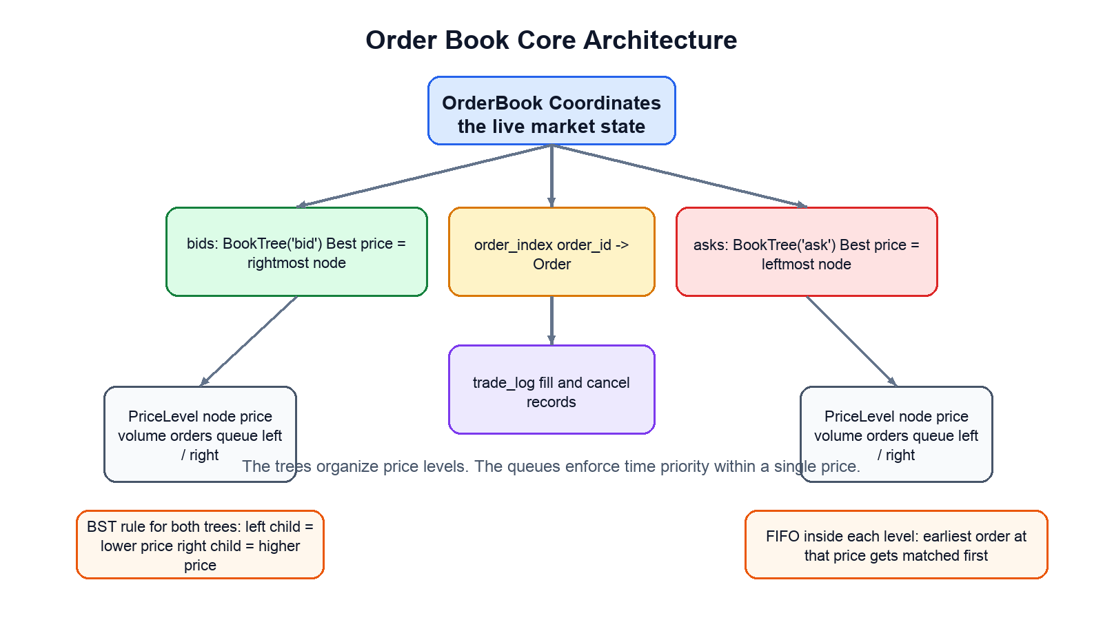
Figure 6.3.2. Internal structure of the order book and price-level trees.

6.3.3 Runtime Processing Flow
At runtime, each incoming Event is emitted by EventStream, dispatched by MatchingEngine, applied to OrderBook and its BookTree/PriceLevel structures, and then reflected in the execution log, metrics, and UI.
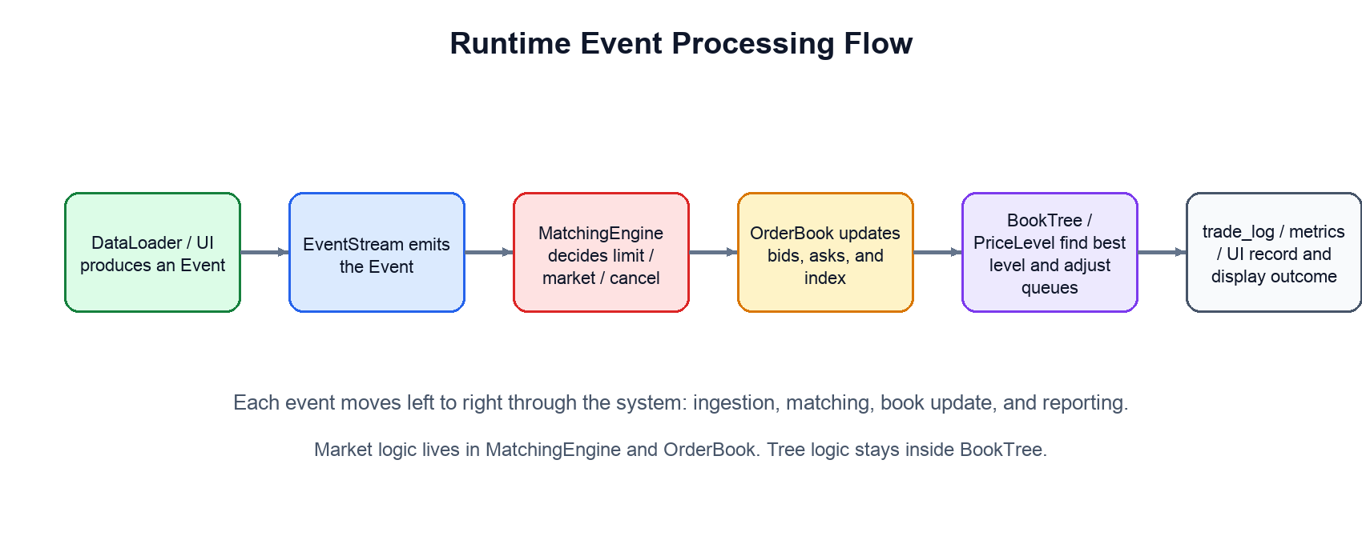
Figure 6.3.3. Event processing flow from ingestion to output.

6.4 Transaction Log Entry
Field | Description
timestamp | When the fill occurred
maker_order_id | Resting order that was hit
taker_order_id | Incoming aggressor order
side | Side of the taker order
filled_qty | Quantity exchanged in this fill
exec_price | Actual execution price
remaining_qty | Taker remaining quantity after this fill
slippage | Execution price minus expected price
Each fill record follows the execution-log structure in the class reference: timestamp, maker_order_id, taker_order_id, side, filled_qty, exec_price, remaining_qty, and slippage.

7. Matching Engine Logic

7.1 Processing Pipeline (per event)
- Validate and normalize the Event (see Section 6.2)
- MatchingEngine.process_event routes the Event to process_limit, process_market, or process_cancel
- For a cancel: resolve order_id through OrderBook.order_index, remove the order from its PriceLevel queue, and delete the tree node if the level becomes empty
- For a limit order: compare against the best price on the opposite BookTree and match immediately if the price crosses
- For a market order: walk the opposite BookTree from the best price inward until quantity is exhausted or the side is empty
- Within each matched PriceLevel, consume resting orders in FIFO order
- For each fill: build a fill record, update slippage and metrics, and append the result to execution_log and OrderBook.trade_log
- If a limit order has residual quantity after matching, rest it at its own PriceLevel in the appropriate BookTree
- After matching, clean any empty PriceLevel nodes from the trees
- Expose the updated book state, trade log, and metrics to the API / UI layer
- Append all log entries for this event

7.2 Match Conditions and Routing
Order Type | Side | Match Condition
Limit | Buy | Match while best ask exists and incoming buy price >= best_ask.price; otherwise rest in bids tree
Limit | Sell | Match while best bid exists and incoming sell price <= best_bid.price; otherwise rest in asks tree
Market | Buy | Walk the ask tree from the minimum-price node upward until quantity is exhausted or asks are empty
Market | Sell | Walk the bid tree from the maximum-price node downward until quantity is exhausted or bids are empty
Cancel | Either | Resolve by order_id through order_index; remove from its PriceLevel; delete empty price nodes
The reference implementation separates matching behaviour by order type. Limit orders may rest in the book; market orders never rest and instead walk the opposite tree greedily from the current best price.

7.3 Ground-Truth Validation
After processing each event, the engine's computed best bid and best ask can be compared against the corresponding row in the LOBSTER orderbook CSV. A mismatch indicates a bug in the BST or matching logic. This gives 57,515 built-in test cases.
assert abs(book.best_ask() - ob_ground_truth[i][0] / 10000) < 1e-6
assert abs(book.best_bid() - ob_ground_truth[i][2] / 10000) < 1e-6

8. Performance Metrics

Metric | Formula | Interpretation
Bid-Ask Spread | best_ask − best_bid | Liquidity indicator
Market Depth | Σ volume at each price level | Price impact of large orders
Fill Rate | fully_filled / total_orders | Execution success rate
Slippage | exec_price − expected_price (signed) | Positive = paid more than expected
Execution Cost | Σ (exec − mid) × qty | Total cost above mid across all trades
Queue Wait Time | exec_time − submit_time | Latency from submission to fill
Simulated P&L | Σ cash flows across all fills | Net result of simulated strategy

9. Visualization (Python / Plotly)

⚠ All visualization is implemented in Python using Plotly. No React.js or Flask is used. The handout permits only pure Python (plus trivial JS for simple static webpage display if needed). Note: ui.js exists in the repository as a scaffold. The active visualization is produced entirely in Python via Plotly as stated in Section 1.3.

9.1 Plotly Figures Produced
- Mid-price over time (line chart)
- Bid-ask spread over time (line chart)
- Order book depth curves — cumulative bid and ask volume vs. price (area chart)
- Order event feed — timestamped table of submitted, matched, partially filled, and cancelled orders
- Metrics summary panel — fill rate, avg slippage, total execution cost, total P&L
- (Optional) Side-by-side comparison across simulation scenarios

9.2 Display Method
Plotly figures are rendered using plotly.offline.plot() or plotly.io.show() depending on environment. If an HTML file is produced, it may contain minimal JavaScript for interactivity (e.g., Plotly's built-in controls), which is permitted by the handout exception for simple interactive webpages.
ℹ The TA will not review any JavaScript code. Interactive features are provided by Plotly's standard output, not custom JS.

10. ML Module (Optional Extension)

This module is an extension and is not required for the core submission. In the reference architecture, the ML layer lives in neural_net.py and is composed of OrderBookNet, Trainer, and Agent. If included, pretrained weights must be shipped with the project so the TA can load them immediately.

10.1 OrderBookNet, Trainer, and Agent
- OrderBookNet is a PyTorch neural network that maps a book-state feature vector to three logits: buy, sell, or hold.
- Trainer owns the training loop, loss function, optimizer, validation pass, and checkpoint saving to model.pt.
- Agent loads model.pt, observes the current OrderBook state, selects an action, and records running P&L.
- Saved artifact: model.pt - written by Trainer.save() and loaded by Agent during inference.

10.2 Input Feature Vector
Feature | Description
best_bid | Current highest bid price
best_ask | Current lowest ask price
spread | best_ask - best_bid
bid_depth_1 | Top bid-side resting volume
ask_depth_1 | Top ask-side resting volume
bid_depth_2_to_5 | Additional bid-side depth features
ask_depth_2_to_5 | Additional ask-side depth features
mid_price | Arithmetic midpoint of best bid and ask
imbalance | Book imbalance derived from bid and ask depth
The reference feature extractor builds a book-state vector from values such as best bid, best ask, spread, depth levels, mid-price, and order-book imbalance. The resulting vector is passed to OrderBookNet.forward() during inference and training.

11. Evaluation Criteria (from Handout)

11.1 Overall Computational Complexity — Three Areas
The handout states a strong project (A grade) needs at least two of the three areas, or one to an exceptional degree. An A+ needs multiple areas to an exceptional degree.

Area | Description | Quantyze Coverage
1. Non-trivial data processing | Filtering/cleaning data, merging datasets, building trees/graphs from data | Loading + validating 57,515 LOBSTER events; building BST order book from real tick data
2. Non-trivial algorithms | Implementing algorithms beyond built-ins / library calls; going beyond course exercises | Full price-time priority matching engine with BST + FIFO; custom BST implementation
3. Non-trivial visualization / interactivity | Multiple Plotly graphs, AI recommendations, interactive display | Multiple Plotly charts (price, spread, depth, metrics); optional ML recommendation display

11.2 Report Sections Required
Section | Requirement
Title + Names | Required on page 1
Introduction / Problem + Goal | Goal must be in bold. Include inline citations.
Dataset Description | Name, format, source URL, which columns are used
Computational Overview | How trees/graphs are used, major computations, visualization, libraries
Running Instructions | How TA downloads zip, installs requirements, runs main.py, what to expect
Changes from Proposal | What changed since Phase 1 and why
Discussion | ~500–800 words. Results, limitations, next steps.
References | All datasets, libraries, papers cited

11.3 Peer Evaluation & Weighted Individual Grade
Each group member submits a self-evaluation and peer-evaluations for all other members after the deadline. Individual grade = overall project grade × contribution score (out of 1.0).
Contribution is assessed across four categories:
- Communication: listening, clarifying, explaining, encouraging
- Decision Making: multi-perspective analysis, logical problem-solving, adaptability
- Collaboration: inclusive participation, constructive feedback, crediting others
- Productivity: staying focused, meeting deadlines, setting priorities, monitoring progress

12. AI Agent Integration Context

12.1 Invariants the Agent Must Preserve
- The bids BST must always yield the maximum price as the best bid
- The asks BST must always yield the minimum price as the best ask
- FIFO ordering within each price level must never be violated
- order_id values must be globally unique across all active orders
- Every match must produce exactly one transaction log entry per (aggressor, resting) pair
- volume at each PriceLevel must equal the sum of quantities in its FIFO queue
- PriceLevel.volume (not total_volume) must equal the sum of remaining_qty across its queue at all times
- Empty price nodes must be deleted immediately after their last order is consumed
- All code must be pure Python 3.13.5 — no non-Python dependencies
- All files must be at top level — no subfolders

12.2 Operation Complexity
Operation | Data Structure | Expected Complexity
Insert new price level | BST | O(log n)
Delete empty price level | BST | O(log n)
Find best bid / best ask | BST | O(log n)
Enqueue order at price level | FIFO deque | O(1)
Dequeue order at price level | FIFO deque | O(1)
Cancel order by order_id | dict + BST | O(1) lookup + O(log n) cleanup
Compute fill rate | Transaction log | O(N) where N = log length

12.3 Prompt Suggestions for Agent
- When implementing matching logic: keep routing in MatchingEngine, tree operations in BookTree, and FIFO queue logic in PriceLevel.
- When adding a metric: compute it from execution_log / trade_log, expose it through MatchingEngine.compute_metrics(), and surface it through EventStream / the UI layer.
- When debugging fills: verify volume consistency at each PriceLevel, then check best-price lookup in BookTree, and only then inspect FIFO behaviour within the queue.
- When generating any code: ensure it is pure Python 3.13.5, no external runtimes
- When writing any module: include module docstring with title, description, copyright claim, and a main block with doctest.testmod() and python_ta.check_all()
- When handling Type 5 events (hidden executions): log as external fill, never look up order_id='0' in the book
- When prices come from LOBSTER: always divide by 10000 before using as USD

13. References

- Plotly Technologies Inc. Plotly Python Graphing Library. https://plotly.com/python/
- PyTorch Contributors. PyTorch Documentation. https://pytorch.org/docs/stable/index.html
- PyTorch. https://pytorch.org/
- Investopedia. Limit Order Book. https://www.investopedia.com/terms/l/limitorderbook.asp
- Investopedia. Depth of Market (DOM). https://www.investopedia.com/terms/d/depth-of-market.asp
- QuestDB. Limit Order Book Glossary. https://questdb.com/glossary/limit-order-book/
- LOBSTER. Limit Order Book System — The Efficient Reconstructor. https://lobsterdata.com
- NUS@Oxford (2019). Introduction to Limit Order Book Markets. University of Oxford. https://www.maths.ox.ac.uk/system/files/attachments/NUS-LOB19.pdf
- Skiena, S. Market Microstructure Lecture Notes. Stony Brook University. http://www3.cs.stonybrook.edu/~skiena/691/lectures/lecture24.pdf
- University of Toronto. CSC111 Project 2 Phase 2 Handout. Winter 2026.

