Image Restoration: Noise Reduction Techniques in Digital Image Processing

First: Median filter
In image processing median filter is usually necessary to perform a high degree of noise reduction in an image before performing higher-level processing steps. The median filter is a non-linear digital filter technique, often used to remove speckle (salt and pepper) noise from images or other signals. Median filtering is a common step in image processing.
The main idea of the median filter is to sort the pixel values in a neighborhood region with certain window size (W_{S}) and then chose the median of these values and places it in the center of the window in a new image, see figure 1.
Old Image
Old Value
Sort and chose median
New Value
……
New Image
……….
Window
W_{S}
W_{S}
Figure 1: Main idea of median filter
As the window size increased, the effect of the filter is increased, as shown in figure 2.

Implementation steps of Median filter on Image
The idea is to calculate the median of neighboring pixels' values. This can be done by repeating the following steps for each pixel in the image:
- Store the values of the neighboring pixels in an array. The array is called the window, and it should be odd sized.
- Sort the values in the window in ascending order.
- Pick the median from the window as the new pixel value and place it in the center of the window in the new image, see figure 1.

Notes
- We work on gray-level images. So, each pixel has a value ranged from 0 to 255. Where 0 is the black pixel and 255 is the white pixel.
- The median is the middle value in the window array after sorting.

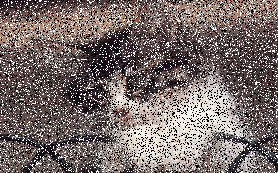
Image with salt & pepper noise Median filter with window 3×3


Median filter with window 5×5 Median filter with window 7×7
Figure 2: Effect of the median filter with different window size

Second: Mid-point filter
It is also a non-linear digital filter technique, often used to remove random noise from images or other signals.
The main idea is similar to the median filter except that instead of choosing the median, it calculates midpoint = (min + max) / 2 and places it in the center of the window in a new image, see figure 3.
Old Image
Old Value
Midpt = (min + max) / 2
New Value
……
New Image
……….
Window
W_{S}
W_{S}
Figure 3: Main idea of midpoint filter
As the window size increased, the effect of the filter is increased, as shown in figure 4.

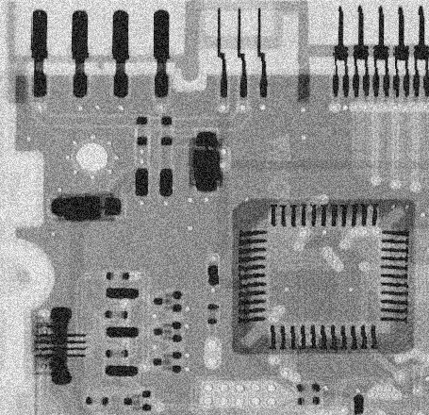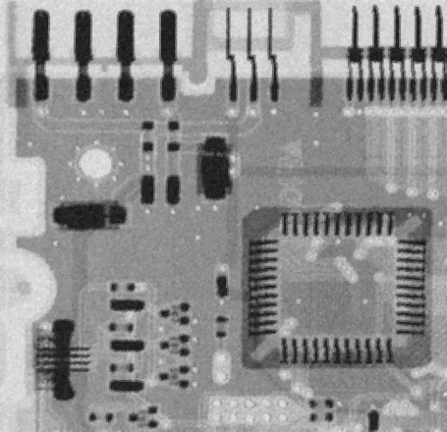
Image with random noise Midpoint filter with window 3×3

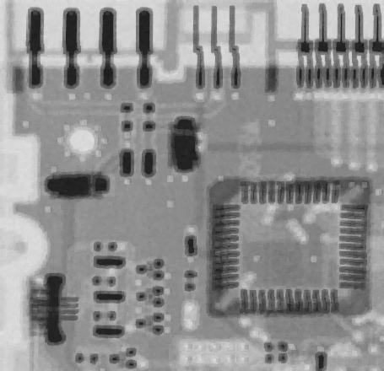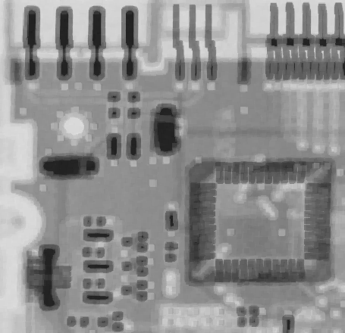
Midpoint filter with window 5×5 Midpoint filter with window 7×7
Figure 4: Effect of the midpoint filter with different window size

Implementation steps of Midpoint filter on Image
The idea is to calculate the midpoint of neighboring pixels' values. This can be done by repeating the following steps for each pixel in the image:
- Store the values of the neighboring pixels in an array. The array is called the window, and it should be odd sized.
- Chose the min and max value of this window.
- Calculate the midpoint as the new pixel value and place it in the center of the window in the new image, see figure 3.

Project Requirements
- Apply the median filter with three different algorithms:
- Quick sort.
- Counting sort.
- Selecting K^{th} smallest element (median) in the array without sorting it (Textbook sec. 9.2). where K = index of median = (W_{S} × W_{S}) / 2
- Apply the midpoint filter with two different algorithms:
- Selecting each of the min and max value separately.
- Selecting both of them efficiently as described in Textbook sec. 9.1.
- Display two graphs (one for each filter) to show the execution time of each method against different window size.

Notes:
- To calculate time of certain peace of code:
- Get the system time before the code
- Get the system time after the code
- Subtract both of them to get the time of your code
To get system time in milliseconds, you can use System.Environment.TickCount
- To draw the graph, you can use the Z-graph library attached with the project materials.

Given:
- TEMPLATE C# Code to
- Open image & load it in 2D array stored in a global variable of type byte[,]called ImageMatrix, using the following function inside ImageOperations class
byte [,] OpenImage(string ImagePath)
- Get width and height of the image matrix
int GetHeight(byte[,] ImageMatrix)
int GetWidth(byte[,] ImageMatrix)

- Display an image on a given PictureBox control using the following function inside ImageOperations class
void DisplayImage(byte[,] ImageMatrix, PictureBox PicBox)
- Zed-Graph library to use it for drawing the graph, with sample code showing how to use it.

Input:
- Noisy image
- Window size of the filter
- You should allow the user to select
  - filter (median or midpoint)
  - method to be used under the selected filter (e.g. counting, quick, Kth smallest in median filter)

Deliverables

Implementation (60%)
- Midpoint filter using 2 methods
- Select min & max separately
- Select both of them efficiently (sec. 9.1)
- Median filter using 3 methods
- Select K^{th} smallest element (sec. 9.2)
- Counting sort
- Quick sort
- Display two graphs (one for each filter) to show the execution time against different window size for different methods within the filter.

Document contains (40%):
- Midpoint filter codes
- Median filter codes
- Detailed analysis of the above codes (handwritten analysis only not printed)
- Median filter: Determine which method is better based on your results? And explain why?

BONUS TASK:
There are some heuristics that can achieve implement median filter in image processing in MUCH better performance than any sorting algorithm. Try to find/search the idea and implement it.

