# Part 1 – Setting Up a Flask App Image

## Build Flask App Image Using Dockerfile

Create a dockerfile with instructions on how to set up the Flask application:

Build an image using the dockerfile – image is called flaskapp:v1

Run image on a container and map host port 8321 to container port 5000:

Check by navigating to <http://localhost:8321>:

## Push the Flask App Image to Docker Remote Repository

Tag the flaskapp image first using **docker tag** command:

Push the newly created image to remote repository with **docker push** command:

Confirm that it is available online:

# Part 2 – Setting Up AWS ECS

## IAM – ECS Role Creation

Select *AWS Services* for Trusted Entity Type and *Elastic Container Service (Elastic Container Service Task)* for Use Case:

Enter Role Details and Create Role:

## ECS Cluster

Navigate to ECS > Cluster > Create Cluster and select Networking Only to use AWS Fargate:

## ECS Task Definition

Set Task memory and CPU size:

Click Add Container:

Keep all other configurations as default and create task definition:

ECS Task (i.e. Container)

Select Fargate as launch type and Linux as OS Family:

Select a VPC and a subnet to use – make sure to set security group correctly with right ports:

Confirm creation of task:

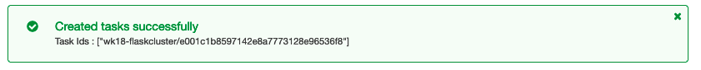

Navigate to <http://3.82.240.254:5000/> to check that the container is running:

## Tearing Down Resources in ECS

Stop the Task:

Delete Cluster:

Deregister Task Definition:

