Using Docker Compose and Dockerfile to Deploy a Full Stack App

In a project directory called fullStackApp, create two sub-folders – one for frontend and one for backend

In each of the folders, create a dockerfile:

fullStackApp/frontend/dockerfile

fullStackApp/backend/dockerfile

Make sure urls inside the frontend’s App.js and APIService.js files are correct (i.e. <http://localhost:5000/>)

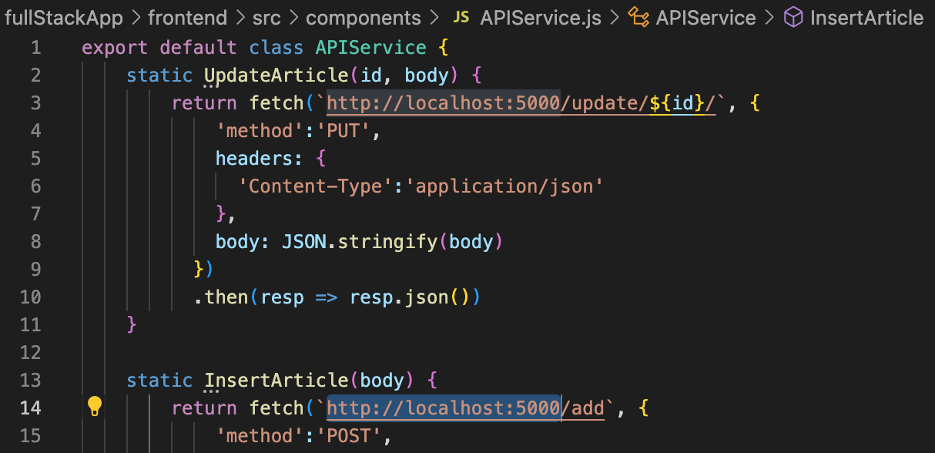

Then, create a docker-compose file at the project directory level:

fullStackApp/docker-compose.yaml

Lines 5 and 9 indicates the location of dockerfile, which contains the build configuration for creating container images

Lines 6-7 and 10-11 indicates the mapping of host port to container port

Once you access the website: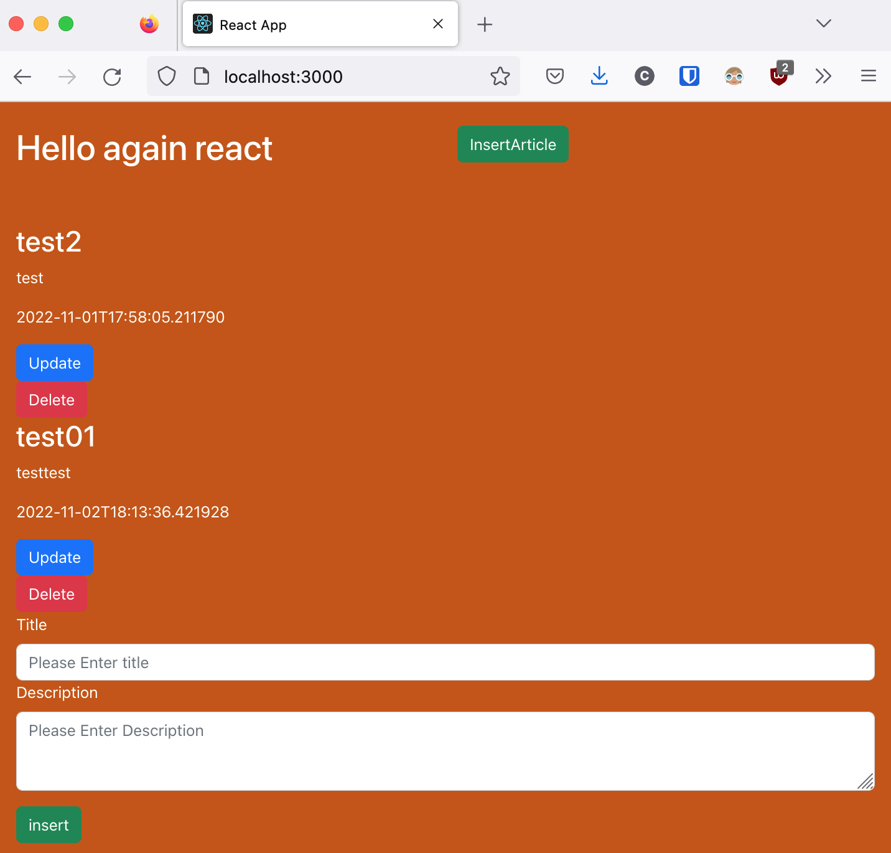



To destroy the created containers and images, run the command ***docker-compose down***:



***Notice that there is a network that gets created and deleted – this is how the co