# Using Docker Compose and Dockerfiles to Deploy a Full Stack App

## Setup

In a project directory called *fullStackApp*, create two sub-directories called *frontend* and *backend* and upload necessary application files inside each of the corresponding folder

For *frontend*, make sure the URLs inside *App.js* and *APIService.js* files are correct (i.e. pointing to <http://localhost:5000/> since that’s where backend will be):

*fullStackApp/frontend/src/App.js*

*fullStackApp/frontend/src/components/APIServices.js*

## Dockerfile

In each of the folders, create a *dockerfile* to build frontend and backend images:

*fullStackApp/frontend/dockerfile*

*fullStackApp/backend/dockerfile*

## Docker Compose

Then, create *docker-compose.yaml* at the project directory level:

*fullStackApp/docker-compose.yaml*

* Lines 5 and 9 indicates the location of *dockerfile*, which contains the build configuration for creating container images
* Lines 6-7 and 10-11 indicates the mapping of host port to container port

## Build Images and Containers

To create the images, build the containers and then start the containers, run the command ***docker-compose up***:

Access the frontend container using <http://localhost:3000>:

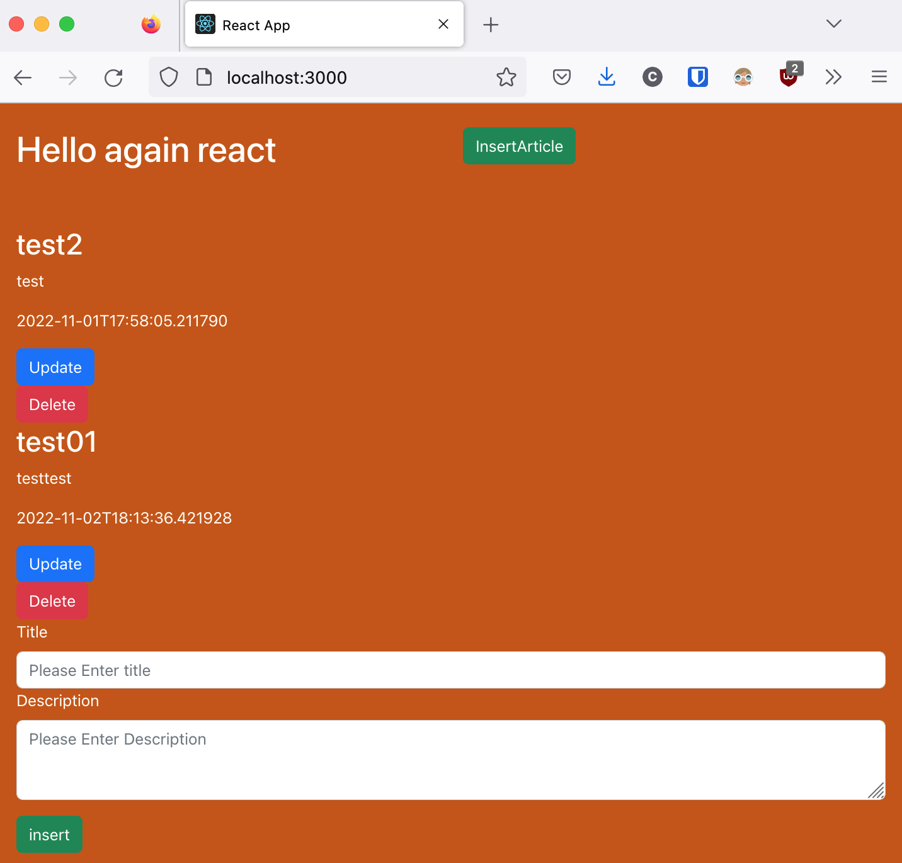

Log shows that the GET request to backend data was successful:



## Clean Up

To destroy the created containers and images, run the command ***docker-compose down***:



******************************************************************************

Notice that there is a network that gets created with ***docker-compose up*** and deleted with ***docker-compose down***:

[Docker Compose Documentation](https://docs.docker.com/compose/networking/):

*By default Compose sets up a single network for your app. Each container for a service joins the default network and is both reachable by other containers on that network, and discoverable by them at a hostname identical to the container name.*

******************************************************************************