CSCI 320 – Lab 2.0

Created by Caden Johnson

2/20/2021

**Objectives:**

The objective of this lab was to load a vector into memory and then reverse it’s contents.

P.S. – As I was looking at the Lab, I became a little confused since there are two versions posted in “Assignments” and “2021New”. I am assuming that the lab found in “2021New” is the required lab, but if I am mistaken, then there is also the concept of Block Move that I am missing, allowing the program instruction to move to another memory location.

**Equipment Used:**

Easy68k Simulator

**Procedure:**

I uploaded the code provided by the lab guide, and walked through how the memory was loaded, what registers were used, and how the program went about reversing the vector by swapping the letters. This was done using the three-step method using the data register “D0” as a temporary storage while one letter replaced the other. The swapped letters were then moved to their new memory locations,

P.S. – I noticed through this lab that (in this simplified example) we could instead:

1) use the same memory location as the original vector to save memory space

or

2) use a post decrement move instruction to work through the vector (backwards) and save lines of instructions as well as removing the use of the data register.

**Operations Used:**

MOVE.B

LEA.L

Direct An

Indirect (An)

Increment (An)+

Decrement –(An)

Data Registers (D0-D7)

**Description:**

As mentioned before, I used pen and paper to determine changes in the memory and registers before I executed the program. After, I used a trace to double check and go further into analyzing the program. Using the Trace function in Easy68k, I was able to trace the program step-by-step and see each change in memory. Using this, I was able to learn more and become more acquainted with memory and addressing modes.

**Code:**

Below is the code that I used for the program:

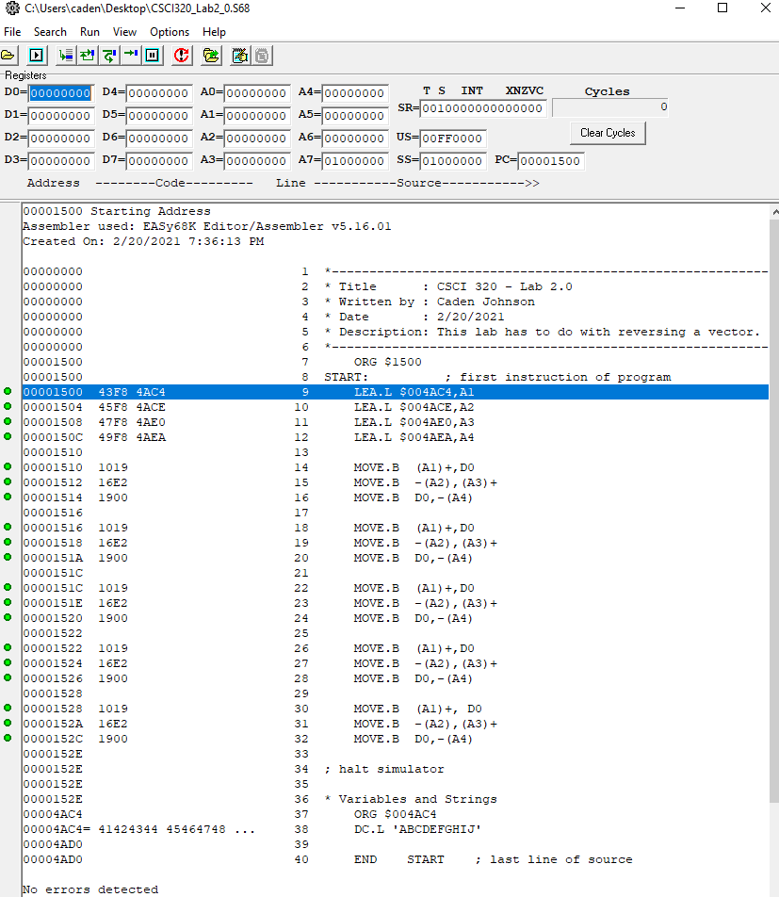

**Results:**

Before Memory:

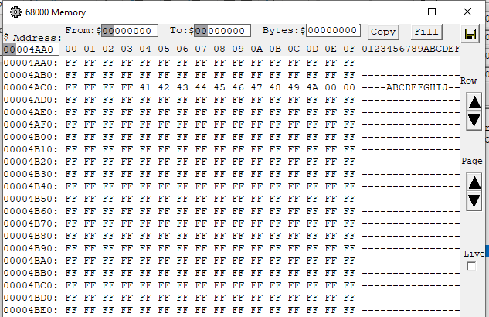

After Memory:

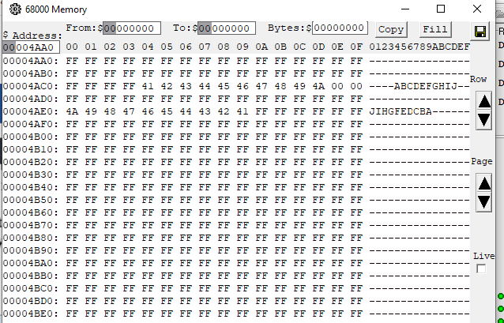

Here is the beginning of the trace file. I will also attach this to my submission on D2L:

