Itrack Process , CR Process,User Process,RM CM,EBS User deletion :
- Overview
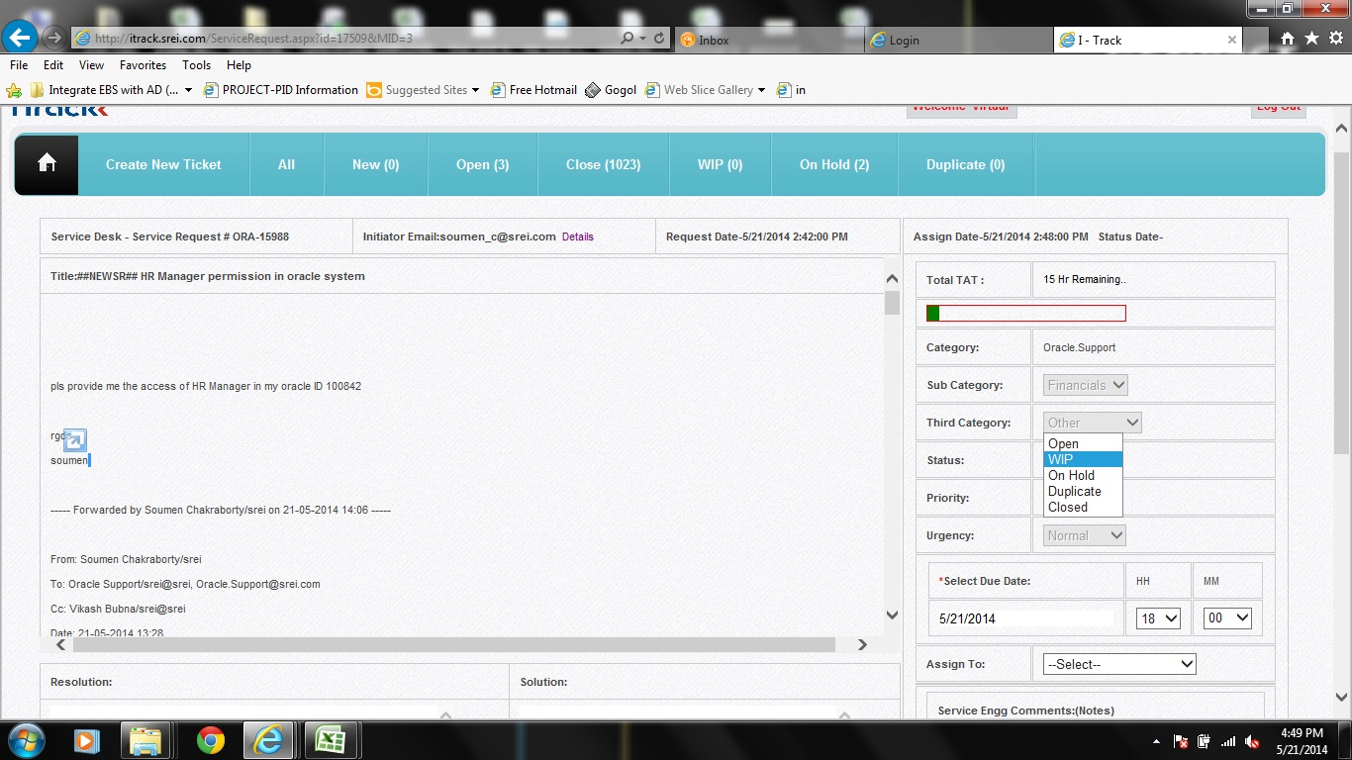
SREI group usually send calls to db.support@srei.com . Calls are handled using SREI’s iTracker system. Calls are handled via tickets raised by SREI’s users and the ticketing tool can be accessed from http://itrack.srei.com. Users will raise ticket by email with hash in the subject line as ##NEWSR## and send to db.support@srei.com
Fig:1 The iTracker System
- Ticket Lifecycle
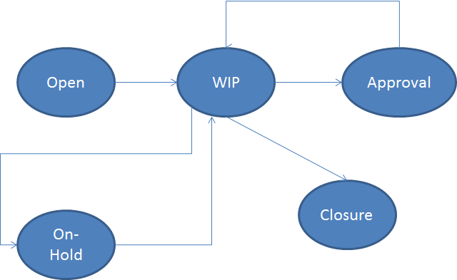

- The iTracker System
  - How to access
- Invoke iTracker : http://itrack.srei.com
- Login : db.support@srei.com
- Password ********
The screen below will appear with multiple tabs for e.g.

  - iTracker Tabs
New : Ticket is has been raised to db.support@srei.com by users.
Assign : Ticket to be assigned to the engineer after choosing sub-category,third- category and priority
Open : for ticket which has been raised by users, can be checked.
Close : for ticket (issue) which has been closed.
WIP(Work in progress) : for ticket (issue) where issue is in working (to be completed)
On Hold : for ticket (issue) where issue is in holding state (may be because of time frame at later or after office hours)
Duplicate : for ticket (issue) which has been raised more already.
Priority : As per incident severity HIGH/MEDIUM/LOW (if production server not accessible then HIGH)

  - Ticket Types :
Tickets are in two form either Incident or Change Request (CR). Issue which can be resolved without changing in DB/Application those will be considering as Incident, whereas issues which can’t be resolved without changing any DB/Application will be raised as a Change Request (CR ) accompanied with change request form.
  - Resolving the Ticket
Incident could be resolved by the concern person from DB / Infra team and need to update the tracker as per the status of the incident - Close / WIP / On Hold. (Note : Some of the incidents might require a CR for eg. Bug fixing by a patch,script execution/modification,etc only thing is that CR requestor will not be DB/Infra Team).
Change Requester CR Form incident could be resolved by DBA / Techno functional with the following process.
- Action Plan
- Solution
- Resolution on test incident (If required take help from oracle metaLink support)
The resolution methods are usually performed in Test / Patch servers and then sent for User Acceptance Testing (UAT)
For Change Request Form, need to take approval from Change approval board (CAB ) typically Mr. Vikash Bubna and / or Mr. Ritayan Banerjee / or Indrajyoti Mukherjee
After approval, if required then need to take approval for downtime (might be merged with previous process also) by through mail.

  - Incident closure
- Need to take necessary Backup (If required)
- Do the Action Plan Accordingly
- Deploy / Fix the necessary components. The components should be from UAT server where it has been tested and UAT sign off was obtained or as provided by user in the iTrack as attachment.
- Once deployed the incident (or ticket) in iTracker should be marked as “CLOSED”

- The iTracker Monthly dump
Login to iTrack with db.support@srei.com and click “ADMIN” tab->provide the date range for e.g. “01-05-2016 to 31-05-2016” -> Application Name -> “DB.SUPPORT”
CLICK “POPULATE”-

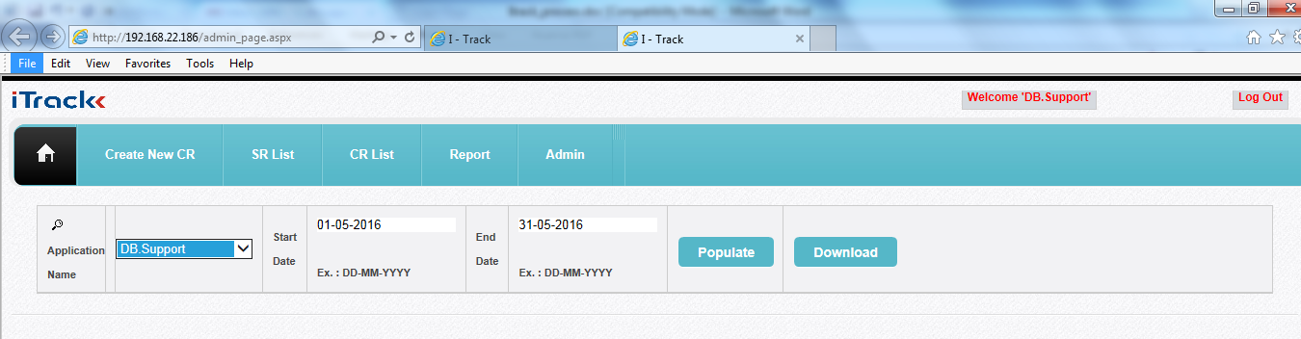
→ “DOWNLOAD”
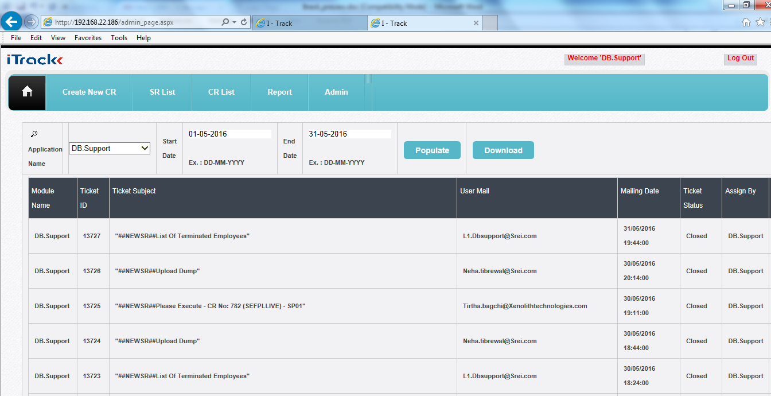

- The CR process to deploy
The CR is logged as iTrack ticket with documents or scripts attached to be executed or steps to be followed to deploy the same in Production environment. Below is an example of CR to be deployed in EBS server.

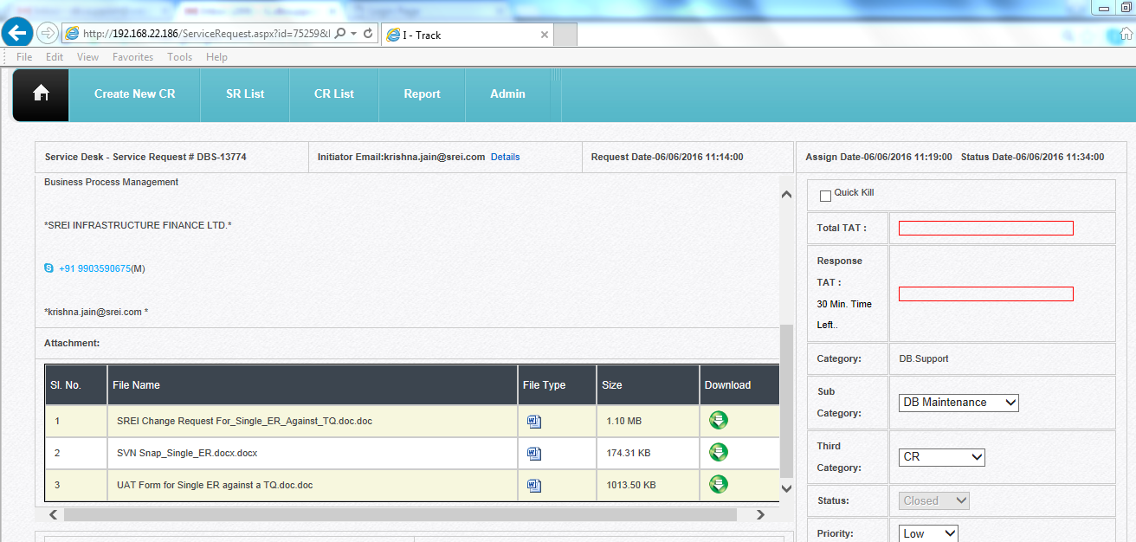

Below is the sql to be executed in SP02,here we have to execute the sql and inform user once completed the deployment in production.

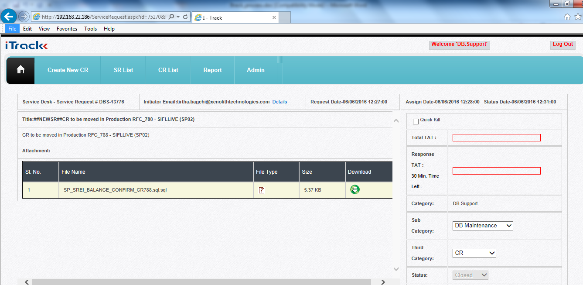

- The User password change in Production.
We have to inform user about the schema passwords that are about to change 10 days prior to expiry. Then user requests to change the password and we have to check the user belongs to which dB and what are the dB Links that will be impacted and alter the dB links as and where necessary and raise the ticket in iTrack.

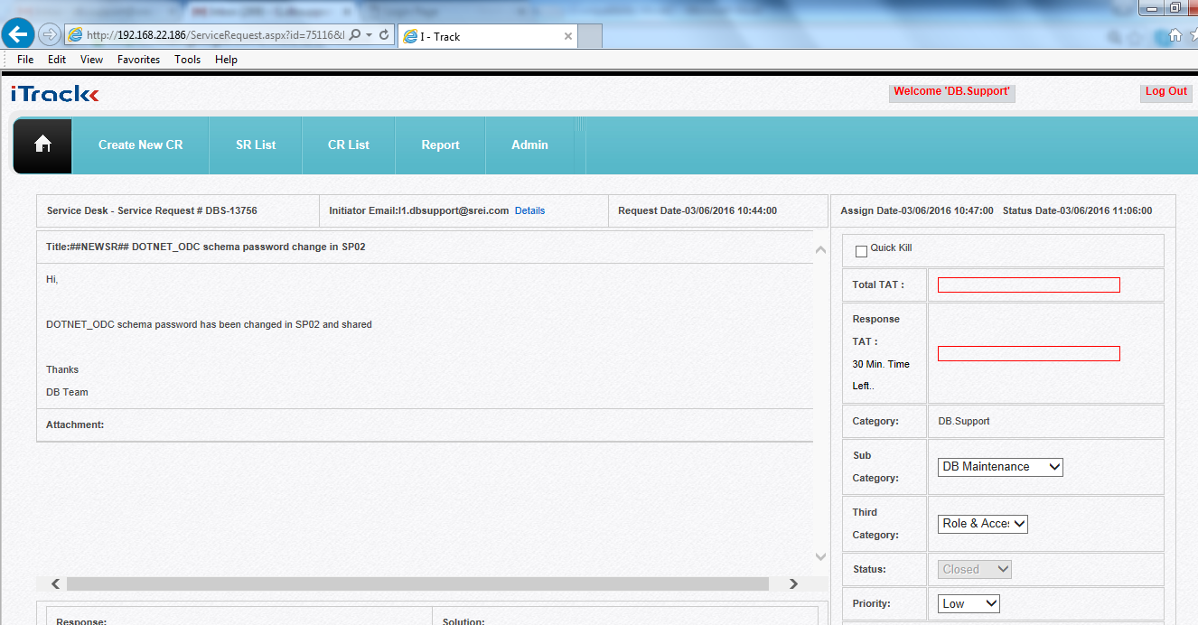

- The RM CM Process

Below is the sql to be executed in SP01, This is RM_CM sql to be executed in production environment

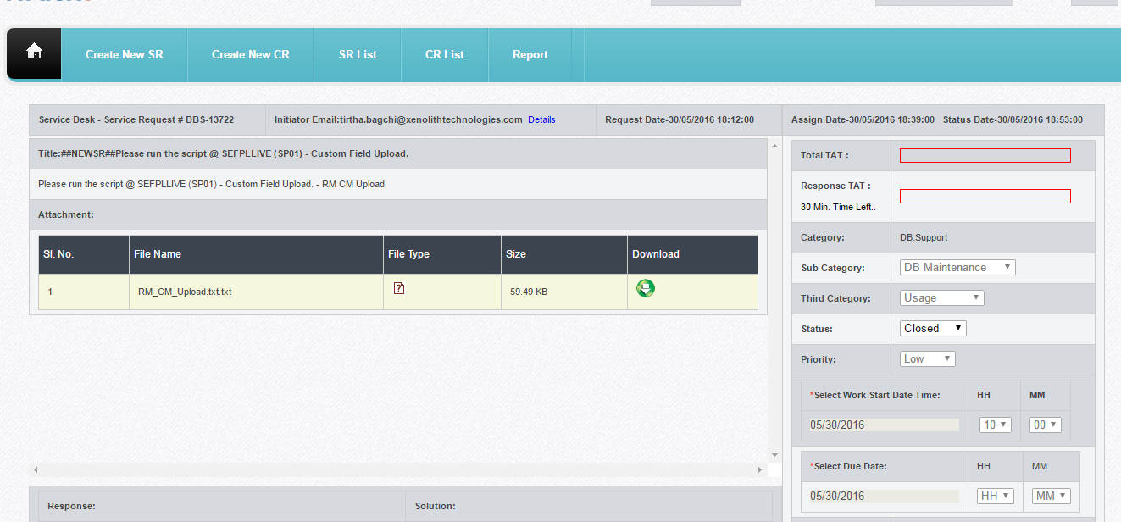

- The EBS User deletion

This is “:##NEWSR##List of Terminated Employees” which is logged in iTrack automatically at 18:19 PM daily

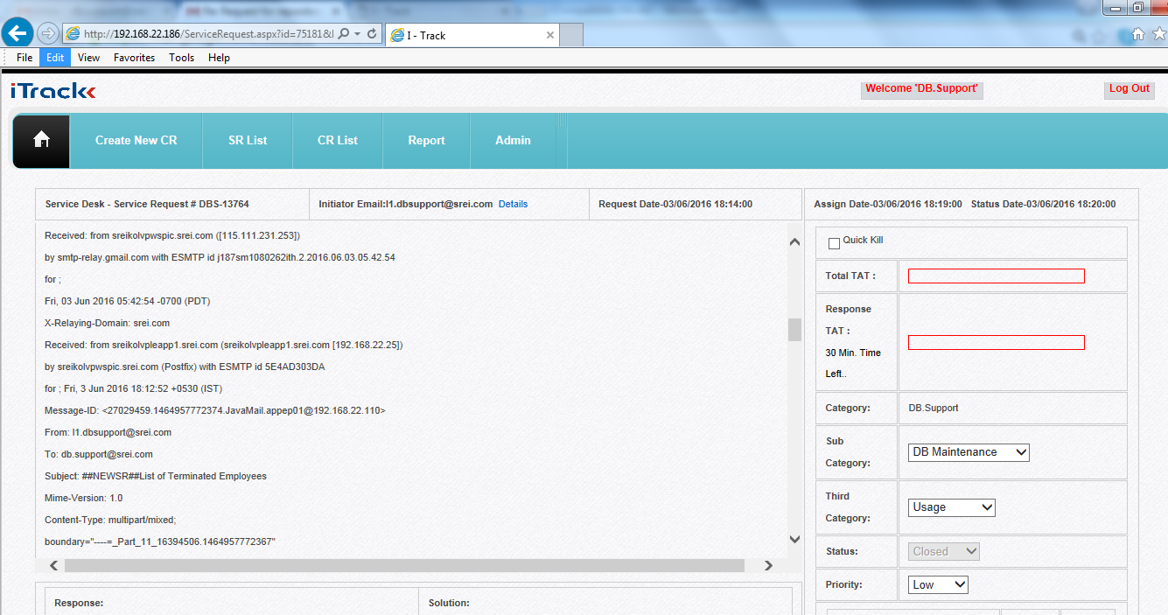

We have to login to EBS and choose “System Administrator” -> “Users”
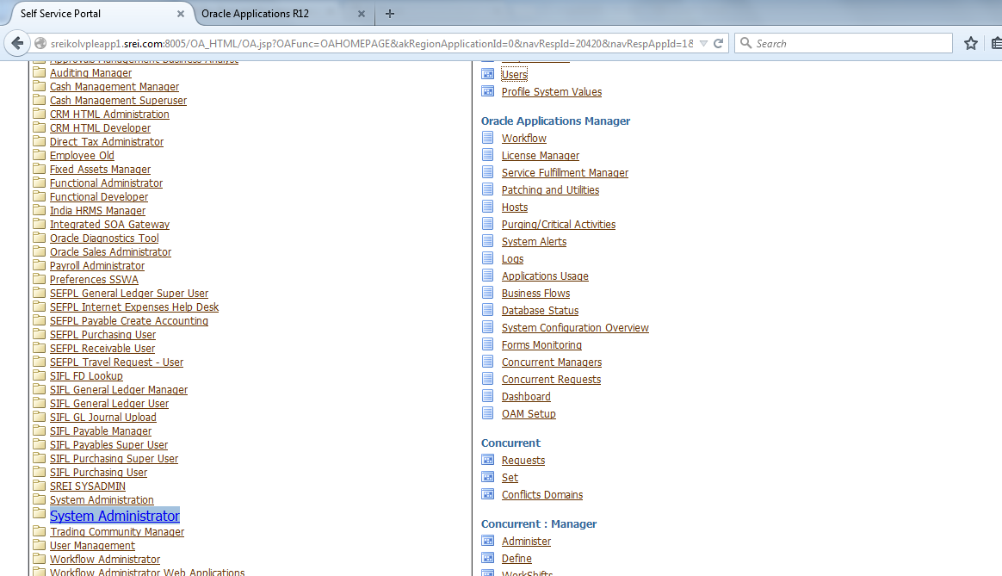

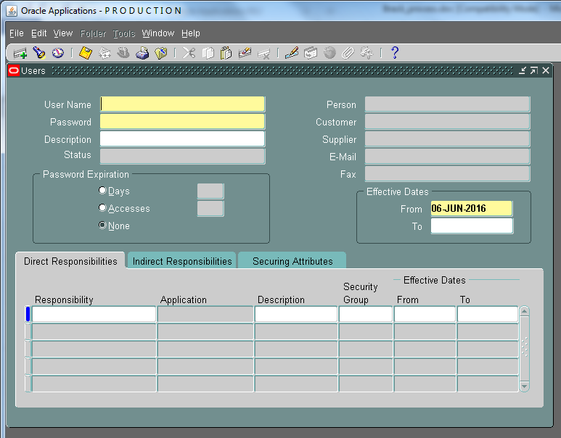
Press F11
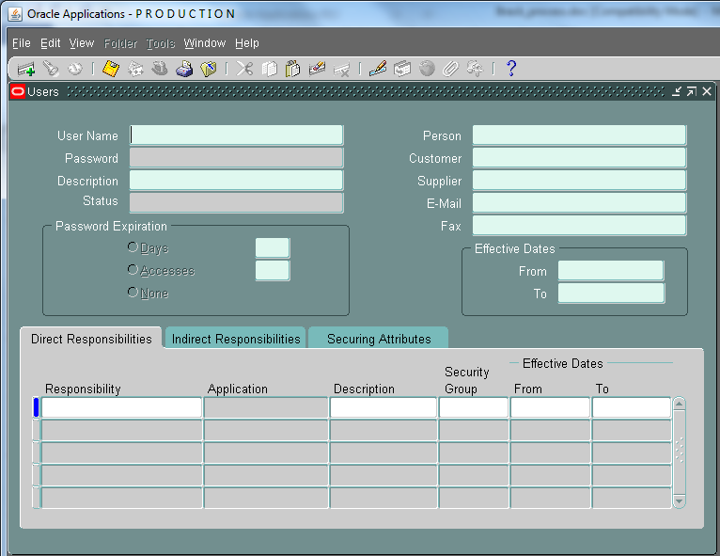
Provide the username as per list “%11846%”and press “ctrl+F11”
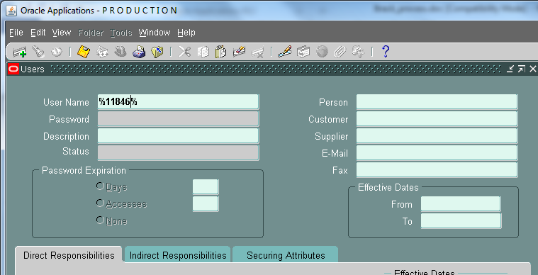

Put “END date” as per list.

- The Subversion Repository
To access subversion repository login to the URL: https://192.168.22.113:18080/svn/PWC_DB/
With username :DBA_PWC and password: $$srei12$$
And go to ep01 folder to access the files to modify or download
