**1**

Tracer measurements

CADET Workshop

PhD research book #42

2024-11-02

Ran experiments on the ÄKTA today to estimate transport effects on the column.

Used the column I received from XXXXXXX. The product specifications from the manufacturer are pasted here:



The flow rate was set to 1.0 ml/min. The column was equilibrated in 25 mM phosphate buffer at pH 7.0. The ÄKTA was set to load the column for   
1 second with Pump A, then to wash from Pump B for 180 seconds.

Solutions:

Pump A: 1 mM Acetone in MilliQ water

Pump B: 25 mM Phosphate buffer pH 7.0

A photo of the setup and the flow sheet is given in Appendix A.

For connections after the injection valve, I used the red tube set, which has an inner radius of 0.5 mm and an axial dispersion of 6 x 10-6 (based on XXXXX’s tests).

Then I replicated the experiment, this time also recording the conductivity data.

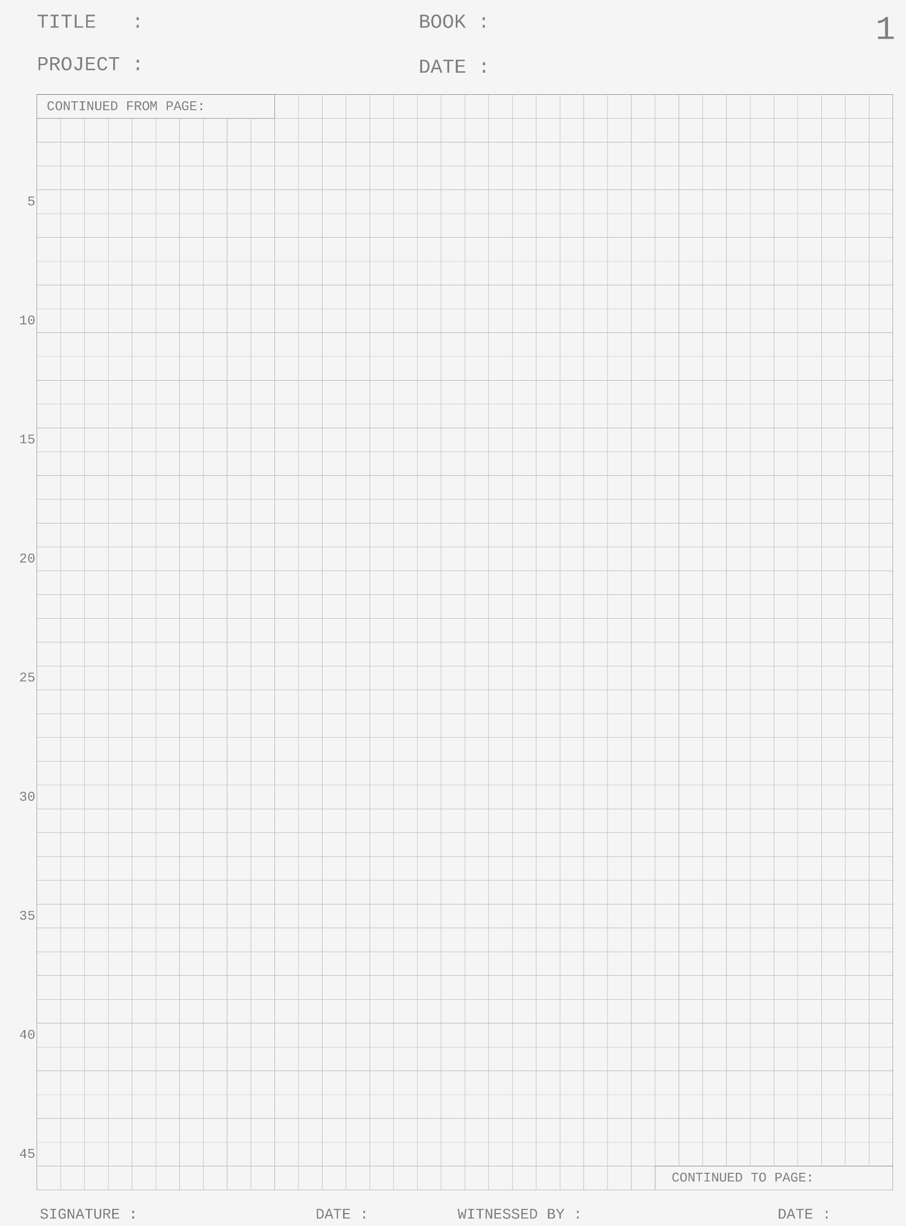

2024-11-06

Supervisor McSuperface

Phil D. Student

2024-11-02

**2**

Today I re-ran the gradient experiments.

We decided on one 15 column volume (cv) gradient and one 120 cv gradient, in addition to the breakthrough curve. The system was set up as before   
(p. 1) and equilibrated in Buffer A.

Buffers:

A: 50 mM Sodium Chloride

B: 50 mM Sodium Chloride + 1 mM of all three proteins

C: 500 mM Sodium Chloride

From t=0 to t=10 seconds, the column was loaded with Buffer B.

From 10 to 90 seconds the column was washed in Buffer A.

Then, a gradient going from 0% Buffer C to 100% Buffer C was started over 15 cv or 120 cv.   
Finally, the column was washed with Buffer C for 10 minutes.

I’ve stored the data in the experimental_results folder, with the conductivity already converted into buffer salt concentration.

For the breakthrough experiments, the same setup was used, but the column was just loaded with Buffer B for 60 minutes.



2024-11-06

Supervisor McSuperface

Phil D. Student

2024-11-04

CADET Workshop

PhD research book #42

2024-11-04

Final gradient experiments #5

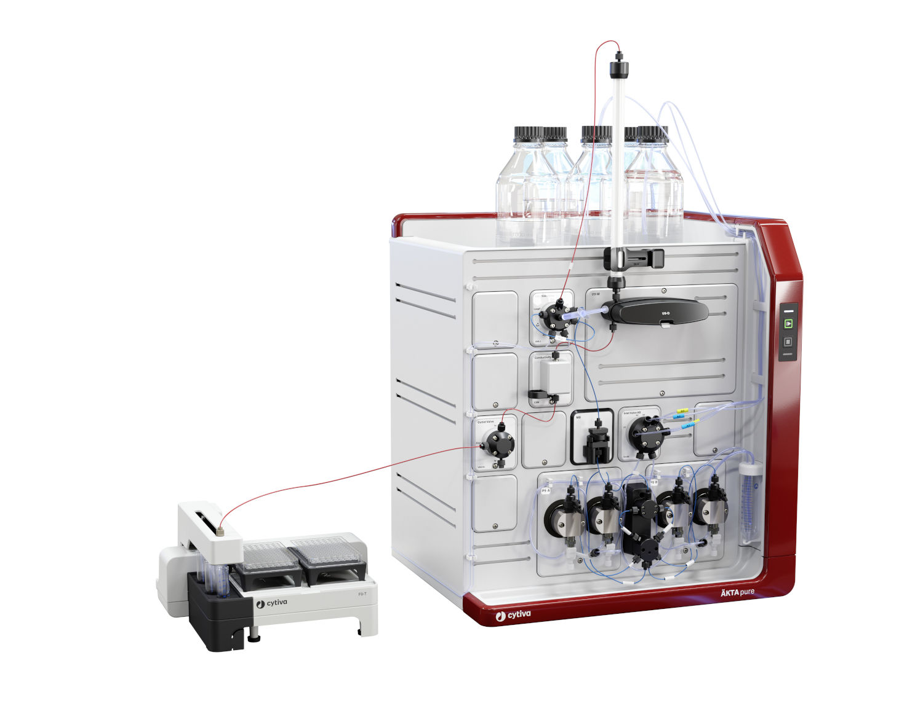Appendix A

https://www.bionity.com/de/produkte/1129840/aekta-pure-micro-cytiva.html

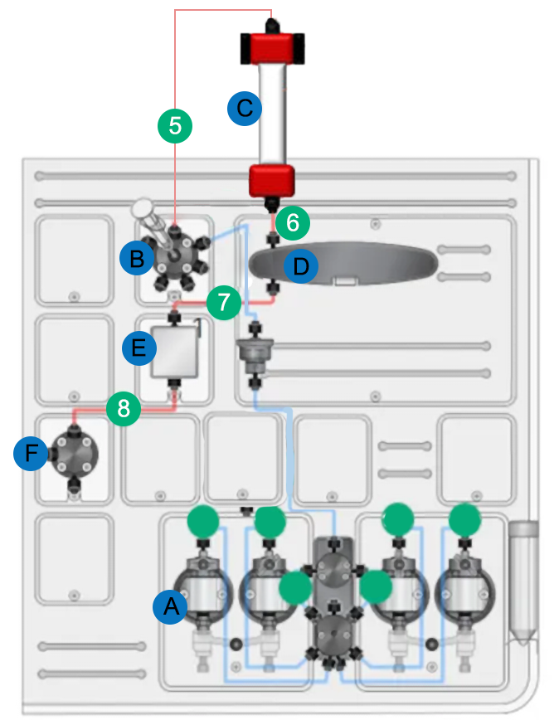

A: Pumps and mixing chamber

B: Injection valve

C: Column

D: UV detector

E: Conductivity sensor

F: Outlet valve to fractionator

5: length 10 cm

6: length 2 cm

7: length 10 cm

8: length 10 cm