Appendix Diet Summaries

Catalina Burch

2023-05-22

## Appendix 1: Focal Predator Diet Compositions over Time

An additional component of this research project was to create data visualizations of diet summaries. These plots are intended to fill knowledge gaps in management documents, including the GOA Ecosystem Status Report and the ecosystem components of commercial predators Stock Status Reports. Appendix one visualizes the change in the percent weight of prey contributions to diet over time for the four focal predator species at each size class. The size class is indicated at the top of each panel in black text. Red asterisks above bars indicates that there were fewer than 30 samples collected for that species/year/size class.

## [1] 40-54 >54 <25 25-39 >69 39-69 <39 45-59 >59 29-44 <29 29-49  
## [13] >49   
## 14 Levels: <25 <29 <39 25-39 29-44 29-49 39-69 40-54 45-59 >39 >49 >54 ... >69

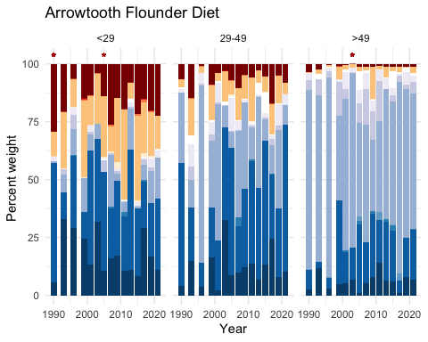

## Including Plots

You can also embed plots, for example:

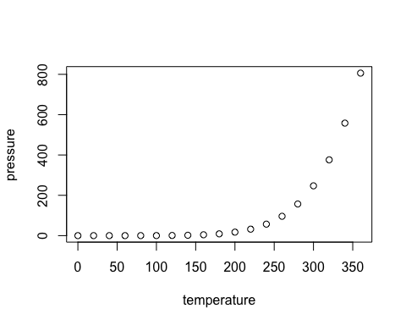

Note that the echo = FALSE parameter was added to the code chunk to prevent printing of the R code that generated the plot.