You’ve got to check out this website. This is where I downloaded the data from.

<https://www.thesquirrelcensus.com/>

Also the handy dandy squirrel siter app

<https://apps.apple.com/us/app/id1053758396>

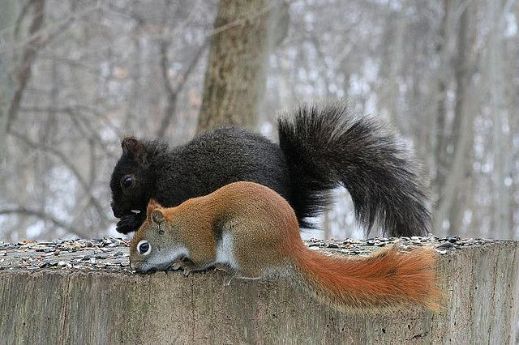

Editj slfjksdlsdfkjsdjf