Results

Chris Adlam

# Results

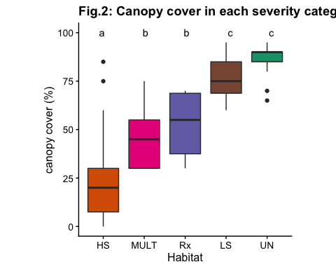

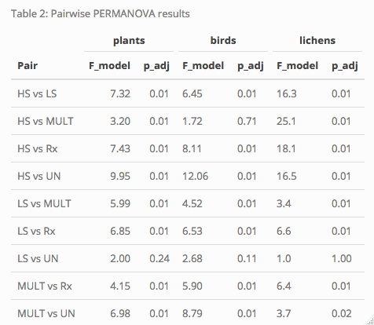

## Variation in community composition across habitats

### Effect of fire history on species composition

The main PERMANOVA revealed that species composition varies for all taxa in response to the severity category (*p* < 0.001). Using pairwise PERMANOVAs to compare the habitats, there is no detectable difference between plant and lichen communities of low-severity and unburnt stands, while the difference in bird communities was only marginally significant (Table 1). In addition, bird communities of high-severity burns and multiple burns are not detectably different. For lichens, contrary to expectations, the communities of multiple burns, thin+burn and low severity differed significantly.

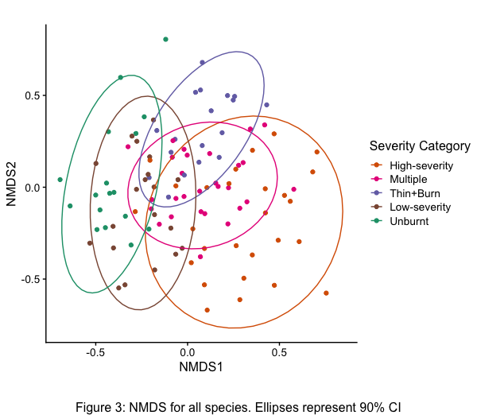

### Species assemblage ordination

The NMDS confirms a considerable overlap in species communities of long-unburnt and low-severity burn stands. high-severity stands have distinct species communities, while the communities in thinned and burnt stands and multiple burn stands appear to be intermediate between the high-severity stands and long-unburnt/low-severity stands. Figure 3 shows the first two dimensions of a 3-dimensional ordination that found convergent solutions with a stress of 0.17 (“stress” represents the degree of distortion required to reduce the dimensionality of the data; a stress of <0.20 is considered acceptable).

## Alpha, Beta, Gamma diversity patterns

### Alpha diversity

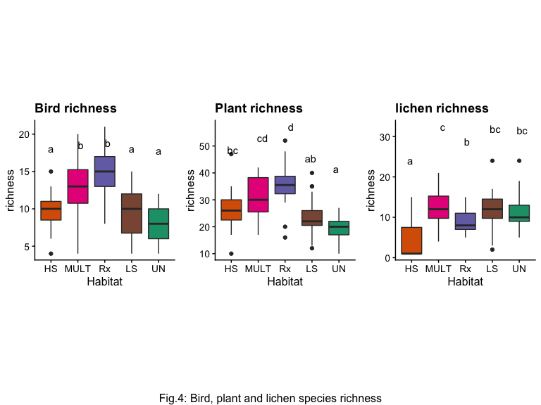

Bird and plant species richness were highest in the multiple burns and thinned and burnt stands (for plants the difference between high-severity burns and multiple burns was not significant) (Figure 4). Bird and plant richness in low-severity burns and unburnt plots was slightly lower than in high-severity burns, but the difference was overall not significant. Lichens were predictably less diverse in the high-severity stands, but richness in the other severity categories was similar.

Within the multiple burns and thinned and burnt stands, canopy cover was negatively correlated with plant richness (*F*(1,44) = 8.561, *p* = 0.005) and bird richness (*F*(1,44) = 5.302, *p* = 0.026). In the low-severity and long-unburnt stands, canopy cover was negatively correlated with bird richness (*F*(1,35) = 10.191, *p* = 0.003), but only weakly correlated with plant richness (*F*(1,35) = 2.254, *p* = 0.142). In the high-severity stands, canopy cover was not correlated with either plant or bird richness (*F*(1,25) = 2.382, *p* = 0.135 and *F*(1,25) = 1.863, *p* = 0.184 respectively).

### Beta Diversity

Beta diversity was highest in the high-severity burns and multiple burns for birds and plants, and lowest for the thinned and burnt stands, possibly because they were spatially clustered rather than because of an effect of treatment (figure 5). For lichens, high-severity burns had the highest beta diversity, likely not because of a high level of species turnover between sites, but rather because of the variation in species richness between plots with no surviving trees and those that had surviving trees, and therefore lichens.

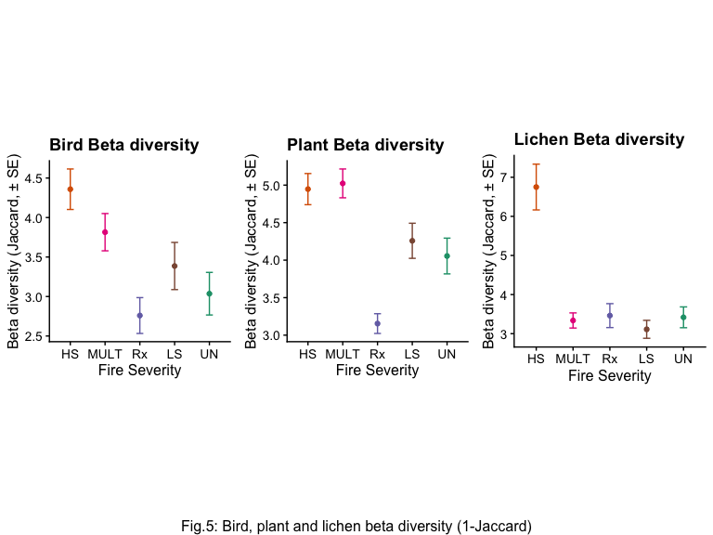

### Gamma diversity

Based on the extrapolated species richness, the total pool of species for birds appears to be largest in the multiple burns and thinned and burnt stands, intermediate in the high-severity burns, and lowest in the low-severity and long-unburnt stands (Fig. 5). For plants, the pattern is the same except that species pool from the thinned and burnt stands appears smaller than the high-severity burns, and more similar to the low-severity stands instead. high-severity fire eliminates lichens and most of their substrate [@millerAlteredFireRegimes2018], and their species pool is smaller in the high-severity stands than in the other severity categories, which are similar.

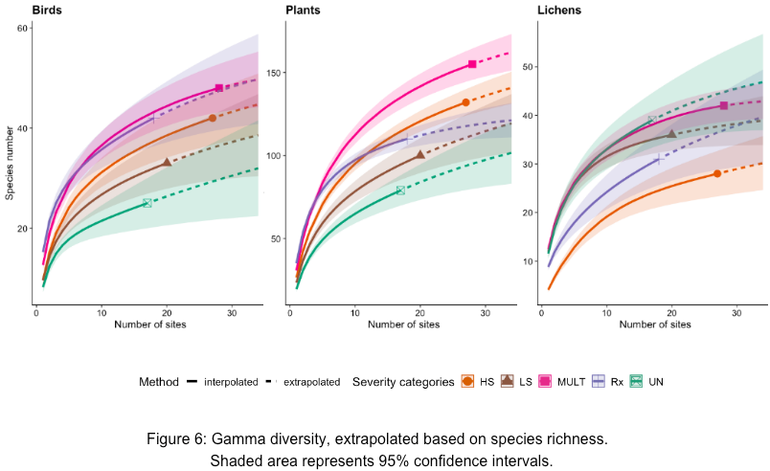

## Insect Indicator Species Analysis

Six insect taxa (order or suborder) were indicators of the high-severity habitats (table 2). These were mainly pollinators (Aculeata (bees/stinging wasps), Brachyceran flies, Coleoptera) and herbivores (Homoptera, Heteroptera, Orthoptera), which probably reflects the higher abundance of flowers and broadleaf shrubs/trees in high-severity burns.

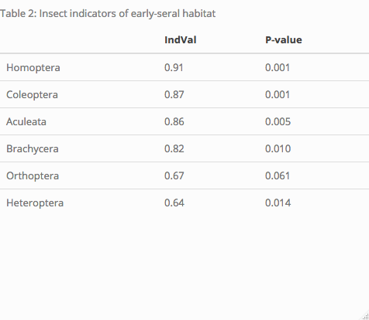

## Warning: NAs introduced by coercion

## Joining, by = "species"  
## Joining, by = "species"

## Warning: NAs introduced by coercion

## Joining, by = "species"  
## Joining, by = "species"

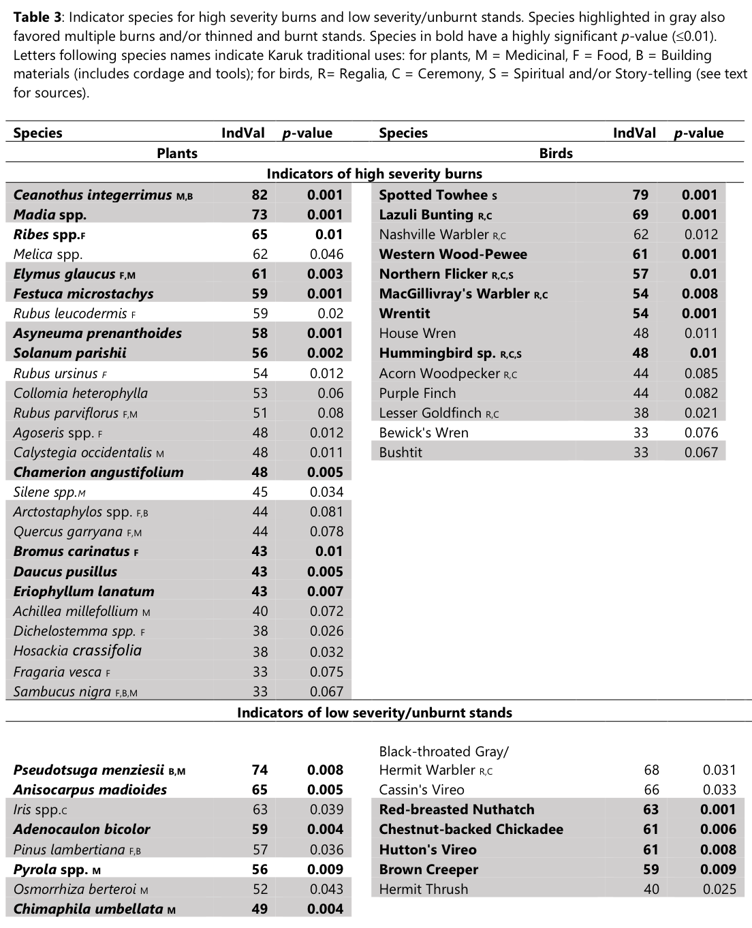

## Early and late seral species in actively and passively managed stands

The indicator analysis for birds and plants of high-severity and low-severity/unburnt stands suggests distinct communities in each habitat (Table 2). Plants preferring such stands were predictably shade-tolerant species (e.g. *Goodyera oblongifolia* (rattlesnake plantain), *Pyrola spp.* (wintergreen), *Adenocaulon bicolor* (pathfinder), *Anisocarpus madioides* (woodland tarweed)), whereas these stands were favored by bark-gleaning (Red-breasted Nuthatch and Brown Creeper) and canopy-dwelling birds (Chestnut-backed Chickadee, Black-throated Gray/Hermit Warbler, Cassin’s Vireo). In contrast, species that preferred early-seral conditions created by high-severity fire included shrubs (e.g. *Ceanothus integerrimus* (deerbrush), *Rubus spp.* (blackberries, raspberries and thimbleberries), *Arctostaphylos spp.* (manzanita), *Solanum parishii* (Parish’s nightshade)), grasses (e.g. *Melica spp.* (oniongrass), *Elymus glaucus* (blue wildrye), *Bromus carinatus* (California brome)), annual forbs (e.g. *Madia spp.* (tarweeds), *Collomia heterophylla* (vari-leaved collomia), *Cryptantha spp.* (popcorn flower), *Epilobium spp.* (willowherbs)) and perennial forbs (e.g. *Asyneuma prenanthoides* (California harebell), *Eriophyllum lanatum* (woolly sunflower), *Dichelostemma spp.* (blue dicks/Indian potatoes), *Chamerion angustifolium* (fireweed), *Hosackia crassifolia* (big deervetch)). Birds that favored these stands tended to be species associated with shrubs and deciduous tree cover (e.g. Spotted Towhee, Wrentit, Nashville Warbler, MacGillivray’s Warbler, Anna’s/Rufous Hummingbirds, Black-headed Grosbeak), open habitat species (Lesser Goldfinch, Lazuli Bunting), and cavity nesters (Acorn Woodpeckers, House Wren, Northern Flicker). This classification into early and late seral species agrees with other regional studies for those species for which information is available [@donatoVegetationResponseShort2009; @fontaineBirdCommunitiesFollowing2009].

I identified 61 species (birds, plants and lichens combined) that seemed to favor high-severity burns (occurring at least twice as frequently in that habitat compared to low-severity and unburnt stands), and 45 species that favored low-severity and unburnt stands (occurring at least twice as frequently in that habitat compared to high-severity burns). These habitat associations correspond to the findings of other fire ecology studies [@fontaineBirdCommunitiesFollowing2009]. Additionally, most species that have a preference for either of these habitats exhibited the same affinity for multiple burns and thinned and burnt sites: 34 species (75.5555556%) preferring low-severity and unburnt stands also favor multiple burns, while 31 (68.8888889%) also favor thinned and burnt sites. Conversely, 49 species (80.3278689%) that prefer high-severity burns also favor multiple burns, and 41 (67.2131148%) also favor thinned and burnt sites. Figure 7 (a and b) displays graphically the proportion of plants and birds that prefer high-severity burns or unburnt and low-severity stands that also favor multiple burns and thin+burn sites.

