Fire and Biodiversity in the WKRP: Preliminary analysis

Chris Adlam

12/14/2019

# Summary

The Klamath Mountains mixed evergreen forest is adapted to frequent, low to moderate severity fires. Today, the Karuk Tribe, US Forest Service, and local community organizations have formed the Western Klamath Restoration Partnership to restore this fire regime, altered by a century of fire suppression. Part of the WKRP’s mission is to address concerns about the impacts on biodiversity of both high severity fire on one hand, and the exclusion of fire on the other. First, I investigate how communities of plants, birds, lichens and insects differ between long-unburnt stands, low severity burns and high severity burns. Next I evaluate the response of diversity to two management options that can reduce canopy cover to within its historical range: multiple burns (wildland fire use) and thinning and burning. Based on 110 plots across the WKRP project area, low severity burns and unburnt areas did not differ in species composition. Plant, bird and insect diversity (alpha, beta and gamma) were as high or higher in high severity burns as in low severity/unburnt stands. Lichens were negatively impacted by high severity fire, beginning to recover only after 16 years. Multiple burns and thinned/burnt stands were the highest in diversity, because they provided habitat for both species preferring high severity burns and those preferring low severity/unburnt stands. This suggests that management, whether passive (allowing fires to burn and overlap) or active (thinning and burning) can help maintain biodiversity in this fire-dependent landscape.

## Top findings (so far)

* No detectable difference in community composition between long-unburnt stands and low severity burns. This suggests that in fire-suppressed stands, fires that lead to < 25% canopy reduction do not cause a strong biodiversity response.
* Plant and bird diversity in high severity burns is as high or higher than in low severity/unburnt plots (alpha, beta and gamma diversity); almost all measures of diversity are highest in multiple burns and/or prescribed burnt plots.
  + **Alpha**: High severity burns have higher plant species richness than low severity/unburnt stands, but bird species richness is similar and lichen species richness lower. Several taxa of insect pollinators and herbivores are significantly more abundant in high severity plots than low severity/unburnt plots.
  + **Beta**: High severity burns are more heterogeneous than low severity/unburnt plots.
  + **Gamma**: The total species pool is lowest in low severity/unburnt stands (except for lichens).
  + **Multiple burns** and **prescribed burns** have the highest bird diversity (alpha, beta and gamma), and similar to higher plant diversity.
* A majority of species with a strong preference for either high severity burns or low severity/unburnt stands also favor multiple burn and prescribed burnt plots, suggesting that such stands can provide suitable habitat for both cohorts of species.

## Ongoing questions

* How best to analyze time-since-fire (incorporating heat load?)?
* What environmental factors mediate species response to different severities/treatments (shrub or tree cover, open space for herbaceous species, snags, tree density/size)?
* Characterize species responses by guilds/functional groups (eg. different fire-related life histories for plants, foraging guilds for birds/insects, plant floristic origins).

# Introduction

## Sampling strategy

In June/July 2018 and 2019, I sampled 110 plots from high severity burns (HS), low severity burns (LS), long-unburnt areas (UN), multiple burns (MULT), and prescribed burns (Rx). HS sites were defined as having >75% canopy reduction, and LS sites as <25% canopy reduction. Based on personal observation and a cursory GIS analysis, a reduction in canopy cover of 25-75% is uncommon in the lower elevations of the Klamath Mountains (usually <10% of the burnt area), probably because canopy continuity is such that fires tend to be either surface or canopy fires.

It is important to note that plots in MULT and Rx sites were not randomly distributed. Instead I used a form of stratified random sampling, targeting stands where the canopy had been reduced to 30-75%, which I am assuming to be closer to the historic range of variation pre-fire-suppression. My findings are therefore meant to investigate biodiversity responses in treatments that achieve this level of canopy reduction; multiple high severity burns or prescribed burns that do not reduce the canopy cover signitficantly are intentionally not included in this study. As a result, the habitats studied follow a gradient of canopy cover (Figure 1).

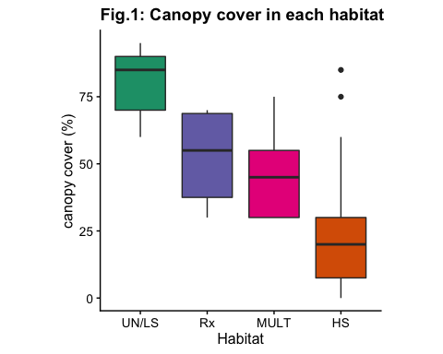

# Analysis

## Analysis summary

First, I analyzed the community composition across habitats to see which differed significantly (PERMANOVA). Next, I analyzed patterns of alpha, beta and gamma diversity for plants, birds, and lichens. Insect data was analyzed separately using an indicator species analysis, because I did not sample insects in the MULT and Rx sites. Lastly, I compared the occurrence of species with a strong preference for either HS or UN/LS habitats in the MULT and Rx habitats, to see if these habitats can be suitable for such species.

## Comparing community composition by habitat

### PERMANOVA

First, I take a look at which habitats have similar or different species composition, using PERMANOVA. For all taxa, there is an effect of habitat (p < 0.001; main PERMANOVA not shown).

### Pairwise comparisons

Using pairwise PERMANOVAs to compare the habitats, there is no detectable difference between plant, bird or lichen communities of LS and UN habitat (plants: p = 0.22; birds: p = 0.09 lichens: p = 1). For this reason, I will from here on lump unburnt stands and los severity burns together as UN/LS.

In addition, bird communities of HS and MULT are not detectably different (p = 0.76). For lichens, the only habitat that stands out is the HS habitat (p < 0.01), although it is not statistically different from the MULT habitat (p = 1).

Table 1: Pairwise PERMANOVA results

plants

birds

lichens

Pair

F_model

p_adj

F_model

p_adj

F_model

p_adj

HS vs LS

7.333

0.01

6.446

0.01

12.848

0.01

HS vs MULT

3.188

0.01

1.721

0.72

1.161

1.00

HS vs Rx

7.441

0.01

8.106

0.01

14.540

0.01

LS vs MULT

5.971

0.01

4.520

0.01

6.908

0.04

LS vs Rx

6.854

0.01

6.528

0.01

4.253

0.03

LS vs UN

1.997

0.23

2.678

0.11

1.031

1.00

LS vs UN

9.953

0.01

12.057

0.01

8.085

0.02

MULT vs Rx

4.139

0.01

5.902

0.01

7.898

0.02

MULT vs UN

6.956

0.01

8.791

0.01

3.871

0.17

UN vs RX

5.681

0.01

8.732

0.01

4.133

0.07

## Alpha, Beta, Gamma diversity patterns

Below I present the patterns of alpha, beta, and gamma diversity for birds and plants (lichens are not included; briefly, lichen species richness is highest in UN/LS, lowest in HS, and intermediate in the multiple and prescribed burns). The analysis here is based on presence/absence data, and does not account for relative abundance.

### Alpha diversity

Bird and plant species richness are highest in the prescribed and multiple burns, lower in the UN/LS and HS burns. Plant species richness is significantly higher in the HS burns than in the UN/LS stands.

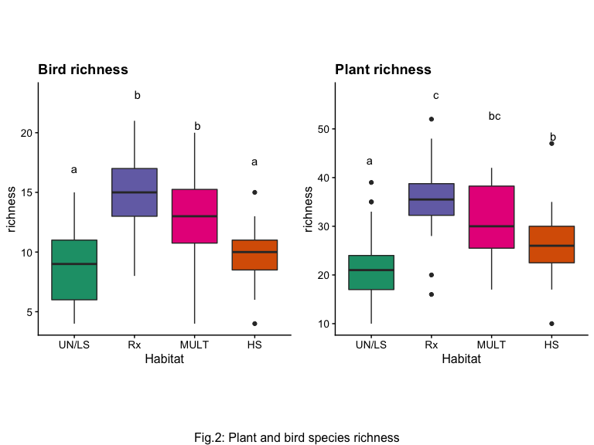

### Beta Diversity

Beta diversity is highest in the prescribed and multiple burns; it is significantly higher in the HS burns than in the UN/LS stands.

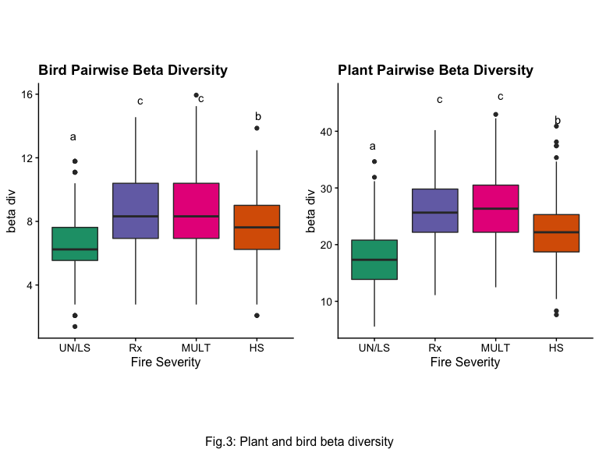

### Gamma diversity and rarefaction curves

I had a different number of samples in each habitat, so instead of presenting simple gamma diversity numbers which would be misleading, I am showing species accumulation curves. The pool of species appears largest in the multiple burns, lowest in the UN/LS stands, and intermediate in the HS burns. For birds, the species pool in the prescribed burn sites is also high, but for plants it levels out faster and is intermediate between the HS and UN/LS sites (however I want to caution against over-interpreting the Rx burn sites, because I had fewer plots and they were more gegraphically clustered).

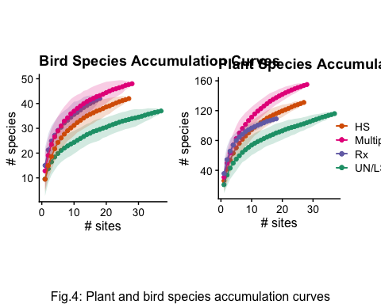

## Insect Indicator Species Analysis

Insect data was analyzed to the order or suborder level (and only for HS, LS and UN habitats). Six taxa were indicator species for the HS habitats. These are mainly pollinators (Aculeata (bees/stinging wasps), Brachyceran flies, Coleoptera), and herbivores (Homoptera, Heteroptera, Orthoptera), which probably reflects the higher abundance of flowers and broadleaf shrubs/trees in HS burns.

Table 2: Insect indicator species for high severity burns

(Sub)order

IndVal

Homoptera

83

Coleoptera

76

Aculeata

74

Brachycera

67

Orthoptera

45

Heteroptera

41

## Species community composition

Looking at the fequency of occurrence of all plant, bird, and lichen species detected at least 5 times (144 species), I identified species with a strong preference for HS sites or for UN/LS sites. Species were associated with each of these two cohorts if they were found at least twice as frequently in one habitat than in the other. For example, Achillea millefolium (Yarrow) was found in 19% of HS plots and 3% of UN/LS plots; therefore this species was classified as prefering HS stands. Then I determined if these species also favored MULT and/or Rx sites using the same rule. In this case, Achillea millefolium is found in 29% of MULT plots and 28% of Rx plots; because this is also more than twice the UN/LS frequency (3%), I concluded this species also favors MULT and Rx sites.

I identified 61 species (birds, plants and lichens combined) that seem to favor HS, and 35 species that favor UN/LS. What I find is that most species that have a preference for UN/LS or HS are **also** found abundantly in MULT and/or Rx sites: 22 species (63%) prefering UN/LS also favor MULT, while 26 (74%) also favor Rx. Conversely, 50 species (82%) that prefer HS also favor MULT, and 40 (66%) also favor Rx.

Figure 5 breaks down the proportion of plants and birds that prefer HS or UN/LS that also favor MULT and Rx sites.

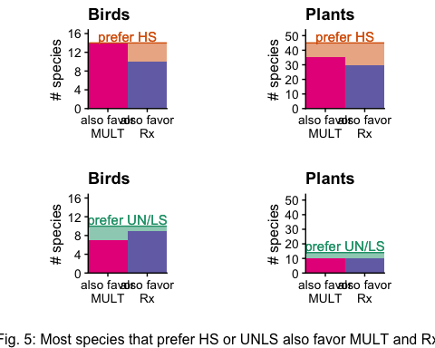

While high severity burns are important for biodiversity when compared with unburnt/low severity stands, species that are associated with both of these habitats are found in multiple burns and prescribed burns, which are more diverse as a result. This suggests that both active (thinning/burning) and passive (wildland fire use) management can achieve biodiversity conservation goals while also protecting or maximizing other values and ecosystem services.