

**CSE461: Introduction to Robotics**

**LAB REPORT 1**

**Name of the experiment:**

**Introduction to the Raspberry Pi GPIO pins, and using push buttons to control LEDs.**

**Group: 05**

**Name:** Arpita Saha

**Student Id:** 22101460

**Section:** 03

**G-Suite:** arpita.saha@g.bracu.ac.bd

**Date Of Submission:** 17.02.2024

**Objective:**

1. Introducing the pins of Raspberry Pi.
2. Learning how to use Push buttons to control LEDs.
3. Learning to write code to read the states of the push button using Raspberry Pi.
4. Understanding the process and operations.

**Equipment:**

Raspberry Pi, LED, Resistor, Monitor, Breadboard, Push Button, Connecting wires, SD card, Card-reader, Keyboard, Mouse.

**Experimental Setup:**

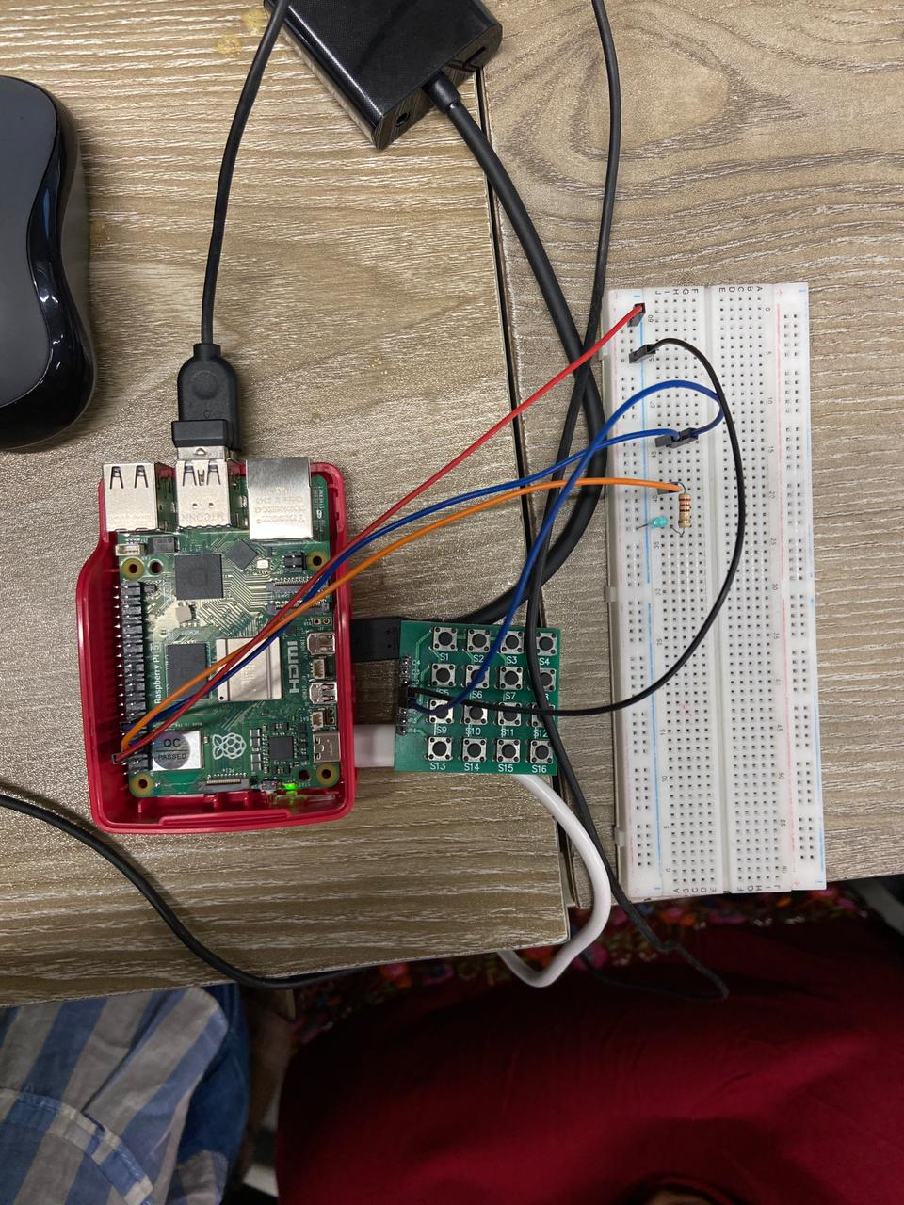 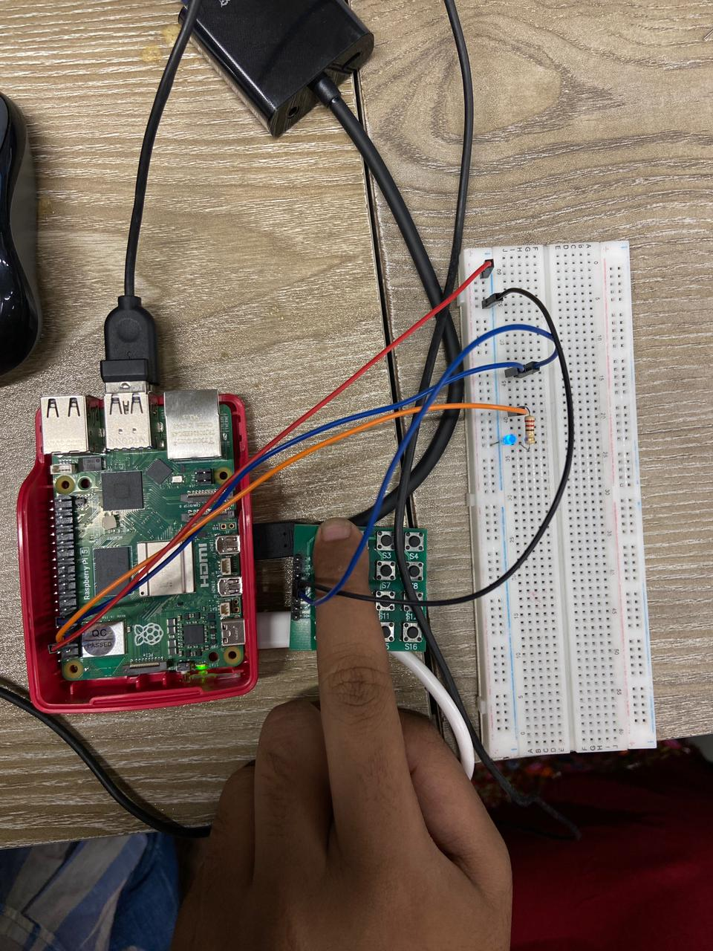

The Raspberry Pi is connected to the desktop through an HDMI connector and the breadboard is also connected to the Raspberry Pi via connecting wires. The desktop operates the Raspberry Pi and we have written a few lines of code so that the Raspberry Pi gets to read the states of the push button and give output accordingly. The 6th pin of the Raspberry Pi acts as the ground so we shorted the C1 pin of the 4x4 matrix keypad with the ground of the Raspberry Pi. We have connected the GPIO17 pin (pin 11) to the R1 pin of the 4x4 matrix keypad board. We have used S1 as our push switch and for this reason, we used R1 and C1 pins. Also, we have connected the GPIO04 pin (pin 7) to one point of the 220 ohms resistor and the other point of the resistor is connected to the LED. This is how we have constructed the circuit. Here, the GPIO17 pin acts as the output of the push button and the GPIO04 pin will give the LED output.

**Code:**

from gpiozero import LED

from gpiozero import Button

led = LED(4)

button = Button(17)

while True:

button.wait_for_press()

led.on()

button.wait_for_release()

led.off()

**Results:**

After completing the experimental setup, we connected the power cable to the Raspberry Pi. Then we entered the code to the Raspberry Pi with the help of a desktop monitor. After completing all these steps, when we pressed the push button, the LED turned ON and it remained ON as long as we kept holding the push button in the pressed state. The LED turned OFF when we stopped pressing the push button.

**Discussion:**

In this lab, we learned how to install a Raspberry Pi and how to do basic operations using Raspberry Pi. We have learned about the pins of a Raspberry Pi which helped us to complete our lab work. Also, we have learned how to operate a push button. We haven’t faced any difficulties throughout the lab because of clear instructions and the fresh state of the Raspberry Pi. We also worked very carefully so that the pins or the connecting points of the Raspberry Pi didn’t get damaged. We used the Thony software to write the codes to input into the Raspberry Pi. It can be said that we need to be careful while constructing the circuit so that all the connections can be accurate and we need to use Raspberry Pi carefully to get the result without any hassle.

**Question-Answers:**

**Question 1.** **Why is there a 220 ohms resistor in series with the LED?**

**Answer:** LEDs are prone to get damaged due to overheating. For this reason, to reduce the load current entering the LED, we use a 220 ohms resistor which decreases the current flow to the LED and prevents the LED from getting damaged.

**Question 2.** **Why is the push button connected from a GPIO pin on the RPI to the GND pin of the RPI instead of being connected directly to the LED and the resistor combination?**

**Answer:** The circuit of the push button and the circuit of the LED have been connected to the Raspberry Pi separately so that we can get the expected output by controlling the output of the LED. If we directly connected the push button to the resistor, the LED would always be turned ON regardless of whether pressing the button or not. But our expected circuit should only turn ON the LED when the button is pressed, otherwise not. That is why, the push button and the LED are connected to Raspberry Pi by different GPIO pins and not connected directly.

**Question 3:** **What would happen if the series 220Ohms resistor was replaced with a 1KOhms resistor? What visual change would you see?**

**Answer:** Higher resistance limits the current flow to the LED more than before which leads to a decrease of brightness while the LED is turned ON. As we know, resistors are used to limit the current flow and higher-valued resistors limit the current flow more than lower-valued resistors. So, we will be able to notice the LED appearing as less bright when the 220Ohms resistor gets replaced with a 1KOhms resistor. This is the visual change we will be able to see upon the mentioned change.