# Polyhedral dials by ray-tracing

Jean-Luc Astre

The [CadsolOnLine software](https://cadsolonline.web-pages.fr/) has already been presented in Issue 5 of « Cadrans Solaires Pour Tous » . The ray tracing algorithm was described in issue 9.

Polyhedral sundials feature a sundial on each face of a polyhedron. Ray tracing techniques allow time lines and diurnal arcs to be drawn without worrying about complex mathematical formulas. You just need to know the 3D coordinates of each vertex, orient the polyhedron, and set up a gnomon on each face. The CadsolOnLine menu contains all the necessary commands.

The 3D coordinates of the [polyhedra are read](https://fr.wikipedia.org/wiki/Poly%C3%A8dre) into a json file containing (currently) the data for: the 5 Platonic solids, the 13 Archimedes solids, the 8 right prisms, the 8 anti-prisms, and the 92 [Johnson solids](https://fr.wikipedia.org/wiki/Solide_de_Johnson) [1]

As an example, here is data for the regular tetrahedron:

Tetrahedron : {

"name":"Tetrahedron",

"category":["Platonic Solid"],

"vertex":[[0,0,1.732051],[1.632993,0,-0.5773503],[-0.8164966,1.414214,-0.5773503],[-0.8164966,-1.414214,-0.5773503]],

"edge":[[0,1],[0,2],[0,3],[1,2],[1,3],[2,3]],

"face":[[0,1,2],[0,2,3],[0,3,1],[1,3,2]]}

“vertex” line: the 3D coordinates of the vertices (4 vertices for the tetrahedron)

“face” line: the indexes of each face. For example, the second face has vertices 0, 2 and 3 as its vertices.

(table numbering starts at 0)

This database was established by Professor [Lee Stemkoski](https://home.adelphi.edu/~stemkoski/): Professor of Mathematics and Computer Science, Adelphi University, New York.

To model other polyhedra, simply add the data of the corresponding json objects.

The software must be able to draw a sundial on each face of the polyhedron, without spilling onto the other faces. Each face is modeled by a truncated pyramid whose vertex is the center of symmetry of the polyhedron. For example, for a dodecahedron (12 pentagonal faces) each face is represented by a solid limited by 2 pentagons (one exterior, one interior) and 5 trapezoids (see the perspective view opposite). The mesh of each face is gener[ated by the convex hull algorithm[2]](https://fr.wikipedia.org/wiki/Enveloppe_convexe) (Quickhull algorithm).

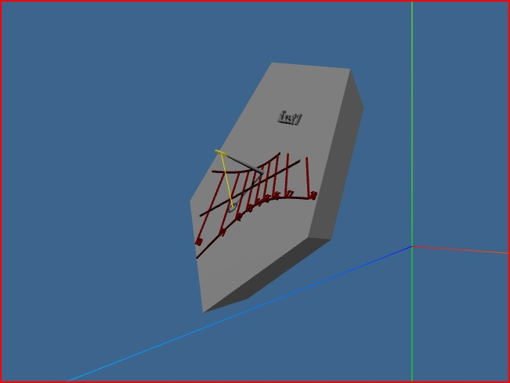

The polyhedron is therefore subdivided into as many solids as there are faces. The time lines and diurnal arcs are obtained by ray tracing on each face.

For each face, we can specify:

* the height, position and shape of the gnomon,

the text, position and size of the currency

The 2D view allows you to visualize and print each of the faces of the polyhedron, with its hour lines and its diurnal arcs.

* It is possible to export:
* a spreadsheet in csv format for each face (coordinates of the plot points)
* a file in svg format for each side (for printer, milling machine, laser engraver etc...)

3D files (in stl, ply, obj, gltf formats) for 3D printers

The software is free and open source.

Website: [https://cadsolonline.web-pages.fr](https://github.com/cadsol/CadsolOnLine)

Code: <https://github.com/cadsol/CadsolOnLine>

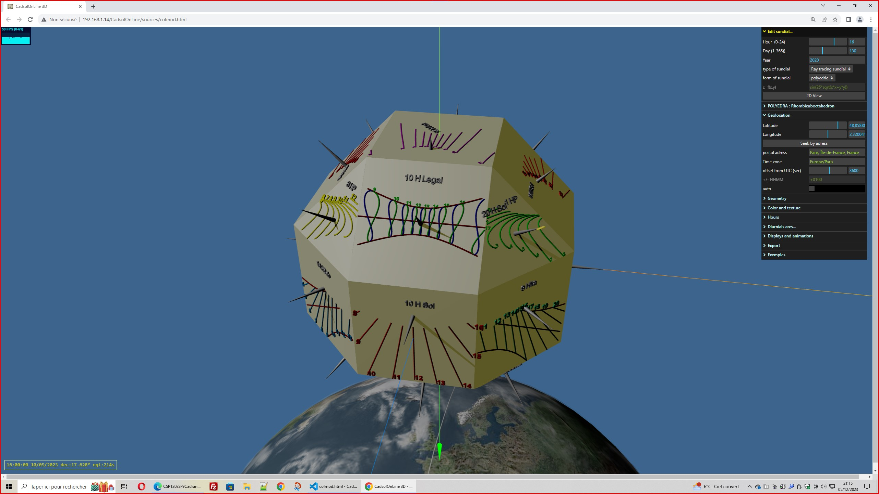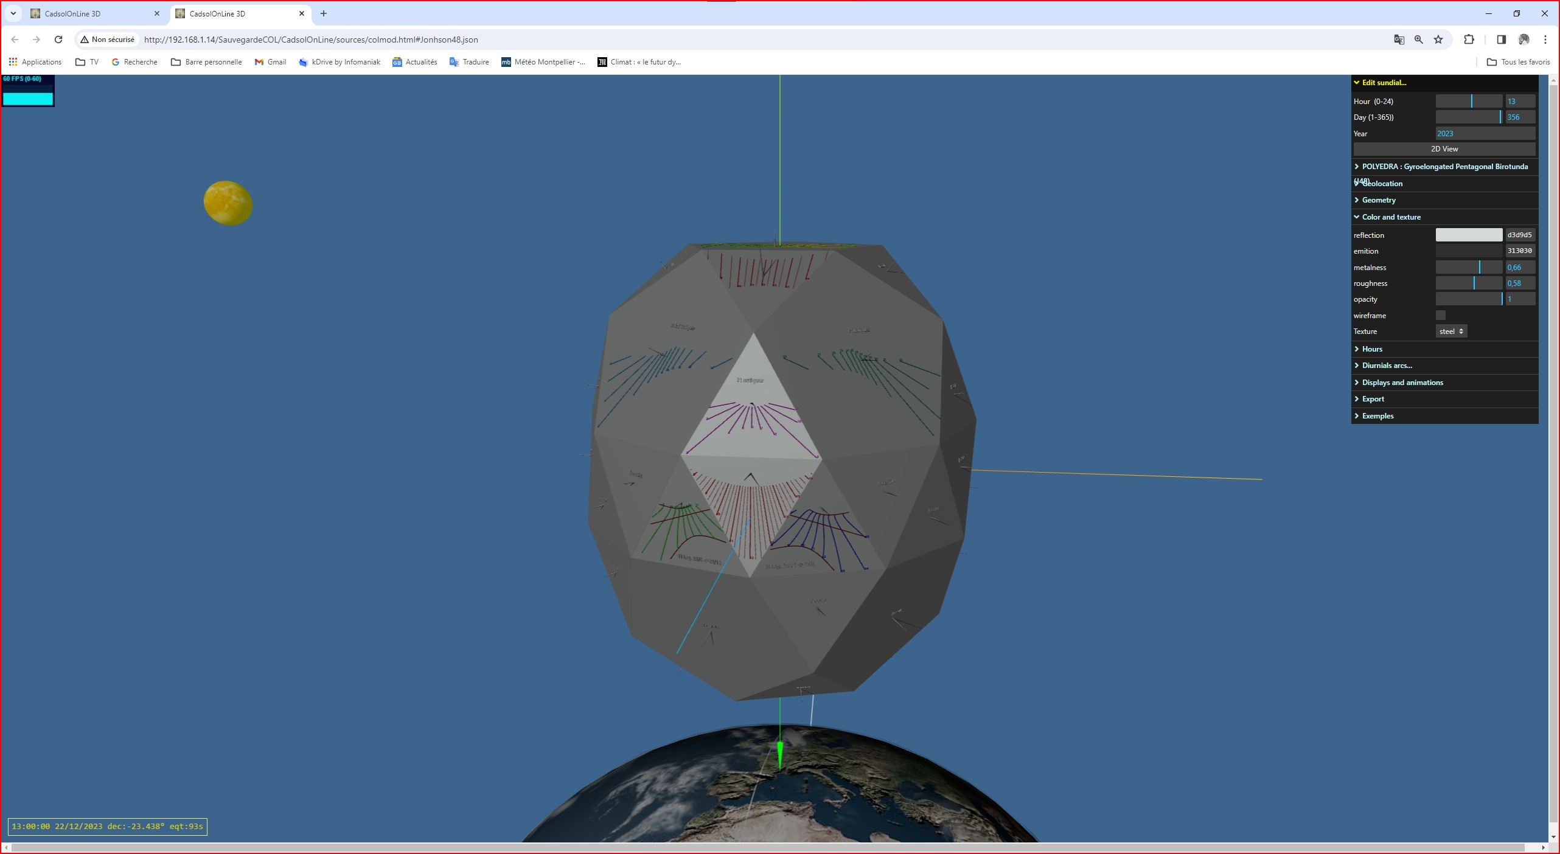

*Thanks to Mr. Yvon Massé for his careful reading of the code and the numerous tests of the software.*

1. Norman W. Johnson,  Convex Solids with Regular Faces, [*Canad.J.Math.*](https://fr.wikipedia.org/wiki/Journal_canadien_de_math%C3%A9matiques),  vol. 18,‎ 1966, p. 169–200 ([DOI](https://fr.wikipedia.org/wiki/Digital_Object_Identifier) [10.4153/CJM-1966-021-8](https://dx.doi.org/10.4153/CJM-1966-021-8))

   Contient l'énumération originale des 92 solides.
2. Dirk Gregorius. March 2014. "Implementing QuickHull." Game Developers Conference. [Slides](http://media.steampowered.com/apps/valve/2014/DirkGregorius_ImplementingQuickHull.pdf)