• How you framed the problem — which errors matter more and why.

In designing this machine learning system, we framed the problem around the business and operational costs of the two types of errors the model can make:

Error A -
False Alarm (False Positive)
The model is flagging perfectly good claim to be denied.
Result - High customer friction, increased cost to the customer support, brand damage, and extra manual labour for our team to review and overturn the mistake.

Error B -
Missed Leakage(False Negative)
The model missed a bad claim and approve it.
Result - Direct financial loss as a bad claim is accepted which should have been rejected.

Which error matter the most?
Error A is riskier than Error B as it lead to bad experience for the customer and bring bad reputation to the company. It also lead to overwork by the customer support.

The trade off based on our data -
Our model currently priortise catching bad claims - The model has a recall of 66% on denial, thus able to successfully catch two-third of the bad actors.
The consequence - As the model is very aggressive, its precision is only 35%. This means 65% of prediction are false alarm(Error A)

What This Means for the Business:
With nearly 2 out of 3 flagged denials being incorrect, running this model on autopilot would severely damage the customer experience. This data perfectly justifies why the model should be used as an initial filtering tool to fast-track low-risk approvals, routing the aggressive high-risk flags to a manual review queue to catch the false alarms before a final decision is made.

• Two or three data findings worth sharing with a non-technical manager.

- Missing Documentation & Unverified Eligibility are the Biggest Denial Triggers
The Finding: Claims with missing documentation are denied at a staggering 38.6% rate (compared to just 17.6% when info is complete). Similarly, when eligibility isn't verified, denials spike to 36.0% (compared to 19.4% when verified).

2. Inpatient Visits and Medicaid MCO Have Critical Denial Vulnerabilities
- Looking at visit types, Inpatient visits face a 30.6% denial rate—far higher than Outpatient or Emergency visits (~18%–20%). Payer-wise, Medicaid MCO is our riskiest channel with a 30.6% denial rate.

3.Prior Authorizations Matter, but "Missing" vs. "Required" Reveals a GapThe Finding: When a - prior authorization is required, denials jump to 26.8%. However, looking at whether a prior authorization was actually present only changes the denial rate by about 2% (22.5% vs 20.1%).

• What you built, what baselines you compared against, and your threshold choice.
-> We have build AI-powered Claims Risk Scoring Model. Instead of just giving a simple "Yes/No" decision, the model calculates a precise risk probability (from 0% to 100%) of how likely a claim is to be denied based on historical patterns (like missing documentation, payer type, and inpatient status).

-> Baseline 1: The "Approve All" Standard: If the business blindly approved every claim to avoid customer friction, we would suffer heavy financial leakage from the 26% of claims that should have been denied (the baseline denial rate in our test set). Our model successfully flags 66% of those bad claims, providing a massive safety net.

-> Our Threshold Choice (The 3-Tier Risk Strategy)
Rather than picking a single arbitrary cutoff point, we implemented a 3-tier traffic light system (High, Medium, Low Risk) to maximize our manual review resources (which are capped at auditing a maximum of 25% of cases).

High Risk (Probability >= 85%)-
Looking at the buckets above 0.85, the precision jumps significantly to 69% (between 0.85–0.90) and 89% (between 0.90–0.95).

The Logic: When the model is this confident, it is rarely a false alarm. These claims have a very high concentration of actual denials, making them safe to automatically hold or route for immediate correction.

Medium Risk (Probability 50% to 84%)
The Data: In this middle zone, the model successfully captures a huge volume of actual denials (about 48% of our total risk exposure is sitting in these buckets), but the precision is lower (hovering between 19% to 50%).

The Logic: This is our primary auditing queue. Because the false-alarm rate is higher here, human eyes are required to filter out the legitimate claims. This tier lets us efficiently allocate our 25% manual audit capacity to where the risk is densest but uncertain.

Low Risk (Probability < 50%)
The Data: Claims scoring below 0.50 have a high concentration of successful approvals.

The Logic: By auto-approving these low-risk claims, we completely eliminate administrative friction for the vast majority of our legitimate customers, drastically speeding up processing times.

• Test set metrics and denial capture at top 25%.

i) Test set metrics overall
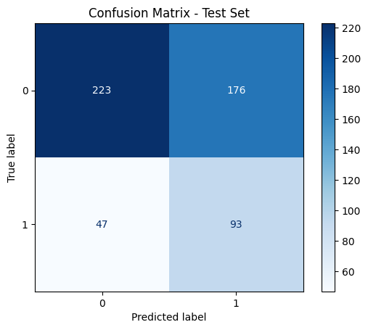

ii) Top 25% Precision and Recall

Prediction Score Bucket | Total Claims | Actual Denials | Precision | Recall Contribution
0.75 - 0.80 | 22 | 10 | 0.4545 | 0.0714
0.80 - 0.85 | 18 | 9 | 0.5000 | 0.0643
0.85 - 0.90 | 13 | 9 | 0.6923 | 0.0643
0.90 - 0.95 | 9 | 8 | 0.8889 | 0.0571
0.95 - 1.00 | 0 | 0 | 0.0000 | 0.0000
TOTAL (75% - 100%) | 62 | 36 | 0.5806 | 0.2571

• Your LLM prompt, one example explanation, and one honest limitation.

Model response prompt -

You are an expert healthcare risk auditor. Your task is to summarize claim risk using the provided data into a layman-friendly explanation of exactly 2 lines.
Line 1: State the risk score, tier, and a brief, plain-English summary of why the claim is a risk based on its top features (using their raw/scaled values).
Line 2: Provide a direct, actionable next step on what needs to be done to resolve or audit this specific case.
Do not include any introductory or concluding text. Strictly output exactly 2 lines.

One Example -

Risk Score: 0.917 (High Tier) – This claim is high-risk due to missing documentation, unverified eligibility, and lack of prior authorization despite being an inpatient Medicaid claim with a high number of procedures and diagnoses.
Next Step: Immediately verify patient eligibility, obtain missing documentation, and confirm prior authorization requirements to prevent payment delays or denials.

1 honest limitation:
Risk of "Hallucinating" Clinical Context from Raw Numbers:
The Limitation: Without explicit feature mapping, the LLM is making an educated guess about what those specific numbers represent. If 10 actually represents a completely different feature (like “number of procedures” ), the LLM’s explanation becomes factually incorrect.
-> No. At low scores, the LLM exhibits clear hallucination signs. Because the prompt explicitly commands it to act as an "expert risk auditor" and summarize "claim risk," the model suffers from confirmation bias. It signals that risk drivers exist and that the claim needs to be revisited, even when the data shows the claim is perfectly safe.

• What you would improve with more time.

While our current model provides an excellent safety net by catching 66% of actual denials, its primary bottleneck is its high false-alarm rate (65%). If we had more time and resources, our primary focus would be driving down Error A to protect the customer experience and prevent our manual review team from being overwhelmed.

Model code - colab _code

(google sheet) -
final_data

