Kickstarter Data Analysis

The data is from May 2009 to March 2017 and includes 4114 campaigns and their results.

Results from analysis of campaigns by category and the timing of the launch:

1. The successful campaigns that launch in Kickstarter are primarily in the arts with Theater the most popular category. Although the success rate of theater campaigns is not the best of all the categories it has the most successful launches of all categories. The second most popular category is Music which also has the highest success rate. Kickstarter seems to be a great place to fund music campaigns. The categories with least successful success rates are Food, Technology, Journalism and Publishing.

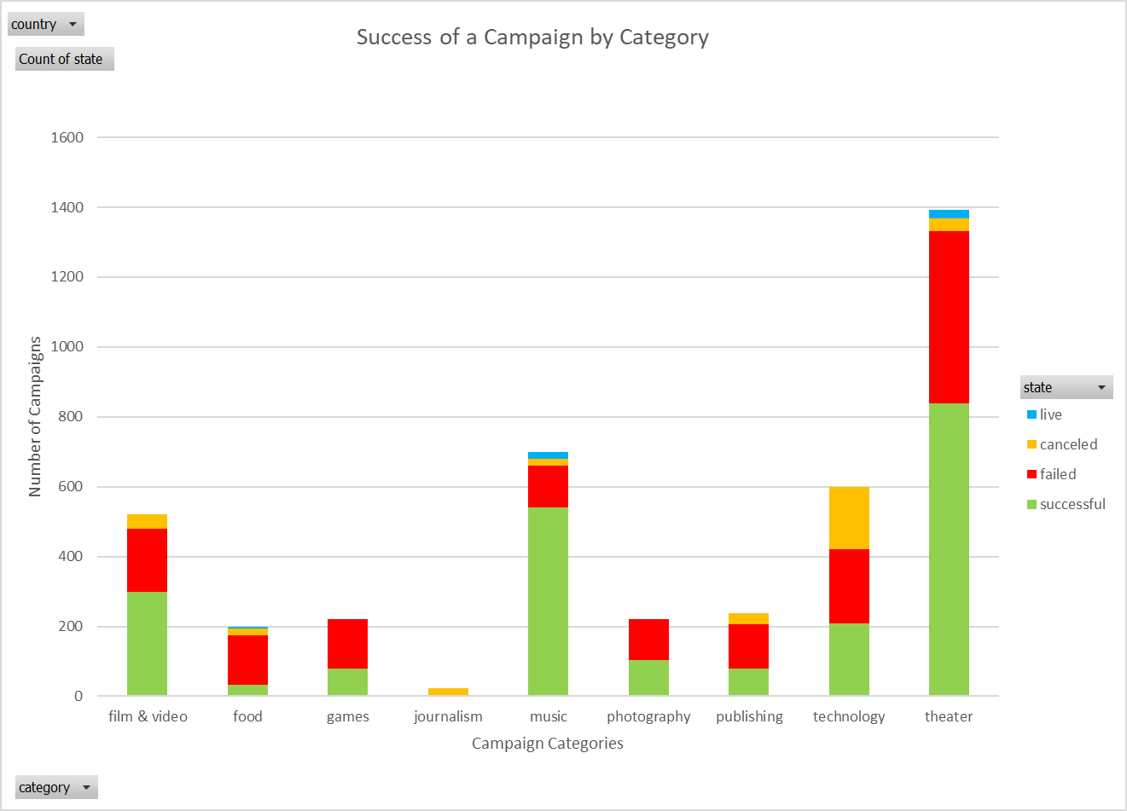

1. The most successful subcategory by far (even though it does not have the greatest success rate) is the Play subcategory.

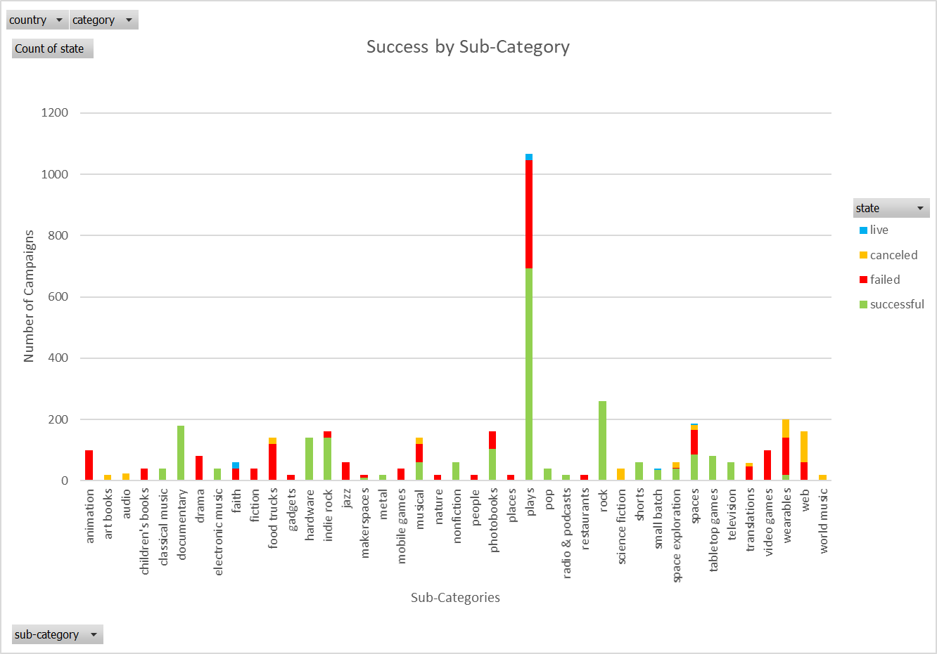

It is easier to analyze the rest of the sub-categories if we remove Plays from the graphs as shown below. Here we can see that some sub-categories have an almost 100% success rate while other sub-categories have an almost 100% failure/cancellation rate.

Most successful subcategories: Classical music, Documentary, Hardware, Nonfiction, Pop, Radio & podcasts, Rock, Shorts, Small Batch, Table top games, Television.

Most unsuccessful subcategories: Animation, Art books, Audio, Children’s books, Drama, Faith, Fiction, Food Trucks, Gadgets, Jazz, Nature, People, Places, Restaurants, Science Fiction, Translations, Video games, Web, World music.

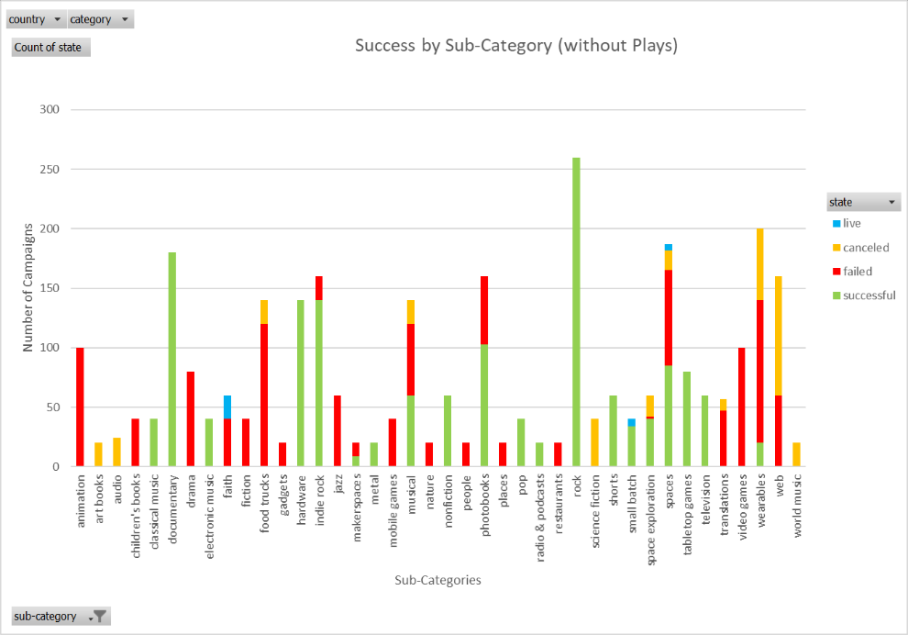

1. The time of year a product is launched may affect the success of a campaign. Although less campaigns launch in early winter (November, December, January), there are also less successful campaigns with winter launch dates. Late spring (April, May) has the highest number of successful launches.

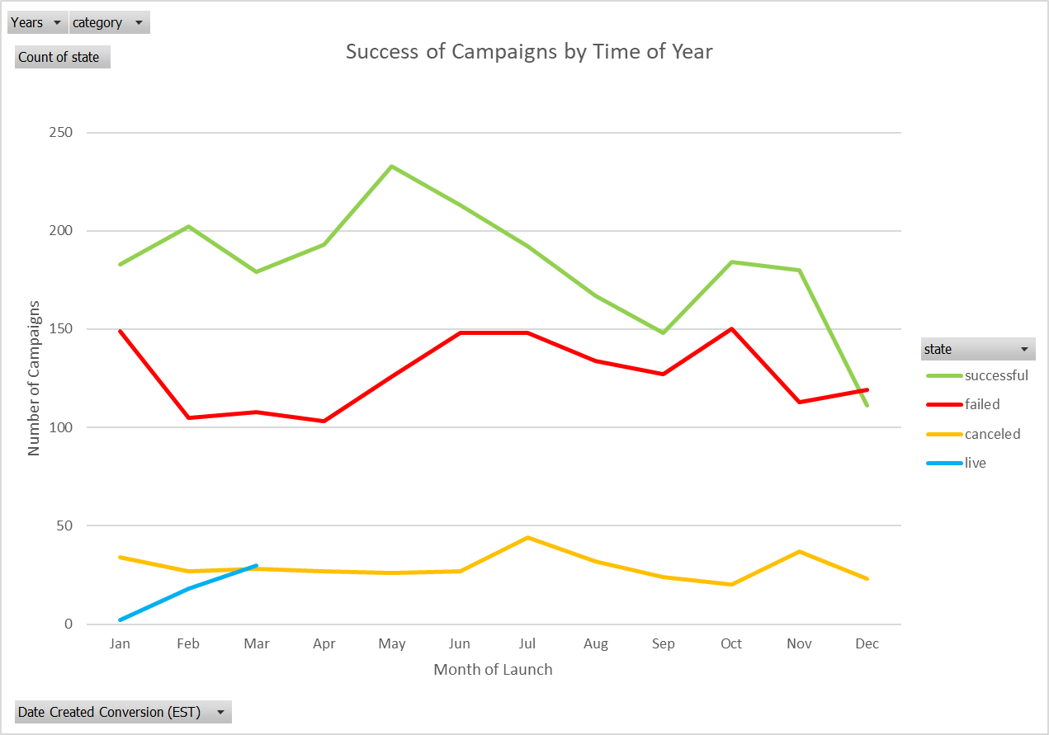

Limitations of the dataset:

This dataset does not include a few points that would be helpful to predict success. I would like to see how much advertising the campaigns had outside of the kickstarter page. Also it does not show what incentives are being provided for each donation. A guaranteed receivable “gift” is a much more likely to incentivize donors to give money. Therefore, a campaign with either tickets or a product gift may be much more likely to be successful than a campaign the simply gives a small gift or a gift not associated with the product campaign.

Other possible table/graphs:

Other graphs we could make would be *amount of the goal* vs *success of a campaign* (see bonus) and also the *amount of a goal* or the amount raised by categories vs *success of a campaign*. We could then see if the reason the artistic categories are so successful is due to a typically smaller campaign goal or not.

The data also includes whether the campaigns were *featured by staff* or *spotlighted*. We could check to see if these campaigns had a higher success rate then other campaigns.

Bonus:

Unfortunately, the data is presented in several different currencies (US, GPD, CAD, for example), therefore the results of this table are not quite comparable to itself. Ideally the currencies would be converted to a standard currency at the time of the launch for every campaign. Assuming the currencies are relatively similar, this table shows that super large goals usually result in either cancellation or failure, while small goals have great success rates. Also, there is a small bump in medium high goals.

