**Declaration on Plagiarism**

**Assignment Submission Form**

This form must be filled in and completed by the student(s) submitting an assignment

|  |
| --- |
| Name(s): Caelan Smyth |
| Programme: Computer Applications and Software Engineering (CASE) |
| Module Code: CA214 |
| Assignment Title: SSADM Project |
| Submission Date: |
| Module Coordinator: Renaat Verbruggen |

I/We declare that this material, which I/We now submit for assessment, is entirely my/our own work and has not been taken from the work of others, save and to the extent that such work has been cited and acknowledged within the text of my/our work. I/We understand that plagiarism, collusion, and copying are grave and serious offences in the university and accept the penalties that would be imposed should I engage in plagiarism, collusion or copying. I/We have read and understood the Assignment Regulations. I/We have identified and included the source of all facts, ideas, opinions, and viewpoints of others in the assignment references. Direct quotations from books, journal articles, internet sources, module text, or any other source whatsoever are acknowledged and the source cited are identified in the assignment references. This assignment, or any part of it, has not been previously submitted by me/us or any other person for assessment on this or any other course of study.

I/We have read and understood the referencing guidelines found at

<http://www.dcu.ie/info/regulations/plagiarism.shtml>, <https://www4.dcu.ie/students/az/plagiarism>and/or recommended in the assignment guidelines.

Name(s): Caelan Smyth Date:

# Business Activity Model

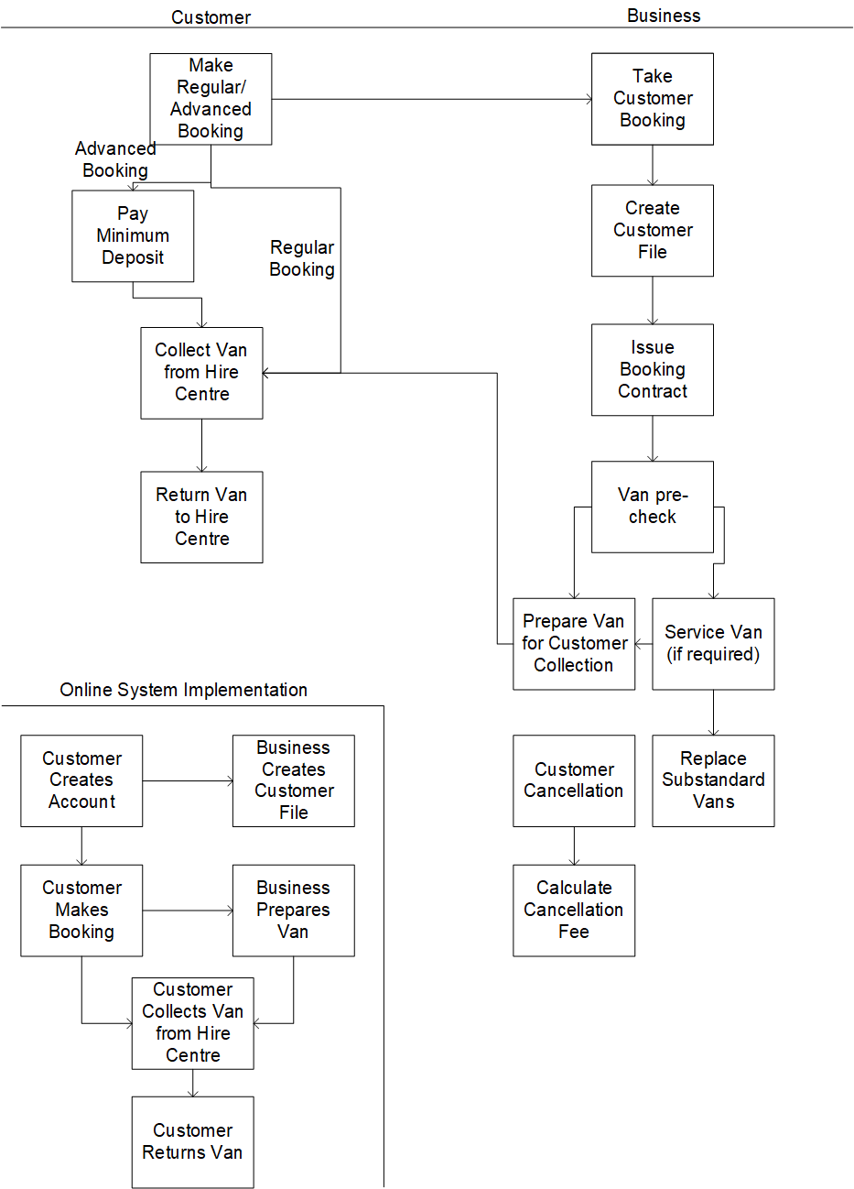

# Logical Data Model

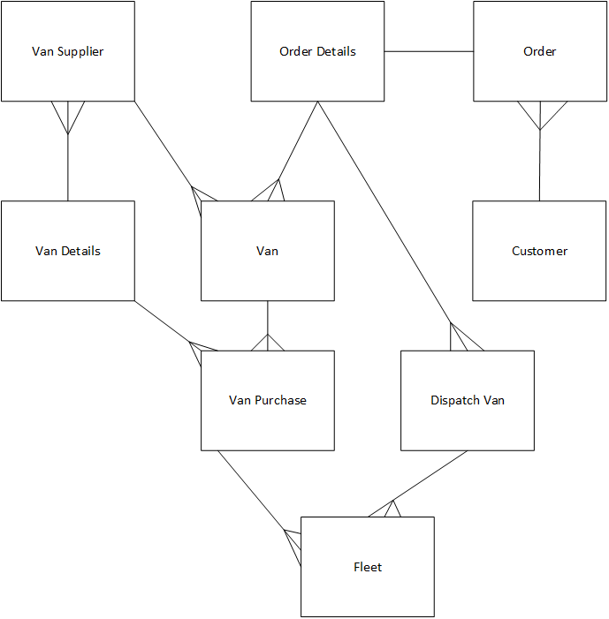

# Top Level Context Diagram

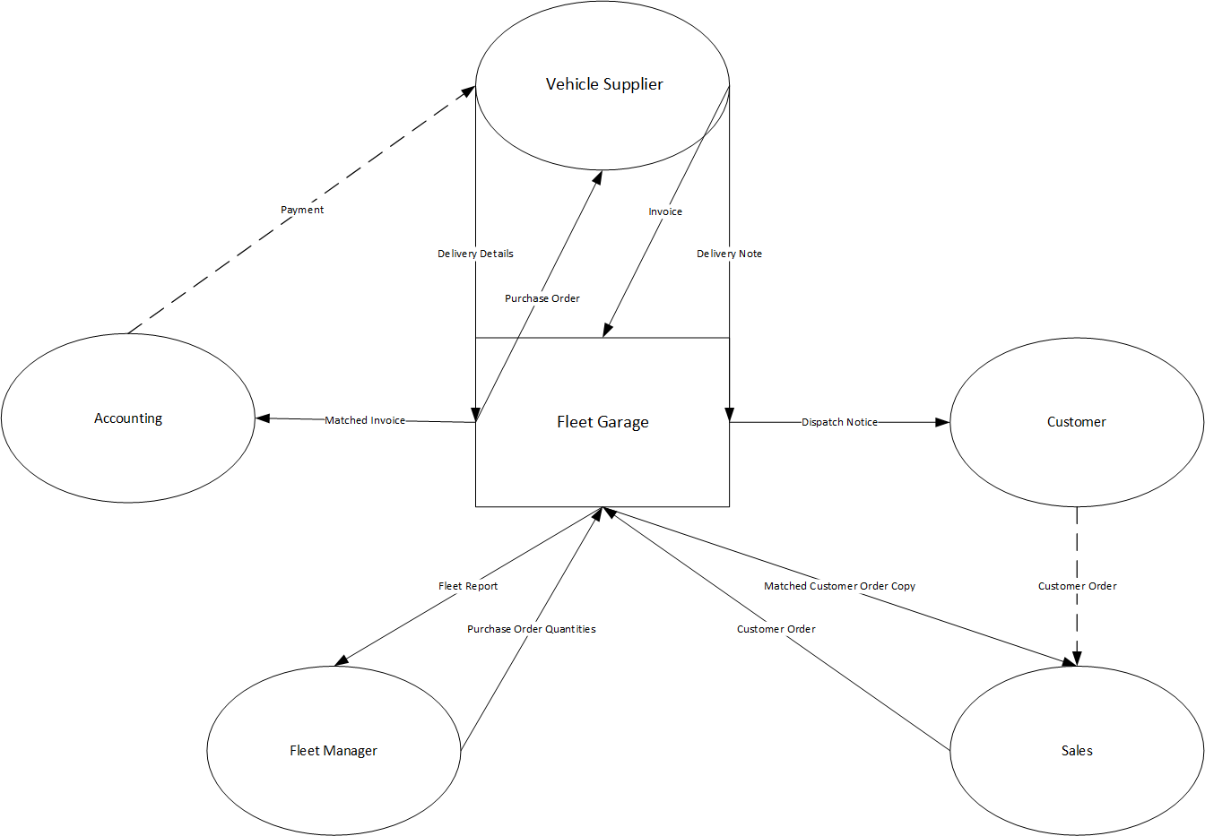

# Document Flow Diagram

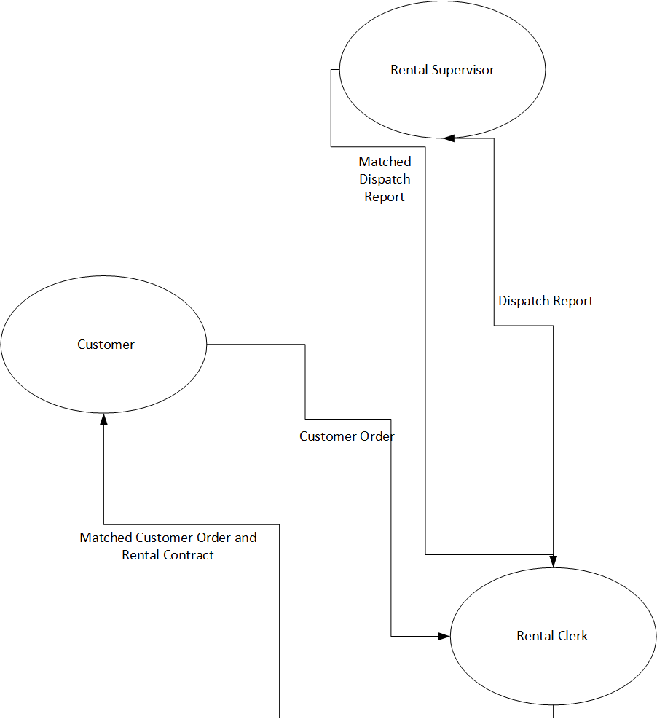

# Data Flow Diagram – Level 1

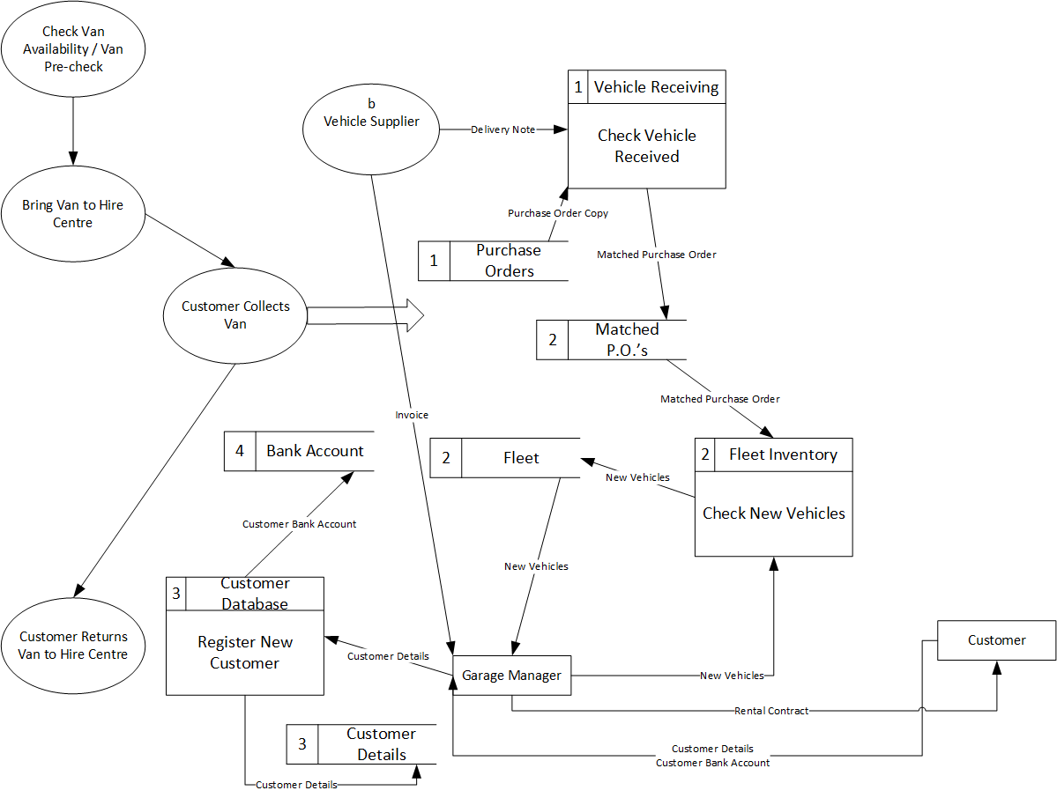

# Data Flow Diagram – Level 2

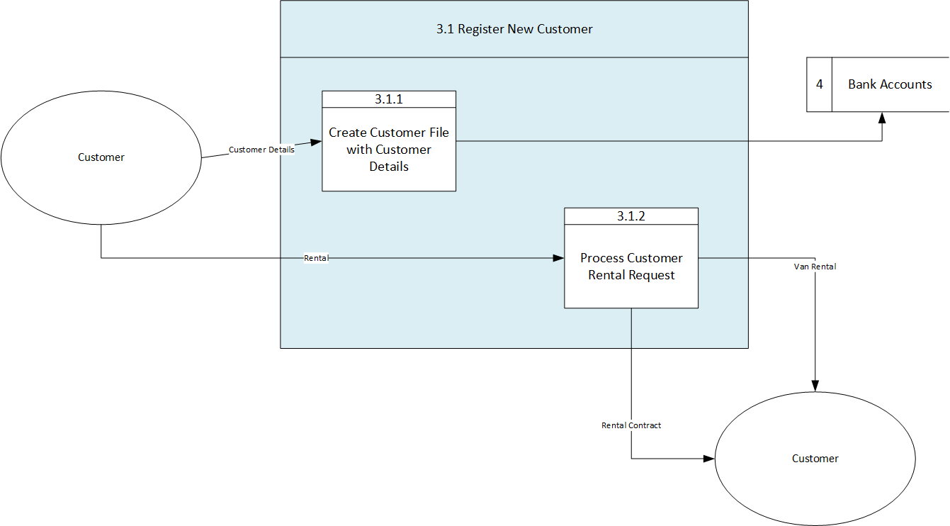

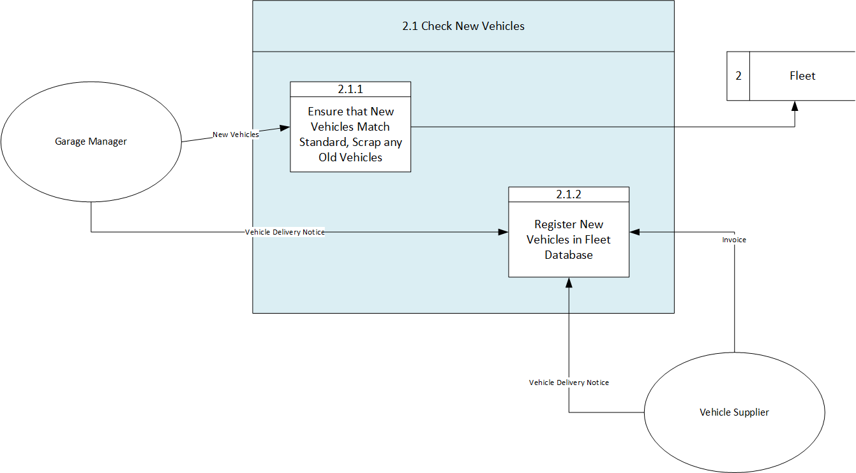

# Logical Data Flow Diagrams

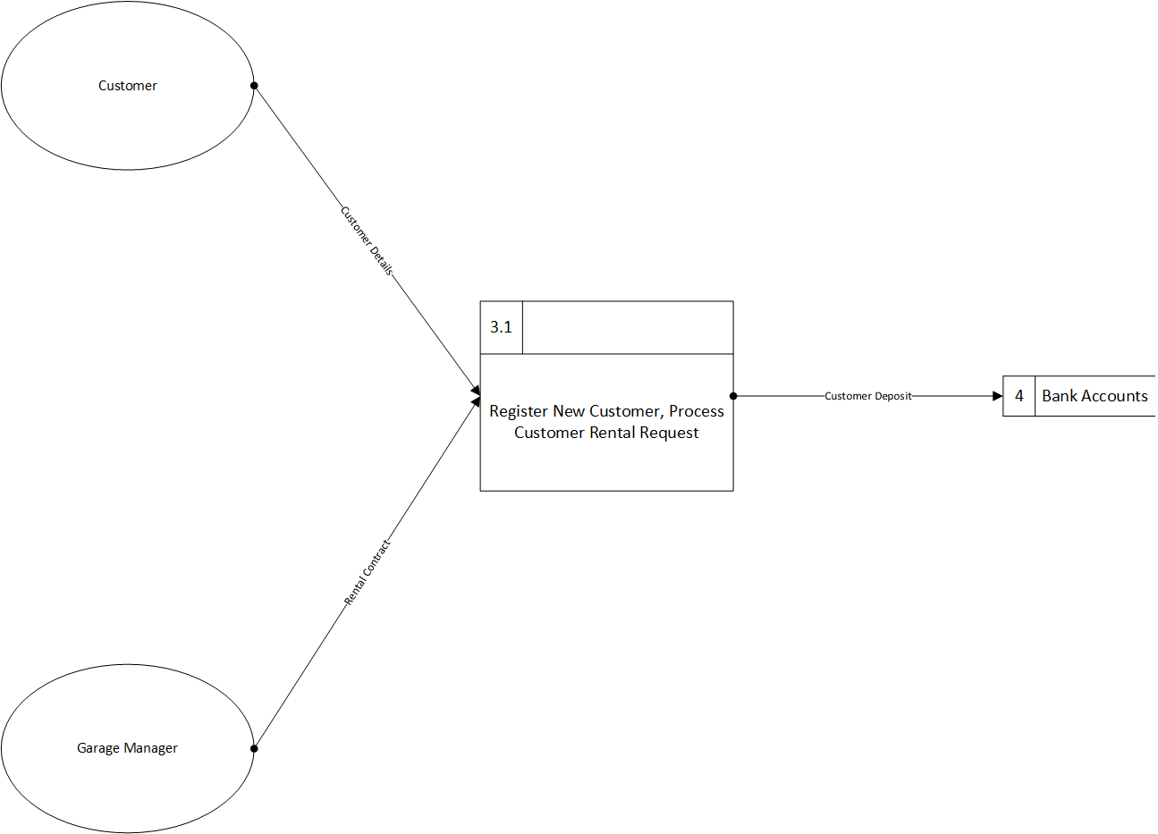

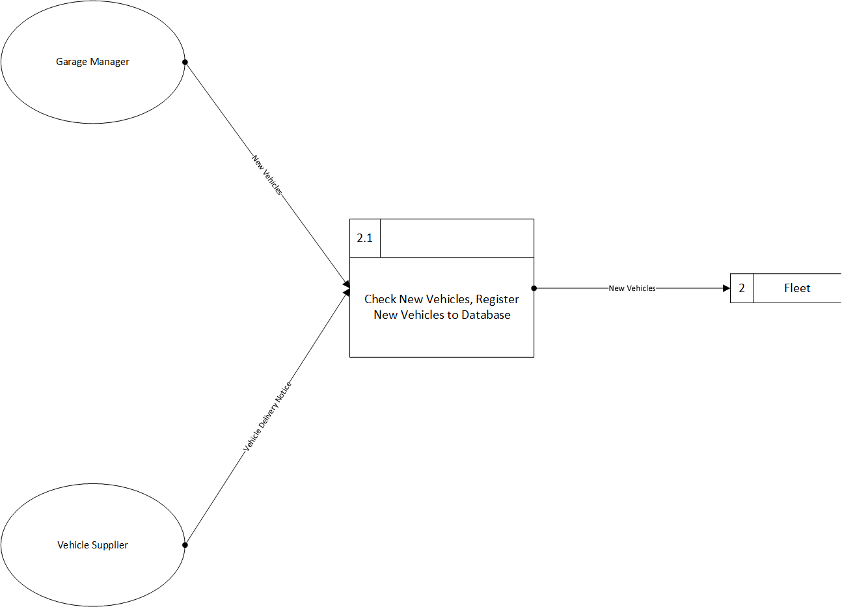

# Function Definition

## Register New Customer – DFD Level 1

This function is used to get customer details and store them in a database. This database will allow the business to more easily reference customer details if need be. The database will contain entries for name, address, contact details and rental history. This database will also enable repeat customers to more easily make bookings as the business will be able to reference this customer’s entry in the database rather than having to make a new entry.

## Check Van Availability/Van Pre-Check – DFD Level 1

This function is used to ensure that the vans that are being hired out to customers are available and in good condition. This will ensure that customers are not receiving faulty vans, and that customers’ needs will be satisfied with the appropriate van for their requirements. This will also allow the business the opportunity to update their fleet with newer models if they find any vans that do not satisfy their standards.

# I/O Diagram

