

Table of Contents

Introduction 7

Chapter 1: The Basics 9
What is Bioinformatics? 9
What Skill Sets Should a Bioinformatician Have? 10
Setting Up Your Computer 12
Setting up Linux 14
BASH Crash Course 20
Accessing and Navigating the Terminal 22
Essential Commands for the Command Line 29
Setting Up Essential Software 38

Chapter 2 - Example Script 41
Outlining a plan 42
RNAseq Basics 42
Rough Plan 44
Preparation 45
Import Libraries - Gather Your Tools 48
Creating Helper Functions 50
Main Function - Why is it There? 59
Creating Arguments 61
Pre-Flight Check 64
Verify Fastq Files 65
Setup Output Directories 67
Download Genome Data 69
Locate FASTA and GTF 72
Build HISAT2 Index 74
Run FastQC 76
HISAT2 Allignment Loop 77
FeatureCounts 80
Quality Control 81
R Analysis - What do the numbers mean? 82
Summary 93

Chapter 3 - Analysis 94
Quality Control Check 95
MultiQC 95
Principal Component Analysis (PCA) 109
Dispersion Plot 112
Analysis and Graphing 115
Differentially Expressed Genes Table 115
Volcano Plot - Visualize Significant Genes 117
GSEA Plot - Contextualize in Biological Pathways 121

Chapter 4 - Conclusions 123

Appendices 127
Appendix A - Important Commands 127
Appendix B - BASH Aliasises & Shortcuts 129
Appendix C - Useful Bioinformatics Software 131

Sources 132

Introduction
If you are reading this then you are likely the unfortunate soul that was assigned to be the resident undergraduate bioinformaticist for your specific research project. If you are a student reading this voluntarily, I seriously question your sanity. However, know that you are in good company with the author of this thesis and the scientific community as a whole.

No matter how you ended up here, the goal of this thesis is to give a brief introduction to bioinformatics, walk through a common example bioinformatics pipeline, and explain the pros and cons between two common ways of running a bioinformatics pipeline. I have chosen RNAseq differential expression as the example pipeline for this thesis as it is relatively simple to explain and acts as a good baseline for more complex bioinformatics pipelines such as methylseq and ChIPseq. As of the time of writing, RNAseq is also an extremely in demand skill that is capable of producing tangible results.

To prevent this thesis from recapping the entire history of biology, experimental design, and computer science this thesis is written with certain assumptions about the reader. While there is no expectation for the reader to have a computer science background, basic competency with computers is assumed. Additionally, there will be some higher level biology concepts appropriate for an undergraduate. If you experience any confusion while reading this, I highly recommend talking with some of the faculty members in the biology department to get a basic familiarity with the concept. Additionally, a glossary is provided in the back of the thesis that has simple definitions of many of the terms used in this document.

The structure of the thesis itself will be split into three parts. Section one will consist of an introduction of what bioinformatics is and some information on how to effectively navegate your computer terminal. The second section is a detailed explanation of a pipeline I created to analyze a sample RNAseq dataset. The final section explains exactly how to analyze the results of the pipeline complete with both good and bad examples.

By the end of this thesis, you should have the skills to effectively run RNAseq pipelines and understand what the results mean. While we are focusing RNAseq, many of the skills learned in this project will apply to many other bioinformatics projects. Therefore, if RNAseq is not the protocol you need, this thesis should still be beneficial (especially if you have a foundation in biology but not computer science).

Thank you for taking the time to read this and let's get started with a brief crash course on bioinformatics.

Chapter 1: The Basics

What is Bioinformatics?
Bioinformatics can be seen as the intersection of Biology, Statistics, and Computer Science. Specifically, it is the process of taking large-scale data gained from some kind of experiment and turning it into meaningful results using computational models. The primary goal of bioinformatics is to translate the complexities of biology into tangible and workable data, then turn that data into insights into biology as a whole.^{1,2} Explained another way, bioinformatics is the process of turning biological measurements into meaningful insights.

While bioinformatics is a bit more complex than turning A, G, T’s, and C’s into statistics, it isn’t that much more complex at its core. In fact, most bioinformatics projects fall into one of four categories: Assembly, Resequencing, Classification, and Quantification. These categories focus on identifying biological sequences, differences, makeup, and outcomes respectively. Further explanation for each of the four categories can be seen below in Table 1.

Table 1.1: Bioinformatics Project Types
Table 1.1. A table explaining the 4 different categories of bioinformatics as well as some notable examples of each.

There is a good chance that, since the time of writing, new techniques or even categories may need to be considered. As new biological techniques are created and our fundamental understanding of biology evolves, bioinformatics changes as well. For example, bioinformatics was founded on genomics in an attempt to make sense of The Human Genome Project. As our understanding of biology advanced, transcriptomics (RNA), proteomics (proteins), epigenomics (non-coding DNA), and other -omics developed. While it may seem like training to be a bioinformatician is aiming for a moving target, the fundamentals are likely to remain consistent. These fundamentals are what I hope to teach you.

What Skill Sets Should a Bioinformatician Have?
Asking “What skills should a bioinformatician have?” is much like asking “What skills should a biologist have?” In both scenarios, the majority of skills you will need to do proper analysis are project-specific²¹. However, much in the same way that there are foundational skills that nearly every biologist will learn (pipetting, aseptic technique, etc.), there are also fundamental techniques that need to be learned for bioinformatics. The most important of which is being able to comfortably navigate your computer’s “command line interface” or CLI.

Most of our interactions with computers are done through a graphical user interface (or GUI) which consists of your desktop, mouse, web browsers, and everything else that comes to mind when you think of a modern computer. This makes accessing computers extremely user-friendly by combining complex processes into simple mouse clicks and putting up guard rails that make it hard to break your computer. While this is nice for everyday use, the tradeoff is that it limits what you can do to what the developers thought you would need. As bioinformaticians, we need to talk directly to the computer through the command line to ensure that it is doing exactly what we tell it to do.

Unfortunately, this means that an introductory knowledge of programming is needed to be successful in bioinformatics. While this skill is relatively trivial for people with a computer science background, it is the biggest hurdle that biologists will have in their transition to bioinformatics. While it will likely be frustrating at first, it will get easier in time. I should note that there are non-command line ‘alternatives’ like Galaxy, I highly recommend avoiding these. These programs are easy to use, but are difficult to customize and troubleshoot. In addition, most open source and public bioinformatic tools rely on the command line, limiting yourself to programs like Galaxy isolates you from a community and tools that could be incredibly useful.

Setting Up Your Computer
As we mentioned in the previous section, the most important thing we need access to is something called a “Unix-based operating system” or Unix. Unix is an operating system, like Microsoft's Windows, that works directly from the command line. However, Unix is stripped of most of the bells and whistles that most modern operating systems have, making it extremely fast and efficient.

As a side note, “UNIX” is technically a proprietary product created by Ken Thompson, Dennis Ritchie, and their team at AT&T’s Bell Lab.²³ However, the open source community has functionally recreated the UNIX operating system and released to the public what we know as Linux. Today, Linux that has become the standard for most devices that just want to run simple commands. There are slightly different versions of Linux that are managed and released to the public in packages called distributions – or distros for short. At the current moment there are seven main distros with countless other community made distros that fulfill a specific purpose. See Figure 1 to see a visual representation of this hierarchy of distros.

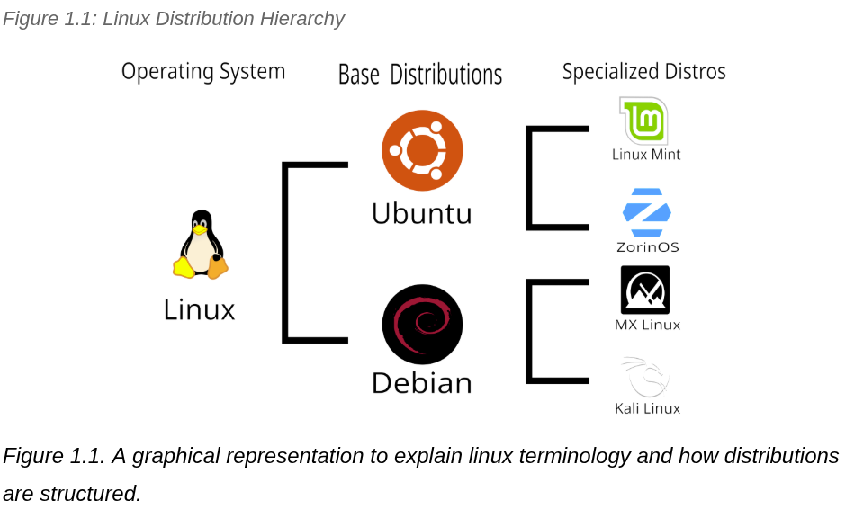

For this thesis, we will be using a computer running an Ubuntu-based Linux distribution. Many, if not all, of the bioinformatic software packages and tools can be run on macOS and Windows; however, I suggest Linux for two reasons: First, Linux is highly customizable and open source, while macOS and Windows are proprietary and built for a general audience. This means that if you need to go into the internals for whatever reason, fewer guardrails could get in the way of troubleshooting (note that these guardrails exist for a reason, so more care is needed when making changes like these). The second reason is simply that I am more familiar with Linux as it is what I have run during my time as a master’s student. Therefore, I am able to talk in more depth about and anticipate troubleshooting for Linux better than I can for other operating systems. However, as long as you have access to a Unix based command line, most of the information here will be directly transferable, no matter the OS you are using.

Setting up Linux²⁵
The work on this thesis will be done using the Linux Mint. I find this distribution to be the best for newer bioinformaticists since it comes with a GUI that looks and functions similar to Windows and is user-friendly straight out of the box. The following section will be a specific explanation on setting up Linux Mint; however, any Ubuntu-based Linux distro will have nearly identical results when commands are entered into the command line interface (or CLI). Non-Ubuntu distros (including Unix-based macOS) will be similar, but diverge in key areas. Windows will diverge even further.

This thesis will give a broad explanation of the steps to install Linux Mint as of the time of writing. However, small details may change slightly over time or differ based on hardware. Please use this as a supplement for the official installation documentation that can be found on the website of the distro of choice. Currently, the Linux Mint installation guide can be found at https://linuxmint-installation-guide.readthedocs.io/en/latest/. Additionally, if you or a mentor already have a bootable media, please skip to the section: Boot and Install Linux.

Creating a Bootable Media
The easiest way to install an OS on your computer is through what is called a boot stick. This is usually a USB stick that contains what is called an ISO image. You can think of an ISO file as an Ikea box for a new table you hired your computer to build; It contains all of the parts needed to build the OS as well as instructions for your computer to do it²⁴ resulting in the computer building an exact replica of what is on the ISO file. Most Linux Operating Systems, especially free ones, are created and maintained by an asynchronous group of individuals instead of large companies. Most of these individuals won’t have the funds to set up a server that will allow you to download the ISO image at a reasonable speed. These groups will go to organizations or individuals that are willing to “Mirror” their site. That is where we are going to get our ISO image.

When you navigate to Linux Mint’s download mirror site, you should be met with a list of organizations from all around the world. Each of these sites is hosting copies of the official downloads provided by Linux Mint. Click on the location that is closest to you for the fastest download (“Purdue Linux Users Group” is currently the closest mirror to ECU). This will take you to a stripped down page with only a title and links. While this page will likely raise some red for someone seeing a page like this for the first time, the simplicity is purposeful; making a site look pretty takes time, resources, and requires more maintenance. Most mirrors will look similar, especially if they are being hosted voluntarily. To double-check the site's safety, click on the search bar and look for “https://” at the beginning of the URL (this signifies that the website is encrypted and malicious actors can’t eavesdrop on you. Click on the “stable/” directory (comp-sci term for folder) to navigate to another page that will list various Linux Mint versions that have been bug-tested and are approved for release. Click on the latest release and you should see a list of Linux Mint files that end in ‘.iso’ as well as two additional files that will have ‘sha256sum’ in their names. The different ISO images are for different subtypes of Linux Mint that have differing amounts of features. I recommend downloading the most fully loaded version into an empty folder. At the moment, this version is “Cinnamon,” but the different versions and their capabilities can be double-checked on the official website. In addition, download the two ‘sha256sum’ files into that same folder by right-clicking on the link, then clicking “Save as” (Note: do not copy paste the contents into a different text file. The verification process counts this as tampering and will cause the authentication check to flag the false positive). I will explain what these files do next.

If you are copying an OS image to your computer, it is extremely important to know you can trust the source; building a replica of something on your computer is extremely convenient and powerful, but that means that it is also extremely dangerous if used for malicious purposes. In order to ensure that the Linux Mint file that you download is an unmodified official image, the OS you are downloading will provide a checksum file. This file is essentially a unique fingerprint that can be checked against the official download to ensure that the ISO you download is what you think it is.

At this point, you should have an ISO image and two sha256 checksum files in a folder. The next step is to double-check those files using the checksums to ensure that the files have not been tampered with. While it is rare for people to tamper with files on an official mirror, occasionally files can get corrupted during the download process which, for the code that will run your computer, can be just as bad as if it was tampered with. Also, it is good general practice to check any image file downloaded over the internet whenever you can. We do this by verifying 2 things: integrity (has it been modified?) and authenticity (is it official?).

In order to verify the ISO image, we are going to use the command line for the first time. On macOS, first open the “Terminal” app installed on your Mac. Then enter the command shasum -a 256 yourfile.iso. Essentially, this will run the file through a complex math equation that will create a unique line of characters that is unique to the file. Any modifications made to the file (even renaming it) will cause the character string to change. This string should be identical to the string located in the “sha256.txt” file. If it doesn’t, there are modifications in the ISO image that could indicate that it’s been tampered with or corrupted; delete the download and try again. If they match, you know that the file is what it says it is.

We know that the file is a one-to-one copy, but how do we know this is an official file and not a counterfeit? In order to find this out, we need to do an authenticity check using a command-line program called gpg to check the sha256sum with the one that is verified by Linux Mint. Once again, open up the command line the same way you did in the last step and copy this into the command line:
gpg --keyserver hkp://keys.openpgp.org:80 --recv-key 27DEB15644C6B3CF3BD7D291300F846BA25BAE09
This pulls the official key uploaded by Linux Mint to your computer. The recv-key option comes straight from Linux Mint’s website, and we can verify that it came from Linux Mint with the command:
gpg --list-key --with-fingerprint A25BAE09
This should produce the output below:
pub rsa4096 2016-06-07 [SC]
27DE B156 44C6 B3CF 3BD7 D291 300F 846B A25B AE09
uid [ unknown] Linux Mint ISO Signing Key <root@linuxmint.com>

Notice how the output confirms that it is a “Linux Mint ISO Signing Key” This confirms that the imported key comes from Linux Mint, and we can compare it to our ISO sha256 key by entering the command gpg --verify sha256sum.txt.gpg sha256sum.txt. If the output tells you the file signature is good, then you know that the fingerprint in the “sha256sum.txt” and therefore in your ISO file is legit, and you are ready to proceed!

Now that we have a legit ISO file, we need to write it to a bootable medium like a USB stick that will tell the computer how to install the OS onto your computer. Using the analogy of the Ikea table before, the file we just got is the equivalent of packing up the physical lumber and tools into the box; writing that file to the USB stick is the equivalent of adding the manual. To do this, we need an image writer software that is capable of doing this. Both Linux Mint and I recommend Etcher²⁶ as it is both user-friendly and reliable. Follow the instructions of the image writer you use to write the ISO file to the chosen USB stick (Important Note: Make sure to remove any important data from the stick BEFORE writing the image. The formatting process will delete all previous data on the USB and it CANNOT be recovered.

Congratulations! You are now the proud owner of an OS on a stick! Now comes the fun part; let’s install your handywork.

Boot and Install Linux.
Whether created or inherited, you should be in possession of a bootable media, most likely a USB stick, containing a Linux Mint ISO image. Now, let's install it on a computer. Luckily, this step is substantially easier than the previous step.

First, we need to navigate to your computer’s Basic Input/Output System (BIOS) menu. Your computer’s BIOS is firmware that checks to see that your computer is good to go before loading your OS, and can be accessed by pressing a special key as your computer turns on. Unfortunately, the specific button differs from computer to computer; however, the specific button is often displayed on the monitor as the computer turns on (Usual culprits include Escape, F1, F2, F8, F10, F11, F12, and Delete). On Mac, the BIOS can be accessed by holding either the “Alt.” or Options key while your system boots up. Insert the USB into your computer and navigate to the system BIOS. Once you enter the system BIOS, there should be a section or tab named “Boot Order.” Once you get to that section, there should be an entry named either “Linux Mint” or “USB Boot.” Move this boot option to the top of the list and exit the system BIOS. Save changes and exit the BIOS menu. If everything goes well, the next time you boot up your computer, it should start Linux Mint.

If you see the Linux Mint homepage, you are on the right track. However, we are not entirely done yet. What we are looking at is something called a “Live Boot Session.” This is a version of your OS that exists directly on the USB and not your computer. If we make any changes to this version, they will be erased when we boot it up again. In order to make changes permanent, we need to install a version of this boot directly on your computer’s storage. To do this, click the “Install Linux Mint” icon at the top left of the desktop and follow the steps.

BASH Crash Course
Like I said earlier, one skill that any bioinformatician needs is a foundational understanding of the command line. As a note, terms like “the command line”, “the command line interface (CLI),” “the terminal,” “Unix,” and oftentimes even “BASH” are used interchangeably in the field and throughout this thesis. While there are technically slight differences between these terms, all of these terms are colloquially used to describe the computer terminal.

If you haven’t coded before, your first exposure will likely be extremely overwhelming. Additionally, as you go through examples, you will likely get many, many errors that may be discouraging as you go through the process of learning bioinformatics. This is completely normal and a rite of passage for anyone starting to code. Unfortunately, these errors will continue for as long as you code. What separates, new coders from career coders is how fast they deal with those error codes. You will see yourself get better at that with time.

Additionally, seeing that many error messages and making that many mistakes may tempt you to subvert the command line entirely using a GUI tool like Galaxy or have AI code for you. While I would highly discourage using a GUI tool for reasons previously described, AI can be an incredibly valuable tool for both coding and learning.

To be clear, I don’t recommend having AI code everything for you. While this may seem tempting, and AI may be able to produce something that works, AI is currently bad at editing code in a consistent manner, which often leads to more failpoints in the final product if not properly supervised. Additionally, having AI alone write your code, especially during the learning process, means that you are less likely to learn how individual blocks of code work in your overall pipeline. This usually results in an error code that takes much more time to fix because you are less sure how the overall code works. Because you don’t get practice, you never get better at the problem. However, AI is incredible at teaching you when prompted correctly. When you run into errors, put the error into AI and ask what the error message means, what line of code specifically is causing the error, and how you would fix the error. When the AI responds, ask clarifying questions. Remember, LLMs can't judge you, so ask as many times as is necessary to understand how and why the code is working the way it is.

Accessing and Navigating the Terminal
There are a couple of different ways to access the terminal. The first is to click the Linux Mint button in the bottom left and search for the terminal app. For a quicker way of opening the terminal, you can click “Ctrl. + Alt. + T.” Some software available in the “Software Manager” app lets you open and close a terminal using a keybind (I recommend Guake Terminal. Once you open the terminal, a black box will open that you are able to type commands into.

Note: All blocks of code below will be color coded to the following key:
Input Code
Standard Terminal Output
Error Messages

pwd - Where am I?

While it may not look like it, you are able to navigate the terminal the exact same way that you would navigate the files of your computer. The terminal’s equivalent of folders are called “directories.” When you first open the terminal, you are taken to the “home directory.” This is the default directory that will contain other directories that you make in the future. To make sure that we are where we think we are, enter the “path to working directory” command into the terminal by typing pwd and hitting enter.

The pwd command will output the directory that you are currently looking at. At this point it should look something like /home/<user>. Directories are listed like this with each directory being signified with a “/”.

To list all files and directories within your current working directory (the one you’re looking at), use the command:
ls
This should output a list of the default directories that come with Linux Mint, such as “Documents“ and “Desktop”.

cd & mkdir - Creating and Moving Through Directories

Data management is an essential skill that will save you countless hours throughout your time as a bioinformatician. For that reason, you typically don’t want to put files directly into your home directory because it will become cluttered very quickly. While everyone will have a different organization system, you should typically create a new directory for each project you start or each application you download.

You can create a directory in a couple of different ways. The first and most user-friendly way of creating a directory is through the “Files” app. To create a directory in this manner, open the Files application through the Linux Mint menu (clicking on the bottom left icon when looking at the desktop). This should bring up a file GUI similar to what you would use with Windows or macOS. Right-click on an empty space and click on “Create New Folder.” This is how you would normally create a new directory without using the terminal.

There are many times in which you will need to create and move through directories through either the terminal or in a script you write. To create a directory in the terminal, use the make directory command by typing mkdir. Try it by typing:
mkdir test1
To check to see if it worked, list the directories in the working directory by typing:
ls
If the directory was made, you should see test1 listed among the output.

Now let's move into the new directory we just created. To move into a new directory, we can use the “Call Directory Command” by typing cd followed by the directory you want to navigate to. Try it by typing:
cd test1
Now, you should be in the “test1” directory. Confirm it by using the path to working directory command:
pwd
If it worked, you should see the following output:
/home/<user>/test1
Let's make a directory inside this directory and navigate to it by typing:
mkdir test2
cd test2
pwd
You should see the output:
/home/<user>/test1/test2

In the past few examples, we have been moving “down” directories, or away from the home directory. Now we will be navigating towards the home directory or “up” directories. To go up one directory, we can use two periods. Try it by typing:
pwd
You should see the output,
/home/<user>/test1/test2
Now let’s navigate up one directory to “test1” by typing:
cd ..
pwd
You should see:
/home/<user>/test1
Now let’s do it one more time to get back to the home directory:
cd ..
pwd
You should see:
/home/<user>

Navigating to a directory one step at a time is called “navigating using a relative path.” You can also navigate directly to a chosen directory by calling its “absolute path,” or the exact location it is on your computer. You can think of relative paths as directions; navigating with relative paths is the equivalent of “Take the first left…” while absolute pathing is like inputting the exact address. Navigate to the test2 directory using its absolute path by typing:
cd ~/test1/test2
pwd
To which you should see:
/home/<user>/test1/test2

Notice the “~” in the previous command. This symbol is used in the command line as a shortcut for the home directory. As you may have noticed, the specific user’s name is used in calling the home directory, which would result in issues if a different user were to use a script that references the home directory if we wrote it out verbatim. The ~ shortcut not only saves time but also allows for a script referencing the home directory to reference the home directory of the person running the script.

Oftentimes, you will need to go back to the home directory. Luckily, the home directory can be accessed quickly by typing in cd without any path. Try it with:
pwd
This should output:
/home/<user>/test1/test2
Then enter:
cd
pwd
Which should output your home directory:
/home/<user>

rm - Removing Directories

If you want to remove a directory through the terminal, use the “remove directory” (rmdir) command. However, there are some specific caveats about this command. Navigate to the home directory, then type:
rmdir test1
At this point you should see the following error message:
rmdir: failed to remove 'test1': Directory not empty
Removing a directory or file from the CLI can be dangerous; unlike other OSes, there isn’t a terminal equivalent of a “recycle bin,” meaning that anything that is deleted can not be recovered. Because of this, the Bash language that the CLI runs on will always check to see if a directory is empty before running the rmdir command. That’s why the error occurred.

There are a couple of ways of getting around this problem. Since the only thing in the “test1” directory is the empty “test2” directory, one way of dealing with this problem is to cd into the “test1” directory, then run rmdir on “test2” because “test2” is empty, the rmdir command would work. Then we cd back to the home directory and rerun rmdir test1. However, this is a lot of commands and would take a lot of time. Additionally, some directories could be filled with hundreds or thousands of files that would take hours to remove one by one.

An easier and more practical way of removing a non-empty file is to use the “Recursive” and “Force” options for the “Remove” (rm) command. Most commands that you use in the command line will have several different “options” that will slightly modify how a command runs. These options are typically used by adding a hyphen followed by a letter (or letters for multiple options) or a short phrase. For this case, we can use the “Force Option (-f)” combined with the “recursive option (-r)” to tell the “rm” command to force remove the directory and repeat the command for every item inside that directory. Try it from the home directory with:
rm -rf test1
ls
If the command worked as expected, you should notice that the “test1” directory no longer exists, and therefore everything contained in the file is also gone. Additionally, a similar option exists for the rmdir command with the --ignore-fail-on-non-empty option, but the rm command is typically quicker for this scenario. Once again, be extremely careful with the rm and rmdir commands. If something is deleted like this, you can not get it back.

Essential Commands for the Command Line
Now that we know how to orient and move through the terminal, we need to build a vocabulary of essential commands that will be needed for general everyday use of the command line. While these commands aren’t specific to bioinformatics, being familiar with these in particular will make your life easier in the long run. Think of it as if you are a doctor practicing in an area with a different common language from yours. You could be the best in the world, but if you don’t know how to communicate with your patients (or the files & software) you’re working with, it’s going to be a struggle.

sudo - “No Really, Do It.”

I need to admit something: I lied when I said that Linux and the CLI don’t have any guardrails. By default, Unix will prevent certain actions that are inherently dangerous if accessed by malicious actors. These actions include downloading software that can access your whole system, modifying configuration files that make your computer function, and accessing root files that could brick your computer if edited without care. However, there are times in which you will need to actually do these things (especially download software), and that’s where the sudo command comes in.

sudo stands for “Super User DO” and is the equivalent of an admin password for a Windows device. If you need to do something that the system believes you either don’t have permission to access or that may be detrimental to your computer if you accidentally delete or modify, you are required to put sudo in front of the desired command. Once you do this you will be prompted for an administrator password. If you are the administrator of your computer, this will be the password you use for accessing your computer.

Let's run through an example by trying to list the files in the root directory. Unlike the “home” directory, the root directory contains files that keep your computer up and running:
ls /root
At this point you will see one of two responses: either a clear error message like,
bash: ls /root: Permission denied
Or you will be prompted to enter your password and see an output like,
[sudo] password for <User>:
If your computer defaults to the first option, type sudo in front of the command or type in sudo !! (!! is a shortcut for “run last command again”) and you will see the second prompt. Once you see the second prompt, enter your password to confirm that the computer has permission to make those changes. When asked for your sudo password, always ask yourself if you can trust the program before granting access.

touch - “Creating a File”
touch is the command to create an empty file from the command line. While this can often be done in a more user-friendly way through the files GUI, this command is particularly useful if you want to create a file that you want to output other commands to. Let's create a test file in a sandbox directory to explore this command as well as some later ones.
mkdir sandbox
cd sandbox
touch test.txt
touch test2.txt
ls
Which should output:
test.txt test2.txt
In the previous series of commands, we made the sandbox directory, traveled into it, made a text document called test.txt and listed all the files in the directory.

cat - “Reading and Combining Files”
Technically, the cat command is short for "concatenate" and is used to combine two files. While it is really good at that, you’ll find yourself using cat as an easy way to read files from the terminal. Let's add some text to the two test files we made earlier and walk through an example:
echo “lorum ipsum” >> test.txt
echo “is hard to spell” >> test2.txt
The previous two commands tell the computer to say back to you – or echo – a specific line of text and store (>>) the result of that command (the text you echoed) into the test.txt and test2.txt files you made earlier. Now let's use cat to read the files:
cat test.txt
lorum ipsum
cat test2.txt
is hard to spell
As you can see, putting cat and the file you want to read will result in the output of what is in the file directly in your terminal. Now, let’s use cat for its original purpose and combine the two files.
cat test.txt test2.txt >> test3.txt
ls
test.txt test2.txt test3.txt
cat test3.txt
lorum ipsum
is hard to spell
As you can see the code made a third file called test3.txt that contains both of the text files on different lines. Please note that the >> is necessary for the creation of the new file without that the file will just read both of the files back to back.

mv - Moving and Renaming Files
Now, let’s turn the “test3.txt” file into a shell script that can run code. To do this, the first step is to rename the file to a file ending in “.sh”. Similar to the cat command that is used more for reading files than concatenating them, the move (mv) command is often used more for renaming rather than moving files. Let's rename the test3 file into a shell file by running the code below:
mv test3.txt testScript.sh
ls
test.txt test2.txt testScript.sh
As you can see, we no longer have the “test3.txt” and instead we now have the testScript.sh file. In the case that we wanted to move the directory, we would replace the name of the file name with a path to the directory we want to move it to.

nano - Editing Small Files
If we wanted to edit a file, there are a couple of ways to do it. For larger files, we would want to use a dedicated text editor (See the Setting Up Essential Software section below). However, if we want to make a small, simple edit, we can do that directly in the terminal using the nano command. Let’s edit the text of the testScript.sh file so that it echoes the text that’s still stored in the file. Let’s edit it with the nano command:
nano testScript.sh
This should bring up a terminal text editor with the lines we wrote in the test.txt and test2.txt files. Use the editor to change the file to say echo "lorum ipsum is hard to spell". The bottom of the text editor has a series of different characters preceded by a “^.” the “^” represents either the “Ctrl.” or “Command” key, depending on whether you are on Mac or PC. To exit the text editor, hit ^X followed by y to save changes, then Enter to confirm. Finally, cat the file to make sure that the changes are saved:
cat testScript.sh
echo "lorum ipsum is hard to spell"
If the command returns that output, you are good to go!

chmod - Change Permissions
All of the files that you create will have one or more permissions attached to them. These permissions will either be read (-r), write (-w), and/or execute (-x). These permissions will tell the user (or the programs they run) that they are able to look at, edit, and run in the terminal (if it’s code), respectively. If you write a script that you want to run in the terminal and it’s not running properly, there’s a good chance that you need to change the permissions first. Let's first try to run our new script normally with the following:
./testScript.sh
The “./“ before the script you want to run indicates that you want to execute the script. However, because we haven’t changed the permissions, we should get the following error message:
bash: ./testScript.sh: Permission denied
To check what permissions the file has, let's use the ls command with the -l option:
ls -l
total 36K
-rw-rw-r-- 1 <owner> <group> 12 Jan 21 12:27 test.txt
-rw-rw-r-- 1 <owner> <group> 17 Jan 21 12:28 test2.txt
-rw-rw-r-- 1 <owner> <group> 36 Jan 21 15:45 testScript.sh
While this output looks complicated, it isn’t that complicated when you break it down. The first line that’s outputted (total 36K) shows you the total amount of space that the file takes up in bits. Therefore, 36K is 36kB of storage taken up by the files in the directory. Each of the next lines represents a file. The first section lists the permissions for the owner, group (a predetermined group of people), and others (everyone else). The second and third parts list the owner of the file and the group they belong to (will be the user if a group isn’t assigned). The next two sessions list the file's last edit date and name.

The thing that we want to notice is that the owner can only read and edit (write) the files, but there is no execute privilege for the testScript.sh file. To add this file, we will use the chmod command with the +x option to indicate that we want the file to become executable. Let's add the permission and see how that changes the ls -l command.
chmod +x testScript.sh
ls -l
-rw-rw-r-- 1 caden caden 12 Jan 21 12:27 test.txt
-rw-rw-r-- 1 caden caden 17 Jan 21 12:28 test2.txt
-rwxrwxr-x 1 caden caden 36 Jan 21 15:45 testScript.sh
Notice how the testScript.sh file has an x in each of the user's permissions. This indicates that the file is now executable for everyone. Test it now by rerunning the code that created the error message:
./testScript.sh
lorum ipsum is hard to spell
If you got the output seen above, then you know the edits worked!

grep - Finding a Needle in a Haystack
There are times, especially in bioinformatics, when you will want to find something very specific in an extremely large file, directory, or even in the system as a whole. For example, say you have a .fasta file (a file that contains the A's, G's, T’s, and C’s contained in DNA) and you want to determine the number of times the AAGTCTAG motif appears in that file. In a case like this, you would use the grep command.
grep stands for Global Regular Expression Print, and this is a command that searches a file, directory, or even your full computer for a specific pattern. To explain this, I have made a completely new file in which I have put the lyrics of Bohemian Rhapsody in.
touch rhapsody.txt
nano rhapsody.txt
At this point, I pasted the lyrics into the nano editor. Now you can use the grep command to find specific words in the lyrics. For example:
grep “no” rhapsody.txt
Caught in a landslide, no escape from reality
I'm just a poor boy, I need no sympathy (Ooh, poor boy)
Put a gun against his head, pulled my trigger, now he's dead
There are a lot more outputs, but I will stop there. Notice how the no’s are highlighted. This tool is extremely versatile and has many different options for specific purposes. See some useful options in Appendix A or by using the man command.

man - Figuring Out Other Things
There are countless other commands, and with every software you install. If you want to know more about the details, the man command is perfect. To use it, simply type man <command>, and you will get a detailed description of the command.

Tab Autocomplete and Final Bash Thoughts
I will leave the Bash crash course with one final piece of wisdom. Now that you should be getting comfortable with the command line, tab autocomplete should be extremely useful. Whenever you are typing a command, hit tab to complete. If there is only one option that you can type, the full command will fill out. If not, the command will complete as much as it can. At this point, you can hit the next letter in the command you want to type and hit tab again.

Finally, as a reminder, this is an extremely brief crash course. Additional help would be extremely helpful. For additional resources, I recommend checking out the third-party sources such as those from CodeAcademy, Command Line Bootcamp, or Unix and Perl Primer for Biologists.

Setting Up Essential Software
Now that we are a bit familiar with Bash, we need to download the software needed for proper RNAseq analysis. Three specific pieces of software are essential to download: R, a text editor meant for code, and Conda.²⁷ Let's first explain what exactly these software are.

Conda
Let’s start with Conda. Conda is a software management application that ensures that all of the software that you use is compatible with each other using what is called “Environments.” To understand why that’s important, we must first consider that software is constantly updated with new syntax, bug fixes, and other changes. Some software also often depends on other preexisting software (often called dependencies). Sometimes, if a software dependency is updated, it could mess up the larger software. While you can probably fix it without too much trouble if it’s just a couple of software packages, once you work on larger projects, it would take hundreds of hours to get all of the software packages working for that project. If you are working on multiple projects, this problem grows exponentially.

Conda is a software that solves this problem. Instead of downloading software directly on the computer, you create an environment and install software in that environment using Conda. Conda will make sure that all the software that you install in the environment is compatible with one another and will upgrade/downgrade software and dependencies so that the larger project will work with minimal issues. We can install conda by running the following code:
bash anaconda-latest-Linux-x86_64.sh
Then we can test if the installation worked with the command:
conda list
If a list of packages shows up, then the install was successful.

R and RStudio
Now let's talk about R. R is an open source programming language that is relatively user-friendly and designed specifically for statistics, data analysis, and graphics. R is often used in the sciences as it is relatively user-friendly, has the ability to make publication-ready graphs, and has a lot of backing and support from the wider scientific community.

To download R on your computer, go to https://cran.rstudio.com/. From there, click your Linux distro under “Download for Linux” (Linux Mint will be Ubuntu). Copy and paste the commands listed into the terminal. To test if R was successfully installed, type “R” into the terminal. If you see a message from R appear on the terminal, Congratulations, you have R on your computer! But we’re not done yet; While technically we can do everything we need directly in the R terminal, the experience is even less fun than normally working with the CLI. Instead, we can download what is called an “Integrated Development Environment (IDE)” to make the process much easier. Let’s download an IDE for R called “RStudio.”

To download RStudio, go to the official RStudio download page by Posit at the URL: https://posit.co/download/rstudio-desktop/. From there, click the download link for the Distribution you have (Ubuntu 24 for Linux Mint). Install the program in your home directory. Once that is done, you should be able to find RStudio in the Linux Mint Menu.

Coding Text Editor
You may be familiar with the default text editor (or notepad) that comes with your computer. This is a simple program where you can change the text of a document. Theoretically all your coding can be done in this software. However, text editors that are built to handle code make a world of difference.

There are many options for coding specific text editors out there, each with their own specific features and strengths. I recommend doing some research to find the one that works for you, but I prefer Visual Studio Code (VSCode). This is a popular text editor with support for upgrades and plugins. Before you commit to a text editor, I would highly recommend ensuring that it has a built in linter (a tool that checks your syntax). This is pretty standard but coding without a linter is extremely time consuming and inefficient.

Chapter 2 - Example Script
For the second part of this thesis, we will review a sample pipeline that I wrote to analyze a typical differential expression analysis. First, we will outline a general plan that we hope to accomplish. Then, we will identify how we will accomplish each step of this plan. Some steps we will be able to solve ourselves; however, we will need to use some tools for others. After that, we will explain every step in the thought process of writing the script and build the pipeline step by step. We will then explain how to run and troubleshoot some common errors we may run into.

For this example script, we will be using an mRNA differential expression dataset on the common dog (Canis lupus familiaris). Specifically, we will be using the study “RNA-seq of TGF-β induced and histone variant H2A.Z-knocked-down canine MDCK cells in epithelial-to-mesenchymal transition (EMT)” (ENA Study: ERP022283; Study Accession: PRJEB20155)²⁸. This study looked at the role that a specific histone acetylation (H2A.Z) plays on a tumor suppressor gene (TGF-β) and the ability of the affected cancer cells to become malignant (EMT) in an immortalized dog cell line (MDCK). They separated the cells into three different groups: the first group had a gene knockdown for TGF-β, then had shRNA target H2A.Z, the second had shRNA target H2A.Z without having the TGF-β gene knocked out, and the last was a control group that had no treatment assigned to it. mRNA differential expression was used to compare the two treatment groups to the control group, and gene up- and downregulation was determined. Official results can be found on the Gene Expression Atlas.²⁹

I highly recommend that you follow along and build the pipeline yourself as you read this thesis. This will build the skills needed to write future scripts and get you used to writing the syntax needed to code. However, please feel free to use or reference the full script in a GitHub repo that will contain the full script for download.

Outlining a plan

RNAseq Basics
First, let’s outline what exactly we are trying to accomplish with RNAseq analysis. Extremely briefly, RNAseq is a technique that is used to figure out what genetic differences cause a specific trait or disease. To do this, we measure the amounts of mRNA we can detect in a subset of cells and use a refseq to identify exactly what genes the mRNA maps to. If we see any genes that are upregulated (producing more mRNA) or downregulated (producing less mRNA), we can associate that gene with the trait or disease we are studying.
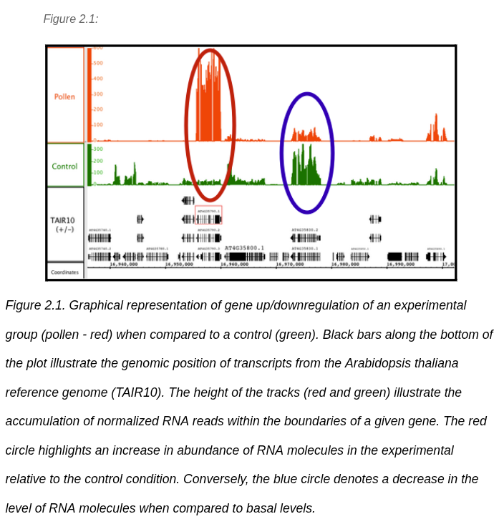

So now that we know the broad strokes of the direction of where to go, let's figure out what we’re going to be working with. First, we need to know what we are working with. Typical RNAseq data will consist of a “.fastq” file that consists of millions of unordered and unorganized short reads that are picked up from the sample. Physically, this fastq file will be structured like the example following this paragraph. While looking complex, the format is simple. The first line will always start with an @ and contain identifying information for the machine it was run on, sample ID, start time, and other meta information. The second line will consist of the nucleotide sequence. The 3rd line will consist of a single + tying the previous line to the next line. The 4th and final line will consist of a series of characters that represent how confident the sequencer is in saying that the nucleotide above it is correct. Knowing what each character means in its confidence is outside the scope of this thesis, but if you are curious, look up what Phred scores are, then search “ASKII encoded Phred scores.”

Fastq File Example
@2fa9ee1… runid=f53ee404… sampleid=18S_am… read=109831 ch=33 start_time=2019-09…
CGGTAGCCAGCTGCGTTCAGTATGGAAGATTTGATTTGTTTAGCGATCGCCATACTACCGTGACAAGA
+
+&&-&%$%%$$$#)33&0$&%$''*''%$#%$%#+-5/---*&&%$%&())(&$#&,'))5769*+..

Rough Plan
Now that we know what we’ll be working with, let's figure out what we physically need to do. We need to prepare any helper functions we need, set up directories where the files will be going, download the data that we need, build an index file, map our sequences to our index file, count how many maps each gene has, and finally check the quality of our results.

Preparation
The first thing we should do when making a new project is make a dedicated conda environment. Let's create a conda environment called “DE_script” with the “conda-forge” and “bioconda” channels. Type the following command into the terminal:
conda create -n DE_script -c conda-forge -c bioconda
conda activate -n DE_script
At this point, you should see the “DE_script” environment activated.

Now that we have the Conda environment, we need to install the tools we’ll need to run our pipeline. When you write your own pipeline, you’ll find the tools you need either in the planning phase or as you go (if/when things don’t go according to plan). However, since we are just following along, we will download all the tools we need now. Once you have activated your conda environment, use the commands in Table 2.1 in the CLI to install the following tools.
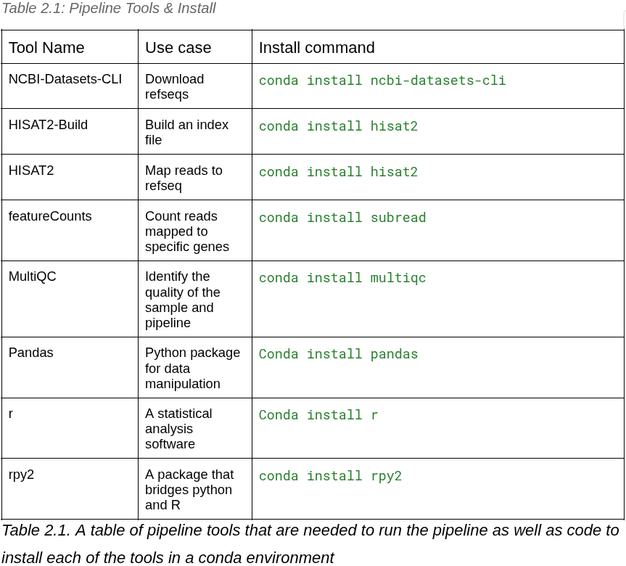

A couple of important things to note are that both HISAT2 and its corresponding build tool are both packaged under the hisat2 package, meaning you won’t need to run that code twice. Additionally, if you try to install featureCounts directly, your installation will fail. The tool is located in the subread software package.

We will be running our script in Python which means that we will need to import some useful packages of library functions that the open source community has made. We can use the python package installer pip to do this but we need to install it first. Let’s do this by using the command:
conda install pip
Then accept any confirmation that shows up.

Now that we have pip installed on our environment, we need to import the packages that have helper functions we will be using in our script. When you are building a script on your own, you will install these packages as you need them. However, for simplicity we will download all the packages we will need right now. Make sure that you have activated the Conda environment and then install the software according to Table 2.1.

Finally we need to make a table listing the experiment’s “metadata.” This includes important information about our data and we are most interested in making sure that we label our experimental and control groups. Additionally, it is typically best practice to put these files in a designated folder. To do this let's start on the script. First, let’s create a new working directory called “diffEx” and cd into it. Use the mkdir inputFiles to create a directory to hold our metadata. Finally, use a table editor like google sheets to make a metadata.csv file formatted like the table in Table 2.2.
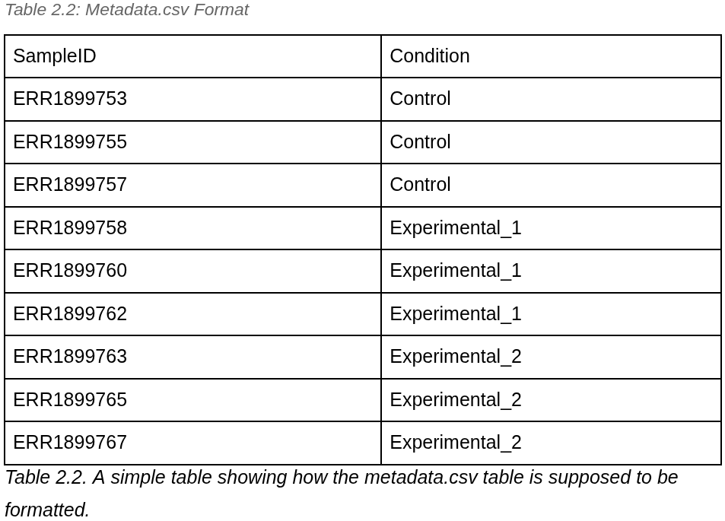

Now that we’ve prepared our Conda environment and metadata. We can finally start on our script. In the project directory, make a new empty file called “deScript.py” and open it in your text editor.

Import Libraries - Gather Your Tools
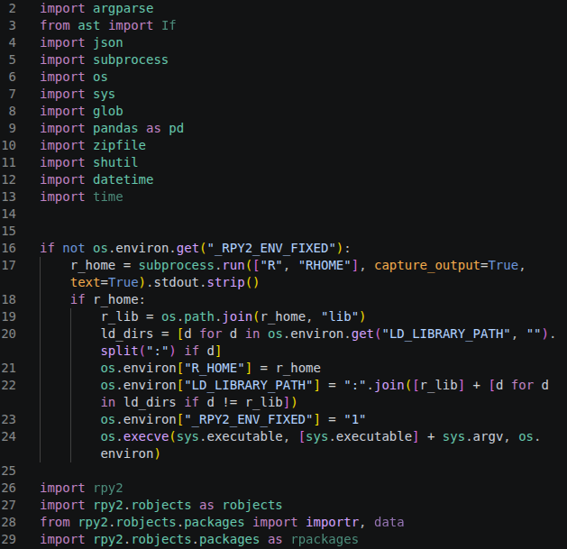

The first step in any Python script is to import any functions from Python libraries we will need to use in our script. Python comes installed with a lot of helpful functions that make our lives a lot easier in specific situations. However, many of these functions are situational, and the python community has developed additional ones to help with pretty much anything you could imagine.

We need to tell Python to look at some of these specific libraries using the import command. When you are making your pipeline this section will start small and, you will add more imports as you need them.

You may notice that the rpy2 library has an if statement preceding it. The rpy2 library acts as a bridge between R and Python. Because of this, we need to make sure that Python knows where R is before the main part of the script runs. This if statement checks to see if the R library is visible by Python. If it isn’t, it prepares some variables then restarts the script in preparation for the rest of the script.

Creating Helper Functions
The next thing we do when making a bioinformatics pipeline (or anything) in Python is make helper functions that will assist in writing the main part of the script. These helper functions are usually made to either assist you with debugging by letting you know where and how the script failed or by turning a long and repetitive command into a shorter one. We will be making three helper functions with our script. The first will be a command that will help with errors. More specifically, we want to tell Python to run a tool in BASH and physically tell us when the program runs and if it completes. That way, if it fails, we are able to pinpoint exactly where it failed without having to translate the error logs. Put the full command below, then we’ll go over each part of it.

Run Command Helper Function
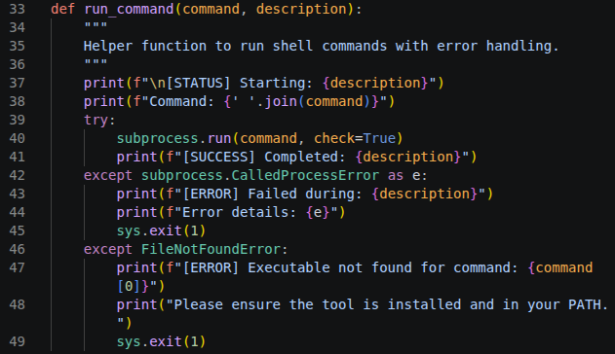

The def in the first line tells Python that the following text is a function. The run_command is the name that you give your function, and the command and description within the parentheses are parameters that you will reference in the function. In order to run this command later on in the script, we will make a list of the commands we would type into the terminal, then pass that list into the command parameter. For example, if we wanted to run the command cd && ls -a we would store that command as a list in Python like this:
cd_cmd = [“cd”, “&&”, “ls -a]”
Then, when we want to run the command, we would type this into the script:
run_command(cd_cmd, “Go to home directory then list all files & directories”)

This part of the script is a comment and actually doesn’t do anything. In Python, anything that has either a # in front of it, or is enclosed by ””” is treated as a comment and is ignored by the program. The main purpose of this is to remind you (the programmer) what the section does so that you don’t need to decipher the code after not looking at it for a while.

This part of the code will print or display directly on the screen a short string of your choosing the f in front of the ”tells Python to treat anything inside {} as if it weren’t part of the string. This means that the terminal will tell you that it’s starting whatever task you enter as the description. The second print line will tell you the exact command that is being run. Since we will be storing our command as a list. The ’ ‘.join(command) will be how we connect that list into a command that the terminal can use. This command says that the command list we have will be .joined with a space (’ ‘). For our example, cd_cmd the join process would be joined together like this cd && ls -a.

This part of the code will try to tell the run command from the subprocess library to run the list you stored in the command list. The subprocess.run command expects a list in the same format as was pieced together with the previous .join command. The check=True parameter tells Python to check to see if it completed successfully. If not, it’ll call a separate subprocess function called CalledProcessError that will let you know what went wrong. If the command ends successfully, then the rest of the function is skipped. If the process fails, then we will go to the next part of the function.

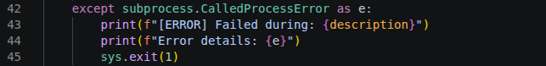

The except statement will only occur if the first process fails. If this occurs, Python will call the CalledProcessError function from the subprocess library that is automatically created with the check=True parameter in the previous section and store it as the variable e. It will print that the command failed, similarly to the success process of the previous section, then tell you the error details by printing whatever was inside e. The function will then exit using sys.exit(1) which tells Python that an error has occurred.

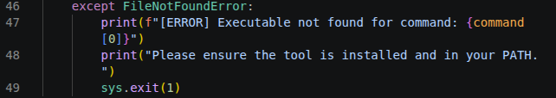

This last part of the function will only occur if the previous two sections didn’t work and is functionally similar to the previous section. However, as you may be noticing, the previous two scenarios were “If the subprocess command worked” or “if it didn’t work.” The only other situation that may occur is if the subprocess command wasn’t found at all. Since the package comes with Python, this is unlikely, but it’s good to cover it just in case.

Check Tools Helper Function
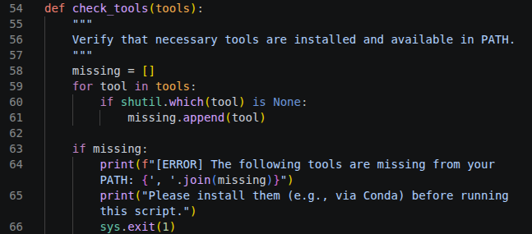

Next, we will look at the check_tools helper function. This helper function is designed to check your conda environment to see if you have all the tools you need installed. If it detects that some are missing, it will end the program immediately. It’s helpful to know it immediately because if not, you will spend hours waiting for a program to finish just to have it fail. Additionally, this and future code will have similar parts to the previous code. The full code is available, but I will only explain the new code in detail (I will refer back to the previous code whenever possible).

Later in the main portion of the pipeline, you will make a list of tools that you will need to pre-install on conda. By passing those tools into the tools parameter, you can ensure that the program can see the tools before moving on. Even if you know you have the tools installed, it’s always good to have something like this so that you know that nothing is going wrong.

This first line makes an empty list that the function can refer to later on.

This next section is a for loop that will look at each item (which we call tool) that we put in the tools parameter. Note that whether or not it’s plural is important; each tool is a single element of tools. Since we will be putting a list in the tools parameter, the for loop will run the indented text below it on every item in the list. The if statement will use a package library called shutil to run subprocesses on your computer terminal. In this case, it’ll ruin the which command to see if the tool it is looking at is present on your computer. If the tool isn’t installed on your conda environment, the which command will not return anything (None) and add that tool to the missing list.

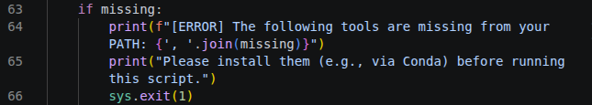

If any tools were added to the missing list, the function will list those tools to you, similarly to the first except of the run_command function.

Find Fastq Pairs Helper Function
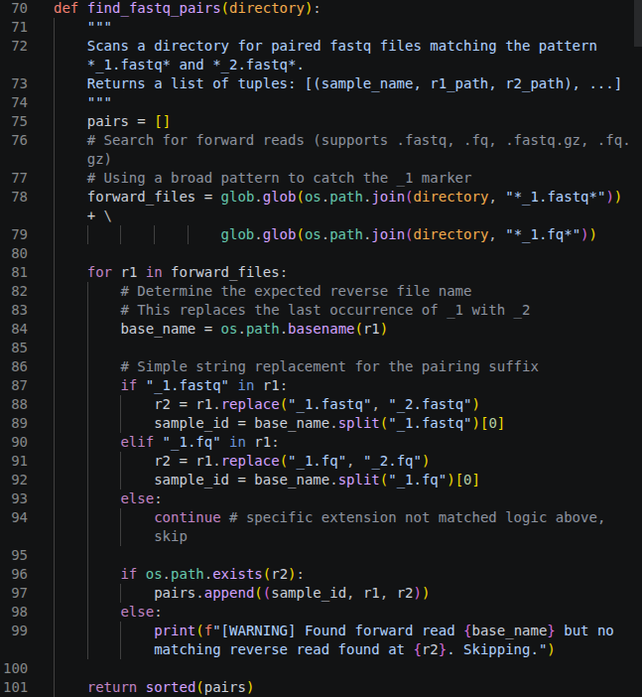

When you download fastq files from the internet or from a sequencer, you will often get both forward and reverse reads. It is standard naming convention to have the run name at the front of the file, followed by either a 1 or 2 to indicate if it’s that run’s forward or reverse read. When you provide a directory, this helper function is meant to automatically organize these files so that you can accurately pair them together when needed.

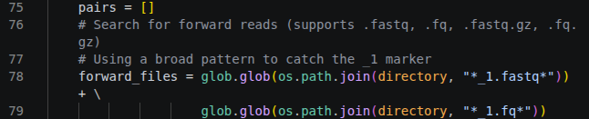

The first line makes an empty list called pairs. Then it makes a list of file paths and saves it as the variable forward_files. In order to do this, it uses the glob function from the glob package that allows us to use wildcards to add multiple files without having to know the exact file names. It also uses the os.path.join function from the os module to make sure that the file path can work regardless of the OS they are using. The code goes into the directory you put into the parameter and checks for each file that has either a 1.fastq or _1.fq in it and saves its directory to the forward_files list.

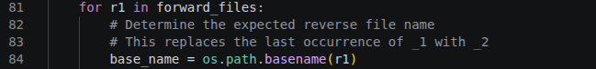

This for loop goes through each of the forward file directories in the forward_files list and uses the os.path.basename to take the file name and saves it to a variable named base_name.

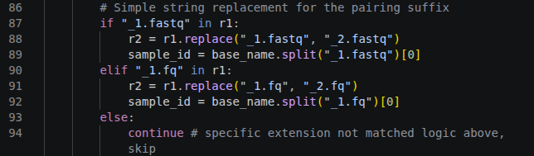

This if statement will take the forward read (saved as r1) that the computer is looking at, replace the _1.fastq in the basename with a _2.fastq, and save it to the variable r2. It will then save the text before the ”_1.fq” (the run ID) to a variable called sample_id. If the file ends with a _1.fq instead, the elif statement will do the same with that naming convention. If the file doesn’t fit either of these, the else statement will skip this step entirely.

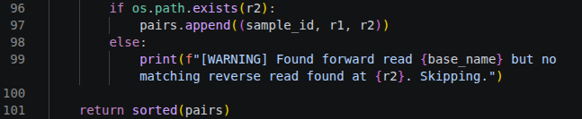

This if statement will check to see if the r2 path exists (the file with “_2”). If the file exists, it will append the run ID (sample_id), forward file path (r1), and reverse file path (r2) to the pairs list we made previously. We will refer to this later on in the script. If it doesn’t, then it will trigger the else statement, letting you know that it didn’t find a file but will try to continue.

Main Function - Why is it There?
At this point, we have created all the helper functions that we need, meaning that we can move to the actual program that your computer will be running. You may notice that this part of the script is stored under a function called main. Because it’s a function, this means it won’t be called immediately when we run the script. However, if we skip to the bottom of the script, we see what actually runs when we call the script is this:

When you run a Python script in the terminal, Python assigns the string “__main__” to a secret variable called __name__. However, if you import the script as we do with subprocess, glob, etc, it’ll save the base name (the filename without the “.py”) to __main__. This means, in our code, essentially says, if __main__ is __main__, run the program. While this seems unnecessary, it allows you to import this script into another Python script without it messing up the script you are importing it into. This is actually common practice when you write a Python script, and is highly recommended.

Let’s use an example to explain why this is important. Say we hypothetically make another script, but we want to reuse the find_fastq_pairs helper function. Instead of copying and pasting the function into our new script, we can instead import deScript and then run deScript.find_fastq_pairs(directory) in our new script. Without the def main(), the function would see the “deScript…” at the front of the command and run the full script within our script, even though we only want to use the helper function. With this in mind, it is highly suggested to use this syntax in any Python script you use.

Creating Arguments
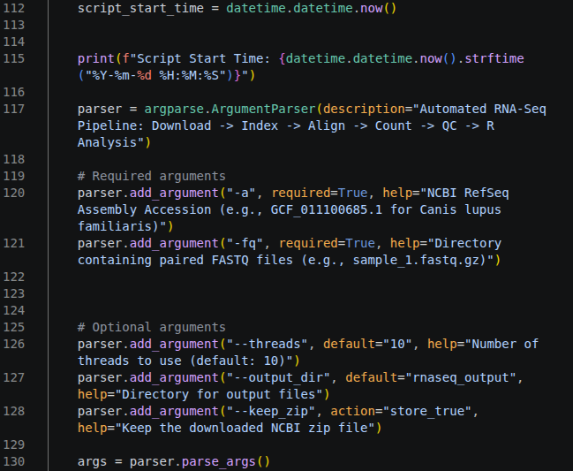

This section of the script is meant to allow you to add arguments to the script. Arguments are functionally identical to parameters for functions or options for BASH commands. We will explain each section in more detail below.



This section of the script simply saves the time the command was run to a script_start_time variable and prints that time to the screen. This serves no functional purpose for the script but is used to keep track of where the script is and how long it has been running. There are many more instances of code like this in the future, and the explanation for which will be skipped.



This code makes a variable named parser that holds the information needed for our arguments. The code uses the ArgumentParser function from the argparse library with the description parameter with a brief explanation of the pipeline. This description will show when someone uses the -h or --help argument, along with all the possible arguments and their help parameters.



This section of code sets the required arguments that are needed in order for the code to run. If these arguments aren’t included when running the script, the script will exit before running. The first parameter is the name of the argument, the second parameter states if it is required, and the third is a brief description that will appear if the user uses the -h argument on the script. The first argument asks the user for the NCBI accession number for the RefSeq we want to use. The second asks for the directory for the fastq files you want to analyze.
clone


The next set of arguments is the optional arguments. They work identically to the required arguments with the exception that the required=True is replaced with default=<something>. If the argument is left blank, any instance of that argument will be replaced with what was set as the default. The first of these optional arguments sets the number of PC threads that will be dedicated to the pipeline. Threads are parts of your PC that are dedicated to completing tasks. The second argument is --output_dir, which creates a directory to put all of the created files in. The third option, --keep_zip, gives you the option to keep the zip file that the refseq comes from (on by default).

Pre-Flight Check
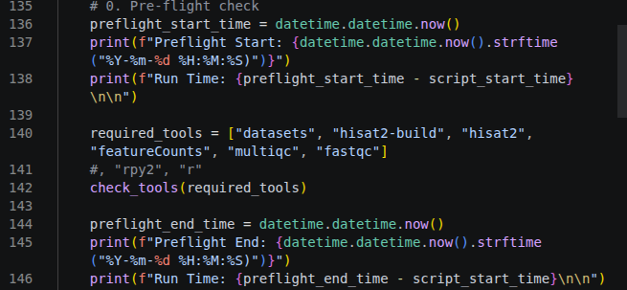

This code is what we call a pre-flight check; in this code, we make sure that the computer has the required tools needed for the pipeline. If the tools aren’t there, you don’t want to waste time and computing power by running a pipeline that will inevitably fail.


In this code, we make a list called required_tools that consist’s of all the tools we will need for the pipeline. These are the tools that we installed in the ”Preparation” section and uses the check_tools function that we described in the “Creating Helper Functions” section.

Verify Fastq Files
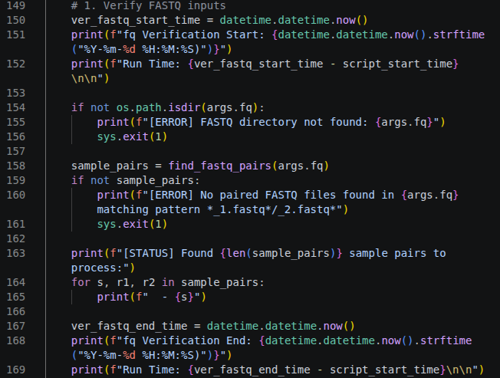

In this section of the code, we will verify that the directory containing the fastq files are formatted in a way that the pipeline is able to be used. If the program isn’t able to parse the data using the find_fastq_pairs helper function we previously described, the program will exit.


This if statement will use the isdir (“is directory?”) function in the os module (path submodule) to see if the path we used for the argument --fastq_dir is even a directory. If the user used a file or mispelled the directory, the script will print that it couldn’t find the directory and exit. If it passes, the next block of code will run.



This next section will first run the find_fastq_pairs helper function on what the user entered as the --fastq_dir and save the outputted list (in [ID, path to forward, path to reverse] format) and save it to the variable sample_pairs. If the directory doesn’t contain any fastq files or those fastqs aren’t formatted properly, the following if statement will cause the terminal to print an error message and exit safely (“sys.exit(1)”).



If those last two safety checks passed, then this code will tell the user that it found the specific number of files to process, and then print out the ID of the samples found. One important thing I would like to bring attention to is the structure of the for loop. Most for statements will be followed by one variable leading to every item being treated the same. For our example, it's followed by three variables. Because of this, the first item in the list will be treated as the variable s, the second r1, and the third r2 it will then repeat and treat the fourth as s again. This makes it so that if we have a list that follows a specific pattern we can choose only to work with a subset of that list. Because our example works with a list that is formatted as [ID, forward read, reverse read] we can choose to only print the ID or s.

Setup Output Directories
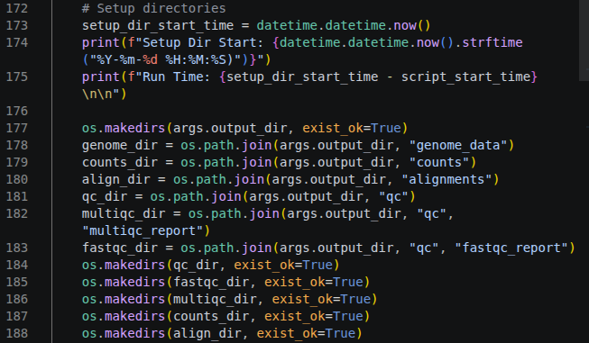

At this point, we have confirmed that the user has everything they need to run the pipeline. The next step is to prepare the output directory to hold the files made by the pipeline in an organized way.



This specific line of code checks to see if the user specified a specific output_dir as an argument. If they don’t, the default of rnaseq_output that was specified in the “Creating Arguements” section will be entered. The exists_ok=True parameter lets the program know that if the directory already exists (which would normally cause an error), the program will continue using that directory.




These next two lines of code are technically separated, but are together here to save space. The first line of code will make a new subdirectory inside our output_dir called genome_data. If a subdirectory already exists with that name, the next line of code will use that directory instead. This code is repeated for a counts_directory, align_dir, sam_dir, and qc_dir.

Download Genome Data
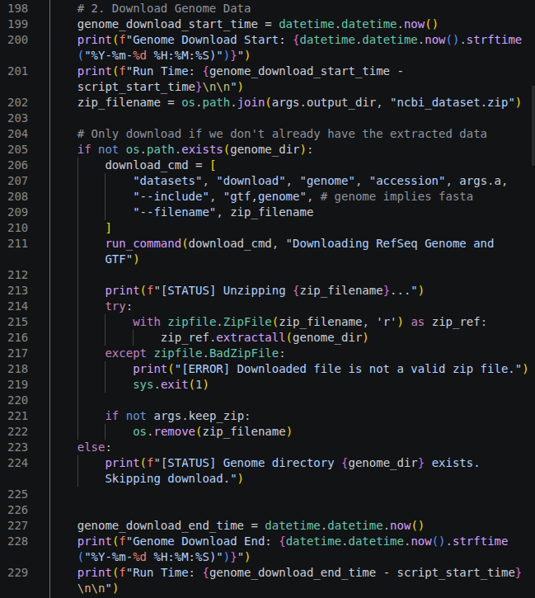

Once again, in RNASeq we need to prepare a refseq to compare our results to. Most of these refseqs can be found online through a genome browser. Some useful browsers that will have most general and well known genomes that you will need for most projects include the NCBI³⁰, UCSC³¹, and Ensembl³². For some more common model organisms there will be specialized genome ontologies with more specialized datasets (For example FlyBase³³ is a gene ontology for Drosophila melanogaster.


This specific line of code will see if the ncbi_dataset.zip already exists in the working directory. If the file exists, it will save it to a variable called zip_filename.



This section will check if the keep_zip argument was set to true (It is by default). If the keep_zip argument was set to False, then the remove function from the os package will remove the zip file located in the zip_filename variable. If the zip file already exists when creating the zip_filename variable, the screen will let you know that the file already exists and that it will skip the next command.


If the genome directory doesn’t exist, then the following line of code runs. Since the command actually runs in BASH using the run_command function we first need to make a list that will be combined. We want our final command to be,
datasets download genome accession <accession number> --include gtf,genome --filename <zip file name>

So we enter each of those words each separated by a comma and enclosed in ” “ . There are two parameters that are not enclosed with ” “, which are arguments that the user will input when they run the script. The line starting with run_command… will string the command together to run in the command in whatever language the computer is using (BASH for our case) then print ”Downloading Refseq Genome and GTF”*.

The try loop will first print that the zip file will be unzipped. Then, the program will unzip the file located at the genome_dir directory using the zipFile package. The except statement will detect if there are any problems with the zipfile and print an error message on the screen before exiting. If the keep_zip argument was set to False, the remove function from the os package will remove the zip file. If the genome_dir directory exists, the else statement will trigger, causing the script to skip the previously described steps.

Locate FASTA and GTF
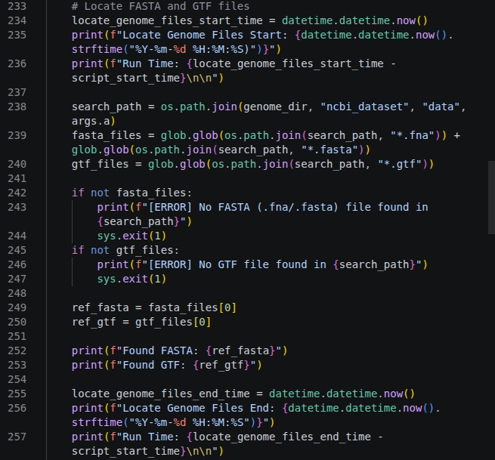

This next section is focused on making some variables that will store the directory of the FASTA and GTF files within our downloaded zipfile.



The extracted zipfile will contain a folder that is structured in a standardized format. The more upstream directories will contain metadata and reports for the downloaded data and our requested will always be located in the ncbi_datasets/data subdirectory. The first few lines make a search_path directory that holds the important ncbi_datasets/data subdirectory, as well as fasta_files and gtf_files lists that will hold paths to any file in the search_path directory that ends in either “.fna” / “.fasta” or “.gtf” respectively.



If there are no FASTA or GTF files in the expected location, one of these lines of code will recognize it, let the user know with an error message, and then stop safely.



In nearly every case there will only be one FASTA and GTF file to reference. However, in the case that there are multiple, the reference FASTA and GTF will be the first file in the list. This line of code will assign that first file to a variable called ref_fasta or ref_gtf and let the user know. These variables will be used in future steps of the script.

Build HISAT2 Index
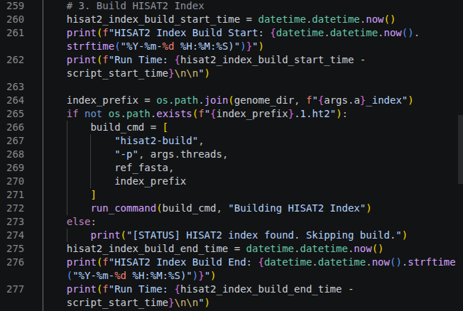

The following block of code will build what is called a HISAT2 Index file. HISAT2³⁴ is a bioinformatics tool that will align the random pile of RNA reads you got through the wetlab section of the RNASeq and assign them to specific parts of the reference genome. In order to use this tool, we need to translate the genome (FASTA) and annotation (GTF) into a format that HISAT2 can read, called a “HISAT2 index file.”



This first section of code will first create a variable named index_prefix that contains a subdirectory located in the genome_dir path that will be the accession number, followed by “_index.” The program will then check to make sure there is no files in that directory that end in “.1.ht2.” (The existence of this file would imply that this command was already run, and we don’t need to do this step. Once the computer knows that the file doesn’t exist, we prep a build_cmd that will be used to build the HISAT2 index in BASH, then run the same way we did in the “Download Genome Data” section.

Run FastQC
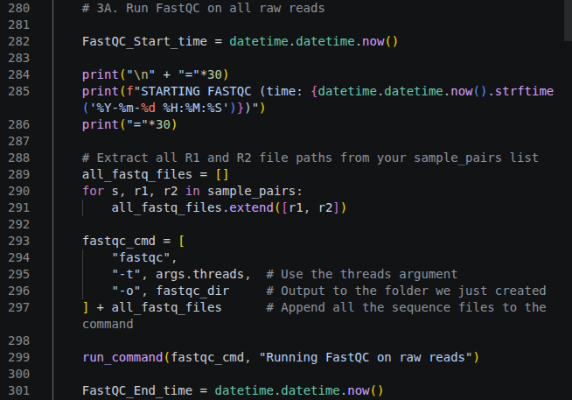

This line of code runs a “quality check” program called fastqc on each of our raw reads. This will tell us important information about how our reads went so that we know exactly how much we can trust our later analysis. Later on in our pipeline we will run another program called multiqc that will put all of the information in these fastqc files into an easy to read sheet that allows us to compare our runs.

HISAT2 Allignment Loop
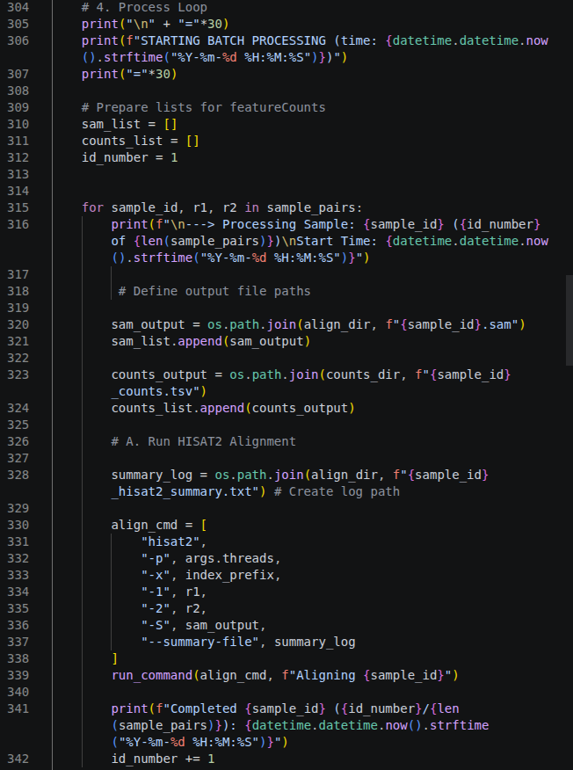

Now that we have an index file that we can use as a “map” for our experimental samples, we can use HISAT2 to assign each of the individual reads in our experimental FASTQs to the index file map. However, we will most likely have many different fastq files that we want to run HISAT2 on. Instead of running this program multiple times for every fastq we have, then adding them all up manually, we can tell a program to run the same process on a list of different files in a method called batch processing. This code does exactly this.

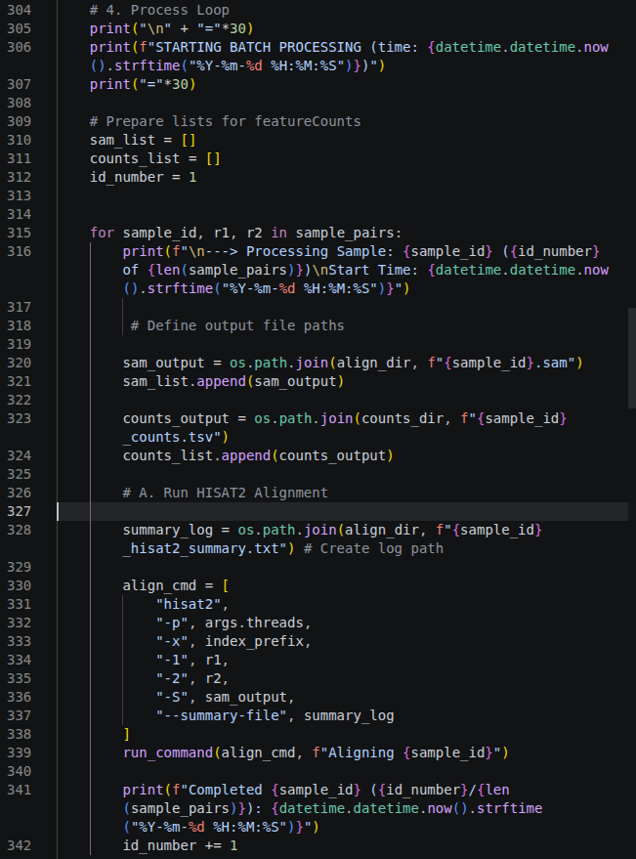

First, these lines of code create an empty sam_list and counts_list that we can add to later. Then we assign the integer 1 to the variable id_number that will act as a counter so we can keep track of what the script is doing.



This block of code will loop through the sample_pairs list we made and let the user know what files the computer is working on. If you are confused about the syntax of the for loop see the “Verify Fastq Files” section.



This next block of code creates output file names for the two expected outputs for this program (SAM files and a tab-separated values sheet containing counts). The program will take the sample_id that it’s currently looking at and make a file named <sample_id>.sam or <sample_id>_counts.tsv in either an align_dir or counts_dir subdirectory, respectively. The program will then add that specific file path to our previously created sam_output or counts_output list.


This next block of code prepares an align_cmd that we want to run on each of our `sample_id`’s. Much like the code in the “Download Genome Data,” the command will enter the parts in ” “ exactly, the variables outside of the quotations will enter their values. Each comma separation will represent a space entered into the command line. For more info on what each of the command parameters does, enter hisat2 -help.

FeatureCounts
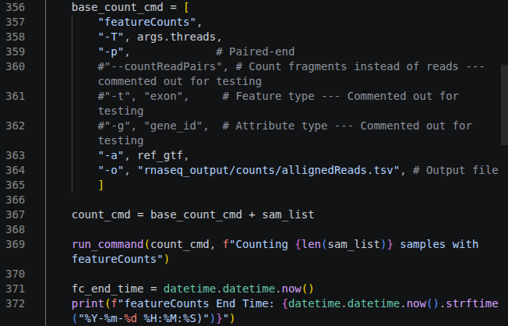

This next block of code sets up the computer to run featureCounts, a tool to physically determine which gene each contig maps to. This code works similarly to the other commands that we have used with one major exception. Towards the bottom we make a new variable that combines the base_count_cmd that we just set up with the sam_list that holds the directory of all the sam files. This appends the directories of all the .sam files to the end of the command which tells the computer to run the base_count_cmd on all of the listed .sam files. The run_cmd function executes our command in BASH.

Quality Control
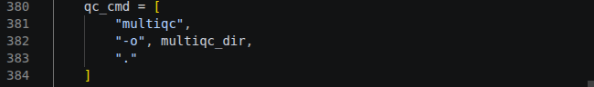

‌Our final functional command runs a program called MultiQC. This tool makes an easy-to-read Quality Control document that gives you an idea of how reliable the data is.

R Analysis - What do the numbers mean?
The next part of the analysis consists of automated R-analysis. The majority of the analysis is done using a package called rpy2. This acts as a bridge between R and Python and allows us to automate the R analysis process.

Libraries & Directories
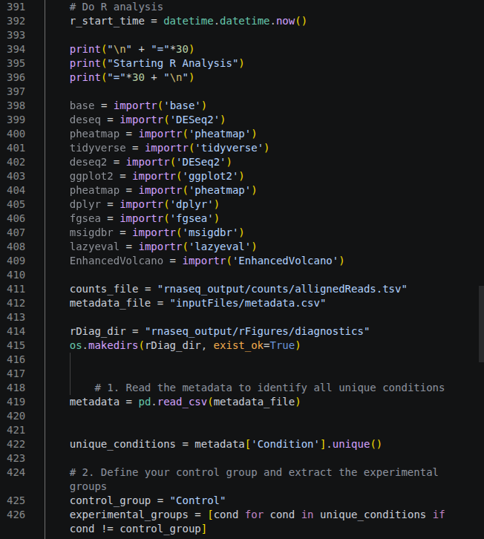

This first block of code imports the different R packages we are going to need for our R analysis. To shorten the overall length of this colossal document, see the documentation for each of the packages by entering ?<package name> into the console of R-Studio for each of the following packages. The next two lines lines set variables for the featureCounts reads and metadata file. The next two lines create a directory for the diagnostic plots that we will be making later on in the script. Finally the last lines define the experimental and control groups based on the metadata.

Data Prep
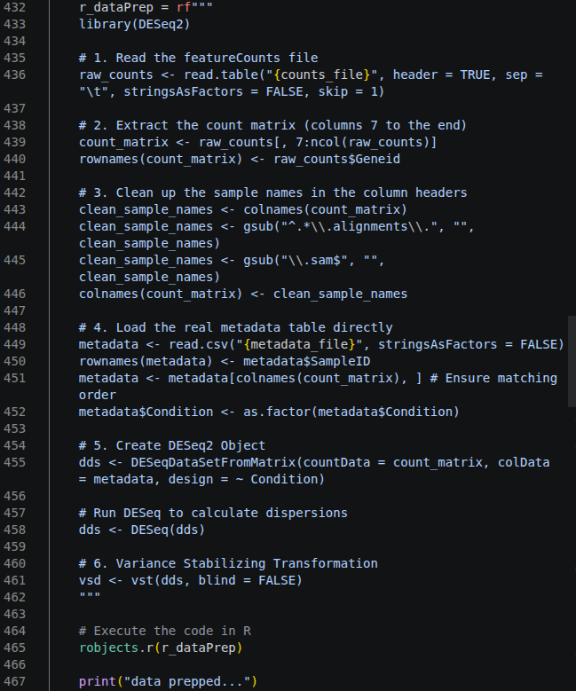

This code runs six different steps that prep the featureCounts table that was output by the first part of our Python script into a format that is usable by R. Please note that each of the R code chunks will be formatted as an R chunk saved as a variable, then executed using robjects.r(<code chunk variable>). This is the formatting for running rpy2 in Python. Here are the specifics for each step:
- This step reads the featureCounts table in our directory, tells the program to skip the first line (which consists of run metadata), reads the first row as a header, and treats each tab (notated as \t) as a separation, then saves it as the variable r_counts.
- This step extracts the table columns that contain the counts we want to a variable called count_matrix. The first 7 columns are metadata and can be disregarded for this analysis.
- This step cleans up the headers in the count_matrix. The read names are defined as their full file path. This code uses the R gsub package to remove the filepath and the suffix so that only the read ID remains. Then those clean column names are put back into our count_matrix variable to make the analysis easier.
- This step loads our uploaded metadata file so that R can see it. The program reads the directory that we listed in our metadata_file variable, then ensures the file is in a format the program can read.
- This step uses an RNAseq analysis program called DESeq2 to analyze the differential expression results from our featureCounts table. The program pulls data from the previously made count_matrix file and separates the different experimental groups we defined in our metadata file.
- Applied a variance stabilizing transformation to the data to account for any multimodal distribution of data. In essence, this allows for our data to be analyzed even if the counts don’t follow a normal distribution.

Analysis Loop - Same Analysis, Different Experimental Groups
The next section of code is a for loop that will automatically compare each of our experimental groups listed in our metadata with our control group. For each comparison, a table showing raw differentially expressed values is created, as well as a GSEA and Volcano Plot. Most of the code works similarly to previous code, so to save time, I will refrain from going step by step through each line of code and will instead highlight some of the more interesting or complex code. For more information, see the comments within the code itself.

Graphing Principal Component Analysis
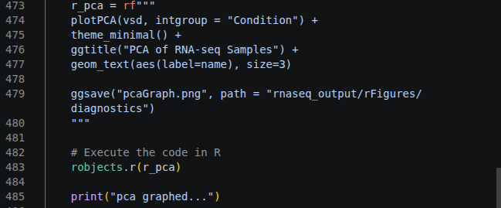

The above code block creates a principal component analysis (PCA) plot using our analyzed data. Please refer to the Quality Control Check section and Figure 3.15 for more details.

Making a Dispersion Estimates Graph
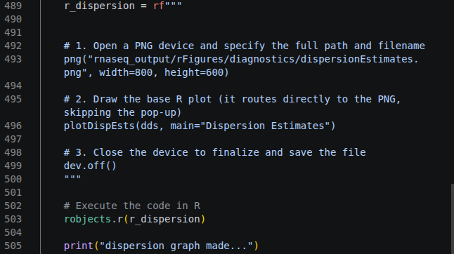

The above code block creates a dispersion estimate plot using our data. Please refer to the Dispersion Plot section and Figure 3.20 for more details.

Extracting Target Species
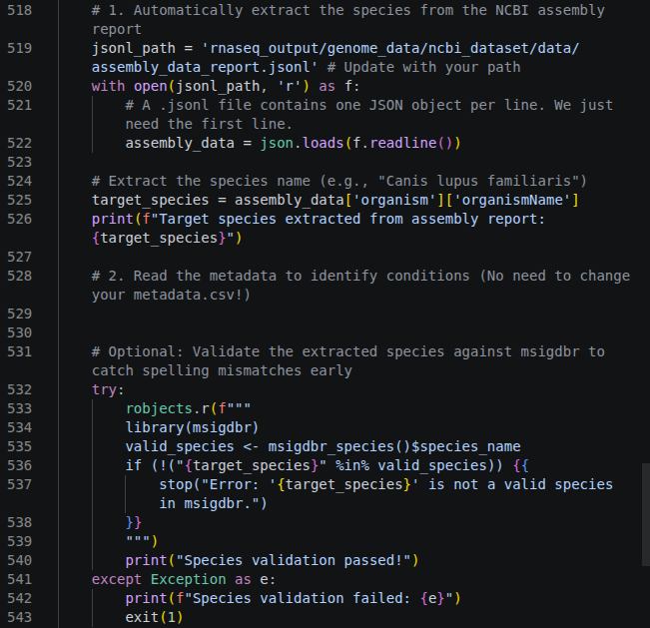

In order to make a GSEA later on in the code, we need to use the msigdbr package to extract the relevant metabolic pathways for our reference organism. In R, we would type out the species name (Canis lupus familiaris) into R. This causes a problem when trying to automate the analysis in the simplest way possible because we may want to use this pipeline for RNAseq on an organism that is not a dog. While we could add another argument in the “Creating Arguments” section, this adds more points of failure (misspellings, forgotten input, etc.) and unnecessary complexity to a pipeline that is supposed to be as simple as possible.

To solve this problem, this block of code looks into an Assembly Data Report that is automatically downloaded alongside our FASTA and annotation and pulls the organism name from the metadata. This file is always downloaded when you pull information from the NCBI database and contains structured information on how the data was collected. This code will pull the species name from this file and automatically insert it into the R code in the structure that it wants.

Making a Dispersion Estimates Table
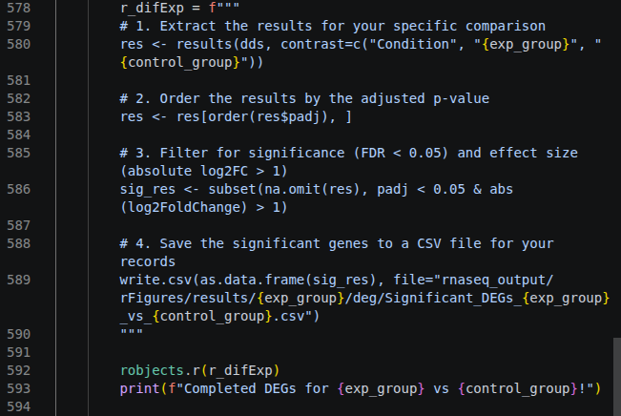

This chunk of code will create a table of differentially expressed genes that lists information on the specific genes that were over- and underexpressed. The table will be outputted as a “.csv” file in the results folder of this pipeline. See the Differentially Expressed Genes Table section or Figure 3.23 for more information.

Making a Volcano Plot
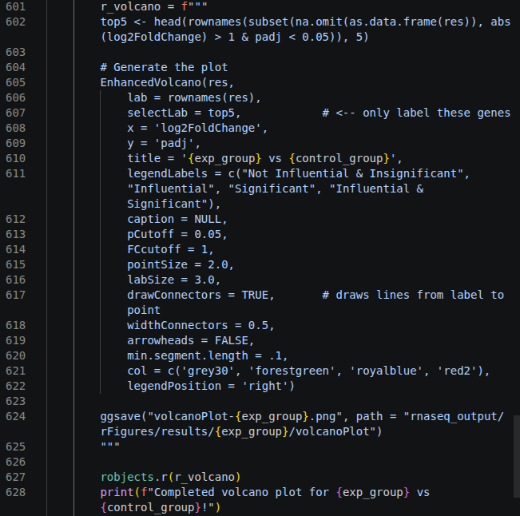

This chunk of code will create a volcano plot that shows the distribution of gene influence and significance. For more information on the volcano plot, see the Volcano Plot section and Figure 3.24.

Making a GSEA Plot
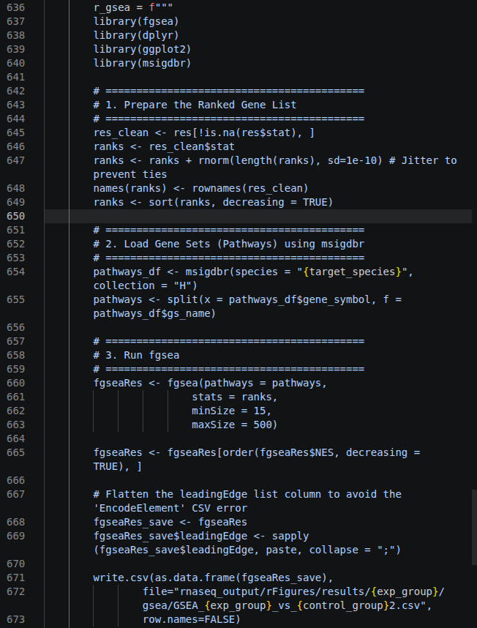
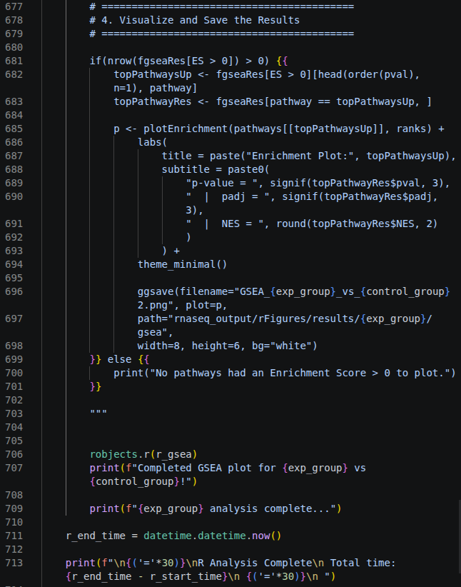
This final chunk of code creates a GSEA plot and is divided into four steps. The first step prepares a gene list ranked from the most overexpressed do the most underexpressed for the GSEA plot to refer to. The second uses a package called msigdbr to pull metabolic pathway information on the target species we pulled from the JSON file. The third step runs the GSEA algorithm on the differentially expressed genes to find how the genes fit into the overall metabolic pathways. The fourth and final step visualizes the best fitting GSEA into a plot. For more information on how to read the GSEA plot see the GSEA Plot section and refer to Figure 3.24.

Summary
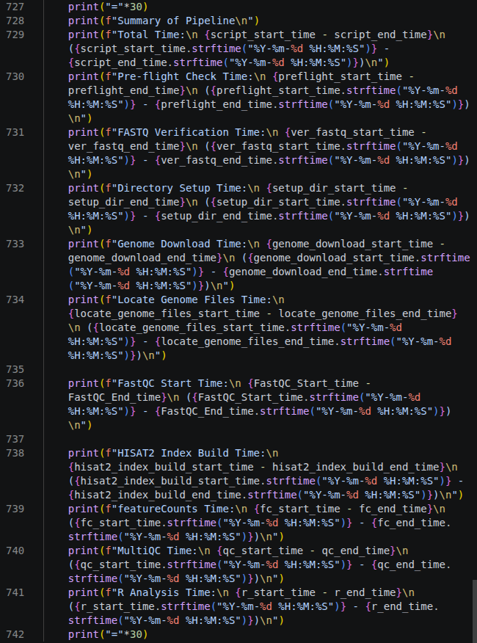
This final chunk of code displays a final report on how long it took to run each section. This should be used for reference, but doesn’t serve any functional purpose in the pipeline.

Chapter 3 - Analysis
We got oriented with the tools we needed in part 1, and we walked through an example in part 2. Now we need to turn the cryptic scramble of genes and numbers that we got into our output into meaningful results that can be communicated with other scientists through analysis. This is arguably the most important part of a bioinformaticist's job because most of the output of bioinformatics tools is unintelligible to scientists who don't have hours to sift through mountains of data to find the most important. Therefore, as the scientist that is closest to the data, it is your job to effectively communicate what the results are, what it means, and – most importantly – how confident we are in our findings. In this section, we will use the output from the previous part and translate it into meaningful results using R.

One final important note before we move on. Most people like to think of statistics as completely objective. However, there is also an art to statistical analysis in how you “manipulate” the data. Data manipulation is not necessarily a bad thing; almost all data needs to be manipulated in some way to find meaningful results. For example, without any data manipulation, if you wanted to estimate the wealth of the everyday US citizen, you would find that the average net worth of $1,063,700.^{36.} The everyday US citizen isn’t a millionaire, but there are a few outliers who make absurd amounts of money that skew the average. However, once you account for these outliers by using the median, you find that it’s closer to $192,900.

Depending on your “goal,” you can manipulate data to fit a motive. However, as a scientist, you have a responsibility to report data as objectively as possible. It may be tempting at times to manipulate data to make it more impactful, especially when there's financial or academic pressure to find something impactful. However, this kind of data manipulation can leave a major stain on your scientific career. Always report how you manipulate your data and be truthful about what your data can be applied to and what it can’t.

Quality Control Check
There’s a common saying that is especially important with regard to bioinformatics and science as a whole: “Garbage in, garbage out.” This means that in order for us to put any stock into our results, we need to determine if the data we are working with is acceptable. This is called quality control or QC. There are many different methods of going about it. While there is no definite “stop point,” it is best practice to run multiple QCs to find the strengths and weaknesses of your data.

MultiQC

In our pipeline, we included software called FastQC and MultiQC that turns all of the useful checks we need into an easy-to-read HTML file. The MultiQC HTML file will consist of all of the FastQC information together. The top of the MultiQC report contains a summary of some of the more important diagnostic information in the format shown above. More detailed information on each of the statistics can be found below the summary, and we will go into detail on what to look for below.

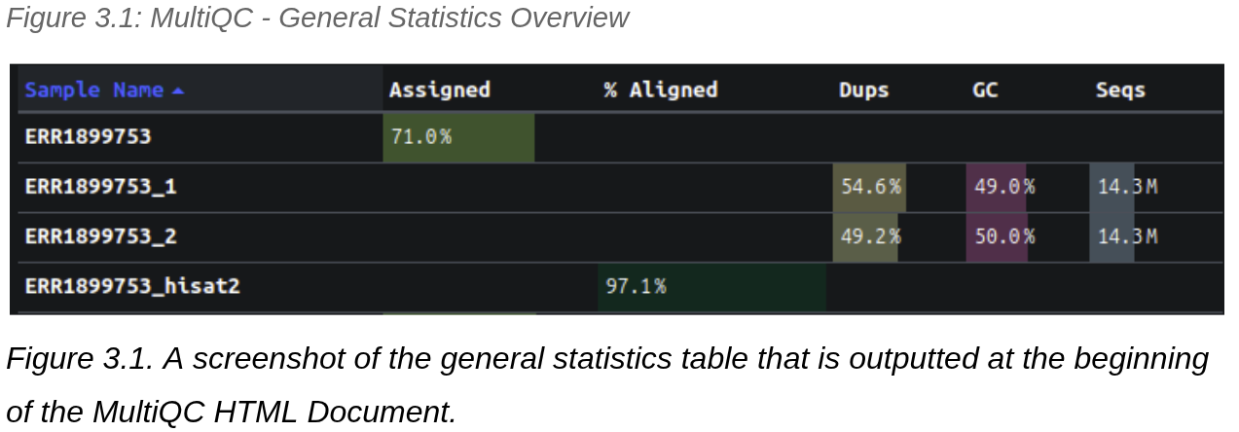

Gene Assignments - Mapping to Genes
Gene assignment graphs measure how many of our reads are mapped to specific genes. We hope to find a high proportion of assigned reads and a high sequencing depth (reads mapped).

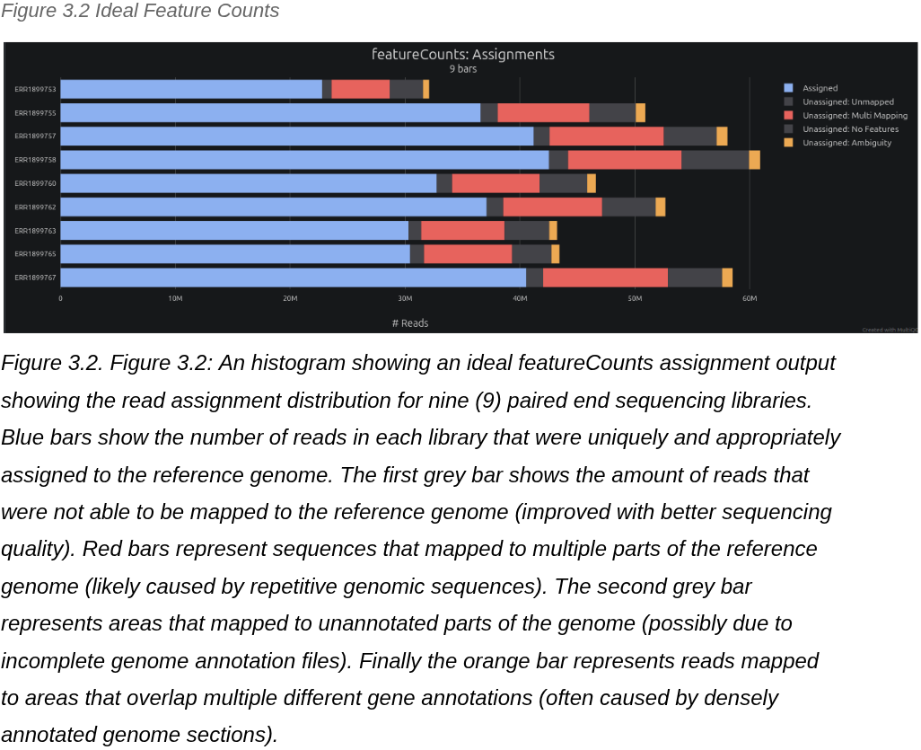

Sequence Counts - Unique Mapping
The sequence counts graph displays how many of our reads map to a unique part of the genome. We expect to see some repeats, but want to make sure that we have enough unique reads to cover a good portion of the genome.

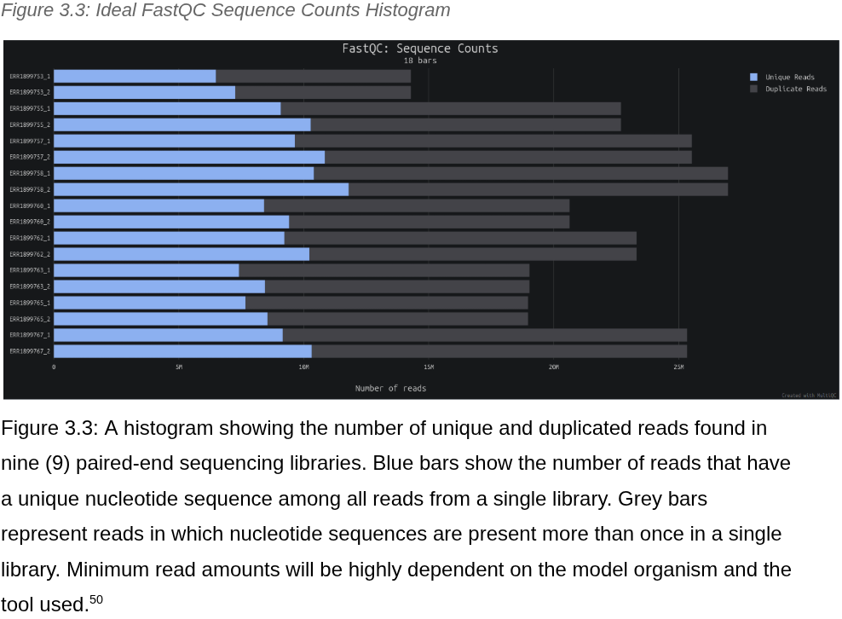
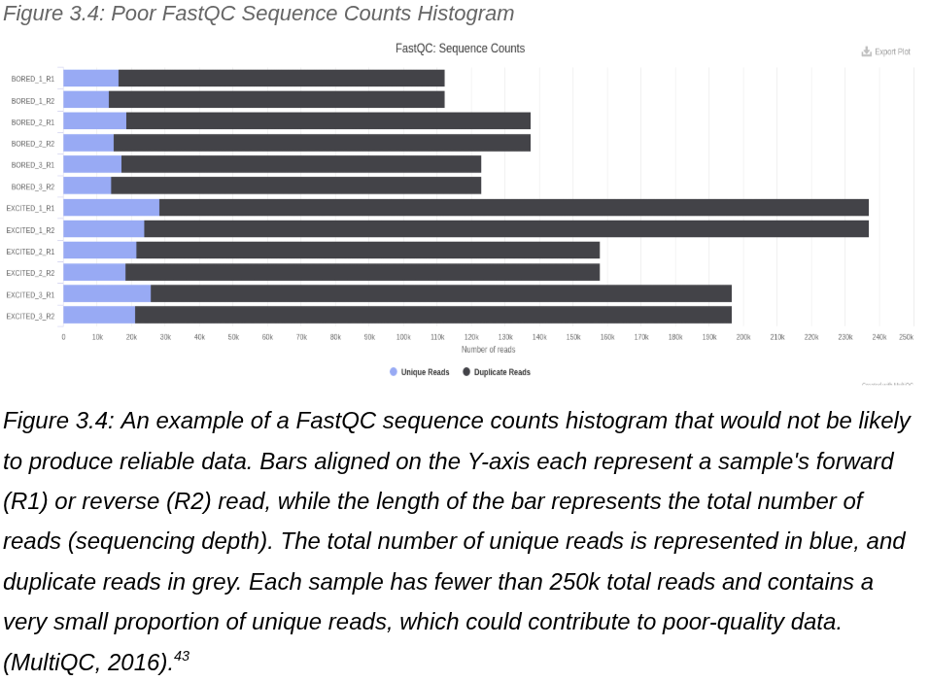

Sequence Quality Histogram- How Good Are Our Reads as bp Increases?
The sequence quality histogram shows the “Phred scores” of our reads. In short a Phred score is an indication of how confident we are that a specific nucleotide is what we say it is, as measured in Equation 3.1. In short, the larger the Phred score, the more confident you are that nucleotide you’re looking at is accurate.

Equation 3.1: Phred Score Equation
$Q = -10log_{10}P$
P = Error Probability
Q = Phred Score

Equation 3.1. The equation used to calculate the Phred score of a nucleotide. In short, a Phred score can be thought of as having a “one in Q” chance of being wrong.

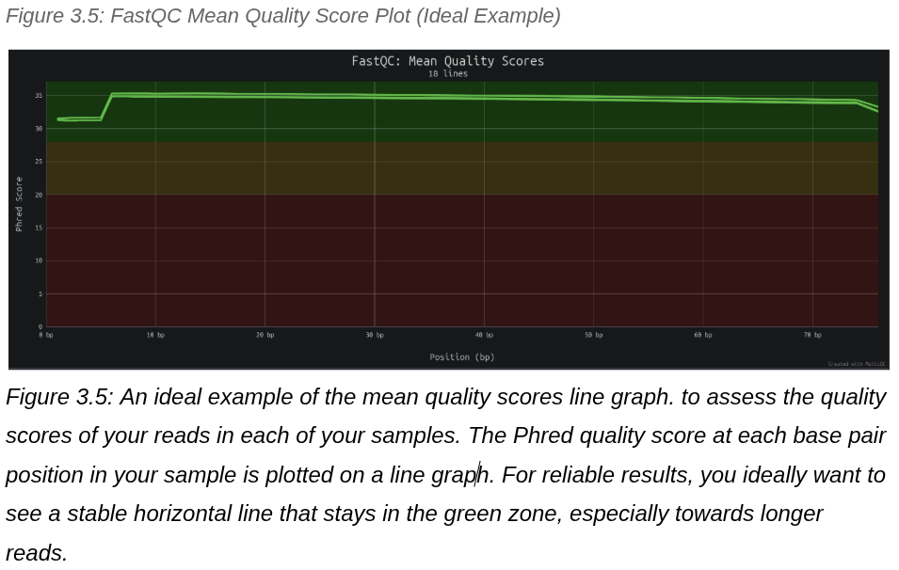

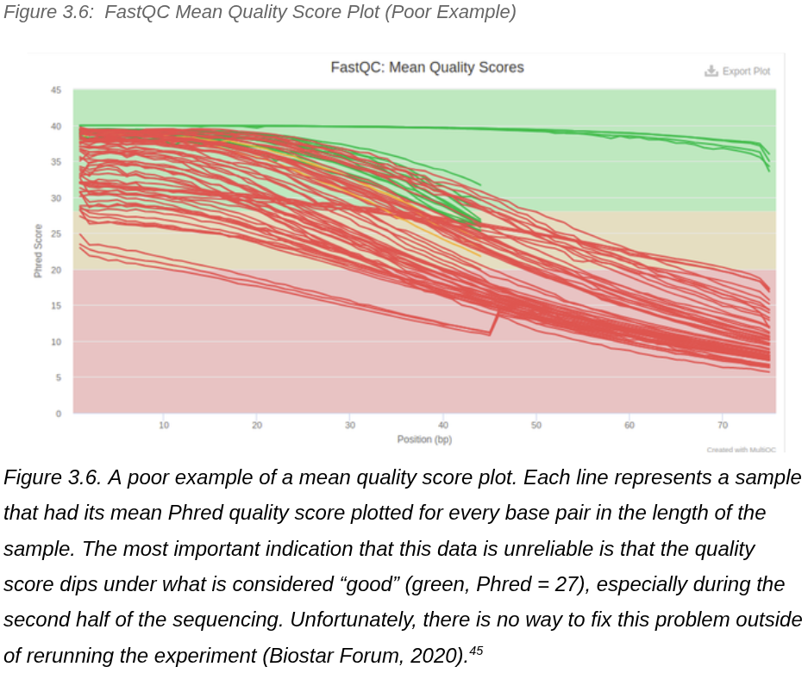

Per Sequence Quality Scores - How Good Are Our Samples on Average
The per sequence quality score graph is similar to the sequence quality histogram except that it displays the average quality across the entire read. We are looking for a peak in the green area.

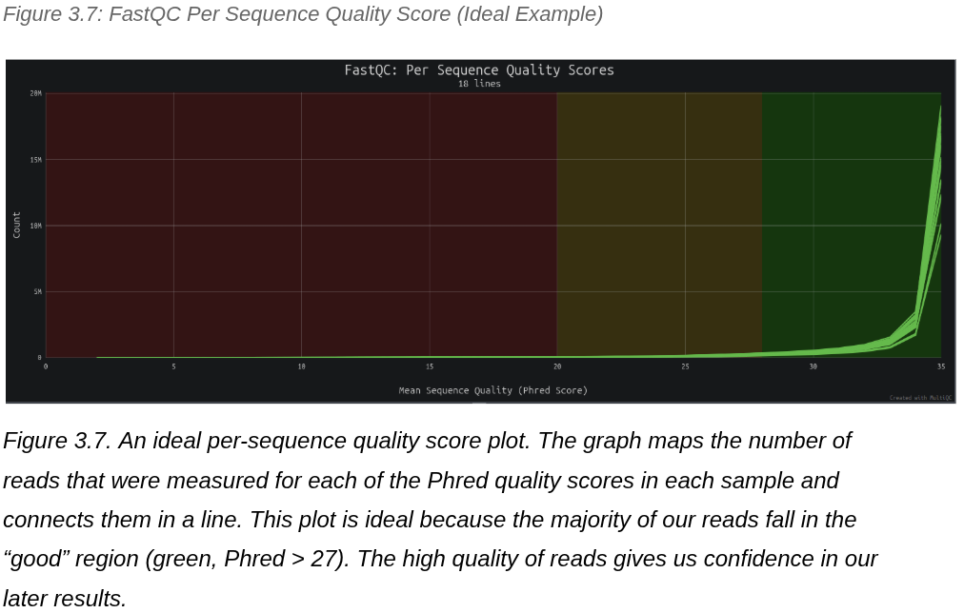

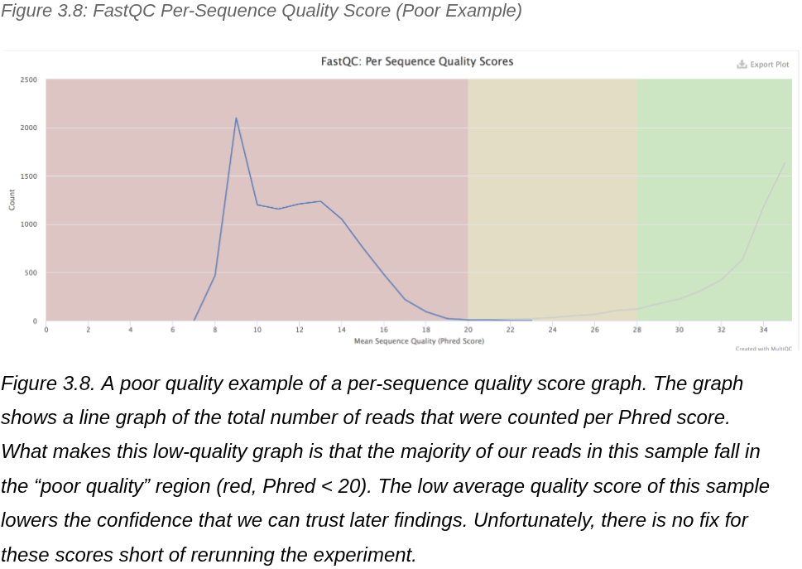

Per Base Sequence Content - Unusual Sequence Content
The per-base sequence content shows a color-coded figure that displays a section of base pairs and the average nucleotides that make up that section. We may see an abnormally high percentage of a specific bp towards the beginning due to a known bias in the library prep process (especially with Illumina sequenced samples⁴⁷). However, we should see a relatively equal proportion of nucleotide content with complementary reads having complementary majority base pairs (for example, the latter end of ERR1899762_1 has a red hue indicating that it’s mostly Thymine, while ERR1899762_2 has a slightly green hue indicating that it's mostly Adanine).

The only exception is that occasionally some organisms – like thermophiles⁴⁷– will have a higher than average GC content. If you suspect there’s an unusually high amount of guanine and cytosine, check to see if the model organism you are working on is expected to have a higher than average GC content.

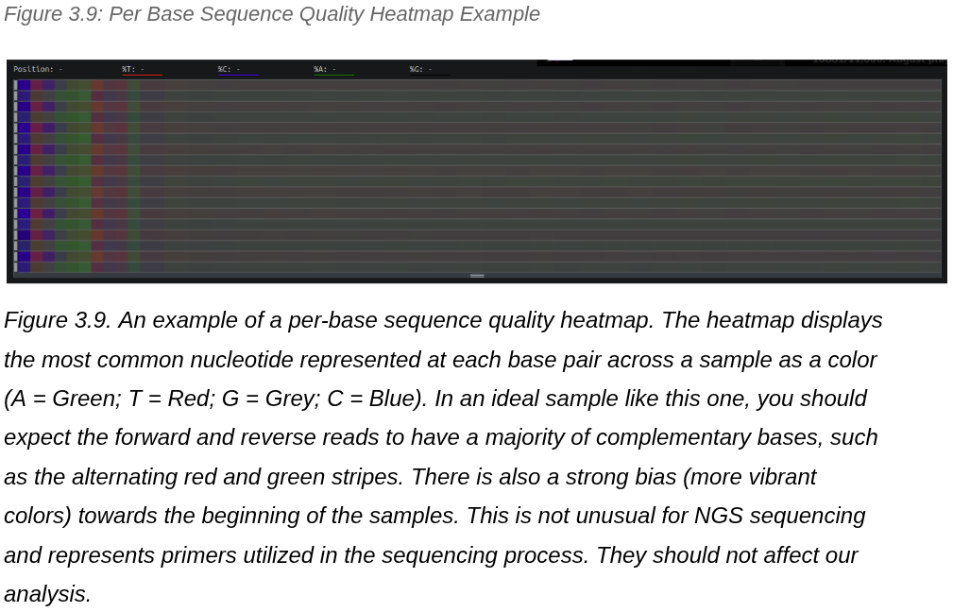

Per Sequence GC Content - Identify Nucleotide Composition
The per sequence GC content is a graph that checks to see what the average Guanine-Cytosine concentration is in your samples. Ideally, you should see a normal distribution of GC content.

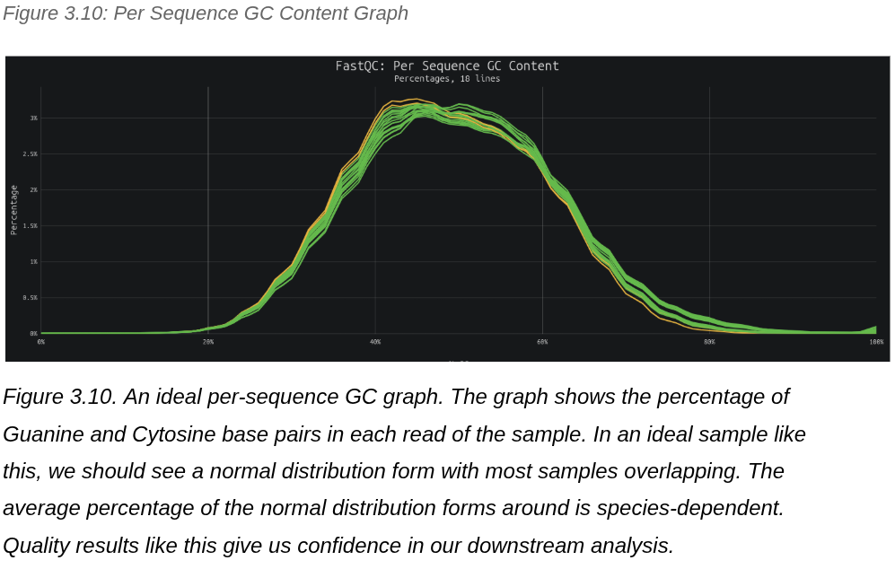

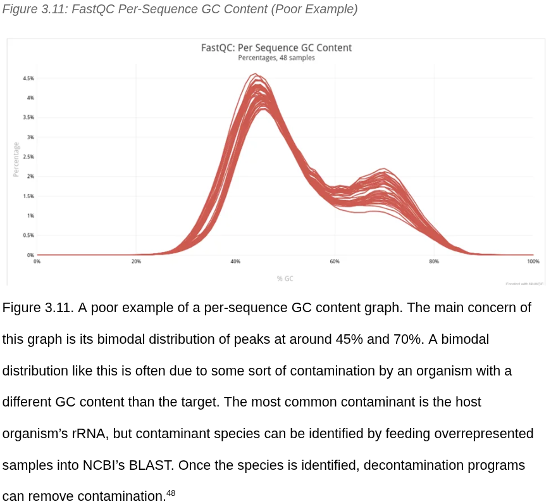

Adapter Content - Were Adaptors Removed?
The last important graph we need to look at is the adaptor content graph. Typically, bioinformatic programs will remove the adaptors that are added to the target DNA. These adaptors will be known nucleotide sequences that are specific to the sequencer used. We should see a flat graph that doesn’t show any peaks.

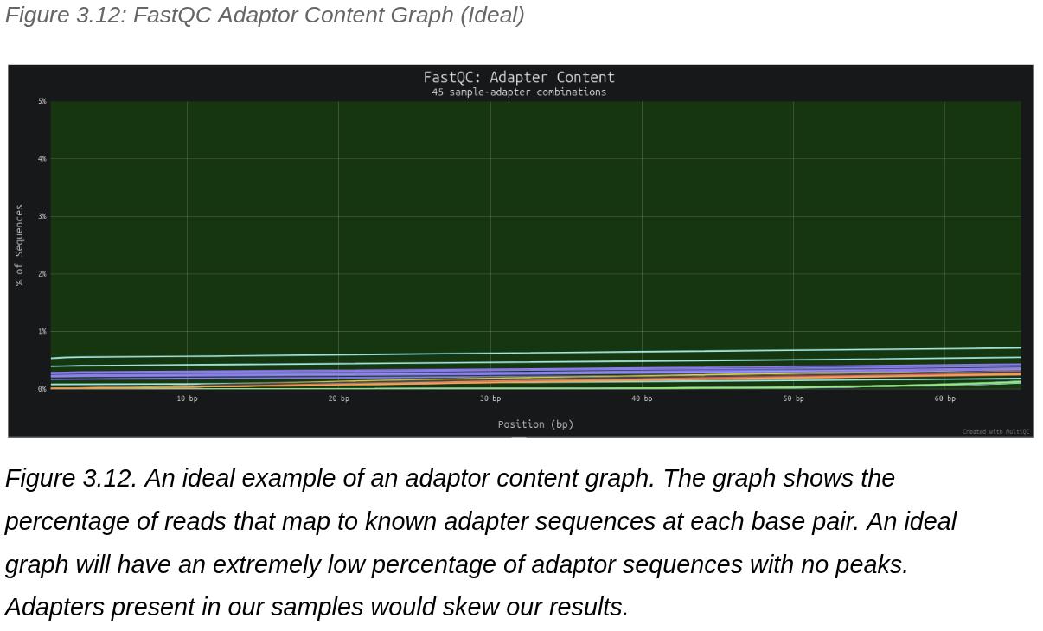

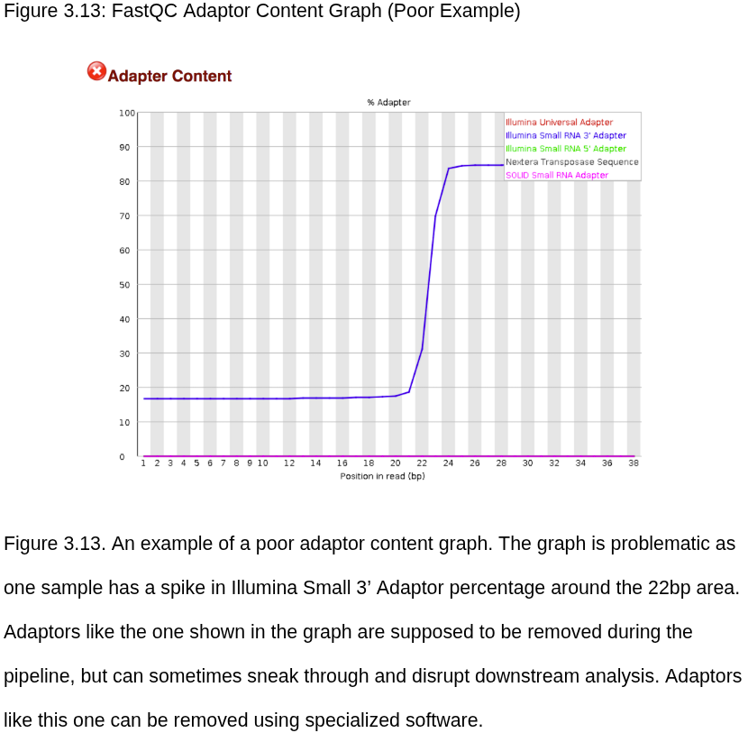

FastQC Status Check
The final heatmap at the bottom shows a status check of all the previous graphs. The only other thing of note is the red and yellow lines under “per base sequence content” and “sequence duplication levels.” This is actually completely normal for RNA-seq and is caused by library prep bias. The rest of our checks are alright.

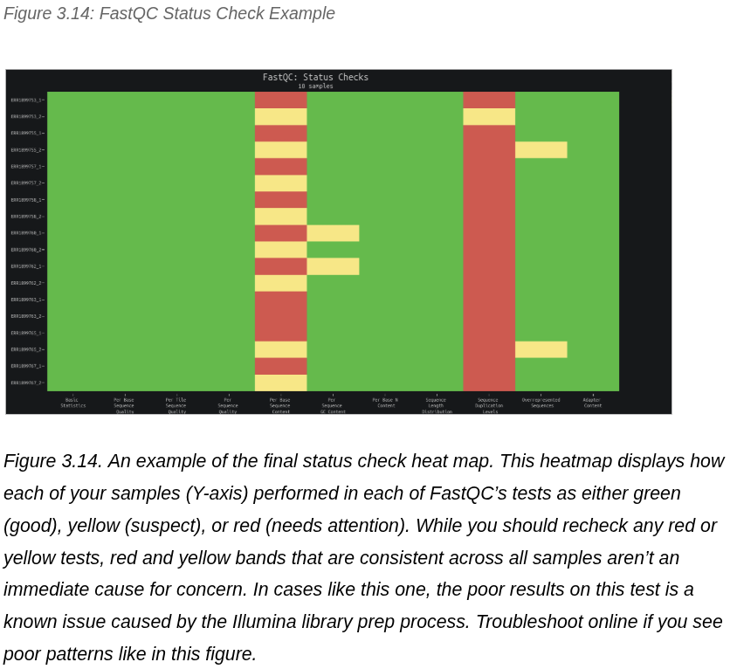

Principal Component Analysis (PCA)
One of the most important diagnostic plots is called a principal component analysis (PCA) plot (Figure 3.15). A PCA plot is used to visualize how similar data groups are. In order to do this, an algorithm determines the two variables with the most variation across treatment groups and plots them on a 2D graph. Ideal treatment groups will have each treatment group isolated from one another. PCA plots that are mixed are less likely to produce significant results.

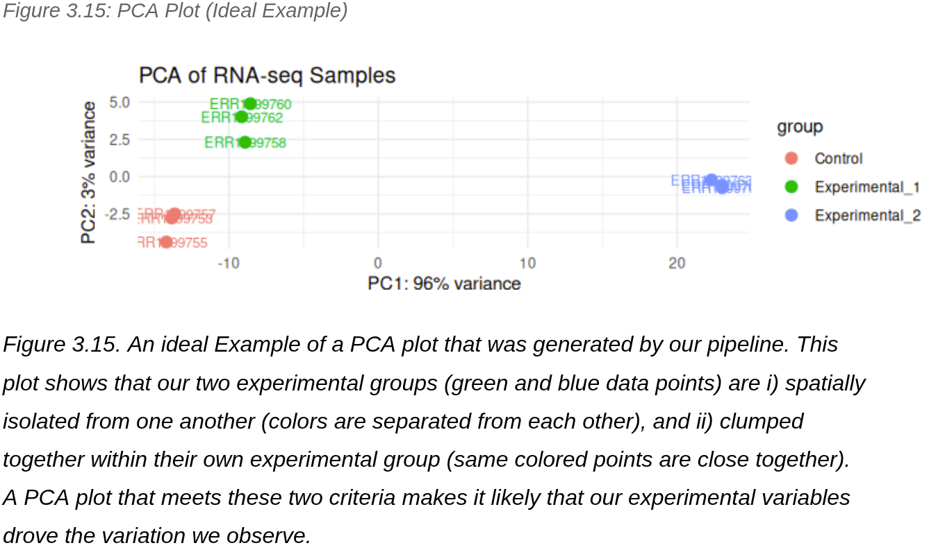

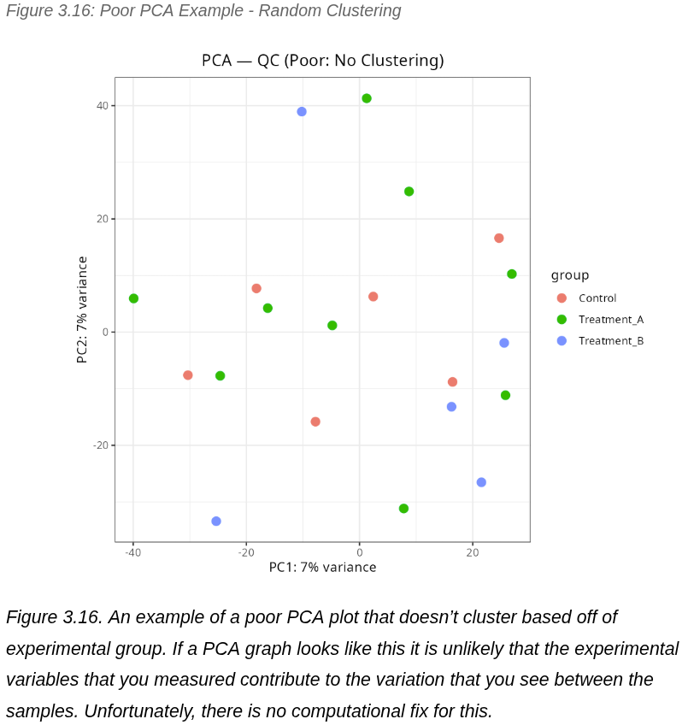

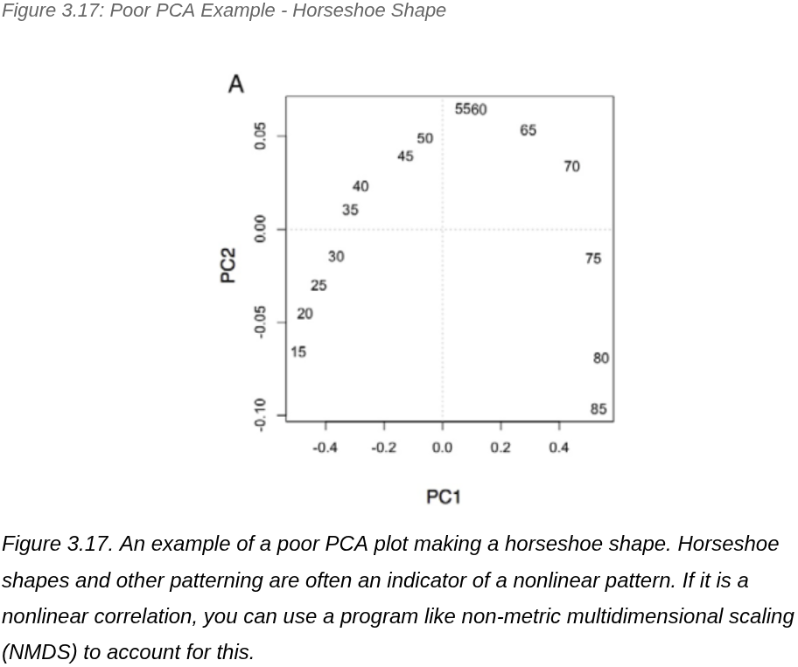

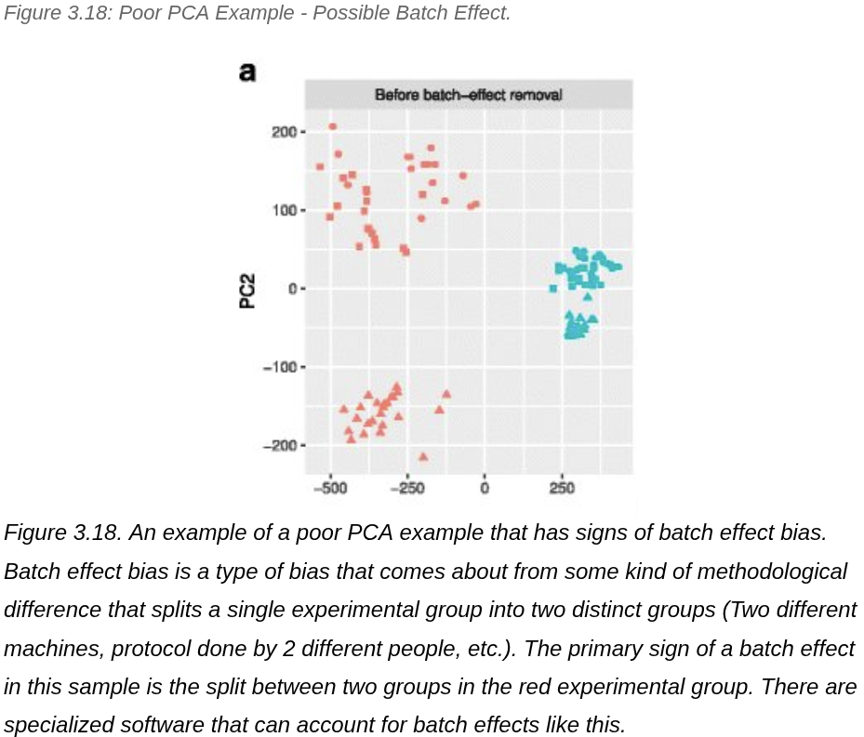

Dispersion Plot
Another useful diagnostic plot is the dispersion plot, which measures the amount of reads per gene against that gene’s variability. In RNAseq experiments, the amount of biological replicates we have is low (we only have 3 samples per treatment group) To fix this, this dispersion plot shares gene information across all of our samples to account for this limitation.

In this graph, each black dot represents a gene's dispersion (or variability) measured against its own dataset, which contributes to the red “fitted” trendline. If a datapoint's “black dot” is far from the fitted trendline but doesn’t hold much weight, gene information from the other datasets is taken into account, and the point is colored blue. Black dots surrounded by blue circles are outliers that were far from the trendline, but held enough weight without considering other datasets.

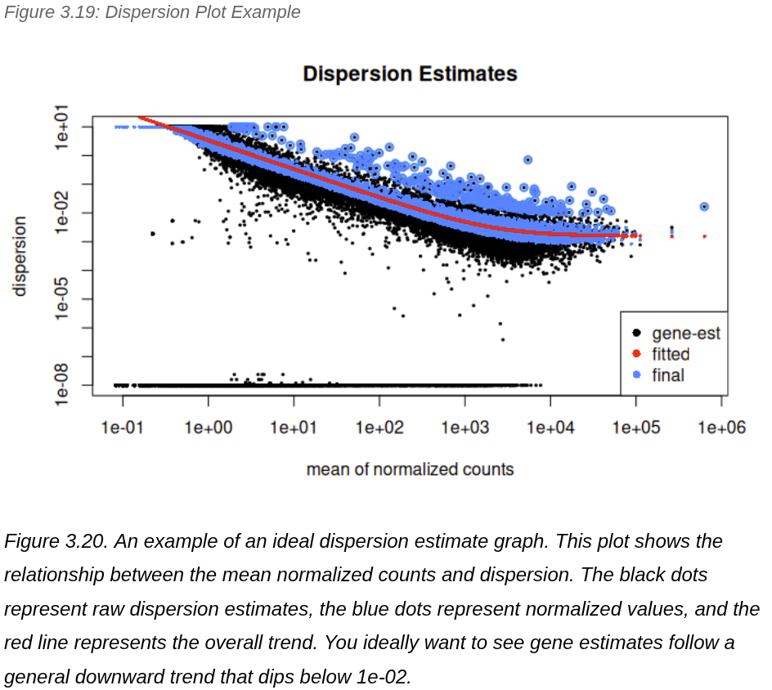
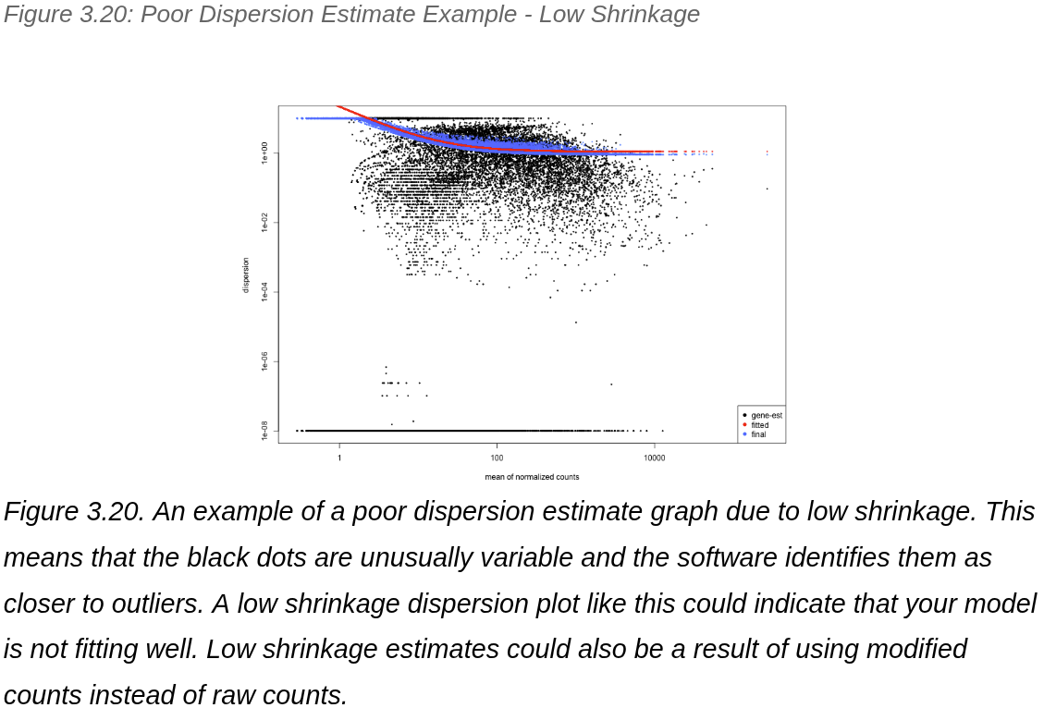

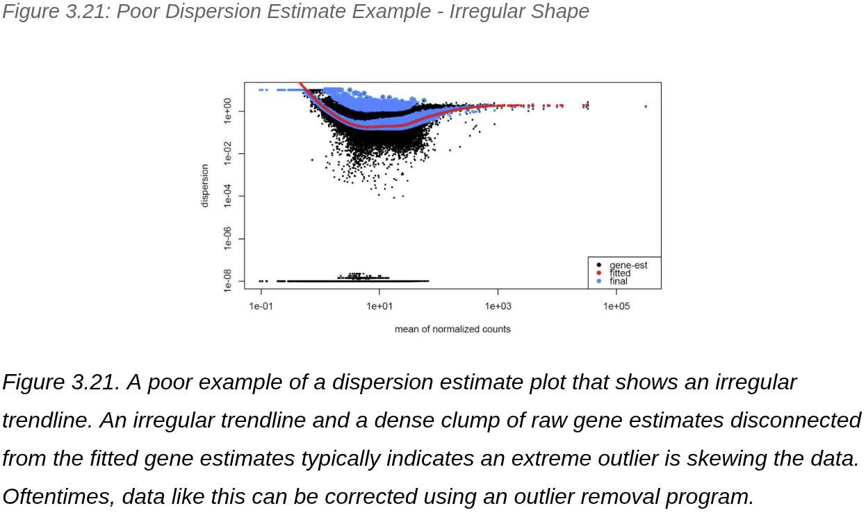

Analysis and Graphing

Differentially Expressed Genes Table
Now that we know we can trust our data, we can look into what our data is telling us. The first thing we need to do is determine what genes are over- and underexpressed. A table with the raw differential expression information will be output in a differentially expressed genes “.csv” file located in the results folder. A preview of what this table looks like can be seen in Figure 3.23, and each aspect is explained below.

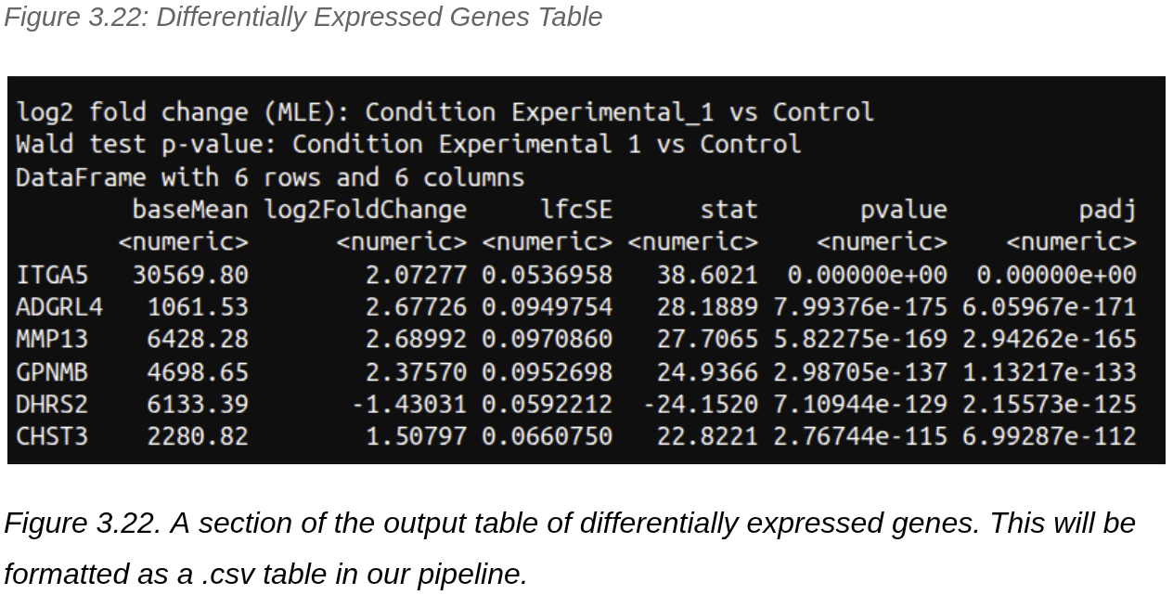

Each row represents a gene with a padj value less than .05. There are two important values that we want to pay attention to in this table: the log2FoldChange and the padj. The log2FoldChange represents how up or downregulated that specific gene is. The more up/downregulated a gene is, the more likely that dysregulation is to affect the overall system. This means that big numbers (positive or negative) are especially interesting.

padj values represent a p-value that has been manipulated to be more accurate. As a reminder, the p-value is the probability that our result happened by chance alone. In science, it is standard to treat any p-value below .05 (meaning that there is less then a 1/20 chance that we accidentally found meaning in a meaningless result) as significant – or trustworthy. However, when we are looking at thousands of samples like we are doing here, this means that even if we look at a sample with a p-value of .05 there could be hundreds of false positives. A adjusted p-value accounts for this in a couple different ways. The most popular of which is multiplying the p-value by the number of samples you have. Additionally while any p-value under .05 is considered significant, the lower the p-value, the more confident you can be that the result is significant.

Volcano Plot - Visualize Significant Genes
Another useful plot for RNA differential expression is a volcano plot. Named this way because it looks like a volcano, this plot visually demonstrates how many genes are up/downregulated. The X-axis of this graph is the Log₂ of the “fold change” or how big the change is. The Y-axis is the -log₁₀ of the P-value or how confident we are in that value. What we want to look for are the points in the top corners that are both high up/down regulation and a high confidence. To plot a volcano graph use the following code.
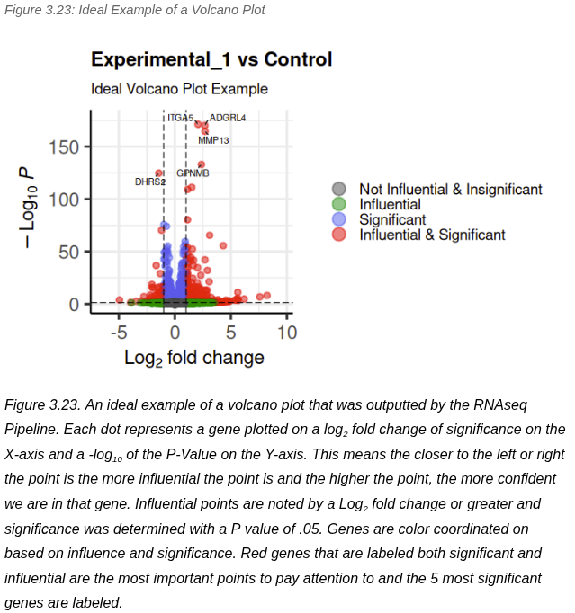

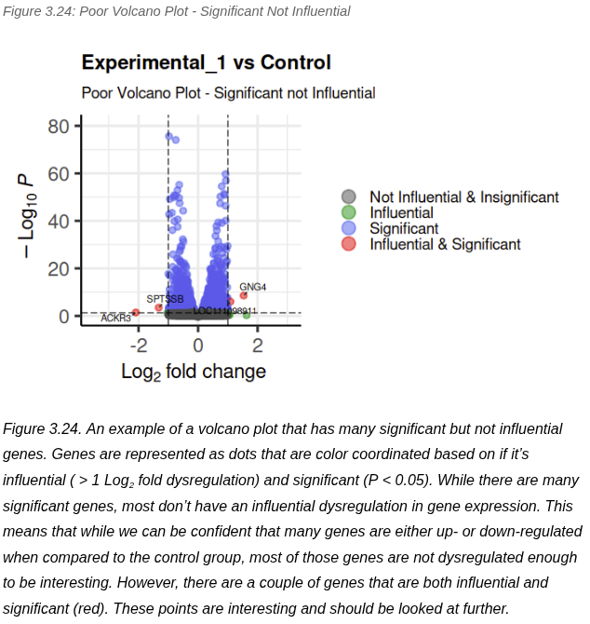

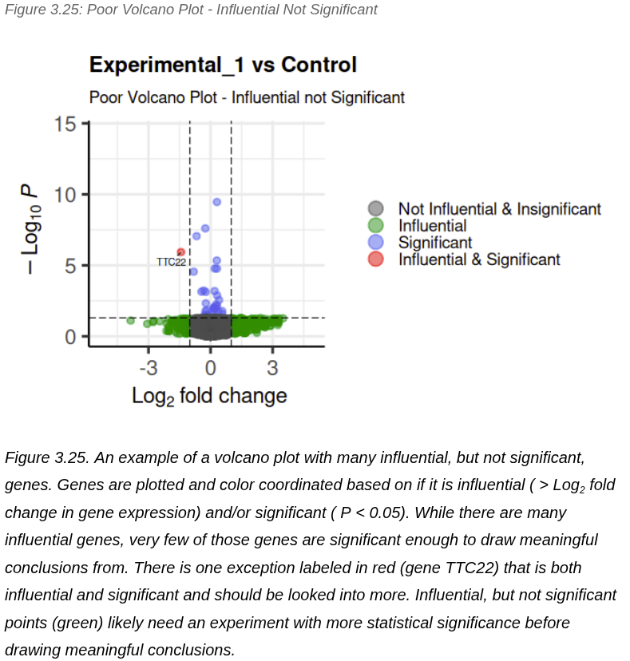

GSEA Plot - Contextualize in Biological Pathways
One important figure that is used to contextualize our results in real biological pathways GSEA plot seen in Figure 3.27. This plot ranks your genes from most overexpressed to most underexpressed across the X-axis. The plot then looks at a specific biological pathway, in this case, the epithelial-mesenchymal transition pathway (seen in the title). Once the pathway is specified, every gene that is related to that pathway is marked on the bottom of the graph (this is the barcode pattern just above the X-Axis). The green line then scans across the X-axis, starting at 0 and rising each time it hits one of the barcoded genes, and falling each time it hits a gene that isn’t barcoded.

A green line that rises sharply at the beginning at the beginning and/or end of the graph are particularly of interest. This would mean that Many of the most upregulated (beginning) and/or downregulated (end) genes are associated with our pathway of interest. A line that stays relatively steady or doesn’t make a defined “sideways S-like” curve is particularly suspect. Additionally, there are thousands of different pathways in an organism, and it would take years to manually check every pathway. To speed this up a bit, there are R-packages with algorithms that can find the most influential biological pathways in seconds. The implementation of our code can be seen in Chapter 2: Making a GSEA Plot.

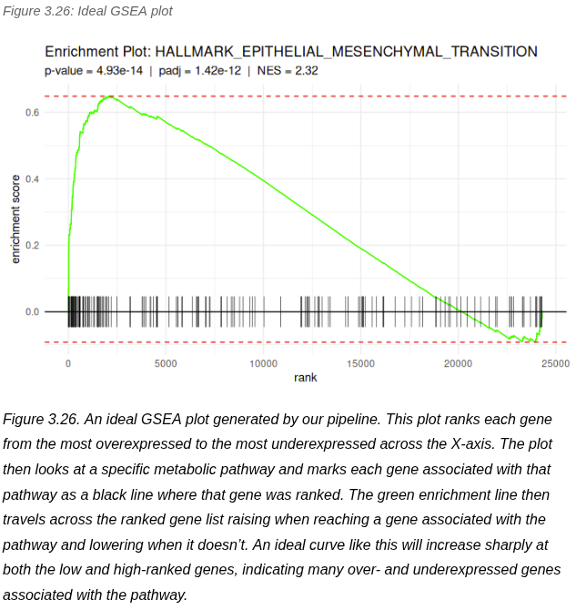

Chapter 4 - Conclusion
Hopefully, this thesis has given you the materials needed to kickstart your bioinformatics journey here at ECU. Chapter 1 described what bioinformatics is, what skills a bioinformatician needs, and some reference material on skills needed to set yourself up for success in your bioinformatics journey. Chapter 2 went into detail on the function of, as well as the thought process of writing, a bioinformatic pipeline I wrote for RNAseq differential expression analysis. Finally, Chapter 3 explained how to read the complex QC and analysis figures produced by this pipeline, with visual examples of what these graphs look like when things go wrong and why they occur.

I understand that the information in this thesis may feel like you’re drinking from a firehose. While I attempted to break down these concepts and explanations as best as I could while maintaining accuracy, much of this information may be overwhelming. Rest assured, this is expected and completely normal to not fully understand everything the first time through. This thesis was not meant to be a “one and done” read, but more of a guide to be referenced as needed. Therefore, as you reach times in your research when you need to make or read a volcano plot, GSEA plot, or Python pipeline, I highly recommend you refer back to this thesis throughout your journey as a researcher.

As for immediate future directions of this thesis, the design of the pipeline itself (down to the model organism used) is meant to fit into the larger ECU Bulldog Fetal Anasarca Project being led by Dr. Alicia Howard. While unforeseen setbacks have kept our current data from being usable, the pipeline should be directly usable with data from at least two biological replicates of “water puppies” and “healthy puppies” (however, I highly recommend more). Currently, commercial differential analysis services cost around $600 a sample⁵¹. While samples will still need to be sequenced out of house, I have gotten this pipeline to run on an 8-core processor for the cost of the electricity it uses, and it can be modified to work with future techniques. The full pipeline, along with a copy of this thesis, can be found at my GitHub here

As for the longer-term future directions of this thesis, I hope that this becomes the start of a “living document” to be added to by future students. While this thesis was long, it only covered NGS RNAseq. Bioinformatic techniques evolve alongside our understanding of biology and will likely be expedited with AI advancement. If future students want to add to or modify a copy of this document to reflect technological advancements, add techniques, and help future students, I highly encourage it.

Thank you for taking the time to read this thesis. If you are an ECU student who has any questions or concerns, feel free to contact me at caden.elizalde@gmail.com. Good luck in your journey into bioinformatics.

Glossary
A
Argument - something that is added to the command that runs a BASH command, which gives a piece of information that affects how the script runs.

B
Batch Processing - A group (or batch) of inputs that are fed (or processed) through a specific section of code one by one. Therefore, being processed identically.
BIOS (Basic Input/Output System) - Firmware that checks to see that your computer is good to go before loading your OS.
C
Channels- In conda, a channel represents a website that stores and hosts conda packages.
Command Line - The text based interface between you and the computer.
Command Line Interface (CLI) - The same as the Command Line
Conda - A package management software.
CPU - “Central Processing Unit” the part of the computer that deals with heavy calculations.
CRAN - Stands for “Comprehensive R Archive Network” and is a repository that stores and maintains R packages and language versions.
D
Debian - One of the 7 base distributions that has gained popularity for general use.
Distribution/Distro - A specialized version of Linux designed for a specific use case. subdivided into 7 base distributions, with many more specialized.
E
EMT - “Epithelial-Mesanchamal Transition” Cancer cell’s transition from epithelial cells to mesanchamal cells. A key step in cancer metastasis.
ENA - “European Nucleotide Archive” one of the many gene repositories where you can download public genomic Datasets.
Environment - an isolated directory that contains a specific collection of packages, including a particular Python or R version, libraries, and other software, along with their dependencies.
F
G
Genome - The nucleic acid sequence that can be found in an individual.
GSEA - “Gene Set Enrichment Analysis” A differential expression plot that shows how genes are over and underexpressed in a given metabolic pathway
H
The Human Genome Project - A scientific project that lasted from 1990 - 2003 that sought to map the entirety of the Human Genome.
I
Integrated Development Environment (IDE) - A piece of software that makes it more user friendly to run code.
ISO Image - A single file that's a perfect representation of an entire OS.
J
K
Kernel - The very base level of a computer system.
L
Linter - A coding tool that detects syntax errors in code.
Linux - Short for “Libre Unix” is an open source clone of Linux. Colloquially and functionally identical to Unix.
Linux Mint - An Ubuntu based specialized distribution notable for being user friendly.
M
MacOS - The operating system made by Apple that runs on Macintosh Computers.
N
O
Open Source - Typically free software with code that is open and available to the public.
OS - “Operating System” Protocols that allow people to interact with the internals of the machine.
P
Parameter - Something that is added to the command that runs a Python script, which gives a piece of information that affects how the script runs.
Phred Score - A quality score for nucleotides that measures a “1 in X” chance that the the nucleotide is wrong (i.e. Phred Score of 20 = 1/20 chance the nucleotide is wrong).
Plugin - An add on to a software that allows for a specific feature
Q
Quality Score - An integer value representing the estimated probability of an error.
R
Reference Sequence (RefSeq) - A genome that is representative of the typical individual of a species.
Repository (Repo) - A central digital storage location for organizing, managing, and sharing project files, code, and data.
S
Script - A sequence of commands or instructions used to run a series of predefined tasks.
SHA-256 - A cryptographic hash function that acts as a 256-bit string of characters that acts as a digital fingerprint.
shRNA - Short Hairpin RNA
Syntax - The way code is “phrased.”
T
U
Ubuntu - One of 7 base distributions specialized for general use. The base Distribution of Linux Mint.
Unix - Colloquially identical to Linux. A proprietary command line based operating system made by AT&T’s Bell Lab. Unix gained popularity due to its speed, efficiency, and simplicity.
URL - The web address of a unique resource on the internet, such as a web page or file.
V
Variance Stabilizing Transformation - A type of data manipulation useful for allowing data that doesn’t follow a normal distribution, to be analyzed by data that needs to be normally distributed.
Volcano Plot - A differential expression plot that visually displays genes based on influence and significance.
W
Wildcard - A character (typically “ * ”) that symbolizes a placeholder for any number of characters.
X
Y
Z

Appendix A - Important Commands

Command | Brief Description | Notable options | Usage Example
apt | A software package management tool | install: Install a software package  upgrade: update all installed software  remove: Remove a software package | apt install <software>
cat | Read or combine files. | -n: number output lines | cat <file>
cd | Navigate to a specified directory |  | cd <directory>
chmod | Change file permissions. | -v: Have the terminal output a result for everything it looks at  -f: Silence most error messages  -c: Only outputs a terminal message when a change is made | chmod <file>
cp | Copy a file. | -f: Force the command to go through even if an error message occurs  -i: Pop up an interactive prompt before an overwrite. | cp <source file> <destination file>
echo | Repeat a string of text back to you. |  | echo “<string to repeat>”
grep | Search a file or location for a pattern of text |  | grep <pattern> <file>
rm | Remove a file or directory. | -r: “recursive,” do the same to files in all subdirectories  -f: Force remove the file | rm <file>
sudo | Grant administrative access to a command. |  | sudo <command requiring admin access>
history | Gets a numbered list of previously run commands | <number>: Immediately following the command with a number will only list that many commands back  -w: Writes the history to a history file | history <number> <options>
less | Shows large files one page at a time | -c: Clears screen before displaying each page | less <file>
ls | List files and directory in the current. | -l: List permissions of the files  -a: Lists hidden files and directory (starting with .) as well | ls <options>
man | Look at the manual for a given command. | -f: Displays a short description if available. | man <options> <command>
mkdir | Make a directory to the current working directory | -p: Make parent directories if needed | mkdir <options> <directory>
more | Read a file |  | more <file>
mv | Rename or move a file. | -f: Don’t prompt before overwrite  -i: Prompt the user before an overwrite occurs | Rename:  mv <old name> <new name>  Move:  mv <source directory> <destination directory>
nano | Access an in terminal text editor for a given file. |  | nano <file>
ps | Shows currently running processes | -A: Shows all processes.  -f: Full format listing. | ps
pwd | Shows the current working directory. |  | pwd
tail | Shows the end of a file | -n <number>: specifies a number of lines back to show.  -f: Continuously output new lines being created | tail <file>
tee | Takes a standard input and writes it to the standard output as well as another specified file. | -a: append to file rather than overwrite  -i: ignore interrupts | tee <file>
touch | Create a file |  | touch <new filename>
watch | Repeats a command over time and prints the output | -n: how many seconds pass before the next command repeat | watch <command>
wget | Retrieves a file from the internet. | -v: “Verbose” displays all available output.  -q: “quiet” suppresses all output besides for error messages. | wget <URL>

Appendix B - BASH Aliasises & Shortcuts
Shortcut | What it Does | Example
!! | Rerun last command | > echo “hello world”  hello world  > !!  hello world
!$ | Repeat last argument | > mkdir folder  > cd !$  (you are now in the folder directory)
!<number> | Repeat the <number> command in the terminals history (useful when paired with the history command) | > history 3  1 ...  2 echo “hello world”  3 ...  > !2  hello world
!-<number> | Repeat the command <number> steps back | > echo “hello”  hello  > echo “world”  world  > !-2  hello
* | Wildcard: matches to anything | > ls *.txt  file1.txt  file2.txt  File2.txt  (shows only files ending in .txt)
$USER | Home Directory of the current user (useful if you want a script that works on any computer regardless of user) | > pwd $USER  /home/caden  (Will show the current user instead of Caden
~ | Shortcut for home directory | > cd ~  > pwd  /home/<user>  (calls the home directory)
> | Overwrite to file | > cat sample.txt  hello world  > “my name is Caden” > sample.txt  > cat sample.txt  my name is Caden
>> | Append to file | > cat sample.txt  hello world  > “my name is Caden” >> sample.txt  > cat sample.txt  hello world my name is Caden
“” | Strings in double quotes except certain special characters and variables | > echo “I am $USER”  I am caden
‘’ | Strings in single quotes will be treated as literal | > echo ‘I am $USER’  I am $USER
; | Will immediately run the next command when placed between 2 commands | > echo "hello" ; echo "hello"  Error: ...  hello
&& | Putting && between two commands will only run the second command if the first one succedes | > ech "hello" ; echo "hello"  Error: ...

Appendix C - Useful Bioinformatics Software
Software | Description
Bioconductor | A project that contains useful R packages for genomic data analysis.
Conda | A package management software used to ensure software compatibility.
FastQC | Used to create documentation on the quality of reads.
featureCounts | Creates a summary table of reads mapped to genes.
HISAT2 | Used for alignment mapping for NGS sequencing data.
HISAT2-build | Used to build index files from a refseq.
MultiQC | Used to combine the documentation of FastQC into an easy to read document.
pandas | Standard Python package for data manipulation
Python | A simple object based coding language that is useful for scripting.
R | A coding language optimized for statistical analysis.
R Studio | An IDE used to run R code.
rpy2 | A software that acts as a bridge between R and Python

Sources
- Albert, I. (2021). The Biostar Handbook: 2nd Edition (2nd ed.).
- Can, T. (2014). Introduction to Bioinformatics. In M. Yousef & J. Allmer (Eds.), miRNomics: MicroRNA Biology and Computational Analysis (pp. 51–71). Humana Press. https://doi.org/10.1007/978-1-62703-748-8_4
- Chen, J., Wang, X., Ma, A., Wang, Q.-E., Liu, B., Li, L., Xu, D., & Ma, Q. (2022). Deep transfer learning of cancer drug responses by integrating bulk and single-cell RNA-seq data. Nature Communications, 13(1), 6494. https://doi.org/10.1038/s41467-022-34277-7
- Cho, C.-S., Xi, J., Si, Y., Park, S.-R., Hsu, J.-E., Kim, M., Jun, G., Kang, H. M., & Lee, J. H. (2021). Microscopic examination of spatial transcriptome using Seq-Scope. Cell, 184(13), 3559-3572.e22. https://doi.org/10.1016/j.cell.2021.05.010
- Ding, J., Sharon, N., & Bar-Joseph, Z. (2022). Temporal modelling using single-cell transcriptomics. Nature Reviews Genetics, 23(6), 355–368. https://doi.org/10.1038/s41576-021-00444-7
- Greener, J. G., Kandathil, S. M., Moffat, L., & Jones, D. T. (2022). A guide to machine learning for biologists. Nature Reviews Molecular Cell Biology, 23(1), 40–55. https://doi.org/10.1038/s41580-021-00407-0
- Harshil Patel, Jonathan Manning, Phil Ewels, Maxime U Garcia, Alexander Peltzer, Rickard Hammarén, Olga Botvinnik, Adam Talbot, Friederike Hanssen, Gregor Sturm, nf-core bot, Matthias Zepper, Denis Moreno, Pranathi Vemuri, Mahesh Binzer-Panchal, Ezra Greenberg, silviamorins, Lorena Pantano, Robert Syme, … Chris Cheshire. (2025). nf-core/rnaseq: Nf-core/rnaseq v3.22.1 - Polished Palladium Penguin (Version 3.22.1) [Computer software]. Zenodo. https://doi.org/10.5281/ZENODO.17833254
- Homo sapiens (ID 214799)—BioProject—NCBI. (n.d.). Retrieved December 5, 2025, from https://www.ncbi.nlm.nih.gov/bioproject/?term=PRJNA214799
- Human Data. (n.d.). Retrieved December 5, 2025, from https://www.ncbi.nlm.nih.gov/geo/query/acc.cgi?acc=GSE49712
- Jaganathan, K., Kyriazopoulou Panagiotopoulou, S., McRae, J. F., Darbandi, S. F., Knowles, D., Li, Y. I., Kosmicki, J. A., Arbelaez, J., Cui, W., Schwartz, G. B., Chow, E. D., Kanterakis, E., Gao, H., Kia, A., Batzoglou, S., Sanders, S. J., & Farh, K. K.-H. (2019). Predicting Splicing from Primary Sequence with Deep Learning. Cell, 176(3), 535-548.e24. https://doi.org/10.1016/j.cell.2018.12.015
- Li, X., & Wang, C.-Y. (2021). From bulk, single-cell to spatial RNA sequencing. International Journal of Oral Science, 13(1), 36. https://doi.org/10.1038/s41368-021-00146-0
- Liao, J., Qian, J., Fang, Y., Chen, Z., Zhuang, X., Zhang, N., Shao, X., Hu, Y., Yang, P., Cheng, J., Hu, Y., Yu, L., Yang, H., Zhang, J., Lu, X., Shao, L., Wu, D., Gao, Y., Chen, H., & Fan, X. (2022). De novo analysis of bulk RNA-seq data at spatially resolved single-cell resolution. Nature Communications, 13(1), 6498. https://doi.org/10.1038/s41467-022-34271-z
- Mao, D. (2025). The use of artificial intelligence in RNA sequencing: A review. Advances in Engineering Innovation, 16(5), 90–94. https://doi.org/10.54254/2977-3903/2025.23332
- Mortazavi, A., Williams, B. A., McCue, K., Schaeffer, L., & Wold, B. (2008). Mapping and quantifying mammalian transcriptomes by RNA-Seq. Nature Methods, 5(7), 621–628. https://doi.org/10.1038/nmeth.1226
- Ozsolak, F., & Milos, P. M. (2011). RNA sequencing: Advances, challenges and opportunities. Nature Reviews Genetics, 12(2), 87–98. https://doi.org/10.1038/nrg2934
- Perelo, L. W., Gabernet, G., Straub, D., & Nahnsen, S. (2024). How tool combinations in different pipeline versions affect the outcome in RNA-seq analysis. NAR Genomics and Bioinformatics, 6(1), lqae020. https://doi.org/10.1093/nargab/lqae020
- Transcriptomic responses of Arabidopsis thaliana l... (ID 674629)—BioProject—NCBI. (n.d.). Retrieved December 5, 2025, from https://www.ncbi.nlm.nih.gov/bioproject/?term=PRJNA674629
- VanInsberghe, M., Van Den Berg, J., Andersson-Rolf, A., Clevers, H., & Van Oudenaarden, A. (2021). Single-cell Ribo-seq reveals cell cycle-dependent translational pausing. Nature, 597(7877), 561–565. https://doi.org/10.1038/s41586-021-03887-4
- Wang, Y., Ma, X., Xu, E., Huang, Z., Yang, C., Zhu, K., Dong, Y., & Zhang, C. (2024). Identifying squalene epoxidase as a metabolic vulnerability in high‐risk osteosarcoma using an artificial intelligence‐derived prognostic index. Clinical and Translational Medicine, 14(2), e1586. https://doi.org/10.1002/ctm2.1586
- Zaitsev, A., Chelushkin, M., Dyikanov, D., Cheremushkin, I., Shpak, B., Nomie, K., Zyrin, V., Nuzhdina, E., Lozinsky, Y., Zotova, A., Degryse, S., Kotlov, N., Baisangurov, A., Shatsky, V., Afenteva, D., Kuznetsov, A., Paul, S. R., Davies, D. L., Reeves, P. M., … Bagaev, A. (2022). Precise reconstruction of the TME using bulk RNA-seq and a machine learning algorithm trained on artificial transcriptomes. Cancer Cell, 40(8), 879-894.e16. https://doi.org/10.1016/j.ccell.2022.07.006
- Chang, J. (2015). Core services: Reward bioinformaticians. Nature, 520(7546), 151–152. https://doi.org/10.1038/520151a
- Overview of the GNU System—GNU Project—Free Software Foundation. (n.d.). Retrieved January 4, 2026, from https://www.gnu.org/gnu/gnu-history.en.html
- Ritchie, D. M., & Thompson, K. (1978). The UNIX Time-Sharing System†. Bell System Technical Journal, 57(6), 1905–1929. https://doi.org/10.1002/j.1538-7305.1978.tb02136.x
- College, S. M.-W. (n.d.). What Is an ISO File? Lifewire. Retrieved January 5, 2026, from https://www.lifewire.com/iso-file-2625923
- Linux Mint Installation Guide. (2024). Linux Mint. https://linuxmint-installation-guide.readthedocs.io/_/downloads/en/latest/pdf/
- Etcher | Etcher. (n.d.). Retrieved January 8, 2026, from https://etcher.pages.dev/
- Conda Documentation—Conda 25.11.1 documentation. (n.d.). Retrieved January 22, 2026, from https://docs.conda.io/projects/conda/en/stable/index.html
- EMBL-EBI. (2026). ENA Browser. Ebi.ac.uk. https://www.ebi.ac.uk/ena/browser/view/ERP022283
- Team, G. (2026). Experiment < Expression Atlas < EMBL-EBI. Ebi.ac.uk. https://www.ebi.ac.uk/gxa/experiments/E-MTAB-5628/Results
- NCBI Genome Data Viewer. (2026). Nih.gov. https://www.ncbi.nlm.nih.gov/gdv/
- ‌UCSC Genome Browser Home. (2026). Ucsc.edu. https://genome.ucsc.edu/
- Ensembl Genomes. (2026). Ensemblgenomes.org. https://ensemblgenomes.org/
- FlyBase. (2026). FlyBase Homepage. Flybase.org. https://flybase.org/
- HISAT2. (2021). HISAT2. https://daehwankimlab.github.io/hisat2/
- Research & analysis changes in U.S. family finances from 2019 to 2022. (n.d.). https://www.federalreserve.gov/publications/files/scf23.pdf
- Bakker, J. D. (2026, January 2). PCA. Applied Multivariate Statistics in R; University of Washington. https://uw.pressbooks.pub/appliedmultivariatestatistics/chapter/pca/
- ‌Lewis, P. D., & Menzies, G. E. (2015). Vibrational spectra, principal components analysis and the horseshoe effect. Vibrational Spectroscopy, 81, 62–67. https://doi.org/10.1016/j.vibspec.2015.10.002
- ‌Kennedy, W. B. (2024, November 2). A Simple Example Using PCA for Outlier Detection. Medium; TDS Archive. https://medium.com/data-science/a-simple-example-using-pca-for-outlier-detection-ab2773b98e4a
- ‌Zhu, X., Wolfgruber, T. K., Tasato, A., Arisdakessian, C., Garmire, D. G., & Garmire, L. X. (2017). Granatum: a graphical single-cell RNA-Seq analysis pipeline for genomics scientists. Genome Medicine, 9(1). https://doi.org/10.1186/s13073-017-0492-3
- Piper, M. (2017, May 12). Gene-level differential expression analysis with DESeq2. Introduction to DGE - ARCHIVED. https://hbctraining.github.io/DGE_workshop/lessons/04_DGE_DESeq2_analysis.html
- ‌The ENCODE Consortium. (2011, June). Standards, guidelines and best practices for RNA-seq (V1.0). https://genome.ucsc.edu/ENCODE/protocols/dataStandards/ENCODE_RNAseq_Standards_V1.0.pdf
- Biostar Forum, Featurecounts: Extremely low rate of “successfully assigned alignments.” (2020). https://www.biostars.org/p/448496/
- MultiQC. (2016). MultiQC Report. Cancer.gov. https://bioinformatics.ccr.cancer.gov/docs/b4b/data/module2_outputs/multiqc_report_snidget.html
- cageseq: Output. (2018). Nf-Co.re. https://nf-co.re/cageseq/output
- Biostar Forum, fastqc result: whether trim off low quality reads or not” (2020). https://www.biostars.org/p/448709/
- 11. Advanced quality control with MultiQC copy - Bioinformatics for Beginners 2022. (2022). Cancer.gov. https://bioinformatics.ccr.cancer.gov/docs/b4b/11.-Advanced-quality-control-with-MultiQC%20copy/
- Wu, H., Zhang, Z., Hu, S., & Yu, J. (2012). On the molecular mechanism of GC content variation among eubacterial genomes. Biology Direct, 7(1). https://doi.org/10.1186/1745-6150-7-2
- Reddit - The heart of the internet. (2025). Reddit.com. https://www.reddit.com/r/bioinformatics/comments/1imuyho/fastqc_gc_content/
- fastqc gc-content peak and adapter content” (2020). https://www.biostars.org/p/258230/
- Baccarella, A., Williams, C. R., Parrish, J. Z., & Kim, C. C. (2018). Empirical assessment of the impact of sample number and read depth on RNA-Seq analysis workflow performance. BMC Bioinformatics, 19(1), 423. https://doi.org/10.1186/s12859-018-2445-2
- Service Fees | Nebraska Center for Biotechnology | Nebraska. (n.d.). Retrieved April 22, 2026, from https://biotech.unl.edu/bioinformatics/service-fees/

