Milestone Design Specification

Document Name: Milestone Design Specification
Version: v4.0
Prepared By: Engineering Team
Date: 12-21-2025
Status: Approved
Purpose
The purpose of this document is to define the functional expectations and to describe the Mock UI behaviour and flow for the Milestone module. This document serves as a reference guide for Product Design and Development teams to ensure consistent understanding and implementation.
Scope
This document covers the following topics:
- Overview of the milestone feature
- Key objectives of implementing milestones
- Milestone components
- Milestone lifecycle and rules
- Adding a new milestone
- Updating an existing milestone
- Closing a milestone
- Milestone deadline expiry
- Follow-up milestones

1. Overview of the milestone feature
The Milestone Module allows users to break down a ticket into smaller, actionable, and trackable units called milestones. Each milestone is created using an admin-configured template for the selected milestone type and supports lifecycle tracking through start dates, deadlines, status, descriptions, delay reasons, and user accountability. This module ensures timely completion of sub-tasks, minimizes unnecessary delays, improves visibility of progress, and provides options for meaningful audits across the entire lifecycle of a ticket.
2. Key objectives of implementing milestones
- Enable structured decomposition of tickets into manageable milestones
- Standardize creation of sub-tasks through configurable templates
- Capture mandatory reasons for delays or missed deadlines
- Facilitate follow-ups with responsible parties (vendors, technicians et al) in case of hold-ups
- Improve accountability through real-time alerts and enforced actions
- Restrict user actions to enforce compliance
- Make admin configurational changes to milestone templates hassle free by implementing a version-controlled applicability criteria for milestone types
3. Milestone components
Milestone components are created and maintained using the Milestone Configuration panel.
  - Milestone Types
- Milestone types are defined by the App Admin.
- Each milestone type is mapped to a milestone template. The mapping is done at the time of creation of the milestone type but can be changed later. A version-controlled applicability criteria ensures that the template which is applicable to a milestone of a certain milestone type is decided by the mapping that exists at the time the milestone is created.
  - Milestone Templates
- Milestone templates are designed and maintained by the App Admin.
- Key attributes of a template include:
- Template Name
- Template Type (Generic, Follow-up et al)
- System-defined fields (such as Start DateTime and Status)
- Reusable standalone fields
- Reusable grouped fields
Everything except Template Type and System-defined fields can be defined and configured by the App Admin.
  - Milestone Templates
- Summary of Milestone fields:
Field | Required | Defined By | Value Assigned By
Start DateTime | Yes | System | System
End DateTime | Yes | System | User
Status | Yes | System | System
Milestone Name | Yes | System | App Admin
Milestone Type | Yes | System | App Admin
Description | Yes | System | User
Custom fields | May be optional | App Admin | User
- The following input validation rules apply for the user input values:
- Description field can accommodate a maximum of 200 characters.
- Phone numbers must have a 10-digit format
- At least one value set must be entered by user when the milestone template contains grouped fields like "Vendor Details" or "Item Details".
4. Milestone lifecycle and rules

  - Milestone Types
Milestones can have one of the two statuses:
- In Progress
- Closed
  - Milestone Rules
- A ticket can have only one milestone In Progress at any given time.
- A milestone cannot be created if:
- The ticket already has a milestone In Progress.
- The ticket not assigned to the user.
- The ticket is closed.
- The ticket is currently not assigned to the user trying to create the milestone.
- Closed milestones cannot be updated or reopened.
5. Adding a new milestone

  - Adding the first milestone
- When a user assigns a ticket to himself or accepts a ticket that has been assigned to his queue, the system automatically redirects the user to the Milestone tab and presents the "Create Milestone" modal dialog for the user to select the milestone type.
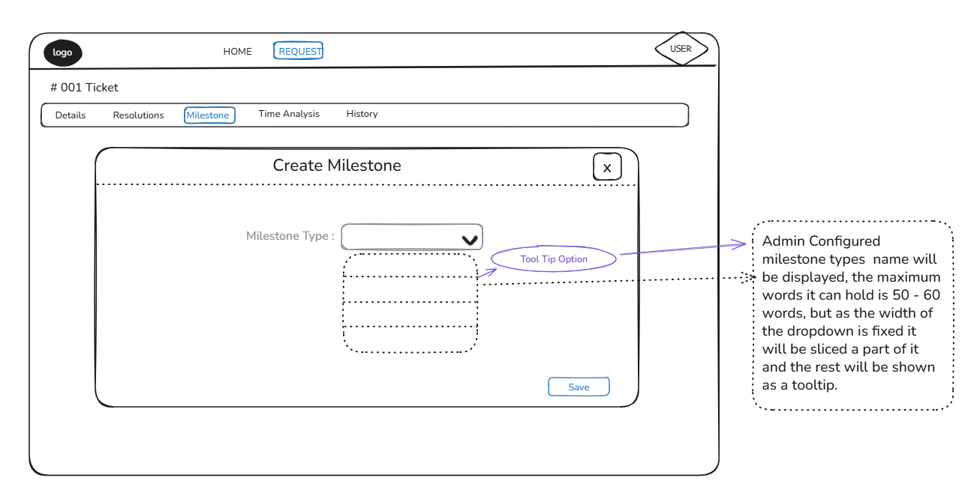
When the user selects the milestone type and clicks "Save", the system loads a new instance of the milestone template associated with the selected milestone type.
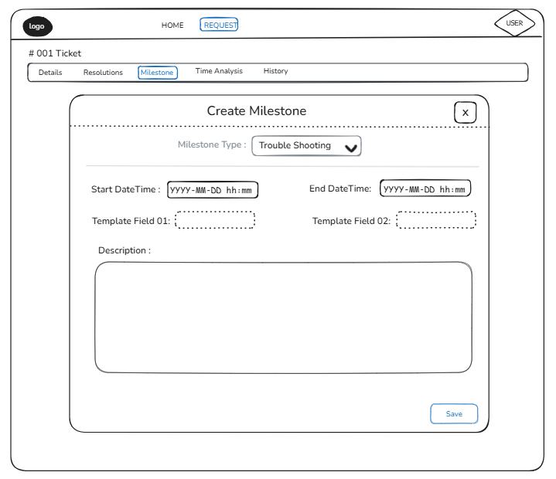
When the user assigns values to the fields for this new milestone and clicks the Save button, the first milestone is created.
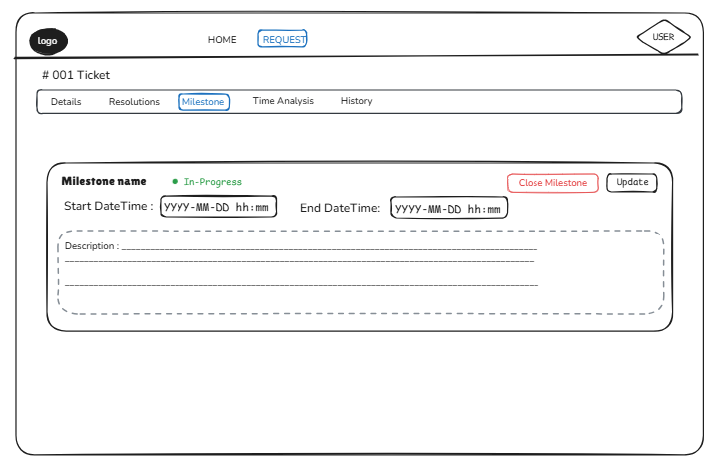
- The flow sequence for creating the first milestone can be outlined as follows: User accepts the ticket -> User is redirected to the Milestone tab -> Modal dialog box titled "Create Milestone" pops up -> User selects Milestone Type and assigns values to the fields for that milestone type -> User clicks the Save button
  - Adding subsequent milestones
- When a user tries to close an existing milestone by clicking the "Close Milestone" button, he is presented with a confirmation dialog box that reads "Select an action to proceed with closing this milestone:"
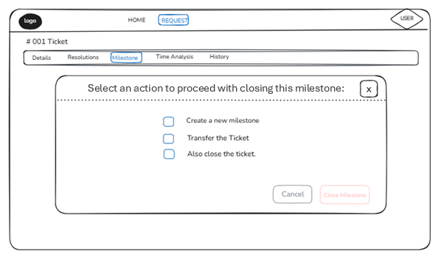
If the user selects "Create a new milestone" and clicks on the "Close Milestone" button, the user is presented with the "Create Milestone" modal dialog for selecting the milestone type.
On selecting the milestone type and then clicking "Save", the system loads a new instance of the milestone template associated with that milestone type.
When the user assigns values to the fields for the new milestone type and clicks the Save button, the existing milestone is closed and a new milestone is created as a part of the same transaction.
- If any of the steps mentioned above fails, the entire transaction is rolled back and an appropriate error message (stating that the milestone couldn't be closed owing to an error) is displayed to the user.
6. Updating an existing milestone

  - Initiating a request for updating milestone field values
- Milestone field values cannot be directly updated by a user. If a user needs to update values of milestone fields other than system-defined fields (such as Start DateTime and Status), the user can place a request for the same by clicking the "Update" button.
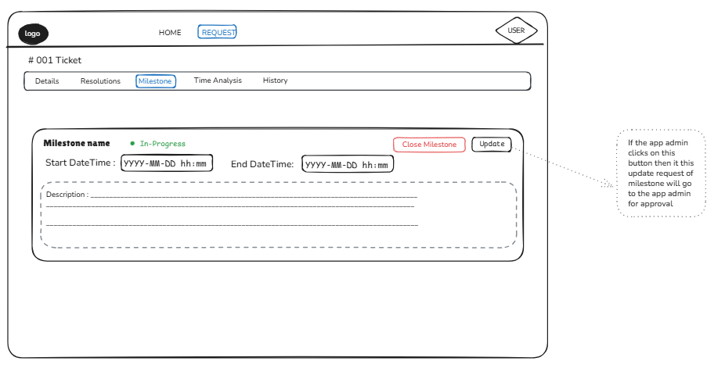
Upon clicking the "Update" button, all milestone fields, with the exception of "End DateTime", becomes updatable, allowing the user to update the fields values he wants to change. The field value for "End DateTime" can be updated only if the update is attempted within the first 10 minutes after the creation of the milestone in question.
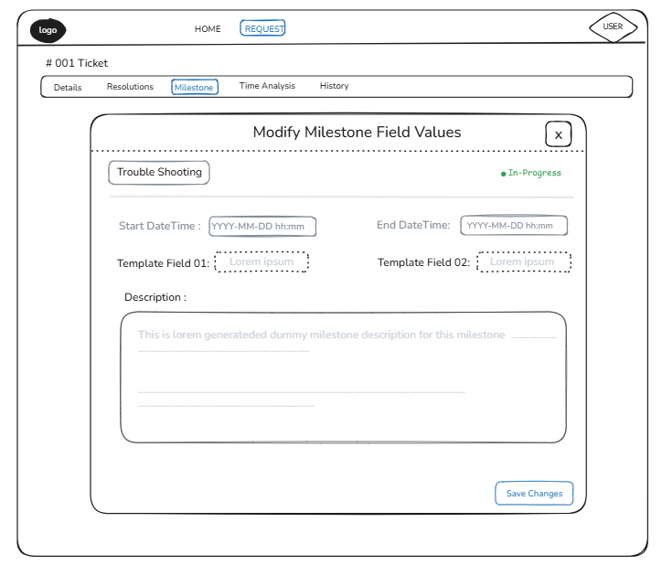
On clicking the "Save Changes" button, the system sends a request to the App Admin for approval of the requested changes and an alert with the message "Changes to milestone field values are subject to approval by the App Admin" to the user.
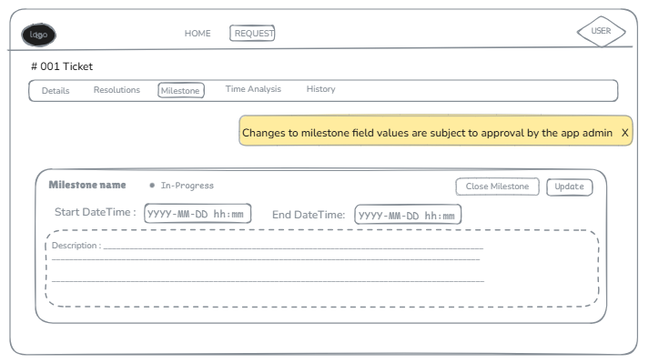
The alert stays visible for 3 seconds and then automatically fades away.
  - Approval of a milestone update by the application administrator
- The App Admin can approve a milestone update by locating the corresponding approval request under his worklist and then approving the same. Once approved by the App Admin, the milestone in question reflects the updated field values.
- When a milestone update request is sent to the App Admin, the "Update button" for that milestone becomes inactive (grayed out) and remains in that state until the App Admin either approves or rejects the update request. This prevents multiple update approval requests for the same milestone from being sent to the admin's worklist.
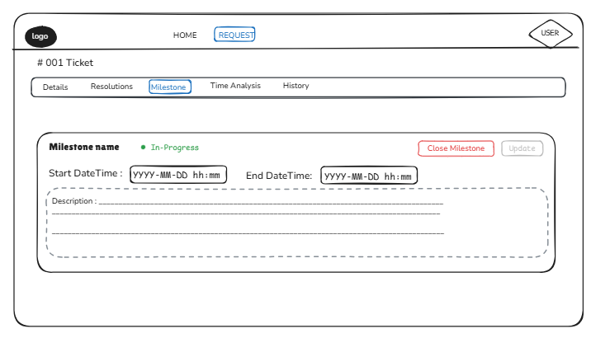
7. Closing a milestone

  - Initiating the process for closing a milestone
- A user can initiate the process for closing a milestone by clicking the "Close Milestone" button, following which he is presented with a confirmation dialog box that reads "Select an action to proceed with closing this milestone:". The user is then required to select one of the following three radio button choices:
- Create a new milestone
- Transfer the ticket
- Close the ticket
  - Associated action mandatory for closing a milestone
- The user needs to select one of the three radio buttons and carry out the associated action as a mandatory prerequisite for closing the milestone. If the user selects "Create a new milestone", he is required to create a new milestone prior to closing the existing one (as discussed in Sec 1.2).
- If the user selects "Transfer the ticket", he is presented with a modal dialog box for selecting a user to whom he intends to transfer the ticket.
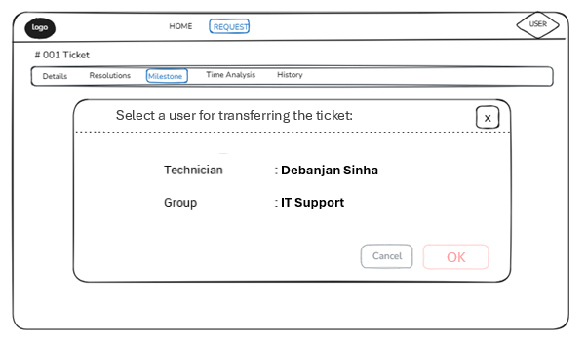
Upon selecting the user and then clicking "OK", the existing milestone is closed and the ticket is transferred successfully as a part of the same transaction.
- If the user selects "Close the ticket", he is redirected to the Resolution section if it has not been filled up already. In case the Resolution has already been submitted earlier, the ticket as well as the milestone is closed as a part of one single transaction.
  - Rolling the transaction back if mandatory action fails
- If any mandatory associated action viz. opening a new milestone, transferring the ticket or closing the ticket fails, the entire transaction is rolled back and an appropriate error message (stating that the milestone couldn't be closed owing to an error) is displayed to the user. When this happens, the user is required to re-initiate the process for closing the milestone.
8. Milestone deadline expiry

  - Alerts prior to deadline expiry
- Mobile App: Triggers vibration/buzz every 5 minutes between 60 minutes to 15 minutes prior to deadline expiry and every 1 minute thereafter (till the deadline expires).
- Web App: Triggers on-screen pop-up alerts every 5 minutes between 60 minutes to 15 minutes prior to deadline expiry and every 1 minute thereafter (till the deadline expires)
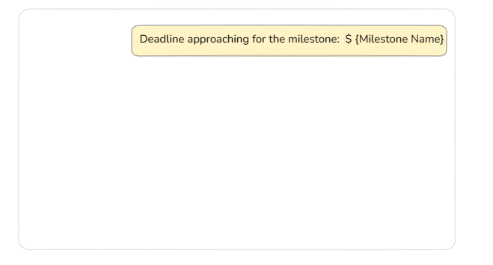
  - Mandatory action when milestone deadline expires
- When a milestone deadline expires, the milestone is automatically closed. The device is frozen on a screen that prompts the user (technician) to take appropriate action with regard to the expired milestone. The device continues to buzz/vibrate until the technician takes appropriate action.
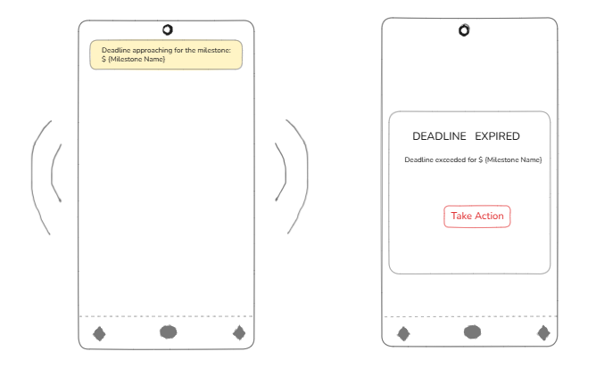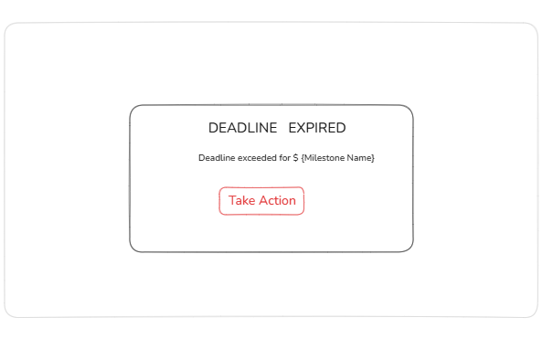
- Once the technician agrees to take necessary action, he is redirected to the application where he's required to document a reason for missing the deadline.
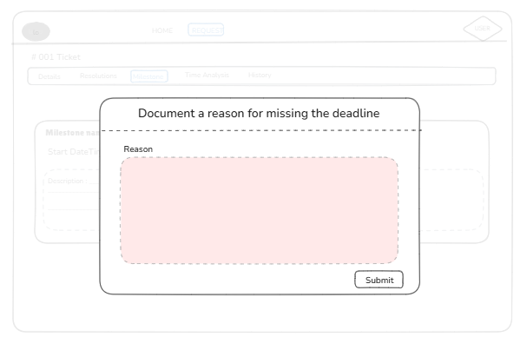
- Once the reason for missing the milestone deadline is submitted, the technician is required to select one of the three radio-button choices viz. "Create New Milestone", "Transfer Ticket" and "Close Ticket". Immediately after selecting a radio-button, the technician is expected to follow through with the corresponding action.
- Normal app execution resumes only after submission of the reason for missing the deadline, followed by selection of one of the three checkbox options and the subsequent completion of the action thereafter (creating a new milestone, transferring the ticket or closing the ticket), failing any of which the device reverts to the frozen state.
- If the device restarts while in a frozen state, then it reverts to the frozen state post restart, while flashing the same prompt for taking appropriate action with regard to the expired milestone.

9. Follow-up milestones
- A follow-up milestone is created when an existing milestone is not closed on or before its deadline (End DateTime). Missing the deadline triggers a screen freeze alert and prompts the user to take action. The user must document the reason for not completing the task within the stipulated timeframe. After providing the reason, the user must create a follow-up milestone.
- The follow-up milestone inherits the context of the parent milestone. It continues the same background tasks as the parent milestone.

