Notification Service High-Level Design (HLD)

Contents

1. Overview 1

2. Objectives 1

3. Architecture Components 1

4. Workflow 2

5. Plain UML - Component Diagram 3

6. External Dependencies 3

7. Future Considerations 4

# 1. Overview

The Notification Service handles all outbound communications in a Ticket Management System. It listens for task-related events and sends notifications through various channels (Email, SMS, In-App). The service ensures timely delivery and respects user preferences.

# 2. Objectives

- Real-time and scheduled notifications

- Support for Email, SMS, and In-App

- User-specific preferences and delivery options

- Logging and retry mechanisms

# 3. Architecture Components

3.1 Event Producer

- Task Management System publishes events (e.g., task assignment)

### 3.2 Message Broker

- Kafka or RabbitMQ queues events

### 3.3 Notification Processor

- Consumes events from the broker

- Coordinates fetching user preferences, templates

- Dispatches messages to appropriate channels

### 3.4 Template Engine

- Loads and personalizes templates for each notification

### 3.5 User Preferences Service

- API to retrieve user settings (e.g., enable SMS, disable email)

### 3.6 Channel Senders

- Email Sender (via SMTP)

- SMS Sender (e.g., Twilio)

- In-App Notifier (e.g., via WebSocket)

### 3.7 Notification Database

- Stores metadata and delivery status

### 3.8 Retry Manager

- Retries failed messages with exponential backoff

# 4. Workflow

1. Task Management System emits an event to the message broker

2. Notification Processor consumes the event

3. User Preferences are checked

4. Template is rendered

5. Message is sent via preferred channel(s)

6. Delivery status is logged

7. Retry Manager handles failures if needed

# 5. Plain UML - Component Diagram

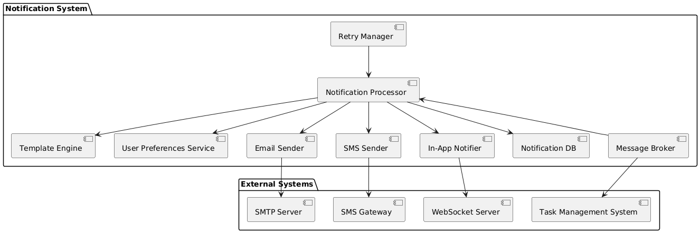

Fig 1: Notification System

6. DFD – Notification service

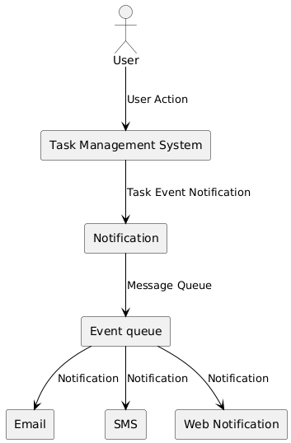

Fig 2: Notification service DFD

# 6. External Dependencies

- SMTP Server (for emails)

- SMS Gateway (Twilio, etc.)

- WebSocket infrastructure (for in-app)

# 7. Future Considerations

- Add push notifications (mobile)

- Support for localized templates

- Analytics dashboard for notification stats