**THE 2ND REMEDIAL TEST**

**Name : Desak Putu Kirana Allodya Raharja**

**PIN ID : 22285**

**Tutor : Miss Herna**

**Date : February 22, 2020**

1. **DIRECTION**

**Please give direction to the places!**

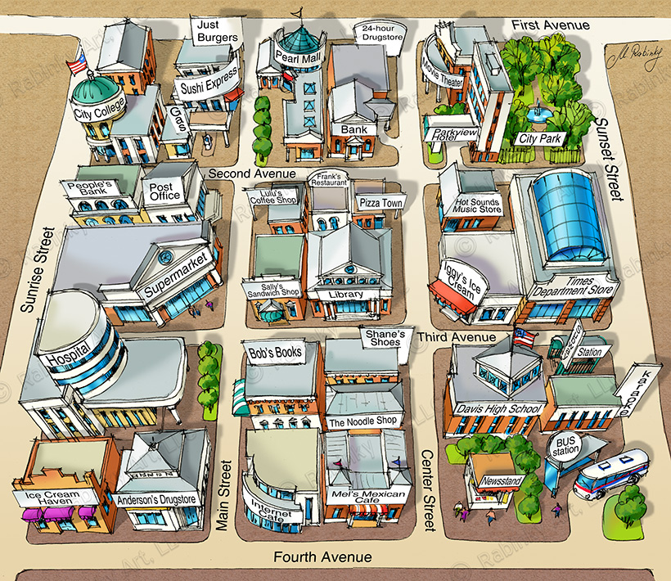

**---GOOD LUCK---**

**How do I get ice cream haven from Davis High School?**

**_________________________________________________________________________________________________________________________________________________________________________________________________________________________________________________________________________________________________________________________________________________________________________________________________**

**How do I get city park from the library?**

**_________________________________________________________________________________________________________________________________________________________________________________________________________________________________________________________________________________________________________________________________________________________________________________________________**

**--GOOD LUCK--**