Quadrilateral Identification Conditions
An English study reference for proving that a convex quadrilateral is a parallelogram, rectangle, rhombus, square, trapezoid, kite, or cyclic quadrilateral.
Throughout this guide, A, B, C, and D are consecutive vertices. The diagonals AC and BD intersect at O. Each numbered test is an alternative proof route, not an additional requirement. Figures illustrate examples; the written conditions supply the proof.

1 Parallelogram
A parallelogram is a quadrilateral with both pairs of opposite sides parallel.
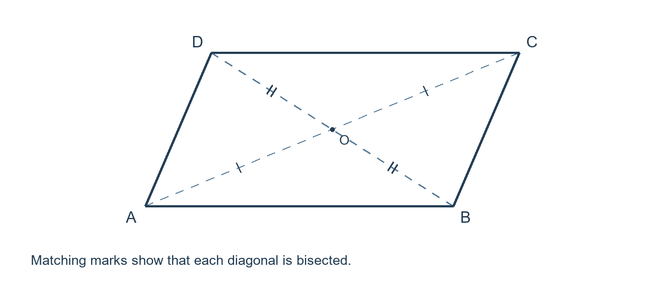

Sufficient conditions
1. Both pairs of opposite sides are parallel. $AB ∥ CD and AD ∥ BC$
2. Both pairs of opposite sides are equal in length. $AB = CD and AD = BC$
3. The same pair of opposite sides is both parallel and equal in length. $AB ∥ CD and AB = CD$
4. The diagonals bisect each other. $AO = OC and BO = OD$
5. Both pairs of opposite angles are equal. $∠A = ∠C and ∠B = ∠D$

Proof strategy
Draw a diagonal and use congruent triangles to establish parallel opposite sides. For the diagonal test, compare the triangles around O using side angle side congruence.

2 Rectangle
A rectangle is a quadrilateral with four right angles. A square is also a rectangle.
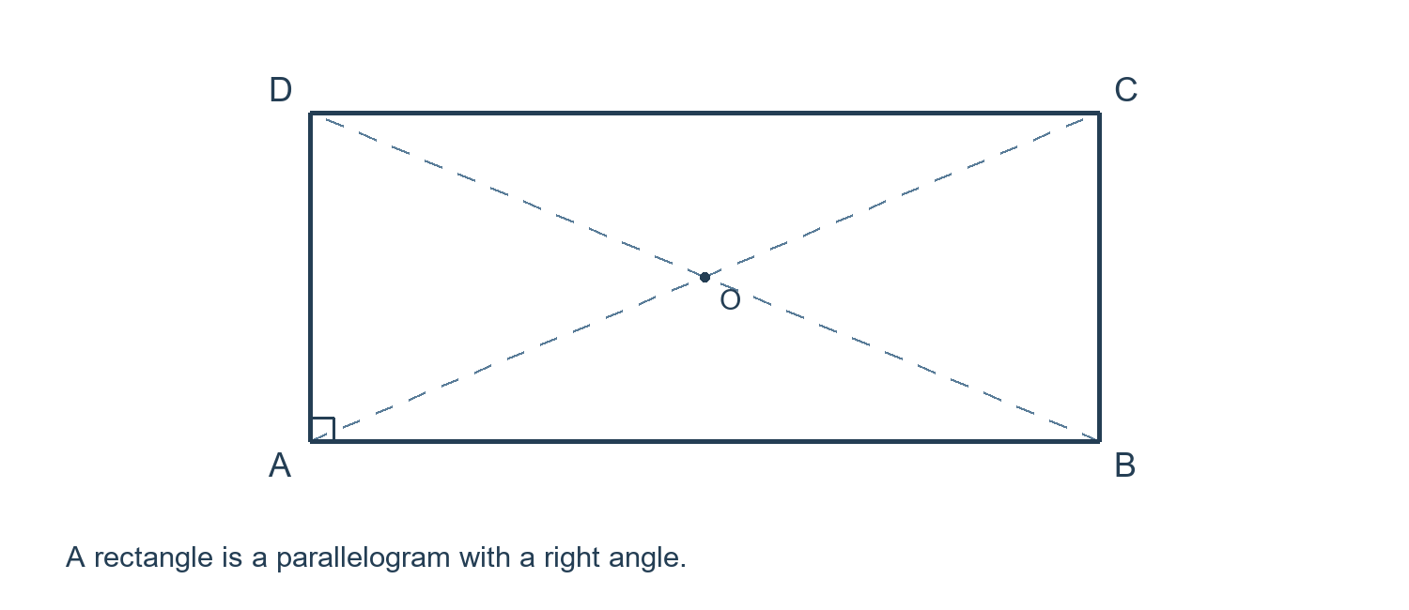

Sufficient conditions
Any one numbered condition below is sufficient. All requirements within that condition must hold together.
1. A quadrilateral has three right angles. The fourth is then also a right angle.
2. A parallelogram has one right angle.
3. A parallelogram has equal diagonals. $AC = BD$
4. The diagonals bisect each other and are equal in length. $AO = OC, BO = OD, and AC = BD$

Proof strategy
For Test 3, compare triangles ABC and BAD. The sides AB and BA are common, BC equals AD, and AC equals BD, so the triangles are congruent by SSS. Thus adjacent angles ABC and BAD are equal. Adjacent angles in a parallelogram are supplementary, so both are right angles.
Remember Equal diagonals alone do not prove that a quadrilateral is a rectangle. A nonrectangular isosceles trapezoid is a counterexample.

Useful properties after identification
Opposite sides are parallel and equal. All four angles are right angles. The diagonals are equal and bisect each other; consequently, O is equidistant from all four vertices.

3 Rhombus
A rhombus is a quadrilateral with four equal sides. A square is also a rhombus.
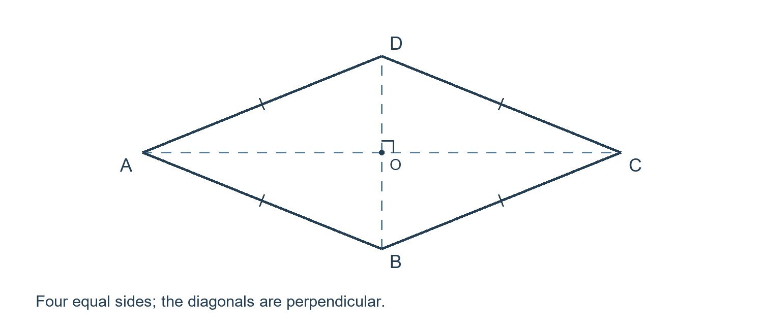

Sufficient conditions
Any one numbered condition below is sufficient. All requirements within that condition must hold together.
1. All four sides are equal in length. $AB = BC = CD = DA$
2. A parallelogram has two equal adjacent sides. $AB = BC$
3. A parallelogram has perpendicular diagonals. $AC ⊥ BD$
4. The diagonals bisect each other and are perpendicular. $AO = OC, BO = OD, and AC ⊥ BD$
5. A diagonal of a parallelogram bisects an interior angle. For example, AC bisects angle DAB. $∠DAC = ∠CAB$

Proof strategy
For Test 3, use the fact that a parallelogram has diagonals that bisect each other. Right triangles AOB and COB have equal legs AO and CO and share OB, so they are congruent. Therefore AB equals BC. Opposite sides are already equal, giving four equal sides.
Remember Perpendicular diagonals alone do not prove that a quadrilateral is a rhombus. A kite can have perpendicular diagonals without having four equal sides.

4 Square
A square has four equal sides and four right angles. Equivalently, it is both a rectangle and a rhombus.
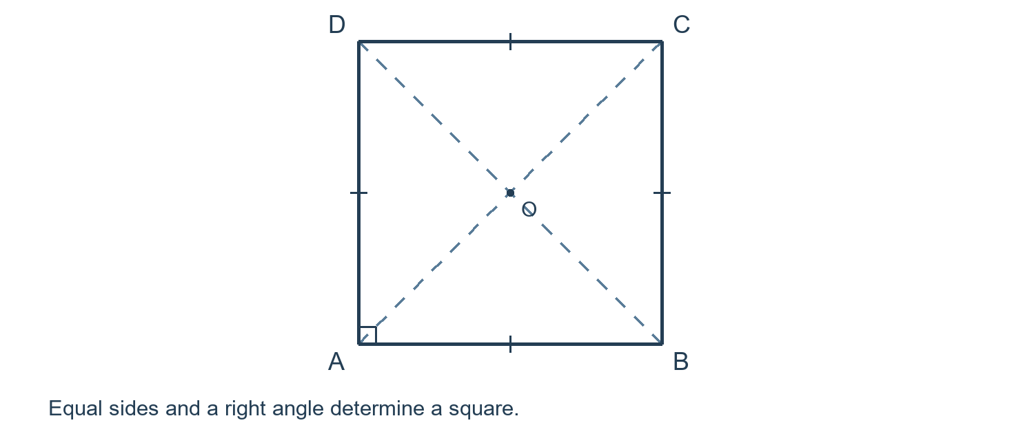

Sufficient conditions
Any one numbered condition below is sufficient. All requirements within that condition must hold together.
1. A rectangle has two equal adjacent sides.
2. A rectangle has perpendicular diagonals.
3. A rhombus has one right angle.
4. A rhombus has equal diagonals.
5. A quadrilateral has four equal sides and one right angle.
6. The diagonals bisect each other, are equal in length, and are perpendicular. $AO = OC, BO = OD, AC = BD, and AC ⊥ BD$

Proof strategy
For Test 6, first use diagonal bisection to prove that ABCD is a parallelogram. Equal diagonals then prove that it is a rectangle. Perpendicular diagonals also prove that it is a rhombus. A quadrilateral that is both a rectangle and a rhombus is a square.
Remember The word "bisect" is essential in Test 6. Equal and perpendicular diagonals, by themselves, do not guarantee a square.

5 Trapezoid and isosceles trapezoid
This guide uses the exclusive definition: a trapezoid has exactly one pair of parallel opposite sides. An isosceles trapezoid has equal legs.
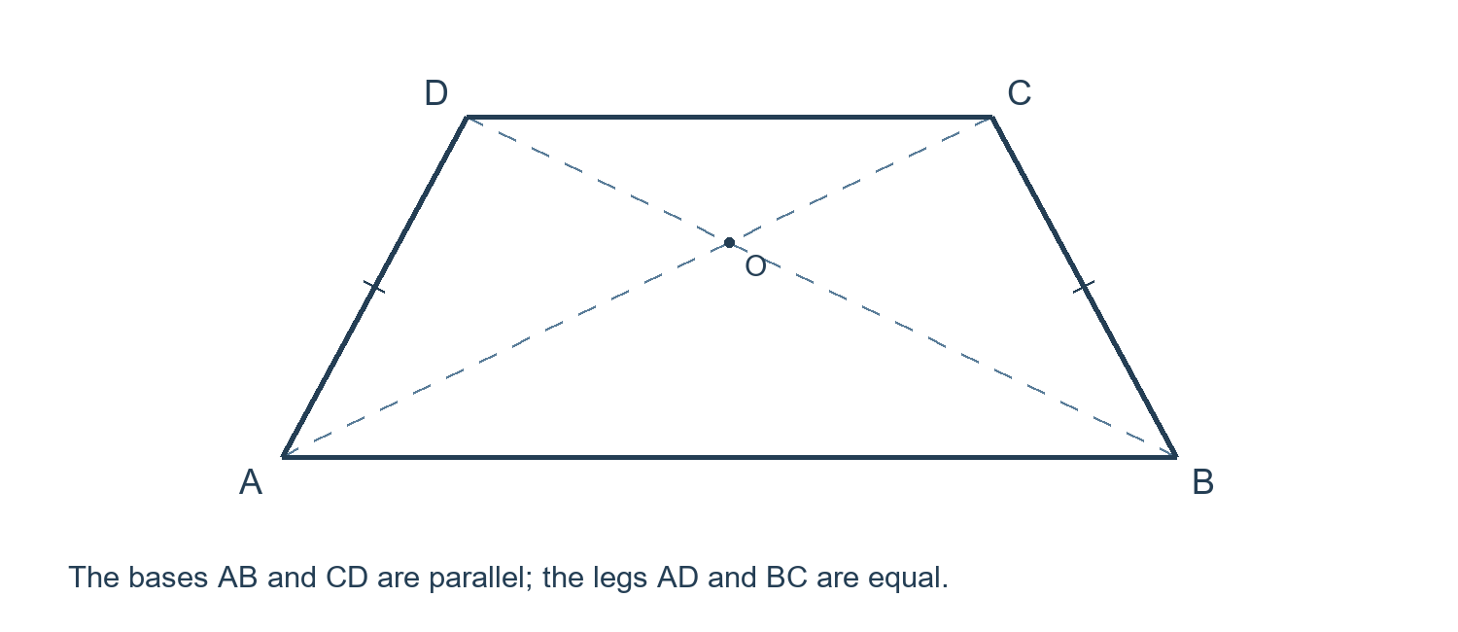
To prove that ABCD is a trapezoid with bases AB and CD, prove that AB is parallel to CD and AD is not parallel to BC. Some English textbooks use an inclusive definition that allows parallelograms; check the definition in your course.

Tests for an isosceles trapezoid
For each test below, first establish that ABCD is a trapezoid with bases AB and CD.
1. The legs are equal in length. $AD = BC$
2. The two angles adjacent to the same base are equal. $∠DAB = ∠ABC$
3. The diagonals are equal in length. $AC = BD$

Proof strategy
Drop perpendiculars from C and D to the line containing AB. Use the equal distance between parallel lines and congruent right triangles to compare the legs or the base angles.
Remember The condition "equal diagonals" is an isosceles trapezoid test only after the trapezoid premise has been established.

6 Kite
A kite has two pairs of equal adjacent sides. This guide uses the inclusive definition, so rhombi and squares are also kites.
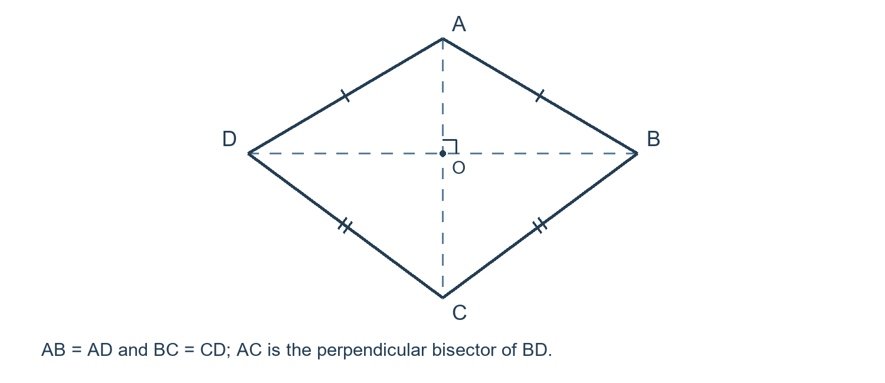

Sufficient conditions
Any one numbered condition below is sufficient. All requirements within that condition must hold together.
1. There are two pairs of equal adjacent sides. $AB = AD and BC = CD$
2. One diagonal is the perpendicular bisector of the other. For example, AC is the perpendicular bisector of BD. $AC ⊥ BD and BO = OD$

Proof strategy
For Test 2, use the perpendicular bisector theorem. Since A and C lie on the perpendicular bisector of BD, A is equidistant from B and D, and C is equidistant from B and D. Thus AB equals AD and BC equals CD.
Remember One diagonal bisecting the other is different from the diagonals bisecting each other. A general kite need not have AO equal to OC.

Definition convention
Under a definition that excludes rhombi, also require the two side lengths to be different. With the labeling above, add the condition that AB is not equal to BC.

7 Cyclic quadrilateral
A cyclic quadrilateral has all four vertices on one circle. It can also belong to another category; for example, every rectangle is cyclic.
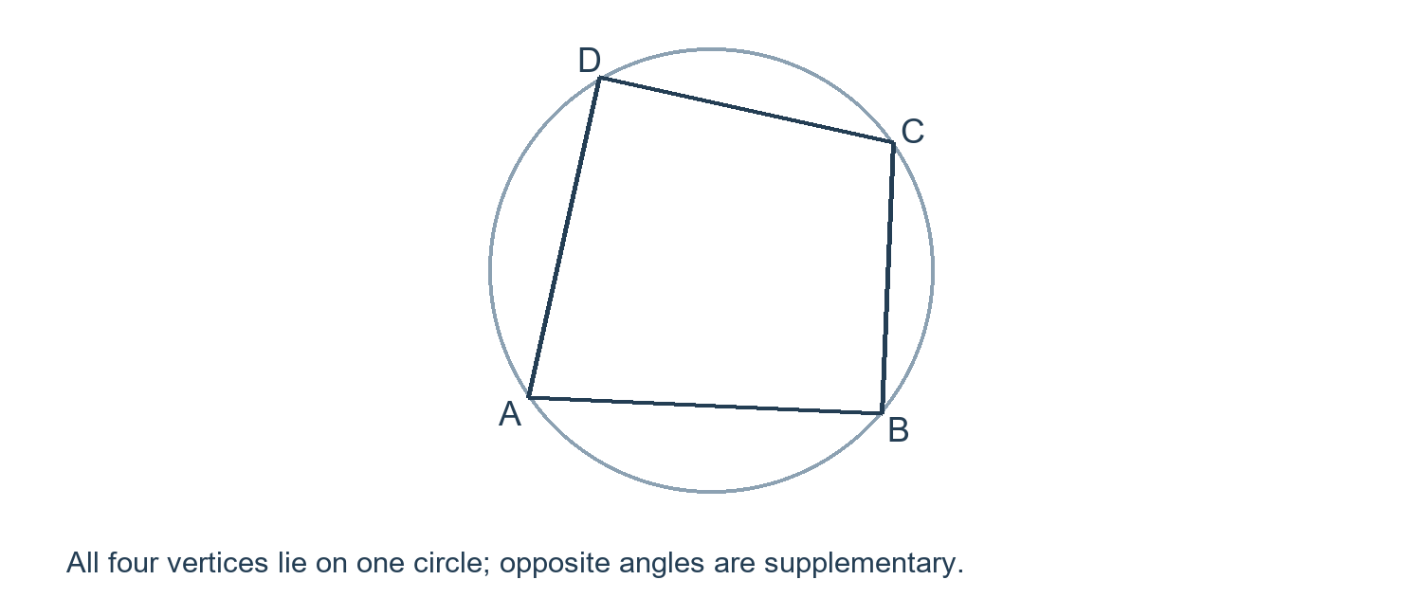

Sufficient conditions
Any one numbered condition below is sufficient. All requirements within that condition must hold together.
1. A pair of opposite interior angles is supplementary. $∠DAB + ∠BCD = 180°$
2. An exterior angle equals the opposite interior angle. For example, extend AB beyond B to E; then angle EBC equals angle ADC. $∠EBC = ∠ADC$
3. Two equal angles subtend the same segment, with their vertices on the same side of its line. For example, B and C lie on the same side of line AD and the following angles are equal. $∠ABD = ∠ACD$

Proof strategy
Look for opposite angles whose measures add to 180 degrees, or equal angles subtending the same segment. Apply the converse of the corresponding circle angle theorem.
Remember The same side requirement in Test 3 matters. The angle statement must use the specified vertices and segment; arbitrary equal angles do not prove concyclicity.

8 Quick reference and common mistakes
The following diagonal tests apply to a convex quadrilateral. Each row gives a complete sufficient condition.
Diagonal conditions | Guaranteed conclusion
Bisect each other | Parallelogram
Bisect each other and are equal | Rectangle
Bisect each other and are perpendicular | Rhombus
Bisect each other, are equal, and are perpendicular | Square

Conditions that are not sufficient
1. Equal diagonals alone do not imply a rectangle. Counterexample: an isosceles trapezoid that is not a rectangle.
2. Perpendicular diagonals alone do not imply a rhombus. Counterexample: a kite with unequal adjacent side lengths.
3. Equal and perpendicular diagonals alone do not imply a square. For a concrete convex example, take A(0, 3), B(2, 0), C(0, -1), and D(-2, 0). Both diagonals have length 4 and are perpendicular, but BD does not bisect AC.
4. One pair of opposite sides parallel and the other pair equal does not imply a parallelogram. The sufficient test requires the same pair to be both parallel and equal.

A useful proof template
State the target shape. List the facts already proved. Choose one complete sufficient condition from this guide. Prove every requirement in that condition, then name the identification theorem in your conclusion.
Example: "Since the diagonals bisect each other, ABCD is a parallelogram. Since its diagonals are equal, ABCD is a rectangle. Since its diagonals are perpendicular, it is also a rhombus. Therefore ABCD is a square."

