**Laboratory work 7**

**We continue to work with the database from the previous laboratory works.**

**Take a full-page screenshot that covers the code and results of each task.**

**Tasks**:

1. Create an index on the actual_departure column in the flights table.

1. Create a unique index to ensure flight_no and scheduled_departure combinations are unique.

1. Create a composite index on the departure_airport_id and arrival_airport_id columns.

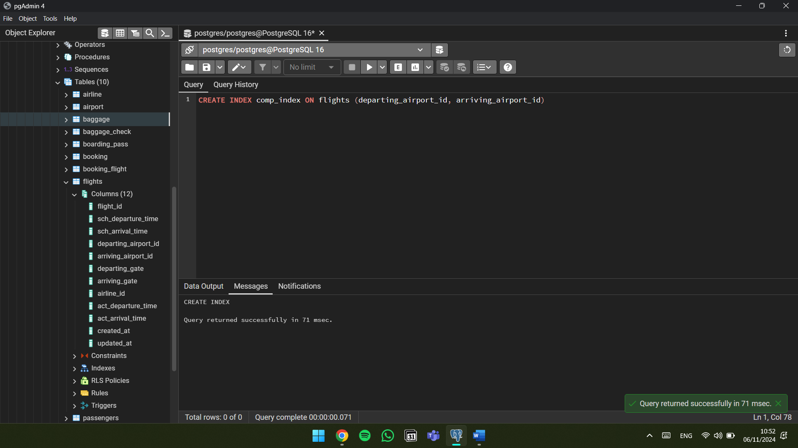

1. Evaluate the difference in query performance with and without indexes. Measure performance differences.

1. Use EXPLAIN ANALYZE to check index usage in a query filtering by departure_airport and arrival_airport.

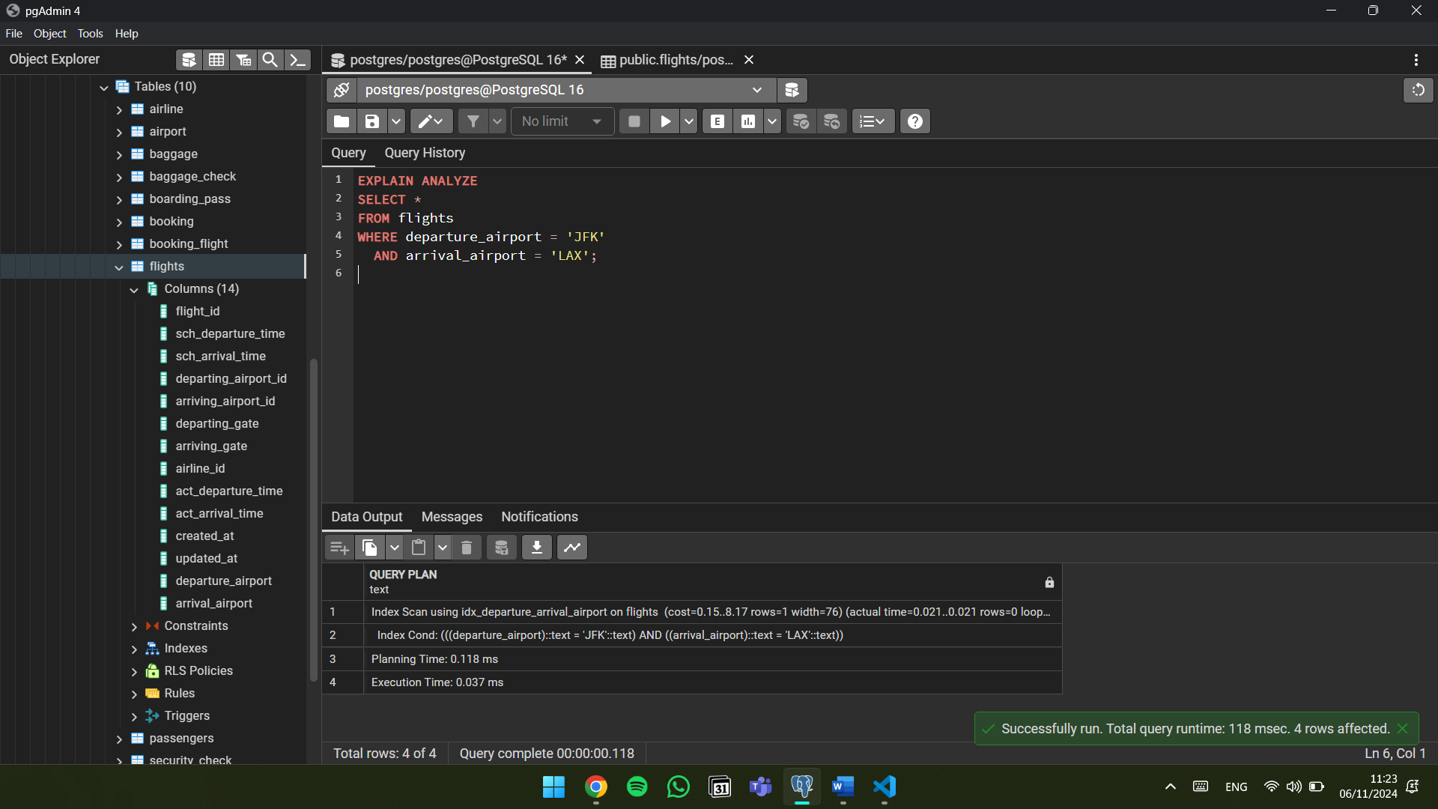

1. Create a unique index for the passport_number of the Passengers table. Check if the index was created or not. Insert into the table two new passengers.

Explain in your own words what is going on in the output?

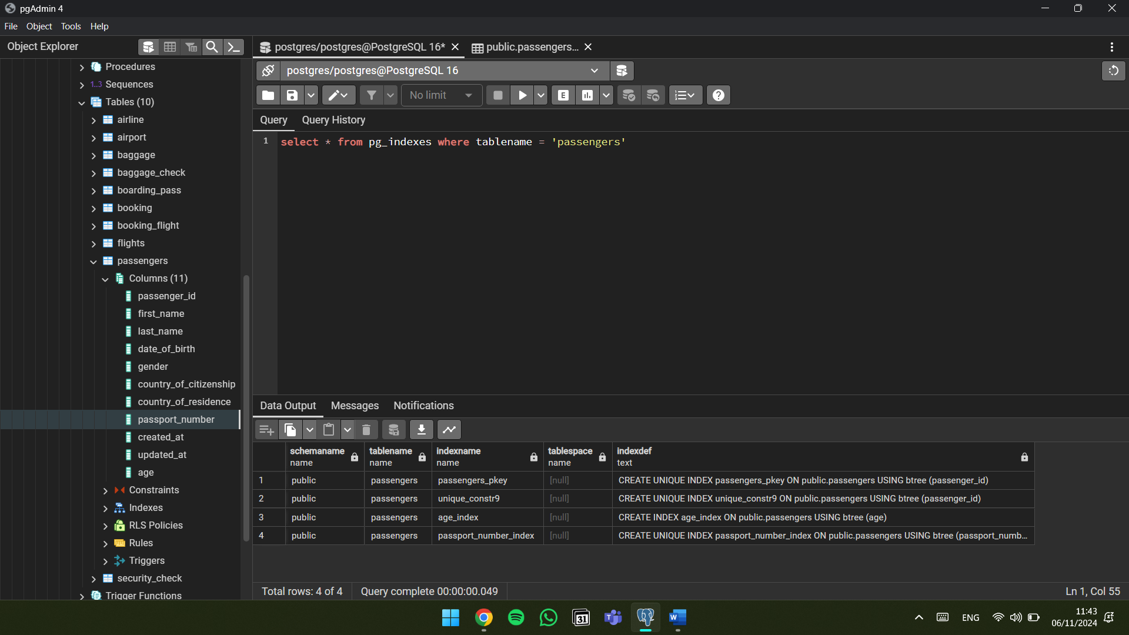

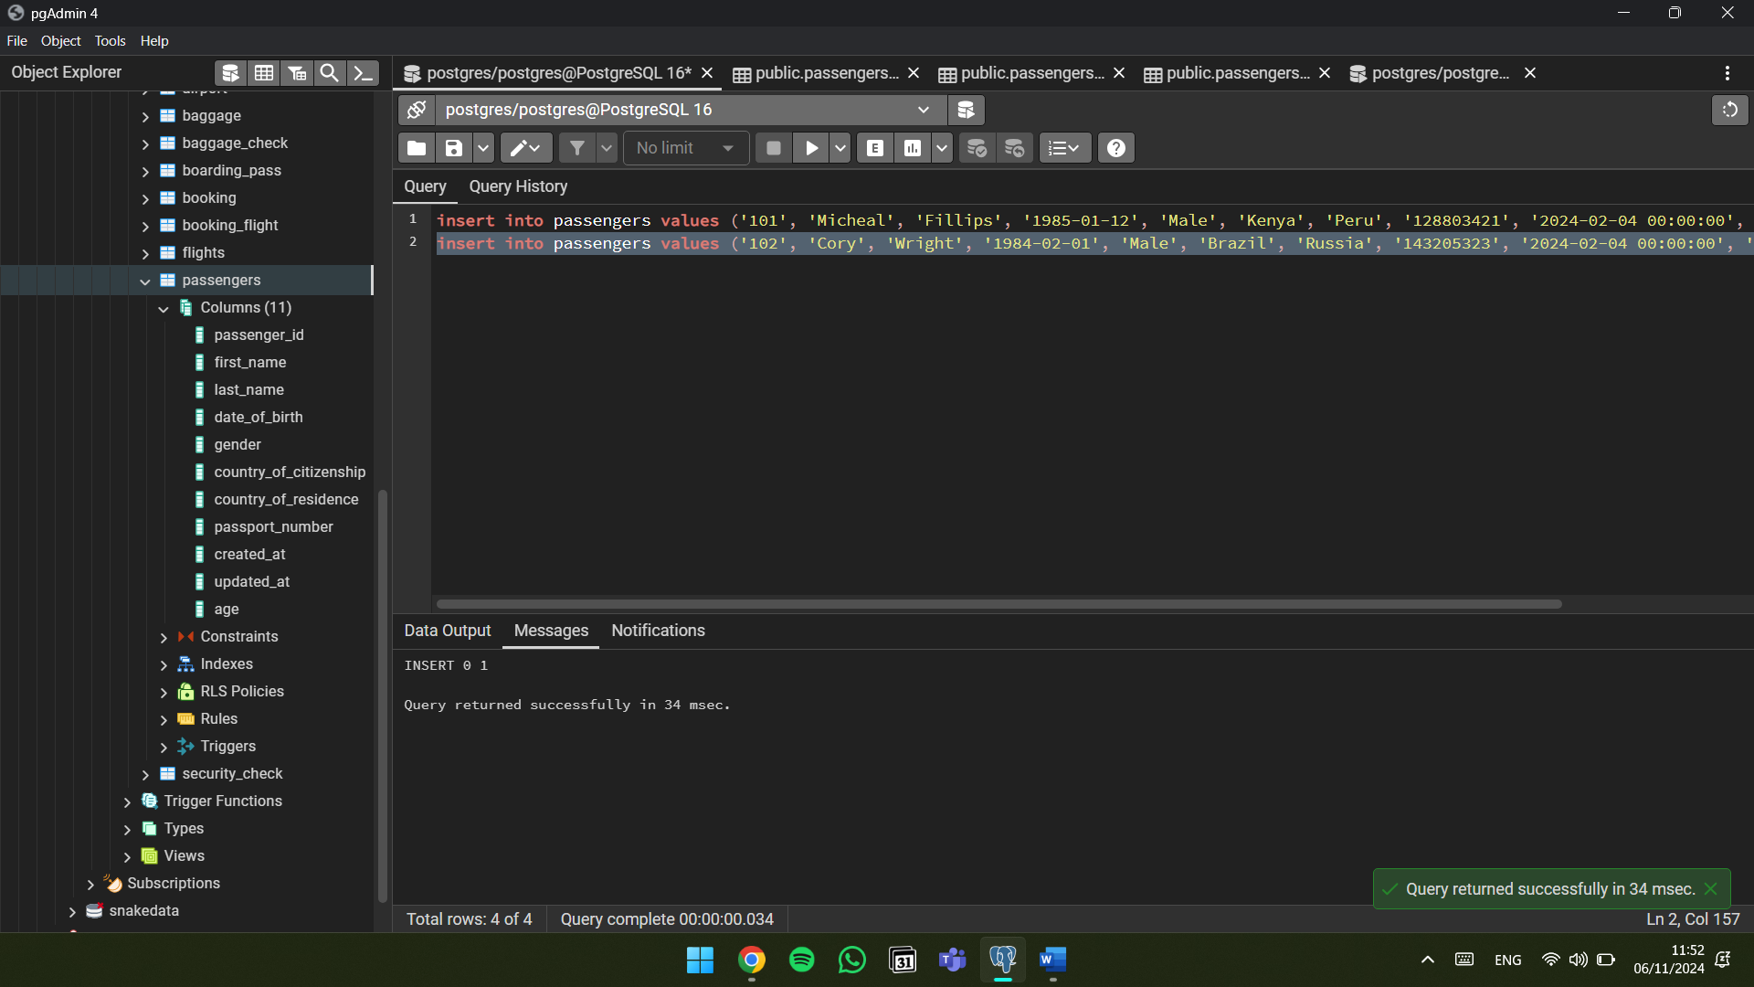

*So, when inserting new data into a table with index, index needs to be updated to include new rows of data. This provides insurance that index will be current and can be used for future queries without errors. Plus, when inserting new data it impacts performance because of former reasons.*

1. Create an index for the Passengers table. Use for that first name, last name, date of birth and country of citizenship. Then, write a SQL query to find a passenger who was born in Philippines and was born in 1984 and check if the query uses indexes or not. Give the explanation of the results.

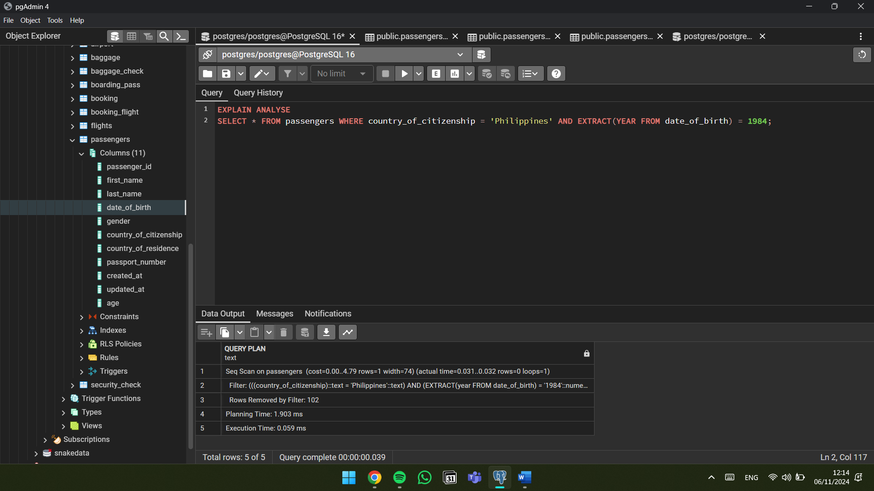

If we check first row, analyze gives us that query used sequential scanning, not index scanning, despite having an index. Reason for this might be many factors, to list some of them: uniqueness of columns, size of table, query complexity, cost of operations when comparing scan types and etc.

1. Write a SQL query to list indexes for table Passengers. After delete the created indexes.

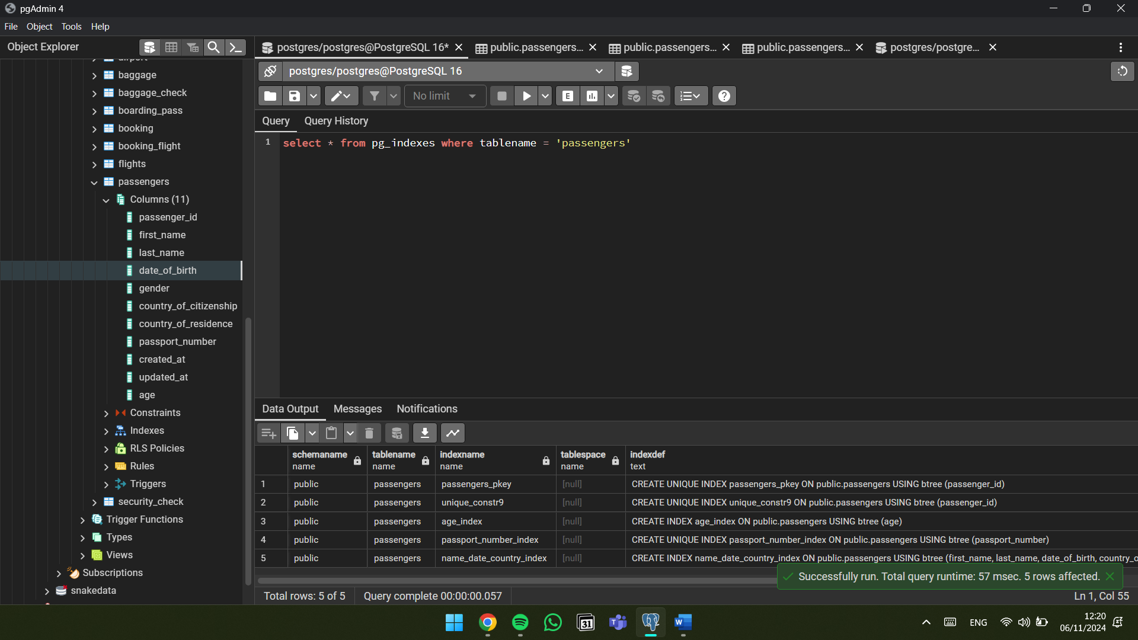

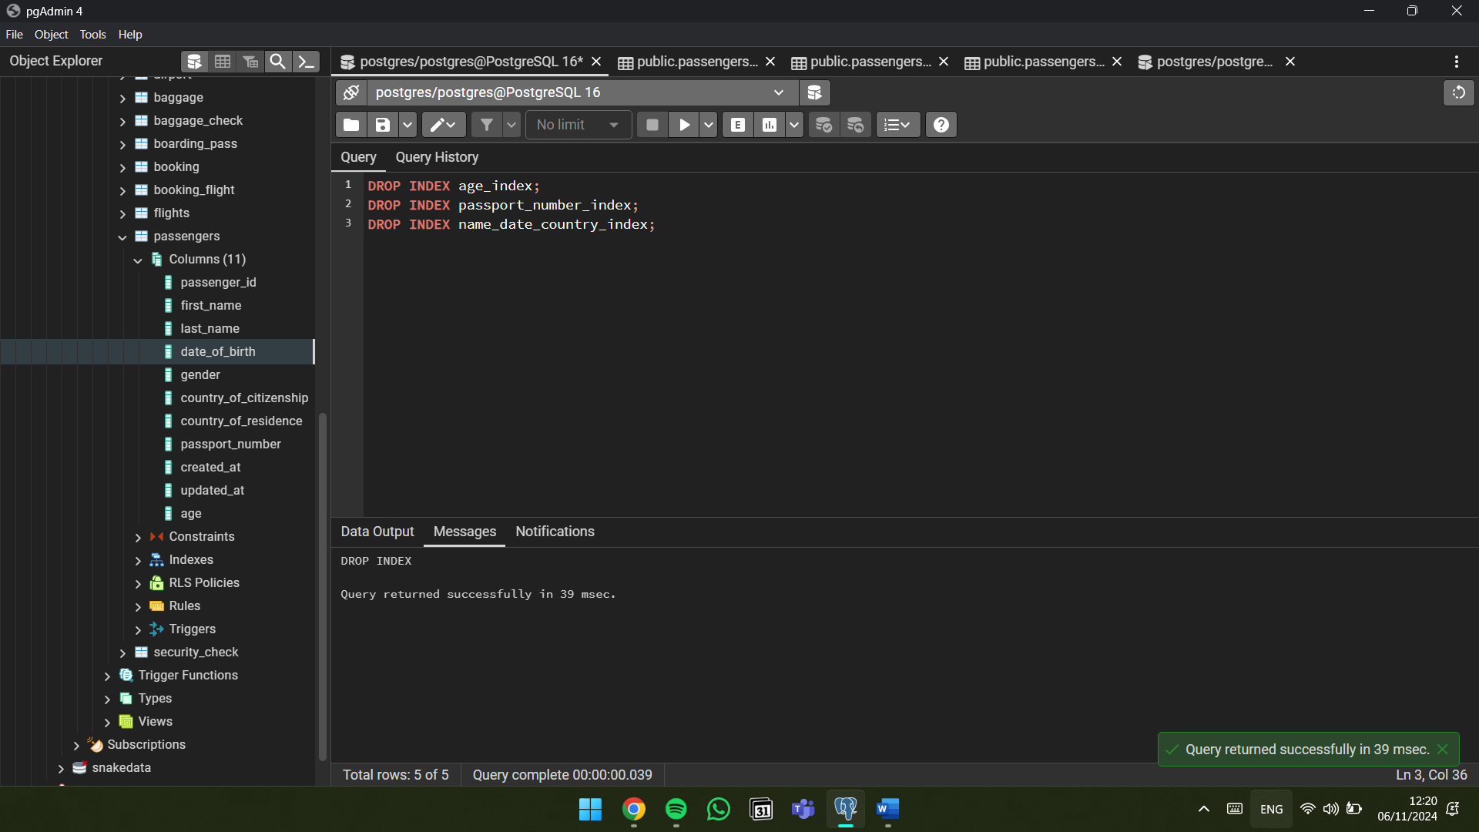

**By Imangali Kaisar**