

KB3930 for OLPC

**Keyboard Controller Data Sheet**

V 0.2

May. 2010

[www.DataSheet.net/](http://www.DataSheet.net/)

ENE RESERVES THE RIGHT TO AMEND THIS DOCUMENT WITHOUT NOTICE AT ANY TIME. ENE ASSUMES NO RESPONSIBILITY FOR ANY ERRORS APPEAR IN THE DOCUMENT, AND ENE DISCLAIMS ANY EXPRESS OR IMPLIED WARRANTY, RELATING TO SALE AND/OR USE OF ENE PRODUCTS INCLUDING LIABILITY OR WARRANTIES RELATING TO FITNESS FOR A PARTICULAR PURPOSE, OR INFRINGEMENT OF ANY PATENTS, COPYRIGHTS OR OTHER INTELLECTUAL PROPERTY RIGHTS.

**Headquarters**

4F-1, No.9, Prosperity Rd., Science-based Industrial Park, Hsinchu City, Taiwan, R.O.C TEL: 886-3-6662888

FAX: 886-3-6662999

[http://www.ene.com.tw](http://www.ene.com.tw/)

Copyright©2010, ENE Technology Inc. All rights reserved.

**Taipei Office**

4F, No.88, Bauchiau Rd. Shindian City, Taipei, Taiwan, R.O.C.

TEL: 886-2-89111525

FAX: 886-2-89111523

# Revision

|  |  |  |
| --- | --- | --- |
| **Revision** | **Description** | **Date** |
| 0.1 | 1. 1st release as KB3930 OLPC datasheet | 2010/04 (0.7) |
| 0.2 | 1. Remove Watermark | 2010/5 |

w

## GENERAL DESCRIPTION 0

* 1. **OVERVIEW 0**
  2. FEATURES 1
  3. COMPARISON (KB3926D VS. KB3930) 6
  4. BLOCK DIAGRAM 7

1. PIN ASSIGNMENT AND DESCRIPTION 8
   1. KB3930 128-PIN LQFP DIAGRAM TOP VIEW 8
   2. KB3930 128 LFBGA BALL MAP 9
   3. KB3930 PIN ASSIGNMENT SIDE A 10
   4. KB3930 PIN ASSIGNMENT SIDE B 11
   5. KB3930 PIN ASSIGNMENT SIDE C 12
   6. KB3930 PIN ASSIGNMENT SIDE D 13
   7. I/O CELL DESCRIPTIONS 14
      1. I/O Buffer Table 14
      2. I/O Buffer Characteristic Table 14
2. PIN DESCRIPTIONS 15
   1. HARDWARE TRAP 15

[www.DataSheet.net/](http://www.DataSheet.net/)

* 1. PIN DESCRIPTIONS BY FUNCTIONS 16
     1. Low Pin Count I/F Descriptions. 16
     2. SPI Flash I/F Descriptions 16
     3. PS/2 I/F Descriptions 16
     4. Internal Keyboard Encoder (IKB) Descriptions 17
     5. SMBus Descriptions 17
     6. FAN Descriptions 17
     7. Pulse Width Modulation (PWM) Descriptions 17
     8. Analog-to-Digital Converter Descriptions 17
     9. Digital-to-Analog Converter Descriptions 18
     10. 8051 External I/F Descriptions 18
     11. External Clock Descriptions 18
     12. Miscellaneous Signals Descriptions 18
     13. Voltage Comparator Pins Descriptions 19
     14. Power Pins Descriptions 19

1. MODULE DESCRIPTIONS 20
   1. CHIP ARCHITECTURE 20
      1. Power Planes 20
      2. Clock Domains 21

4.1.4 Internal Memory Map 24

* 1. GPIO 25
     1. GPIO Function Description 25
     2. GPIO Structures 28
     3. GPIO Attribution Table 29
     4. GPIO Registers Descriptions 32
     5. GPIO Programming Sample 43
  2. KEYBOARD AND MOUSE CONTROL INTERFACE (KBC) 44
     1. KBC I/F Function Description 44
  3. ENE SERIAL BUS CONTROLLER (ESB) 49
     1. ESB Function Description 49
     2. ESB Registers Description 50
  4. RESERVED 56
  5. PECI 57
     1. PECI Functional Description 57
     2. PECI Register Description (Base address = FCD0h, 16 bytes) 58
  6. OWM 61
     1. OWM Functional Description ...[www..DataSh.eet.net./](http://www.DataSh.eet.net./) 61
  7. PULSE WIDTH MODULATION (PWM) 65
     1. PWM Function Description 65
     2. PWM Registers Description 66
     3. PWM Programming Sample 68
  8. FAN CONTROLLER 69
     1. Fan Function Description 69
     2. Fan Registers Description 70
     3. Fan Programming Sample 76
  9. GENERAL PURPOSE TIMER (GPT) 77
     1. GPT Function Description 77
     2. GPT Registers Description 77
     3. GPT Programming Sample 79
  10. SDI HOST/DEVICE INTERFACE CONTROLLER 80
      1. SDI Host/Device Interface Description 80
      2. SDI Host Interface Description 80
      3. SDI Device Interface Description 81
      4. SDI Programming Sample 84
  11. WATCHDOG TIMER (WDT) 85
      1. WDT Function Description 85
      2. WDT Registers Description 85
      3. WDT Programming Sample 88
  12. LOW PIN COUNT INTERFACE (LPC) 89
      1. LPC Function Description 89
      2. LPC I/O Decode Range 89
      3. LPC Memory Decode Range 89
      4. FWH Memory Decode Range 90
      5. Index-I/O Port 90
      6. Extended I/O Port (Debug Port, Port80) 91
      7. LPC Registers Description 92
  13. X-BUS INTERFACE (XBI) 100
      1. XBI Function Description 100
      2. XBI SPI Enhancement 100
      3. XBI Registers Description 103
  14. CONSUMER IR CONTROLLER (CIR) 109
      1. CIR Function Description 109
      2. CIR Block Diagram 111
      3. CIR Remote Protocol ..............[www..DataSh.eet.net./](http://www.DataSh.eet.net./) 112
         1. Philips RC5 Protocol 112
         2. Philips RC6 Protocol 113
         3. NEC Protocol 113
      4. CIR Automatic Carrier Frequency Detection and Modulation 114
      5. CIR Registers Description 116

4.15.3 CIR Programming Sample 120

* 1. PS/2 INTERFACE (PS/2) 121
  2. EMBEDDED CONTROLLER (EC) 122
     1. EC Function Description 122
     2. EC Command Program Sequence 123
     3. EC SCI Generation 124
     4. EC/KBC Clock Configuration 125
     5. A/D Converter Control 125
     6. D/A Converter Control 127
     7. Power Management Control 128
     8. EC Registers Description 129
  3. GENERAL PURPOSE WAKE-UP CONTROLLER (GPWU) 140
     1. GPWU Function Description 140
     2. GPWU Registers Description 141
     3. GPWU Programming Sample 146
  4. SYSTEM MANAGEMENT BUS CONTROLLER (SMBUS) 147
     1. SMBus Function Description 147
     2. SMBus Register Description 149
  5. 8051 MICROPROCESSOR 154
     1. 8051 Microprocessor Function Description 154
     2. 8051 Microprocessor Instruction 155
     3. 8051 Interrupt Controller 159
     4. Interrupt Enable/Flag Table 160
     5. 8051 Special Function Register (SFR) 162
     6. 8051 Microprocessor Register Description 163

1. ELECTRICAL CHARACTERISTICS 170
   1. ABSOLUTE MAXIMUM RATING 170
   2. DC ELECTRICAL CHARACTERISTICS 170

BQCZ16HIV 170

BQC04HIV 170

BQCW16HIV 171

BCC16HI..............................................[www..DataSh.eet.net./](http://www.DataSh.eet.net./) 171

BQC04HI 172

IQTHI (ADC cell) 172

OCT04H (DAC cell) 172

BQC08HIV 173

BQC04HIVPECI 173

* 1. A/D & D/A CHARACTERISTICS 174
  2. OPERATING CURRENT 175
  3. PACKAGE THERMAL INFORMATION 175
  4. AC ELECTRICAL CHARACTERISTICS 176
     1. SPI Flash Timing 176
     2. LPC interface Timing 177
     3. PS/2 interface Timing 179
     4. SMBus interface Timing 180

2. SMBUS frequencry dependant 180

* + 1. PECI interface Timing 181
    2. OWM interface Timing 182

1. PACKAGE INFORMATION 183
   1. LQFP 128-PIN OUTLINE DIAGRAM 183
      1. Top View 183
      2. Side View 184
      3. Lead View 185
      4. LQFP Outline Dimensions 186
   2. LFBGA 128-PIN OUTLINE DIAGRAM 187
      1. Top View 187
      2. Side View 188
      3. Bottom View 189
      4. LFBGA Outline Dimensions 190
   3. PART NUMBER DESCRIPTION 191

[www.DataSheet.net/](http://www.DataSheet.net/)

**Copyright©2010, ENE Technology Inc. vi**

# General Description

## Overview

The ENE KB3930 is a highly customized embedded controller (EC) for notebook platforms.

The embedded controller contains industrial standard 8051 microprocessor and provides function of i8042 keyboard controller basically. KB3930 is embedded LPC interface used to communicate with Host. KB3930 is designed with Shared-ROM architecture. The EC firmware and system BIOS will co-exist in single SPI flash. The embedded controller also features rich interfaces for general applications, such as PS/2 interface, Keyboard matrix encoder, PWM controller, A/D converter, D/A converter, Fan controller, SMBus controller, GPIO controller, PECI controller, one wire master, SPI controller, voltage comparator and extended interface (ENE Serial Bus) for more applications, like capacitive touch button application and GPIO extender.

Compared with last generation of KB3926 series, KB3930 added PECI/OWM, another 2 SMBus, another 2 Fan tachometers, enhanced SPI host/slave controller, voltage comparator, internal oscillator for newest application. KB3930 also improves structure of other modules including 8051, XBI, LPC, IKB, FAN, WDT, GPIO, ESB, EDI. For detail improvement, please refer the related section.

[www.DataSheet.net/](http://www.DataSheet.net/)

## Features

#### LPC Low Pin Count Interface

SIRQ supporting IRQ1, IRQ12, SCI or SMI# interrupt and one programmable IRQ provided.



I/O Address Decoding:



* + - Legacy KBC I/O port 60h/64h
    - Programmable EC I/O port, 62h/66h(recommend)
    - I/O port 68h/6Ch (sideband)
    - **2** Programmable 4-byte Index-I/O ports to access internal EC registers.
    - **1** Programmable extended (debug) port I/O. Memory Decoding:



* + - Firmware Hub decode
    - LPC memory decode

Compatible with LPC specification v1.1



Support LPC interface re-direction to IKB for debugging



1. **bus Bus Interface (XBI) : Flash Interface** SPI flash is supported, size up to 4MB. SPI frequency supports 33/45/66MHz.



New SPI command (dual read) tw o enhance the performance.



The 64KB code memory can be mapped into system memory by one 16KB and one 48KB programmable pages independently.



Support SPI flash in-system-programming via IKB pins. Enhanced pre-fetch mechanism.



#### 8051 Microprocessor

Compatible with industrial 8051 instructions with 3 cycles. 8051 runs at 8/16/22 MHz, programmable.



256 bytes internal RAM and 4KB tight-coupled SRAM. 24 extended interrupt sources.



Two 16-bit timers.



Full duplex UART integrated. Supports idle and stop mode. Enhanced ENE debug interface.



Support Tx/Rx re-direction to IKB for debugging



#### 8042 Keyboard Controller

8 standard 8042 commands processed by hardware.



Each hardware command can be optionally processed by firmware. Pointing device multiplex mode support.



Fast GA20 and KB reset support.



#### PS/2 Controller

Support at most 3 external PS/2 devices. External PS/2 device operation in firmware mode.



#### Internal Keyboard Matrix (IKB)

18x8 keyboard scan matrix.



Support W2K Internet and multimedia keys. Support hotkey events defined.



Ghost key cancellation mechanism provided. Enhanced de-bounce feature added



#### Embedded Controller (EC)

ACPI Spec 2.0 compliant.



5 standard EC command suppowrted directly by hardware.



Each hardware command can be processed by firmware optionally. Programmable EC I/O ports, 62h/66h by default.



#### SMBus Host Controller

4 SMBus interfaces with 2 SMBus controllers SMBus Spec 2.0 compliant.



Byte mode support. Slave function support.



#### Digital-to-Analog Converter (DAC)

4 DAC channels with 8-bit resolution.



All DAC pins can be alternatively configured as GPO (general purpose output) function.



#### Analog-to-Digital Converter (ADC)

6 ADC channels with 10-bit resolution.



All ADC pins can be alternatively configured as GPI (general purpose input) function.



#### Pulse Width Modulator (PWM)

6 PWM channels are provided. (8-bit *2, 14-bit *2 and FANPWM(12-bit) *2) Clock source selectable:.



* + 1MHz/64KHz/4KHz/256Hz (for 8-bit PWM)
  + Peripheral clock or 1MHz (for 14-bit PWM)
  + Peripheral clock (for FANPWM)

Duty cycle programmable and cycle time up to 1 sec(for 8-bit PWM)



#### Watch Dog Timer (WDT)

32.768KHz input clock.



10-bit counter with 32ms unit for watchdog reset. Three watchdog reset mechanisms.



* + Reset 8051 only
  + Reset whole chip, except GPIO module.
  + Reset whole chip including GPw IO module.

#### Real Time Clock

32.768KHz input clock. 24-bit timer support.



#### General Purpose Timer (GPT)

Two 16-bit and two 8-bit general purpose timer with 32.768KHz clock source.



#### General Purpose Wakeup (GPWU)

Those I/O with GPI (general purpose input) configuration can generate interrupts or wakeup events, except those pins named in **GPXIOAxx**.



#### General Purpose Input/Output (GPIO)

All general purpose I/O can be programmed as input or output. All output pins can be configured to be tri-state optionally.



All input pins are equipped with pull-up, high/low active and edge/level trigger selection.



For the pins of DAC can be configured as GPO function only. For the pins of ADC can be configured as GPI function only. A specific pair of GPIO pins with signal pass-through feature.



#### FAN Controller

Two fan controllers with tachometer inputs. Automatic fan control support.



12-bit FANPWM support.



Enhanced FAN tracking resolution added



#### Consumer IR (CIR)

Several protocols decoded/encoded by hardware. Interrupt for CIR application.



Support wide/narrow band receiver. Transmit/Receive simultaneouslwwyw.DataSh.eet.net/ Remote power-on support.



#### ENE Serial Bus Interface (ESB)

A proprietary and flexible interface for extension with ENE KBC. Firmware accesses ESB devices via internal memory address directly. Interrupt capability.



#### ENE Debug Interface (EDI)

Flexible debug interface with SPI pins. Keil-C development tool compatible



#### SPI Device Interface (SDI)

An enhanced SPI host/device controller is embedded. Flexible design for SPI applications.



**One Wire Master Interface**

Embedded One Wire controller used to control one wire devices.



**PECI**



Support Intel PECI

Support wide speed range from 2Kbps to 2Mbps.

#### Power Management

Sleep mode: 8051 program counter (PC) stops and enters idle mode.



Deep sleep mode: All clocks stop except external 32.768KHz OSC. 8051 enters stop mode.



**Misc.**



Support two hardware voltage comparator (initialed by F/W, operated by H/W), two voltage input sources and one digital output, used to detect abnormal situation (like over temperature).

Support two output pins to report KB3930 power fail status.

#### Package

128-pin LQFP package, Lead Fr[www.DeataSheet.neet/](http://www.DeataSheet.neet/)



(RoHS).

## Comparison (KB3926D vs. KB3930)

|  |  |  |
| --- | --- | --- |
|  | **KB3926D** | **KB3930** |
| Microprocessor | 8051 | 8051 |
| Built-in SRAM | 2KB | 4KB |
| LPC | 2 index-I/O sets | 2 index I/O sets |
| X-Bus | SPI ROM: 4MB  Enhanced pre-fetch mechanism. | SPI ROM: 4MB  Enhanced pre-fetch mechanism. |
| Real Time Clock | Support | Support |
| ADC | Six 10-bit ADC channels | Six 10-bit ADC channels |
| DAC | Four 8-bit DAC channels | Four 8-bit DAC channels |
| WDT | 128ms timer unit with 8bits control | 32ms timer unit with 10bits control |
| PWM | 6 sets  PWM0/1 – 8 bit  PWM2/3 – 14 bit FANPWM0/1 – 12 bit | 6 sets  PWM0/1 – 8 bit  PWM2/3 – 14 bit FANPWM0/1 – 12 bit |
| External PS/2 I/F | 3 | 3 |
| GPIO | Programmable Bi-direction I/O GPIO pass through : 1 pair  Max GPIO: 100 | Enhanced Bi-direction I/O cell GPIO pass through : 1 pair  Max GPIO: 100 |
| IKB Matrix | 18x8 | 18x8 |
| FAN controller | 2 | 2 (Enhanced precision and 2 additional Tachometer Monitors) |
| GPT | 4 | 4 |
| SMBus | 2  Byte mode support | 4  Byte mode support |
| CIR | Hardware encode/decode IRQ and I/O port support Carrier frequency calculation  TX with carrier modulation w  Learning mode support TX/RX simultaneously | Hardware encode/decode IRQ and I/O port support Carrier frequency calculation TX with carrier modulation Learning mode support  TX/RX simultaneously |
| EDI | Enhanced | Enhanced (Support break point) |
| ESB | Support | Support |
| SDI | Support | Support both SPI host/device |
| Package | 128 LQFP | 128 LQFP |
| Dimension | 14mmx14mm | 14mm x 14 mm |
| New-added Function |  | PECI  One Wire Master  POFR signals Voltage Comparator |

* 1. **Block Diagram**

www.DataSheet.net/

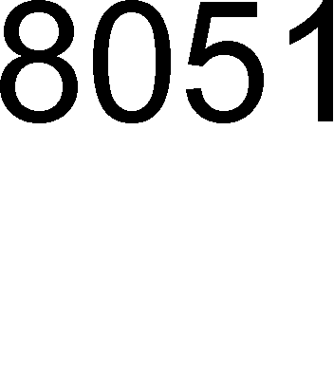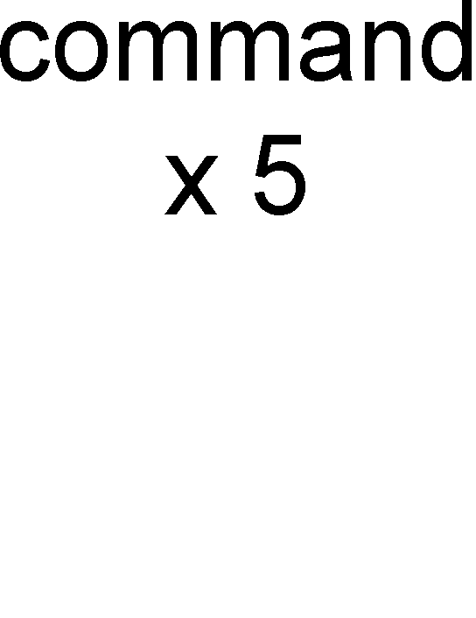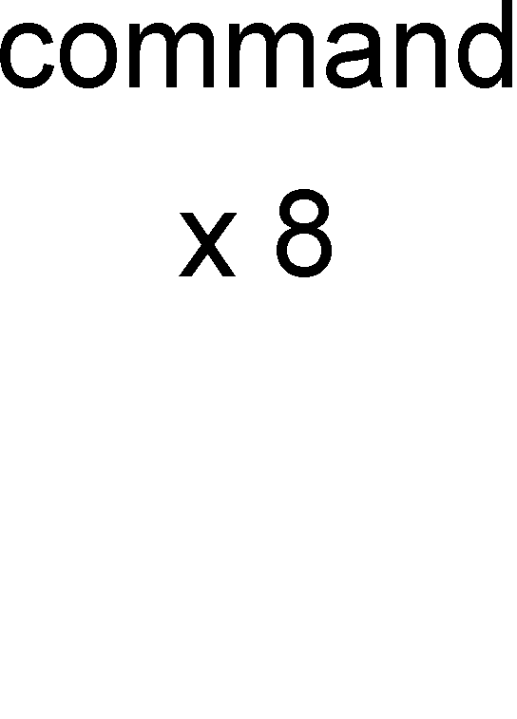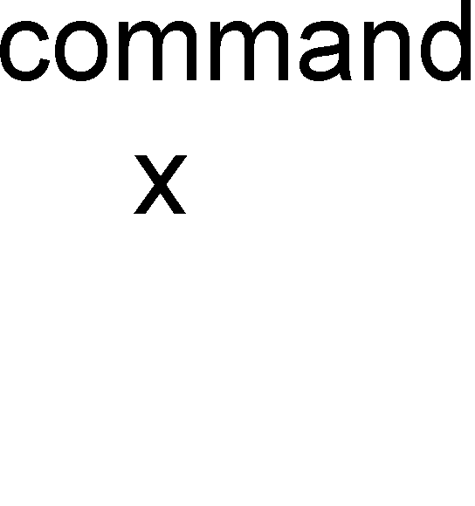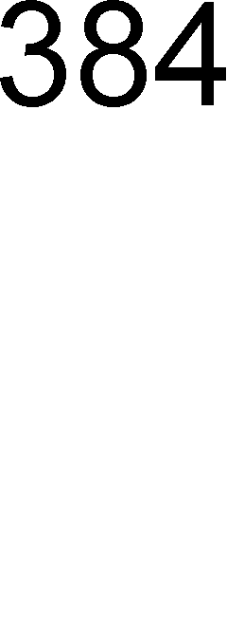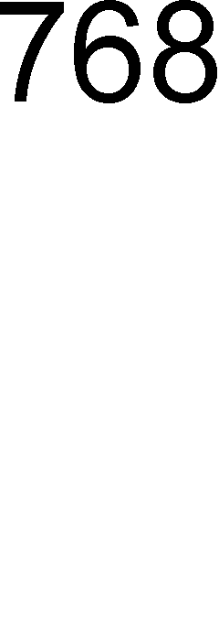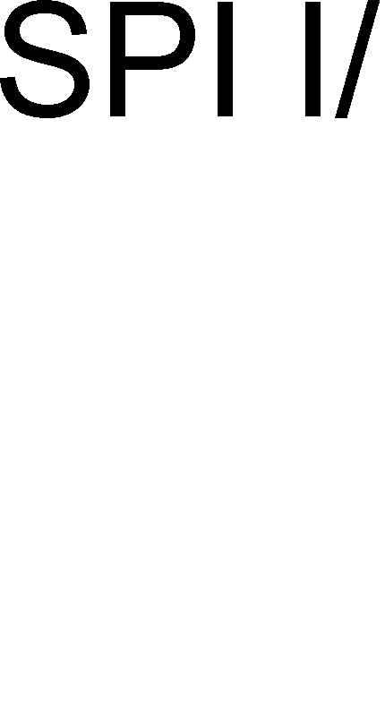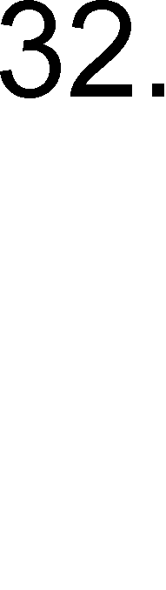



# Pin Assignment and Description

## KB3930 128-pin LQFP Diagram Top View

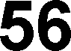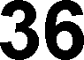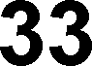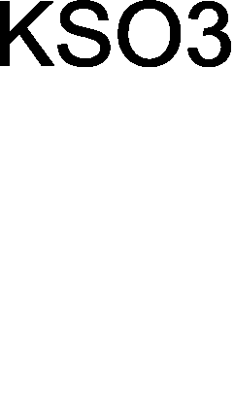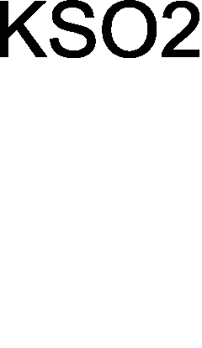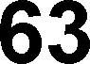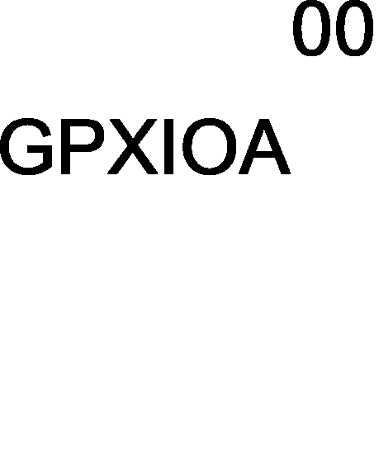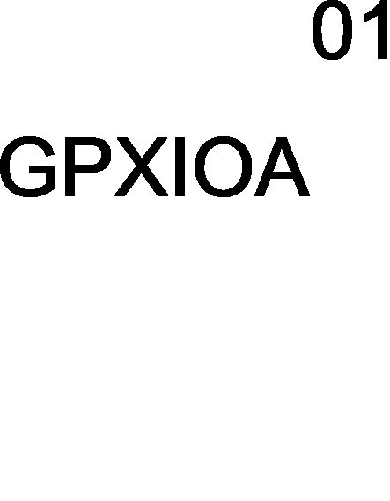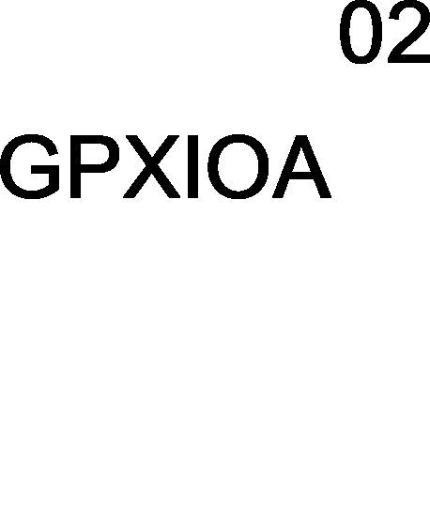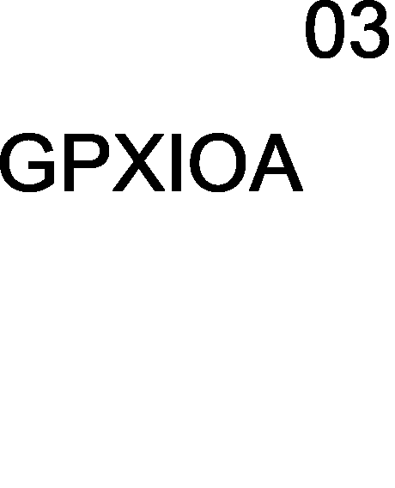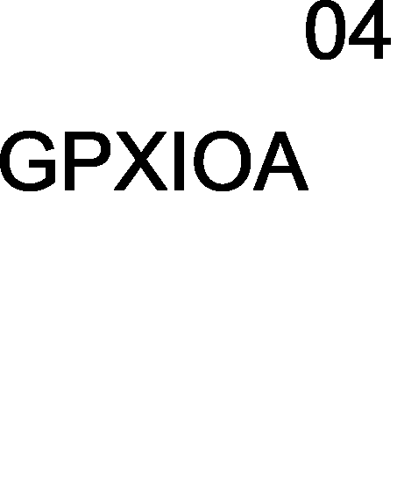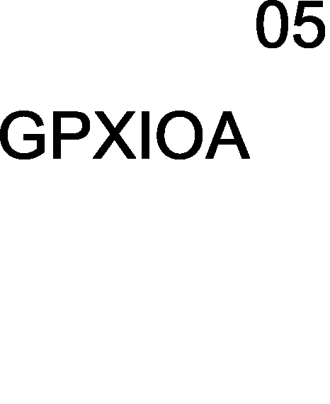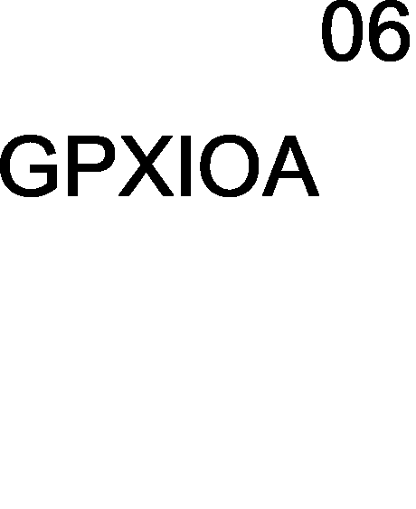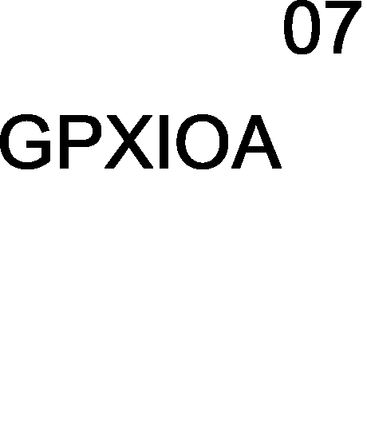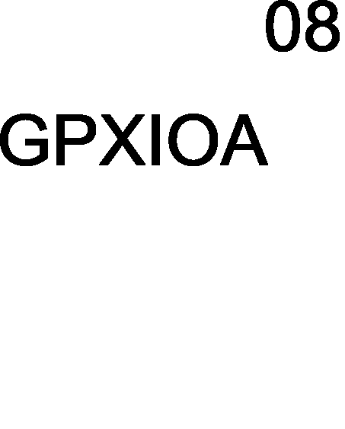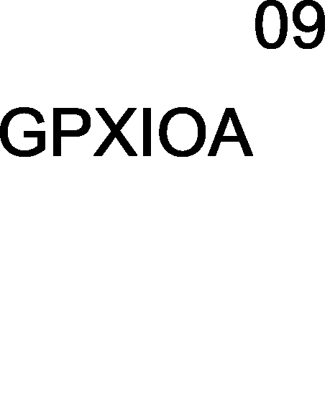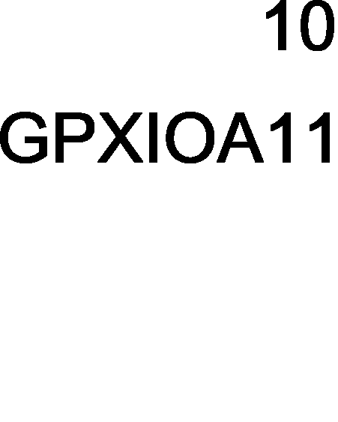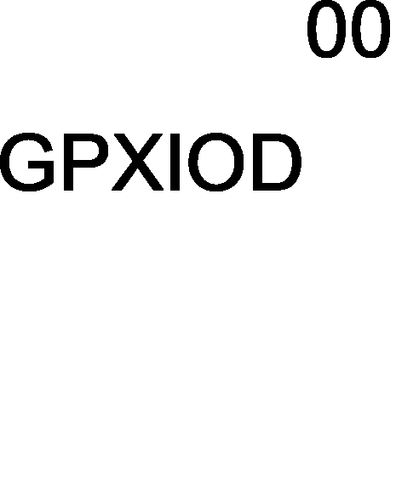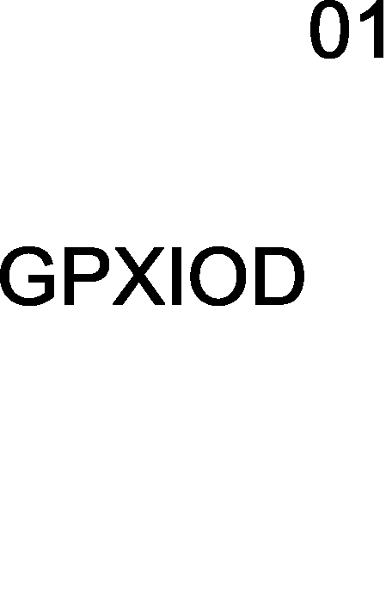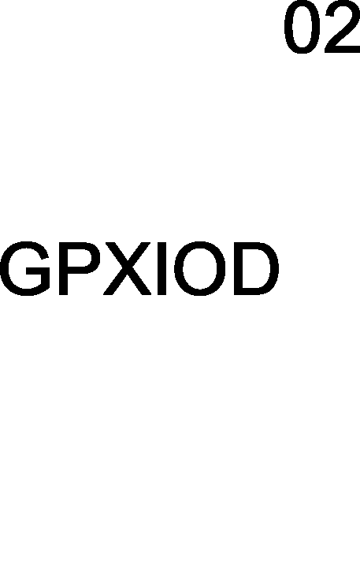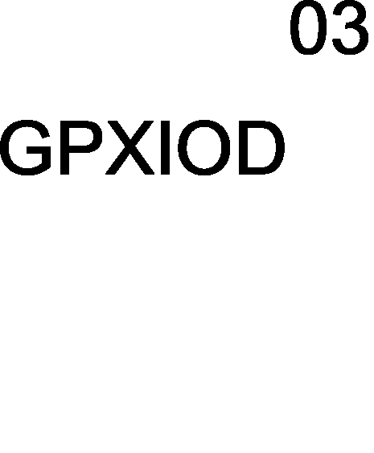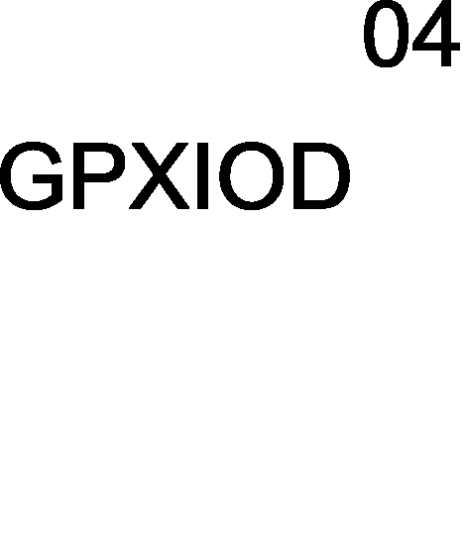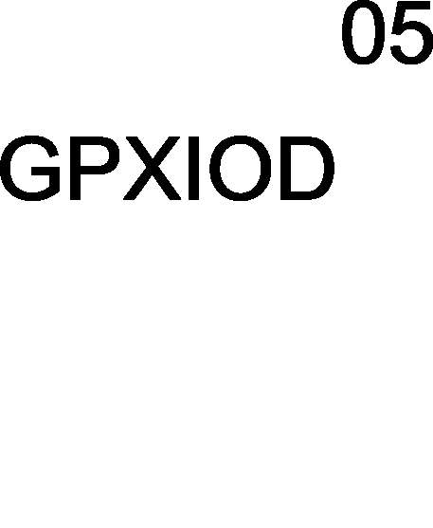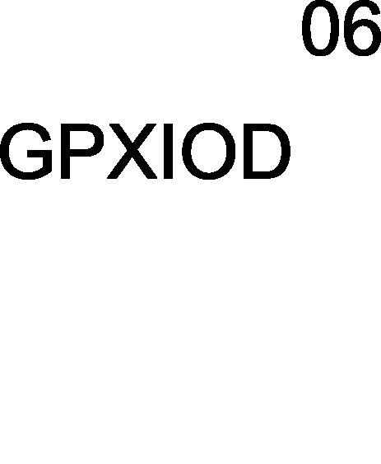

* 1. **KB3930 128 LFBGA Ball Map**

### This page is leaved blank intentionally.

w

## KB3930 Pin Assignment Side A

www.DataSheet.net/

## KB3930 Pin Assignment Side B

|  |  |  |  |  |  |  |  |  |
| --- | --- | --- | --- | --- | --- | --- | --- | --- |
| **KB3930**  **Pin No.** | **KB3930 BGA** | **Name** | **GPIO** | **Alt Output** | **Alt. Input** | **Default** | **ECRST#**  **L/H** | **IO CELL** |
| 33 |  | VCC |  |  |  |  |  | VCC |
| 34 |  | GPIO19 | GPIO19 | PWM3 |  | GPIO19 | HiZ / HiZ | BCC16HI |
| 35 | GND GND | | | | | | | |
| 36 |  | GPIO1A | GPIO1A | NUMLED# |  | GPIO1A | HiZ / HiZ | BCC16HI |
| 37 |  | ECRST# |  |  |  |  | IE / IE | BQC04HIV |
| 38 |  | CLKRUN# | GPIO1D | CLKRUN# | CLKRUN# | GPIO1D | HiZ / HiZ | BCC16HI |
| 39 |  | KSO0 | GPIO20 | KSO0 | TP_TEST | GPIO20 | IE(PU)/IE(PU) | BQC04HIV |
| 40 |  | KSO1 | GPIO21 | KSO1 | TP_PLL | GPIO21 | IE(PU)/IE(PU) | BQC04HIV |
| 41 |  | KSO2 | GPIO22 | KSO2 | TP_TMUX | GPIO22 | IE(PU)/IE(PU) | BQC04HIV |
| 42 |  | KSO3 | GPIO23 | KSO3 | TP_ISP | GPIO23 | IE(PU)/IE(PU) | BQC04HIV |
| 43 |  | KSO4 | GPIO24 | KSO4 |  | GPIO24 | HiZ / HiZ | BQC04HIV |
| 44 |  | KSO5 | GPIO25 | KSO5 | PCICLK (LPC) | GPIO25 | HiZ / HiZ | BQCZ16HIV |
| 45 |  | KSO6 | GPIO26 | KSO6 | PCIRST# (LPC) | GPIO26 | HiZ / HiZ | BQC04HIV |
| 46 |  | KSO7 | GPIO27 | KSO7 SERIRQ(LPC) | SERIRQ(LPC) | GPIO27 | HiZ / HiZ | BQC04HIV |
| 47 |  | KSO8 | GPIO28 | KSO8 | LFRAME# (LPC) | GPIO28 | HiZ / HiZ | BQC04HIV |
| 48 |  | KSO9 | GPIO29 | KSO9 | [www.DataSheet.net/](http://www.DataSheet.net/) | GPIO29 | HiZ / HiZ | BQCZ16HIV |
| 49 |  | KSO10 | GPIO2A | KSO10 |  | GPIO2A | HiZ / HiZ | BQCZ16HIV |
| 50 |  | KSO11 | GPIO2B | KSO11 LAD3(LPC) | LAD3(LPC) | GPIO2B | HiZ / HiZ | BQC04HIV |
| 51 |  | KSO12 | GPIO2C | KSO12 LAD2(LPC) | LAD2(LPC) | GPIO2C | HiZ / HiZ | BQC04HIV |
| 52 |  | KSO13 | GPIO2D | KSO13 LAD1(LPC) | LAD1(LPC) | GPIO2D | HiZ / HiZ | BQC04HIV |
| 53 |  | KSO14 | GPIO2E | KSO14 LAD0(LPC) | LAD0(LPC) | GPIO2E | HiZ / HiZ | BQC04HIV |
| 54 |  | KSO15 | GPIO2F | KSO15 | E51_RXD | GPIO2F | HiZ / HiZ | BQC04HIV |
| 55 |  | KSI0 | GPIO30 | E51_TXD | KSI0 | GPIO30 | IE(PU)/IE(PU) | BQC04HIV |
| 56 |  | KSI1 | GPIO31 |  | KSI1 | GPIO31 | IE(PU)/IE(PU) | BQC04HIV |
| 57 |  | KSI2 | GPIO32 |  | KSI2 | GPIO32 | IE(PU)/IE(PU) | BQC04HIV |
| 58 |  | KSI3 | GPIO33 |  | KSI3 | GPIO33 | IE(PU)/IE(PU) | BQC04HIV |
| 59 |  | KSI4 | GPIO34 |  | KSI4/EDI_CS | GPIO34 | IE(PU)/IE(PU) | BQC04HIV |
| 60 |  | KSI5 | GPIO35 |  | KSI5/EDI_CLK | GPIO35 | IE(PU)/IE(PU) | BQC04HIV |
| 61 |  | KSI6 | GPIO36 |  | KSI6/EDI_DIN | GPIO36 | IE(PU)/IE(PU) | BQC04HIV |
| 62 |  | KSI7 | GPIO37 | EDI_DO | KSI7 | GPIO37 | IE(PU)/IE(PU) | BQC04HIV |
| 63 |  | AD0 | **GPI**38 |  | AD0 | GPI38 | HiZ / HiZ | IQTHI |
| 64 |  | AD1 | **GPI**39 |  | AD1 | GPI39 | HiZ / HiZ | IQTHI |

* 1. **KB3930 Pin Assignment Side C**

|  |  |  |  |  |  |  |  |  |
| --- | --- | --- | --- | --- | --- | --- | --- | --- |
| **KB3930**  **Pin No.** | **KB3930 BGA** | **Name** | **GPIO** | **Alt Output** | **Alt. Input** | **Default** | **ECRST#**  **L/H** | **IO CELL** |
| 65 |  | AD2 | **GPI**3A |  | AD2 | **GPI**3A | HiZ / HiZ | IQTHI |
| 66 |  | AD3 | **GPI**3B |  | AD3 | **GPI**3B | HiZ / HiZ | IQTHI |
| 67 |  | AVCC |  |  |  |  |  | AVCC |
| 68 |  | DA0 | **GPO**3C | DA0 |  | **GPO**3C | HiZ / HiZ | OCT04H |
| 69 | AGND AGND | | | | | | | |
| 70 |  | DA1 | **GPO**3D | DA1 |  | **GPO**3D | HiZ / HiZ | OCT04H |
| 71 |  | DA2 | **GPO**3E | DA2 |  | **GPO**3E | HiZ / HiZ | OCT04H |
| 72 |  | DA3 | **GPO**3F | DA3 |  | **GPO**3F | HiZ / HiZ | OCT04H |
| 73 |  | GPIO40 | GPIO40 |  | CIR_RX | GPIO40 | HiZ / HiZ | BQC04HI |
| 74 |  | GPIO41 | GPIO41 | CIR_RLC_TX  / PECI | PECI | GPIO41 | HiZ / HiZ | BQC04HIVPECI |
| 75 |  | AD4 | **GPI**42 |  | AD4 | **GPI**42 | HiZ / HiZ | IQTHI |
| 76 |  | AD5 | **GPI**43 |  | AD5 | **GPI**43 | HiZ / HiZ | IQTHI |
| 77 |  | SCL0 | GPIO44 | SCL0 |  | GPIO44 | HiZ / HiZ | BQC04HI |
| 78 |  | SDA0 | GPIO45 | SDA0 |  | GPIO45 | HiZ / HiZ | BQC04HI |
| 79 |  | SCL1 | GPIO46 | SCL1 |  | GPIO46 | HiZ / HiZ | BQC04HI |
| 80 |  | SDA1 | GPIO47 | SDA1 |  | GPIO47 | HiZ / HiZ | BQC04HI |
| 81 |  | KSO16 | GPIO48 | KSO16 |  | GPIO48 | HiZ / HiZ | BQC04HIV |
| 82 |  | KSO17 | GPIO49 | KSO17 www.DataSheet. | net/ | GPIO49 | HiZ / HiZ | BQC04HIV |
| 83 |  | PSCLK1 | GPIO4A | PSCLK1 / SCL2 |  | GPIO4A | HiZ / HiZ | BQC04HI |
| 84 |  | PSDAT1 | GPIO4B | PSDAT1 / SDA2 |  | GPIO4B | HiZ / HiZ | BQC04HI |
| 85 |  | PSCLK2 | GPIO4C | PSCLK2  / SCL3 |  | GPIO4C | HiZ / HiZ | BCC16HI |
| 86 |  | PSDAT2 | GPIO4D | PSDAT2  / SDA3 |  | GPIO4D | HiZ / HiZ | BCC16HI |
| 87 |  | PSCLK3 | GPIO4E | PSCLK3 |  | GPIO4E | HiZ / HiZ | BQC04HI |
| 88 |  | PSDAT3 | GPIO4F | PSDAT3 |  | GPIO4F | HiZ / HiZ | BQC04HI |
| 89 |  | GPIO50 | GPIO50 |  |  | GPIO50 | HiZ / HiZ | BQC04HI |
| 90 |  | GPIO52 | GPIO52 | E51CS# |  | GPIO52 | HiZ / HiZ | BCC16HI |
| 91 |  | GPIO53 | GPIO53 | CAPSLED# | E51TMR1 | GPIO53 | HiZ / HiZ | BCC16HI |
| 92 |  | GPIO54 | GPIO54 | WDT_LED# | E51TMR0 | GPIO54 | HiZ / HiZ | BCC16HI |
| 93 |  | GPIO55 | GPIO55 | SCROLED# | E51INT0 | GPIO55 | HiZ / HiZ | BCC16HI |
| 94 | GND GND | | | | | | | |
| 95 |  | GPIO56 | GPIO56 |  | E51INT1 | GPIO56 | HiZ / HiZ | BQC04HIV |
| 96 |  | VCC |  |  |  |  |  | VCC |

## KB3930 Pin Assignment Side D

w

## I/O Cell Descriptions

## I/O Buffer Table

|  |  |  |
| --- | --- | --- |
| **Cell** | **Description** | **Application** |
| BQCZ16HIV | Schmitt trigger, 16mA Output / Sink Current, Input / Output / Pull Up Enable(40KΩ), 5 V Tolerance. | GPIO |
| BQC04HIV | Schmitt trigger, 4mA Output / Sink Current, Input / Output / Pull Up Enable(40K  Ω), 5 V Tolerance | GPIO |
| BQCW16HIV | Schmitt trigger, 16mA Output / Sink Current, 5 V Tolerance, Input / Output / Pull Up Enable | ESB_CLK/ SPI_CLK |
| BCC16HI | 16mA Output / Sink Current , 5 V Tolerance, Input / Output Enable | LPC I/F |
| BQC04HI | Schmitt trigger, 4mA Output / Sink Current, 5 V Tolerance, Input / Output Enable | GPIO |
| IQTHI | Mixed mode IO, ADC Enable, with GPI, Input Enable | ADC, GPI |
| OCT04H | Mixed mode IO, DAC Enable, with GPO, 4mA Output Current, Output Enable  **(For GPO function, it is not recommended to control the device powered before KBC chip.)** | DAC, GPO |
| BQC08HIV | Schmitt trigger, 8mA Output / Sink Current, 5V Tolerance, Input / Output / Pull Up Enable | ESB_DAT |
| BQC04HIVPECI | Mixed Mode IO, PECI enable, with GPIO  GPIO: Schmitt trigger, 4mA Output / Sink Current, PECI: 0.9V~1.2V | PECI, GPIO |

**\* 5V Tolerance, only if pull-high disable and output disable.**

**\*\* Please note, the total current in each side on VCC or VSS of chip can not exceed over 48mA**.

* + 1. **I/O Buffer Characteristic Table**[www.DataSheet.net/](http://www.DataSheet.net/)

|  |  |  |  |  |  |  |  |
| --- | --- | --- | --- | --- | --- | --- | --- |
| **Cell** | **Output** | **Input** | **Analog Signal** | **Pull-High Enable(40k)** | **5V**  **Tolerance** | **Current (mA)** | **Application** |
| BQCZ16HIV | ˇ | ˇ |  | ˇ | ˇ | 8~16 | GPIO |
| BQC04HIV | ˇ | ˇ |  | ˇ | ˇ | 2~4 | GPIO |
| BQCW16HIV | ˇ | ˇ |  | ˇ | ˇ | 8~16 | ESB_CLK/ SPI_CLK |
| BCC16HI | ˇ | ˇ |  |  | ˇ | 8~16 | LPC I/F |
| BQC04HI | ˇ | ˇ |  |  | ˇ | 2~4 | GPIO |
| IQTHI |  | ˇ | ˇ |  |  |  | ADC, GPI |
| OCT04H | ˇ |  | ˇ |  |  | 2~4 | DAC, GPO |
| BQC08HIV | ˇ | ˇ |  | ˇ | ˇ | 4~8 | ESB_DAT |
| BQC04HIVPECI | ˇ | ˇ |  | ˇ | ˇ | 2~4 | PECI, GPIO |

Application Notice: The Pads with I/O cells of IQTHI, OCT04H should be designed carefully. Under specific environment when: KBC is power-off, external application circuit is power-on. Signals must not be connected with pads of IQTHI/OCT04H (ADCs/DACs). It would cause unexpected voltage level on these pad if KBC is still power-off.

# Pin Descriptions

## Hardware Trap

Hardware trap pins are used to latch external signal at rising edge of **ECRST#**. The hardware trap pins are for some special purpose which should be defined while boot-up. The following table gives the collection of hardware trap pins. Please note, all the following hardware trap pins are **pull-high** internally after reset.

|  |  |  |
| --- | --- | --- |
| **Pin No.** | **Normal Mode** | **FlashDirectAccess Mode** |
| 59 | KSI4 (I) | (Input) EDI_CS, Transfer signal from terminal into KBC and though SPICS# to SPI_Flash |
| 60 | KSI5 (I) | (Input) EDI_CLK, Transfer signal from terminal into KBC and though SPICLK to SPI_Flash |
| 61 | KSI6 (I) | (Input) EDI_DIN, Transfer signal from terminal into KBC and though MOSI to SPI_Flash |
| 62 | KSI7 (I) | (Output) EDI_DO, Transfer signal from terminal into KBC and though MISO to SPI_Flash |

## Pin Descriptions by Functions

## Low Pin Count I/F Descriptions.

|  |  |  |  |
| --- | --- | --- | --- |
| **Pin Name** | **Pin No.** | **Direction** | **Description** |
| LAD[3:0] | 5, 7,8,10 | I/O | LPC address bus. |
| LFARAME# | 4 | I | LPC frame control signal. |
| PCIRST# | 13 | I | LPC module reset by this signal. |
| PCICLK | 12 | I | 33MHz PCI clock input. |
| SERIRQ | 3 | I/O | Serial IRQ |
| CLKRUN# | 38 | I/OD | Clock run control |

## SPI Flash I/F Descriptions

|  |  |  |  |
| --- | --- | --- | --- |
| **Pin Name** | **Pin No.** | **Direction** | **Description** |
| MISO | 119 | I | SPI read control signal |
| MOSI | 120 | O | SPI write control signal |
| SPICLK | 126 | O | SPI clock output |
| SPICS# | 128 | O | SPI chip select signal |
| These pins are input/output disable during reset phase. | | | |

## PS/2 I/F Descriptions

w

## Internal Keyboard Encoder (IKB) Descriptions

|  |  |  |  |
| --- | --- | --- | --- |
| **Pin Name** | **Pin No.** | **Direction** | **Description** |
| KSO[17:0] | 82,81,54-39 | O | Keyboard Scan Out |
| KSI[7:0] | 62-55 | I | Keyboard Scan In |

## SMBus Descriptions

|  |  |  |  |
| --- | --- | --- | --- |
| **Pin Name** | **Pin No.** | **Direction** | **Description** |
| SCL0 | 77 | I/OD | SMBus clock (interface 0) |
| SDA0 | 78 | I/OD | SMBus data (interface 0) |
| SCL1 | 79 | I/OD | SMBus clock (interface 1) |
| SDA1 | 80 | I/OD | SMBus data (i`nterface 1) |
| SCL2 | 83 | I/OD | SMBus clock (interface 2) Muxed with PS/2 port 1 clock |
| SDA2 | 84 | I/OD | SMBus data (interface 2) Muxed with PS/2 port 1 data |
| SCL3 | 85 | I/OD | SMBus clock (interface 3) Muxed with PS/2 port 2 clock |
| SDA3 | 86 | I/OD | SMBus data (interface 3) Muxed with PS/2 port 2 data |

## FAN Descriptions

[www.DataSheet.net/](http://www.DataSheet.net/)

|  |  |  |  |
| --- | --- | --- | --- |
| **Pin Name** | **Pin No.** | **Direction** | **Description** |
| FANPWM0 | 26 | O | FANPWM0 output |
| FANPWM1 | 27 | O | FANPWM1 output |
| FANFB0 | 28 | I | FAN0 tachometer input |
| FANFB1 | 29 | I | FAN1 tachometer input |
| FANFB2 | 100 | I | FAN2 tachometer input |
| FANFB3 | 101 | I | FAN3 tachometer input |

## Pulse Width Modulation (PWM) Descriptions

|  |  |  |  |
| --- | --- | --- | --- |
| **Pin Name** | **Pin No.** | **Direction** | **Description** |
| PWM0 | 21 | O | PWM pulse output |
| PWM1 | 23 | O | PWM pulse output |
| PWM2 | 25 | O | PWM pulse output |
| PWM3 | 34 | O | PWM pulse output |

## Analog-to-Digital Converter Descriptions

|  |  |  |  |
| --- | --- | --- | --- |
| **Pin Name** | **Pin No.** | **Direction** | **Description** |
| AD[3:0] | 66-63 | I | 10bit A/D converter input |
| AD[5:4] | 76,75 | I | 10bit A/D converter input |

## Digital-to-Analog Converter Descriptions

|  |  |  |  |
| --- | --- | --- | --- |
| **Pin Name** | **Pin No.** | **Direction** | **Description** |
| DA[3:0] | 72-70,68 | O | 8bit D/A converter output |

## 8051 External I/F Descriptions

|  |  |  |  |
| --- | --- | --- | --- |
| **Pin Name** | **Pin No.** | **Direction** | **Description** |
| E51TXD | 30 | O | 8051 serial port, transmit port. |
| E51RXD | 31 | I | 8051 serial port, receive port. |
| E51CLK | 31 | O | For different serial scheme, E51CLK will shift out clock. |
| E51CS# | 90 | O |  |
| E51TMR0 | 92 | I |  |
| E51INT0 | 93 | I |  |
| E51TMR1 | 91 | I |  |
| E51INT1 | 95 | I |  |

## External Clock Descriptions

|  |  |  |  |
| --- | --- | --- | --- |
| **Pin Name** | **Pin No.** | **Direction** | **Description** |
| XCLKI | 122 | I | 32.768KHz input |
| XCLKO | 123 | O | 32.768KHz output |

[www.DataSheet.net/](http://www.DataSheet.net/)

## Miscellaneous Signals Descriptions

|  |  |  |  |
| --- | --- | --- | --- |
| **Pin Name** | **Pin No.** | **Direction** | **Description** |
| GA20 | 1 | O | KBC will gate A20 address line |
| KBRST# | 2 | O | KBRST# is used to generate system reset. |
| SCI# | 20 | O | SCI# asserts to the system for requesting service while related events occur. |
| ECRST# | 37 | I | While ECRST# asserted, the KBC will reset globally. |
| OWM | 16 | I/O | One Wire Master input and output signal |
| PECI | 74 | I/O | PECI input and output signal |

## Voltage Comparator Pins Descriptions

|  |  |  |  |
| --- | --- | --- | --- |
| **Pin Name** | **Pin No.** | **Direction** | **Description** |
| VCIN0 | 109 | I | Voltage comparator input port0 |
| VCIN1 | 114 | I | Voltage comparator input port1 |
| VCOUT | 103 | O | Voltage comparator output |

## Power Pins Descriptions

|  |  |  |  |
| --- | --- | --- | --- |
| **Pin Name** | **Pin No.** | **Direction** | **Description** |
| VCC | 9,22,33,96,111,125 |  | Power supply for digital plane. |
| GND | 11,24,35,94,113 |  | Power ground for digital plane. |
| AVCC | 67 |  | Power supply for analog plane. |
| AGND | 69 |  | Power ground for analog plane. |
| V18R | 124 |  | Connected to external Capacitor for internal 1.8V |

w

# Module Descriptions

## Chip Architecture

## Power Planes

Two power planes are in the KBC. One is for digital logic and the other is for analog circuit. Both power planes are ±10% tolerance for recommend operation condition, The KBC provides V1.8 power plane for different generation.

[www.DataSheet.net/](http://www.DataSheet.net/)

## Clock Domains

Three clock sources, PCICLK, DPLL_CLK and XCLKI will be discussed in this section. A summary is list in the following table.

The following figure shows more detail about the operation in the KBC. The external 32.768KHz is provided for two purposes. One is to provide an accurate reference for internal DPLL module, and the other one is to provide another clock source for watchdog timer.

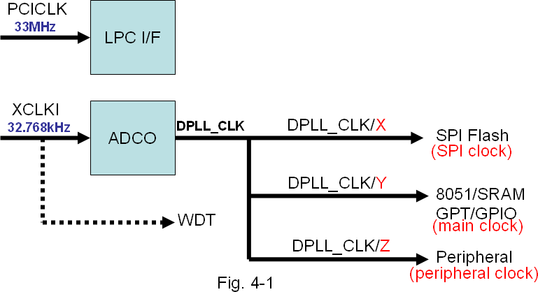

The possible (X,Y,Z) combination with exact clock value is summarized as the following table.

|  |  |  |  |  |  |  |
| --- | --- | --- | --- | --- | --- | --- |
|  | SPI Clock (X) | | Main Clock (Y) | | Peripheral Clock (Z) | |
|  | CLKCFG[6]=0  (default) | CLKCFG[6]=1 | CLKCFG[6]=0  (default) | CLKCFG[6]=1 | CLKCFG[6]=0  (default) | CLKCFG[6]=1 |
| CLKCFG[3:2]=0  (default) | 16* | 66 | 8* | 8 | 4* | 4 |
| CLKCFG[3:2]=1 | 32 | 66 | 16 | 16 | 8 | 8 |
| CLKCFG[3:2]=2 | 32 | 66 | 22 | 22 | 11 | 11 |
| CLKCFG[3:2]=3 | 32 | 66 | 32 | 32 | 16 | 16 |
| * While power on default, no matter what value CLKCFG[3:2], CLKCFG[6] are, the dividend (X,Y,Z) is always (4, 8, 16). The PCI clock is 66MHz, X= 66/4 = 16MHz, Y= 66/8 = 8Mhz , Z= 66/16 = 4MHz | | | | | | |
| Be noted that, these clock frequency is only valid after KBC correctly referring clock. | | | | | | |

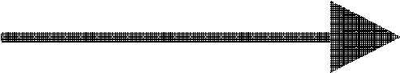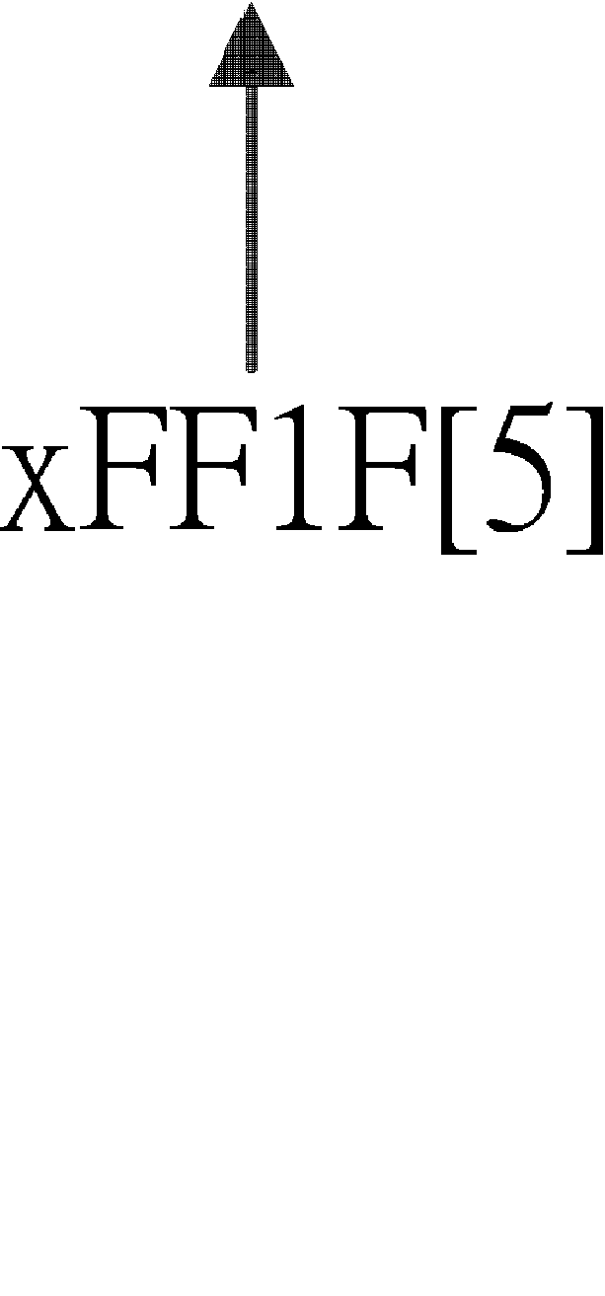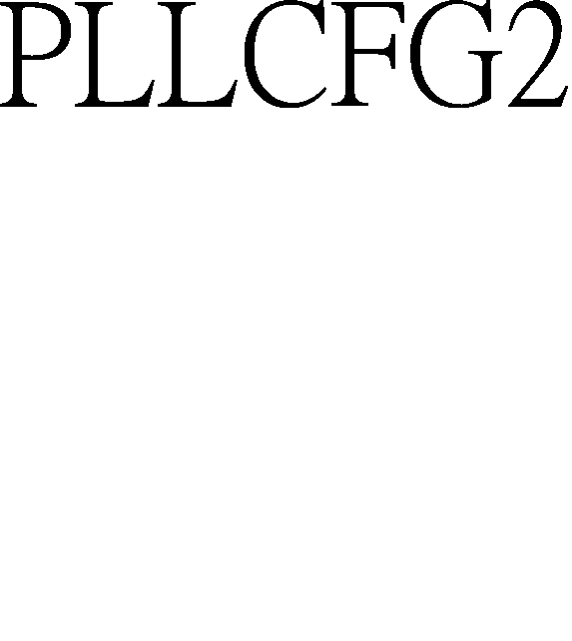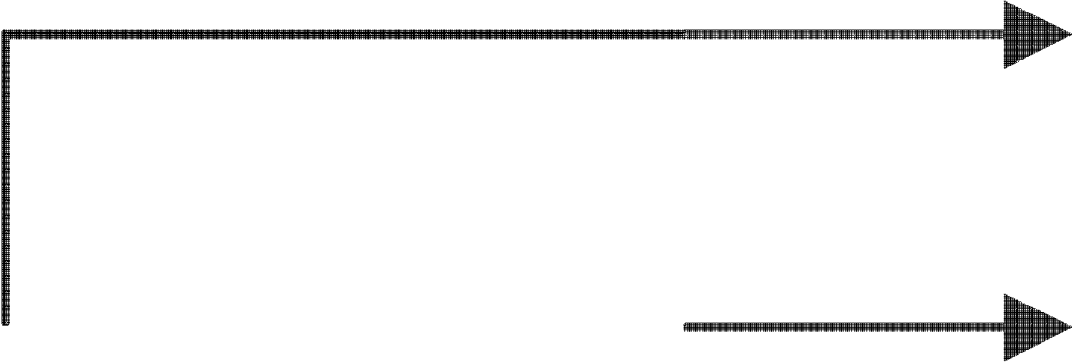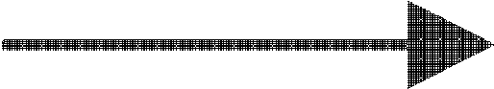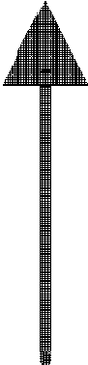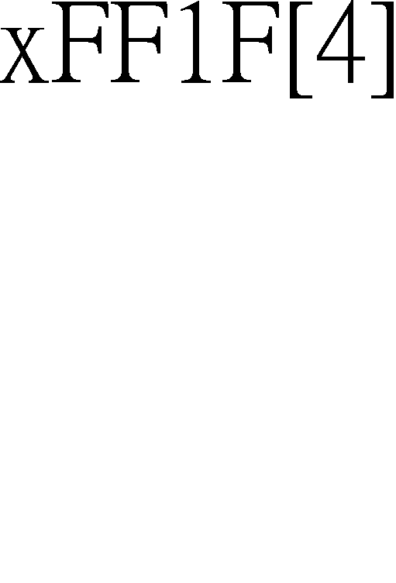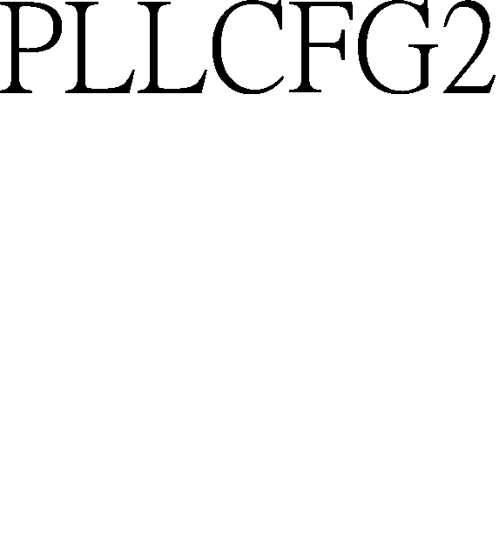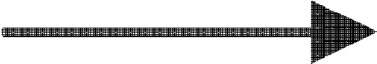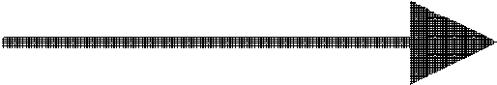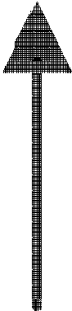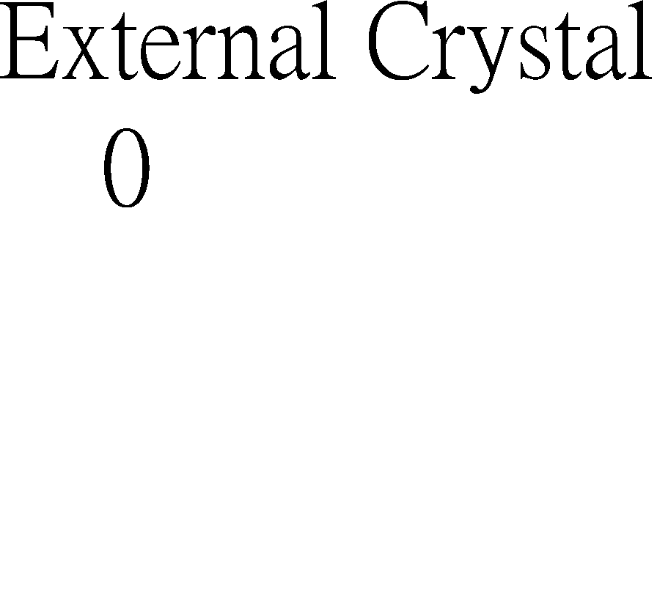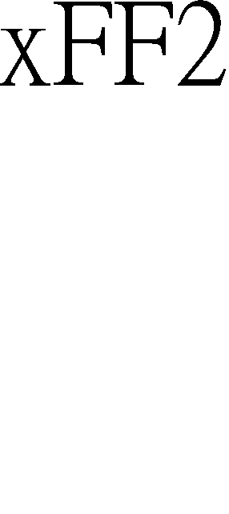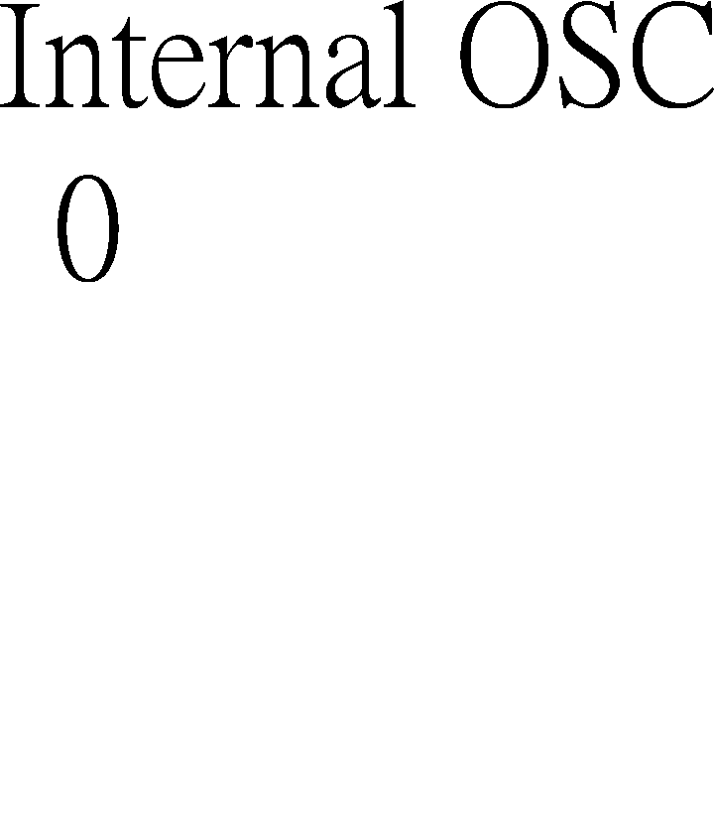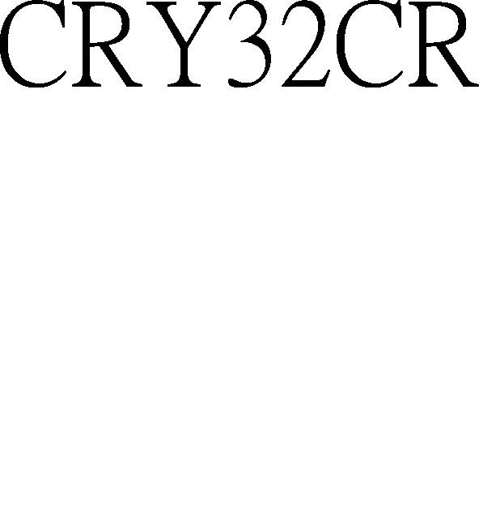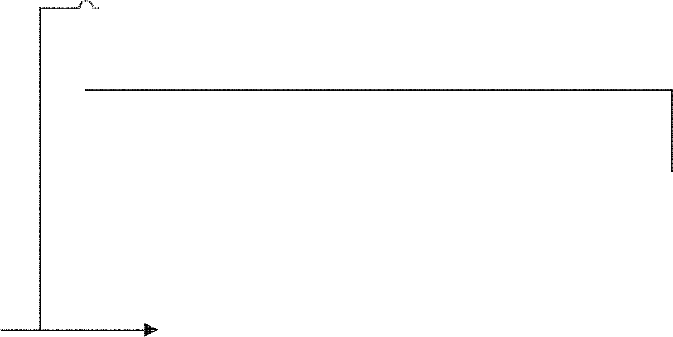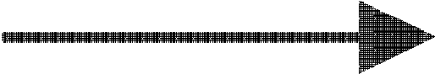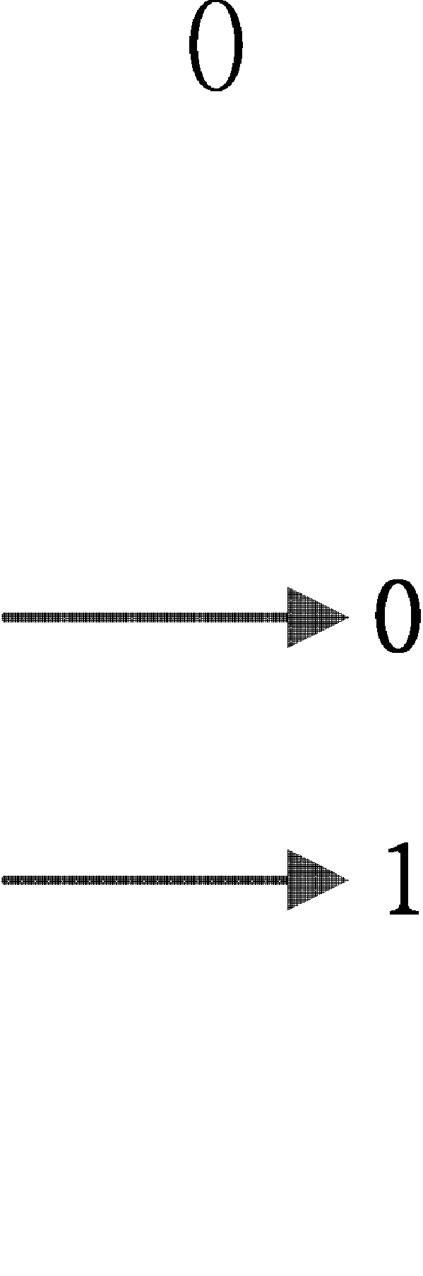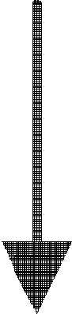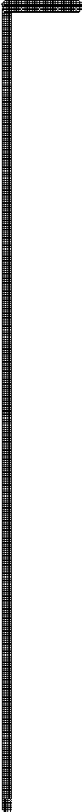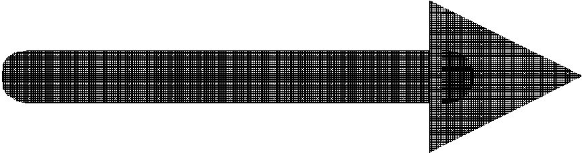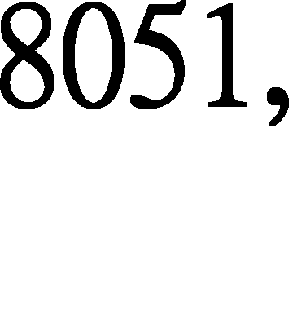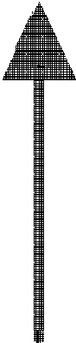

**Note: Internal OSC of KBx930 application**

Since KBx930 provide internal OSC, the clock source selection are different from KBx926D series. Developer could chose clock source from internal-OSC, external crystal, or host LPCLCK depending on different application and system status. As following is simplified clocking distribution tree for setting.

## PCICLK and CLKRUN#

While system power-on, the host starts to drive CLKRUN# low for a while to inform the slaves that a 33MHz PCICLK will be given. At this moment, CLKRUN# of KBC is in input mode. If the host tries to stop the PCICLK for some purpose, the CLKRUN# will be de-asserted. In the current design, the KBC needs PCICLK for normal operation. Therefore the KBC keeps CLKRUN# for 2 clock cycles and releases it. This forces the host to start driving PCICLK. The following figure gives the explanation. For more detail please refer to *PCI Mobile Design Guide version 1.1*.

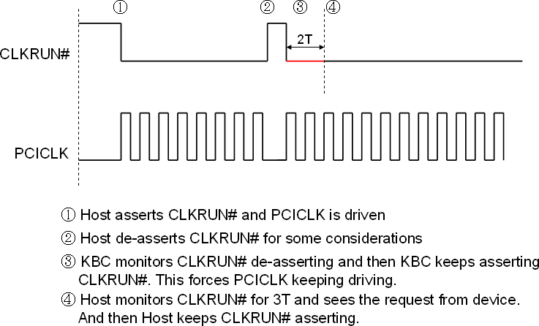

## Internal Memory Map

|  |  |  |  |  |  |
| --- | --- | --- | --- | --- | --- |
| **No** | **Module** | **Descriptions** | **Address Range** | **Size (Byte)** | |
| 1 | Flash | Space mapped to system BIOS | 0x0000~0xEBFF | 59K | |
| 2 | XRAM | Embedded SRAM | 0xEC00~0xFBFF | 4K | |
| 3 | GPIO | General purpose I/O | 0xFC00~0xFC7F | 128 | 1K |
| 4 | KBC | Keyboard controller | 0xFC80~0xFC8F | 16 |
| 5 | ESB | ENE serial bus controller | 0xFC90~0xFC9F | 16 |
| 6 | IKB | Internal keyboard matrix | 0xFCA0~0xFCAF | 16 |
| 7 | RSV | Reserved | 0xFCB0~0xFCBF | 16 |
| 8 | RSV | Reserved | 0xFCC0~0xFCCF | 16 |
| 9 | PECI | PECI controller | 0xFCD0~0xFCDF | 16 |
| 10 | RSV | Reserved | 0xFCE0~0xFCEF | 16 |
| 11 | OWM | One Wire Master | 0xFCF0~0xFCFF | 16 |
| 12 | RSV | Reserved | 0xFD00~0xFDFF | 256 |
| 13 | PWM | Pulse width modulation | 0xFE00~0xFE1F | 32 |
| 14 | FAN | Fan controller | 0xFE20~0xFE4F | 48 |
| 15 | GPT | General purpose timer | 0xFE50~0xFE6F | 32 |
| 16 | SDIH/ SDID | SPI host interface/ SPI device interface | 0xFE70~0xFE7F | 16 |
| 17 | WDT | Watchdog timer w | 0xFE80~0xFE8F | 16 |
| 18 | LPC | Low pin count interface | 0xFE90~0xFE9F | 16 |
| 19 | XBI | X-bus interface | 0xFEA0~0xFEBF | 32 |
| 20 | CIR | Consumer IR controller | 0xFEC0~0xFECF | 16 |
| 21 | RSV | Reserved | 0xFED0~0xFEDFh | 16 |
| 22 | PS2 | PS/2 interface | 0xFEE0~0xFEFF | 32 |
| 23 | EC | Embedded controller | 0xFF00~0xFF2F | 48 |
| 24 | GPWU | General purpose wakeup event | 0xFF30~0xFF7F | 80 |
| 25 | SMBus | System management bus controller | 0xFF80~0xFFBF | 64 |
| 26 | RSV | Reserved | 0xFFC0~0xFFCF | 16 |  |
| 27 | RSV | Reserved | 0xFFD0~0xFFFF | 48 |  |

* 1. **GPIO**

GPIOFSx is only for **Output Function Selection**, not for **Input Function**. Example1 – GPIO14 is used as FANFB1, then

GPIO(GPIOFS10) 0xFC02 b’4 must be 0, GPIO(GPIOIE10) 0xFC62 b’4 must be 1.

Example2 – PS/2 clock/data lines and SMBus clock/data are bi-directional.

They must be programmed as **Output Function Selection = 1** and **Input Enable = 1**. For other specific GPIO initialization, please refer the SW programming guide of KBx930.

## GPIO Function Description

The GPIO module is flexible for different applications. Each GPIO pin can be configured as alternative input or alternative output mode. The alternative function can be selected by register setting. A summary table is given as below for more detail.

|  |  |  |  |  |
| --- | --- | --- | --- | --- |
| **GPIO** | **Alt. Output** | **Alt. Input** | **Default Alt. Output** | **Alt. Selection Reg.** |
| GPIO1D | CLKRUN# | CLKRUN# | GPIO1D | GPIOFS18.[5] |
| GPIO1E＊ |  |  | GPIO1E | GPIOFS18.[6] |
| GPIO1F＊ |  |  | GPIO1F | GPIOFS18.[7] |
| GPIO20 | KSO00 | TP_TEST | GPIO20 | GPIOFS20.[0] |
| GPIO21 | KSO01 | TP_PLL | GPIO21 | GPIOFS20.[1] |
| GPIO22 | KSO02 | TP_TMUX | GPIO22 | GPIOFS20.[2] |
| GPIO23 | KSO03 | TP_ISP | GPIO23 | GPIOFS20.[3] |
| GPIO24 | KSO04 |  | GPIO24 | GPIOFS20.[4] |
| GPIO25 | KSO05 | PCICLK (LPC) | GPIO25 | GPIOFS20.[5] GPIO_MISC2[7] |
| GPIO26 | KSO06 | PCIRST# (LPC) | GPIO26 | GPIOFS20.[6] GPIO_MISC2[7] |
| GPIO27 | KSO07 SERIRQ (LPC) | SERIRQ (LPC) | GPIO27 | GPIOFS20.[7] GPIO_MISC2[7] |
| GPIO28 | KSO08 | LFRAME# (LPC) | GPIO28 | GPIOFS28.[0] GPIO_MISC2[7] |
| GPIO29 | KSO09 |  | GPIO29 | GPIOFS28.[1] |
| GPIO2A | KSO10 |  | GPIO2A | GPIOFS28.[2] |
| GPIO2B | KSO11 LAD0 (LPC) | LAD0 (LPC) | GPIO2B | GPIOFS28.[3] GPIO_MISC2[7] |
| GPIO2C | KSO12 LAD1 (LPC) | LAD1 (LPC) | GPIO2C | GPIOFS28.[4] GPIO_MISC2[7] |
| GPIO2D | KSO13 LAD2 (LPC) | [www.DataSheet.net/](http://www.DataSheet.net/)  LAD2 (LPC) | GPIO2D | GPIOFS28.[5] GPIO_MISC2[7] |
| GPIO2E | KSO14 LAD3 (LPC) | LAD3 (LPC) | GPIO2E | GPIOFS28.[6] GPIO_MISC2[7] |
| GPIO2F | KSO15 |  | GPIO2F | GPIOFS28.[7] |
| GPIO30 |  | KSI0 | GPIO30 | GPIOFS30.[0] |
| GPIO31 |  | KSI1 | GPIO31 | GPIOFS30.[1] |
| GPIO32 |  | KSI2 | GPIO32 | GPIOFS30.[2] |
| GPIO33 |  | KSI3 | GPIO33 | GPIOFS30.[3] |
| GPIO34 |  | KSI4  / EDI_CS | GPIO34 | GPIOFS30.[4] |
| GPIO35 |  | KSI5  / EDI_CLK | GPIO35 | GPIOFS30.[5] |
| GPIO36 |  | KSI6  / EDI_DIN | GPIO36 | GPIOFS30.[6] |
| GPIO37 | EDI_DO | KSI7 | GPIO37 | GPIOFS30.[7] |
| GPI38 |  | AD0 | GPI38 | GPIOFS38.[0] |
| GPI39 |  | AD1 | GPI39 | GPIOFS38.[1] |
| GPI3A |  | AD2 | GPI3A | GPIOFS38.[2] |
| GPI3B |  | AD3 | GPI3B | GPIOFS38.[3] |
| GPO3C | DA0 |  | GPO3C | GPIOFS38.[4] ★ |
| GPO3D | DA1 |  | GPO3D | GPIOFS38.[5] ★ |
| GPO3E | DA2 |  | GPO3E | GPIOFS38.[6] ★ |

|  |  |  |  |  |
| --- | --- | --- | --- | --- |
| **GPIO** | **Alt. Output** | **Alt. Input** | **Default Alt. Output** | **Alt. Selection Reg.** |
| GPO3F | DA3 |  | GPO3F | GPIOFS38.[7] ★ |
| GPIO40 |  | CIR_RX | GPIO40 | GPIOFS40.[0] |
| GPIO41 | CIR_RLC_TX  / PECI | PECI | GPIO41 | GPIOFS40.[1] GPIO_MISC2[0] |
| GPI42 |  | AD4 | GPI42 | GPIOFS40.[2] |
| GPI43 |  | AD5 | GPI43 | GPIOFS40.[3] |
| GPIO44 | SCL0 |  | GPIO44 | GPIOFS40.[4] |
| GPIO45 | SDA0 |  | GPIO45 | GPIOFS40.[5] |
| GPIO46 | SCL1 |  | GPIO46 | GPIOFS40.[6] |
| GPIO47 | SDA1 |  | GPIO47 | GPIOFS40.[7] |
| GPIO48 | KSO16 |  | GPIO48 | GPIOFS48.[0] |
| GPIO49 | KSO17 |  | GPIO49 | GPIOFS48.[1] |
| GPIO4A | PSCLK1 / SCL2 |  | GPIO4A | GPIOFS48.[2] GPIO_MISC2[4] |
| GPIO4B | PSDAT1  / SDA2 |  | GPIO4B | GPIOFS48.[3] GPIO_MISC2[4] |
| GPIO4C | PSCLK2  / SCL3 |  | GPIO4C | GPIOFS48.[4] GPIO_MISC2[5] |
| GPIO4D | PSDAT2  / SDA3 |  | GPIO4D | GPIOFS48.[5] GPIO_MISC2[5] |
| GPIO4E | PSCLK3 |  | GPIO4E | GPIOFS48.[6] |
| GPIO4F | PSDAT3 |  | GPIO4F | GPIOFS48.[7] |
| GPIO50 |  | [www.DataSheet.net/](http://www.DataSheet.net/) | GPIO50 | GPIOFS50.[0] |
| GPIO51＊ |  |  | GPIO51 | GPIOFS50.[1] |
| GPIO52 | E51CS# |  | GPIO52 | GPIOFS50.[2] |
| GPIO53 | CAPSLED# | E51TMR1 | GPIO53 | GPIOFS50.[3] |
| GPIO54 | WDT_LED# | E51TMR0 | GPIO54 | GPIOFS50.[4] |
| GPIO55 | SCORLED# | E51INT0 | GPIO55 | GPIOFS50.[5] |
| GPIO56 |  | E51INT1 | GPIO56 | GPIOFS50.[6] |
| GPIO57 | XCLK32K |  | GPIO57 | GPIOFS50.[7] |
| GPIO58 | SPICLK |  | GPIO58 | GPIOFS58.[0] |
| GPIO59 |  | TEST_CLK/SPICLK | GPIO59 | GPIOFS58.[1] |
| GPXIOA00 | SDICS# |  |  | GPIO_MISC.[2] |
| GPXIOA01 | SDICLK |  |  | GPIO_MISC.[2] |
| GPXIOA02 | SDIMOSI |  |  | GPIO_MISC.[2] |
| GPXIOA03 |  | FANFB2 |  | FANTMCFG0[0] |
| GPXIOA04 |  | FANFB3 |  | FANTMCFG1[0] |
| GPXIOA05 |  |  |  |  |
| GPXIOA06 | VOUT |  |  | GPX_MISC[0] |
| GPXIOA07 |  |  |  |  |
| GPXIOA08 |  |  |  |  |
| GPXIOA09 |  |  |  |  |
| GPXIOA10 |  |  |  |  |
| GPXIOA11 |  |  |  |  |

|  |  |  |  |  |
| --- | --- | --- | --- | --- |
| **GPIO** | **Alt. Output** | **Alt. Input** | **Default Alt. Output** | **Alt. Selection Reg.** |
| GPXIOD00 |  | SDIMISO / VCIN0 |  | VCCSR[0] |
| GPXIOD01 |  |  |  |  |
| GPXIOD02 |  |  |  |  |
| GPXIOD03 |  | VCIN1 |  | VCCSR[1] |
| GPXIOD04 |  |  |  |  |
| GPXIOD05 |  |  |  |  |
| GPXIOD06 |  |  |  |  |
| GPXIOD07 |  |  |  |  |

＊ In KBx930, these GPIO pins no more exist. The corresponding register bits do not work.

## GPIO Structures

★ If DAC function selected, please do not set this register bit.

In this section, the GPIO structure is illustrated as following diagram. The upper part is alternative output circuit and the lower part is alternative input circuit. In the figure, **GPIOFS** is used to enable alternative output. **GPIOOD** is for open-drain setting with output function. **GPIOOE** is the switch for data output. As shown in the figure, the alternative input embedded with pull-high and interrupt feature.

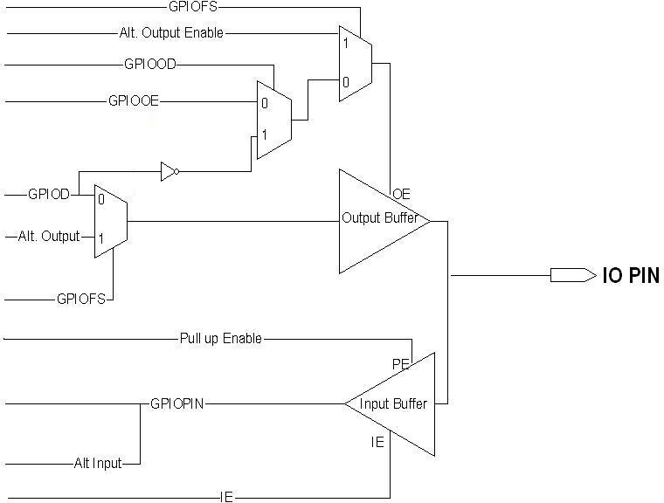

## GPIO Attribution Table

|  |  |  |  |  |  |  |  |  |  |
| --- | --- | --- | --- | --- | --- | --- | --- | --- | --- |
| GPIO | Alt. Output | Alt. Input | Default Alt. Output | Alt. Selection Reg. | Input Enable | Output Enable | Pull Up (40KΩ) | Open Drain | Output Current |
| GPIO00 | GA20 |  | GPIO00 | GPIOFS00.[0] | V | V | V | V | 2-4mA |
| GPIO01 | KBRST# |  | GPIO01 | GPIOFS00.[1] | V | V | V | V | 2-4mA |
| GPIO02＊ |  |  | GPIO02 | GPIOFS00.[2] |  |  |  |  |  |
| GPIO03＊ |  |  | GPIO03 | GPIOFS00.[3] |  |  |  |  |  |
| GPIO04 |  |  | GPIO04 | GPIOFS00.[4] | V | V | V | V | 2-4mA |
| GPIO05 |  | PCIRST# | GPIO05 | GPIOFS00.[5] | V | V |  | V | 8-16mA |
| GPIO06＊ |  |  | GPIO06 | GPIOFS00.[6] |  |  |  |  |  |
| GPIO07 | i_clk_805) |  | GPIO07 | GPIOFS00.[7] | V | V | V | V | 2-4mA |
| GPIO08 | i_clk_peri |  | GPIO08 | GPIOFS08.[0] | V | V | V | V | 2-4mA |
| GPIO09＊ |  |  | GPIO09 | GPIOFS08.[1] |  |  |  |  |  |
| GPIO0A | OWM | RLC_RX2 OWM | GPIO0A | GPIOFS08.[2] OWMCFG[7] | V | V | V | V | 2-4mA |
| GPIO0B | ESB_CLK |  | GPIO0B | GPIOFS08.[3] | V | V | V | V | 8-16mA |
| GPIO0C | ESB_DAT | ESB_DAT | GPIO0C | GPIOFS08.[4] | V | V | V | V | 4~8mA |
| GPIO0D | RLC_TX2 |  | GPIO0D | GPIOFS08.[5] | V | V | V | V | 2-4mA |
| GPIO0E | SCI# |  | GPIO0E | GPIOFS08.[6] | V | V | V | V | 2-4mA |
| GPIO0F | PWM0 |  | GPIO0F | GPIOFS08.[7] | V | V | V | V | 8-16mA |
| GPIO10 | PWM1 |  | GPIO10 | GPIOFS10.[0] | V | V | V | V | 2-4mA |
| GPIO11 | PWM2 |  | GPIO11 | GPIOFS10.[1] | V | V | V | V | 2-4mA |
| GPIO12 | FANPWM0 |  | GPIO12 | GPIOFS10.[2] | V | V | V | V | 2-4mA |
| GPIO13 | FANPWM1 |  | GPIO13 | GPIOFS10.[3] | V | V | V | V | 2-4mA |
| GPIO14 |  | FANFB0 | GPIO14 | GPIOFS10.[4] | V | V | V | V | 2-4mA |
| GPIO15 |  | FANFB1 | GPIO15 | GPIOFS[www.Da1taShee0t.net/](http://www.Da1taShee0t.net/) .[5] | V | V | V | V | 2-4mA |
| GPIO16 | E51TXD |  | GPIO16 | GPIOFS10.[6] | V | V | V | V | 2-4mA |
| GPIO17 | E51CLK | E51RXD | GPIO17 | GPIOFS10.[7] | V | V | V | V | 2-4mA |
| GPIO18 |  |  | GPIO18 | GPIOFS18.[0] | V | V | V | V | 2-4mA |
| GPIO19 | PWM3 |  | GPIO19 | GPIOFS18.[1] | V | V |  | V | 8-16mA |
| GPIO1A | NUMLED# |  | GPIO1A | GPIOFS18.[2] | V | V |  | V | 8-16mA |
| GPIO1B＊ |  |  | GPIO1B | GPIOFS18.[3] |  |  |  |  |  |
| GPIO1C＊ |  |  | GPIO1C | GPIOFS18.[4] |  |  |  |  |  |
| GPIO1D | CLKRUN# | CLKRUN# | GPIO1D | GPIOFS18.[5] | V | V |  | V | 8-16mA |
| GPIO1E＊ |  |  | GPIO1E | GPIOFS18.[6] |  |  |  |  |  |
| GPIO1F＊ |  |  | GPIO1F | GPIOFS18.[7] |  |  |  |  |  |
| GPIO20 | KSO00 | TP_TEST | GPIO20 | GPIOFS20.[0] | V | V | V | V | 2-4mA |
| GPIO21 | KSO01 | TP_PLL | GPIO21 | GPIOFS20.[1] | V | V | V | V | 2-4mA |
| GPIO22 | KSO02 | TP_TMUX | GPIO22 | GPIOFS20.[2] | V | V | V | V | 2-4mA |
| GPIO23 | KSO03 | TP_ISP | GPIO23 | GPIOFS20.[3] | V | V | V | V | 2-4mA |
| GPIO24 | KSO04 |  | GPIO24 | GPIOFS20.[4] | V | V | V | V | 2-4mA |
| GPIO25 | KSO05 | PCICLK(LPC) | GPIO25 | GPIOFS20.[5] GPIO_MISC2[7] | V | V | V | V | 8-16mA |
| GPIO26 | KSO06 | PCIRST#(LPC) | GPIO26 | GPIOFS20.[6] GPIO_MISC2[7] | V | V | V | V | 2-4mA |
| GPIO27 | KSO07 / SERIRQ(LPC) | SERIRQ(LPC) | GPIO27 | GPIOFS20.[7] GPIO_MISC2[7] | V | V | V | V | 2-4mA |
| GPIO28 | KSO08 | LFRAME#(LPC) | GPIO28 | GPIOFS28.[0] GPIO_MISC2[7] | V | V | V | V | 2-4mA |
| GPIO29 | KSO09 |  | GPIO29 | GPIOFS28.[1] | V | V | V | V | 8-16mA |
| GPIO2A | KSO10 |  | GPIO2A | GPIOFS28.[2] | V | V | V | V | 8-16mA |
|  | | | | | | | | | |

|  |  |  |  |  |  |  |  |  |  |
| --- | --- | --- | --- | --- | --- | --- | --- | --- | --- |
| GPIO | Alt. Output | Alt. Input | Default Alt. Output | Alt. Selection Reg. | Input Enable | Output Enable | Pull Up (40KΩ) | Open Drain | Output Current |
| GPIO2B | KSO11 / LAD0(LPC) | LAD0(LPC) | GPIO2B | GPIOFS28.[3] GPIO_MISC2[7] | V | V | V | V | 2-4mA |
| GPIO2C | KSO12 / LAD1(LPC) | LAD1(LPC) | GPIO2C | GPIOFS28.[4] GPIO_MISC2[7] | V | V | V | V | 2-4mA |
| GPIO2D | KSO13 / LAD2(LPC) | LAD2(LPC) | GPIO2D | GPIOFS28.[5] GPIO_MISC2[7] | V | V | V | V | 2-4mA |
| GPIO2E | KSO14 / LAD3(LPC) | LAD3(LPC) | GPIO2E | GPIOFS28.[6] GPIO_MISC2[7] | V | V | V | V | 2-4mA |
| GPIO2F | KSO15 |  | GPIO2F | GPIOFS28.[7] | V | V | V | V | 2-4mA |
| GPIO30 |  | KSI0 | GPIO30 | GPIOFS30.[0] | V | V | V | V | 2-4mA |
| GPIO31 |  | KSI1 | GPIO31 | GPIOFS30.[1] | V | V | V | V | 2-4mA |
| GPIO32 |  | KSI2 | GPIO32 | GPIOFS30.[2] | V | V | V | V | 2-4mA |
| GPIO33 |  | KSI3 | GPIO33 | GPIOFS30.[3] | V | V | V | V | 2-4mA |
| GPIO34 |  | KSI4 / EDI_CS | GPIO34 | GPIOFS30.[4] | V | V | V | V | 2-4mA |
| GPIO35 |  | KSI5 / EDI_CLK | GPIO35 | GPIOFS30.[5] | V | V | V | V | 2-4mA |
| GPIO36 |  | KSI6 / EDI_DIN | GPIO36 | GPIOFS30.[6] | V | V | V | V | 2-4mA |
| GPIO37 | EDI_DO | KSI7 | GPIO37 | GPIOFS30.[7] | V | V | V | V | 2-4mA |
| GPI38 |  | AD0 |  | GPIOFS38.[0] | V |  |  |  |  |
| GPI39 |  | AD1 |  | GPIOFS38.[1] | V |  |  |  |  |
| GPI3A |  | AD2 |  | GPIOFS38.[2] | V |  |  |  |  |
| GPI3B |  | AD3 |  | GPIOFS38.[3] | V |  |  |  |  |
| GPO3C | DA0 |  | GPO3C | GPIOFS38.[4] |  | V |  |  | 2-4mA |
| GPO3D | DA1 |  | GPO3D | GPIOFS38.[5]  [www.DataSheet.net/](http://www.DataSheet.net/) |  | V |  |  | 2-4mA |
| GPO3E | DA2 |  | GPO3E | GPIOFS38.[6] |  | V |  |  | 2-4mA |
| GPO3F | DA3 |  | GPO3F | GPIOFS38.[7] |  | V |  |  | 2-4mA |
| GPIO40 |  | CIR_RX | GPIO40 | GPIOFS40.[0] | V | V |  | V | 2-4mA |
| GPIO41 | CIR_RLC_TX / PECI | PECI | GPIO41 | GPIOFS40.[1] GPIO_MISC2[0] | V | V | V | V | 2-4mA |
| GPI42 |  | AD4 |  | GPIOFS40.[2] | V |  |  |  | 2-4mA |
| GPI43 |  | AD5 |  | GPIOFS40.[3] | V |  |  |  | 2-4mA |
| GPIO44 | SCL0 |  | GPIO44 | GPIOFS40.[4] | V | V |  | V | 2-4mA |
| GPIO45 | SDA0 |  | GPIO45 | GPIOFS40.[5] | V | V |  | V | 2-4mA |
| GPIO46 | SCL1 |  | GPIO46 | GPIOFS40.[6] | V | V |  | V | 2-4mA |
| GPIO47 | SDA1 |  | GPIO47 | GPIOFS40.[7] | V | V |  | V | 2-4mA |
| GPIO48 | KSO16 / |  | GPIO48 | GPIOFS48.[0] | V | V | V | V | 2-4mA |
| GPIO49 | KSO17 |  | GPIO49 | GPIOFS48.[1] | V | V | V | V | 2-4mA |
| GPIO4A | PSCLK1  / SCL2 |  | GPIO4A | GPIOFS48.[2] GPIO_MISC2[4] | V | V |  | V | 2-4mA |
| GPIO4B | PSDAT1  / SDA2 |  | GPIO4B | GPIOFS48.[3] GPIO_MISC2[4] | V | V |  | V | 2-4mA |
| GPIO4C | PSCLK2  / SCL3 |  | GPIO4C | GPIOFS48.[4] GPIO_MISC2[5] | V | V |  | V | 8-16mA |
| GPIO4D | PSDAT2  / SDA3 |  | GPIO4D | GPIOFS48.[5] GPIO_MISC2[5] | V | V |  | V | 8-16mA |
| GPIO4E | PSCLK3 |  | GPIO4E | GPIOFS48.[6] | V | V |  | V | 2-4mA |
| GPIO4F | PSDAT3 |  | GPIO4F | GPIOFS48.[7] | V | V |  | V | 2-4mA |
| GPIO50 |  |  | GPIO50 | GPIOFS50.[0] | V | V |  | V | 2-4mA |
| GPIO51＊ |  |  | GPIO51 | GPIOFS50.[1] |  |  |  |  |  |
| GPIO52 | E51CS# |  | GPIO52 | GPIOFS50.[2] | V | V |  | V | 8-16mA |

|  |  |  |  |  |  |  |  |  |  |
| --- | --- | --- | --- | --- | --- | --- | --- | --- | --- |
| GPIO | Alt. Output | Alt. Input | Default Alt. Output | Alt. Selection Reg. | Input Enable | Output Enable | Pull Up (40KΩ) | Open Drain | Output Current |
| GPIO53 | CAPSLED# | E51TMR1 | GPIO53 | GPIOFS50.[3] | V | V |  | V | 8-16mA |
| GPIO54 | WDT_LED# | E51TMR0 | GPIO54 | GPIOFS50.[4] | V | V |  | V | 8-16mA |
| GPIO55 | SCORLED# | E51INT0 | GPIO55 | GPIOFS50.[5] | V | V |  | V | 8-16mA |
| GPIO56 |  | E51INT1 | GPIO56 | GPIOFS50.[6] | V | V | V | V | 2-4mA |
| GPIO57 | XCLK32K |  | GPIO57 | GPIOFS50.[7] | V | V | V | V | 2-4mA |
| GPIO58 | SPICLK |  | GPIO58 | GPIOFS58.[0] | V | V | V | V | 8-16mA |
| GPIO59 |  | TEST_CLK/ SPICLK | GPIO59 | GPIOFS58.[1] | V | V | V | V | 2-4mA |
| GPXIOA00 | SDICS# |  |  | GPIO_MISC.[2] | V | V | V |  | 2-4mA |
| GPXIOA01 | SDICLK |  |  | GPIO_MISC.[2] | V | V | V |  | 2-4mA |
| GPXIOA02 | SDIMOSI |  |  | GPIO_MISC.[2] | V | V | V |  | 2-4mA |
| GPXIOA03 |  | FANFB2 |  | FANTMCFG0[0] | V | V | V |  | 2-4mA |
| GPXIOA04 |  | FANFB3 |  | FANTMCFG1[0] | V | V | V |  | 2-4mA |
| GPXIOA05 | VCOUT |  |  | GPX_MISC[0] | V | V | V |  | 2-4mA |
| GPXIOA06 |  |  |  |  | V | V | V |  | 2-4mA |
| GPXIOA07 |  |  |  |  | V | V | V |  | 2-4mA |
| GPXIOA08 |  |  |  |  | V | V | V |  | 8-16mA |
| GPXIOA09 |  |  |  |  | V | V | V |  | 8-16mA |
| GPXIOA10 |  |  |  |  | V | V | V |  | 8-16mA |
| GPXIOA11 |  |  |  |  | V | V | V |  | 8-16mA |
| GPXIOD00 |  | SDIMISO  / VCIN0 |  | VCCSR[0] | V | V | V |  | 2-4mA |
| GPXIOD01 |  |  |  |  | V | V | V |  | 2-4mA |
| GPXIOD02 |  |  |  |  | V | V | V |  | 2-4mA |
| GPXIOD03 |  | / VCIN1 |  | VCCSw R[1] | V | V | V |  | 2-4mA |
| GPXIOD04 |  |  |  |  | V | V | V |  | 2-4mA |
| GPXIOD05 |  |  |  |  | V | V | V |  | 2-4mA |
| GPXIOD06 |  |  |  |  | V | V | V |  | 2-4mA |
| GPXIOD07 |  |  |  |  | V | V | V |  | 2-4mA |

＊ Denotes that these pins do not exist in KBx930

## GPIO Registers Descriptions

|  |  |  |  |  |  |
| --- | --- | --- | --- | --- | --- |
| **Function Selection Register** | | | | | |
| **Offset** | **Name** | **Type.** | **Description** | **Default** | **Bank** |
| 0x00 | GPIOFS00 | R/W | GPIO00~GPIO07 Function Selection  bit[0]~bit[7] stand for GPIO00~GPIO07 separately  **0:** General purpose output function selected  **1:** Alternative output function selected. | 0x00 | 0xFC |
| 0x01 | GPIOFS08 | R/W | GPIO08~GPIO0F Function Selection  bit[0]~bit[7] stand for GPIO08~GPIO0F separately  **0:** General purpose output function selected  **1:** Alternative output function selected. | 0x00 | 0xFC |
| 0x02 | GPIOFS10 | R/W | GPIO10~GPIO17 Function Selection  bit[0]~bit[7] stand for GPIO10~GPIO17 separately  **0:** General purpose output function selected  **1:** Alternative output function selected. | 0x00 | 0xFC |
| 0x03 | GPIOFS18 | R/W | GPIO18~GPIO1F Function Selection  bit[0]~bit[7] stand for GPIO18~GPIO1F separately  **0:** General purpose output function selected  **1:** Alternative output function selected. | 0x00 | 0xFC |
| 0x04 | GPIOFS20 | R/W | GPIO20~GPIO27 Function Selection  bit[0]~bit[7] stand for GPIO20~GPIO27 separately  **0:** General purpose output function selected  **1:** Alternative output function selected. | 0x00 | 0xFC |
| 0x05 | GPIOFS28 | R/W | GPIO28~GPIO2F Function Selection  bit[0]~bit[7] stand for GPIO28~GPIO2F separately  **0:** General purpose outpu[www.DattaSheet.neft/](http://www.DattaSheet.neft/) unction selected  **1:** Alternative output function selected. | 0x00 | 0xFC |
| 0x06 | GPIOFS30 | R/W | GPIO30~GPIO37 Function Selection  bit[0]~bit[7] stand for GPIO30~GPIO37 separately  **0:** General purpose output function selected  **1:** Alternative output function selected. | 0x00 | 0xFC |
| 0x07 | GPIOFS38 | R/W | GPIO3C~GPIO3F Function Selection  bit[4]~bit[7] stand for GPIO3C~GPIO3F separately  **0:** General purpose output function selected  **1:** Alternative output function selected.  ＊*GPI38~GPI3B without alternative output function.* | 0x00 | 0xFC |
| 0x08 | GPIOFS40 | R/W | GPIO40~41, 44~47 Function Selection  bit[0:1], bit[4:7] stand for GPIO40~41, 44~47 separately  **0:** General purpose output function selected  **1:** Alternative output function selected.  ＊*GPI42~GPI43 without alternative output function.* | 0x00 | 0xFC |
| 0x09 | GPIOFS48 | R/W | GPIO48~GPIO4F Function Selection  bit[0]~bit[7] stand for GPIO48~GPIO4F separately  **0:** General purpose output function selected  **1:** Alternative output function selected. | 0x00 | 0xFC |
| 0x0A | GPIOFS50 | R/W | GPIO50~GPIO57 Function Selection  bit[0]~bit[7] stand for GPIO50~GPIO57 separately  **0:** General purpose output function selected  **1:** Alternative output function selected. | 0x02 | 0xFC |
| 0x0B | GPIOFS58 | R/W | GPIO58~GPIO59 Function Selection  bit[0]~bit[1] stand for GPIO58~GPIO59 separately  **0:** General purpose output function selected  **1:** Alternative output function selected. | 0x00 | 0xFC |

|  |  |  |  |  |  |
| --- | --- | --- | --- | --- | --- |
| **Output Enable Register** | | | | | |
| **Offset** | **Name** | **Type.** | **Description** | **Default** | **Bank** |
| 0x10 | GPIOOE00 | R/W | GPIO00~GPIO07 Output Enable  bit[0]~bit[7] stand for GPIO00~GPIO07 separately  **0:** Output Disable  **1:** Output Enable | 0x00 | 0xFC |
| 0x11 | GPIOOE08 | R/W | GPIO08~GPIO0F Output Enable  bit[0]~bit[7] stand for GPIO08~GPIO0F separately  **0:** Output Disable  **1:** Output Enable | 0x00 | 0xFC |
| 0x12 | GPIOOE10 | R/W | GPIO10~GPIO17 Output Enable  bit[0]~bit[7] stand for GPIO10~GPIO17 separately  **0:** Output Disable  **1:** Output Enable | 0x00 | 0xFC |
| 0x13 | GPIOOE18 | R/W | GPIO18~GPIO1F Output Enable  bit[0]~bit[7] stand for GPIO18~GPIO1F separately  **0:** Output Disable  **1:** Output Enable | 0x00 | 0xFC |
| 0x14 | GPIOOE20 | R/W | GPIO20~GPIO27 Output Enable  bit[0]~bit[7] stand for GPIO20~GPIO27 separately  **0:** Output Disable  **1:** Output Enable | 0x00 | 0xFC |
| 0x15 | GPIOOE28 | R/W | GPIO28~GPIO2F Output Enable  bit[0]~bit[7] stand for GPIO28~GPIO2F separately  **0:** Output Disable  **1:** Output Enable | 0x00 | 0xFC |
| 0x16 | GPIOOE30 | R/W | GPIO30~GPIO37 Output[www.DaEtaSheet.net/nable](http://www.DaEtaSheet.net/nable)  bit[0]~bit[7] stand for GPIO30~GPIO37 separately  **0:** Output Disable  **1:** Output Enable | 0x00 | 0xFC |
| 0x17 | GPIOOE38 | R/W | GPIO3C~GPIO3F Output Enable  bit[4]~bit[7] stand for GPIO3C~GPIO3F separately  **0:** Output Disable  **1:** Output Enable  *\* GPI38~GPI3A without output enable feature.* | 0x00 | 0xFC |
| 0x18 | GPIOOE40 | R/W | GPIO40~41 , 44~47 Output Enable  bit[0:1], bit[4:7] stand for GPIO40~1, 44~47 separately  **0:** Output Disable  **1:** Output Enable  ＊*GPI42~GPI43 without output enable.* | 0x00 | 0xFC |
| 0x19 | GPIOOE48 | R/W | GPIO48~GPIO4F Output Enable  bit[0]~bit[7] stand for GPIO48~GPIO4F separately  **0:** Output Disable  **1:** Output Enable | 0x00 | 0xFC |
| 0x1A | GPIOOE50 | R/W | GPIO50~GPIO57 Output Enable  bit[0]~bit[7] stand for GPIO50~GPIO57 separately  **0:** Output Disable  **1:** Output Enable | 0x02 | 0xFC |
| 0x1B | GPIOOE58 | R/W | GPIO58~GPIO59 Output Enable  bit[0]~bit[1] stand for GPIO58~GPIO59 separately  **0:** Output Disable  **1:** Output Enable | 0x00 | 0xFC |
| 0x1C | GPXAOE00 | R/W | GPXIOA00~GPXIOA07 Output Enable  bit[0]~bit[7] stand for GPXIOA00~GPXIOA07 separately  **0:** Output Disable  **1:** Output Enable | 0x00 | 0xFC |

|  |  |  |  |  |  |
| --- | --- | --- | --- | --- | --- |
| **Output Enable Register (Continued)** | | | | | |
| **Offset** | **Name** | **Type.** | **Description** | **Default** | **Bank** |
| 0x1D | GPXAOE08 | R/W | GPXIOA08~GPXIOA11 Output Enable  bit[0]~bit[3] stand for GPXIOA08~GPXIOA11 separately  **0:** Output Disable  **1:** Output Enable | 0x00 | 0xFC |
| 0x1E | RSV | RSV | Reserved | RSV | 0xFC |
| 0x1F | GPXDOE00 | R/W | GPXIOD00~GPXIOD07 Output Enable  bit[0]~bit[7] stand for GPXIOD00~GPXIOD07 separately  **0:** Output Disable  **1:** Output Enable | 0x00 | 0xFC |

|  |  |  |  |  |  |
| --- | --- | --- | --- | --- | --- |
| **Output Data Port Register** | | | | | |
| **Offset** | **Name** | **Type.** | **Description** | **Default** | **Bank** |
| 0x20 | GPIOD00 | R/W | GPIO00~GPIO07 Output Data Port for output function. Bit[0]~bit[7] stand for GPIO00~GPIO07 separately | 0x00 | 0xFC |
| 0x21 | GPIOD08 | R/W | GPIO08~GPIO0F Output Data Port for output function. Bit[0]~bit[7] stand for GPIO08~GPIO0F separately | 0x00 | 0xFC |
| 0x22 | GPIOD10 | R/W | GPIO10~GPIO17 Output Data Port for output function. Bit[0]~bit[7] stand for GPIO10~GPIO17 separately | 0x00 | 0xFC |
| 0x23 | GPIOD18 | R/W | GPIO18~GPIO1F Output Data Port for output function. Bit[0]~bit[7] stand for GPIO18~GPIO1F separately | 0x00 | 0xFC |
| 0x24 | GPIOD20 | R/W | GPIO20~GPIO27 Output Data Port for output function. Bit[0]~bit[7] stand for GPIO20~GPIO27 separately | 0x00 | 0xFC |
| 0x25 | GPIOD28 | R/W | GPIO28~GPIO2F Output[www.DatDaSheet.net/ ata](http://www.DatDaSheet.net/ata) Port for output function. Bit[0]~bit[7] stand for GPIO28~GPIO2F separately | 0x00 | 0xFC |
| 0x26 | GPIOD30 | R/W | GPIO30~GPIO37 Output Data Port for output function. Bit[0]~bit[7] stand for GPIO30~GPIO37 separately | 0x00 | 0xFC |
| 0x27 | GPIOD38 | R/W | GPIO3C~GPIO3F Output Data Port for output function. Bit[4]~bit[7] stand for GPIO3C~GPIO3F separately  *\* GPI38~GPI3B have no output data ports.* | 0x00 | 0xFC |
| 0x28 | GPIOD40 | R/W | GPIO40~41, 44~47 Output Data Port for output function. Bit[0:1],bit[4:7] stand for GPIO40~41, 44~47 separately  *\* GPI42~GPI43 have no output data ports.* | 0x00 | 0xFC |
| 0x29 | GPIOD48 | R/W | GPIO48~GPIO4F Output Data Port for output function. Bit[0]~bit[7] stand for GPIO48~GPIO4F separately | 0x00 | 0xFC |
| 0x2A | GPIOD50 | R/W | GPIO50~GPIO57 Output Data Port for output function. Bit[0]~bit[7] stand for GPIO50~GPIO57 separately | 0x00 | 0xFC |
| 0x2B | GPIOD58 | R/W | GPIO58~GPIO59 Output Data Port for output function. Bit[0]~bit[1] stand for GPIO58~GPIO59 separately | 0x00 | 0xFC |
| 0x2C | GPXAD00 | R/W | GPXIOA00~GPXIOA07 Output Data Port for output function. Bit[0]~bit[7] stand for GPXIOA00~GPXIOA07 separately | 0x00 | 0xFC |
| 0x2D | GPXAD08 | R/W | GPXIOA08~GPXIOA11 Output Data Port for output function. Bit[0]~bit[3] stand for GPXIOA08~GPXIOA11 separately | 0x00 | 0xFC |
| 0x2E | RSV | RSV | Reserved | RSV | 0xFC |
| 0x2F | GPXDD00 | R/W | GPXIOD00~GPXIOD07 Output Data Port for output function. Bit[0]~bit[7] stand for GPXIOD00~GPXIOD07 separately | 0x00 | 0xFC |

|  |  |  |  |  |  |
| --- | --- | --- | --- | --- | --- |
| **Input Data Port Register** | | | | | |
| **Offset** | **Name** | **Type.** | **Description** | **Default** | **Bank** |
| 0x30 | GPIOIN00 | R | GPIO00~GPIO07 Input Data Port for input function. Bit[0]~bit[7] stand for GPIO00~GPIO07 separately | 0xFF | 0xFC |
| 0x31 | GPIOIN08 | R | GPIO08~GPIO0F Input Data Port for input function. Bit[0]~bit[7] stand for GPIO08~GPIO0F separately | 0xFF | 0xFC |
| 0x32 | GPIOIN10 | R | GPIO10~GPIO17 Input Data Port for input function. Bit[0]~bit[7] stand for GPIO10~GPIO17 separately | 0xFF | 0xFC |
| 0x33 | GPIOIN18 | R | GPIO18~GPIO1F Input Data Port for input function. Bit[0]~bit[7] stand for GPIO18~GPIO1F separately | 0xFF | 0xFC |
| 0x34 | GPIOIN20 | R | GPIO20~GPIO27 Input Data Port for input function. Bit[0]~bit[7] stand for GPIO20~GPIO27 separately | 0xFF | 0xFC |
| 0x35 | GPIOIN28 | R | GPIO28~GPIO2F Input Data Port for input function. Bit[0]~bit[7] stand for GPIO28~GPIO2F separately | 0xFF | 0xFC |
| 0x36 | GPIOIN30 | R | GPIO30~GPIO37 Input Data Port for input function. Bit[0]~bit[7] stand for GPIO30~GPIO37 separately | 0xFF | 0xFC |
| 0x37 | GPIOIN38 | R | GPIO38~GPIO3B Input Data Port for input function. Bit[0]~bit[3] stand for GPIO38~GPIO3B separately  *\* GPO3C~GPO3F have no input data ports.* | 0x0F | 0xFC |
| 0x38 | GPIOIN40 | R | GPIO40~GPIO47 Input Data Port for input function. Bit[0]~bit[7] stand for GPIO40~GPIO47 separately | 0xFF | 0xFC |
| 0x39 | GPIOIN48 | R | GPIO48~GPIO4F Input Data Port for input function. Bit[0]~bit[7] stand for GPIO48~GPIO4F separately | 0xFF | 0xFC |
| 0x3A | GPIOIN50 | R | GPIO50~GPIO57 Input Data Port for input function. Bit[0]~bit[7] stand for GPIO50~GPIO57 separately | 0xFF | 0xFC |
| 0x3B | GPIOIN58 | R | GPIO58~GPIO59 Input Data Port for input function. Bit[0]~bit[1] stand for GPIw O58~GPIO59 separately | 0x01 | 0xFC |
| 0x3C | GPXAIN00 | R | GPXIOA00~GPXIOA07 Input Data Port for input function. Bit[0]~bit[7] stand for GPXIOA00~GPXIOA07 separately | 0xFF | 0xFC |
| 0x3D | GPXAIN08 | R | GPXIOA08~GPXIOA11 Input Data Port for input function. Bit[0]~bit[3] stand for GPXIOA08~GPXIOA11 separately | 0xFF | 0xFC |
| 0x3E | RSV | RSV | Reserved | RSV | 0xFC |
| 0x3F | GPXDIN00 | R | GPXIOD00~GPXIOD07 Input Data Port for input function. Bit[0]~bit[7] stand for GPXIOD00~GPXIOD07 separately | 0xFF | 0xFC |

|  |  |  |  |  |  |
| --- | --- | --- | --- | --- | --- |
| **Pull-up Enable Register** | | | | | |
| **Offset** | **Name** | **Type.** | **Description** | **Default** | **Bank** |
| 0x40 | GPIOPU00 | R/W | GPIO00~04, 06~07 Internal Pull-Up Resistor Enable for input function  bit[0:4],bit[6:7] stand for GPIO00~04, 06~07 separately  **0:** Pull-Up resistor disable  **1:** Pull-Up resistor enable  * GPIO05 (bit 5)do not exist internal pull-up resistor | 0x00 | 0xFC |
| 0x41 | GPIOPU08 | R/W | GPIO08~GPIO0F Internal Pull-Up Resistor Enable for input function  bit[0]~bit[7] stand for GPIO08~GPIO0F separately  **0:** Pull-Up resistor disable  **1:** Pull-Up resistor enable  *The ESB_CLK Pull-Up is changed to default off.* | 0x00 | 0xFC |
| 0x42 | GPIOPU10 | R/W | GPIO10~GPIO17 Internal Pull-Up Resistor Enable for input function  bit[0]~bit[7] stand for GPIO10~GPIO17 separately  **0:** Pull-Up resistor disable  **1:** Pull-Up resistor enable | 0x00 | 0xFC |
| 0x43 | GPIOPU18 | R/W | GPIO18, 1B~1C, 1E~1F Internal Pull-Up Resistor Enable for input function  bit[0], bit[3:4], bit[6:7] stand for GPIO18, 1B~1C, 1E~1F separately  **0:** Pull-Up resistor disable  **1:** Pull-Up resistor enable.  * GPIO19/1A/1D (bit 1/2/5)do not exist internal pull-up resistor | 0x00 | 0xFC |
| 0x44 | GPIOPU20 | R/W | GPIO20~GPIO27 Internal Pull-Up Resistor Enable for input function  bit[0]~bit[7] stand for GPIO20~GPIO27 separately  **0:** Pull-Up resistor disable  **1:** Pull-Up resistor enablweww.DataSheet.net/ | 0x0F | 0xFC |
| 0x45 | GPIOPU28 | R/W | GPIO28~GPIO2F Internal Pull-Up Resistor Enable for input function  bit[0]~bit[7] stand for GPIO28~GPIO2F separately  **0:** Pull-Up resistor disable  **1:** Pull-Up resistor enable | 0x00 | 0xFC |
| 0x46 | GPIOPU30 | R/W | GPIO30~GPIO37 Internal Pull-Up Resistor Enable for input function  bit[0]~bit[7] stand for GPIO30~GPIO37 separately  **0:** Pull-Up resistor disable  **1:** Pull-Up resistor enable | 0xFF | 0xFC |
| 0x47 | RSV | RSV | Reserved |  | 0xFC |
| 0x48 | GPIOPU40 | R/W | GPIO41 Internal Pull-Up Resistor Enable for input function bit[1] stand for GPIO41  **0:** Pull-Up resistor disable  **1:** Pull-Up resistor enable | 0x00 | 0xFC |
| 0x49 | GPIOPU48 | R/W | GPIO48~GPIO49 Internal Pull-Up Resistor Enable for input function  bit[0]~bit[1] stand for GPIO48~GPIO49 separately  **0:** Pull-Up resistor disable  **1:** Pull-Up resistor enable. | 0x00 | 0xFC |
| 0x4A | GPIOPU50 | R/W | GPIO56/57 Internal Pull-Up Resistor Enable for input function bit[6]~bit[7] stand for GPIO56~57 separately  **0:** Pull-Up resistor disable  **1:** Pull-Up resistor enable. | 0x00 | 0xFC |
| 0x4B | GPIOPU58 | R/W | GPIO58~GPIO59 Internal Pull-Up Resistor Enable for input function  bit[0]~bit[1] stand for GPIO58~GPIO59 separately  **0:** Pull-Up resistor disable  **1:** Pull-Up resistor enable. | 0x00 | 0xFC |

|  |  |  |  |  |  |
| --- | --- | --- | --- | --- | --- |
| **Pull-up Enable Register (Continued)** | | | | | |
| **Offset** | **Name** | **Type.** | **Description** | **Default** | **Bank** |
| 0x4C | GPXAPU00 | R/W | GPXIOA00~ GPXIOA07 Internal Pull-Up Resistor Enable for input function  bit[0]~bit[7] stand for GPXIO00~ GPXIO07 separately  **0:** Pull-Up resistor disable  **1:** Pull-Up resistor enable | 0x00 | 0xFC |
| 0x4D | GPXAPU08 | R/W | GPXIOA08~ GPXIOA11 Internal Pull-Up Resistor Enable for input function  bit[0]~bit[3] stand for GPXIOA08~ GPXIOA11 separately  **0:** Pull-Up resistor disable  **1:** Pull-Up resistor enable | 0x00 | 0xFC |
| 0x4E | RSV | RSV | Reserved | RSV | 0xFC |
| 0x4F | GPXDPU00 | R/W | GPXIOD00~ GPXIOD07 Internal Pull-Up Resistor Enable for input function  bit[0]~bit[1] stand for GPXIOD00~ GPXIOD07 separately  **0:** Pull-Up resistor disable  **1:** Pull-Up resistor enable | 0x00 | 0xFC |

[www.DataSheet.net/](http://www.DataSheet.net/)

|  |  |  |  |  |  |
| --- | --- | --- | --- | --- | --- |
| **Open Drain Enable Register** | | | | | |
| **Offset** | **Name** | **Type.** | **Description** | **Default** | **Bank** |
| 0x50 | GPIOOD00 | R/W0C | GPIO00~GPIO07 Open Drain Enable for output function bit[0]~bit[7] stand for GPIO00~GPIO07 separately  **0:** Open drain disable  **1:** Open drain enable. | 0x00 | 0xFC |
| 0x51 | GPIOOD08 | R/W0C | GPIO08~GPIO0F Open Drain Enable for output function bit[0]~bit[7] stand for GPIO08~GPIO0F separately  **0:** Open drain disable  **1:** Open drain enable. | 0x00 | 0xFC |
| 0x52 | GPIOOD10 | R/W0C | GPIO10~GPIO17 Open Drain Enable for output function bit[0]~bit[7] stand for GPIO10~GPIO17 separately  **0:** Open drain disable  **1:** Open drain enable. | 0x00 | 0xFC |
| 0x53 | GPIOOD18 | R/W0C | GPIO18~GPIO1F Open Drain Enable for output function bit[0]~bit[7] stand for GPIO18~GPIO1F separately  **0:** Open drain disable  **1:** Open drain enable. | 0x00 | 0xFC |
| 0x54 | GPIOOD20 | R/W0C | GPIO20~GPIO27 Open Drain Enable for output function bit[0]~bit[7] stand for GPIO20~GPIO27 separately  **0:** Open drain disable  **1:** Open drain enable. | 0x00 | 0xFC |
| 0x55 | GPIOOD28 | R/W0C | GPIO28~GPIO2F Open Drain Enable for output function bit[0]~bit[7] stand for GPIO28~GPIO2F separately  **0:** Open drain disable  **1:** Open drain enable. | 0x00 | 0xFC |
| 0x56 | GPIOOD30 | R/W0C | GPIO30~GPIO37 Open D[www.DataSrheet.anet/](http://www.DataSrheet.anet/) in Enable for output function bit[0]~bit[7] stand for GPIO30~GPIO37 separately  **0:** Open drain disable  **1:** Open drain enable. | 0x00 | 0xFC |
| 0x57 | RSV | RSV | RSV |  | 0xFC |
| 0x58 | GPIOOD40 | R/W0C | GPIO40~41, 44~47 Open Drain Enable for output function bit[0:1], bit[4:7] stand for GPIO40~41, 44~47 separately  **0:** Open drain disable  **1:** Open drain enable.  * GPI42/43 do not exist open drain function | 0x00 | 0xFC |
| 0x59 | GPIOOD48 | R/W0C | GPIO48~GPIO4F Open Drain Enable for output function bit[0]~bit[7] stand for GPIO48~GPIO4F separately  **0:** Open drain disable  **1:** Open drain enable. | 0x00 | 0xFC |
| 0x5A | GPIOOD50 | R/W0C | GPIO50~GPIO57 Open Drain Enable for output function bit[0]~bit[7] stand for GPIO50~GPIO57 separately  **0:** Open drain disable  **1:** Open drain enable. | 0x00 | 0xFC |
| 0x5B | GPIOOD58 | R/W0C | GPIO58~GPIO59 Open Drain Enable for output function bit[0]~bit[1] stand for GPIO58~GPIO59 separately  **0:** Open drain disable  **1:** Open drain enable. | 0x00 | 0xFC |

|  |  |  |  |  |  |
| --- | --- | --- | --- | --- | --- |
| **Input Enable Register** | | | | | |
| **Offset** | **Name** | **Type.** | **Description** | **Default** | **Bank** |
| 0x60 | GPIOIE00 | R/W | GPIO00~GPIO07 Input Enable for input function bit[0]~bit[7] stand for GPIO00~GPIO07 separately **0:** GPIO input mode disable  **1:** GPIO input mode enable. | 0x20 | 0xFC |
| 0x61 | GPIOIE08 | R/W | GPIO08~GPIOF Input Enable for input function bit[0]~bit[7] stand for GPIO08~GPIO0F separately **0:** GPIO input mode disable  **1:** GPIO input mode enable. | 0x00 | 0xFC |
| 0x62 | GPIOIE10 | R/W | GPIO10~GPIO17 Input Enable for input function bit[0]~bit[7] stand for GPIO10~GPIO17 separately **0:** GPIO input mode disable  **1:** GPIO input mode enable. | 0x00 | 0xFC |
| 0x63 | GPIOIE18 | R/W | GPIO18~GPIO1F Input Enable for input function bit[0]~bit[7] stand for GPIO18~GPIO1F separately **0:** GPIO input mode disable  **1:** GPIO input mode enable. | 0x00 | 0xFC |
| 0x64 | GPIOIE20 | R/W | GPIO20~GPIO27 Input Enable for input function bit[0]~bit[7] stand for GPIO20~GPIO27 separately **0:** GPIO input mode disable  **1:** GPIO input mode enable. | 0x0F | 0xFC |
| 0x65 | GPIOIE28 | R/W | GPIO28~GPIO2F Input Enable for input function bit[0]~bit[7] stand for GPIO28~GPIO2F separately **0:** GPIO input mode disable  **1:** GPIO input mode enable. | 0x00 | 0xFC |
| 0x66 | GPIOIE30 | R/W | GPIO30~GPIO37 Input Ewwwn.DataSheet.net/ ble for input function bit[0]~bit[7] stand for GPIO30~GPIO37 separately **0:** GPIO input mode disable  **1:** GPIO input mode enable. | 0xFF | 0xFC |
| 0x67 | GPIOIE38 | R/W | GPIO38~GPIO3B Input Enable for input function bit[0]~bit[3] stand for GPIO38~GPIO3B separately **0:** GPIO input mode disable  **1:** GPIO input mode enable.  *\* GPO3C~GPO3F have no input functions.* | 0x00 | 0xFC |
| 0x68 | GPIOIE40 | R/W | GPIO40~GPIO47 Input Enable for input function bit[0]~bit[7] stand for GPIO40~GPIO47 separately **0:** GPIO input mode disable  **1:** GPIO input mode enable. | 0x00 | 0xFC |
| 0x69 | GPIOIE48 | R/W | GPIO48~GPIO4F Input Enable for input function bit[0]~bit[7] stand for GPIO48~GPIO4F separately **0:** GPIO input mode disable  **1:** GPIO input mode enable. | 0x00 | 0xFC |
| 0x6A | GPIOIE50 | R/W | GPIO50~GPIO57 Input Enable for input function bit[0]~bit[7] stand for GPIO50~GPIO57 separately **0:** GPIO input mode disable  **1:** GPIO input mode enable. | 0x00 | 0xFC |
| 0x6B | GPIOEE58 | R/W | GPIO58~GPIO59 Input Enable for input function bit[0]~bit[1] stand for GPIO58~GPIO59 separately **0:** GPIO input mode disable  **1:** GPIO input mode enable. | 0x03 | 0xFC |

|  |  |  |  |  |  |
| --- | --- | --- | --- | --- | --- |
| **Input Enable Register (Continued)** | | | | | |
| **Offset** | **Name** | **Type.** | **Description** | **Default** | **Bank** |
| 0x6C | GPXAIE00 | R/W | GPXIOA00~GPXIOA07 Input Enable for input function bit[0]~bit[7] stand for GPXIOA00~GPXIOA07 separately **0:** GPIO input mode disable  **1:** GPIO input mode enable. | 0x00 | 0xFC |
| 0x6D | GPXAIE08 | R/W | GPXIOA08~GPXIOA11 Input Enable for input function bit[0]~bit[3] stand for GPXIOA08~GPXIOA11 separately **0:** GPIO input mode disable  **1:** GPIO input mode enable. | 0x00 | 0xFC |
| 0x6E | RSV | RSV | Reserved | RSV | 0xFC |
| 0x6F | GPXDIE00 | R/W | GPXIOD00~GPXIOD07 Input Enable for input function bit[0]~bit[7] stand for GPXIOD00~GPXIOD07 separately **0:** GPIO input mode disable  **1:** GPIO input mode enable. | 0x00 | 0xFC |

w

|  |  |  |  |  |  |  |
| --- | --- | --- | --- | --- | --- | --- |
| **GPIO_MISC Control Register** | | | | | | |
| **Offset** | **Name** | **Bit** | **Type** | **Description** | **Default** | **Bank** |
| 0x70 | GPIO_MISC | 7 | R/W | ESB_DAT(GPIO0C) output current selection 0: 4mA  1: 8mA | 0x60 | 0xFC |
| 6 | R/W | SPICLK(GPIO58) output current selection 0: 8mA  1: 16mA |
| 5 | R/W | ESB_CLK(GPIO0B) output current selection 0: 8mA  1: 16mA |
| 4 | R/W | RSV |
| 3 | R/W | GPIO17 / GPIO18 are featured with signal bypass function. Signal input via GPIO17 can be directly passed through GPIO18.  **0:** Pass through function disable  **1:** Pass through function enable |
| 2 | R/W | Alternative functions select for GPXIOA00~GPXIOA02.  **0:** GPXIOA00~GPXIOA02 remain default output function  **1:** GPXIOA00~GPXIOA02 become SDICS#, SDICLK, and  SDIMOSI functions. |
| 1 | RSV | Reserved |
| 0 | R/W | Beep glue logic switch.  GPIO12 can be output a specific function as following formula. GPIO12 = PWM2 ♁GPIO16(input) ♁GPIO17(input) **0:** Beep glue logic function disable  **1:** Beep glue logic function enable |

[www.DataSheet.net/](http://www.DataSheet.net/)

|  |  |  |  |  |  |  |
| --- | --- | --- | --- | --- | --- | --- |
| **GPIO_MISC 2 Control Register** | | | | | | |
| **Offset** | **Name** | **Bit** | **Type** | **Description** | **Default** | **Bank** |
| 0x71 | GPIO_MISC2 | 7 | R/W | LPC bus redirection enable, will redirect LPC bus to relative KSO pins:  0: Disable  1: Enable  PCICLK to GPIO25(KSO5) PCIRST# to GPIO26(KSO6) SERIRQ to GPIO27(KSO7) LFRAME# to GPIO28(KSO8) LAD3 to GPIO2B(KSO11) LAD2 to GPIO2C(KSO12) LAD1 to GPIO2D(KSO13)  LAD0 to GPIO2E(KSO14) | 0x00 | 0xFC |
| 6 | R/W | Select GPIO25(KSO5) output current 4mA/16mA  =0, Select Output Current 4mA for GPIO25(KSO5)  =1, Select Output Current 16mA for GPIO25(KSO5) |
| 5 | R/W | Enable SMBus port 3 (SCL3/SDA3) 0:Disable  1:Enable |
| 4 | R/W | Enable SMBus port 2 (SCL2/SDA2) 0:Disable  1:Enable |
| 3 | RSV | Reserved |
| 2 | RSV | Reserved |
| 1 | RSV | Reserved |
| 0 | R/W | PECI function enable to GPIO41 0:Disable  [www.DataSheet.net/](http://www.DataSheet.net/)  1:Enable |

|  |  |  |  |  |  |  |
| --- | --- | --- | --- | --- | --- | --- |
| **GPIO Test Mux Register** | | | | | | |
| **Offset** | **Name** | **Bit** | **Type** | **Description** | **Default** | **Bank** |
| 0x72 | GPIO_TMR | 7 | R/W | Enable Test Mux Mode  **0:** Disable  **1:** Enable | 0x00 | 0xFC |
| 6~4 | RSV | Reserved |
| 3~0 | RO | Test Mux Mode Counter Show Current Test Mode |

|  |  |  |  |  |  |  |
| --- | --- | --- | --- | --- | --- | --- |
| **GPX MISC Control Register** | | | | | | |
| **Offset** | **Name** | **Bit** | **Type** | **Description** | **Default** | **Bank** |
| 0x73 | GPX_MISC | 7~3 | RSV | Reserved | 0x00 | 0xFC |
| 2 | R/W | GPXIOA07 output power fail flag enable  **0:** Disable  **1:** Enable |
| 1 | R/W | GPXIOA03 output power fail flag enable  **0:** Disable  **1:** Enable |
| 0 | R/W | GPXA06 output VC(Voltage comparator) Enable  **0:** Disable  **1:** Enable |

## GPIO Programming Sample

In this section gives some programming sample to control GPIO module. Please note, ENE does not guarantee these codes in every field application. The following table describes scenario of GPIO filed application.

## Keyboard and Mouse Control Interface (KBC)

## KBC I/F Function Description

The KBC is compatible with i8042 and responsible for keyboard/mouse accessing via legacy 60h/64h ports. The port 60h is the data port and port 64h is the command port. The legacy IRQ1 for keyboard devices and IRQ12 for mouse devices can be generated. The KBC interface provides fast GA20 control for legacy application.

KBC data register can be accessed by host or KBC firmware. Writing this register will setup a **OBF** (**O**utput **B**uffer **F**ull) flag, which can be clear by firmware. While the host issues I/O write to 60h/64h port, an **IBF** (**I**nput **B**uffer **F**ull) flag will assert. The interrupts can be programmed to issue while the flag of IBF/OBF asserting.

The following table gives a summary about port 60h/64h accessing.

|  |  |  |  |  |  |
| --- | --- | --- | --- | --- | --- |
| **Port** | **Access** | **Type** | **Register** | **Flag** | **Comment** |
| 60h | I/O Write | Data | KBCDAT (0xFC85) | IBF | Write data to keyboard/mouse |
| 64h | I/O Write | Command | KBCCMD (0xFC84) | IBF | Write command to keyboard/mouse |
| 60h | I/O Read | Data | KBCDAT (0xFC85) | OBF | Read data from keyboard/mouse |
| 64h | I/O Read | Status | KBCSTS (0xFC86) |  | Read status from keyboard/mouse |

KBC data register, **KBCDAT**, keeps data from h[www.DataSoheet.net/](http://www.DataSoheet.net/) st or data written by KBC firmware.

|  |  |  |  |  |  |  |  |  |
| --- | --- | --- | --- | --- | --- | --- | --- | --- |
| **Bit** | **7** | **6** | **5** | **4** | **3** | **2** | **1** | **0** |
| Name | Keyboard/Mouse Data Register | | | | | | | |

KBC command register, **KBCCMD**, is used to keep the command from host. This register is read only.

KBC status register, **KBCSTS**, keeps the status as the following table. For more detail please refer to the section, **KBC Registers Description**.

## KBC Registers Description

|  |  |  |  |  |  |  |
| --- | --- | --- | --- | --- | --- | --- |
| **KBC Command Byte Register (KBC command 20h/60h)** | | | | | | |
| **Offset** | **Name** | **Bit** | **Type** | **Description** | **Default** | **Bank** |
| 0x80 | KBCCB | 7 | R/W | PS/2 hardware mode enable | 0x40 | 0xFC |
|  |  |  |  | **0**: Disable |  |  |
|  |  |  |  | **1**: Enable |  |  |
|  |  |  |  | If the host issues command 20h via port 64h, and the KBC returns data via port 60h. This bit will always be read as **zero**. |  |  |
|  |  | 6 | R/W | Scan code set2 conversion enable (PS/2 scan code set2 converts to set 1) |  |  |
|  |  |  |  | **0**: Disable |  |  |
|  |  |  |  | **1**: Enable |  |  |
|  |  | 5 | R/W | Disable Auxiliary device |  |  |
|  |  |  |  | **0**: Enable |  |  |
|  |  |  |  | **1**: Disable |  |  |
|  |  | 4 | R/W | Disable Keyboard device |  |  |
|  |  |  |  | **0**: Enable |  |  |
|  |  |  |  | **1**: Disable |  |  |
|  |  | 3 | R/W | Inhibit Override |  |  |
|  |  |  |  | **0**: Disable |  |  |
|  |  |  |  | **1**: Enable |  |  |
|  |  | 2 | R/W | System Flag (warm boot flag) |  |  |
|  |  |  |  | **0**: cold boot |  |  |
|  |  |  |  | **1**: warm boot |  |  |
|  |  | 1 | R/W | IRQ12 Enable |  |  |
|  |  |  |  | While KBCSTS[5]=1(Auxiliary Data Flag) and KBCSTS[0]=1 (OBF), then IRQ12 will issue. |  |  |
|  |  |  |  | **0**: Disable |  |  |
|  |  |  |  | **1**: Enable w |  |  |
|  |  | 0 | R/W | IRQ1 Enable |  |  |
|  |  |  |  | While KBCSTS[5]=0 (Auxiliary Data Flag) and KBCSTS[0]=1 (OBF), then IRQ1 will issue. |  |  |
|  |  |  |  | **0**: Disable |  |  |
|  |  |  |  | **1**: Enable |  |  |

|  |  |  |  |  |  |  |
| --- | --- | --- | --- | --- | --- | --- |
| **KBC Configuration** | | | | | | |
| **Offset** | **Name** | **Bit** | **Type** | **Description** | **Default** | **Bank** |
| 0x81 | KBCCFG | 7 | R/W | Keyboard lock enable | 0x00 | 0xFC |
|  |  |  |  | **0**: Disable |  |  |
|  |  |  |  | **1**: Enable |  |  |
|  |  | 6 | R/W | Fast gate A20 control |  |  |
|  |  |  |  | **0**: Disable gate A20 control |  |  |
|  |  |  |  | **1**: Enable gate A20 control |  |  |
|  |  | 5 | R/W | KBC hardware command sets (90h~93h, D4h) enable. |  |  |
|  |  |  |  | **0**: Disable |  |  |
|  |  |  |  | **1**: Enable |  |  |
|  |  | 4 | R/W | KBC hardware command sets (60h, A7h~ABh, Adh~Aeh) enable. |  |  |
|  |  |  |  | **0**: Disable |  |  |
|  |  |  |  | **1**: Enable |  |  |
|  |  | 3 | R/W | Keyboard lock flag status |  |  |
|  |  |  |  | **0**: keyboard not lock or not inhibit |  |  |
|  |  |  |  | **1**: keyboard lock or inhibit |  |  |
|  |  | 2 | R/W | KBC hardware command sets (A4h, A6h) enable. |  |  |
|  |  |  |  | **0**: Disable |  |  |
|  |  |  |  | **1**: Enable |  |  |
|  |  | 1 | R/W | IBF (KBCSTS[1]) interrupt enable. (IBF from 0 to 1) |  |  |
|  |  |  |  | **0**: Disable |  |  |
|  |  |  |  | **1**: Enable |  |  |
|  |  | 0 | R/W | OBF (KBCSTS[0]) interrupt enable (OBF from 1 to 0) |  |  |
|  |  |  |  | **0**: Disable |  |  |
|  |  |  |  | **1**: Enable |  |  |

w

|  |  |  |  |  |  |  |
| --- | --- | --- | --- | --- | --- | --- |
| **KBC Interrupt Pending Flag** | | | | | | |
| **Offset** | **Name** | **Bit** | **Type** | **Description** | **Default** | **Bank** |
| 0x82 | KBCIF | 7-3 | RSV | Reserved | 0x00 | 0xFC |
| 2 | R/W1C | Status of KBC command handled by firmware  While receiving KBC commands which need firmware to handle, the hardware will set this bit. Then the firmware will deal with all the following command until this bit is clear by firmware. |
| 1 | R/W1C | IBF interrupt pending flag  **0**: no IBF interrupt occurs  **1**: IBF interrupt occurs |
| 0 | R/W1C | OBF interrupt pending flag **0**: no OBF interrupt occurs **1**: OBF interrupt occurs |

|  |  |  |  |  |  |  |
| --- | --- | --- | --- | --- | --- | --- |
| **KBC Hardware Command Enable** | | | | | | |
| **Offset** | **Name** | **Bit** | **Type** | **Description** | **Default** | **Bank** |
| 0x83 | KBCHWEN | 7 | R/W | KBC hardware command set (FEh) enable  **0**: Disable  **1**: Enable | 0x00 | 0xFC |
| 6 | R/W | KBC hardware command set (E0h) enable  **0**: Disable  **1**: Enable |
| 5 | R/W | KBC hardware command set (D3h) enable  **0**: Disable  **1**: Enable |
| 4 | R/W | KBC hardware command set (D2h) enable  **0**: Disable  **1**: Enable |
| 3 | R/W | KBC hardware command set (D1h) enable  **0**: Disable  **1**: Enable |
| 2 | R/W | KBC hardware command set (D0h) enable  **0**: Disable  **1**: Enable |
| 1 | R/W | KBC hardware command set (C0h) enable  **0**: Disable  **1**: Enable |
| 0 | R/W | KBC hardware command set (20h) enable  **0**: Disable  **1**: Enable |

|  |  |  |  |  |  |  |
| --- | --- | --- | --- | --- | --- | --- |
| [www.DataSheet.net/](http://www.DataSheet.net/)  **KBC Command Buffer** | | | | | | |
| **Offset** | **Name** | **Bit** | **Type** | **Description** | **Default** | **Bank** |
| 0x84 | KBCCMD | 7-0 | RO | Command written to port 64h will be stored in this register | 0x00 | 0xFC |

|  |  |  |  |  |  |  |
| --- | --- | --- | --- | --- | --- | --- |
| **KBC Data Input/Output Buffer** | | | | | | |
| **Offset** | **Name** | **Bit** | **Type** | **Description** | **Default** | **Bank** |
| 0x85 | KBCDAT | 7-0 | R/W | Data written to this register to make OBF set (OBF=1). The host read this register via port 60h. | 0x00 | 0xFC |

|  |  |  |  |  |  |  |
| --- | --- | --- | --- | --- | --- | --- |
| **KBC Host Status** | | | | | | |
| **Offset** | **Name** | **Bit** | **Type** | **Description** | **Default** | **Bank** |
| 0x86 | KBCSTS | 7 | R/W | Parity error  **0**: No parity error occurs in PS/2 protocol  **1**: Parity error occurs in PS/2 protocol. | 0x00 | 0xFC |
| 6 | R/W | Timeout  **0**: No timeout occurs in PS/2 protocol  **1**: Timeout occurs in PS/2 protocol. |
| 5 | R/W | Auxiliary data flag |
| 4 | RO | Uninhibited  **0**: keyboard inhibited  **1**: keyboard not inhibited |
| 3 | RO | Address (A2)  **0**: output buffer data from 60h  **1**: output buffer data from 64h |
| 2 | RO | System flag |
| 1 | R/W1C | IBF |
| 0 | R/W1C | OBF |

|  |  |  |  |  |  |  |
| --- | --- | --- | --- | --- | --- | --- |
| **(Reserved)** | | | | | | |
| **Offset** | **Name** | **Bit** | **Type** | **Description** | **Default** | **Bank** |
| 0x87 | RSV | 7-0 | RSV | Reserved | 0x00 | 0xFC |

w

|  |  |  |  |  |  |  |
| --- | --- | --- | --- | --- | --- | --- |
| **(Reserved)** | | | | | | |
| **Offset** | **Name** | **Bit** | **Type** | **Description** | **Default** | **Bank** |
| 0x89 | RSV | 7~0 | RSV | Reserved | 0x00 | 0xFC |

|  |  |  |  |  |  |  |
| --- | --- | --- | --- | --- | --- | --- |
| **KBC Write Data** | | | | | | |
| **Offset** | **Name** | **Bit** | **Type** | **Description** | **Default** | **Bank** |
| 0x8A | KBCDATR | 7-0 | RO | Read back port of KBCDAT, [0xFC85] | 0x00 | 0xFC |

## ENE Serial Bus Controller (ESB)

## ESB Function Description

To extend the usage of the current design, an ENE serial bus interface is introduced. An external ESB device can be controlled by firmware transparently. As the following table, 4 memory address ranges are reserved for ESB devices.

In the ESB architecture, external ESB devices are supported. And each device can be configured with interrupt capability. A figure gives the topology of ENE Serial Bus as following.

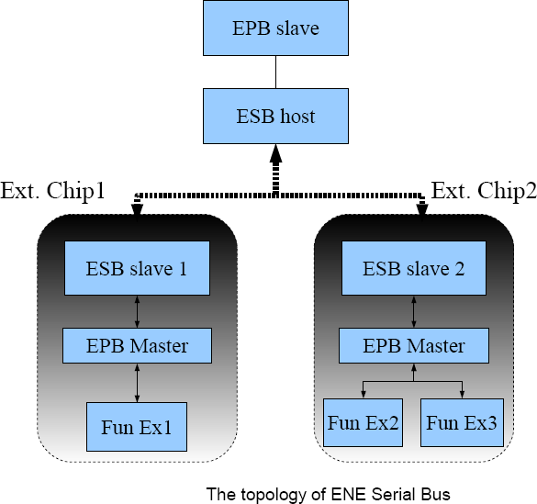

## ESB Registers Description

|  |  |  |  |  |  |  |
| --- | --- | --- | --- | --- | --- | --- |
| **ESB Configuration** | | | | | | |
| **Offset** | **Name** | **Bit** | **Type** | **Description** | **Default** | **Bank** |
| 0x90 | ESBCFG | 7 | R/W | Loop back test enable  **0**: Disable  **1**: Enable | 0x00 | 0xFC |
| 6-5 | R/W | ESB clock selection.  **00**: (main clock) / 8 (2MHz)  **01**: (main clock) / 4 (4MHz)  **10**: (main clock) / 2 (8MHz)  **11**: (main clock) / 1 (16MHz) |
| 4 | R/W | External device access mode.  **0**: Access external device via 4 predefined memory ranges. (automatic mode)  **1**: Access external devices via **ESBCA**, **ESBCD** and **ESBRD**  registers. (byte mode) |
| 3 | R/W | ESB clock output enable  **0**: Disable  **1**: Enable |
| 2 | R/W | ESB interrupt enable  **0**: Disable  **1**: Enable |
| 1 | R/W | ESB host queries device interrupt status automatically. (when  **ESBCFG**[3]=1)  **0**: Disable  **1**: Enable |
| 0 | R/W | ESB function enable  **0**: Disable  **1**: Enable w |

|  |  |  |  |  |  |  |
| --- | --- | --- | --- | --- | --- | --- |
| **ESB Command and Status** | | | | | | |
| **Offset** | **Name** | **Bit** | **Type** | **Description** | **Default** | **Bank** |
| 0x91 | ESBCS | 7 | RSV | Reserved | 0x00 | 0xFC |
| 6 | R/W1C | Device resume signal flag  **0**: no event  **1**: event occurs. |
| 5 | R/W1C | ESB bus timeout status  **0**: no timeout event  **1**: bus timeout |
| 4 | R/W1C | Device data received status.  **0**: no data received  **1**: data received. |
| 3 | R | ESB host busy flag.  **0**: not busy  **1**: host busy |
| 2 | W | Start to send command, command byte in **ESBCD**, 0xFC94 Please write “0” will not work.  **1**: send command |
| 1-0 | R/W | ESB access command type (while **ESBCFG**[3]=1) **00**: interrupt query  **01**: read  **10**: write  **11**: Reserved |

w

|  |  |  |  |  |  |  |
| --- | --- | --- | --- | --- | --- | --- |
| **ESB Interrupt Enable of External Device** | | | | | | |
| **Offset** | **Name** | **Bit** | **Type** | **Description** | **Default** | **Bank** |
| 0x92 | ESBINTE | 7 | RSV | Reserved | 0x00 | 0xFC |
| 6 | R/W | Device resume signal interrupt enable  **0**: Disable  **1**: Enable |
| 5 | R/W | Bus timeout interrupt enable  **0**: Disable  **1**: Enable |
| 4 | R/W | Device data received interrupt enable  **0**: Disable  **1**: Enable |
| 3 | R/W | Interrupt enable (IRQ3) of external ESB device.  **0**: Disable  **1**: Enable |
| 2 | R/W | Interrupt enable (IRQ2) of external ESB device.  **0**: Disable  **1**: Enable |
| 1 | R/W | Interrupt enable (IRQ1) of external ESB device.  **0**: Disable  **1**: Enable |
| 0 | R/W | Interrupt enable (IRQ0) of external ESB device.  **0**: Disable  **1**: Enable |

|  |  |  |  |  |  |  |
| --- | --- | --- | --- | --- | --- | --- |
| **ESB Command Address** | | | | | | |
| **Offset** | **Name** | **Bit** | **Type** | w **Description** | **Default** | **Bank** |
| 0x93 | ESBCA | 7-0 | R/W | External ESB device address to be accessed. (when  **ESBCFG**[3]=1)  The address is predefined according to different device. | 0x00 | 0xFC |

|  |  |  |  |  |  |  |
| --- | --- | --- | --- | --- | --- | --- |
| **ESB Command Data** | | | | | | |
| **Offset** | **Name** | **Bit** | **Type** | **Description** | **Default** | **Bank** |
| 0x94 | ESBCD | 7-0 | R/W | Write data port to external ESB device (when **ESBCFG**[3]=1) | 0x00 | 0xFC |

|  |  |  |  |  |  |  |
| --- | --- | --- | --- | --- | --- | --- |
| **ESB Received Data** | | | | | | |
| **Offset** | **Name** | **Bit** | **Type** | **Description** | **Default** | **Bank** |
| 0x95 | ESBRD | 7-0 | R/W | Read data port to external ESB device (when **ESBCFG**[3]=1)  If loop back test enabled, ESBCFG[7]=1, the register will be writable, otherwise, read-only. | 0x00 | 0xFC |

|  |  |  |  |  |  |  |
| --- | --- | --- | --- | --- | --- | --- |
| **ESB Enable for External Device** | | | | | | |
| **Offset** | **Name** | **Bit** | **Type** | **Description** | **Default** | **Bank** |
| 0x96 | ESBED | 7-5 | RSV | Reserved | 0x00 | 0xFC |
|  |  | 4 | R/W | Low clock mode enable (clock source 32KHz) |  |  |
|  |  |  |  | For performance and power saving consideration, while low |  |  |
|  |  |  |  | clock mode enabled, please set the query function off. |  |  |
|  |  |  |  | **0**: Disable |  |  |
|  |  |  |  | **1**: Enable |  |  |
|  |  | 3 | R/W | Enable external ESB device decoding address 0xFEE0~0xFEFF |  |  |
|  |  |  |  | **0**: Disable |  |  |
|  |  |  |  | **1**: Enable |  |  |
|  |  | 2 | R/W | Enable external ESB device decoding address 0xFCC0~0xFCCF |  |  |
|  |  |  |  | **0**: Disable |  |  |
|  |  |  |  | **1**: Enable |  |  |
|  |  | 1 | R/W | Enable external ESB device decoding address 0xFCB0~0xFCBF |  |  |
|  |  |  |  | **0**: Disable |  |  |
|  |  |  |  | **1**: Enable |  |  |
|  |  | 0 | R/W | Enable external ESB device decoding address 0xFD00~0xFDFF. |  |  |
|  |  |  |  | **0**: Disable |  |  |
|  |  |  |  | **1**: Enable |  |  |

|  |  |  |  |  |  |  |
| --- | --- | --- | --- | --- | --- | --- |
| **ESB Interrupt Event Pending Flag for External Chip** | | | | | | |
| **Offset** | **Name** | **Bit** | **Type** | **Description** | **Default** | **Bank** |
| 0x97 | ESBINT | 7 | R/W1C | Interrupt event pending flag of IRQ7 (cascade mode only)  [www.DataSheet.net/](http://www.DataSheet.net/)  **0**: no event  **1**: event occurs | 0x00 | 0xFC |
| 6 | R/W1C | Interrupt event pending flag of IRQ6 (cascade mode only)  **0**: no event  **1**: event occurs |
| 5 | R/W1C | I Interrupt event pending flag of IRQ5 (cascade mode only)  **0**: no event  **1**: event occurs |
| 4 | R/W1C | Interrupt event pending flag of IRQ4 (cascade mode only)  **0**: no event  **1**: event occurs |
| 3 | R/W1C | Interrupt event pending flag of IRQ3  **0**: no event  **1**: event occurs |
| 2 | R/W1C | Interrupt event pending flag of IRQ2  **0**: no event  **1**: event occurs |
| 1 | R/W1C | Interrupt event pending flag of IRQ1  **0**: no event  **1**: event occurs |
| 0 | R/W1C | Interrupt event pending flag of IRQ0  **0**: no event  **1**: event occurs |

|  |  |  |  |  |  |  |
| --- | --- | --- | --- | --- | --- | --- |
| **ESB Cascade Mode Configuration** | | | | | | |
| **Offset** | **Name** | **Bit** | **Type** | **Description** | **Default** | **Bank** |
| 0x98 | ESBCAS | 7 | R/W | Interrupt enable of IRQ7 for external chip  **0**: disable  **1**: enable | 0x00 | 0xFC |
| 6 | R/W | Interrupt enable of IRQ6 for external chip  **0**: disable  **1**: enable |
| 5 | R/W | Interrupt enable of IRQ5 for external chip  **0**: disable  **1**: enable |
| 4 | R/W | Interrupt enable of IRQ4 for external chip  **0**: disable  **1**: enable |
| 3-1 | RSV | Reserved |
| 0 | R/W | Cascade mode enable  **0**: disable  **1**: enable |

[www.DataSheet.net/](http://www.DataSheet.net/)

## ESB Programming Sample

In this section gives some programming sample to control ESB module. Please note, ENE does not guarantee these codes in every field application. The following table describes scenario of ESB filed application.

w

## Reserved

### This page is leaved blank intentionally.

[www.DataSheet.net/](http://www.DataSheet.net/)

## PECI

## PECI Functional Description

The **Platform Environment Control Interface (PECI)** is a one-wire bus interface that provides a communication channel between Intel processor and chipset components to external monitoring devices. The PECI is a subset of SST**(Simple Serial Transport)** application. The PECI specification provides information for electrical requirements, platform topologies, power management handling, bus device enumeration, commands and addressing for Intel based system.

Please be noted that the PECI enable bit is in GPIO_MISC2, and should be set properly before PECI start to work.

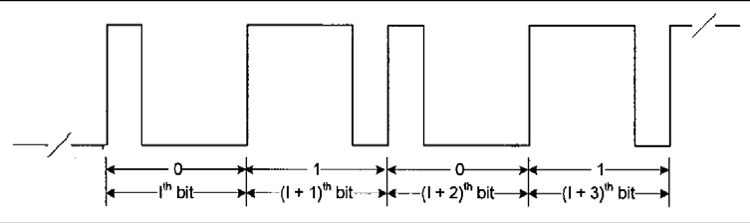

Figure 4.6.1 Example stream of 4 bits: “0101”

(Logic ‘0’ encodes into 1000 pulse; Logic ‘1’ encodes into 1110 pulse)

[www.DataSheet.net/](http://www.DataSheet.net/)





Figure 4.6.2 Conceptual Block Diagram for PECI application

## PECI Register Description (Base address = FCD0h, 16 bytes)

|  |  |  |  |  |  |  |
| --- | --- | --- | --- | --- | --- | --- |
| **PECI function configuration** | | | | | | |
| **Offset** | **Name** | **Bit** | **Type** | **Description** | **Default** | **Bank** |
| 0xD0 | PECICFG | 7~6 | R/W | PECI operation frequency Selection, default support highest speed. | 0x00 | 0xFC |
|  |  |  |  | **00**: 2M ~ 15.6k Hz |  |  |
|  |  |  |  | **01**: 1M ~ 7.8k Hz |  |  |
|  |  |  |  | **10**: 0.5M ~ 3.9k Hz |  |  |
|  |  |  |  | **11**: 0.25M ~ 2k Hz |  |  |
|  |  | 5 | RSV | Reserved |  |  |
|  |  | 4 | R/W | Slow clock at idle state disable (for low power) |  |  |
|  |  |  |  | **0**: enable |  |  |
|  |  |  |  | **1**: disable |  |  |
|  |  | 3 | R/W | PECI Interrupt Enable (total enable) |  |  |
|  |  | 2 | R/W | Stealth cycle at quarter tBIT time |  |  |
|  |  |  |  | **0**: disable |  |  |
|  |  |  |  | **1**: enable |  |  |
|  |  |  |  | This bit is set, then quarter tBIT time will be reduced 1T. |  |  |
|  |  | 1 | RSV | Reserved |  |  |
|  |  | 0 | R/W | PECI function enable |  |  |
|  |  |  |  | PECI state machine will come back to idle state, when this bit is |  |  |
|  |  |  |  | disabled. |  |  |

|  |  |  |  |  |  |  |
| --- | --- | --- | --- | --- | --- | --- |
| **PECI function control** | | | | | | |
| **Offset** | **Name** | **Bit** | **Type** | [www.DataSheet.net/](http://www.DataSheet.net/) **Description** | **Default** | **Bank** |
| 0xD1 | PECICTL | 7~3 | RSV | Reserve | 0x00 | 0xFC |
| 2 | RSV | Reserve |
| 1 | R/W | Issue abort command  This bit will be auto clear when abort behavior finish.  The originator can't abort message when receives data state. |
| 0 | R/W | Issue package to client  This bit will be auto clear when package transfer finish. |

|  |  |  |  |  |  |  |
| --- | --- | --- | --- | --- | --- | --- |
| **PECI status observation** | | | | | | |
| **Offset** | **Name** | **Bit** | **Type** | **Description** | **Default** | **Bank** |
| 0xD2 | PECIST | 7~6 | RSV | Reserved | 0x01 | 0xFC |
| 5 | RO | TX active flag for transmitter state |
| 4 | RO | RX active flag for receiver state |
| 3 | RO | PECI bus line status for debugging |
| 2 | RO | Bus busy |
| 1 | RO | FIFO full flag for write/read state |
| 0 | RO | FIFO empty flag for write/read state |

|  |  |  |  |  |  |  |
| --- | --- | --- | --- | --- | --- | --- |
| **PECI interrupt enable control** | | | | | | |
| **Offset** | **Name** | **Bit** | **Type** | **Description** | **Default** | **Bank** |
| 0xD3 | PECIINTE | 7 | R/W | PECI data input de-bounce enable  **0**: no de-bounce  **1**: de-bounce enable | 0x00 | 0xFC |
| 6 | R/W | PECI output enable selection  **0**: normal mode  PECI output enable high, when issue package  **1**: PECI output enable always high |
| 5 | R/W | PECI output data selection  **0**: normal mode  **1**: PECI output data always high for debugging |
| 4 | RSV | Reserved |
| 3 | R/W | Interrupt Enable of Client Abort |
| 2 | R/W | Interrupt Enable of FCS fault |
| 1 | R/W | Interrupt Enable of FIFO half |
| 0 | R/W | Interrupt Enable of FIFO error |

www.DataSheet.net/

|  |  |  |  |  |  |  |
| --- | --- | --- | --- | --- | --- | --- |
| **PECI target address** | | | | | | |
| **Offset** | **Name** | **Bit** | **Type** | **Description** | **Default** | **Bank** |
| 0xD5 | PECIADR | 7~0 | R/W | This is the address of the PECI device targeted to receive a message. | 0x00 | 0xFC |

|  |  |  |  |  |  |  |
| --- | --- | --- | --- | --- | --- | --- |
| **PECI write length byte** | | | | | | |
| **Offset** | **Name** | **Bit** | **Type** | **Description** | **Default** | **Bank** |
| 0xD6 | PECIWLB | 7~0 | R/W | The Write Length byte in the PECI header is used to convey the number of bytes the originator will send to the target device. The length byte includes command and data byte. | 0x00 | 0xFC |

|  |  |  |  |  |  |  |
| --- | --- | --- | --- | --- | --- | --- |
| **PECI read length byte** | | | | | | |
| **Offset** | **Name** | **Bit** | **Type** | **Description** | **Default** | **Bank** |
| 0xD7 | PECIRLB | 7~0 | R/W | The Read Length byte is used by the target to determine the number of data bytes it must supply to the originator before  Returning the FCS over that data. | 0x00 | 0xFC |

|  |  |  |  |  |  |  |
| --- | --- | --- | --- | --- | --- | --- |
| **PECI write data byte** | | | | | | |
| **Offset** | **Name** | **Bit** | **Type** | **Description** | **Default** | **Bank** |
| 0xD8 | PECIWD | 7~0 | R/W | PECI Write data. This includes both commands and data. All commands require at least one Command byte with the exception of Ping(). | 0x00 | 0xFC |

|  |  |  |  |  |  |  |
| --- | --- | --- | --- | --- | --- | --- |
| **PECI read data byte** | | | | | | |
| **Offset** | **Name** | **Bit** | **Type** | **Description** | **Default** | **Bank** |
| 0xD9 | PECIRD | 7~0 | RO | PECI Received (Read) data from client devices. | 0x00 | 0xFC |

|  |  |  |  |  |  |  |
| --- | --- | --- | --- | --- | --- | --- |
| **PECI received FCS value** | | | | | | |
| **Offset** | **Name** | **Bit** | **Type** | **Description** | **Default** | **Bank** |
| 0xDA | PECICFCS | 7~0 | RO | The FCS value received from client | 0x00 | 0xFC |

|  |  |  |  |  |  |  |
| --- | --- | --- | --- | --- | --- | --- |
| **PECI generated FCS value** | | | | | | |
| **Offset** | **Name** | **Bit** | **Type** | **Description** | **Default** | **Bank** |
| 0xDB | PECIOFCS | 7~0 | RO | [www.DataSheet.net/](http://www.DataSheet.net/)  The FCS value generated from originator | 0x00 | 0xFC |

|  |  |  |  |  |  |  |
| --- | --- | --- | --- | --- | --- | --- |
| **PECI tbit counter value observation** | | | | | | |
| **Offset** | **Name** | **Bit** | **Type** | **Description** | **Default** | **Bank** |
| 0xDC | PECIQTB | 7~0 | RO | The counter value of quarter tBIT time for debugging | 0x01 | 0xFC |

|  |  |  |  |  |  |  |
| --- | --- | --- | --- | --- | --- | --- |
| **PECI FIFO write/read pointer observation** | | | | | | |
| **Offset** | **Name** | **Bit** | **Type** | **Description** | **Default** | **Bank** |
| 0xDD | PECIPOIN | 7~4 | RO | FIFO Read Pointer  FIFO read pointer points to the location in the FIFO to read from next | 0x00 | 0xFC |
| 3~0 | RO | FIFO Write Pointer  FIFO write pointer points to the location in the FIFO to write to next |

## OWM

**4.7.1 OWM Functional Description**

OWM is called One Wire Bus Master Interface (GPIO0A).

OWM supports Dallas One Wire Bus Master and TI HDQ protocol. OWM supports Reset/Break, Read and Write command.

Separate 8-bit read and write buffers.

Configurable timing registers can be setting by F/W.

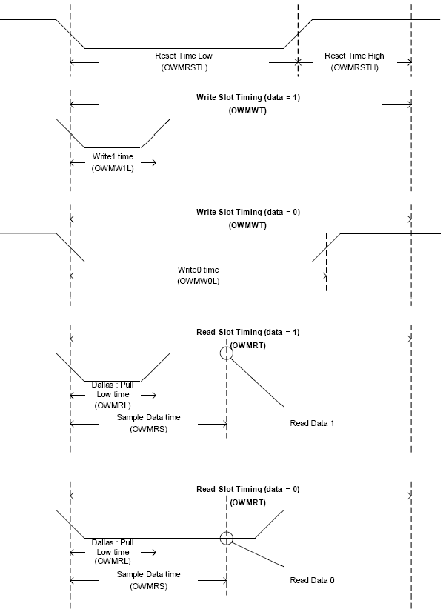

|  |  |  |  |  |  |  |
| --- | --- | --- | --- | --- | --- | --- |
| **OWM bus master configuration** | | | | | | |
| **Offset** | **Name** | **Bit** | **Type** | **Description** | **Default** | **Bank** |
| 0xF0 | OWMCFG | 7 | R/W | **EN** : One Wire Bus Master Interface Enable | 0x00 | 0xFC |
|  |  |  |  | **0**: Disable One Wire Bus Master Interface |  |  |
|  |  |  |  | **1**: Enable One Wire Bus Master Interface |  |  |
|  |  | 6 | R/W | TI/Dallas Mode Select |  |  |
|  |  |  |  | **1**: TI mode |  |  |
|  |  |  |  | **0**: Dallas mode |  |  |
|  |  | 5~4 | RSV | Reserved |  |  |
|  |  | 3 | R/W | **ETMOI**: Enable Timeout Interrupt. |  |  |
|  |  |  |  | Interrupt occurs if timeout interrupt flag is set |  |  |
|  |  |  |  | **0**: Disable |  |  |
|  |  |  |  | **1**: Enable |  |  |
|  |  | 2 | R/W | **EWRI**: Enable Write Command Complete Interrupt. |  |  |
|  |  |  |  | Interrupt occurs if write command complete flag is set |  |  |
|  |  |  |  | **0**: Disable |  |  |
|  |  |  |  | **1**: Enable |  |  |
|  |  | 1 | R/W | **ERDI**: Enable Read Command Complete Interrupt. |  |  |
|  |  |  |  | Interrupt occurs if read command complete flag is set |  |  |
|  |  |  |  | **0**: Disable |  |  |
|  |  |  |  | **1**: Enable |  |  |
|  |  | 0 | R/W | **ERSTI**: Enable Reset/Break Completely Interrupt. |  |  |
|  |  |  |  | Interrupt occurs if reset/break complete flag is set |  |  |
|  |  |  |  | **0**: Disable |  |  |
|  |  |  |  | **1**: Enable |  |  |

[www.DataSheet.net/](http://www.DataSheet.net/)

|  |  |  |  |  |  |  |
| --- | --- | --- | --- | --- | --- | --- |
| **OWM bus master status** | | | | | | |
| **Offset** | **Name** | **Bit** | **Type** | **Description** | **Default** | **Bank** |
| 0xF1 | OWMSR | 7 | RO | **BSY** : One Wire Host Busy Status  **0**: Idle  **1**: Busy | 0x00 | 0xFC |
| 6~5 | RO | Reserved |
| 4 | RO | **PDR**: Presence Detect Result. (for Dallas Only)  The detect result status of the presence detect when reset/break complete interrupt occurs.  **0**: Not Exist  **1**: Exist |
| 3 | R/W1C | **TMO**: Timeout flag of read/write command for slave response.  **0**: No timeout event  **1**: Timeout event |
| 2 | R/W1C | **WRC**: Status flag of write command for operation completion  **0**: Write command not complete  **1**: Write command complete |
| 1 | R/W1C | **RDC** : Status flag of read command for operation completion  **0**: Read command not complete  **1**: Read command complete |
| 0 | R/W1C | **RSTC**: Status flag of reset/break for operation completion  **0**: Reset/Break command not complete  **1**: Reset/Break command complete  (Set when the reset high time reached after reset low time ) |

|  |  |  |  |  |  |  |
| --- | --- | --- | --- | --- | --- | --- |
| **OWM bus master command** | | | | | | |
| **Offset** | **Name** | **Bit** | **Type** | **Description** | **Default** | **Bank** |
| 0xF2 | OWMCMD | 7~2 | RSV | Reserved | 0x03 | 0xFC |
| 1~0 | R/W | One Wire Interface Command  **00**: Reset /Break  **01**: Read  **10**: Write  **11**: No operation |

|  |  |  |  |  |  |  |
| --- | --- | --- | --- | --- | --- | --- |
| **OWM bus master write data buffer (transmit)** | | | | | | |
| **Offset** | **Name** | **Bit** | **Type** | **Description** | **Default** | **Bank** |
| 0xF3 | OWMWB | 7~0 | R/W | The transmit data buffer send to a slave device | 0x00 | 0xFC |
| **OWM bus master read data buffer (receive)** | | | | | | |
| **Offset** | **Name** | **Bit** | **Type** | **Description** | **Default** | **Bank** |
| 0xF4 | OWMRB | 7~0 | RO | The receive data buffer got from a slave device | 0x00 | 0xFC |

|  |  |  |  |  |  |  |
| --- | --- | --- | --- | --- | --- | --- |
| **OWM reset/break low timing** | | | | | | |
| **Offset** | **Name** | **Bit** | **Type** | **Description** | **Default** | **Bank** |
| 0xF5 | OWMRSTL | 7 | RSV | Reserved | 0x40 | 0xFC |
| 6~0 | R/W | The Reset Time Low interval,, Clock time base = 8us |
| **OWM reset/break high timing** | | | | | | |
| **Offset** | **Name** | **Bit** | **Type** | [www.DataSheet.net/](http://www.DataSheet.net/)  **Description** | **Default** | **Bank** |
| 0xF6 | OWMRSTH | 7 | RSV | Reserved | 0x40 | 0xFC |
| 6~0 | R/W | The Reset Time High interval Clock time base = 8us |

|  |  |  |  |  |  |  |
| --- | --- | --- | --- | --- | --- | --- |
| **OWM write slot timing** | | | | | | |
| **Offset** | **Name** | **Bit** | **Type** | **Description** | **Default** | **Bank** |
| 0xF7 | OWMWT | 7~0 | R/W | Write 1-bit Data time interval Clock time base = 2us | 0x2D | 0xFC |
| **OWM write 1 low timing** | | | | | | |
| **Offset** | **Name** | **Bit** | **Type** | **Description** | **Default** | **Bank** |
| 0xF8 | OWMW1L | 7~0 | R/W | Write 1 time interval Clock time base = 1us | 0x0A | 0xFC |
| **OWM write 0 low timing** | | | | | | |
| **Offset** | **Name** | **Bit** | **Type** | **Description** | **Default** | **Bank** |
| 0xF9 | OWMW0L | 7~0 | R/w | Write 0 time interval Clock time base = 1us | 0x50 | 0xFC |

|  |  |  |  |  |  |  |
| --- | --- | --- | --- | --- | --- | --- |
| **OWM read slot timing** | | | | | | |
| **Offset** | **Name** | **Bit** | **Type** | **Description** | **Default** | **Bank** |
| 0xFA | OWMRT | 7 | R/W | Host Read 1-bit Data time, clock time base = 2us . | 0x2D | 0xFC |
| **OWM read low timing** | | | | | | |
| **Offset** | **Name** | **Bit** | **Type** | **Description** | **Default** | **Bank** |
| 0xFB | OWMRL | 7~4 | RSV | Reserved | 0x03 | 0xFC |
| 3~0 | R/W | For Dallas only, Host to pull low time Clock time base = 1us |

|  |  |  |  |  |  |  |
| --- | --- | --- | --- | --- | --- | --- |
| **OWM read sample timing** | | | | | | |
| **Offset** | **Name** | **Bit** | **Type** | **Description** | **Default** | **Bank** |
| 0xFC | OWMRS | 7~0 | R/W | The time interval for Host to check read data 0 or 1, Clock time base = 1us. | 0x14 | 0xFC |

[www.DataSheet.net/](http://www.DataSheet.net/)

## Pulse Width Modulation (PWM)

## PWM Function Description

Pulse width modulation (PWM) is a powerful technique for controlling analog circuits with a processor’s digital outputs. PWM is employed in a wide variety of applications, ranging from measurement and communications to power control and conversion.

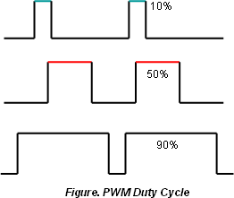The KBC supports 4 PWM channels. 2 channels (PWM0/PWM1) are for 8-bit resolution and 2 channels (PWM2/PWM3) are for 14-bit resolution. The PWM provides clock source selection which is defined in the register description.

. The duty cycle of PWM is illustrated as the above figure. The following table summarizes the relationship about the applications with the definw ition in the PWM registers description.

For the limitation of current design, in some critical cases, the PWM output will be the one as the following table.

## PWM Registers Description

|  |  |  |  |  |  |  |
| --- | --- | --- | --- | --- | --- | --- |
| **PWM Configuration** | | | | | | |
| **Offset** | **Name** | **Bit** | **Type** | **Description** | **Default** | **Bank** |
| 0x00 | PWMCFG | 7-6 | R/W | PWM1 clock source selection | 0x00 | 0xFE |
|  |  |  |  | **0**: 0.976μs (1μs) |  |  |
|  |  |  |  | **1**: 62.5μs (64μs) |  |  |
|  |  |  |  | **2**: 250μs (256μs) |  |  |
|  |  |  |  | **3**: 3.99ms (4ms) |  |  |
|  |  | 5 | RSV | Reserved |  |  |
|  |  | 4 | R/W | PWM1 Enable |  |  |
|  |  |  |  | **0**: Disable |  |  |
|  |  |  |  | **1**: Enable |  |  |
|  |  | 3-2 | R/W | PWM0 clock source selection |  |  |
|  |  |  |  | **0**: 0.976μs (1μs) |  |  |
|  |  |  |  | **1**: 62.5μs (64μs) |  |  |
|  |  |  |  | **2**: 250μs (256μs) |  |  |
|  |  |  |  | **3**: 3.99ms (4ms) |  |  |
|  |  | 1 | RSV | Reserved |  |  |
|  |  | 0 | R/W | PWM0 Enable |  |  |
|  |  |  |  | **0**: Disable |  |  |
|  |  |  |  | **1**: Enable |  |  |

|  |  |  |  |  |  |  |
| --- | --- | --- | --- | --- | --- | --- |
| **PWM0 High Period Length** | | | | | | |
| **Offset** | **Name** | **Bit** | **Type** | **Description** | **Default** | **Bank** |
| 0x01 | PWMHIGH0 | 7-0 | R/W | High Period Length of PWM0.  This should be smallweww.DataSrheet.net/ than Cycle Length. | 0x00 | 0xFE |

|  |  |  |  |  |  |  |
| --- | --- | --- | --- | --- | --- | --- |
| **PWM0 Cycle Length** | | | | | | |
| **Offset** | **Name** | **Bit** | **Type** | **Description** | **Default** | **Bank** |
| 0x02 | PWMCYC0 | 7-0 | R/W | Cycle Length of PWM0. | 0x00 | 0xFE |

|  |  |  |  |  |  |  |
| --- | --- | --- | --- | --- | --- | --- |
| **PWM1 High Period Length** | | | | | | |
| **Offset** | **Name** | **Bit** | **Type** | **Description** | **Default** | **Bank** |
| 0x03 | PWMHIGH1 | 7-0 | R/W | High Period Length of PWM1.  This should be smaller than Cycle Length. | 0x00 | 0xFE |

|  |  |  |  |  |  |  |
| --- | --- | --- | --- | --- | --- | --- |
| **PWM1 Cycle Length** | | | | | | |
| **Offset** | **Name** | **Bit** | **Type** | **Description** | **Default** | **Bank** |
| 0x04 | PWMCYC1 | 7-0 | R/W | Cycle Length of PWM1 | 0x00 | 0xFE |

|  |  |  |  |  |  |  |
| --- | --- | --- | --- | --- | --- | --- |
| **Reserved** | | | | | | |
| **Offset** | **Name** | **Bit** | **Type** | **Description** | **Default** | **Bank** |
| 0x05 | RSV | 7-0 | RSV | RSV | 0x00 | 0xFE |

|  |  |  |  |  |  |  |
| --- | --- | --- | --- | --- | --- | --- |
| **PWM2 Configuration** | | | | | | |
| **Offset** | **Name** | **Bit** | **Type** | **Description** | **Default** | **Bank** |
| 0x06 | PWMCFG2 | 7 | R/W | PWM2 Enable  **0**: Disable  **1**: Enable | 0x00 | 0xFE |
| 6 | R/W | PWM2 pre-scaler clock selection  **0**: peripheral clock  **1**: 1MHz clock (fixed) |
| 5-0 | R/W | The 6-bit pre-scaler of PWM2  The pre-scalar value = register value + 1 |

|  |  |  |  |  |  |  |
| --- | --- | --- | --- | --- | --- | --- |
| **PWM3 Configuration** | | | | | | |
| **Offset** | **Name** | **Bit** | **Type** | **Description** | **Default** | **Bank** |
| 0x07 | PWMCFG3 | 7 | R/W | PWM3 Enable  **0**: Disable  **1**: Enable | 0x00 | 0xFE |
| 6 | R/W | PWM3 pre-scaler clock selection  **0**: peripheral clock  **1**: 1MHz clock (fixed) |
| 5-0 | R/W | The 6-bit pre-scaler of PWM3  The pre-scaler value = register value + 1 |

|  |  |  |  |  |  |  |
| --- | --- | --- | --- | --- | --- | --- |
| **PWM2 High Period Length (14-bit)** | | | | | | |
| **Offset** | **Name** | **Bit** | **Type** | **Description** | **Default** | **Bank** |
| 0x08 | PWMHIGH2H | 5-0 | R/W | Higher 6 bits (of 14-bit)  [www.DataSheet.net/](http://www.DataSheet.net/) | 0x00 | 0xFE |
| 0x09 | PWMHIGH2L | 7-0 | R/W | Lower 8 bits (of 14-bit) | 0x00 | 0xFE |

|  |  |  |  |  |  |  |
| --- | --- | --- | --- | --- | --- | --- |
| **PWM2 Cycle Length (14-bit)** | | | | | | |
| **Offset** | **Name** | **Bit** | **Type** | **Description** | **Default** | **Bank** |
| 0x0A | PWMCYC2H | 5-0 | R/W | Higher 6 bits (of 14-bit) | 0x00 | 0xFE |
| 0x0B | PWMCYC2L | 7-0 | R/W | Lower 8 bits (of 14-bit) | 0x00 | 0xFE |

|  |  |  |  |  |  |  |
| --- | --- | --- | --- | --- | --- | --- |
| **PWM3 High Period Length (14-bit)** | | | | | | |
| **Offset** | **Name** | **Bit** | **Type** | **Description** | **Default** | **Bank** |
| 0x0C | PWMHIGH3H | 5-0 | R/W | Higher 6 bits (of 14-bit) | 0x00 | 0xFE |
| 0x0D | PWMHIGH3L | 7-0 | R/W | Lower 8 bits (of 14-bit) | 0x00 | 0xFE |

|  |  |  |  |  |  |  |
| --- | --- | --- | --- | --- | --- | --- |
| **PWM3 Cycle Length (14-bit)** | | | | | | |
| **Offset** | **Name** | **Bit** | **Type** | **Description** | **Default** | **Bank** |
| 0x0E | PWMCYC3H | 5-0 | R/W | Higher 6 bits (of 14-bit) | 0x00 | 0xFE |
| 0x0F | PWMCYC3L | 7-0 | R/W | Lower 8 bits (of 14-bit) | 0x00 | 0xFE |

## PWM Programming Sample

In this section gives some programming sample to control PWM module. Please note, ENE does not guarantee these codes in every field application. The following table describes scenario of PWM filed application.

## Fan Controller

## Fan Function Description

The KBC provides 2 interfaces with speed monitor for fan control. Two clock selections for fan controller, one is based on main clock and the other is fixed 62.5μs. The fan controller can be configured as a PWM function, as known as FANPWM.

## Fan Tachometer Monitor

The fan tachometer is implemented by a 12-bit counter with four resolution(In Reg FANSTS0/FANSTS1) as follows, 62.5μs, 31.25μs, 15.625μs, 7.8125μs. The following figure gives an example for fan speed monitor and control with 62.5 μs. The KBC uses the pin FANPWM0/1 to drive external fan device, and the fan device feedback the speed via the pin FANFB0/1. The fan controller keeps the speed in the monitor register. The fan controller will compare the speed and check if the current speed is higher or slower than the expected one. If

slower, then the controller will increase the frequency to drive FANPWM0/1 automatically, otherwise decrease the frequency. The expected speed can be programmable by F/W.

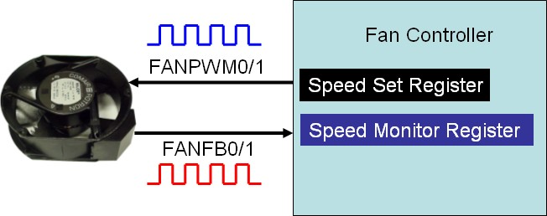

As following RPM table is given for programmers. In this table, the information between RPM and value for fan speed set is shown with 62.5μs resolution. The target speed counter value is require when fan controller is operated under auto-fan mode.

**RPM (round/min) = 60,000,000 / (FANMON *62.5)**

## FANPWM Function

The fan controller can be used as a 12-bit PWM function. While PWM function applied, the fan controller will refer to the peripheral clock, and the PWM high period and cycle time can be determined as the following formula:

***PWM Cycle Length = (PWM cycle register + 1 ) * peripheral clock resolution PWM High Period = (PWM high period register + 1 ) * peripheral clock***

Please note, to program the high pulse width of PWM (**FANPWMH0/FANPWML0** and **FANPWMH1/FANPWML1**, i.e., 0xFE26/0xFE27 and 0xFE36/0xFE37), *high-byte first and then low-byte in order.*

The fan controller could be operated in **Auto-fan** or **Fixed-fan mode**.

In Auto-fan mode, it’s required to set the Fan Speed Set Counter Value based on the table in

4.9.1.1 (Be cautious that the resolution could be different by register value)

In Fixed-fan mode, it’s required to set the PWM cycle length, PWM high period based on the formula in 4.9.1.2. By setting these registers, specific PWM frequency, duty cycle could be generated.

## Fan Registers Description

|  |  |  |  |  |  |  |
| --- | --- | --- | --- | --- | --- | --- |
| **Fan0 Configuration** | | | | | | |
| **Offset** | **Name** | **Bit** | **Type** | **Description** | **Default** | **Bank** |
| 0x20 | FANCFG0 | 7 | R/W | FAN0 monitor clock selection.  **0**: peripheral clock  **1**: the monitor base cw lock will based on FANSTS0[6:5](0xFE21) | 0x00 | 0xFE |
| 6 | R/W | FAN0 speed monitor counter edge trigger selection.  **0**: count pulse event on rising edge.  **1**: count pulse event on rising and falling edge. |
| 5 | R/W | FANPWM0 cycle width enable  **0**: Disable  **1**: Enable |
| 4 | R/W | FANPWM0 enable.  **0**: Disable  **1**: Enable |
| 3 | R/W | FAN0 speed monitor interrupt enable  **0**: Disable  **1**: Enable |
| 2 | R/W | FAN0 speed monitor timeout error interrupt enable  **0**: Disable  **1**: Enable |
| 1 | R/W | Auto-fan mode control enable.  FANCFG0[0] and FANCFG0[4] should be set at the same time to make it work. (The tachometer is required for feedback, PWM should also be enabled)  **0**: Disable  **1**: Enable |
| 0 | R/W | FAN0 tachometer monitor enable.  **0**: Disable  **1**: Enable |

|  |  |  |  |  |  |  |
| --- | --- | --- | --- | --- | --- | --- |
| **Fan0 Control and Status Register** | | | | | | |
| **Offset** | **Name** | **Bit** | **Type** | **Description** | **Default** | **Bank** |
| 0x21 | FANSTS0 | 7 | R/W | FAN0 auto-load FANCPWM function enable  **0**: Disable  **1**: Enable | 0x00 | 0xFE |
| 6-5 | R/W | FANPWM clock resolution selection.  FANCFG0[7](0xFE20) should be set for selection take effect  **00**: 62.5us (default)  **01**: 31.25us  **10**: 15.625us  **11**: 7.8125us |
| 4 | R/W | FAN0 digital noise filter enable.  **0**: Disable  **1**: Enable |
| 3-2 | RSV | Reserved |
| 1 | R/W1C | Flag of FAN0 speed monitor timeout error  **0**: no timeout error  **1**: timeout error event |
| 0 | R/W1C | Flag of FAN0 speed monitor update event.  **0**: no update event.  **1**: update event |

www.DataSheet.net/

|  |  |  |  |  |  |  |
| --- | --- | --- | --- | --- | --- | --- |
| **Fan0 Speed Set Counter Value (12-bit)** | | | | | | |
| **Offset** | **Name** | **Bit** | **Type** | **Description** | **Default** | **Bank** |
| 0x24 | FANSETH0 | 3-0 | R/W | High 4 bits of target FAN0 speed counter value. | 0x00 | 0xFE |
| 0x25 | FANSETL0 | 7-0 | R/W | Low 8 bits of target FAN0 speed counter value. | 0x00 | 0xFE |
| Notice: These two registers are used in auto-fan mode and are set as target fan speed counter value | | | | | | |

|  |  |  |  |  |  |  |
| --- | --- | --- | --- | --- | --- | --- |
| **FANPWM0 High Pulse Width Bits (12-bit)** | | | | | | |
| **Offset** | **Name** | **Bit** | **Type** | **Description** | **Default** | **Bank** |
| 0x26 | FANPWMH0 | 3-0 | R/W | High 4 bits of FANPWM0 high pulse width. (FANCFG0[1]=0 only) | 0x00 | 0xFE |
| 0x27 | FANPWML0 | 7-0 | R/W | Low 8 bits of FANPWM0 high pulse width. (FANCFG0[1]=0 only) | 0x00 | 0xFE |
| Notice: These two registers are used in fixed-fan mode and are set as target FANPWM width to change effective fan speed  ***PWM high period = (PWM high pulse register + 1) * peripheral clock*** | | | | | | |

|  |  |  |  |  |  |  |
| --- | --- | --- | --- | --- | --- | --- |
| **Current FANPWM0 High Pulse Width Bits (12-bit)** | | | | | | |
| **Offset** | **Name** | **Bit** | **Type** | **Description** | **Default** | **Bank** |
| 0x28 | FANCPWMH0 | 3-0 | RO | High 4 bits of current FANPWM0 high pulse width. | 0x00 | 0xFE |
| 0x29 | FANCPWML0 | 7-0 | RO | Low 8 bits of current FANPWM0 high pulse width. | 0x00 | 0xFE |

|  |  |  |  |  |  |  |
| --- | --- | --- | --- | --- | --- | --- |
| **Offset** | **Name** | **Bit** | **Type** | **Description** | **Default** | **Bank** |
| 0x2A | FANPWMCH0 | 3-0 | R/W | High 4 bits of Cycle length of FANPWM0 (FANCFG0[5]=1) | 0x00 | 0xFE |
| 0x2B | FANPWMCHL0 | 7-0 | R/W | Low 8 bits of Cycle length of FANPWM0 (FANCFG0[5]=1) | 0x00 | 0xFE |
| Notice: These two registers are used in fixed-fan mode and are set as target FANPWM cycle  ***Cycle length = (PWM cycle register + 1 ) * peripheral clock*** | | | | | | |

|  |  |  |  |  |  |  |
| --- | --- | --- | --- | --- | --- | --- |
| **FANPWM0 Auto-Load High Pulse Width Bits** | | | | | | |
| **Offset** | **Name** | **Bit** | **Type** | **Description** | **Default** | **Bank** |
| 0x2C | FANUPWM0 | 7-4 | RSV | Reserved | 0x0F | 0xFE |
| 3-0 | R/W | If auto-load feature enabled (FANSTS0[7]=1), this register value will be auto-loaded into FANCPWMH0 registers and FANCPWML0 will be forced to be zero while monitor timeout occurs |

www.DataSheet.net/

|  |  |  |  |  |  |  |
| --- | --- | --- | --- | --- | --- | --- |
| **FAN tachometer monitor speed monitor counter value for FANFB2** | | | | | | |
| **Offset** | **Name** | **Bit** | **Type** | **Description** | **Default** | **Bank** |
| 0x2E | FANTMMONH0 | 3-0 | R/W | High 4 bits of FANFB2 speed monitor counter value | 0x0F | 0xFE |
| 0x2F | FANTMMONL0 | 7-0 | R/W | Low 8 bits of FANFB2 speed monitors counter value. | 0xFF | 0xFE |

|  |  |  |  |  |  |  |
| --- | --- | --- | --- | --- | --- | --- |
| **Fan1 Configuration** | | | | | | |
| **Offset** | **Name** | **Bit** | **Type** | **Description** | **Default** | **Bank** |
| 0x30 | FANCFG1 | 7 | R/W | FAN1 monitor clock selection.  **0**: peripheral clock  **1**: the monitor base clock will based on FANSTS1[6:5](0xFE31) | 0x00 | 0xFE |
| 6 | R/W | FAN1 speed monitor counter edge trigger selection.  **0**: count pulse event on rising edge.  **1**: count pulse event on rising and falling edge. |
| 5 | R/W | FANPWM1 cycle width enable  **0**: Disable  **1**: Enable |
| 4 | R/W | FANPWM1 enable.  **0**: Disable  **1**: Enable |
| 3 | R/W | FAN1 speed monitor interrupt enable  **0**: Disable  **1**: Enable |
| 2 | R/W | FAN1 speed monitor timeout error interrupt enable  **0**: Disable  **1**: Enable |
| 1 | R/W | Automatic FANPWM control enable.  FANCFG1[0] and FANCFG1[4] should be set at the same time to make it work. (The tachometer is required for feedback, PWM should also be enabled)  **0**: Disable  **1**: Enable |
| 0 | R/W | FAN1 tachometer monitor enable.  **0**: Disable  **1**: Enable  w |

|  |  |  |  |  |  |  |
| --- | --- | --- | --- | --- | --- | --- |
| **Fan1 Control and Status Register** | | | | | | |
| **Offset** | **Name** | **Bit** | **Type** | **Description** | **Default** | **Bank** |
| 0x31 | FANSTS1 | 7 | R/W | FAN1 auto-load FANCPWM function enable  **0**: Disable  **1**: Enable | 0x00 | 0xFE |
| 6-5 | R/W | FANPWM clock resolution selection.  FANCFG1[7](0xFE30) should be set for selection take effect  **00**: 62.5us (default)  **01**: 31.25us  **10**: 15.625us  **11**: 7.8125us |
| 4 | R/W | FAN1 digital noise filter enable.  **0**: Disable  **1**: Enable |
| 3-2 | R/W | Reserved |
| 1 | R/W | Flag of FAN1 speed monitor timeout error  **0**: no timeout error  **1**: timeout error event |
| 0 | R/W | Flag of FAN1 speed monitor update event.  **0**: no update event.  **1**: update event |

www.DataSheet.net/

|  |  |  |  |  |  |  |
| --- | --- | --- | --- | --- | --- | --- |
| **Fan1 Speed Set Counter Value (12-bit)** | | | | | | |
| **Offset** | **Name** | **Bit** | **Type** | **Description** | **Default** | **Bank** |
| 0x34 | FANSETH1 | 3-0 | R/W | High 4 bits of target FAN1 speed counter value. | 0x00 | 0xFE |
| 0x35 | FANSETL1 | 7-0 | R/W | Low 8 bits of target FAN1 speed counter value. | 0x00 | 0xFE |
| Notice: These two registers are used in auto-fan mode and are set as target fan speed counter value | | | | | | |

|  |  |  |  |  |  |  |
| --- | --- | --- | --- | --- | --- | --- |
| **FANPWM1 High Pulse Width Bits (12-bit)** | | | | | | |
| **Offset** | **Name** | **Bit** | **Type** | **Description** | **Default** | **Bank** |
| 0x36 | FANPWMH1 | 3-0 | R/W | High 4 bits of FANPWM1 high pulse width. (FANCFG1[1]=0 only) | 0x00 | 0xFE |
| 0x37 | FANPWML1 | 7-0 | R/W | Low 8 bits of FANPWM1 high pulse width. (FANCFG1[1]=0 only) | 0x00 | 0xFE |
| Notice: These two registers are used in fixed-fan mode and are set as target FANPWM width to change effective fan speed  ***PWM high period = (PWM high pulse register + 1) * peripheral clock*** | | | | | | |

|  |  |  |  |  |  |  |
| --- | --- | --- | --- | --- | --- | --- |
| **Current FANPWM1 High Pulse Width Bits (12-bit)** | | | | | | |
| **Offset** | **Name** | **Bit** | **Type** | **Description** | **Default** | **Bank** |
| 0x38 | FANCPWMH1 | 3-0 | RO | High 4 bits of current FANPWM1 high pulse width. | 0x00 | 0xFE |
| 0x39 | FANCPWML1 | 7-0 | RO | Low 8 bits of current FANPWM1 high pulse width. | 0x00 | 0xFE |

|  |  |  |  |  |  |  |
| --- | --- | --- | --- | --- | --- | --- |
| **FANPWM1 Cycle Length (12-bit)** | | | | | | |
| **Offset** | **Name** | **Bit** | **Type** | **Description** | **Default** | **Bank** |
| 0x3A | FANPWMCH1 | 3-0 | R/W | High 4 bits of Cycle length of FANPWM1 (FANCFG1[5]=1) | 0x00 | 0xFE |
| 0x3B | FANPWMCHL1 | 7-0 | R/W | Low 8 bits of Cycle length of FANPWM1 (FANCFG1[5]=1) | 0x00 | 0xFE |
| Notice: These two registers are used in fixed-fan mode and are set as target FANPWM cycle  ***Cycle length = (PWM cycle register + 1 ) * peripheral clock*** | | | | | | |

|  |  |  |  |  |  |  |
| --- | --- | --- | --- | --- | --- | --- |
| **FANPWM1 Update High Pulse Width Bits** | | | | | | |
| **Offset** | **Name** | **Bit** | **Type** | **Description** | **Default** | **Bank** |
| 0x3C | FANUPWM1 | 7-4 | RSV | Reserved | 0x0F | 0xFE |
| 3-0 | R/W | If auto-load feature enabled (FANSTS1[7]=1), this register value will be auto-loaded into FANCPWMH1 registers and FANCPWML1 will be forced to be zero while monitor timeout occurs |

|  |  |  |  |  |  |  |
| --- | --- | --- | --- | --- | --- | --- |
| **FAN tachometer monitor controller configuration for FANFB3** | | | | | | |
| **Offset** | **Name** | **Bit** | **Type** | **Description** | **Default** | **Bank** |
| 0x3D | FANTMCFG1 | 7-6 | RSV | Reserved | 0x00 | 0xFE |
|  |  | 5-4 | R/W | FAN tachometer monitor speed sample range  FANTMCFG1[1](0xFE3D) should be set for selection take effect |  |  |
|  |  |  |  | **00**: 62.5us (default) |  |  |
|  |  |  |  | **01**: 31.25us |  |  |
|  |  |  |  | **10**: 15.625us |  |  |
|  |  |  |  | **11**: 7.8125us |  |  |
|  |  | 3 | R/W1C | Flag bit for Fan tachometer monitor timeout error event. |  |  |
|  |  |  |  | **0**: no timeout errowrww.DataSheet.net/ |  |  |
|  |  |  |  | **1**: timeout error event |  |  |
|  |  | 2 | R/W | FAN digital filter enable for Fan tachometer monitor |  |  |
|  |  |  |  | **0**: Disable |  |  |
|  |  |  |  | **1**: Enable |  |  |
|  |  | 1 | R/W | Test mode enable for Fan tachometer monitor |  |  |
|  |  |  |  | **1**: the monitor base clock will be peripheral clock. |  |  |
|  |  |  |  | **0**: the monitor base clock will be based on FANTMCFG1[5:4] |  |  |
|  |  | 0 | R/W | FAN tachometer monitor enable |  |  |
|  |  |  |  | To enable addition FAN Tachometer Monitor FANFB3 |  |  |
|  |  |  |  | **0**: Disable |  |  |
|  |  |  |  | **1**: Enable |  |  |

|  |  |  |  |  |  |  |
| --- | --- | --- | --- | --- | --- | --- |
| **FAN tachometer monitor speed monitor counter value for FANFB3** | | | | | | |
| **Offset** | **Name** | **Bit** | **Type** | **Description** | **Default** | **Bank** |
| 0x3E | FANTMMONH1 | 3-0 | R/W | High 4 bits of FANFB3 speed monitor counter value | 0x0F | 0xFE |
| 0x3F | FANTMMONL1 | 7-0 | R/W | Low 8 bits of FANFB3 speed monitors counter value. | 0xFF | 0xFE |

## Fan Programming Sample

In this section gives some programming sample to control FAN module. Please note, ENE does not guarantee these codes in every field application. The following table describes scenario of FAN filed application.

## General Purpose Timer (GPT)

## GPT Function Description

The KBC provides 4 GPTs (General Purpose Timers), two 16-bit timers and two 8-bit timers. These 4 GPTs operate based on 32.768KHz and all timers have the interrupt capability. The GPT is simply a free run counter. While the timer meets the specific value in count register, for instance, 0xFE53 and 0xFE55, an interrupt issues (if interrupt enabled) and the counter reset to be zero.

* + - * GPT0 and GPT1 are 8-bit timers.
      * GPT2 and GPT3 are 16-bit timers.

## GPT Registers Description

|  |  |  |  |  |  |  |
| --- | --- | --- | --- | --- | --- | --- |
| **GPT Configuration** | | | | | | |
| **Offset** | **Name** | **Bit** | **Type** | **Description** | **Default** | **Bank** |
| 0x50 | GPTCFG | 7-5 | RSV | Reserved | 0x00 | 0xFE |
| 4 | R/W | GPT test mode enable.  In test mode, the GPT runs with main clock.  **0**: Disable  **1**: Enable |
| 3 | R/W | GPT3 counting and interrupt enable.  **0**: Disable  **1**: Enable |
| 2 | R/W | GPT2 counting and interrupt enable.  **0**: Disable w  **1**: Enable |
| 1 | R/W | GPT1 counting and interrupt enable.  **0**: Disable  **1**: Enable |
| 0 | R/W | GPT0 counting and interrupt enable.  **0**: Disable  **1**: Enable |

|  |  |  |  |  |  |  |
| --- | --- | --- | --- | --- | --- | --- |
| **GPT Pending Flag** | | | | | | |
| **Offset** | **Name** | **Bit** | **Type** | **Description** | **Default** | **Bank** |
| 0x51 | GPTPF | 7 | WO | Writing “1” to this bit forces GPT3 restart. | 0x00 | 0xFE |
| 6 | WO | Writing “1” to this bit forces GPT2 restart. |
| 5 | WO | Writing “1” to this bit forces GPT1 restart. |
| 4 | WO | Writing “1” to this bit forces GPT0 restart. |
| 3 | R/W1C | Interrupt pending flag of GPT3. |
| 2 | R/W1C | Interrupt pending flag of GPT2. |
| 1 | R/W1C | Interrupt pending flag of GPT1. |
| 0 | R/W1C | Interrupt pending flag of GPT0. |

|  |  |  |  |  |  |  |
| --- | --- | --- | --- | --- | --- | --- |
| **GPT0 Counter Value** | | | | | | |
| **Offset** | **Name** | **Bit** | **Type** | **Description** | **Default** | **Bank** |
| 0x53 | GPT0 | 7-0 | R/W | Once GPT0 counter meets this value, an interrupt issues. GPT0 restart to count from zero. | 0x00 | 0xFE |

|  |  |  |  |  |  |  |
| --- | --- | --- | --- | --- | --- | --- |
| **Reserved** | | | | | | |
| **Offset** | **Name** | **Bit** | **Type** | **Description** | **Default** | **Bank** |
| 0x54 | RSV | 7-0 | RSV | Reserved | 0x00 | 0xFE |

|  |  |  |  |  |  |  |
| --- | --- | --- | --- | --- | --- | --- |
| **GPT1 Counter Value** | | | | | | |
| **Offset** | **Name** | **Bit** | **Type** | **Description** | **Default** | **Bank** |
| 0x55 | GPT1 | 7-0 | R/W | Once GPT1 counter meets this value, an interrupt issues. GPT1 restart to count from zero. | 0x00 | 0xFE |

|  |  |  |  |  |  |  |
| --- | --- | --- | --- | --- | --- | --- |
| **GPT2 Counter Value (16-bit)** | | | | | | |
| **Offset** | **Name** | **Bit** | **Type** | **Description** | **Default** | **Bank** |
| 0x56 | GPT2H | 7-0 | R/W | High byte of GPT2 counter value  Once GPT2 counter meets this 16-bit value, an interrupt issues. GPT2 restart to count from zero. | 0x00 | 0xFE |
| 0x57 | GPT2L | 7-0 | R/W | Low byte of GPT2 counter value  Once GPT2 counter meets this 16-bit value, an interrupt issues. GPT2 restart to counwwwt.DataSheeft.netr/ om zero. | 0x00 | 0xFE |

|  |  |  |  |  |  |  |
| --- | --- | --- | --- | --- | --- | --- |
| **GPT3 Counter Value (16-bit)** | | | | | | |
| **Offset** | **Name** | **Bit** | **Type** | **Description** | **Default** | **Bank** |
| 0x58 | GPT3H | 7-0 | R/W | High byte of GPT3 counter value.  Once GPT3 counter meets this 16-bit value, an interrupt issues. GPT3 restart to count from zero. | 0x00 | 0xFE |
| 0x59 | GPT3L | 7-0 | R/W | Low byte of GPT3 counter value.  Once GPT2 counter meets this 16-bit value, an interrupt issues. GPT3 restart to count from zero. | 0x00 | 0xFE |

## GPT Programming Sample

In this section gives some programming sample to control GPT module. Please note, ENE does not guarantee these codes in every field application. The following table describes scenario of GPT filed application.

w

## SDI Host/Device Interface Controller

The SDI host/device controller can be programmed to a SPI Host or a SPI Device (0xFE74.7).

The Default is the SPI Host. The SPI Host and Device use the same IO.

## SDI Host/Device Interface Description

The Serial Peripheral Interface Bus or SPI (often pronounced “spy”) bus is a synchronous serial data link standard designed by Motorola that operates in full duplex mode. Devices communicate in master/slave mode where the master device initiates the data frame.

In KBCx930, the SDI host could support the SPI mode 0/1, and is configurable by SFICFG[1] SDI slave could support the SPI mode 0.

## SDI Host Interface Description

|  |  |  |  |  |  |  |
| --- | --- | --- | --- | --- | --- | --- |
| **SDI host interface configuration** | | | | | | |
| **Offset** | **Name** | **Bit** | **Type** | **Description** | **Default** | **Bank** |
| 0x70 | SHICFG | 7 | RO | SDI host Idle flag. If this bit set, the SDI host is in an idle state.  **0**: busy  **1**: idle | 0x00 | 0xFE |
| 6-5 | RSV | Reserved |
| 4 | R/W | SDI host SDICS# Pin Control 0 : Set SDICS# High  1 : Set SDICS# Low |
| 3-2 | R/W | SDI host CLK divider[www..DataSheet.net/](http://www.DataSheet.net/)  ***SPICLK frequency = peripheral clock / [( divider +1)*2]*** |
| 1 | R/W | SDI Host SDIMOSI/SDIMISO Timing.  **0**: SDIMOSI changes data at falling edge of SDICLK. (device latches at rising edge of SDICLK)  SDIMISO latch data at rising edge of SDICLK. (device changes at falling edge of SDICLK).  **1**: SDIMOSI changes data at rising edge of SDICLK. (device latches at falling edge of SDICLK)  SDIMISO latch data at falling edge of SDICLK. (device changes at rising edge of SDICLK). |
| 0 | R/W | SDI host controller enable  **0**: Disable  **1**: Enable |

|  |  |  |  |  |  |  |
| --- | --- | --- | --- | --- | --- | --- |
| **SDI host interface transmit data port** | | | | | | |
| **Offset** | **Name** | **Bit** | **Type** | **Description** | **Default** | **Bank** |
| 0x71 | SHITBUF | 7-0 | R/W | While SHICFG[7]=0 (SDI not busy), writing to this register  forces data output to SDIMOSI in continuously serial 8 bits. MSB first. | 0x00 | 0xFE |
| **SDI host interface receive data port** | | | | | | |
| **Offset** | **Name** | **Bit** | **Type** | **Description** | **Default** | **Bank** |
| 0x72 | SHIRBUF | 7-0 | RO | SDI host reading port. | 0x00 | 0xFE |

## SDI Device Interface Description

|  |  |  |  |  |  |  |
| --- | --- | --- | --- | --- | --- | --- |
| **SDI device interface configuration** | | | | | | |
| **Offset** | **Name** | **Bit** | **Type** | **Description** | **Default** | **Bank** |
| 0x78 | SDICFG | 7 | RO | SDICS# status | 0x44 | 0xFE |
| 6~4 | RSV | Reserved |
| 3 | R/W | SDI command mode  **0**: Disable. (Normal mode)  **1**: Enable. (Command mode)  (When enable this mode, SDICFG[2:1] would not take effect) (Configurable command : Read TX buffer in register SDICMD) |
| 2 | R/W | Enable SDI device TX.  **0**: Disable  **1**: Enable |
| 1 | R/W | Enable SDI device RX.  **0**: Disable  **1**: Enable |
| 0 | R/W | SDI device controller enable  **0**: Disable  **1**: Enable |

|  |  |  |  |  |  |  |
| --- | --- | --- | --- | --- | --- | --- |
| **SDI device interface interrupt configuration** | | | | | | |
| **Offset** | **Name** | **Bit** | **Type** | **Description** | **Default** | **Bank** |
| 0x79 | SDIRS | 7 | RSV | Reserved | 0x00 | 0xFE |
| 6 | R/W1C | (Normal mode onlwwwy.DataSh)eet.net/ Transmit buffer empty pending flag |
| 5 | R/W1C | (Normal mode only) Receive buffer full pending flag |
| 4 | R/W1C | SDICS# rising edge pending flag |
| 3 | RSV | Reserved |
| 2 | R/W | (Normal mode only) Transmit buffer empty interrupt enable bit  **0**: Disable  **1**: Enable |
| 1 | R/W | (Normal mode only) Receive buffer full interrupt enable bit  **0**: Disable  **1**: Enable |
| 0 | R/W | SDICS# rising edge interrupt enable bit  **0**: Disable  **1**: Enable |

|  |  |  |  |  |  |  |
| --- | --- | --- | --- | --- | --- | --- |
| **SDI device interface transmit status** | | | | | | |
| **Offset** | **Name** | **Bit** | **Type** | **Description** | **Default** | **Bank** |
| 0x7A | SDITSTS | 7 | RSV | Reserved | 0x00 | 0xFE |
|  |  | 6~4 | RO | ***Transmit buffer count*** |  |  |
|  |  |  |  | **In normal mode:** |  |  |
|  |  |  |  | The count is the number how many data in Tx Buffer aren’t |  |  |
|  |  |  |  | transmitted yet. |  |  |
|  |  |  |  | **In command mode:** |  |  |
|  |  |  |  | The count is the number of transmitted byte data in single |  |  |
|  |  |  |  | transition. |  |  |
|  |  | 3 | RSV | Reserved |  |  |
|  |  | 2 | R/W1C | (Normal mode only) Transmit buffer underflow flag |  |  |
|  |  | 1 | RO | (Normal mode only) Transmit buffer full flag |  |  |
|  |  | 0 | R | (Normal mode only) Transmit buffer empty flag |  |  |
|  |  |  | W | ***Write 1 to clear Tx buffer*** |  |  |
|  |  |  |  | **Normal mode:** |  |  |
|  |  |  |  | FIFO's write point and read point are both reset to point to |  |  |
|  |  |  |  | position "0". |  |  |
|  |  |  |  | **Command mode:** |  |  |
|  |  |  |  | Only FIFO's write point is reset to point to position "0". |  |  |

|  |  |  |  |  |  |  |
| --- | --- | --- | --- | --- | --- | --- |
| **SDI device interface receive status** | | | | | | |
| **Offset** | **Name** | **Bit** | **Type** | **Description** | **Default** | **Bank** |
| 0x7B | SDIRSTS | 7 | RSV | Reserved | 0x00 | 0xFE |
| 6~4 | RO | ***Receive Buffer count***  [www.DataSheet.net/](http://www.DataSheet.net/)  **Normal mode :**  The count is the number how many data in Rx Buffer aren’t read yet.  **Command mode:**  The count is the number of received byte data in single transition. |
| 3 | RSV | Reserved |
| 2 | R/W1C | (Normal mode only) Receive buffer overflow flag |
| 1 | RO | (Normal mode only) Receive buffer full flag |
| 0 | R | (Normal mode only) Receive buffer empty flag |
| W | ***Write 1 to clear Rx buffer***  **Normal mode:**  FIFO's write point and read point are both reset to point to position "0".  **Command mode:**  Only FIFO's write point is reset to point to position "0". |

|  |  |  |  |  |  |  |
| --- | --- | --- | --- | --- | --- | --- |
| **SDI device interface transmit data port** | | | | | | |
| **Offset** | **Name** | **Bit** | **Type** | **Description** | **Default** | **Bank** |
| 0x7C | SDITBUF | 7~0 | WO | ***SDI Device Interface Transmitted Data Port***  (4 bytes buffers, External SPI Host must supply SPI clock)  **Normal mode**:  Please check full flag to finish the write operation.  If the TX buffer is full, SDI will skip the newly data and preserve the previous data. If the TX buffer is empty, SDI will always Transmit data = 0x00. | 0x00 | 0xFE |

|  |  |  |  |  |  |  |
| --- | --- | --- | --- | --- | --- | --- |
| **SDI device interface receive data port** | | | | | | |
| **Offset** | **Name** | **Bit** | **Type** | **Description** | **Default** | **Bank** |
| 0x7D | SDIRBUF | 7 | RO | ***SDI Device Interface Received Data Port***  (4 bytes buffers, Read the data from the external SPI Host)  **Normal mode:**  Please check empty flag to finish the reading operation.  If the RX buffer is full, SDI will skip the newly data and preserve the previous data. If the RX buffer is empty, SDI will always read data = 0x00.  **Command mode:**  In a transaction, SDI will only receive 4 bytes data.  If over 4 bytes data, SDI will skip the newly data and preserve the previous data. We can read the RX buffer according the Rx buffer's read point. | 0x00 | 0xFE |

|  |  |  |  |  |  |  |
| --- | --- | --- | --- | --- | --- | --- |
| **Command : Read TX buffer** | | | | | | |
| **Offset** | **Name** | **Bit** | **Type** | [www.DataSheet.net/](http://www.DataSheet.net/) **Description** | **Default** | **Bank** |
| 0x7E | SDICMD | 7~0 | R/W | ***Configurable command. : Read TX buffer***  This function should be used along with SDI command mode (SDICFG[3], 0xFE78.3 = 1) | 0x5A | 0xFE |

|  |  |  |  |  |  |  |
| --- | --- | --- | --- | --- | --- | --- |
| **SDI TX/RX buffer write point and read point** | | | | | | |
| **Offset** | **Name** | **Bit** | **Type** | **Description** | **Default** | **Bank** |
| 0x7F | SDIPT | 7~6 | RO | **Normal mode:**  When writing SDI Tx buffer, write point will increase 1 until SDI Tx buffer is full.  **Command mode:**  When writing SDI Tx buffer, write point will increase 1. | 0x00 | 0xFE |
| 5~0 | RSV | Reserved |

## SDI Programming Sample

In this section gives some programming sample to control SDI module. Please note, ENE does not guarantee these codes in every field application. The following table describes scenario of SDI filed application.

## Watchdog Timer (WDT)

## WDT Function Description

A Watchdog Timer (WDT) is a hardware timing device that triggers a system reset while the system encounters any unrecoverable situation. The WDT utilizes 32.768KHz for operation. The WDT triggers the system reset in three ways.

* + - * Reset the 8051 microprocessor only.
      * Reset the whole logic, except GPIO modules.
      * Reset the whole logic, including GPIO modules.

Here gives the highlight of WDT features:

* + - * 20 bit Watchdog
      * Watchdog password protection.
      * Interrupt support.
      * WDT LED blinking support.
      * New 24 bit timer (TMR) support.

## WDT Registers Description

|  |  |  |  |  |  |  |
| --- | --- | --- | --- | --- | --- | --- |
| **WDT Configuration** | | | | | | |
| **Offset** | **Name** | **Bit** | **Type** | **Description** | **Default** | **Bank** |
| 0x80 | WDTCFG | 7 | R/W | WDT clock source sew lection  **0**: DPLL 32.768KHz source  **1**: Internal OSC or External Crystal 32.768KHz source | 0x00 | 0xFE |
| 6~4 | RSV | Reserved |
| 3 | RSV | Reserved |
| 2 | R/W | WDT test mode enable.  **0**: normal mode  **1**: test mode, clock driven by internal 32MHz. (WDTCFG[7] ignore) |
| 1 | R/W | WDT interrupt enable.  **0**: Disable  **1**: Enable |
| 0 | R/W | WDT reset enable.  Once WDT resets, two WDT pending flags are clear.  **0**: Disable  **1**: Enable |

|  |  |  |  |  |  |  |
| --- | --- | --- | --- | --- | --- | --- |
| **WDT Pending Flag** | | | | | | |
| **Offset** | **Name** | **Bit** | **Type** | **Description** | **Default** | **Bank** |
| 0x81 | WDTPF | 7-5 | RSV | Reserved | 0x00 | 0xFE |
| 1 | R/W1C | WDT interrupt flag  Once the timer counts to half of WDT (0xFE82), an interrupt occurs. If the timer counts to WDT(0xFE82), a WDT reset occurs.  **0**: no event  **1**: event occurs |
| 0 | R/W1C | WDT reset flag  Once the timer counts to WDT (0xFE82), a WDT reset occurs and this flag is set.  **0**: no event  **1**: event occurs |

|  |  |  |  |  |  |  |
| --- | --- | --- | --- | --- | --- | --- |
| **WDT High 8-bit Counter Value (for WDT reset system of 10 bits counter)** | | | | | | |
| **Offset** | **Name** | **Bit** | **Type** | **Description** | **Default** | **Bank** |
| 0x82 | WDT | 7-0 | R/W | The high 8-bits of WDT counter value. The WDT timer unit is 32ms.  Please note, fill this value at least greater than or equal **3** (>=3) for hardware limitation. | 0x00 | 0xFE |

|  |  |  |  |  |  |  |
| --- | --- | --- | --- | --- | --- | --- |
| **WDT Blinking LED Configuration** | | | | | | |
| **Offset** | **Name** | **Bit** | **Type** | **Description** | **Default** | **Bank** |
| 0x83 | LEDCFG | 7~6 | R/W | The low 2-bits of WDT counter value. The WDT timer unit is 32ms.  Please note, fill this v[www.DaataSheet.nlet/ ue](http://www.DaataSheet.nlet/ue) at least greater than or equal **3** (>=3) for hardware limitation. | 0x00 | 0xFE |
| 5-3 | RSV | Reserved |
| 2-0 | R/W | LED Blinking configuration.  **0**: LED output keeps high  **1**: LED output keeps low 500ms for every 1 sec. **2**: LED output keeps low 500ms for every 2 sec **3**: LED output keeps low 500ms for every 4 sec  **4**: LED output keeps low 500ms for every 8 sec |

|  |  |  |  |  |  |  |
| --- | --- | --- | --- | --- | --- | --- |
| **WDT TMR (24-bit Timer) Configuration** | | | | | | |
| **Offset** | **Name** | **Bit** | **Type** | **Description** | **Default** | **Bank** |
| 0x84 | TMR_CFG | 7 | R/W | TMR enable  **0**: Disbale/reset TMR  **1**:Enable TMR | 0x00 | 0xFE |
| 6~3 | RSV | Reserved |
| 2 | RO | TMR interrupt pending flag overflow.  While TMR interrupt flag (TMR_CFG[1]) is set and an interrupt event occurs again. This bit will be set and can be clear via writing TMR_CFG[7] with “0”.  **0**: no event  **1**: event occurs |
| 1 | R/W1C | TMR interrupt flag.  When TMR counter[23:16] is equal to TMR_MATCH register. This bit will be set.  **0**: no event  **1**: event occurs |
| 0 | R/W | TMR counter start control.  **0**: stop counting  **1**: start counting |

|  |  |  |  |  |  |  |
| --- | --- | --- | --- | --- | --- | --- |
| **WDT TMR (24-bit Timer) Counter Match Value** | | | | | | |
| **Offset** | **Name** | **Bit** | **Type** | **Description** | **Default** | **Bank** |
| 0x85 | TMR_MATCH | 7-0 | R/W | The 8bit match value register.  If the clock source is from 32.768KHz OSC, the time base is approximated as 2.048s. When timer counter[23:16] is reached this value, timer emits interrupt and TMR_CFG[1] is set to 1 . | 0x00 | 0xFE |

[www.DataSheet.net/](http://www.DataSheet.net/)

|  |  |  |  |  |  |  |
| --- | --- | --- | --- | --- | --- | --- |
| **WDT TMR (24-bit Timer) Counter Value 1** | | | | | | |
| **Offset** | **Name** | **Bit** | **Type** | **Description** | **Default** | **Bank** |
| 0x86 | TMR_V1 | 7-0 | RO | Value for TMR counter[23:16] | 0x00 | 0xFE |

|  |  |  |  |  |  |  |
| --- | --- | --- | --- | --- | --- | --- |
| **WDT TMR (24-bit Timer) Counter Value 2** | | | | | | |
| **Offset** | **Name** | **Bit** | **Type** | **Description** | **Default** | **Bank** |
| 0x87 | TMR_V2 | 7-0 | RO | Value for TMR counter[15:8] | 0x00 | 0xFE |

## WDT Programming Sample

In this section gives some programming sample to control WDT module. Please note, ENE does not guarantee these codes in every field application. The following table describes scenario of WDT filed application.

w

## Low Pin Count Interface (LPC)

## LPC Function Description

The Low Pin Count (LPC) is an interface for modern ISA-free system. The KBC connects to the system via LPC interface. The following LPC cycle types are supported.

## LPC I/O Decode Range

|  |  |  |
| --- | --- | --- |
| **Item** | **Port** | **Comment** |
| Keyboard Controller | 60h/64h |  |
| Embedded Controller | 62h/66h (default) | Programmable |
| Legacy I/O | 68h/6Ch, 2Eh/2Fh |  |
| EC Index-I/O | FF29h~FF2Bh/FF2Dh~FF2Fh(default) | 2 Sets, Programmable. |
| Debug Port | 80h | Only write cycle support interrupt |

w

## LPC Memory Decode Range

|  |  |  |
| --- | --- | --- |
| **Memory Address (hex)** | **Size** | **Setting (LPCSCFG[3],LPCFWH[7:6])** |
| 000C_0000 ~ 000F_FFFF＊ FFFC_0000 ~ FFFF_FFFF | 256K (default) | 0b,00b |
| 000C_0000 ~ 000F_FFFF＊ FFF8_0000 ~ FFFF_FFFF | 512K | 0b,01b |
| 000C_0000 ~ 000F_FFFF＊ FFF0_0000 ~ FFFF_FFFF | 1M | 0b,10b |
| 000C_0000 ~ 000F_FFFF＊ FFE0_0000 ~ FFFF_FFFF | 2M | 0b,11b |
| 000C_0000 ~ 000F_FFFF＊ FFC0_0000 ~ FFFF_FFFF | 4M | 1b,00b |
| 000E_0000 – 000F_FFFF FFFE_0000 – FFFF_FFFF | 128K | 1b,11b |
| ＊ LPC module decodes low memory address only in 256K range. | | |

## FWH Memory Decode Range

|  |  |  |
| --- | --- | --- |
| **Memory Address (hex)** | **Size** | **Setting (LPCSCFG[3],LPCFWH[7:6])** |
| 00C_0000 ~ 00F_FFFF＊ FFC_0000 ~ FFF_FFFF | 256K (default) | 0b,00b |
| 00C_0000 ~ 00F_FFFF＊ FF8_0000 ~ FFF_FFFF | 512K | 0b,01b |
| 00C_0000 ~ 00F_FFFF＊ FF0_0000 ~ FFF_FFFF | 1M | 0b,10b |
| 00C_0000 ~ 00F_FFFF＊ FE0_0000 ~ FFF_FFFF | 2M | 0b,11b |
| 00C_0000 ~ 00F_FFFF＊ FC0_0000 ~ FFF_FFFF | 4M | 1b,00b |
| 00E_0000 – 00F_FFFF FFE_0000 – FFF_FFFF | 128K | 1b,11b |
| ＊ LPC module decodes low memory address only in 256K range. | | |

## Index-I/O Port

The KBC provides a method to communicate with the host via legacy I/O port. The host can access the XRAM space inside the KBC. The I/O port is called Index-I/O. Two Index-I/Os are supported and programmable. The registers, **LPCIBAH** and **LPCIBAL** (0xFE92 and 0xFE93), are used to specify the desired I/O port base. To enablew the 2nd Index-I/O, the **LPCSCFG**[5], (0xFE90[5]) should be set. The index-I/O base address will be **8** bytes align if the **LPCSCFG**[5] set, otherwise **4** bytes alignment . For example, while the base address is 0xFF2C and LPCSCFG[5] set, the 1st index-I/O address will be 0xFF29 (io_base +1).

The following table collects the port definition for the *host*. The base address of Index-I/O is assumed to be **io_base**.

Here is an example how to use an Index-I/O.

|  |  |
| --- | --- |
| **EC F/W** | **Host software** |
| 1. EC F/W setups the base address, for instance, 0x380. That is, LPCIBAH=0x03 and LPCIBAL=0x80. 2. If the 2nd Index-I/O is needed, turn on the enable bit. That is, LPCSCFG[5]=1 (0xFE90[5]=1). | 1. Host setups the desired XRAM address: Port 0x381 = high byte of XRAM address Port 0x382 = low byte of XRAM address 2. And then the host can access the content/data via Port 0x383. 3. If the 2nd Index-I/O required.   Port 0x385 = high byte of XRAM address  Port 0x386 = low byte of XRAM address Port 0x387 = content/data of XRAM address |

## Extended I/O Port (Debug Port, Port80)

Developers may use legacy I/O port, 0x80 for debug. The KBC provides a debug interface for this application, called extended I/O port (debug port). The port address can be programmable in the KBC. The host software can use this interface not only for debug but also for special communication with the EC F/W. This interface provides interrupt capability as well. That is, while host accesses this I/O port, an interrupt to 8051 occurs. There is one thing should be reminded. The interrupt feature is only for **I/O-write** to this port, not for I/O-read. Please note, the interrupt capability is controlled in the register **ECCFG**[2] (0xFF04[2]).

w

## LPC Registers Description

|  |  |  |  |  |  |  |
| --- | --- | --- | --- | --- | --- | --- |
| **LPC SIRQ Configuration for Quiet Mode** | | | | | | |
| **Offset** | **Name** | **Bit** | **Type** | **Description** | **Default** | **Bank** |
| 0x90 | LPCSCFG | 7-6 | R/W | LPC Register Bank Switch | 0x20 | 0xFE |
|  |  |  |  | Registers, 0xFE91~0xFE9F, are mapping to 2 banks. |  |  |
|  |  |  |  | **00**: Bank 0 |  |  |
|  |  |  |  | **01**: Bank 1 |  |  |
|  |  |  |  | **10**: Reserved |  |  |
|  |  |  |  | **11**: Reserved |  |  |
|  |  | 5 | R/W | Enable 2nd index-I/O mode |  |  |
|  |  | 4 | R/W | Switch of CIR/User-defined IRQ |  |  |
|  |  |  |  | Switch between CIR and User defined SIRQ, and the SIRQ |  |  |
|  |  |  |  | channel is defined in LPCTCFG[3:0] |  |  |
|  |  |  |  | **0**: User defined SIRQ |  |  |
|  |  |  |  | **1**: CIR SIRQ (Any one from CIRPF [3:0],FEC2h ) |  |  |
|  |  | 3 | R/W | Memory size 4MB enable (LPC/FWH). |  |  |
|  |  |  |  | If this bit enable, please make sure LPCFWH[7:6]=00**b** |  |  |
|  |  |  |  | **0**: Disable |  |  |
|  |  |  |  | **1**: Enable |  |  |
|  |  | 2 | R/W | LPC I/O 2Eh/2Fh decode enable. |  |  |
|  |  |  |  | If enabled, 0xFE9A/0xFE9B are configured to take in charge of |  |  |
|  |  |  |  | LPC I/O 2Eh/2Fh. |  |  |
|  |  |  |  | **0**: Disable |  |  |
|  |  |  |  | **1**: Enable |  |  |
|  |  | 1 | Ro | LPC SIRQ mode |  |  |
|  |  |  |  | **0**: Continuous mode |  |  |
|  |  |  |  | **1**: Quiet mode |  |  |
|  |  | 0 | WO | Force LPC SIRQ cycle start. |  |  |
|  |  |  |  | Writing “**1**” to this bit wwfw.DaotaSheet.nret/ ces SIRQ signal low for a pulse. |  |  |

* + - 1. **LPC Registers Bank0 Descriptions (LPCSCFG[7:6]=2'b00, 15 bytes)**

|  |  |  |  |  |  |  |
| --- | --- | --- | --- | --- | --- | --- |
| **LPC SIRQ Configuration** | | | | | | |
| **Offset** | **Name** | **Bit** | **Type** | **Description** | **Default** | **Bank** |
| 0x91 | LPCSIRQ | 7 | R/W | Ignore A22 of FWH cycle. | 0x00 | 0xFE |
|  |  |  |  | **0**: Disable |  |  |
|  |  |  |  | **1**: Enable |  |  |
|  |  | 6 | R/W | SCI SIRQ enable |  |  |
|  |  |  |  | **0**: Disable |  |  |
|  |  |  |  | **1**: Enable |  |  |
|  |  | 5 | R/W | IRQ12 SIRQ enable |  |  |
|  |  |  |  | **0**: Disable |  |  |
|  |  |  |  | **1**: Enable |  |  |
|  |  | 4 | R/W | IRQ1 SIRQ enable |  |  |
|  |  |  |  | **0**: Disable |  |  |
|  |  |  |  | **1**: Enable |  |  |
|  |  | 3-0 | R/W | SCI SIRQ channel. |  |  |
|  |  |  |  | **0x00**: no SIRQ |  |  |
|  |  |  |  | **0x01**: IRQ1 |  |  |
|  |  |  |  | **0x02**: SMI# |  |  |
|  |  |  |  | **0x03**: IRQ3 |  |  |
|  |  |  |  | **0x04**: IRQ4 |  |  |
|  |  |  |  | …. |  |  |
|  |  |  |  | **0x0F**: IRQ15 |  |  |

|  |  |  |  |  |  |  |
| --- | --- | --- | --- | --- | --- | --- |
| [www.DataSheet.net/](http://www.DataSheet.net/)  **LPC Index-I/O Base Address (16-bit)** | | | | | | |
| **Offset** | **Name** | **Bit** | **Type** | **Description** | **Default** | **Bank** |
| 0x92 | LPCIBAH | 7-0 | R/W | High byte of LPC index-I/O address | 0xFF | 0xFE |
| 0x93 | LPCIBAL | 7-0 | R/W | Low byte of LPC index-I/O address (8-byte alignment required) | 0x28 | 0xFE |

|  |  |  |  |  |  |  |
| --- | --- | --- | --- | --- | --- | --- |
| **LPC Firmware Hub Configuration** | | | | | | |
| **Offset** | **Name** | **Bit** | **Type** | **Description** | **Default** | **Bank** |
| 0x94 | LPCFWH | 7-6 | R/W | Memory size selection (LPC/FWH)  **00**: 256KB  **01**: 512KB  **10**: 1MB  **11**: 2MB / (Select 128KB when LPCSCFG[3]=1) | 0x00 | 0xFE |
| 5 | R/W | FWH memory cycle enable  **0**: Disable  **1**: Enable |
| 4 | R/W | FWH IDSEL check enable  **0**: Disable  **1**: Enable |
| 3-0 | R/W | FWH ID |

|  |  |  |  |  |  |  |
| --- | --- | --- | --- | --- | --- | --- |
| **LPC Configuration** | | | | | | |
| **Offset** | **Name** | **Bit** | **Type** | **Description** | **Default** | **Bank** |
| 0x95 | LPCCFG | 7 | R/W | LPC memory write protection (including FWH)  **0**: Disable  **1**: Enable | 0x80 | 0xFE |
| 6 | R/W | Index-I/O port enable  **0**: Disable  **1**: Enable |
| 5 | R/W | KBC 60h/64h I/O port enable  **0**: Disable  **1**: Enable |
| 4 | R/W | Debug port (port 80) enable  **0**: Disable  **1**: Enable |
| 3 | R/W | EC I/O port enable (default port 62h/66h)  **0**: Disable  **1**: Enable |
| 2 | R/W | LPC memory cycle enable (not including FWH)  **0**: Disable  **1**: Enable |
| 1 | R/W | SIRQ always in continuous mode enable  **0**: Disable  **1**: Enable |
| 0 | R/W | LPC CLKRUN# enable  **0**: Disable  **1**: Enable |

[www.DataSheet.net/](http://www.DataSheet.net/)

|  |  |  |  |  |  |  |
| --- | --- | --- | --- | --- | --- | --- |
| **LPC Extended (Debug) I/O Base Address (16-bit)** | | | | | | |
| **Offset** | **Name** | **Bit** | **Type** | **Description** | **Default** | **Bank** |
| 0x96 | LPCXBAH | 7-0 | R/W | High byte of Extended I/O (debug port) | 0x00 | 0xFE |
| 0x97 | LPCXBAL | 7-0 | R/W | Low byte of Extended I/O (debug port) | 0x80 | 0xFE |

|  |  |  |  |  |  |  |
| --- | --- | --- | --- | --- | --- | --- |
| **LPC EC I/O Base Address (16-bit)** | | | | | | |
| **Offset** | **Name** | **Bit** | **Type** | **Description** | **Default** | **Bank** |
| 0x98 | LPCEBAH | 7-0 | R/W | High byte of EC I/O | 0x00 | 0xFE |
| 0x99 | LPCEBAL | 7-0 | R/W | Low byte of EC I/O | 0x62 | 0xFE |

|  |  |  |  |  |  |  |
| --- | --- | --- | --- | --- | --- | --- |
| **LPC I/O 0x2E/0x2F Configuration and Status (LPCSCFG[2]=1)** | | | | | | |
| **Offset** | **Name** | **Bit** | **Type** | **Description** | **Default** | **Bank** |
| 0x9A | LPC2ECFG | 7-4 | RSV | Reserved | 0x00 | 0xFE |
| 3 | RO | The previous access type of 2Eh/2Fh  **0**: Read  **1**: Write |
| 2 | R/W1C | Interrupt flag of accessing 2Fh I/O.  **0**: no event  **1**: event occurs |
| 1 | R/W | 2Fh I/O interrupt enable  If this bit set, while host accesses 2Fh I/O, an interrupt will issue.  **0**: Disable  **1**: Enable |
| 0 | R/W | Decode 2Eh/2Fh I/O enable.  **0**: Disable  **1**: Enable |

|  |  |  |  |  |  |  |
| --- | --- | --- | --- | --- | --- | --- |
| **LPC USER SIRQ Configuration (LPCSCFG[2]=0)** | | | | | | |
| **Offset** | **Name** | **Bit** | **Type** | **Description** | **Default** | **Bank** |
| 0x9B | LPCTCFG | 7-6 | RSV | Reserved | 0x00 | 0xFE |
| 5 | R/W | User defined SIRQ Setting.  **0**: Low  **1**: High |
| 4 | R/W | User defined SIRQ cwwhw.DataShaeet.net/ nnel enable  **0**: Disable  **1**: Enable |
| 3~0 | R/W | User defined SIRQ channel number  **0x00**: no SIRQ  **0x01**: IRQ1  **0x02**: SMI#  **0x03**: IRQ3  **0x04**: IRQ4  ….  **0x0F**: IRQ15 |
| **LPC I/O 2E Read Port Register (LPCSCFG[2]=1)** | | | | | | |
| **Offset** | **Name** | **Bit** | **Type** | **Description** | **Default** | **Bank** |
| 0x9B | LPCTCFG | 7-0 | RO | Host writes data to I/O port 0x2E,  EC F/W could read data from this register. | 0x00 | 0xFE |

|  |  |  |  |  |  |  |
| --- | --- | --- | --- | --- | --- | --- |
| **LPC Read/Write Data of I/O 0x2F (LPCSCFG[2]=1)** | | | | | | |
| **Offset** | **Name** | **Bit** | **Type** | **Description** | **Default** | **Bank** |
| 0x9C | LPC2FDAT | 7-0 | R | Host writes data to I/O port 0x2F,  EC F/W could read data from this register. | 0x00 | 0xFE |
| 7-0 | W | If host issue any read access to I/O port 0x2F,  the host will get the data which kept in this register |

|  |  |  |  |  |  |  |
| --- | --- | --- | --- | --- | --- | --- |
| **LPC I/O 0x68/0x6C Configuration** | | | | | | |
| **Offset** | **Name** | **Bit** | **Type** | **Description** | **Default** | **Bank** |
| 0x9D | LPC68CFG | 7 | R/W | LPC decode I/O port 68h/6Ch enable  **0**: Disable  **1**: Enable | 0x00 | 0xFE |
| 6-2 | RSV | Reserved |
| 1 | R/W | IBF interrupt enable  Interrupt issues while IBF rising (LPC write I/O 68h/6Ch)  **0**: Disable  **1**: Enable |
| 0 | R/W | OBF interrupt enable  Interrupt issues while OBF falling (LPC read I/O 68h)  **0**: Disable  **1**: Enable |

www.DataSheet.net/

|  |  |  |  |  |  |  |
| --- | --- | --- | --- | --- | --- | --- |
| **LPC I/O 0x68/0x6C Data Register** | | | | | | |
| **Offset** | **Name** | **Bit** | **Type** | **Description** | **Default** | **Bank** |
| 0x9F | LPC68DAT | 7-0 | R | Host writes data to I/O port 0x68/0x6C, EC F/W could read data from this register. | 0x00 | 0xFE |
| 7-0 | W | If host issue any read access to I/O port 0x68/0x6C, the host will get the data which kept in this register |

## LPC Registers Bank1 Descriptions (LPCSCFG[7:6]=2'b01, 15 bytes)

|  |  |  |  |  |  |  |
| --- | --- | --- | --- | --- | --- | --- |
| **LPC MEM/FWH Configuration register** | | | | | | |
| **Offset** | **Name** | **Bit** | **Type** | **Description** | **Default** | **Bank** |
| 0x91 | LPCFPCFG | 7~2 | RSV | Reserved | 0x00 | 0xFE |
| 1 | R/W | MEM / FWH access XRAM  **0**: Disable  **1**: Enable  **LPCBIXAR** (0xFE9F bank 1) to set the base address of LPC to map to XRAM. |
| 0 | R/W | Protection enable  **0**: Disable  **1**: Enable |

|  |  |  |  |  |  |  |
| --- | --- | --- | --- | --- | --- | --- |
| **LPC MEM/FWH protection segment** | | | | | | |
| **Offset** | **Name** | **Bit** | **Type** | **Description** | **Default** | **Bank** |
| 0x92 | LPCFPSEG | 7-6 | RSV | Reserved | 0x00 | 0xFE |
| 5-0 | R/W | Protection Segment setting  **LPCSCFG[3]** (0xFE90) , LPCFWH[7:6] (0xFE94 bank 0) to set  the decoding memory size (4M/2M/1M/512K/256K)  1 Segment Size = 64KByte  6 bits valid for 4MB, Max 64 Segment 5 bits valid for 2MB, Max 32 Segment 4 bits valid for 1MB, Max 16 Segment 3 bits valid for 512K,[www.MDataSheet.net/ax](http://www.MDataSheet.net/ax) 8 Segment  2 bits valid for 256K, Max 4 Segment (0~3) |

|  |  |  |  |  |  |  |
| --- | --- | --- | --- | --- | --- | --- |
| **LPC MEM/FWH block number** | | | | | | |
| **Offset** | **Name** | **Bit** | **Type** | **Description** | **Default** | **Bank** |
| 0x93 | LPCFPBKN | 7-6 | RSV | Reserved | 0x00 | 0xFE |
| 5-0 | R/W | Protection Block Number  **00 0000**: indicates 1 block(1Kbyte),  **11 1111**: indicates 64 blocks |

|  |  |  |  |  |  |  |
| --- | --- | --- | --- | --- | --- | --- |
| **LPC misc register set 0** | | | | | | |
| **Offset** | **Name** | **Bit** | **Type** | **Description** | **Default** | **Bank** |
| 0x94 | LPCMISC0 | 7 | R/W | Schmitt Trigger for PCI clock input switch  **0**: Disable  **1**: Enable | 0x00 | 0xFE |
| 6 | R/W1C | SIRQ start frame detection flag  Set 1 by hardware, and clear by firmware |
| 5 | RO | Latched status of SERIRQ (pin3) |
| 4 | RO | Latched status of LFRAME# (pin 4) |
| 3~0 | RO | Latched status of LAD[3:0] ports |

|  |  |  |  |  |  |  |
| --- | --- | --- | --- | --- | --- | --- |
| **LPC control and status register for clock detection function** | | | | | | |
| **Offset** | **Name** | **Bit** | **Type** | **Description** | **Default** | **Bank** |
| 0x95 | LPC_CDCSR | 7~5 | RSV | Reserved | 0x00 | 0xFE |
| 4 | R/W1C | Clock detection pending flag  When clock stopping detected, this bit will be high and clock monitoring will be stopped. Clearing the pending flag will cause detection start again.  **0**:Clock alive detected, and clock source is still in monitoring  **1**:Clock stop detected |
| 3 | RSV | Reserved |
| 2 | R/W | CLKRUN# Pull Down Enable  The signal of CLKRUN# will be pulled down by satisfying following conditions:   1. The port of CLKRUN# is at Pull Up state. 2. PCI Clock stopping detected. 3. There are latched SIRQ request to be emitted.   **0**:Disable **1**:Enable |
| 1 | R/W | Clock source select for detection  **0**: Select PCI clock signal for detection.  **1**: Select clock path of 32K OSC to detect. |
| 0 | R/W | Clock detection enable  **0**:Disable **1**:Enable |

www.DataSheet.net/

|  |  |  |  |  |  |  |
| --- | --- | --- | --- | --- | --- | --- |
| **Reserved** | | | | | | |
| **Offset** | **Name** | **Bit** | **Type** | **Description** | **Default** | **Bank** |
| 0x97 | RSV | 7-0 | RSV | Reserved | 0x00 | 0xFE |

|  |  |  |  |  |  |  |
| --- | --- | --- | --- | --- | --- | --- |
| **LPC transaction debug output register 0** | | | | | | |
| **Offset** | **Name** | **Bit** | **Type** | **Description** | **Default** | **Bank** |
| 0x98 | LPCTDR0 | 7 | RO | Transaction data valid indication | 0x00 | 0xFE |
| 6 | RSV | Reserved |
| 5~4 | RO | Transaction Toggle bits  It will be accumulated after a valid transaction done |
| 3~0 | RSV | Reserved |

|  |  |  |  |  |  |  |
| --- | --- | --- | --- | --- | --- | --- |
| **Reserved** | | | | | | |
| **Offset** | **Name** | **Bit** | **Type** | **Description** | **Default** | **Bank** |
| 0x99~  9E | Reserved | 7-0 | RSV | Reserved | 0x00 | 0xFE |

|  |  |  |  |  |  |  |
| --- | --- | --- | --- | --- | --- | --- |
| **LPC Bank Index for XRAM Access Register** | | | | | | |
| **Offset** | **Name** | **Bit** | **Type** | **Description** | **Default** | **Bank** |
| 0x9F | LPCBIXAR | 7-0 | RSV | The base address for address map to access 4K XRAM | 0x00 | 0xFE |

w

## X-Bus Interface (XBI)

## XBI Function Description

The KBC implements a XBI module to handle the related request from 8051/LPC to flash device. The following figure is operation illustration.

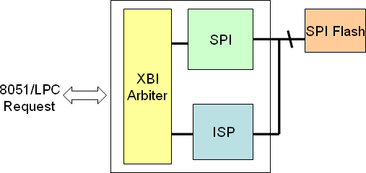

The XBI module also takes the responsibility for the In-System-Programming (ISP) mechanism to update system BIOS. The detail steps to update system BIOS via ISP mode, please refer to the section of ISP. Here gives the feature of w XBI module.

* Two 8051 code segments, one for 16K and the other for 48K.
* XBI arbiter to handle the transaction of 8051 and LPC request.
* XBI pre-fetch code mechanism support for better performance.
* Flash write-protection support.
* ISP flash update support.
* SHC (SPI host controller)
  + - 1. 4 byte buffer for TX/RX
      2. Support mode 0 (clock rising latch data, clock falling drive data)
      3. SPI clock speed is 66 / 33 MHz (Depending on 0xFF0D.6)
      4. Programmable Tx/Rx length

## XBI SPI Enhancement

The 8051 microprocessor executes machine codes from SPI flash and the performance is determined by the read operation. To enhance the performance of SPI flash fetching, special protocols are introduced. They are **Dual/Quad** protocols. The following sections give a brief introduction.

## Original Read Protocol

An original SPI read protocol to read flash is as the following figure. A chip select is asserted to the specific flash device and the SPI flash controller drives clock out. A 24-bit address phase follows 8-bit command phase. After a dummy phase, the SPI flash device returns data. Please note, the KBC currently supports 4MB (22bit) size SPI flash, therefore, address bit, A23~A22 are all zero.

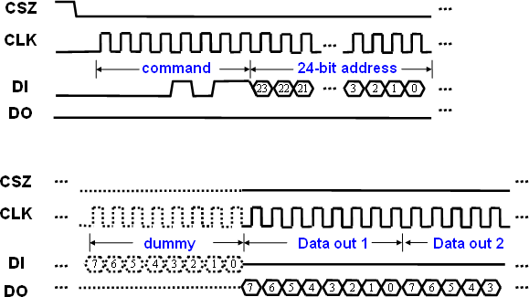

## Dual Input Protocol

An improvement of data phase to increase performance is also introduced. The method is called **Dual Input** mode. In this mode, data output pin works as another input. The bit stream is shown as the following figure. Please note, the high nibble of this protocol is fixed to be 0x3. This is not a standard protocol and SPI flash devices should implement this feature to make it work.

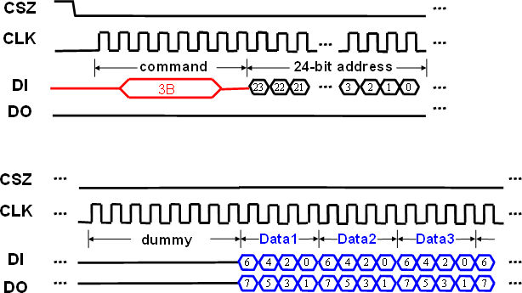

w

## Quad Protocol

Another improvement of data phase to increase performance is introduced, **Quad** mode. Extra pins are served as another IO ports (GPXIO06 / GPXIO07). The data bit stream illustration is as the following figure. The details could be found in register: SPICFG. This is not a standard protocol and SPI flash devices should implement this feature to make it work.



## XBI Registers Description

|  |  |  |  |  |  |  |
| --- | --- | --- | --- | --- | --- | --- |
| **8051 Address Segment 0 Mapping Configuration (0x0000~0x3FFF)** | | | | | | |
| **Offset** | **Name** | **Bit** | **Type** | **Description** | **Default** | **Bank** |
| 0xA0 | XBISEG0 | 7 | R/W | 8051 code segment SEG0 remapping enable.  **0**: Disable  **1**: Enable | 0x00 | 0xFE |
| 6 | RSV | Reserved |
| 5-0 | R/W | SEG0 XBI Address  SEG0 XBI Address = XBISEG0[5:0]*16K + 8051 Address[13:0] |

|  |  |  |  |  |  |  |
| --- | --- | --- | --- | --- | --- | --- |
| **8051 Address Segment 1 Mapping Configuration (0x4000~0xFFFF)** | | | | | | |
| **Offset** | **Name** | **Bit** | **Type** | **Description** | **Default** | **Bank** |
| 0xA1 | XBISEG1 | 7 | R/W | 8051 code segment SEG1 remapping enable.  **0**: Disable  **1**: Enable | 0x00 | 0xFE |
| 6-4 | RSV | Reserved |
| 3-0 | R/W | SEG1 XBI Address  SEG1 XBI Address = XBISEG1[3:0]*64K + 8051 Address[15:0] |

|  |  |  |  |  |  |  |
| --- | --- | --- | --- | --- | --- | --- |
| **SPI host controller configuration** | | | | | | |
| **Offset** | **Name** | **Bit** | **Type** | **Description** | **Default** | **Bank** |
| 0xA2 | SHCCFG | 7 | R/W | Enable SHC Function  **0**: Disable  **1**: Enable  [www.DataSheet.net/](http://www.DataSheet.net/)  When enable SHC , The address 0xFEA8 ~ 0xFEAC, 0xFEAE is changed to another bank for register control. | 0x00 | 0xFE |
| 6~4 | R/W | Tx length  If Tx length is more than 4 , SHC translate data “0x00” |
| 3 | RSV | Reserved |
| 2~0 | R/W | Rx length  If Rx length is more than 4 , SHC only receive 4 bytes data. |

|  |  |  |  |  |  |  |
| --- | --- | --- | --- | --- | --- | --- |
| **LPC Read Buffer Configuration** | | | | | | |
| **Offset** | **Name** | **Bit** | **Type** | **Description** | **Default** | **Bank** |
| 0xA3 | XBI_LPBCFG | 7 | R/W | LPC buffer read enable  **0**: disable (default)  **1**: enable | 0x0F | 0xFE |
| 6 | R/W | LPC buffer auto pre-fetch next 16-byte  **0**: disable (default)  **1**: enable |
| 5-4 | RSV | Reserved |
| 3~0 | R/W | Code-Memory Region Selection  enable Code-Memory by XBICS[3] (0xFEA6), and 8051 can fetch code from XRAM region for following setting  **0**: 0xEC00~0xECFF  **1**: 0xEC00~0xEDFF  **2**: 0xEC00~0xEEFF  **3**: 0xEC00~0xEFFF  ...  **F**: 0xEC00~0xFBFF |

|  |  |  |  |  |  |  |
| --- | --- | --- | --- | --- | --- | --- |
| **XBI XIO Enable** | | | | | | |
| **Offset** | **Name** | **Bit** | **Type** | **Description** | **Default** | **Bank** |
| 0xA4 | RSV | 7-0 | RSV | Reserved | 0x00 | 0xFE |

|  |  |  |  |  |  |  |
| --- | --- | --- | --- | --- | --- | --- |
| **XBI Configuration** | | | | | | |
| **Offset** | **Name** | **Bit** | **Type** | **Description** | **Default** | **Bank** |
| 0xA5 | XBICFG | 7 | RSV | Reserved | 0x07 | 0xFE |
| 6 | R/W | 8051 instruction fetch (sustaining access)  **0**: Disable  **1**: Enable |
| 5~0 | RSV | Reserved |

|  |  |  |  |  |  |  |
| --- | --- | --- | --- | --- | --- | --- |
| **XBI E51CS# Configuration** | | | | | | |
| **Offset** | **Name** | **Bit** | **Type** | **Description** | **Default** | **Bank** |
| 0xA6 | XBICS | 7-6 | RSV | Reserved | 0x00 | 0xFE |
|  |  | 5 | R/W | XBI arbitration priority. |  |  |
|  |  |  |  | **0**: Disable |  |  |
|  |  |  |  | **1**: Enable |  |  |
|  |  | 4 | R/W | Reset code segment enable. |  |  |
|  |  |  |  | Once the 8051 reset, the code segment SEG0 or SEG1 can be |  |  |
|  |  |  |  | reset if the corresponding code segment enabled. |  |  |
|  |  |  |  | (XBISEG0[7]/XBISEG1[7]) |  |  |
|  |  |  |  | **0**: Disable |  |  |
|  |  |  |  | **1**: Enable |  |  |
|  |  | 3 | R/W | Enable XRAM as codw w ew . -D memory |  |  |
|  |  |  |  | Enable 8051 to fetch code from XRAM; the code momory |  |  |
|  |  |  |  | region is selected by XBILPBCFG[3:0] (0xFEA3). Please note, |  |  |
|  |  |  |  | users should move codes from flash to XRAM, jump to XRAM |  |  |
|  |  |  |  | and then enable this bit. |  |  |
|  |  |  |  | **0**: Disable |  |  |
|  |  |  |  | **1**: Enable |  |  |
|  |  | 2 | R/W | Reset XBI arbiter while in idle/stop mode. |  |  |
|  |  |  |  | **0**: Disable |  |  |
|  |  |  |  | **1**: Enable |  |  |
|  |  | 1 | R/W | EHB fast accessing enable. |  |  |
|  |  |  |  | Enable this bit gets better performance in EHB. |  |  |
|  |  |  |  | **0**: Disable |  |  |
|  |  |  |  | **1**: Enable |  |  |
|  |  | 0 | RSV | Reserved |  |  |

|  |  |  |  |  |  |  |
| --- | --- | --- | --- | --- | --- | --- |
| **XBI Write Enable** | | | | | | |
| **Offset** | **Name** | **Bit** | **Type** | **Description** | **Default** | **Bank** |
| 0xA7 | XBIWE | 7-0 | R/W | XBI write command.  **00h**: exit SRAM test mode  **C5h**: enter SRAM test mode | 0x00 | 0xFE |

* + - 1. **XBI Registers Bank 0 Description (SHCCFG[7]=’0’)**

|  |  |  |  |  |  |  |
| --- | --- | --- | --- | --- | --- | --- |
| **XBI SPI Flash Address (22-bit) = [SPIA2(6bit) : SPIA1(8bit) : SPIA0(8bit)]** | | | | | | |
| **Offset** | **Name** | **Bit** | **Type** | **Description** | **Default** | **Bank** |
| 0xA8 | SPIA0 | 7-0 | R/W | SPI Address lower 8-bits (A7:A0) | 0x00 | 0xFE |
| 0xA9 | SPIA1 | 7-0 | R/W | SPI Address middle 8-bits (A15:A8) | 0x00 | 0xFE |
| 0xAA | SPIA2 | 5-0 | R/W | SPI Address upper 6-bits (A21:A16) | 0x00 | 0xFE |

|  |  |  |  |  |  |  |
| --- | --- | --- | --- | --- | --- | --- |
| **XBI SPI Flash Output/Input Data Port** | | | | | | |
| **Offset** | **Name** | **Bit** | **Type** | **Description** | **Default** | **Bank** |
| 0xAB | SPIDAT | 7-0 | R/W | Input (read) / Output (write) data port of SPI flash interface. | 0x00 | 0xFE |

|  |  |  |  |  |  |  |
| --- | --- | --- | --- | --- | --- | --- |
| **XBI SPI Flash Command Port** | | | | | | |
| **Offset** | **Name** | **Bit** | **Type** | **Description** | **Default** | **Bank** |
| 0xAC | SPICMD | 7-0 | R/W | Commands support for SPI flash. Writing this register will force the SPI protocol start. Please note, the address phases must be prior to command phase.  **SPI command support:**  01h: Write Status Register 02h: Byte Program  03h: Read  04h: Write Disable  05h: Read Status Register 06h: Write Enable  0Bh: High Speed Rewad 20h: Sector Erase (SST)  3Bh: Fast Read Dual Output (Windbond, AMIC) 6Bh Fast Read Dual IO(Winbond, ESMT)  BBh Fast Read Quad Output(Winbond, ESMT,MXIC,AMIC) EBh Fast Read Quad IO(Winbond, ESMT)  50h: Enable Write Status Register (SST) 52h: Block Erase (SST)  60h: Chip Erase (SST) B9h: Power Down  C7h: Chip Erase (PMC, NexFlash) D7h: Sector Erase (PMC)  D8h: Block Erase (PMC, NexFlash) | 0x00 | 0xFE |

|  |  |  |  |  |  |  |
| --- | --- | --- | --- | --- | --- | --- |
| **XBI SPI Flash Configuration/Status Register** | | | | | | |
| **Offset** | **Name** | **Bit** | **Type** | **Description** | **Default** | **Bank** |
| 0xAD | SPICFG | 7 | R/W | Fast read dual mode enable  ( IO Mode or Read Output Mode is setting by SPICFG[5]) Please note, if this bit set, the SPICFG[2] will be ignored. **0**: Disable  **1**: Enable | 0x00 | 0xFE |
| 6 | R/W | Fast Read Quad mode enable  ( IO Mode or Read Output Mode is setting by SPICFG[5]) Pin mapping as following:  MOSI(P120): DI(IO0) MISO(P119): DO(IO1) GPXIOD6(P117): WP#(IO2) GPXIOD7(P118): HOLD#(IO3)  Note that This bit has higher priority with bit 7.  **0**: Disable  **1**: Enable |
| 5 | R/W | Dual/Quad IO Mode or Output Mode Select. 0: Read Output Mode  1: IO Mode |
| 4 | R/W | SPICS# force low  **0**: SPICS# high  **1**: SPICS# low |
| 3 | R/W | Write enable of **SPICMD** register,0xFEAC.  **0**: Disable  **1**: Enable |
| 2 | R/W | Dummy byte of read command.  **0**: Disable  **1**: Enable [www.DataSheet.net/](http://www.DataSheet.net/) |
| 1 | RO | SPI controller accessing in busy status.  **0**: not busy  **1**: busy |
| 0 | R/W | SPI flash busy status check enable  Automatic SPI status check after a SPICMD issued, until SPI busy flag, clear, i.e., (SPICFG[1]=0).  **0**: Disable  **1**: Enable |

|  |  |  |  |  |  |  |
| --- | --- | --- | --- | --- | --- | --- |
| **XBI SPI Flash Output Data for Read compare** | | | | | | |
| **Offset** | **Name** | **Bit** | **Type** | **Description** | **Default** | **Bank** |
| 0xAE | SPIDATR | 7-0 | RO | Output data to SPI flash interface. | 0x00 | 0xFE |

|  |  |  |  |  |  |  |
| --- | --- | --- | --- | --- | --- | --- |
| **XBI SPI Flash Configuration 2** | | | | | | |
| **Offset** | **Name** | **Bit** | **Type** | **Description** | **Default** | **Bank** |
| 0xAF | RSV | 7-0 | RSV | Reserved | 0x00 | 0xFE |

## XBI Registers Bank 1 Description (SHCCFG[7]=’1’)

|  |  |  |  |  |  |  |
| --- | --- | --- | --- | --- | --- | --- |
| **Transmit Buffer Data Byte Write Port 2 / Receive Buffer Data Byte Read Port 3** | | | | | | |
| **Offset** | **Name** | **Bit** | **Type** | **Description** | **Default** | **Bank** |
| 0xA8 | SHC_TX2 | 7~0 | W | Transmit Buffer Data Byte Write Port 2 | 0x00 | 0xFE |
| 0xA8 | SHC_RX3 | 7~0 | R | Receive Buffer Data Byte Read Port 3 | 0x00 | 0xFE |

|  |  |  |  |  |  |  |
| --- | --- | --- | --- | --- | --- | --- |
| **Transmit Buffer Data Byte Write Port 1 / Receive Buffer Data Byte Read Port 2** | | | | | | |
| **Offset** | **Name** | **Bit** | **Type** | **Description** | **Default** | **Bank** |
| 0xA9 | SHC_TX1 | 7~0 | W | Transmit Buffer Data Byte Write Port 1 | 0x00 | 0xFE |
| 0xA9 | SHC_RX2 | 7~0 | R | Receive Buffer Data Byte Read Port 2 | 0x00 | 0xFE |

|  |  |  |  |  |  |  |
| --- | --- | --- | --- | --- | --- | --- |
| **Transmit Buffer Data Byte Write Port 0 / Receive Buffer Data Byte Read Port 1** | | | | | | |
| **Offset** | **Name** | **Bit** | **Type** | **Description** | **Default** | **Bank** |
| 0xAA | SHC_TX0 | 7~0 | W | Transmit Buffer Data Byte Write Port 0 | 0x00 | 0xFE |
| 0xAA | SHC_RX1 | 7~0 | R | Receive Buffer Data Byte Read Port 1 | 0x00 | 0xFE |

|  |  |  |  |  |  |  |
| --- | --- | --- | --- | --- | --- | --- |
| **Transmit Buffer Data Byte Write Port 3 / Receive Buffer Data Byte Read Port 0** | | | | | | |
| **Offset** | **Name** | **Bit** | **Type** | **Description** | **Default** | **Bank** |
| 0xAB | SHC_TX3 | 7~0 | W | Transmit Buffer Data Byte Write Port 3 | 0x00 | 0xFE |
| 0xAB | SHC_RX0 | 7~0 | R | Receive Buffer Data Byte Read Port 0 | 0x00 | 0xFE |

w

|  |  |  |  |  |  |  |
| --- | --- | --- | --- | --- | --- | --- |
| **SPI host control command register** | | | | | | |
| **Offset** | **Name** | **Bit** | **Type** | **Description** | **Default** | **Bank** |
| 0xAC | SHC_CMD | 7~0 | R/W | When writing this register, SHC will start to transmit / receive data according Tx/Rx length SHCCFG(0xFEA2) . | 0x00 | 0xFE |

|  |  |  |  |  |  |  |
| --- | --- | --- | --- | --- | --- | --- |
| **SPI host Tx data read path** | | | | | | |
| **Offset** | **Name** | **Bit** | **Type** | **Description** | **Default** | **Bank** |
| 0xAE | SHC_DEB | 7~1 | RSV | Reserved | 0x00 | 0xFE |
| 0 | R/W | Tx buffer read path enable bit  **0**: Disable  **1**: Enable  When we enable this bit, we can read Tx buffer data. |

## XBI/SPI extension registers description

|  |  |  |  |  |  |  |
| --- | --- | --- | --- | --- | --- | --- |
| **XBI error pending flag** | | | | | | |
| **Offset** | **Name** | **Bit** | **Type** | **Description** | **Default** | **Bank** |
| 0xB0 | XBI_ERR_PF | 7~2 | RSV | Reserved | 0x00 | 0xFE |
| 1 | W1C | **Write Protection Hit Pending Flag**  The pending flag would be asserted if any write protection access hit when enable Write Protection. |
| 0 | W1C | **Byte Mode Error Access Pending Flag**  The pending flag would be asserted if any unexpected access flash when enable SPICS manual mode (0xFEAD.5 =1), |

|  |  |  |  |  |  |  |
| --- | --- | --- | --- | --- | --- | --- |
| **SPI idle configuration** | | | | | | |
| **Offset** | **Name** | **Bit** | **Type** | **Description** | **Default** | **Bank** |
| 0xB1 | SPI_IDLE_CFG | 7~2 | RSV | Reserved | 0x00 | 0xFE |
| 1 | R/W | Pull-up SPICS when SPI controller in IDLE state (Only when SPI_IDLE_CFG[0], 0xFEB1 is set to 1) |
| 0 | R/W | High-Z SPICS, SPICK, SPIDO when SPI controller in IDLE state |

|  |  |  |  |  |  |  |
| --- | --- | --- | --- | --- | --- | --- |
| **XBI Write Protection Configuration Register** | | | | | | |
| **Offset** | **Name** | **Bit** | **Type** | **Description** | **Default** | **Bank** |
| 0xB2 | XBIWPCR | 7 | R/W | XBI Write Protect Enable | 0x00 | 0xFE |
|  |  |  |  | When enable , the following commands are inactive: |  |  |
|  |  |  |  | **60h Chip Erase (SS**ww**T**w.DataSh**)**eet.net/ |  |  |
|  |  |  |  | **C7h Chip Erase (PCM, NexFlash)** |  |  |
|  |  |  |  | The following commands with protection region are inactive: |  |  |
|  |  |  |  | **02h Byte Program** |  |  |
|  |  |  |  | **20h Sector Erase (SST)** |  |  |
|  |  |  |  | **50h Enable Write Status Register (SST)** |  |  |
|  |  |  |  | **52h Block Erase (SST)** |  |  |
|  |  |  |  | **D8h Block Erase (PMC, NexFlash)** |  |  |
|  |  |  |  | **D7h Sector Erase (PCM)** |  |  |
|  |  |  |  | **0**: Disable |  |  |
|  |  |  |  | **1**: Enable |  |  |
|  |  | 6~3 | RSV | Reserved |  |  |
|  |  | 2~0 | R/W | XBI write protection size (Unit: 16KB) |  |  |
|  |  |  |  | **000**: 16 KB |  |  |
|  |  |  |  | **001**: 32 KB |  |  |
|  |  |  |  | **010**: 48 KB |  |  |
|  |  |  |  | ... |  |  |
|  |  |  |  | **111**: 128KB |  |  |

|  |  |  |  |  |  |  |
| --- | --- | --- | --- | --- | --- | --- |
| **XBI Write Protection Configuration Register 2** | | | | | | |
| **Offset** | **Name** | **Bit** | **Type** | **Description** | **Default** | **Bank** |
| 0xB3 | XBIWPCR2 | 7~3 | RSV | Reserved | 0x00 | 0xFE |
| 2~0 | R/W | XBI write protection base address (Unit: 16KB)  **000**: 00 0000h  **001**: 00 4000h  **010**: 00 8000h  ...  **111**: 01 C000h |

* 1. **Consumer IR Controller (CIR)**

## CIR Function Description

The KBC embeds with a native hardware Consumer IR controller, which connects to system via LPC interface. Popular protocols are supported, such as RC-5/RC-6/NEC/RLC. The CIR controller handles the protocol of RC-5/RC-6/NEC/RLC for receiving, and only RLC for transmit. IRQ and I/O port are implemented. An extended function is implemented to support learning application. The basic features are list as the following table. The CIR functionality of KBx930 series is compatible to KBx926 series.

A SIRQ channel can be assigned for CIR application. The related programming registers are summarized as following table.

Here is the features highlight.

* Native hardware protocol decoder, such as RC5/RC6/NEC and RLC.
* I/O and IRQ resource for CIR controller.
* Support **2** sets of RX/TX in one chip, and RX/TX works simultaneously.
* RX carrier demodulation/ TX carrier modulation support.
* Wide range of carrier frequency support, **15K~1MHz**. (The carrier frequency is 30K~60KHz in normal application)
* More flexible in carrier sample frequency, **1μs**.**~128μs** (The sample frequencies are 25, 50 and 100μs for normal application).
* Remote controller learning support.

The following figure shows an example how a CIR controller works with narrow band receiver.

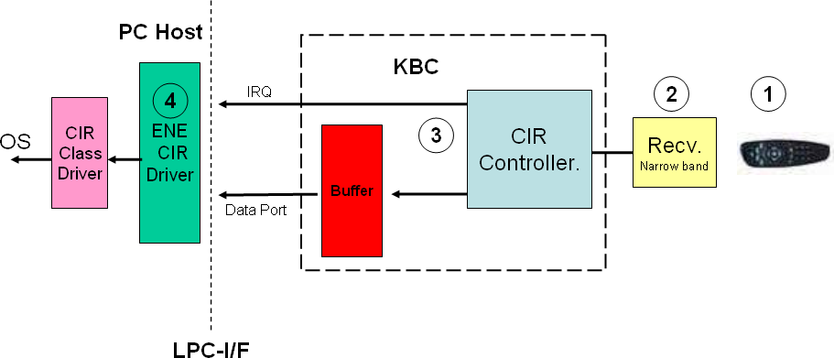

Here gives the guidance for programming CIR.

|  |  |
| --- | --- |
| **For Receive** | **For Transmit** |
| 1. Select protocol via setting CIRCFG2 (0xFEC1) 2. According to the selected protocol, setup CIRHIGH/CIRBIT/CIRSTART/CIRSTART2, i.e., 0xFEC3~0xFEC6 | 1. Select RLC protocol and enable via setting CIRCFG (0xFEC0) 2. Writing to CIRRLC_OUT0, 0xFEC9, will start to transmit. |
| 1. Enable protocol and other configuration setting via CIRCFG (0xFEC0) 2. EC F/W waits for data-in by pooling or interrupt. | 3.w If CIRRLC_OUT0 (0xFEC9) and CIRRLC_OUT1 (0xFECA) are written at the same time, it start to transmit CIRRLC_OUT0 and then CIRRLC_OUT1. |
|  | 4. If only CIRRLC_OUT0 (0xFEC9) is written, the hardware will transmit CIRRLC_OUT0 first and then CIRRLC_OUT1. |
|  | 5. Each byte transmit completion, an interrupt will occur. |

## CIR Block Diagram

The CIR controller supports two RX ports (GPIO40/GPIO0A) and two TX ports (GPIO41/GPIO0D). A register bit, **CIRCFG2**[5] (0xFEC1[5]), is used to determine RX source. For example, if CIRCFG2[5]=0, GPIO40 is the RX source, otherwise GPIO0A. The TX port is selected according to the GPIO function selection register. The following table gives an example of RX/TX combination.

The CIR controller could detect the carrier frequency and demodulate the carrier. This provides a *learning* feature for CIR application. The frequency detection range is from 15.75KHz to 1MHz. After demodulation, the CIR controller handles remote signals with hardware decoder which supports ***RC5/RC6/NEC/RLC*** protocols. If transmit function needed, the CIR controller could modulate the carrier and send it out via GPIO41/GPIO0D. The output carrier frequency range is the same as input (15.75KHz~1MHz). *The RX and TX can work simultaneously in the current design*. The following diagram gives more detail about CIR controller.

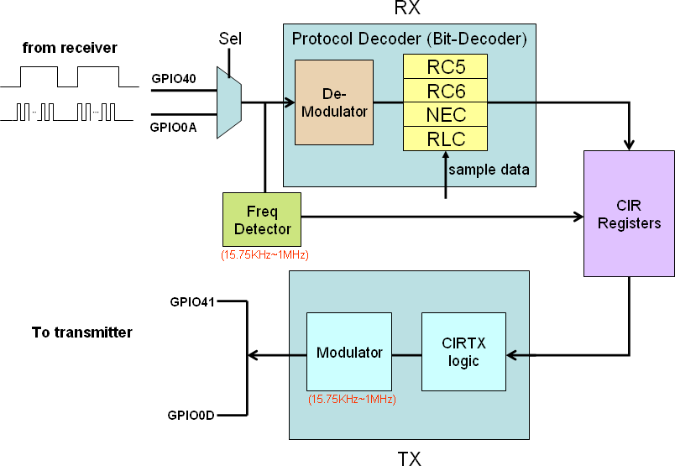

## CIR Remote Protocol

In this section, brief introduction of protocols supported in the CIR is given. Four protocols are supported, Philips RC5/RC6, NEC and Run-Length-Code. Only features and protocol definition listed. For more detail please refer to the related specifications.

## Philips RC5 Protocol

Here highlights the features of Philips RC5 protocol.

* + - * + Manufacturer Philips.
        + Carrier frequency 36KHz.
        + Bi-phase coding.
        + 5 bits address / 6 bits command lengths

|  |  |  |  |  |  |  |  |  |  |  |  |  |  |  |
| --- | --- | --- | --- | --- | --- | --- | --- | --- | --- | --- | --- | --- | --- | --- |
| **RC5 Protocol** | | | | | | | | | | | | | | |
| Bit1 | Bit2 | Bit3 | Bit4 | Bit5 | Bit6 | Bit7 | Bit8 | | Bit9 | Bit10 | Bit11 | Bit12 | Bit13 | Bit14 |
| S1 | S2 | T | Address | | | | | Command | | | | | | |
| **S1/S2**: start bits, always “1”  **T**: toggle bit, This bit is inverted every time a key is released and pressed again.  **Address**: IR device address, MSB first.  **Command**: IR command, MSB first. | | | | | | | | | | | | | | |

w

## Philips RC6 Protocol

Here highlights the features of Philips RC6 protocol.

* + - * + Manufacturer Philips.
        + Carrier frequency 36KHz.
        + Bi-phase coding.
        + 5 bits address
        + Variable command lengths based on the operation mode.

|  |  |  |  |  |  |  |  |  |  |  |  |  |  |  |  |  |  |  |  |  |  |  |  |
| --- | --- | --- | --- | --- | --- | --- | --- | --- | --- | --- | --- | --- | --- | --- | --- | --- | --- | --- | --- | --- | --- | --- | --- |
| **RC6 Protocol** | | | | | | | | | | | | | | | | | | | | | | | |
| LS | SB | MB2 | MB1 | MB0 | T | A 7 | A 6 | A 5 | A 4 | A 3 | A 2 | A 1 | A 0 | | C 7 | C 6 | C 5 | C 4 | C 3 | C 2 | C 1 | C 0 |  |
| Header | | | | | | Control | | | | | | | | Information | | | | | | | | | SF |
| *Header Phase (ENE CIR)* | | | | | | *Data Phase (ENE CIR)* | | | | | | | | | | | | | | | | | |
| **LS**: Leader symbol  **SB**: Start bit, always “1”  **MB2-MB0**: Mode bits, operation mode selection. **T**: Trailer bit, this bit can be served as a toggle bit. **A7-A0**: Address  **C7-C0**: Command  **SF**: Signal free time, 2.666ms. | | | | | | | | | | | | | | | | | | | | | | | |

## NEC Protocol

Here highlights the features of NEC[www.DataSheet.nept/](http://www.DataSheet.nept/) rotocol.

* + - * + Manufacturer NEC.
        + Carrier frequency 38KHz.
        + Pulse distance modulation.
        + 8 bit address / 8 bit command length
        + Address/Command transmitted twice.
        + Total transmit time is constant.

|  |  |  |  |  |  |
| --- | --- | --- | --- | --- | --- |
| **NCE Protocol** | | | | | |
| AGC burst | space | Address | ～Address | Command | ～Command |
| 9ms | 4.5ms | 8bit | 8bit | 8bit | 8bit |
| **AGC burst**: set gain of IR remote controller, 9ms long  **Space**: follow by AGC burst, 4.5ms.  **Address**: 8-bit address, LSB first.  **~Address**: inverted 8-bit address, LSB first.  **Command**: 8-bit command, LSB first.  **~Command**: inverted 8-bit command, LSB first | | | | | |

## CIR Automatic Carrier Frequency Detection and Modulation

To support learning feature, wide-band transmitter and receiver will be used in a system. The KBC introduces a new mechanism to provide carrier frequency information of wide-band receiver to the host.

The CIR controller needs to be programmed with two parameters for the detection. Register **CIRCAR_PULS** is used to determine these two parameters. **CIRCAR_PULS**[7:4] keeps the discard number of carrier pulse and **CIRCAR_PULS**[3:0] keeps the average number to detect. The **CIRCAR_PULS**[7:4] tells the controller to discard the specific number of carrier pulse from the beginning. The controller then gets the average number of carriers pulse as sample data and analyzes. The detection of carrier period is kept in **CIRCAR_PRD**[6:0], and the valid flag is kept in **CIRCAR_PRD**[7]. Please note, the detection range is from *15.75KHz~1MHz*. (The general application is from 30K~60KHz).

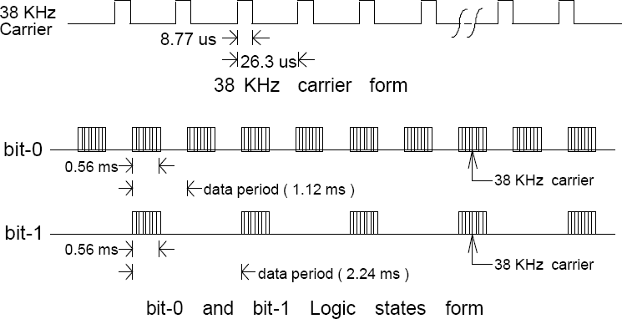

Here gives an example as the above waveform. Bit stream with 38KHz carrier is shown as bit-0. Each bit is 0.56ms in length and 38KHz carrier period is 26.3μs, that is, there will be about 21 carrier pulses in a bit. If **CIRCAR_PULS**[7:4]=5 and **CIRCAR_PULS**[3:0]=10, once the detection enabled, the CIR controller will get 6th carrier pulse as the first one and analyze the sequential 10 pluses. The detection result can be obtained via register **CIRCAR_PRD**.

The related registers for automatic carrier frequency detection are listed as following.

|  |  |  |
| --- | --- | --- |
| **Register** | **Address** | **Description** |
| CIRCFG2[5:4] | 0xFEC1[5:4] | Bit5=1, select wide-band as bit-decoder input. Bit4=1, enable wide-band frequency detection |
| CIRCAR_PULS | 0xFECB | CIRCAR_PULS[7:4] = discard number of carrier pulse CIRCAR_PULS[3:0] = average number of carrier pulse |
| CIRCAR_PRD | 0xFECC | Detection of wide-band carrier period |
| CIRCAR_HPRD | 0xFECD | Detection of wide-band carrier period, pulse width high. |

The KBC provides the modulation ability for RLC transmit. The carrier frequency of modulation can be programmable. Before the carrier modulation, the programmer should notice the modulation polarity. That is, if the data bus (TX) is kept low in idle state, only data in high state will be modulated and the bit, **CIRMOD_PRD**[7], should be “**1**”.

The related registers for RLC modulation is summarized as below.

|  |  |  |
| --- | --- | --- |
| **Register** | **Address** | **Description** |
| CIRCFG[7] | 0xFEC0 | RLC output modulation enable. |
| CIRMOD_PRD | 0xFECE | CIRMOD_PRD[7] = modulation polarity selection CIRMOD_PRD[6:0] = modulation carrier period |
| CIRMOD_HPRD | 0xFECF | CIRMOD_[www.DaHtaSheet.net/ PRD[6:0]](http://www.DaHtaSheet.net/PRD) = modulation carrier period, pulse width high. |

## CIR Registers Description

|  |  |  |  |  |  |  |
| --- | --- | --- | --- | --- | --- | --- |
| **CIR Configuration** | | | | | | |
| **Offset** | **Name** | **Bit** | **Type** | **Description** | **Default** | **Bank** |
| 0xC0 | CIRCFG | 7 | R/W | Output carrier modulator for RLC (TX) | 0x00 | 0xFE |
|  |  |  |  | **0**: Disable |  |  |
|  |  |  |  | **1**: Enable |  |  |
|  |  | 6 | R/W | Output polarity reversed for RLC. (TX) |  |  |
|  |  |  |  | **0**: Disable |  |  |
|  |  |  |  | **1**: Enable |  |  |
|  |  | 5 | R/W | Interrupt while transmit completes with RLC protocol. (TX) |  |  |
|  |  |  |  | **0**: Disable |  |  |
|  |  |  |  | **1**: Enable |  |  |
|  |  | 4 | R/W | Output enable for RLC protocol. (TX) |  |  |
|  |  |  |  | Once the data filled into CIRRLC_OUT1 (0xFECA), the controller starts the transmit with RLC protocol |  |  |
|  |  |  |  | **0**: Disable |  |  |
|  |  |  |  | **1**: Enable |  |  |
|  |  | 3 | R/W | Input carrier demodulator. (RX) |  |  |
|  |  |  |  | **0**: Disable |  |  |
|  |  |  |  | **1**: Enable |  |  |
|  |  | 2 | R/W | Input polarity reversed. (RX) |  |  |
|  |  |  |  | **0**: Disable |  |  |
|  |  |  |  | **1**: Enable |  |  |
|  |  | 1 | R/W | Interrupt enable. (RX)  Two conditions issue interrupt.   1. After decode a byte in RX 2. Once receive the “Repeat” in NEC protocol   **0**: Disable  w  **1**: Enable |  |  |
|  |  | 0 | R/W | Protocol decode enable. (RX) |  |  |
|  |  |  |  | The protocol type is determined by CIRCFG2[3:0] (0xFEC1) |  |  |
|  |  |  |  | **0**: Disable |  |  |
|  |  |  |  | **1**: Enable, |  |  |

|  |  |  |  |  |  |  |
| --- | --- | --- | --- | --- | --- | --- |
| **CIR Configuration 2** | | | | | | |
| **Offset** | **Name** | **Bit** | **Type** | **Description** | **Default** | **Bank** |
| 0xC1 | CIRCFG2 | 7 | R/W | Fast sample (data phase, not leader phase) enable for input signal. If this bit set, the sample period changes. | 0x00 | 0xFE |
|  |  |  |  | For RC5/RC6, period changes from 30μs to 16μs |  |  |
|  |  |  |  | For NEC, period changes from 64μs to 30μs |  |  |
|  |  |  |  | **0**: Disable |  |  |
|  |  |  |  | **1**: Enable |  |  |
|  |  | 6 | R/W | Fast sample (leader phase) enable for input signal. |  |  |
|  |  |  |  | If this bit set, the sample period changes. |  |  |
|  |  |  |  | For RC6, period changes from 64μs to 30μs |  |  |
|  |  |  |  | **0**: Disable |  |  |
|  |  |  |  | **1**: Enable |  |  |
|  |  | 5 | R/W | Input selection for protocol decoder (bit-decoder) |  |  |
|  |  |  |  | **0**: from GPIO40 |  |  |
|  |  |  |  | **1**: from GPIO0A |  |  |
|  |  | 4 | R/W | Frequency detection enable. |  |  |
|  |  |  |  | **0**: Disable |  |  |
|  |  |  |  | **1**: Enable |  |  |
|  |  | 3-0 | R/W | CIR Protocol selection. (valid while CIRCFG[0]=1) |  |  |
|  |  |  |  | **000**: RLC |  |  |
|  |  |  |  | **001**: RC5 |  |  |
|  |  |  |  | **010**: RC6 |  |  |
|  |  |  |  | **011**: NEC |  |  |
|  |  |  |  | **others**: reserved. |  |  |

|  |  |  |  |  |  |  |
| --- | --- | --- | --- | --- | --- | --- |
| **CIR Pending Flag and Status** | | | | | | |
| **Offset** | **Name** | **Bit** | **Type** | [www.DataSheet.net/](http://www.DataSheet.net/) **Description** | **Default** | **Bank** |
| 0xC2 | CIRPF | 7 | RO | Hardware RX idle state.  **0**: not idle state  **1**: idle state | 0x00 | 0xFE |
| 6 | RO | Hardware TX (RLC) idle state.  **0**: not idle state  **1**: idle state |
| 5-4 | RSV | Reserved |
| 3 | R/W1C | Pending flag of RLC transmit complete  **0**: no event  **1**: event occurs |
| 2 | R/W1C | Pending flag of RLC receive counter overflow  **0**: no event  **1**: event occurs |
| 1 | R/W1C | Pending flag of NEC repeat protocol  **0**: no event  **1**: event occurs |
| 0 | R/W1C | Pending flag of data-in  This bit is set while data received and stored in **CIRDAT_IN**. **0**: no event  **1**: event occurs |

|  |  |  |  |  |  |  |
| --- | --- | --- | --- | --- | --- | --- |
| **Value for High Pulse Width** | | | | | | |
| **Offset** | **Name** | **Bit** | **Type** | **Description** | **Default** | **Bank** |
| 0xC3 | CIRHIGH | 5-0 | R/W | This register determines the high pulse width of a “logic bit”. High pulse width = Decoder sample period * **CIRHIGH** | 0x00 | 0xFE |

|  |  |  |  |  |  |  |
| --- | --- | --- | --- | --- | --- | --- |
| **Value for Bit Width(RC5/RC6) / Logic Bit-One (NEC)** | | | | | | |
| **Offset** | **Name** | **Bit** | **Type** | **Description** | **Default** | **Bank** |
| 0xC4 | CIRBIT | 6-0 | R/W | This register determines the bit width of a “logic bit”. (RC5/RC6)  Bit width = Decoder sample period * **CIRBIT**  This register determines the “logic bit-one”. (NEC) Logic bit-one = Decoder sample period * **CIRBIT** | 0x00 | 0xFE |

|  |  |  |  |  |  |  |
| --- | --- | --- | --- | --- | --- | --- |
| **Value for Leader Pulse Width (RC6/NEC) for Normal Packet** | | | | | | |
| **Offset** | **Name** | **Bit** | **Type** | **Description** | **Default** | **Bank** |
| 0xC5 | CIRSTART | 6-0 | R/W | This register determines the leader pulse width for normal packet (RC6/ENC)  Leader pulse width = Decoder sample period * **CIRSTART** | 0x00 | 0xFE |

|  |  |  |  |  |  |  |
| --- | --- | --- | --- | --- | --- | --- |
| **Value for Tailer Bit Width (RC6) / Leader Width of Repeat Packet (NEC)** | | | | | | |
| **Offset** | **Name** | **Bit** | **Type** | **Description** | **Default** | **Bank** |
| 0xC6 | CIRSTART2 | 6-0 | R/W | This register determines the bit width of trailer (RC6) trailer bit width = Decoder sample period * **CIRSTART2**  This register determiwnww.DataSeheet.net/s the leader width of repeat packet (NEC)  Leader width(repeat) = Decoder sample period * **CIRSTART2** | 0x00 | 0xFE |

|  |  |  |  |  |  |  |
| --- | --- | --- | --- | --- | --- | --- |
| **CIR Decode Data Byte** | | | | | | |
| **Offset** | **Name** | **Bit** | **Type** | **Description** | **Default** | **Bank** |
| 0xC7 | CIRDAT_IN | 7-0 | RO | Received data to decode. | 0x00 | 0xFE |

|  |  |  |  |  |  |  |
| --- | --- | --- | --- | --- | --- | --- |
| **CIR Counter Value for RLC Sample Period** | | | | | | |
| **Offset** | **Name** | **Bit** | **Type** | **Description** | **Default** | **Bank** |
| 0xC8 | CIRRLC_CFG | 7 | R/W | Counter overflow control bit.  **0**: if overflow, the counter will stop.  **1**: if overflow, an interrupt issues and the counter keeps counting. | 0x00 | 0xFE |
| 6-0 | R/W | CIR RLC sample period, The unit is **1**μs. Please note CIRRLC_CFG[6:0] can not be zero. |

|  |  |  |  |  |  |  |
| --- | --- | --- | --- | --- | --- | --- |
| **CIR RLC Output 1st Byte** | | | | | | |
| **Offset** | **Name** | **Bit** | **Type** | **Description** | **Default** | **Bank** |
| 0xC9 | CIRRLC_OUT0 | 7-0 | R/W | Output (TX) 1st byte for RLC protocol. | 0x00 | 0xFE |

|  |  |  |  |  |  |  |
| --- | --- | --- | --- | --- | --- | --- |
| **CIR RLC Output 2nd Byte** | | | | | | |
| **Offset** | **Name** | **Bit** | **Type** | **Description** | **Default** | **Bank** |
| 0xCA | CIRRLC_OUT1 | 7-0 | R/W | Output (TX) 2nd byte for RLC protocol. | 0x00 | 0xFE |

|  |  |  |  |  |  |  |
| --- | --- | --- | --- | --- | --- | --- |
| **CIR Carrier Discard/Average Pulse Number Setting for Automatic Carrier Detection.** | | | | | | |
| **Offset** | **Name** | **Bit** | **Type** | **Description** | **Default** | **Bank** |
| 0xCB | CIRCAR_PULS | 7-4 | R/W | Discard carrier pulse number  F/W should specify the number of pulse to discard | 0x44 | 0xFE |
| 3-0 | R/W | Average carrier pulse number  F/W should specify the average number to calculate the carrier period. |

|  |  |  |  |  |  |  |
| --- | --- | --- | --- | --- | --- | --- |
| **CIR Detected Carrier Period** | | | | | | |
| **Offset** | **Name** | **Bit** | **Type** | **Description** | **Default** | **Bank** |
| 0xCC | CIRCAR_PRD | 7 | RO | Detected carrier period valid.  **0**: carrier detection not completed.  **1**: carrier detection completed. | 0x00 | 0xFE |
| 6-0 | RO | Detected carrier period.  Detected carrier period = CIRCAR_PRD[6:0] x 500ns |

|  |  |  |  |  |  |  |
| --- | --- | --- | --- | --- | --- | --- |
| **CIR Detected Pulse Width High of Carrier** | | | | | | |
| **Offset** | **Name** | **Bit** | **Type** | **Description** | **Default** | **Bank** |
| 0xCD | CIRCAR_HPRD | 7 | RSV | Reserved | 0x00 | 0xFE |
| 6-0 | R/W | Detected pulse width high of carrier  Pulse width high = CIRCAR_HPRD[6:0] x 500ns |

|  |  |  |  |  |  |  |
| --- | --- | --- | --- | --- | --- | --- |
| **CIR Modulation Carrier Period (RLC only)** [www.DataSheet.net/](http://www.DataSheet.net/) | | | | | | |
| **Offset** | **Name** | **Bit** | **Type** | **Description** | **Default** | **Bank** |
| 0xCE | CIRMOD_PRD | 7 | R/W | Carrier modulation selection.  **0**: If TX idle state is high ,only low signal in TX will be modulated  **1**: If TX idle state is low, only high signal in TX will be modulated | 0x00 | 0xFE |
| 6-0 | R/W | Modulation carrier period.  This register determines the modulation carrier period. The unit is 500ns. The value can be chosen from 0x02 to 0x7F, i.e., the period is from 15.87KHz~1MHz.  The period = CIRMOD_PRD[6:0] x 500 ns. |

|  |  |  |  |  |  |  |
| --- | --- | --- | --- | --- | --- | --- |
| **CIR Pulse Width High of Modulation Carrier (RLC only)** | | | | | | |
| **Offset** | **Name** | **Bit** | **Type** | **Description** | **Default** | **Bank** |
| 0xCF | CIRMOD_HPRD | 7 | R/W | Reserved | 0x00 | 0xFE |
| 6-0 | R/W | Pulse width high of modulation carrier.  This register determines the pulse width high of modulation carrier. The unit is 500ns. The value can be chosen from 0x01 to 0x7E. *Please note, the pulse width high can not be larger than the carrier period.*  The pulse width high = CIRMOD_HPRD[6:0] x 500 ns. |

## 4.15.3 CIR Programming Sample

In this section gives some programming sample to control CIR module. Please note, ENE does not guarantee these codes in every field application. The following table describes scenario of CIR filed application.

w

## PS/2 Interface (PS/2)

### This page is leaved blank intentionally.

w

## Embedded Controller (EC)

## EC Function Description

The ACPI specification defined for the embedded controller (EC) interface requires either three separate host interfaces (KBC, SCI, SMI) or two interfaces (KBC, and shared SCI/SMI). The ENE KBC supports KBC and SCI interface, and SMI interface can be shared with SCI or use a dedicated GPIO. The embedded controller also provides some features which are collected as following:

* Handles EC standard commands from host, firmware mode support.
* Handles EC extended commands from host, only firmware mode support.
* SCI generation capability.
* Extended I/O write interface, i.e., debug port (port 80) support.
* KBC/EC clock configuration.
* A/D and D/A control.
* Power management control.
* Miscellaneous control.

The host queries (read) EC status and issues (write) EC command via port **66h**. The EC data port is **62h**. The status of EC is defined as the below table:

The EC commands are defined as following, for more detail please refer to ACPI, *Advanced Configuration Power Interface Specification. 2.0*

## EC Command Program Sequence

The following table summarizes the standard EC commands programming flow. Port

**66h** is the EC command and status port and port **62h** is the EC data port.

|  |  |  |
| --- | --- | --- |
| **Command Byte** | **Command** | **Program Sequence** |
| 80h | EC Read | 1. Host writes command byte 80h (EC_Read) to port 66h. 2. EC will issue SCI to host while IBF=0 3. Host writes address to port 62h. 4. EC will issue SCI to host while OBF=1 5. Host reads data via port 62h. |
| 81h | EC Write | 1. Host writes command byte 81h (EC_Write) to port 66h. 2. EC will issue SCI to host while IBF=0 3. Host writes address to port 62h. 4. EC will issue SCI to host while IBF=0 5. Host writes data to port 62h. 6. EC will issue SCI to host while IBF=0 |
| 82h | Burst Enable | 1. Host writes command byte 82h (Burst_Enable) to port 66h. 2. EC will issue SCI to host while OBF=1. 3. Host reads via port62h. If 90h obtained, it’s Burst Ack. |
| 83h | Burst Disable | 1. Host writes command byte 83h (Burst_Disable) to port 66h. 2. EC will issue SCI to host while IBF=0 |
| 84h | Query EC | 1. Host writes command byte 84h (Query_EC) to port 66h. 2. EC will issue SCI to host while OBF=1. 3. Host reads data via port 62h. The data obtained is SCI_ID number. |

w

## EC SCI Generation

The EC can generate SCI with independent enable control and status flag. Plenty of hardware SCI events are predefined, and a firmware SCI event gives more flexible use for different applications. There is a F/W SCI command port located at **SCID** (0xFF0B). As the F/W writes any **non-zero** value to this port, and corresponding enable bit (SCIE0[6]) is set. A hardware SCI signal will issue to host in sequence. Then the host uses standard EC_Query (84h) command to get the **SCI ID** which is written by F/W before. The below table summarizes the information about SCI events, SCI IDs and the priorities.

|  |  |  |  |  |
| --- | --- | --- | --- | --- |
| **SCI ID** | **Event** | **Switch** | **Applications** | **Priority** |
| 00h | Nothing | N/A |  | 0(Highest) |
| 01h-07h | RSV | N/A | Reserved | 1 |
| 08h | WDT | SCIE0[0] | Watchdog | 2 |
| 09h | LPC_IO2F / OWM | SCIE0[1] | LPC I/O 0x2F R/W accessing interrupt  / OWM | 3 |
| 0Ah | PS2 | SCIE0[2] | PS/2 event | 4 |
| 0Bh | KBC | SCIE0[3] | IBF rising (LPC write I/O 60h/64h) OBF falling (LPC read I/O 60h) | 5 |
| 0Ch | IKB | SCIE0[4] | IKB | 6 |
| 0Dh | LPC_IO686C | SCIE0[5] | IBF rising (LPC write I/O 68h/6Ch) OBF falling (LPC read I/O 68h) | 7 |
| 0Eh | LPC_IO6266 | SCIE0[6] | IBF risingwww.D(ataSheLet.net/ PC write I/O 62h/66h)  OBF falling (LPC read I/O 62h) | 8 |
| *FW_SCIID* | *FW_SCI* | *SCIE0[7]* | *EC F/W SCI event* | 9 |
| 10h | FAN0 | SCIE1[0] | FAN0 monitor event (update/overflow) | 10 |
| 11h | FAN1 | SCIE1[1] | FAN1 monitor event (update/overflow) | 11 |
| 12h | SMBus | SCIE1[2] | SMBus events | 12 |
| 13h | CIR | SCIE1[3] | CIR events | 13 |
| 14h | GPT0 | SCIE1[4] | GPT0 event | 14 |
| 15h | GPT1 | SCIE1[5] | GPT1 event | 15 |
| 16h | GPT2 | SCIE1[6] | GPT2 event | 16 |
| 17h | GPT3 / SDI | SCIE1[7] | GPT3 event /SDI | 17 |
| 18h | EXTWIO / PECI | SCIE3[0] | Write extended I/O (LPC I/O port 80) | 18 |
| 19h | GPIO00~GPIO0F | SCIE3[1] | GPIO00~GPIO0F | 19 |
| 1Ah | GPIO10~GPIO1F | SCIE3[2] | GPIO10~GPIO1F | 20 |
| 1Bh | GPIO20~GPIO2F | SCIE3[3] | GPIO20~GPIO2F | 21 |
| 1Ch | GPIO30~GPIO3F | SCIE3[4] | GPIO30~GPIO3F | 22 |
| 1Dh | GPIO40~GPIO4F | SCIE3[5] | GPIO40~GPIO4F | 23 |
| 1Eh | GPIO50~GPIO5F | SCIE3[6] | GPIO50~GPIO59 / GPXIOD00~GPXIOD07 | 24 |
| 1Fh | ADC | SCIE3[7] | ADC update | 25(Lowest) |

The SCI pulse width is programmable for different applications. Two unit basis, 16μs and 64 μs can be chosen. To change the SCI pulse width, register **PXCFG**[2] (0xFF14) is to select the timing base unit and **SCICFG**[3:0] (0xFF03) is to decide another coefficient. The SCI pulse is decided by the following equation. Please refer to registers description for details.

*SCI Pulse Width = SCICFG[3:0] * Unit ( 16μs or 64 μs)*

## EC/KBC Clock Configuration

The EC provides programmable interface to adjust the microprocessor and peripheral frequency. By default, the microprocessor runs at 8MHz and peripherals are at 4MHz. The microprocessor can operate at 32MHz as the highest frequency, and the peripheral runs up to 7.2 MHz. The programming interface is located at register **CLKCFG/CLKCFG2** (0xFF0D/0xFF1E) and **PLLCFG/PLLCFG2** (0xFF0F/0xFF1F). The figure 4-1 (in section **Clock Domain**) illustrates the clock scheme applied in the KBC.

## A/D Converter Control

The control interface of A/D is in the EC space. Details SPEC of the A/D converters could be found in the electronics characteristic chapter.

The following table summarizes the relatwwwe.DataSheet.ndet/ registers of these 6 A/D converters.

|  |  |  |
| --- | --- | --- |
| **Name** | **Address** | **Description** |
| ADDAEN[3:0] | 0xFF15 | ADC port enable bits of ADC3~ADC0 Bit3: ADC3  Bit2: ADC2 Bit1: ADC1 Bit0: ADC0  If ADC selected, please do not set related IE register. |
| ADCTRL[6:5] | 0xFF18 | ADC port enable bits of ADC5~ADC4 Bit6: ADC5  Bit5: ADC4 |
| ADCTRL[4:2] | 0xFF18 | ADC channels selection to be converted and put in ADCDAT and ECIF[7:6] |
| ADCDAT | 0xFF19 | This stands for higher bit9~bit2 of 10bit A/D result. |
| ECIF[7:6] | 0xFF1A | This stands for lower bit1~bit0 of 10bit A/D result. |

The following gives the programming sample to control ADC.

|  |
| --- |
| **Example** |
| **Using ADC0 to get input analog signal** |
| **Programming model** |
| 1. Clear IE of the related pin GPIOIE38[0] (0xFC67[0]) = 0b 2. Enable ADC function ADDAEN[0] (0xFF15[0]) = 1b 3. Enable ADC control ADCTRL (0xFF18) = 0x01 Waiting ADC interrupt. 4. Read ADCDAT (0xFF19) and ECIF (0xFF1A) |

w

## D/A Converter Control

The control interface of D/A is in the EC space. Details SPEC of the D/A converters could be found in the electronics characteristic chapter.

The following table summarizes the related registers of these 4 D/A converters.

|  |  |  |
| --- | --- | --- |
| **Name** | **Address** | **Description** |
| ADDAEN[7:4] | 0xFF15 | DAC port Enable bits of DAC3~DAC0 Bit7: DAC3  Bit6: DAC2 Bit5: DAC1 Bit4: DAC0  If DAC selected, please do not set related GPIO function selection register. |
| DAC0 | 0xFF10 | DAC0 Output Value |
| DAC1 | 0xFF11 | DAC1 Output Value |
| DAC2 | 0xFF12 | DAC2 Output Value |
| DAC3 | 0xFF13 | DAC3 Output Value |

The following gives the programming sample to control a DAC.

|  |
| --- |
| **Example** |
| **Using DAC2** |
| **Programming model** |
| 1. Clear the alternative function selection of the related pin   w  GPIOFS38[6] (0xFC07[6]) = 0b ;   1. Enable DAC function ADDAEN[6] (0xFF15[6]) = 1b 2. Fill the value to be converted.   DAC2 (0xFF12) = specific value to convert |

## Power Management Control

Two power modes are defined, one is **STOP** mode and the other is **IDLE** mode. The register **PMUCFG** (0xFF0C) is used to configure the power management. The following table gives more detail about the definition for these two power modes.

The diagram below shows the relationship between each power mode.

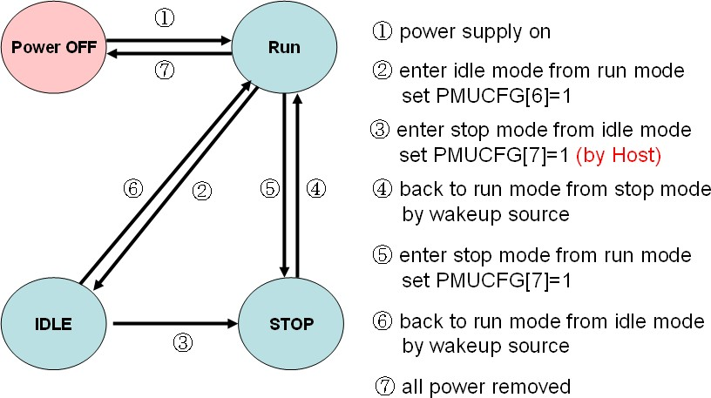

## EC Registers Description

|  |  |  |  |  |  |  |
| --- | --- | --- | --- | --- | --- | --- |
| **EC Hardware Revision ID** | | | | | | |
| **Offset** | **Name** | **Bit** | **Type** | **Description** | **Default** | **Bank** |
| 0x00 | ECHV | 7-0 | RO | EC Hardware version | 0xA0 | 0xFF |

|  |  |  |  |  |  |  |
| --- | --- | --- | --- | --- | --- | --- |
| **EC Firmware Revision ID** | | | | | | |
| **Offset** | **Name** | **Bit** | **Type** | **Description** | **Default** | **Bank** |
| 0x01 | ECFV | 7-0 | R/W | EC firmware version  This register will be a data port, **ADC_test_data**[7:0] in ADC test mode (ADCTRL[1]=1). | 0x00 | 0xFF |

|  |  |  |  |  |  |  |
| --- | --- | --- | --- | --- | --- | --- |
| **EC High Address** | | | | | | |
| **Offset** | **Name** | **Bit** | **Type** | **Description** | **Default** | **Bank** |
| 0x02 | ECHA | 7-6 | R/W | These two bits will be a data port, **ADC_test_data**[9:8] in ADC test mode (ADCTRL[1]=1). | 0x0F | 0xFF |
| 5 | R/W | Write protection of PXCFG[1], PXCFG[4].  **0**: writable.  **1**: write protection. |
| 4 | R/W | Index-I/O mode access control.  **0**: access range 0xF400~0xFFFF  **1**: access range 0xF400~0xF403 and 0xFC00~0xFFFF |
| 3-0 | RSV | Reserved |

|  |  |  |  |  |  |  |
| --- | --- | --- | --- | --- | --- | --- |
| **EC SCI Configuration** w | | | | | | |
| **Offset** | **Name** | **Bit** | **Type** | **Description** | **Default** | **Bank** |
| 0x03 | SCICFG | 7 | R/W | Standard EC commands generate SCI.  **0**: Disable  **1**: Enable | 0x90 | 0xFF |
| 6 | R/W | **SCIID** port enable. (F/W SCI write port enable)  **0**: Disable  **1**: Enable |
| 5 | R/W | SCI polarity  **0**: Low active (default)  **1**: High active |
| 4 | R/W | SCIE0/SCIE1/SCIE2 (0xFF05~0xFF07) enable.  **0**: Disable  **1**: Enable |
| 3-0 | R/W | SCI pulse width. (max. 1ms)  *SCI pulse width = SCICFG[3:0] * (time unit)*  where time unit is determined by PXCFG[2], **64μs or 16μs**  If SCICFG[3:0]=0, SCI pulse width = width of system clock. |

|  |  |  |  |  |  |  |
| --- | --- | --- | --- | --- | --- | --- |
| **EC Configuration** | | | | | | |
| **Offset** | **Name** | **Bit** | **Type** | **Description** | **Default** | **Bank** |
| 0x04 | ECCFG | 7 | R/W | EPB fast access enable. To enhance EPB performance. | 0x00 | 0xFF |
|  |  |  |  | **0**: Disable |  |  |
|  |  |  |  | **1**: Enable |  |  |
|  |  | 6 | R/W | Test mode selection |  |  |
|  |  |  |  | **0**: Normal mode |  |  |
|  |  |  |  | **1**: Test mode. |  |  |
|  |  | 5~3 | RSV | Reserved |  |  |
|  |  | 2 | R/W | Extended I/O (debug I/O, port 80) interrupt enable. Only available while write cycle to port 80 from the host. |  |  |
|  |  |  |  | **0**: Disable |  |  |
|  |  |  |  | **1**: Enable |  |  |
|  |  | 1 | R/W | Reserved |  |  |
|  |  | 0 | R/W | OBF interrupt enable. |  |  |
|  |  |  |  | EC data port interrupt enable. |  |  |
|  |  |  |  | CPU reads data from EC data port. |  |  |
|  |  |  |  | **0**: Disable |  |  |
|  |  |  |  | **1**: Enable |  |  |

|  |  |  |  |  |  |  |
| --- | --- | --- | --- | --- | --- | --- |
| **EC SCI Interrupt Enable (SCIE0,SCIE1,SCIE3)** | | | | | | |
| **Offset** | **Name** | **Bit** | **Type** | **Description** | **Default** | **Bank** |
| 0x05 | SCIE0 | 7-0 | R/W | SCI Event0 enable  **0**: Disable  **1**: Enable | 0x00 | 0xFF |
| 0x06 | SCIE1 | 7-0 | R/W | SCI Event1 enable  **0**: Disable [www.DataSheet.net/](http://www.DataSheet.net/)  **1**: Enable | 0x00 | 0xFF |
| 0x07 | SCIE3 | 7-0 | R/W | SCI Event3 enable  **0**: Disable  **1**: Enable | 0x00 | 0xFF |

|  |  |  |  |  |  |  |
| --- | --- | --- | --- | --- | --- | --- |
| **EC SCI Flag (SCIF0,SCIF1,SCIF3)** | | | | | | |
| **Offset** | **Name** | **Bit** | **Type** | **Description** | **Default** | **Bank** |
| 0x08 | ECIF0 | 7-0 | R/W1C | SCI Event0 flag  **0**: no event  **1**: event occurs | 0x00 | 0xFF |
| 0x09 | ECIF1 | 7-0 | R/W1C | SCI Event1 flag  **0**: no event  **1**: event occurs | 0x00 | 0xFF |
| 0x0A | ECIF3 | 7-0 | R/W1C | SCI Event3 flag  **0**: no event  **1**: event occurs | 0x00 | 0xFF |

|  |  |  |  |  |  |  |
| --- | --- | --- | --- | --- | --- | --- |
| **EC SCI ID Write Port (to Generate SCI Event)** | | | | | | |
| **Offset** | **Name** | **Bit** | **Type** | **Description** | **Default** | **Bank** |
| 0x0B | SCID | 7-0 | R/W | Firmware SCI write port | 0x00 | 0xFF |

|  |  |  |  |  |  |  |
| --- | --- | --- | --- | --- | --- | --- |
| **EC PMU Control/Configuration** | | | | | | |
| **Offset** | **Name** | **Bit** | **Type** | **Description** | **Default** | **Bank** |
| 0x0C | PMUCFG | 7 | WO | Write “**1**” to enter STOP mode. | 0x2F | 0xFF |
| 6 | WO | Write “**1**” to enter Idle mode. |
| 5 | R/W | LPC cycle wakeup system from STOP mode.  **0**: Disable  **1**: Enable |
| 4 | R/W | Reset 8051 while in STOP mode.  **0**: Disable  **1**: Enable |
| 3 | R/W | SCI wakeup system  **0**: Disable  **1**: Enable |
| 2 | R/W | WDT wakeup system from STOP mode.  **0**: Disable  **1**: Enable |
| 1 | R/W | GPWU wakeup system from STOP mode.  **0**: Disable  **1**: Enable |
| 0 | R/W | Interrupt wakeup system from Idle mode.  **0**: Disable  **1**: Enable |

w

|  |  |  |  |  |  |  |
| --- | --- | --- | --- | --- | --- | --- |
| **EC Clock Configuration** | | | | | | |
| **Offset** | **Name** | **Bit** | **Type** | **Description** | **Default** | **Bank** |
| 0x0D | CLKCFG | 7 | R/W | Flash clock from external clock (GPIO59).  **0**: Disable  **1**: Enable | 0x00 | 0xFF |
| 6 | R/W | Flash clock control.  **0**: Half speed. (DPLL_CLK/2)  **1**: Full speed (DPLL_CLK)  please note, while CLKCFG[6]=0 and CLKCFG[3:2]=0 ( power-on default ), the SPI flash clock is always 16MHz. |
| 5 | R/W | Enable DPLL to generate 32.768 MHz  **0**: Disable  **1**: Enable |
| 4 | R/W | DPLL enters low power state while in STOP mode.  **0**: Disable  **1**: Enable |
| 3-2 | R/W | 8051/Peripheral clock selection.  **11b**: 32 MHz / 16 MHz  **10b**: 22 MHz / 11 MHz  **01b**: 16 MHz / 8 MHz  **00b**: 8 MHz / 4 MHz (default) |
| 1 | R/W | Peripheral slow down to 1MHz automatically.  If no host access, the peripheral clock will slow down to 1MHz automatically.  **0**: Disable  **1**: Enable |
| 0 | R/W | Clock slow down to 2MHz / 1MHz (8051 / Peripheral) in Idle mode. If this bit set, the clock of flash will be stopped in idle mode.  **0**: Disable w  **1**: Enable |

|  |  |  |  |  |  |  |
| --- | --- | --- | --- | --- | --- | --- |
| **EC Extended I/O (Debug Port) Write Data** | | | | | | |
| **Offset** | **Name** | **Bit** | **Type** | **Description** | **Default** | **Bank** |
| 0x0E | EXTIOW | 7-0 | R/W | If the host write data to extended I/O (debug port, port80), an interrupt occurs, and then the firmware read it back via this register. | 0x00 | 0xFF |

|  |  |  |  |  |  |  |
| --- | --- | --- | --- | --- | --- | --- |
| **EC PLL Configuration** | | | | | | |
| **Offset** | **Name** | **Bit** | **Type** | **Description** | **Default** | **Bank** |
| 0x0F | PLLCFG | 7-0 | R/W | DPLL initial value. (low 8-bit)  After reset, the DPLL will output frequency about 32MHz with default value 0xD0.  DPLL initial value is 10-bit, the higher two bits are located at 0xFF1F, **PLLCFG2**[7:6]. | 0xD0 | 0xFF |

|  |  |  |  |  |  |  |
| --- | --- | --- | --- | --- | --- | --- |
| **EC DAC0 Output Value (ECMISC[1:0]=00b) / Extended Command (ECMISC[1:0]=11b)** | | | | | | |
| **Offset** | **Name** | **Bit** | **Type** | **Description** | **Default** | **Bank** |
| 0x10 | DAC0 | 7-0 | R/W | The digital data to be converted in DAC0. | 0x00 | 0xFF |
| 0x10 | EXTCMD | 7-0 | R/W | 8051 extended command port.  Once the command is filled, two events may occur.   * if non-zero command written, 8051 interrupt issues. * If zero command written, SCI event issues.   Please note, EXTARG0/EXTARG1/EXTARG2 must be ready before filling this register. | 0x00 | 0xFF |

|  |  |  |  |  |  |  |
| --- | --- | --- | --- | --- | --- | --- |
| **EC DAC1 Output Value (ECMISC[1:0]=00b)/ Extended Command Argument 0(ECMISC[1:0]=11b)** | | | | | | |
| **Offset** | **Name** | **Bit** | **Type** | **Description** | **Default** | **Bank** |
| 0x11 | DAC1 | 7-0 | R/W | The digital data to be converted in DAC1. | 0x00 | 0xFF |
| 0x11 | EXTARG0 | 7-0 | R/W | Extended command argument0 | 0x00 | 0xFF |

|  |  |  |  |  |  |  |
| --- | --- | --- | --- | --- | --- | --- |
| **EC DAC2 Output Value (ECMISC[1:0]=00b)/ Extended Command Argument 1(ECMISC[1:0]=11b)** | | | | | | |
| **Offset** | **Name** | **Bit** | **Type** | **Description** | **Default** | **Bank** |
| 0x12 | DAC2 | 7-0 | R/W | The digital data to be converted in DAC2. | 0x00 | 0xFF |
| 0x12 | EXTARG1 | 7-0 | R/W | Extended command argument1 | 0x00 | 0xFF |

|  |  |  |  |  |  |  |
| --- | --- | --- | --- | --- | --- | --- |
| **EC DAC3 Output Value (ECMISC[1:0]=00b)/ Extended Command Argument 2(ECMISC[1:0]=11b)** | | | | | | |
| **Offset** | **Name** | **Bit** | **Type** | **Description** | **Default** | **Bank** |
| 0x13 | DAC3 | 7-0 | R/W | The digital data to be converted in DAC3.  w | 0x00 | 0xFF |
| 0x13 | EXTARG2 | 7-0 | R/W | Extended command argument2 | 0x00 | 0xFF |

|  |  |  |  |  |  |  |
| --- | --- | --- | --- | --- | --- | --- |
| **EC 8051 On-Chip Control** | | | | | | |
| **Offset** | **Name** | **Bit** | **Type** | **Description** | **Default** | **Bank** |
| 0x14 | PXCFG | 7-5 | RSV | Reserved | 0x00 | 0xFF |
| 4 | R/W | Setting for WDT timeout reset of GPIO This field is only valid when PXCFG[1]=’0’  To write this bit, set the field on ECHA[5]=’0’  **0**: GPIO module when WDT timeout reset will not be reset.  **1**: GPIO module when WDT timeout reset will be reset. |
| 3 | RSV | Reserved |
| 2 | R/W | SCI pulse width time unit.  **0**: 64μs  **1**: 16μs |
| 1 | R/W | WDT timeout reset selection  **0**: reset whole KBC, except GPIO module.  **1**: reset 8051 only  To write this bit, set the field on ECHA[5]=’0’ |
| 0 | R/W | 8051 program counter control  **0**: program counter starts to execute.  **1**: 8051 reset and PC=0  PC will keep 0 (reset vector) until this bit is written to “0” |

|  |  |  |  |  |  |  |
| --- | --- | --- | --- | --- | --- | --- |
| **EC ADC/DAC Function Switch** | | | | | | |
| **Offset** | **Name** | **Bit** | **Type** | **Description** | **Default** | **Bank** |
| 0x15 | ADDAEN | 7-4 | R/W | DAC3~DAC0 Function Enable  Bit7~Bit4 represents DAC3~DAC0 respectively  **0:** DAC Disable  **1:** DAC Enable  If DAC enable, please **do not** set related GPIO function selection register. | 0x00 | 0xFF |
| 3-0 | R/W | ADC3~ADC0 Function Enable  Bit3~Bit0 represents ADC3~ADC0 respectively  **0:** ADC Disable  **1:** ADC Enable.  If ADC enable, please **do not** set related GPIO bit with input enable (IE). |

|  |  |  |  |  |  |  |
| --- | --- | --- | --- | --- | --- | --- |
| **EC PLL Frequency Register (High Byte)** | | | | | | |
| **Offset** | **Name** | **Bit** | **Type** | **Description** | **Default** | **Bank** |
| 0x16 | PLLFRH | 7-0 | R/W | DPLL frequency = 32.768KHz(external) * PLLFR PLLFR[11:0] =( **PLLFRH**[7:0] : PLLFRL[7:4] )  To generate 32.768MHz, PLLFR = 1000 (decimal) = 0x3E8 i.e., PLLFRH=0x3E | 0x3E | 0xFF |

|  |  |  |  |  |  |  |
| --- | --- | --- | --- | --- | --- | --- |
| **EC PLL Frequency Register (Low Byte)** | | | | | | |
| **Offset** | **Name** | **Bit** | **Type** | **Description** | **Default** | **Bank** |
| 0x17 | PLLFRL | 7-4 | R/W | DPLL frequency = 32.768KHz * PLLFR PLLFR[11:0] =( PLLFRH[7:0] : **PLLFRL**[7:4] )  To generate 32.768Mw Hz, PLLFR = 1000 (decimal) = 0x3E8 i.e., PLLFRL[7:4]=0x8 | 0x83 | 0xFF |
| 3 | R/W | DPLL lock value presented in **CHIPID** (0xFF1E~0xFF1F).  **0**: Disable  **1**: Enable. |
| 2 | R/W | DPLL test mode enable  **0**: Disable  **1**: Enable. |
| 1-0 | RSV | Reserved |

|  |  |  |  |  |  |  |
| --- | --- | --- | --- | --- | --- | --- |
| **EC ADC Control Register** | | | | | | |
| **Offset** | **Name** | **Bit** | **Type** | **Description** | **Default** | **Bank** |
| 0x18 | ADCTRL | 7 | RSV | Reserved | 0x00 | 0xFF |
| 6-5 | R/W | ADC5, ADC4 enable.  Bit6 and Bit5 represent for ADC5 and ADC4 respectively.  **0**: Disable  **1**: Enable. |
| 4-2 | R/W | Convert ADC channel selection.  **000**: ADC0  **001**: ADC1  **010**: ADC2  **011**: ADC3  **100**: ADC4  **101**: ADC5 |
| 1 | R/W | ADC test mode enable.  **0**: Disable  **1**: Enable. |
| 0 | R/W | ADC convert start and force interrupt after converting.  **0**: ADC stops converting, interrupt disable  **1**: ADC starts converting, interrupt enable |

|  |  |  |  |  |  |  |
| --- | --- | --- | --- | --- | --- | --- |
| **EC ADC Data Output Port** | | | | | | |
| **Offset** | **Name** | **Bit** | **Type** | **Description** | **Default** | **Bank** |
| 0x19 | ADCDAT | 7-0 | RO | Converted data by ADC. ADC output[9:2]=**ADCDAT**[7:0] | 0x00 | 0xFF |

|  |  |  |  |  |  |  |
| --- | --- | --- | --- | --- | --- | --- |
| **EC Interrupt Pending Flag** w | | | | | | |
| **Offset** | **Name** | **Bit** | **Type** | **Description** | **Default** | **Bank** |
| 0x1A | ECIF | 7-6 | RO | Converted data by ADC. ADC output[1:0]=**ECIF**[7:6] | 0x00 | 0xFF |
| 5-3 | RSV | Reserved |
| 2 | R/W1C | EC firmware mode flag.  If EC command handled by F/W, this flag will be set |
| 1 | R/W1C | EC IBF interrupt pending flag  **0**: no event  **1**: event occurs |
| 0 | R/W1C | EC OBF interrupt pending flag  **0**: no event  **1**: event occurs |

|  |  |  |  |  |  |  |
| --- | --- | --- | --- | --- | --- | --- |
| **EC Data Port** | | | | | | |
| **Offset** | **Name** | **Bit** | **Type** | **Description** | **Default** | **Bank** |
| 0x1B | ECDAT | 7-0 | R/W | EC data port.  If **ECDAT** written, **ECSTS**[0] (OBF) becomes “1”. | 0x00 | 0xFF |

|  |  |  |  |  |  |  |
| --- | --- | --- | --- | --- | --- | --- |
| **EC Command Port** | | | | | | |
| **Offset** | **Name** | **Bit** | **Type** | **Description** | **Default** | **Bank** |
| 0x1C | ECCMD | 7-0 | RO | This register keeps EC command issued by the host. | 0x00 | 0xFF |

|  |  |  |  |  |  |  |
| --- | --- | --- | --- | --- | --- | --- |
| **EC Control and Status Port** | | | | | | |
| **Offset** | **Name** | **Bit** | **Type** | **Description** | **Default** | **Bank** |
| 0x1D | ECSTS | 7 | R/W | Reserved | 0x00 | 0xFF |
| 6 | R/W | Reserved |
| 5 | RO | SCI pending flag  **0**: no event  **1**: event occurs |
| 4 | R/W | Burst enable status.  **0**: EC burst mode disable  **1**: EC burst mode enable. |
| 3 | R/W | EC I/O write port indicator  **0**: host writes for data (writes I/O port 62h)  **1**: host writes for command (writes I/O port 66h) |
| 2 | R/W | Register 0xFF1E and 0xFF1F function select.  **0**: CHIPID display selected  **1**: CLKCFG2/PLLCFG2 function selected |
| 1 | R/W1C | IBF (Input Buffer Full)  **0**: buffer not full  **1**: buffer full |
| 0 | R/W1C | OBF (Output Buffer Full)  **0**: buffer not full  **1**: buffer full |

|  |  |  |  |  |  |  |
| --- | --- | --- | --- | --- | --- | --- |
| **EC Clock Configuration 2** | | | | | | |
| **Offset** | **Name** | **Bit** | **Type** | **Description** | **Default** | **Bank** |
| 0x1E | CHIPID_H | 7-0 | R/W | **CHIPID** high byte. (EwwwC.DataSheet.nSet/ TS[2]=0) | 0x39 | 0xFF |
| 0x1E | CLKCFG2 | 7-0 | R/W | Divider of **(DPLL Freq)/2** to generate 1μs (ECSTS[2]=1)  Eg: DPLL outputs 64MHz (by default), to generate 1μs, the divider should be 32. That is the CLKCFG2 will be 0x1F. | 0x1F | 0xFF |

|  |  |  |  |  |  |  |
| --- | --- | --- | --- | --- | --- | --- |
| **EC PLL Configuration 2** | | | | | | |
| **Offset** | **Name** | **Bit** | **Type** | **Description** | **Default** | **Bank** |
| 0x1F | CHIPID_L | 7-0 | R/W | **CHIPID** low byte. (ECSTS[2]=0) | 0x30 | 0xFF |
| 0x1F | PLLCFG2 | 7-6 | R/W | High 2 bits of DPLL initial value. (ECSTS[2]=1)  DPLL initial value is 10-bit, the low 8 bits are located at 0xFF0F,  **PLLCFG**[7:0]. | 0x21 | 0xFF |
| 5 | R/W | DPLL reference selection.  **0**: Reference PCI clock  **1**: Reference 32.768KHz source. (default) |
| 4 | R/W | DPLL source clock divider.  **0**: Disable. (default)  **1**: Enable.  If PLLCFG2[5]=1, then this bit should be “0”. If PLLCFG2[5]=0, this bit should be “1”. |
| 3-0 | R/W | DPLL low speed state setting in Idle mode.  The default value is **0001b**, the DPLL will provide 2MHz (8051)/ 1MHz (Peripheral) clock. |

|  |  |  |  |  |  |  |
| --- | --- | --- | --- | --- | --- | --- |
| **EC MISC Configuration** | | | | | | |
| **Offset** | **Name** | **Bit** | **Type** | **Description** | **Default** | **Bank** |
| 0x20 | ECMISC | 7 | RO | 8051 state. | 0x80 | 0xFF |
|  |  |  |  | **0**: Idle state |  |  |
|  |  |  |  | **1**: Normal state |  |  |
|  |  | 6 | R/W1C | GPXIOA07 output 8051 IDLE State Flag |  |  |
|  |  |  |  | **0**: 8051 in Normal mode |  |  |
|  |  |  |  | **1**: 8051 in IDLE(STOP) mode |  |  |
|  |  |  |  | This bit is set only by HW when 8051 enters IDLE state |  |  |
|  |  |  |  | This bit is write 1 clear by firmware only |  |  |
|  |  | 5~4 | R/W | Reserved |  |  |
|  |  | 3 | R/W | GPXIOA07 output 8051 IDLE State Enable |  |  |
|  |  |  |  | When setting this bit and GPX_MISC (FF73h) bit 0, GPXA07 will output high only if ECMISC (FF20h) bit 6 is set to 1. And GPXIOA07 will return to previous state if ECMISC (FF20h) bit 6 is clear. The output priority of power fail status is higher than 8051 idle state in GPXIOA07 |  |  |
|  |  | 2 | R/W | 8051 extended command (**ExtCMD**, 0xFF10) interrupt enable. |  |  |
|  |  |  |  | **0**: Disable |  |  |
|  |  |  |  | **1**: Enable |  |  |
|  |  | 1 | R/W | Register function select of 0xFF10~0xFF13 for LPC index-I/O |  |  |
|  |  |  |  | **0**: DAC |  |  |
|  |  |  |  | **1**: LPC index-I/O Extended command related registers |  |  |
|  |  | 0 | R/W | Register function select of 0xFF10~0xFF13 for 8051. |  |  |
|  |  |  |  | **0**: DAC |  |  |
|  |  |  |  | **1**: 8051 Extended command related registers |  |  |

w

|  |  |  |  |  |  |  |
| --- | --- | --- | --- | --- | --- | --- |
| **Embedded Debug Interface Feature Register** | | | | | | |
| **Offset** | **Name** | **Bit** | **Type** | **Description** | **Default** | **Bank** |
| 0x22 | EDIF | 7 | R/W | EDI feature enable  **0**: disable  **1**: enable | 0x00 | 0xFF |
| 6-0 | RSV | Reserved |

|  |  |  |  |  |  |  |
| --- | --- | --- | --- | --- | --- | --- |
| **Embedded Debug Interface Active Status Register** | | | | | | |
| **Offset** | **Name** | **Bit** | **Type** | **Description** | **Default** | **Bank** |
| 0x23 | EDIAS | 7 | R/W | EDI active status  **0**: not active  **1**: active | 0x00 | 0xFF |
| 6-0 | RSV | Reserved |

|  |  |  |  |  |  |  |
| --- | --- | --- | --- | --- | --- | --- |
| **Embedded Debug Version ID** | | | | | | |
| **Offset** | **Name** | **Bit** | **Type** | **Description** | **Default** | **Bank** |
| 0x24 | EDIID | 7-0 | RO | EDI version | 0x02 | 0xFF |

|  |  |  |  |  |  |  |
| --- | --- | --- | --- | --- | --- | --- |
| **RSV** | | | | | | |
| **Offset** | **Name** | **Bit** | **Type** | **Description** | **Default** | **Bank** |
| 0x25 | RSV | 7~0 | RSV | Reserved | 0x00 | 0xFF |

|  |  |  |  |  |  |  |
| --- | --- | --- | --- | --- | --- | --- |
| **RSV** | | | | | | |
| **Offset** | **Name** | **Bit** | **Type** | **Description** | **Default** | **Bank** |
| 0x26 | RSV | 7~0 | RSV | Reserved | 0x00 | 0xFF |

|  |  |  |  |  |  |  |
| --- | --- | --- | --- | --- | --- | --- |
| **Voltage comparator control and status register** | | | | | | |
| **Offset** | **Name** | **Bit** | **Type** | **Description** | **Default** | **Bank** |
| 0x27 | VCCSR | 7 | RO | GPXIOD03 VC (Voltage comparer) status | 0x00 | 0xFF |
| 6 | RO | GPXIOD00 VC (Voltage comparer) status |
| 5~4 | R/W | Voltage comparator De-bounce setting  **00**: No De-bounce  **01**: continually trigger twice  **10**: continually trigger 4 times  **11**: continually trigger 8 times |
| 3~2 | RSV | Reserved |
| 1 | R/W | GPXIOD03 voltage comparator enable  To enable the voltage comparator input from GPXIOD03 pad, detecting the voltage is over 1.2V.  **Note: GPXIOD00/GPXIOD03 is as VC input,**  **GPXIOA06 is as VC output, and GPX_MISC[0] is enable bit** |
| 0 | R/W | GPXIOD00 voltage comparator enable  To enable the voltage[www.DataShecet.net/](http://www.DataShecet.net/) omparator input from GPXIOD00 pad, detecting the voltage is over 1.2V.  **Note: GPXIOD00/GPXIOD03 is as VC input,**  **GPXIOA06 is as VC output, and GPX_MISC[0] is enable bit** |

|  |  |  |  |  |  |  |
| --- | --- | --- | --- | --- | --- | --- |
| **Power fail control and status register** | | | | | | |
| **Offset** | **Name** | **Bit** | **Type** | **Description** | **Default** | **Bank** |
| 0x28 | PFCSR | 7 | R/W1C | Power Fail status flag  This bit is set by hardware if voltage of power is under 2.7V, and write 1 clear by firmware or system reset occur | 0x00 | 0xFF |
| 6 | RSV | Reserved |
| 5~4 | R/W | Power fail De-bounce setting  **00**: No De-bounce  **01**: continually trigger twice  **10**: continually trigger 4 times  **11**: continually trigger 8 times |
| 3~1 | RSV | Reserved |
| 0 | R/W | Power fail status enable  GPXIOA03 or GPXIOA07 will output low to indicate the system power is under 2.7V. The output pin select is controlled by GPX_MISC[2:1].  **0**: Disable  **1**: Enable  **Note: GPXIOA03/GPXIOA07 will return to previous state if PFCSR[7] is written 1 clear.**  **The output priority of power fail status is higher than 8051 idle state in GPXIOA07.** |

|  |  |  |  |  |  |  |
| --- | --- | --- | --- | --- | --- | --- |
| **Internal oscillator control register** | | | | | | |
| **Offset** | **Name** | **Bit** | **Type** | **Description** | **Default** | **Bank** |
| 0x29 | IOSCCR | 7 | R/W | Oscillator current setting enable | 0x00 | 0xFF |
| 6~5 | RSV | Reserved |
| 4~0 | R/W | Oscillator current setting |

|  |  |  |  |  |  |  |
| --- | --- | --- | --- | --- | --- | --- |
| **Crystal 32k control register** | | | | | | |
| **Offset** | **Name** | **Bit** | **Type** | **Description** | **Default** | **Bank** |
| 0x2A | CRY32CR | 7~4 | RSV | Reserved | 0x01 | 0xFF |
| 3 | R/W | **PS2 / GPT / CIR / FAN / FANMON / PWM clock selection**  **1**: clock source from external 32KHz crystal  **0**: clock source from DPLL divider output 32KHz |
| 2 | R/W | **32Khz clock crystal selection**  **0**: Select 32KHz from original external crystal  **1**: Select 32KHz from internal oscillator (embedded)  **Note: Before change this bit, the relative clock should be stable.** |
| 1 | R/W | Internal oscillator enable |
| 0 | R/W | External crystal enable |

w

## General Purpose Wake-up Controller (GPWU)

## GPWU Function Description

The GPIO module provides flexible methods to wakeup the KBC or to generate interrupt. Once the input function is determined, plenty of features for wakeup can be setup. Here is the table to summarize all the features.

w

## GPWU Registers Description

|  |  |  |  |  |  |  |
| --- | --- | --- | --- | --- | --- | --- |
| **GPIO Wakeup Event Enable** | | | | | | |
| **Offset** | **Name** | **Bit** | **Type** | **Description** | **Default** | **Bank** |
| 0x30 | GPWUEN00 | 7-0 | R/W | GPIO00~GPIO07 Wakeup Event Switch bit[0]~bit[7] stand for GPIO00~GPIO07 separately **0:** Wakeup event disable  **1:** Wakeup event enable | 0x00 | 0xFF |
| 0x31 | GPWUEN08 | 7-0 | R/W | GPIO08~GPIO0F Wakeup Event Switch bit[0]~bit[7] stand for GPIO08~GPIO0F separately **0:** Wakeup event disable  **1:** Wakeup event enable | 0x00 | 0xFF |
| 0x32 | GPWUEN10 | 7-0 | R/W | GPIO10~GPIO17 Wakeup Event Switch bit[0]~bit[7] stand for GPIO10~GPIO17 separately **0:** Wakeup event disable  **1:** Wakeup event enable | 0x00 | 0xFF |
| 0x33 | GPWUEN18 | 7-0 | R/W | GPIO18~GPIO1F Wakeup Event Switch bit[0]~bit[7] stand for GPIO18~GPIO1F separately **0:** Wakeup event disable  **1:** Wakeup event enable | 0x00 | 0xFF |
| 0x34 | GPWUEN20 | 7-0 | R/W | GPIO20~GPIO27 Wakeup Event Switch bit[0]~bit[7] stand for GPIO20~GPIO27 separately **0:** Wakeup event disable  **1:** Wakeup event enable | 0x00 | 0xFF |
| 0x35 | GPWUEN28 | 7-0 | R/W | GPIO28~GPIO2F Wakeup Event Switch bit[0]~bit[7] stand for GPIO28~GPIO2F separately **0:** Wakeup event disable  **1:** Wakeup event enable | 0x00 | 0xFF |
| 0x36 | GPWUEN30 | 7-0 | R/W | GPIO30~GPIO37 Wwaww.DatakSheet.neet/ up Event Switch bit[0]~bit[7] stand for GPIO30~GPIO37 separately **0:** Wakeup event disable  **1:** Wakeup event enable | 0x00 | 0xFF |
| 0x37 | GPWUEN38 | 7-0 | R/W | GPIO38~GPIO3B Wakeup Event Switch bit[0]~bit[3] stand for GPIO38~GPIO3B separately **0:** Wakeup event disable  **1:** Wakeup event enable  *\* GPO3C~GPO3F have no input functions.* | 0x00 | 0xFF |
| 0x38 | GPWUEN40 | 7-0 | R/W | GPIO40~GPIO47 Wakeup Event Switch bit[0]~bit[7] stand for GPIO40~GPIO47 separately **0:** Wakeup event disable  **1:** Wakeup event enable | 0x00 | 0xFF |
| 0x39 | GPWUEN48 | 7-0 | R/W | GPIO48~GPIO4F Wakeup Event Switch bit[0]~bit[7] stand for GPIO48~GPIO4F separately **0:** Wakeup event disable  **1:** Wakeup event enable | 0x00 | 0xFF |
| 0x3A | GPWUEN50 | 7-0 | R/W | GPIO50~GPIO57 Wakeup Event Switch bit[0]~bit[7] stand for GPIO50~GPIO57 separately **0:** Wakeup event disable  **1:** Wakeup event enable | 0x00 | 0xFF |
| 0x3B | GPWUEN58 | 7-0 | R/W | GPIO58~GPIO59 Wakeup Event Switch bit[0]~bit[1] stand for GPIO58~GPIO59 separately **0:** Wakeup event disable  **1:** Wakeup event enable | 0x00 | 0xFF |
| 0x3C | GXWUEN00 | 7-0 | R/W | GPXIOD00~GPXIOD07 Wakeup Event Switch bit[0]~bit[1] stand for GPXIOD00~GPXIOD07 separately **0:** Wakeup event disable  **1:** Wakeup event enable | 0x00 | 0xFF |

|  |  |  |  |  |  |  |
| --- | --- | --- | --- | --- | --- | --- |
| **GPIO Wakeup Event Pending Flag** | | | | | | |
| **Offset** | **Name** | **Bit** | **Type** | **Description** | **Default** | **Bank** |
| 0x40 | GPWUPF00 | 7-0 | R/W1C | GPIO00~GPIO07 Wakeup Event Pending Flag bit[0]~bit[7] stand for GPIO00~GPIO07 separately **0:** No wakeup event  **1:** Wakeup event pending | 0x00 | 0xFF |
| 0x41 | GPWUPF08 | 7-0 | R/W1C | GPIO08~GPIO0F Wakeup Event Pending Flag bit[0]~bit[7] stand for GPIO08~GPIO0F separately **0:** No wakeup event  **1:** Wakeup event pending | 0x00 | 0xFF |
| 0x42 | GPWUPF10 | 7-0 | R/W1C | GPIO10~GPIO17 Wakeup Event Pending Flag bit[0]~bit[7] stand for GPIO10~GPIO17 separately **0:** No wakeup event  **1:** Wakeup event pending | 0x00 | 0xFF |
| 0x43 | GPWUPF18 | 7-0 | R/W1C | GPIO18~GPIO1F Wakeup Event Pending Flag bit[0]~bit[7] stand for GPIO18~GPIO1F separately **0:** No wakeup event  **1:** Wakeup event pending | 0x00 | 0xFF |
| 0x44 | GPWUPF20 | 7-0 | R/W1C | GPIO20~GPIO27 Wakeup Event Pending Flag bit[0]~bit[7] stand for GPIO20~GPIO27 separately **0:** No wakeup event  **1:** Wakeup event pending | 0x00 | 0xFF |
| 0x45 | GPWUPF28 | 7-0 | R/W1C | GPIO28~GPIO2F Wakeup Event Pending Flag bit[0]~bit[7] stand for GPIO28~GPIO2F separately **0:** No wakeup event  **1:** Wakeup event pending | 0x00 | 0xFF |
| 0x46 | GPWUPF30 | 7-0 | R/W1C | GPIO30~GPIO37 W[www.DatakSheet.net/eup](http://www.DatakSheet.net/eup) Event Pending Flag bit[0]~bit[7] stand for GPIO30~GPIO37 separately **0:** No wakeup event  **1:** Wakeup event pending | 0x00 | 0xFF |
| 0x47 | GPWUPF38 | 7-0 | R/W1C | GPIO38~GPIO3B Wakeup Event Pending Flag bit[0]~bit[3] stand for GPIO38~GPIO3B separately **0:** No wakeup event  **1:** Wakeup event pending  *\* GPO3C~GPO3F have no input functions.* | 0x00 | 0xFF |
| 0x48 | GPWUPF40 | 7-0 | R/W1C | GPIO40~GPIO47 Wakeup Event Pending Flag bit[0]~bit[7] stand for GPIO40~GPIO47 separately **0:** No wakeup event  **1:** Wakeup event pending | 0x00 | 0xFF |
| 0x49 | GPWUPF48 | 7-0 | R/W1C | GPIO48~GPIO4F Wakeup Event Pending Flag bit[0]~bit[7] stand for GPIO48~GPIO4F separately **0:** No wakeup event  **1:** Wakeup event pending | 0x00 | 0xFF |
| 0x4A | GPWUPf50 | 7-0 | R/W1C | GPIO50~GPIO57 Wakeup Event Pending Flag bit[0]~bit[7] stand for GPIO50~GPIO57 separately **0:** No wakeup event  **1:** Wakeup event pending | 0x00 | 0xFF |
| 0x4B | GPWUPF58 | 7-0 | R/W1C | GPIO58~GPIO59 Wakeup Event Pending Flag bit[0]~bit[1] stand for GPIO58~GPIO59 separately **0:** No wakeup event  **1:** Wakeup event pending | 0x00 | 0xFF |
| 0x4C | GXWUPF00 | 7-0 | R/W1C | GPXIOD00~GPXIOD07 Wakeup Event Pending Flag bit[0]~bit[1] stand for GPXIOD00~GPXIOD07 separately **0:** No wakeup event  **1:** Wakeup event pending | 0x00 | 0xFF |

|  |  |  |  |  |  |  |
| --- | --- | --- | --- | --- | --- | --- |
| **GPIO Wakeup Polarity Selection** | | | | | | |
| **Offset** | **Name** | **Bit** | **Type** | **Description** | **Default** | **Bank** |
| 0x50 | GPWUPS00 | 7-0 | R/W | GPIO00~GPIO07 Wakeup Polarity Selection bit[0]~bit[7] stand for GPIO00~GPIO07 separately **0:** Low active (level trigger) / Falling (edge trigger)  **1:** High active (high trigger) / Rising (edge trigger) | 0x00 | 0xFF |
| 0x51 | GPWUPS08 | 7-0 | R/W | GPIO08~GPIO0F Wakeup Polarity Selection bit[0]~bit[7] stand for GPIO08~GPIO0F separately **0:** Low active (level trigger) / Falling (edge trigger)  **1:** High active (high trigger) / Rising (edge trigger) | 0x00 | 0xFF |
| 0x52 | GPWUPS10 | 7-0 | R/W | GPIO10~GPIO17 Wakeup Polarity Selection bit[0]~bit[7] stand for GPIO10~GPIO17 separately **0:** Low active (level trigger) / Falling (edge trigger)  **1:** High active (high trigger) / Rising (edge trigger) | 0x00 | 0xFF |
| 0x53 | GPWUPS18 | 7-0 | R/W | GPIO18~GPIO1F Wakeup Polarity Selection bit[0]~bit[7] stand for GPIO18~GPIO1F separately **0:** Low active (level trigger) / Falling (edge trigger)  **1:** High active (high trigger) / Rising (edge trigger) | 0x00 | 0xFF |
| 0x54 | GPWUPS20 | 7-0 | R/W | GPIO20~GPIO27 Wakeup Polarity Selection bit[0]~bit[7] stand for GPIO20~GPIO27 separately **0:** Low active (level trigger) / Falling (edge trigger)  **1:** High active (high trigger) / Rising (edge trigger) | 0x00 | 0xFF |
| 0x55 | GPWUPS28 | 7-0 | R/W | GPIO28~GPIO2F Wakeup Polarity Selection bit[0]~bit[7] stand for GPIO28~GPIO2F separately **0:** Low active (level trigger) / Falling (edge trigger)  **1:** High active (high trigger) / Rising (edge trigger) | 0x00 | 0xFF |
| 0x56 | GPWUPS30 | 7-0 | R/W | GPIO30~GPIO37 Wa[www.DatakSheet.neet/](http://www.DatakSheet.neet/) up Polarity Selection bit[0]~bit[7] stand for GPIO30~GPIO37 separately **0:** Low active (level trigger) / Falling (edge trigger)  **1:** High active (high trigger) / Rising (edge trigger) | 0x00 | 0xFF |
| 0x57 | GPWUPS38 | 7-0 | R/W | GPIO38~GPIO3B Wakeup Polarity Selection bit[0]~bit[3] stand for GPIO38~GPIO3B separately **0:** Low active (level trigger) / Falling (edge trigger) **1:** High active (high trigger) / Rising (edge trigger)  *\* GPO3C~GPO3F have no input functions.* | 0x00 | 0xFF |
| 0x58 | GPWUPS40 | 7-0 | R/W | GPIO40~GPIO47 Wakeup Polarity Selection bit[0]~bit[7] stand for GPIO40~GPIO47 separately **0:** Low active (level trigger) / Falling (edge trigger)  **1:** High active (high trigger) / Rising (edge trigger) | 0x00 | 0xFF |
| 0x59 | GPWUPS48 | 7-0 | R/W | GPIO48~GPIO4F Wakeup Polarity Selection bit[0]~bit[7] stand for GPIO48~GPIO4F separately **0:** Low active (level trigger) / Falling (edge trigger)  **1:** High active (high trigger) / Rising (edge trigger) | 0x00 | 0xFF |
| 0x5A | GPWUPS50 | 7-0 | R/W | GPIO50~GPIO57 Wakeup Polarity Selection bit[0]~bit[7] stand for GPIO50~GPIO57 separately **0:** Low active (level trigger) / Falling (edge trigger)  **1:** High active (high trigger) / Rising (edge trigger) | 0x00 | 0xFF |
| 0x5B | GPWUPS58 | 7-0 | R/W | GPIO58~GPIO59 Wakeup Polarity Selection bit[0]~bit[1] stand for GPIO58~GPIO59 separately **0:** Low active (level trigger) / Falling (edge trigger)  **1:** High active (high trigger) / Rising (edge trigger) | 0x00 | 0xFF |
| 0x5C | GXWUPS00 | 7-0 | R/W | GPXIOD00~GPXIOD07 Wakeup Polarity Selection bit[0]~bit[1] stand for GPXIOD00~GPXIOD07 separately **0:** Low active (level trigger) / Falling (edge trigger)  **1:** High active (high trigger) / Rising (edge trigger) | 0x00 | 0xFF |

|  |  |  |  |  |  |  |
| --- | --- | --- | --- | --- | --- | --- |
| **GPIO Wakeup Level/Edge Trigger Selection** | | | | | | |
| **Offset** | **Name** | **Bit** | **Type** | **Description** | **Default** | **Bank** |
| 0x60 | GPWUEL00 | 7-0 | R/W | GPIO00~GPIO07 Wakeup Level/Edge Selection bit[0]~bit[7] stand for GPIO00~GPIO07 separately **0:** Edge trigger  **1:** Level trigger | 0x00 | 0xFF |
| 0x61 | GPWUEL08 | 7-0 | R/W | GPIO08~GPIO0F Wakeup Level/Edge Selection bit[0]~bit[7] stand for GPIO08~GPIO0F separately **0:** Edge trigger  **1:** Level trigger | 0x00 | 0xFF |
| 0x62 | GPWUEL10 | 7-0 | R/W | GPIO10~GPIO17 Wakeup Level/Edge Selection bit[0]~bit[7] stand for GPIO10~GPIO17 separately **0:** Edge trigger  **1:** Level trigger | 0x00 | 0xFF |
| 0x63 | GPWUEL18 | 7-0 | R/W | GPIO18~GPIO1F Wakeup Level/Edge Selection bit[0]~bit[7] stand for GPIO18~GPIO1F separately **0:** Edge trigger  **1:** Level trigger | 0x00 | 0xFF |
| 0x64 | GPWUEL20 | 7-0 | R/W | GPIO20~GPIO27 Wakeup Level/Edge Selection bit[0]~bit[7] stand for GPIO20~GPIO27 separately **0:** Edge trigger  **1:** Level trigger | 0x00 | 0xFF |
| 0x65 | GPWUEL28 | 7-0 | R/W | GPIO28~GPIO2F Wakeup Level/Edge Selection bit[0]~bit[7] stand for GPIO28~GPIO2F separately **0:** Edge trigger  **1:** Level trigger | 0x00 | 0xFF |
| 0x66 | GPWUEL30 | 7-0 | R/W | GPIO30~GPIO37 Wa[www.DatakSheet.neet/](http://www.DatakSheet.neet/) up Level/Edge Selection bit[0]~bit[7] stand for GPIO30~GPIO37 separately **0:** Edge trigger  **1:** Level trigger | 0x00 | 0xFF |
| 0x67 | GPWUEL38 | 7-0 | R/W | GPIO38~GPIO3B Wakeup Level/Edge Selection bit[0]~bit[3] stand for GPIO38~GPIO3B separately **0:** Edge trigger  **1:** Level trigger  *\* GPO3C~GPO3F have no input functions.* | 0x00 | 0xFF |
| 0x68 | GPWUEL40 | 7-0 | R/W | GPIO40~GPIO47 Wakeup Level/Edge Selection bit[0]~bit[7] stand for GPIO40~GPIO47 separately **0:** Edge trigger  **1:** Level trigger | 0x00 | 0xFF |
| 0x69 | GPWUEL48 | 7-0 | R/W | GPIO48~GPIO4F Wakeup Level/Edge Selection bit[0]~bit[7] stand for GPIO48~GPIO4F separately **0:** Edge trigger  **1:** Level trigger | 0x00 | 0xFF |
| 0x6A | GPWUEL50 | 7-0 | R/W | GPIO50~GPIO57 Wakeup Level/Edge Selection bit[0]~bit[7] stand for GPIO50~GPIO57 separately **0:** Edge trigger  **1:** Level trigger | 0x00 | 0xFF |
| 0x6B | GPWUEL58 | 7-0 | R/W | GPIO58~GPIO59 Wakeup Level/Edge Selection bit[0]~bit[1] stand for GPIO58~GPIO59 separately **0:** Edge trigger  **1:** Level trigger | 0x00 | 0xFF |
| 0x6C | GXWUEL00 | 7-0 | R/W | GPXIOD00~GPXIOD07 Wakeup Level/Edge Selection bit[0]~bit[1] stand for GPXIOD00~GPXIOD07 separately **0:** Edge trigger  **1:** Level trigger | 0x00 | 0xFF |

[www.DataSheet.net/](http://www.DataSheet.net/)

## GPWU Programming Sample

In this section gives some programming sample to control GPWU module. Please note, ENE does not guarantee these codes in every field application. The following table describes scenario of GPWU filed application.

w

## System Management Bus Controller (SMBus)

## SMBus Function Description

The SMBus is a two wire interface design based on I2C bus. The SMBus controller in the KBC supports SMBus 2.0 and supports both master and slave mode with 4 interfaces. The SMBus controller supports 12 command protocols as following table. For more detail about each command protocol, please refer to the *System Management Bus Specification 2.0.*

The SMBus introduces new mechanism to communicate with I2C devices, called **Byte mode**. If the SMBus operates in this mode, only 3 protocols are supported, ***05h*** *(Receive Byte),* ***0Ah*** *(Write Block) and* ***0Bh*** *(Read Block)*. Here gives the brief programming guide of how to use Byte mode as following table.

The SMBus controller works as a host (master). The controller can be programmed to enable slave mode. In slave mode, the controller will response to its slave address which is programmable. A slave device could communicate with the SMBus host controller via **SMBus Alert** or **Host Notify** protocols. The **SMBus Alert** protocol can be implemented via optional SMBAlert# signal or periodical ARA (Alert Response Address) command. As to **Host Notify** protocol, The controller provides registers for F/W to achieve different applications. The following gives the brief summary between Host Notify protocol and SMBus register interface.

|  |  |  |  |  |  |  |  |  |  |  |
| --- | --- | --- | --- | --- | --- | --- | --- | --- | --- | --- |
| 1bit | 7bit | 1bit | 1bit | 7bit | 1bit | 8bit | 1bit | 8bit | 1bit | 1bit |
| S | SMB Host Addr. | Wr | A | Device Addr. | A | Data Low Byte | A | Data High Byte | A | P |
| SMB Host Addr : stored in **SMBAADR**, 0xFFBD. Device Addr : stored in **SMBAADR**, 0xFFBD. Data Low Byte: stored in **SMBADAT0**, 0xFFBE. Data High Byte: stored in **SMBADAT1**, 0xFFBF.  S: Start bit P: Stop bit | | | | | | | | | | |

Slave (SMBus device) to Master

Master (SMBus host) to Slave

w

## SMBus Register Description

|  |  |  |  |  |  |  |
| --- | --- | --- | --- | --- | --- | --- |
| **SMBus Selection bank** | | | | | | |
| **Offset** | **Name** | **Bit** | **Type** | **Description** | **Default** | **Bank** |
| 0x80 | SMBBAK | 7-0 | RSV | Reserved | 0x00 | 0xFF |
| 1 | R/W | SMBus selection and registers bank selection , to select SMBus controller  0: Controller 0, for SCL0/SDA0 and SCL1/SDA1 1: Controller 1, for SCL2/SDA2 and SCL3/SDA3 |

|  |  |  |  |  |  |  |
| --- | --- | --- | --- | --- | --- | --- |
|  | | | | | | |
| **Offset** | **Name** | **Bit** | **Type** | **Description** | **Default** | **Bank** |
| 0x81~  0x91 | Reserved | 7-0 | RSV | Reserved | 0x00 | 0xFF |

|  |  |  |  |  |  |  |
| --- | --- | --- | --- | --- | --- | --- |
| **SMBus CRC Value** | | | | | | |
| **Offset** | **Name** | **Bit** | **Type** | **Description** | **Default** | **Bank** |
| 0x92 | SMBTCRC | 7-0 | RO | CRC value transmit to SMBus. | 0x00 | 0xFF |

|  |  |  |  |  |  |  |
| --- | --- | --- | --- | --- | --- | --- |
| **SMBus Pin Control** | | | | | | |
| **Offset** | **Name** | **Bit** | **Type** | **Description** | **Default** | **Bank** |
| 0x93 | SMBPIN | 7 | R/W | SMBus data line forced to low.  Write “**0**” to force **SDA0** or **SDA1** low. (Based on SMBPIN[1:0]) If SMBBAK is selectew d as controller 1,  Write “0” to force SDA2 or SDA3 low.(Based on SMBPIN[1:0]) | 0x00 | 0xFF |
| 6 | R/W | SMBus clock line forced to low.  Write “**0**” to force **SCL0** or **SCL1** low. (Based on SMBPIN[1:0]) If SMBBAK is selected as controller 1,  Write “0” to force SCL2 or SCL3 low.(Based on SMBPIN[1:0]) |
| 5 | RO | Status of SDA0 or SDA1 or SDA0 wired SDA1.. |
| 4 | RO | Status of SCL0 or SCL1 or SCL0 wired SCL1. |
| 3 | R/W | Byte mode function enable  3 protocols support, **Write Block/Read Block/Receive Byte.**  Protocols are defined via register SMBPRTCL[6:0]  **0**: Disable  **1**: Enable |
| 2 | R/W | SCL/SDA input debounce enable.  **0**: Disable  **1**: Enable |
| 1 | R/W | SCL1/SDA1 pin connected to SMBus controller.  **0**: Disable  **1**: Enable  If SMBBAK is selected as controller 1,  Select SCL3/SDA3 pin connected to SMBus controller. |
| 0 | R/W | SCL0/SDA0 pin connected to SMBus controller.  **0**: Disable  **1**: Enable  If SMBBAK is selected as controller 1,  Select SCL2/SDA2 pin connected to SMBus controller. |

|  |  |  |  |  |  |  |
| --- | --- | --- | --- | --- | --- | --- |
| **SMBus Configuration** | | | | | | |
| **Offset** | **Name** | **Bit** | **Type** | **Description** | **Default** | **Bank** |
| 0x94 | SMBCFG | 7 | R/W | SMBus master disable  **0**: Enable master function.  **1**: Disable master function | 0x06 | 0xFF |
| 6 | R/W | SMBus host alarm protocol disable (0xFFBD~0xFFBF disable)  **0**: Enable slave function.  **1**: Disable slave function |
| 5 | RSV | Reserved |
| 4-0 | R/W | SMBus clock period  If **SMBCFG[4:0]>0 and SMBPIN[2]=1,** the period is SMBus clock period = (SMBCFG[4:0]+1) * 4μs  If **SMBCFG[4:0]>0 and SMBPIN[2]=0**, the period is SMBus clock period = SMBCFG[4:0] * 4μs  Please **do not** set these bits to “0”. |

|  |  |  |  |  |  |  |
| --- | --- | --- | --- | --- | --- | --- |
| **SMBus Interrupt Enable** | | | | | | |
| **Offset** | **Name** | **Bit** | **Type** | **Description** | **Default** | **Bank** |
| 0x95 | SMBEN | 7 | RO | SMBus host controller status  **0**: not busy  **1**: busy | 0x00 | 0xFF |
| 6-4 | RSV | Reserved |
| 3 | R/W | SMBus slave protocol selection.  **0**: word read/write  **1**: byte read/write w |
| 2 | R/W | SMBus slave mode enable.  **0**: Disable  **1**: Enable |
| 1 | R/W | SMBus alert (host notify protocol) interrupt  **0**: Disable  **1**: Enable |
| 0 | R/W | SMBus protocol completion interrupt  **0**: Disable  **1**: Enable |

|  |  |  |  |  |  |  |
| --- | --- | --- | --- | --- | --- | --- |
| **SMBus Interrupt Pending Flag** | | | | | | |
| **Offset** | **Name** | **Bit** | **Type** | **Description** | **Default** | **Bank** |
| 0x96 | SMBPF | 7 | RSV | Reserved | 0x00 | 0xFF |
| 6 | R/W | ACK bit of Receive Byte (Byte Mode) protocol  **0**: ACK, the Receive Byte protocol keeps going  **1**: NACK, once the F/W ready to obtain the last Receive Byte, F/W set this bit in advance. After this last byte transferred, the controller issues NACK to device and the protocol stop. |
| 5 | R/W1C | Read data interrupt flag of Receive Byte (Byte Mode) protocol  **0**: no event  **1**: event occurs |
| 4 | RO | Read protocol interrupt flag of SMBus slave  **0**: no event  **1**: event occurs |
| 3 | R/W1C | Interrupt flag of SMBus slave  **0**: no event  **1**: event occurs |
| 2-0 | RSV | Reserved |

|  |  |  |  |  |  |  |
| --- | --- | --- | --- | --- | --- | --- |
| **SMBus Received CRC Value** | | | | | | |
| **Offset** | **Name** | **Bit** | **Type** | **Description** | **Default** | **Bank** |
| 0x97 | SMBRCRC | 7-0 | RO | The CRC value received from SMBus slave device. | 0x00 | 0xFF |

|  |  |  |  |  |  |  |
| --- | --- | --- | --- | --- | --- | --- |
| **SMBus Protocol**  [www.DataSheet.net/](http://www.DataSheet.net/) | | | | | | |
| **Offset** | **Name** | **Bit** | **Type** | **Description** | **Default** | **Bank** |
| 0x98 | SMBPRTCL | 7 | R/W | SMBus transaction with PEC (Packet Error Check)  **0**: Disable  **1**: Enable. | 0x00 | 0xFF |
| 6-0 | R/W | Command protocol. **02h**: Quick Write **03h**: Quick Read **04h**: Send Byte  **05h**: Receive Byte / Receive Byte (Byte Mode)  **06h**: Write Byte **07h**: Read Byte **08h**: Write Word **09h**: Read Word  **0Ah**: Write Block **/** Write Block (Byte Mode) **0Bh**: Read Block / Read Block (Byte Mode) **0Ch**: Word Process  **0Dh**: Block Process others: Reserved |

|  |  |  |  |  |  |  |
| --- | --- | --- | --- | --- | --- | --- |
| **SMBus Status** | | | | | | |
| **Offset** | **Name** | **Bit** | **Type** | **Description** | **Default** | **Bank** |
| 0x99 | SMBSTS | 7 | R/W | SMBus command done flag  **0**: no event (Write 0 to clear)  **1**: event occurs | 0x00 | 0xFF |
| 6 | R/W | SMBus alarm (host notify protocol) interrupt flag  **0**: no event (Write 0 to clear)  **1**: event occurs |
| 5 | R/W | SMBus block data array protocol control. F/W could control the protocol progress via this bit.  **0**: Block Data Array protocol keeps going.  **1**: Block Data Array protocol stops |
| 4-0 | R/W | Error code.  **00h**: no error  **07h**: unknown address failure. **10h**: device address no ACK **12h**: command no ACK  **13h**: device data no ACK **17h**: device access deny **18h**: SMBus timeout  **19h:** unsupported protocol  **1Ah**: SMBus busy  **1Fh**: PEC (Packet Error Check) error others: Reserved |

|  |  |  |  |  |  |  |
| --- | --- | --- | --- | --- | --- | --- |
| **SMBus Address Port** | | | | | | |
| **Offset** | **Name** | **Bit** | **Type** | [www.DataSheet.net/](http://www.DataSheet.net/) **Description** | **Default** | **Bank** |
| 0x9A | SMBADR | 7-0 | R/W | SMBus address (7-bits long), bit0 ignored. | 0x00 | 0xFF |
| 0x9A | SMBADR  (SMBPIN[3]=1) | 7-1 | R/W | SMBus address (7-bits long). | 0x00 | 0xFF |
| 0 | R/W | Data direction bit  **0**: Write  **1**: Read |

|  |  |  |  |  |  |  |
| --- | --- | --- | --- | --- | --- | --- |
| **SMBus Command Port** | | | | | | |
| **Offset** | **Name** | **Bit** | **Type** | **Description** | **Default** | **Bank** |
| 0x9B | SMBCMD | 7-0 | R/W | SMBus command port | 0x00 | 0xFF |

|  |  |  |  |  |  |  |
| --- | --- | --- | --- | --- | --- | --- |
| **SMBus Data Array (8 Bytes)** | | | | | | |
| **Offset** | **Name** | **Bit** | **Type** | **Description** | **Default** | **Bank** |
| 0x9C | SMBDAT0 | 7-0 | R/W | Data port for ***Send/Receive/Read Byte/Write Byte*** protocol | 0x00 | 0xFF |
| 0x9D | SMBDAT1 | 7-0 | R/W | Data port for ***Read Word/Write Word*** protocol, 2nd byte data | 0x00 | 0xFF |
| 0x9E | SMBDAT2 | 7-0 | R/W | Data port for ***Block*** protocol | 0x00 | 0xFF |
| 0x9F | SMBDAT3 | 7-0 | R/W | Data port for ***Block*** protocol | 0x00 | 0xFF |
| 0xA0 | SMBDAT4 | 7-0 | R/W | Data port for ***Block*** protocol | 0x00 | 0xFF |
| 0xA1 | SMBDAT5 | 7-0 | R/W | Data port for ***Block*** protocol | 0x00 | 0xFF |
| 0xA2 | SMBDAT6 | 7-0 | R/W | Data port for ***Block*** protocol | 0x00 | 0xFF |
| 0xA3 | SMBDAT7 | 7-0 | R/W | Data port for ***Block*** protocol | 0x00 | 0xFF |

|  |  |  |  |  |  |  |
| --- | --- | --- | --- | --- | --- | --- |
| **SMBus Slave Address** | | | | | | |
| **Offset** | **Name** | **Bit** | **Type** | **Description** | **Default** | **Bank** |
| 0xA4 | SMBRSA | 7-0 | R/W | SMBus slave address (7-bits long), bit0 ignores. Only valid when SMBEN[2]=1 | 0x00 | 0xFF |

|  |  |  |  |  |  |  |
| --- | --- | --- | --- | --- | --- | --- |
| **SMBus Block Count** | | | | | | |
| **Offset** | **Name** | **Bit** | **Type** | **Description** | **Default** | **Bank** |
| 0xBC | SMBCNT | 7-5 | RSV | Reserved | 0x00 | 0xFF |
| 4~0 | R/W | SMBus block count.  “0x00”, for 32-byte length in a block transfer. |

|  |  |  |  |  |  |  |
| --- | --- | --- | --- | --- | --- | --- |
| **SMBus Alarm (Host Notify Protocol) Address / SMBus Slave Received Command Code** | | | | | | |
| **Offset** | **Name** | **Bit** | **Type** | **Description** | **Default** | **Bank** |
| 0xBD | SMBAADR | 7-0 | R/W | This register is alarm address or SMBus Slave Command Code for Response Slave Address. | 0x00 | 0xFF |

|  |  |  |  |  |  |  |
| --- | --- | --- | --- | --- | --- | --- |
| **SMBus Alarm Data** | | | | | | |
| **Offset** | **Name** | **Bit** | **Type** | **Description** | **Default** | **Bank** |
| 0xBE | SMBDAT0 | 7-0 | R/W | Alarm data (low byte) | 0x00 | 0xFF |
| 0xBF | SMBDAT1 | 7-0 | R/W | Alarm data (high byte) | 0x00 | 0xFF |

w

## SMBus Programming Sample

In this section gives some programming sample to control SMBus module. Please note, ENE does not guarantee these codes in every field application. The following table describes scenario of SMBus filed application.

## 8051 Microprocessor

## 8051 Microprocessor Function Description

The Microprocessor inside KBC is an industrial compatible i8051. The 8051 is featured with 128bytes Special Function Register (SFR), Serial port, 2 16-bit Timers and 3 I/O ports with interrupt capability. The 8051 operates based on external crystal and runs at 8MHz by default. The following figure gives an illustration of the 8051 architecture. Except the standard 128bytes SFR, 8051 in KBx930 series is designed with overall 256 bytes internal memory

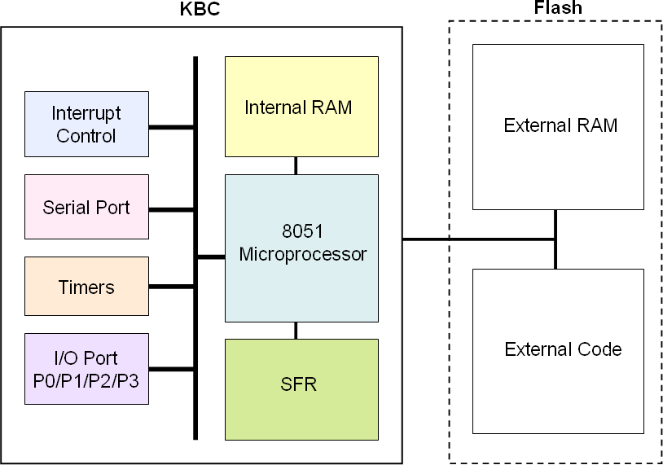

## 8051 Microprocessor Instruction

The instruction of 8051 microprocessor is fully compatible with industrial i8051. The instruction sets are as following table. The **OpCode** is in *Hexadecimal* and (b) means *Binary*. **B** stands for *byte number of instruction*. **C** stands for *number of cycle needed*.

|  |  |  |  |  |
| --- | --- | --- | --- | --- |
| **Arithmetic** | | | | |
| **Mnemonic** | **OP code** | **Byte** | **Cycle** | **Description** |
| ADD A, #data | 24 | 2 | 2 | Add immediate data to Accumulator |
| ADD A, direct | 25 | 2 | 2 | Add direct byte to Accumulator |
| ADD A, @ RN | 26~27 | 1 | 2 | Add indirect RAM to Accumulator (@R0~R1, OP 0x26~0x27) |
| ADD A, RN | 28~2F | 1 | 2 | Add register to Accumulator (R0~R7, OP 0x28~0x2F) |
| ADDC A, #data | 34 | 2 | 2 | Add immediate data to Accumulator with Carry |
| ADDC A, direct | 35 | 2 | 2 | Add direct byte to Accumulator with Carry |
| ADDC A, @ RN | 36~37 | 1 | 2 | Add indirect RAM to Accumulator with Carry (@R0~R1, OP 0x26~0x27) |
| ADDC A, RN | 38~3F | 1 | 2 | Add register to Accumulator with Carry (R0~R7, OP 0x38~0x3F) |
| SUBB A, #data | 94 | 2 | 2 | Subtract immediate data from ACC with Borrow |
| SUBB A, direct | 95 | 2 | 2 | Subtract direct byte from ACC with Borrow |
| SUBB A, @ RN | 96~97 | 1 | 2 | Subtract indirect RAM from ACC with Borrow (R0~R1, OP 0x96~0x97) |
| SUBB A, RN | 98~9F | 1 | 2 | Subtract register from Accumulator with Borrow (R0~R7, OP 0x98~0x9F) |
| INC A | 04 | 1 | 2 | Increment Accumulator |
| INC direct | 05 | 2 | 2 | Increment direct byte |
| INC @ RN | 06~07 | 1 | 2 | Increment indir[www.DeataSheetc.net/](http://www.DeataSheetc.net/) t RAM (R0~R1, OP 0x06~0x07) |
| INC RN | 08~0F | 1 | 2 | Increment Register (R0~R7, OP 0x08~0x0F) |
| DEC A | 14 | 1 | 2 | Decrement Accumulator |
| DEC direct | 15 | 2 | 2 | Decrement direct byte |
| DEC @ RN | 16~17 | 1 | 2 | Decrement indirect RAM (R0~R1, OP 0x16~0x17) |
| DEC RN | 18~1F | 1 | 2 | Decrement Register (R0~R7, OP 0x18~0x1F) |
| INC DPTR | A3 | 1 | 2 | Increment Data Pointer |
| MUL AB | A4 | 1 | 2 | Multiply A & B |
| DIV AB | 84 | 1 | 2 | Divide A by B |
| DA A | D4 | 1 | 2 | Decimal Adjust Accumulator |

www.DataSheet.net/

www.DataSheet.net/

|  |  |  |  |  |
| --- | --- | --- | --- | --- |
| **Bit Operation** | | | | |
| **Mnemonic** | **OP code** | **Byte** | **Cycle** | **Description** |
| SETB bit | D2 | 2 | 2 | Set direct bit |
| SETB C | D3 | 1 | 2 | Set Carry |
| CLR bit | C2 | 2 | 2 | Clear direct bit |
| CLR C | C3 | 1 | 2 | Clear Carry |
| CPL bit | B2 | 2 | 2 | Complement direct bit |
| CPL C | B3 | 1 | 2 | Complement Carry |
| ANL C, bit | 82 | 2 | 2 | AND direct bit to Carry |
| ANL C, /bit | B0 | 2 | 2 | AND complement of direct bit to Carry |
| ORL C, bit | 72 | 2 | 2 | OR direct bit to Carry |
| ORL C, /bit | A0 | 2 | 2 | OR complement of direct bit to Carry |
| MOV C, bit | 92 | 2 | 2 | Move direct bit to Carry |
| MOV bit, C | A2 | 2 | 2 | Move Carry to direct bit |
| JC relative | 4 0 | 2 | 2 | Jump if Carry is set |
| JNC relative | 5 0 | 2 | 2 | Jump if Carry is NOT set |
| JB bit, relative | 2 0 | 3 | 2 | Jump if direct bit is set |
| JBC bit, relative | 1 0 | 3 | 2 | Jump if direct bit is set & clear bit |
| JNB bit, relative | 3 0 | 3 | 2 | Jump if direct bit is NOT set |

www.DataSheet.net/

|  |  |  |  |  |
| --- | --- | --- | --- | --- |
| **Special Instruction** | | | | |
| **Mnemonic** | **OP code** | **Byte** | **Cycle** | **Description** |
| NOP | 00 | 1 | 2 | No Operation |

## 8051 Interrupt Controller

In order to support more application, the 8051 in KBC extends interrupt channel to 24 for internal peripherals, that is, I/O port P0, P1 and P3 are with interrupt capability. The *interrupt priority for each channel is fixed* and no nested interrupt is supported. Here is the table to summarize the implementation of the interrupt controller.

## Interrupt Enable/Flag Table

[www.DataSheet.net/](http://www.DataSheet.net/)

## Interrupt Enable/Flag Table (Continued)

[www.DataSheet.net/](http://www.DataSheet.net/)

## 8051 Special Function Register (SFR)

The Special Function Registers are located in the internal RAM of 8051 microprocessor. The internal address is from 0x80 to 0xFF, sized with 128 bytes. All the SFRs are compatible with the standard ones. Some SFRs are redesigned with new features for flexible application. The following table gives a brief summary.

P3IE, P1IE, P0IE are read/write registers used as Interrupt Enable (IE) to their corresponding interrupt inputs. These three registers are original 8051 port registers with 8-bits. For the embedded 8051 inside KB910, the 3 ports are used for interrupt input (always rise pulses) extensions. The overall interrupt events are 24.

P3IF, P1IF, P0IF are Interrupt Flag(IF) corresponding to the 24 interrupt inputs. The IFs are set by external interrupt event (always a rising pulse, one clock width), and are cleared by software (execute IRET instruction for active interrupt). The original alternate 8051 port 3 functions are not related with P3IE and P3IF.

For more detail, please refer to the section of register description.

|  |  |  |  |  |  |  |  |  |  |
| --- | --- | --- | --- | --- | --- | --- | --- | --- | --- |
| 80 | P0IE | SP | DPL | DPH |  |  | PCON2 | PCON | 87 |
| 88 | TCON | TMOD | TL0 | TL1 | TH0 | TH1 |  |  | 8F |
| 90 | P1IE |  |  |  |  |  |  |  | 97 |
| 98 | SCON | SBUF | SCON2 | SCON3 | SCON4 |  |  |  | 9F |
| A0 | P2 |  |  |  |  |  |  |  | A7 |
| A8 | IE |  |  |  | w |  |  |  | AF |
| B0 | P3IE |  |  |  |  |  |  |  | B7 |
| B8 | IP |  |  |  |  |  |  |  | BF |
| C0 |  |  |  |  |  |  |  |  | C7 |
| C8 |  |  |  |  |  |  |  |  | CF |
| D0 | PSW |  |  |  |  |  |  |  | D7 |
| D8 | P0IF |  |  |  |  |  |  |  | DF |
| E0 | ACC |  |  |  |  |  |  |  | E7 |
| E8 | P1IF |  |  |  |  |  |  |  | EF |
| F0 | B |  |  |  |  |  |  |  | F7 |
| F8 | P3IF |  |  |  |  |  |  |  | FF |
|  | ★ |  |  |  |  |  |  |  |  |

1. The blue parts are changed from standard features and the green ones are the new design for special features. And all the others are the standard features of conventional 8051.
2. The registers listed in the column with ★mark are all *bit addressable*.

## 8051 Microprocessor Register Description

The SFR registers are located at internal RAM 0x80 ~ 0xFF.

|  |  |  |  |  |  |
| --- | --- | --- | --- | --- | --- |
| **P0 Interrupt Enable Register** | | | | | |
| **Address** | **Name** | **Bit** | **Type** | **Description** | **Default** |
| 0x80 | P0IE | 7-0 | R/W | P0 interrupt enable. Bit0~7 for P0[0]~P0[7] respectively.  **0**: Disable  **1**: Enable | 0x00 |

|  |  |  |  |  |  |
| --- | --- | --- | --- | --- | --- |
| **Stack Pointer** | | | | | |
| **Address** | **Name** | **Bit** | **Type** | **Description** | **Default** |
| 0x81 | SP | 7-0 | R/W | 8051 stack pointer register | 0x07 |

|  |  |  |  |  |  |
| --- | --- | --- | --- | --- | --- |
| **Data Pointer Low Byte** | | | | | |
| **Address** | **Name** | **Bit** | **Type** | **Description** | **Default** |
| 0x82 | DPL | 7-0 | R/W | Low byte of DPTR | 0x00 |

|  |  |  |  |  |  |
| --- | --- | --- | --- | --- | --- |
| **Data Pointer High Byte** | | | | | |
| **Address** | **Name** | **Bit** | **Type** | **Description** | **Default** |
| 0x83 | DPH | 7-0 | R/W | High byte of DPTR | 0x00 |

www.DataSheet.net/

|  |  |  |  |  |  |
| --- | --- | --- | --- | --- | --- |
| **Processor Control Register** | | | | | |
| **Address** | **Name** | **Bit** | **Type** | **Description** | **Default** |
| 0x87 | PCON | 7-6 | RSV | Reserved | 0x00 |
| 5 | R/W | Interrupt vector offset address1  **0**: Interrupt vector address offset adding 0x0  **1**: Interrupt vector address offset adding 0x8000 |
| 4 | R/W | Interrupt vector offset address2  **0**: Interrupt vector address offset adding 0x0  **1**: Interrupt vector address offset adding 0x4000  Please note, if PCON[5]=1 and PCON[4]=1 then the result of interrupt vector address will be added 0xC000. |
| 3 | R/W | General purpose flag 1  **0**: no event  **1**: event occurs |
| 2 | R/W | General purpose flag 2  **0**: no event  **1**: event occurs |
| 1 | WO | Stop mode enable.  All clock stop except the external 32.768K OSC and PCICLK.  **1**: Enable (write “0” no work) |
| 0 | WO | Idle mode enable.  The clock of 8051 stops.  **1**: Enable (write “0” no work) |

|  |  |  |  |  |  |
| --- | --- | --- | --- | --- | --- |
| **Timer/Counter Control Register** | | | | | |
| **Address** | **Name** | **Bit** | **Type** | **Description** | **Default** |
| 0x88 | TCON | 7 | R/W1C | **TF1**, Timer1 overfloww flag  **0**: no event  **1**: event occurs | 0x00 |
| 6 | R/W | **TR1**, Timer1 start control.  **0**: stop to count  **1**: start to count |
| 5 | R/W1C | **TF0**, Timer0 overflow flag  **0**: no event  **1**: event occurs |
| 4 | R/W | **TR0**, Timer0 start control.  **0**: stop to count  **1**: start to count |
| 3 | R/W1C | **IE1**, External interrupt 1 flag  **0**: no event  **1**: event occurs |
| 2 | R/W | **IT1**, External interrupt 1 trigger selection  **0**: low level trigger  **1**: falling edge trigger |
| 1 | R/W1C | **IE0**, External interrupt 0 flag  **0**: no event  **1**: event occurs |
| 0 | R/W | **IT0**, External interrupt 0 trigger selection  **0**: low level trigger  **1**: falling edge trigger |

|  |  |  |  |  |  |
| --- | --- | --- | --- | --- | --- |
| **Timer Mode Register** | | | | | |
| **Address** | **Name** | **Bit** | **Type** | **Description** | **Default** |
| 0x89 | TMOD | 7 | R/W | **GATE1**, this bit is the gate control of TR1 and INT1  **0**: Disable  **1**: Enable | 0x00 |
| 6 | R/W | **CT1**, Timer1 timer/counter selection  **0**: Timer  **1**: Counter |
| 5-4 | R/W | **TM1**, Timer1 mode selection  **0**: 13-bit timer  **1**: 16-bit timer  **2**: 8-bit auto reload timer  **3**: Timer 1 stops. |
| 3 | R/W | **GATE0**, this bit is the gate control of TR0 and INT0  **0**: Disable  **1**: Enable |
| 2 | R/W | **CT0**, Timer0 timer/counter selection  **0**: Timer  **1**: Counter |
| 1-0 | R/W | **TM0**, Timer0 mode selection  **0**: 13-bit timer  **1**: 16-bit timer  **2**: 8-bit auto reload timer  **3**: TL0 and TH0 are two 8-bit timers. |

|  |  |  |  |  |  |
| --- | --- | --- | --- | --- | --- |
| **Timer 0 Low Byte** | | | | | |
| **Address** | **Name** | **Bit** | **Type** | **Description**  w | **Default** |
| 0x8A | TL0 | 7-0 | R/W | Low byte of timer 0 | 0x00 |

|  |  |  |  |  |  |
| --- | --- | --- | --- | --- | --- |
| **Timer 1 Low Byte** | | | | | |
| **Address** | **Name** | **Bit** | **Type** | **Description** | **Default** |
| 0x8B | TL1 | 7-0 | R/W | Low byte of timer 1. | 0x00 |

|  |  |  |  |  |  |
| --- | --- | --- | --- | --- | --- |
| **Timer 0 High Byte** | | | | | |
| **Address** | **Name** | **Bit** | **Type** | **Description** | **Default** |
| 0x8C | TH0 | 7-0 | R/W | High byte of timer 0 | 0x00 |

|  |  |  |  |  |  |
| --- | --- | --- | --- | --- | --- |
| **Timer 1 High Byte** | | | | | |
| **Address** | **Name** | **Bit** | **Type** | **Description** | **Default** |
| 0x8D | TH1 | 7-0 | R/W | High byte of timer 1 | 0x00 |

|  |  |  |  |  |  |
| --- | --- | --- | --- | --- | --- |
| **Port1 Interrupt Enable Register** | | | | | |
| **Address** | **Name** | **Bit** | **Type** | **Description** | **Default** |
| 0x90 | P1IE | 7-0 | R/W | Port 1 interrupt enable. Bit0~7 for P1[0]~P1[7] respectively  **0**: Disable  **1**: Enable | 0x00 |

|  |  |  |  |  |  |
| --- | --- | --- | --- | --- | --- |
| **Serial Port Control Register** | | | | | |
| **Address** | **Name** | **Bit** | **Type** | **Description** | **Default** |
| 0x98 | SCON | 7-6 | R/W | **SM1,SM0**, serial port mode  **00**: 8-bit shift register, E51RX will be shift clock of E51CLK.  **01**: 8-bit serial port (variable)  **10**: 9-bit serial port (variable)  **11**: 9-bit serial port (variable) | 0x50 |
| 5 | RSV | Reserved |
| 4 | R/W | **REN**, serial port receive function enable.  **0**: Disable  **1**: Enable |
| 3 | R/W | **TB8**, The 9th bit of transmit data in mode2 and mode3. |
| 2 | R/W | **RB8**, The 9th bit of receive data |
| 1 | R/W0C | **TI**, TX interrupt flag  **0**: no event  **1**: event occurs |
| 0 | R/W0C | **RI**, RX interrupt flag  **0**: no event  **1**: event occurs |

[www.DataSheet.net/](http://www.DataSheet.net/)

|  |  |  |  |  |  |
| --- | --- | --- | --- | --- | --- |
| **Serial Port Data Buffer Register** | | | | | |
| **Address** | **Name** | **Bit** | **Type** | **Description** | **Default** |
| 0x99 | SBUF | 7-0 | R/W | Serial port data buffer | 0x00 |

|  |  |  |  |  |  |
| --- | --- | --- | --- | --- | --- |
| **Serial Port Control Register 2** | | | | | |
| **Address** | **Name** | **Bit** | **Type** | **Description** | **Default** |
| 0x9A | SCON2 | 7-0 | R/W | High byte of 16-bit counter for baud rate | 0x00 |

|  |  |  |  |  |  |
| --- | --- | --- | --- | --- | --- |
| **Serial Port Control Register 3** | | | | | |
| **Address** | **Name** | **Bit** | **Type** | **Description** | **Default** |
| 0x9B | SCON3 | 7-0 | R/W | Low byte of 16-bit counter for baud rate | 0x00 |

|  |  |  |  |  |  |
| --- | --- | --- | --- | --- | --- |
| **Serial Port Control Register 4** | | | | | |
| **Address** | **Name** | **Bit** | **Type** | **Description** | **Default** |
| 0x9C | SCON4 | 7-2 | RSV | Reserved | 0x00 |
| 1~0 | R/W | Serial Port mode 0 baud- rate setting (E51 clock set in CLKCFG, 0xFF0D ) **00:** E51 clock divide 2  **01:** E51 clock divide 4  **10:** E51 clock divide 8  **11**: E51 clock divide 16 |

|  |  |  |  |  |  |
| --- | --- | --- | --- | --- | --- |
| **Port 2 Register** | | | | | |
| **Address** | **Name** | **Bit** | **Type** | **Description** | **Default** |
| 0xA0 | P2 | 7-0 | R/W | Port 2 register | 0x00 |

|  |  |  |  |  |  |
| --- | --- | --- | --- | --- | --- |
| **Interrupt Enable Register** | | | | | |
| **Address** | **Name** | **Bit** | **Type** | **Description** | **Default** |
| 0xA8 | IE | 7 | R/W | **EA**, all interrupts enable.  **0**: Disable  **1**: Enable | 0x00 |
| 6 | R/W | **EP**, Change P0IF, P1IF, P3IF Interrupt event trigger flag to Interrupt event pending flag  **0**: Disable  **1**: Enable |
| 6-5 | RSV | Reserved |
| 4 | R/W | **ES**, serial port interrupt enable  **0**: Disable  **1**: Enable |
| 3 | R/W | **ET1**, timer1 overflow interrupt enable  **0**: Disable  **1**: Enable |
| 2 | R/W | **EX1**, external interrupt 1 enable.  **0**: Disable  **1**: Enable |
| 1 | R/W | **ET0**, timer0 overflow interrupt enable  **0**: Disable  **1**: Enable |
| 0 | R/W | [www.DataSheet.net/](http://www.DataSheet.net/)  **EX0**, external interrupt 0 enable.  **0**: Disable  **1**: Enable |

|  |  |  |  |  |  |
| --- | --- | --- | --- | --- | --- |
| **Interrupt Enable Register** | | | | | |
| **Address** | **Name** | **Bit** | **Type** | **Description** | **Default** |
| 0xB0 | P3IE | 7-0 | R/W | Port 3 interrupt enable. Bit0~7 for P3[0]~P3[7] respectively  **0**: Disable  **1**: Enable | 0x00 |

|  |  |  |  |  |  |
| --- | --- | --- | --- | --- | --- |
| **Interrupt Priority Register** | | | | | |
| **Address** | **Name** | **Bit** | **Type** | **Description** | **Default** |
| 0xB8 | IP | 7-5 | RSV | Reserved | 0x00 |
| 4 | R/W | Serial port interrupt priority  **0**: Low  **1**: High |
| 3 | R/W | Timer1 interrupt priority  **0**: Low  **1**: High |
| 2 | R/W | External interrupt 1 priority  **0**: Low  **1**: High |
| 1 | R/W | Timer 0 interrupt priority  **0**: Low  **1**: High |
| 0 | R/W | External interrupt 0 priority  **0**: Low  **1**: High |

www.DataSheet.net/

|  |  |  |  |  |  |
| --- | --- | --- | --- | --- | --- |
| **Port0 Interrupt Flag Register** | | | | | |
| **Address** | **Name** | **Bit** | **Type** | **Description** | **Default** |
| 0xD8 | P0IF | 7-0 | R/W | Port 0 interrupt flag. | 0x00 |

|  |  |  |  |  |  |
| --- | --- | --- | --- | --- | --- |
| **Accumulator, ACC** | | | | | |
| **Address** | **Name** | **Bit** | **Type** | **Description** | **Default** |
| 0xE0 | ACC | 7-0 | R/W | Accumulator | 0x00 |

|  |  |  |  |  |  |
| --- | --- | --- | --- | --- | --- |
| **Port1 Interrupt Flag Register** | | | | | |
| **Address** | **Name** | **Bit** | **Type** | **Description** | **Default** |
| 0xE8 | P1IF | 7-0 | R/W | Port 1 interrupt flag. | 0x00 |

|  |  |  |  |  |  |
| --- | --- | --- | --- | --- | --- |
| **B Register** | | | | | |
| **Address** | **Name** | **Bit** | **Type** | **Description** | **Default** |
| 0xF0 | B | 7-0 | R/W | **B** register, for MUL and DIV instructions. | 0x00 |

|  |  |  |  |  |  |
| --- | --- | --- | --- | --- | --- |
| **Port3 Interrupt Flag Register** | | | | | |
| **Address** | **Name** | **Bit** | **Type** | **Description** | **Default** |
| 0xF8 | P3IF | 7-0 | R/W | Port 3 interrupt flag. | 0x00 |

w

# Electrical Characteristics

## Absolute Maximum Rating

|  |  |  |  |  |
| --- | --- | --- | --- | --- |
| **Symbol** | **Parameter** | **Condition** | **Rating** | **Unit** |
| VCC | Power Source Voltage | All voltages are referred to GND. | -0.3 ~ 3.6 | V |
| Vi | Input Voltage | -0.3 ~ 3.6 | V |
| Vo | Output Voltage | -0.3 ~ 3.6 | V |
| TSTG | Storage Temperature |  | -65 ~ 150 | ℃ |
|  | ESD | Human Body Mode (HBM) | TBD | V |
| Machine Mode (MM) | TBD |

* 1. **DC Electrical Characteristics BQCZ16HIV**

## BQC04HIV

|  |  |  |  |  |  |  |
| --- | --- | --- | --- | --- | --- | --- |
| **Parameter** | **Symbol** | **Min** | **Typ.** | **Max** | **Unit** | **Condition** |
| Input Low Threshold | Vt- |  | 1.23 |  | V |  |
| Input High Threshold | Vt+ |  | 1.90 |  | V |  |
| Hysteresis | VTH |  | 0.67 |  | V |  |
| Output Low Voltage | VOL |  |  | 0.4 | V | 4mA Sink |
| Output High Voltage | VOH | 2.8 |  |  | V | 4mA Source |
| Input Leakage Current | IIL |  | 0.02 |  | μA | No pull-up |
| Input Pull-Up Resistance | RPU |  | 40K |  | Ω | VI=0V |
| Input Capacitance | CPU |  | 5.5 |  | pF |  |
| Output Capacitance | COUT |  | 5.5 |  | pF |  |
| Bi-directional Capacitance | CBID |  | 5.5 |  | pF |  |

## BQCW16HIV

|  |  |  |  |  |  |  |
| --- | --- | --- | --- | --- | --- | --- |
| **Parameter** | **Symbol** | **Min** | **Typ.** | **Max** | **Unit** | **Condition** |
| Input Low Threshold | Vt- |  | 1.23 |  | V |  |
| Input High Threshold | Vt+ |  | 1.90 |  | V |  |
| Hysteresis | VTH |  | 0.67 |  | V |  |
| Output Low Voltage | VOL |  |  | 0.4 | V | 16mA Sink |
| Output High Voltage | VOH | 2.8 |  |  | V | 16mA Source |
| Input Leakage Current | IIL |  | 0.02 |  | μA | No pull-up |
| Input Pull-Up Resistance | RPU |  | 40K |  | Ω | VI=0V |
| Input Capacitance | CPU |  | 5.5 |  | pF |  |
| Output Capacitance | COUT |  | 5.5 |  | pF |  |
| Bi-directional Capacitance | CBID |  | 5.5 |  | pF |  |

## BCC16HI

(No Schmitt Trigger, No Pull-Up resistance function)

[www.DataSheet.net/](http://www.DataSheet.net/)

## BQC04HI

(No Pull-Up resistance function)

|  |  |  |  |  |  |  |
| --- | --- | --- | --- | --- | --- | --- |
| **Parameter** | **Symbol** | **Min** | **Typ.** | **Max** | **Unit** | **Condition** |
| Input Low Threshold | Vt- |  | 1.23 |  | V |  |
| Input High Threshold | Vt+ |  | 1.90 |  | V |  |
| Hysteresis | VTH |  | 0.67 |  | V |  |
| Output Low Voltage | VOL |  |  | 0.4 | V | 4mA Sink |
| Output High Voltage | VOH | 2.8 |  |  | V | 4mA Source |
| Input Leakage Current | IIL |  | 0.02 |  | μA | No pull-up |
| Input Pull-Up Resistance＊ | RPU |  | -- |  | Ω |  |
| Input Capacitance | CPU |  | 5.5 |  | pF |  |
| Output Capacitance | COUT |  | 5.5 |  | pF |  |
| Bi-directional Capacitance | CBID |  | 5.5 |  | pF |  |

## IQTHI (ADC cell)

(Input only, No Pull-Up resistance function)

[www.DataSheet.net/](http://www.DataSheet.net/)

## OCT04H (DAC cell)

(Output only)

|  |  |  |  |  |  |  |
| --- | --- | --- | --- | --- | --- | --- |
| **Parameter** | **Symbol** | **Min** | **Typ.** | **Max** | **Unit** | **Condition** |
| Output Low Voltage | VOL |  |  | 0.4 | V | 4mA Sink |
| Output High Voltage | VOH | 2.8 |  |  | V | 4mA Source |
| Output Capacitance | COUT |  | 5.5 |  | pF |  |

## BQC08HIV

|  |  |  |  |  |  |  |
| --- | --- | --- | --- | --- | --- | --- |
| **Parameter** | **Symbol** | **Min** | **Typ.** | **Max** | **Unit** | **Condition** |
| Input Low Threshold | Vt- |  | 1.23 |  | V |  |
| Input High Threshold | Vt+ |  | 1.90 |  | V |  |
| Hysteresis | VTH |  | 0.67 |  | V |  |
| Output Low Voltage | VOL |  |  | 0.4 | V | 8mA Sink |
| Output High Voltage | VOH | 2.8 |  |  | V | 8mA Source |
| Input Leakage Current | IIL |  | 0.02 |  | μA | No pull-up |
| Input Pull-Up Resistance | RPU |  | 40K |  | Ω |  |
| Input Capacitance | CPU |  | 5.5 |  | pF |  |
| Output Capacitance | COUT |  | 5.5 |  | pF |  |
| Bi-directional Capacitance | CBID |  | 5.5 |  | pF |  |

## BQC04HIVPECI

|  |  |  |  |  |  |  |
| --- | --- | --- | --- | --- | --- | --- |
| **Parameter** | **Symbol** | **Min** | **Typ.** | **Max** | **Unit** | **Condition** |
| Input Low Threshold | Vt- |  | 1.23 |  | V |  |
| Input High Threshold | Vt+ |  | 1.90 |  | V |  |
| Hysteresis | VTH |  | 0.67 |  | V |  |
| Input Low Threshold | Vt- |  | 0.37 |  | V | PECI Enable |
| Input High Threshold | Vt+ |  | 0.68 |  | V | PECI Enable |
| Hysteresis | VTH | w | 0.31 |  | V | PECI Enable |
| Output Low Voltage | VOL |  |  | 0.4 | V | 4mA Sink |
| Output High Voltage | VOH | 2.8 |  |  | V | 4mA Source |
| Input Leakage Current | IIL |  | 0.02 |  | μA | No pull-up |
| Input Pull-Up Resistance | RPU |  | 40K |  | Ω |  |
| Input Capacitance | CPU |  | 5.5 |  | pF |  |
| Output Capacitance | COUT |  | 5.5 |  | pF |  |
| Bi-directional Capacitance | CBID |  | 5.5 |  | pF |  |

## A/D & D/A Characteristics

### ADC characteristics

|  |  |  |  |  |
| --- | --- | --- | --- | --- |
| **Parameter** | **Limits** | | | **Unit** |
| **Min** | **Typ** | **Max** |
| Resolution |  | 10 |  | Bit |
| Integral Non-linearity Error (INL) |  | TBD |  | LSB |
| Differential Non-linearity Error (DNL) |  | TBD |  | LSB |
| Offset Error |  | TBD |  | LSB |
| Gain Error |  | TBD |  | LSB |
| A/D Input Voltage Range | 0.1Vcca |  | 0.9Vcca | V |
| A/D Input Leakage Current |  | <0.5 |  | uA |
| A/D Input Resistance | 10 |  |  | MΩ |
| A/D Input Capacitance |  |  | 2 | pF |
| A/D Clock Frequency |  | 1 |  | MHz |
| Voltage Conversion Time |  | 256 |  | uS |

DAC characteristics

w

## Recommend Operation Condition

|  |  |  |  |  |  |
| --- | --- | --- | --- | --- | --- |
| **Symbol** | **Parameter** | **Limits** | | | **Unit** |
| **Min** | **Typ** | **Max** |
| Vcc | Power Source Voltage | 3.0 | 3.3 | 3.6 | V |
| GND | Ground Voltage | -0.3 | 0 | 0.3 | V |
| VCCA | Analog Reference Voltage (for A/D and D/A) | 3.0 | 3.3 | 3.6 | V |
| AGND | Analog Ground Voltage | -0.3 | 0 | 0.3 | V |
| Top | Operating Temperature | 0 | 25 | 70 | ℃ |

* 1. **Operating Current**

|  |  |  |  |
| --- | --- | --- | --- |
| **Symbol** | **Parameter** | **Limits** | **Unit** |
| **Typ** |
| Icc | Typical current consumption in operating state under Windows environment. All clock domains are running, and no keyboard/mouse activities. | 20 | mA |

## Package Thermal Information

Thermal resistance (degrees C/W). ThetaJA vaw lues for KBx930.

|  |  |  |  |
| --- | --- | --- | --- |
|  | **ThetaJA @ 0 m/s** | **ThetaJA @ 1 m/s** | **ThetaJA @ 2 m/s** |
| **128-Pin LQFP** | 59.1 | 53.3 | 51.4 |

## AC Electrical Characteristics

## SPI Flash Timing



|  |  |  |  |  |  |  |
| --- | --- | --- | --- | --- | --- | --- |
| **Parameter** | **Symbol** | **Spec.** | | |  | **Condition** |
| **Min.** | **Typ.** | **Max.** | **Unit** |
| SPICLK period | **tSCLK** | 15.2*1 | -- | -- | ns |  |
| SPICLK High Period | **tCLH** | 4 | -- | -- | ns | **tSCLK** = 15.2ns,  CL=12pF |
| SPICLK Low Period | **tCLL** | 4 [www.DataSheet.net/](http://www.DataSheet.net/) | -- | -- | ns | **tSCLK** = 15.2ns, CL=12pF |
| MOSI Setup Time | **tOSU** | -- | tSCLK/2  – 5*2 | -- | ns | CL=12pF |
| MOSI Hold Time | **tOH** | -- | tSCLK/2  + 5*2 | -- | ns | CL=12pF |
| SPICS# Active Setup Time | **tSLCH** | -- | tSCLK | -- | ns |  |
| SPICS# Not Active Hold Time | **tCHSH** | -- | tSCLK/2 | -- | ns |  |
| SPICS# Deselect Time | **tSHSL** | 110 | -- | -- | ns |  |
| MISO Setup Time | **tDSU** | 0 | -- | -- | ns |  |
| MISO Hold Time | **tDH** | tSCLK/2 – 4 | -- | -- | ns |  |

1. Tolerance +/- 3% (need to count in the DPLL tolerance)
2. For characteristic only.

## LPC interface Timing

Note: All AC characteristics of the LPC interface meet the PCI Local Bus SPEC for 3.3V DC signaling.

#### Clock & Reset：

|  |  |  |  |  |  |
| --- | --- | --- | --- | --- | --- |
| **Symbol** | **Parameter** | **Min** | **Max** | **Units** | **Notes** |
| Tcyc | **CLK** Cycle Time | 30 | 33 | ns | 1,4 |
| Thigh | **CLK** High Time | 11 |  | ns |  |
| Tlow | **CLK** Low Time | 11 |  | ns |  |
|  | **CLK** Slew Rate | 1 | 4 | V/ns | 2 |
|  | **Reset** Slew Rate | 50 |  | mV/ns | 3 |

* 1. In general, all PCI components must work within clock frequency constrain. The clock frequency may be changed at any time during the operation of the system so long as the clock edges remain "clean" (monotonic) and the minimum cycle and high and low times are not violated. The clock may only be stopped in a low state.
  2. Rise and fall times are specified in terms of the edge rate measured in V/ns. This slew rate must be met across the minimum peak-to-peak portion of the clock waveform as shown below.
  3. The minimum RST# slew rate applies only to the rising (de-assertion) edge of the reset signal and ensures that system noise cannot render an otherwise monotonic signal to appear to bounce in the switching range.
  4. Device operational parameters at frequencies under 16 MHz may be guaranteed by design rather than by testing.

[www.DataSheet.net/](http://www.DataSheet.net/)

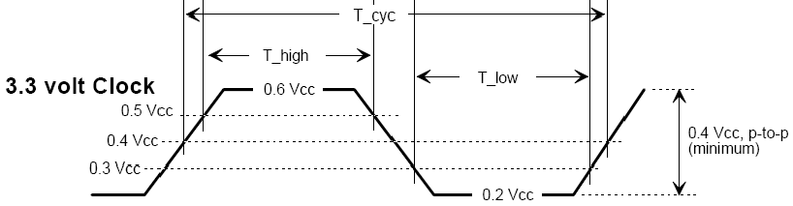

#### Timing Parameters

|  |  |  |  |  |  |
| --- | --- | --- | --- | --- | --- |
| **Symbol** | **Parameter** | **Min** | **Max** | **Units** | **Notes** |
| Tval | **CLK** to Signal Valid Delay | 2 | 11 | ns |  |
| Ton | Float to Active Delay | 2 |  | ns | 1 |
| Toff | Active to Float Delay |  | 28 | ns | 1 |
| Tsu | Input Setup Time to **CLK** | 7 |  | ns | 2,3 |
| Th | Input Hold Time from **CLK** | 0 |  | ns | 3 |

1. For purposes of Active/Float timing measurements, the Hi-Z or “off” state is defined to be when the total current delivered through the component pin is less than or equal to the leakage current specification.
2. Setup time applies only when the device is not driving the pin. Devices cannot drive and receive signals at the same time.
3. Refer the timing measurement conditions as below

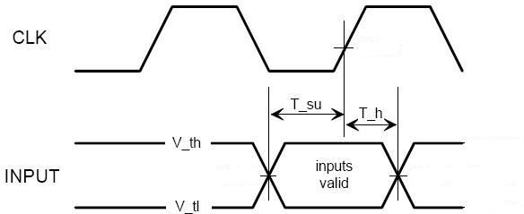

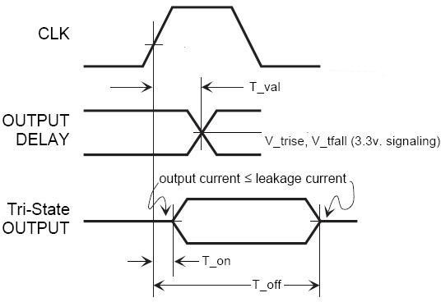

## PS/2 interface Timing

### This page is leaved blank intentionally.

w

## SMBus interface Timing



#### Timing Parameters

|  |  |  |  |  |  |  |
| --- | --- | --- | --- | --- | --- | --- |
| **Symbol** | **Parameter** | **Min** | **Typ.** | **Max** | **Units** | **Notes** |
| Tbuf | Bus free time between Stop and Start Condition | 4.7 |  |  | μs |  |
| Thd:sta | Hold time after (repeated) star condition. After this  period, the first clock is generated. | 4.0 |  |  | μs |  |
| Tsu:sta | Repeated start condition setup time | 4.7 |  |  | μs |  |
| Tsu:sto | Stop confition setup time | 4.0 |  |  | μs |  |
| Thd:dat | Data hold time | 300 |  |  | ns |  |
| Tsu:dat | Data setup time | 250 |  |  | ns |  |
| Ttimeout | Detect clock low timeout | 25 |  | 35 | ms |  |
| Tlow | Clock low period | 4.7 |  |  | μs | 2 |
| Thigh | Clock high period | 4.0 |  | 50 | μs | 2 |
| Tf | Data fall time |  |  | 300 | ns |  |
| Tr | Data rise time |  |  | 1000 | ns |  |

1. For characteristic only
2. SMBUS frequencry dependant

## PECI interface Timing

### This page is leaved blank intentionally.

w

## OWM interface Timing

### This page is leaved blank intentionally.

w

# Package Information

## LQFP 128-Pin Outline Diagram

## Top View

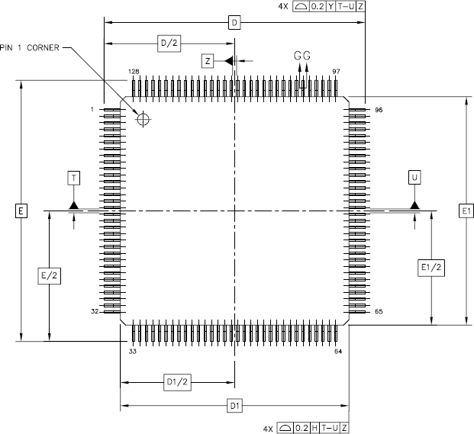

## Side View

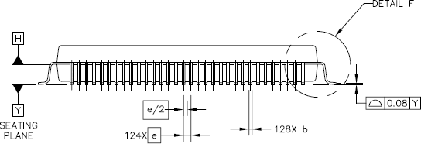

w

## Lead View

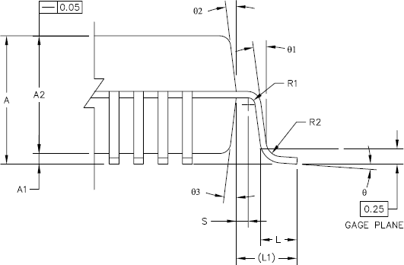

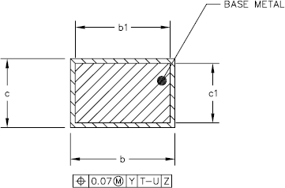

* + 1. **LQFP Outline Dimensions**

|  |  |  |  |  |  |  |  |
| --- | --- | --- | --- | --- | --- | --- | --- |
| **DIM** | **Min.** | **Typ.** | **Max.** | **DIM** | **Min.** | **Typ.** | **Max.** |
| A | ——— |  | 1.6 | E1 |  | 14 BSC |  |
| A1 | 0.05 |  | 0.15 | L | 0.45 | 0.6 | 0.75 |
| A2 | 1.35 | 1.4 | 1.45 | L1 |  | 1 REF |  |
| b | 0.13 | 0.16 | 0.23 | R1 | 0.08 |  | ——— |
| b1 | 0.13 |  | 0.19 | R2 | 0.08 |  | 0.2 |
| c | 0.09 |  | 0.2 | S | 0.2 |  | ——— |
| c1 | 0.09 |  | 0.16 | θ | 0° | 3.5° | 7° |
| D |  | 16 BSC |  | θ1 | 0° |  | ——— |
| D1 |  | 14 BSC |  | θ2 | 11° | 12° | 13° |
| e |  | 0.4 BSC |  | θ3 | 11° | 12° | 13° |
| E |  | 16 BSC |  |  |  |  |  |
| **Unit** | mm | | | | | | |
| **Package** | 14x14x1.4 | | | | | | |
| **Pitch POD** | 0.4 | | | | | | |

[www.DataSheet.net/](http://www.DataSheet.net/)

## LFBGA 128-Pin Outline Diagram

* + 1. **Top View**

### This page is leaved blank intentionally.

[www.DataSheet.net/](http://www.DataSheet.net/)

## Side View

### This page is leaved blank intentionally.

[www.DataSheet.net/](http://www.DataSheet.net/)

## Bottom View

### This page is leaved blank intentionally.

[www.DataSheet.net/](http://www.DataSheet.net/)

## LFBGA Outline Dimensions

### This page is leaved blank intentionally.

w

## Part Number Description

|  |  |  |
| --- | --- | --- |
| **Part Number** | **Package Size** | **Lead Free Process** |
| KB3930QF A1 | 14mm * 14mm 128 pins LQFP | Lead Free |

[www.DataSheet.net/](http://www.DataSheet.net/)