
FPT-aptech computer education
eProject Document
Online Bus Ticket Reservation System
Group 2
Group Member | Đặng Ngọc Tuyền < 4548 >  Nguyễn Khải Hoàn< 4573 >  Lê Hữu Trung < 4118 >  Vũ Ngọc Sơn < 2758 >  Nguyễn Trung Thành < 4564 >
Instructor | Đỗ Quốc Bình
Batch | C0812i
Semester | 3

- Hanoi, 2/2011 -

Table of Contents
1. Introduction 4
2. Problem Definition 4
2.1. Problem Abstraction 4
2.2. The Current System 4
2.3. The Proposed System 4
2.4. Boundaries of the System 6
2.5. Development Environment 7
3. Requirements and Business Flow 7
3.1. Customer Requirement Specification 7
3.1.1. System administrator 7
3.1.2. Website 9
3.1. Use Case Diagram 10
3.1.1. Use case customer 10
3.1.2. Use case Account Management 11
3.1.3. Use case Ticket management 11
3.1.4. Use case Seat management 12
3.1.5. Use case Promote management 12
3.1.6. Use case Category management 13
3.1.7. Use case Place management 13
3.1.8. Use case Bus type management 14
3.1.9. Use case Bus management 14
3.2. Use Case Specification 14
3.3. Activity Diagram 30
3.3.1. Booking 30
3.3.2. Delete 30
3.3.3. Inset 32
3.3.4. Update 33
3.3.5. Register 34
3.3.6. Login 35
3.3.7. Change password 36
3.3.8. Search 37
4. Design 37
4.1. System Architecture 37
4.2. Class Diagram 39
4.3. Entity Relationship diagram 39
4.4. Database Design 40

Introduction
SRC Travel Agencies is a domestic privatized transportation company that runs the vehicles all over the country. They have several branches at different locations of the country, so that they can provide the transportation facilities between the places. They want an online application to be developed, where the details of the bookings done and the customer will be updated from time to time and one can track the details of the available seats immediately.

Problem Definition

Problem Abstraction
SRC Travel Agencies is a domestic privatized transportation company that runs the vehicles all over the country. They have several branches at different locations of the country, so that they can provide the transportation facilities between the places. They want an online application to be developed, where the details of the bookings done and the customer will be updated from time to time and one can track the details of the available seats immediately.

The Current System
SRC Travel Agencies is the agency that provides the transportation facility to the
customers based on their requirements. They provide different buses like Express,
Luxury, and Volvo (Has two types A/C and Non A/C). The charges are different for
different buses. The charges are in the below mentioned format.

Express < Luxury < Volvo (Non A/C) < Volvo (A/C)

The charges also depend on the distance the customer wants to travel and as well on
the age of the customer. The charges also depends on the age, i.e., up to the age of 5 years
there will not be any charges, in between 5 12 there will be half charges and for above
twelve the charges will be full till the age of 50 and for the age above fifty they will get a
discount of 30%. They implement this in order to attract the customers.
They maintain all the records of the bus reservation counter through Online service
itself but the application is only accessed by the Admin and the Employers Alone. Until
now they used to issue the tickets in the buses alone as it is difficult to track the details of
the bookings done as it provides the service allover the country.

The Proposed System
They want incorporate an online service application where they can maintain the
records of the buses along with the details of the customers. The customer can now book
the tickets by visiting the booking counters at their place (nearby) to the respective
destination as required. They want the application to be linked with the database, so that
whatever details are entered like the details of the customers, buses, and bookings can be
viewed by the other centers as well as it is an online application.

They also want to incorporate some feature which performs the tasks that they actually
perform, and an application where the customer can register with the site and then book
the tickets online instead of visiting the booking counter

A database should be maintained where the bus details along with the bus number,
route, the places it covers through out the distance and also the timings are needed to be
maintained. Also the details of the customers that are entered at the time of booking the
tickets are needed to be gathered in the database. So that they can track the details of the
customer at any time using the search option based on the starting place, age, name,
destination place and Date and Time and even based on the bus they had chosen.

The database should also maintain the list of the Employers as they alone book the
tickets with the username and password. The list that is to be maintained is personal
details, contact details, location, qualification, age, etc are needed to be gathered.

There should be buttons like New, Update and Cancel are to be included. Based on the
button chosen the respective action is needed to be performed. Also if the Employee
record is entered (The Employee details will be maintained by the Admin alone), it
should automatically generate a six digit code, and it will ask for the username and the
password (the password can be changed by the Employee) through which he can login in
to the a/c so as to perform the booking tasks.

Also for canceling the ticket, there is a limit like, if cancelled before 2 days then the
whole money will be returned, and if done one day before, then 15% is debited from the
total amount and the remaining amount is returned and if done on that day 30% is debited
from the total amount and the remaining is to be returned back. This action is also to be
performed by the application alone.

They want the application to be maintained in different details like the buses and the
bookings information. When they try to book a ticket it should ask for the customer
details like the name of the customers for whom the tickets are booked, Date and Time,
Starting and Destination place and the age ( as the charges depends on the age). Also the
Bus no. and the seat no. for which the ticket (s) booked are to be entered so that they can
keep track of the bookings done.

Whenever a customer enquires for the availability they can check through the Enquiry
form where the details like Destination Place, Starting Place, Date and Time are asked,
by entering these details (all fields are not mandatory) the availability details should be
displayed. Also there should be a search option through which the records of the
customers and the buses can be known easily with the same above options.

After the ticket is booked, one should be able to print the ticket, including the details
like age, name, Date and time for which the ticket is booked and as well the destination
and Starting locations and the charges for the ticket including the taxes.

The application alone should be able to calculate the payments as per the age criteria
and the distance. Also it has to be updated in the site.

Note :
i. To book the ticket or to fetch the details (Search and Enquiry) first they need to
Login and only then they will be able to perform such actions.
ii. This application is solely for the booking department to book the tickets and is
purely maintained by them. It is not applicable for the customers and they
(customers) cannot book the tickets online by themselves.
iii. The Admin maintains the list of the buses and as well the Employees which
cannot be accessed by the Employee. The Employee can alone change his
Password from the booking window)

Boundaries of the System
Non-Financial:
An online application needed to be developed which is to be solely used and maintained by the booking department alone (regarding the bookings like booking, Enquiry and Updating and canceling). It is implemented so as to automate the process. Also the total authority is taken care of by the admin (Employee, Buses and charges) Also for booking or to perform other actions one has to login with the username and the password assigned.
There will be a new, Update, Cancel, search buttons available on each page with which the employee details
The customer needed to visit to the booking to enquire or book the tickets and he can collect the tickets in the bus alone.
It also maintains a database that consists of the list of buses along with the five digit code that will be assigned to each bus for easy reference.
Also the application should develop a unique six digit code whenever a new employee detail is entered.
Employee s personal, contact, age, qualifications etc are needed to be collected.
There will be an Enquiry form, Booking Form, and the also a page where the search options will be available. Also the Price list is to be maintained separately, where one can access the details of the price by entering the details of the Place of starting and destination, age, number of seats, etc.
The charges are as per the age, bus type and the distance and are to be maintained by the application alone.
Financial:
The charges vary depending on the type of the bus opted, distance of travel and as well the age of the customer, which is to be calculated by the application alone. The price list can be updated by the Admin alone. Also the Reimbursement of the amount will also be as defined by the admin and is calculated by the application alone by considering the above parameters.

Development Environment
Hardware:
A minimum computer system that will help you access all the tools in the courses is a Pentium IV or better, 256 Megabytes of RAM or better, Windows XP (or higher if possible)
Software :
Net 3.5, SQL Server 2005, Visual studio 2008

Requirements and Business Flow

Customer Requirement Specification

3.1.1. System administrator

3.1.1.1. System Login
- Purpose:
- Allow use declared identification to used application.
- Object used:
- Administrator, Employee, Customer, Visitor
- Functional request:
- Allow user input username and password and validate information.
- The program will display error if username or password is invalid.
- Execute condition:

3.1.1.2. Ticket management
- Purpose:
- Allows managers manage employees, bus routes and bus.
- Object used:
- Administrator
- Functional request:
- Application for the search has not set ticket, the fare was set, the online car, truck and control staff.
- Application for additional car online, the location of the vehicle, creating tickets, canceled tickets, booking.
- The application allows managers tickets, sell tickets, to cancel tickets and staff created tickets but not controlled cars and car routes.
- Execute condition:
- Administrator and employee have to login system.

3.1.1.3. Bus management
- Purpose:
- Vehicles and vehicle routes to allow only administrators manage; the list will cover details of online marketing vehicles and vehicle. The administrator has the right to cancel or continue to allow the car trip activities.
- Object used:
- System manager: admin.
- Functional request:
- This application allows administrators to use.
- This application allows administrators to add, edit, delete and update bus, route of bus.
- Execute condition:
- Administrator has to login system.

3.1.1.4. Employee management
- Purpose:
- The administrator has the right to delete, update, create or continue to allow the employee.
- Object used:
- System manager: admin.
- Functional request:
- This application allows administrators to use.
- This application allows administrators to add, edit, delete and update employee.
- Execute condition:
- Administrator has to login system.

3.1.2. Website

3.1.2.1. Register
- Purpose:
- Allow customers to register accounts to transfer.
- Object used:
- Visitors
- Functional request:
- Allow customers to enter their personal’s data to register.
- The system will check the validities of the registered information
- Display “ register success” or “error”
- Execute condition

3.1.2.2. Log in
- Purpose:
- Allow user to log in to transfer.
- Object used:
- Employee and Users or visitor
- Functional request:
- Allow users to enter username, password
- The system will check validate of accounts.
- Display “login success” or “error”
- Execute condition

3.1.2.1. View Services information routes of bus
- Purpose:
- This system is mainly used for management and employees, users visiting the bus ticket. Visitors are not booking.
- Visitors also need an account on the website.
- Object used:
- Employee and Users or visitor
- Functional request:
- Allowing customers to visit, view tickets and information related to the center bus ticket.
- Detailed coverage of the address bus ticket center.
- Allows search other bus, the bus right on the site.
- Execute condition:
- Users or visitor goes to website view bus and route bus.
- Client : Web site User.

Use Case Diagram

Use case customer
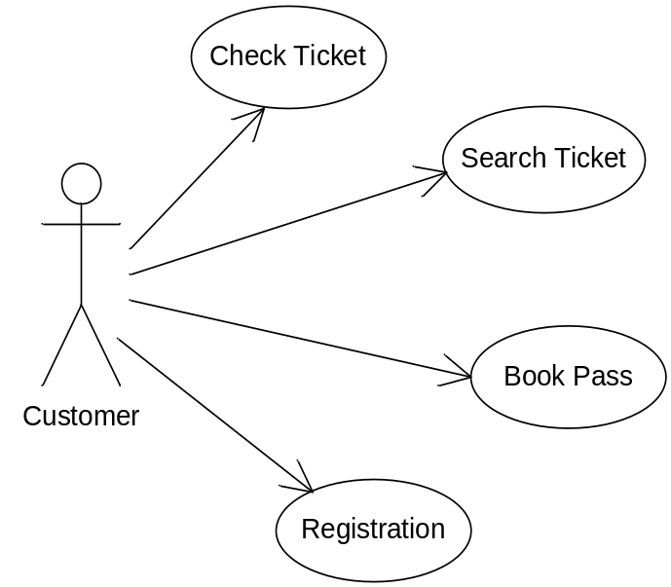

Use case Account Management
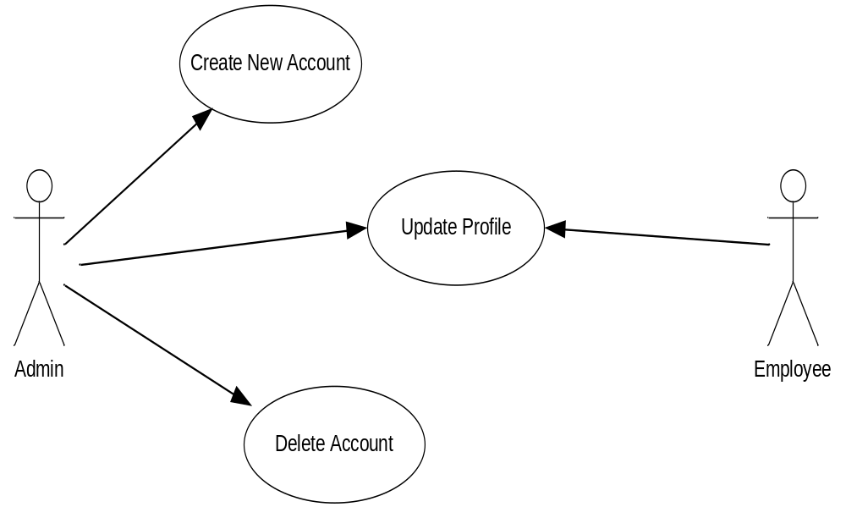

Use case Ticket management
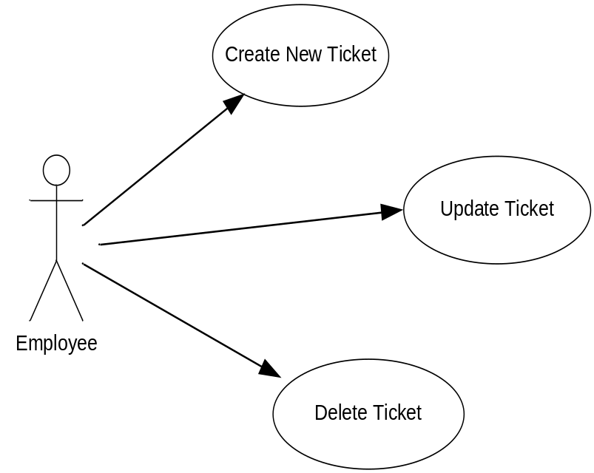

Use case Seat management
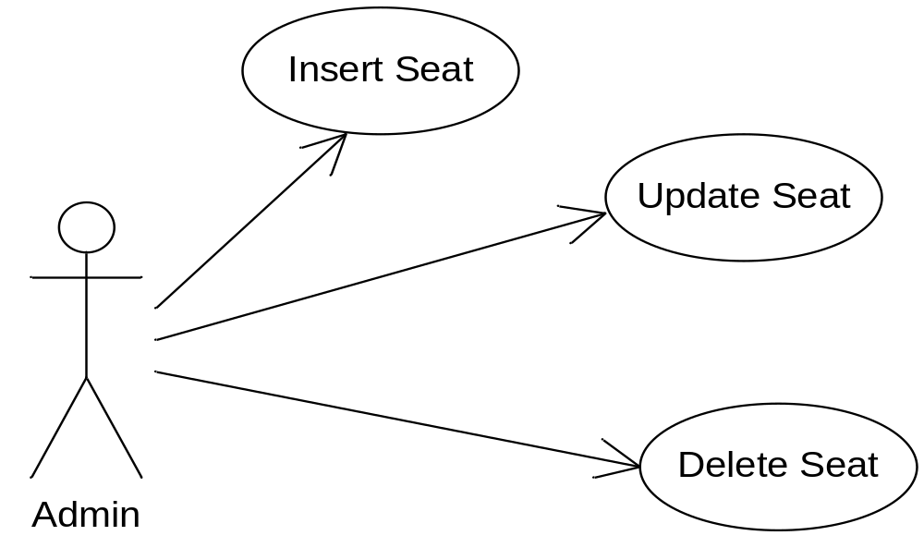

Use case Promote management
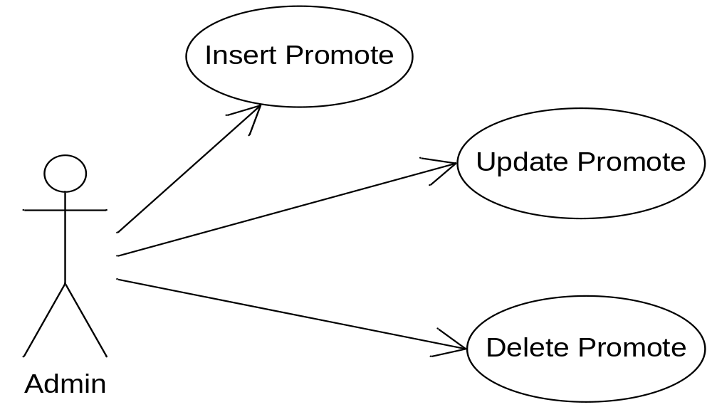

Use case Category management
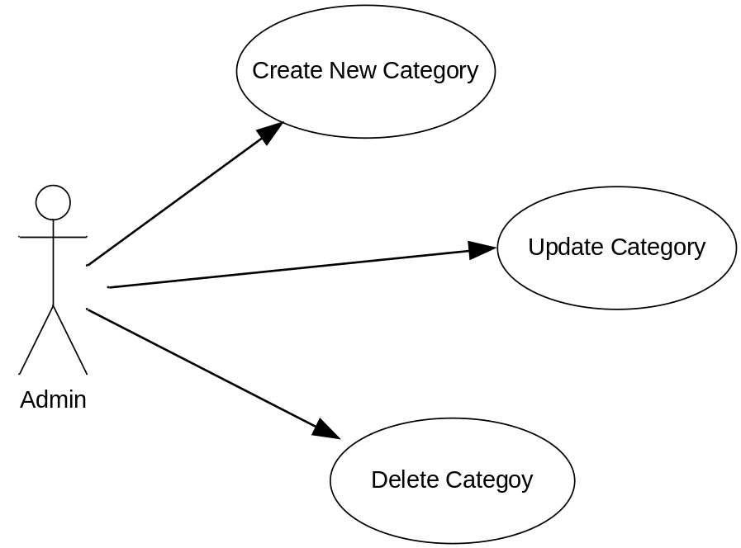

Use case Place management
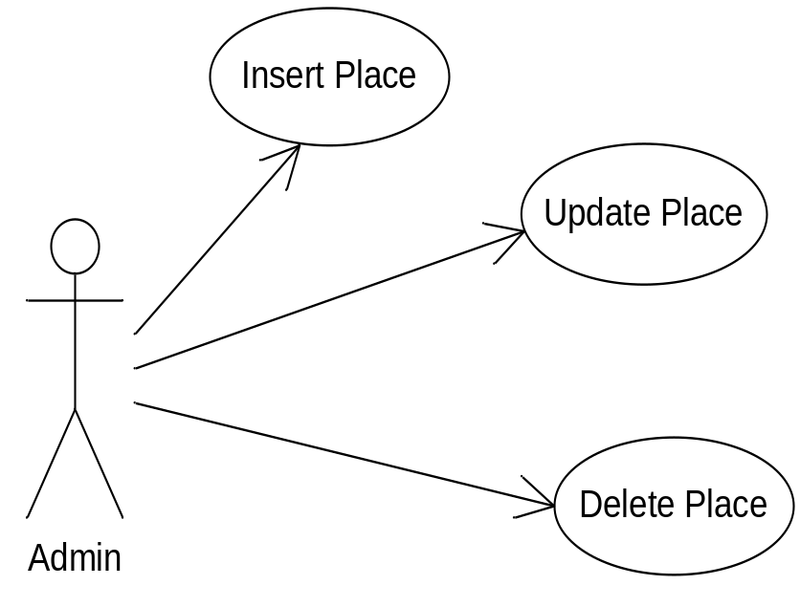

Use case Bus type management
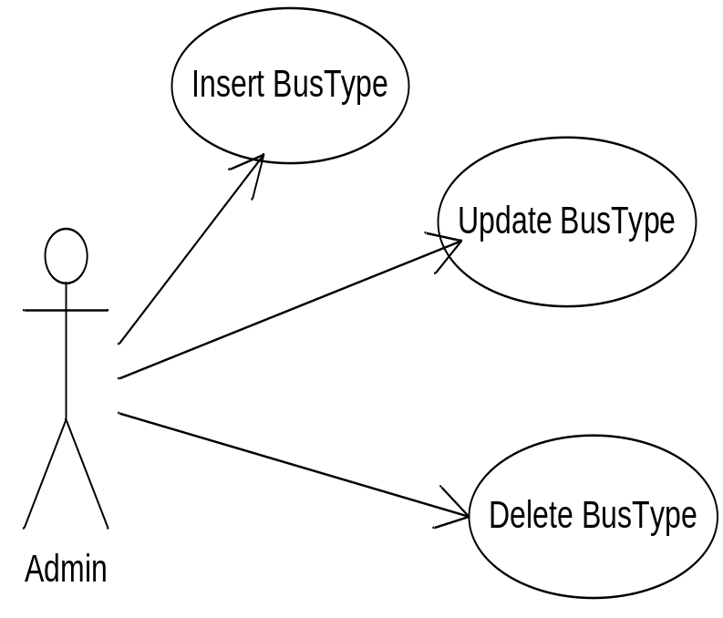

Use case Bus management
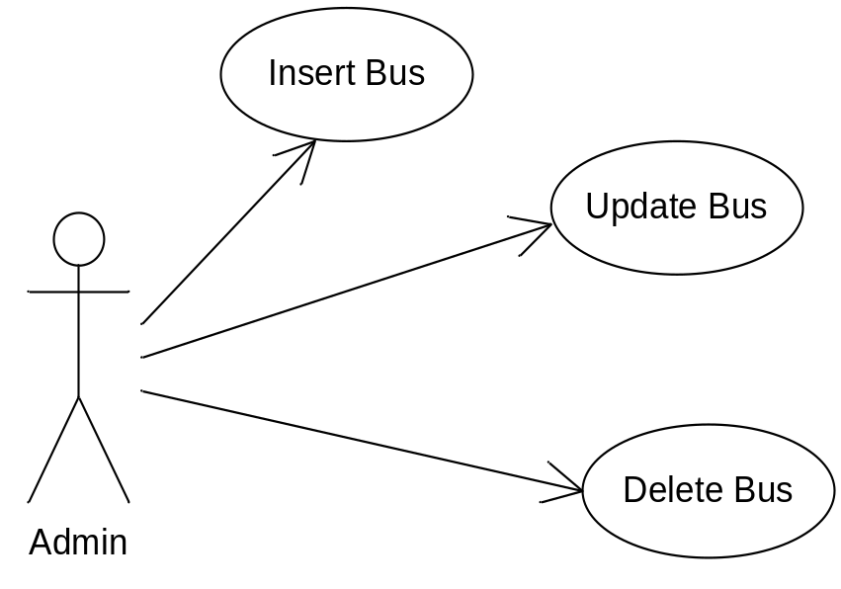

Use Case Specification
USE CASE SPECIFICATION

Use-case No. | UC001 | Use-case Version |  | 1.0
Use-case Name | Create new Account
Author
Date |  | Priority | Normal
Actor:
Admin (Head of the Organization)
Summary:
Create Username (Employee, Admin, Customer)
Goal:
Admin may be create Username
Triggers
Preconditions:
Admin must login to the system
Post Conditions:
After Admin create username, user can be login and to do with the default permission.
Main Success Scenario:
1. Admin add the information of username
2. Press button “SAVE”
3. System will be check the information.
4. If the information are right, that will be insert in the database. If false, do it again.
Alternative Scenario:
Exceptions:
Relationships:
Account Manager
Business Rules:
USE CASE SPECIFICATION

Use-case No. | UC002 | Use-case Version |  | 1.0
Use-case Name | Update Account
Author
Date |  | Priority | Normal
Actor:
Admin , Employee, Customer
Summary:
Edit the private infomation
Goal:
Edit user’s infomation
Triggers
Preconditions:
Users must be login the system
Post Conditions:
Main Success Scenario:
1. Select Account
3. Edit information that he want to change
4. System determines the validity of the information
5. System confirm action
6. Update into the database
Alternative Scenario:
Exceptions:
Relationships: Account Manager
Business Rules:

USE CASE SPECIFICATION

Use-case No. | UC003 | Use-case Version |  | 1.0
Use-case Name | Delete Account
Author
Date |  | Priority | Normal
Actor:
Admin
Summary: Delete username
Goal: Delete the information of user.
Triggers
Preconditions:
Admin must login to the system
Post Conditions:
After remove the account of the employee, when he/she do not login the system and remove record on database
Main Success Scenario:
1. Select account
2. Click “Delete”
3. System checking “Do you want delete this account?”
4. Click “yes” to delete or “no” to cancel
Alternative Scenario:
Exceptions:
Relationships: Account Manager
Business Rules:

USE CASE SPECIFICATION

Use-case No. | UC004 | Use-case Version |  | 1.0
Use-case Name | Create new Ticket
Author
Date |  | Priority | Normal
Actor:
Admin , Employee
Summary:
Create new the ticket
Goal:
Admin can create the ticket for the customer
Triggers
Preconditions:
Admin must login to the system
Post Conditions:
After admin create, passenger can book ticket.
Main Success Scenario:
1. Add the information of ticket
2. Admin create new the ticket
3. System determines the validity of the information
4. System confirm action
5. Insert the new the ticket to database
Alternative Scenario:
Exceptions:
Relationships: Ticket Manager
Business Rules:

USE CASE SPECIFICATION

Use-case No. | UC005 | Use-case Version |  | 1.0
Use-case Name | Edit Ticket
Author
Date |  | Priority | Normal
Actor:
Admin , Employee
Summary:
Update the ticket
Goal:
Edit ticket for the customer
Triggers
Preconditions:
Admin and Employee must login to the system
Post Conditions:
Admin, Employee can update his ticket, after admin agrees for it
Main Success Scenario:
1. Select the ticket
2. Edit information that he want to change
3. System determines the validity of the information
4. System confirm action
5. Admin agrees the ticket
6. Update into the database
Alternative Scenario:
Exceptions:
Relationships: Ticket Manager
Business Rules:

USE CASE SPECIFICATION

Use-case No. | UC006 | Use-case Version |  | 1.0
Use-case Name | Delete Ticket
Author
Date |  | Priority | Normal
Actor:
Admin, Employee
Summary:
delete ticket
Goal:
Remove ticket on the system
Triggers
Preconditions:
Admin, Employee must login to the system
Post Conditions:
After remove the ticket , system will remove record on database
Main Success Scenario:
1. Select the ticket
2. Click “Delete”
3. System checking “Do you want delete?”
4. Select “Yes” to delete, or “no” to cancel.
Alternative Scenario:
Exceptions:
Relationships: Ticket Manager
Business Rules:

USE CASE SPECIFICATION

Use-case No. | UC007 | Use-case Version |  | 1.0
Use-case Name | Create new Category
Author
Date |  | Priority | Normal
Actor:
Admin
Summary:
Create new the Category
Goal:
Admin can create the category of the bus
Triggers
Preconditions:
Admin must login to the system
Main Success Scenario:
1. Add information of category
2. create new the Category
3. System determines the validity of the information
4. System confirm action
5. Insert the new the Category to database
Alternative Scenario:
Exceptions:
Relationships:
Category Manager
Business Rules:

USE CASE SPECIFICATION

Use-case No. | UC008 | Use-case Version |  | 1.0
Use-case Name | Edit Category
Author
Date |  | Priority | Normal
Actor:
Admin
Summary:
Update the Category
Goal:
Edit Category
Triggers
Preconditions:
Admin must login to the system
Post Conditions:
Admin can update his Category, after admin agrees for it
Main Success Scenario:
1. Select category
2. Edit information that he want to change
3. System determines the validity of the information
4. System confirm action
5. Admin agrees the Category
6. Update into the database
Alternative Scenario:
Exceptions:
Relationships: Category Manager
Business Rules:

USE CASE SPECIFICATION

Use-case No. | UC009 | Use-case Version |  | 1.0
Use-case Name | Delete Category
Author
Date |  | Priority | Normal
Actor:
Admin
Summary:
delete Category
Goal:
Remove Category on the system
Triggers
Preconditions:
Admin must login to the system
Post Conditions:
After remove the Category, system will remove record on database
Main Success Scenario:
1. Select Category
2. Click “Delete”
3. System checking “Do you want delete?”
4. Select “Yes” to delete or “no” to cancel.
Alternative Scenario:
Exceptions:
Relationships: Category Manager
Business Rules:

USE CASE SPECIFICATION

Use-case No. | UC010 | Use-case Version |  | 1.0
Use-case Name | Create new Place
Author
Date |  | Priority | Normal
Actor:
Admin
Summary:
Create new the Place
Goal:
Admin can create the Place of the bus
Triggers
Preconditions:
Admin must login to the system
Main Success Scenario:
1. Add information of Place
2. Admin create new the Place
3. System determines the validity of the information
4. System confirm action
5. Insert the new the Place to database
Alternative Scenario:
Exceptions:
Relationships:
Place Manager
Business Rules:

USE CASE SPECIFICATION

Use-case No. | UC011 | Use-case Version |  | 1.0
Use-case Name | Edit Place
Author
Date |  | Priority | Normal
Actor:
Admin
Summary:
Update the Place
Goal:
Edit Place
Triggers
Preconditions:
Admin must login to the system
Post Conditions:
Main Success Scenario:
1. Select Place
2. Edit information that he want to change
3. System determines the validity of the information
4. System confirm action
5. Admin agrees the Place
6. Update into the database
Alternative Scenario:
Exceptions:
Relationships: Place Manager
Business Rules:

USE CASE SPECIFICATION

Use-case No. | UC012 | Use-case Version |  | 1.0
Use-case Name | Delete Place
Author
Date |  | Priority | Normal
Actor:
Admin
Summary:
delete Place
Goal:
Remove Place on the system
Triggers
Preconditions:
Admin must login to the system
Post Conditions:
After remove the Place, system will remove record on database
Main Success Scenario:
1. Select Palce
2. click “Delete”
3. System checking “Do you want delete?”
4. Select “yes” to delete or “no” to cancel
Alternative Scenario:
Exceptions:
Relationships: Place Manager
Business Rules:

USE CASE SPECIFICATION

Use-case No. | UC013 | Use-case Version |  | 1.0
Use-case Name | Create new Bus
Author
Date |  | Priority | Normal
Actor:
Admin
Summary:
Create new the Bus
Goal:
Admin can create the Bus of the bus
Triggers
Preconditions:
Admin must login to the system
Main Success Scenario:
1. Add information of Bus
2. Click “Save”
3. System determines the validity of the information
4. System confirm action
5. Insert the new the Bus to database
Alternative Scenario:
Exceptions:
Relationships:
Bus Manager
Business Rules:

USE CASE SPECIFICATION

Use-case No. | UC014 | Use-case Version |  | 1.0
Use-case Name | Edit Bus
Author
Date |  | Priority | Normal
Actor:
Admin
Summary:
Update the Bus
Goal:
Edit Bus
Triggers
Preconditions:
Admin must login to the system
Post Conditions:
Main Success Scenario:
1. Select Bus
2. Edit information that he want to change
3. System determines the validity of the information
4. System confirm action
5. Admin agrees the Bus
6. Update into the database
Alternative Scenario:
Exceptions:
Relationships: Bus Manager
Business Rules:

USE CASE SPECIFICATION

Use-case No. | UC015 | Use-case Version |  | 1.0
Use-case Name | Delete Bus
Author
Date |  | Priority | Normal
Actor:
Admin
Summary:
delete Bus
Goal:
Remove Bus on the system
Triggers
Preconditions:
Admin must login to the system
Post Conditions:
After remove the Bus, system will remove record on database
Main Success Scenario:
1. Select Bus
2. Click “Delete”
3. System checking “Do you want delete?”
4. Select “yes” to delete, or “no” to cancel
Alternative Scenario:
Exceptions:
Relationships: Bus Manager
Business Rules:

Activity Diagram

3.3.1. Booking
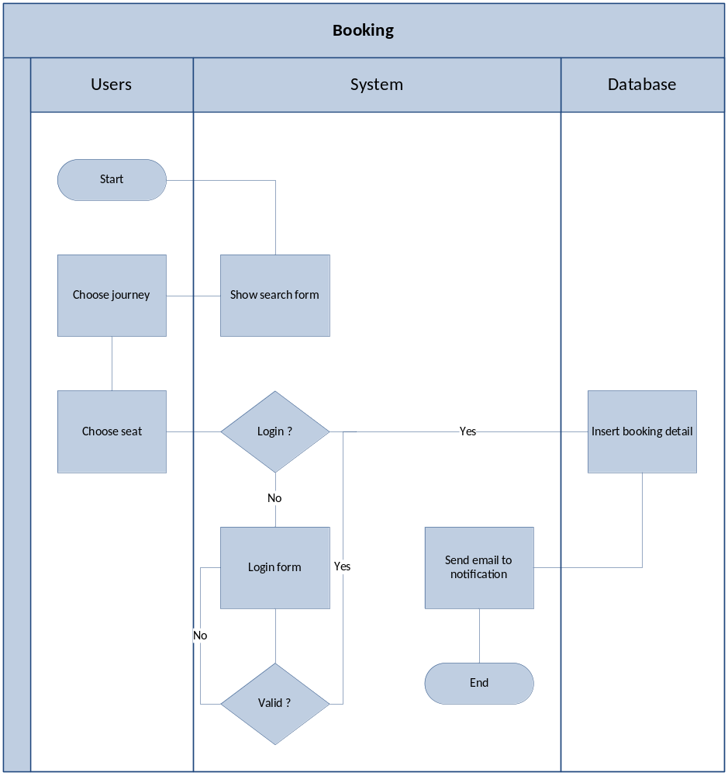

Delete

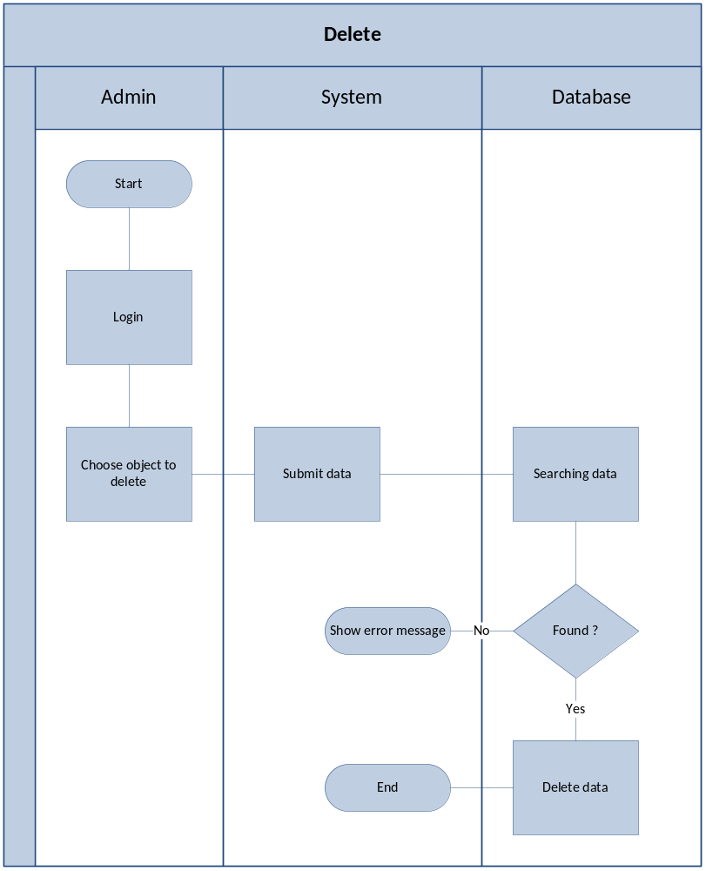

Inset
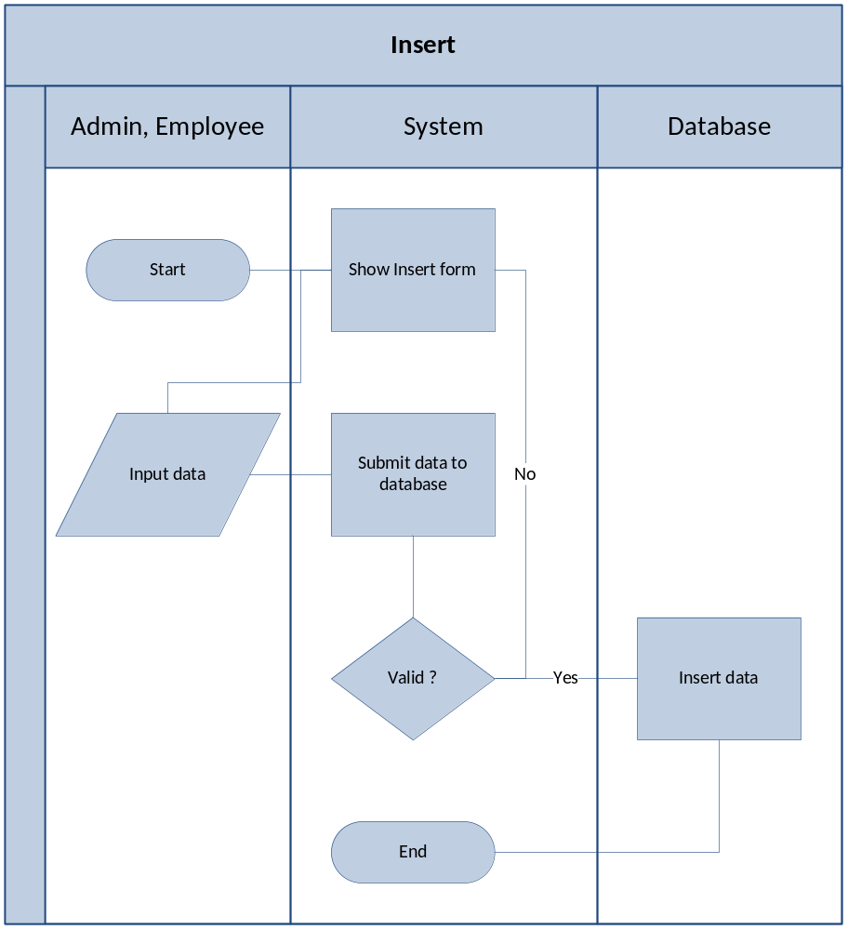

Update
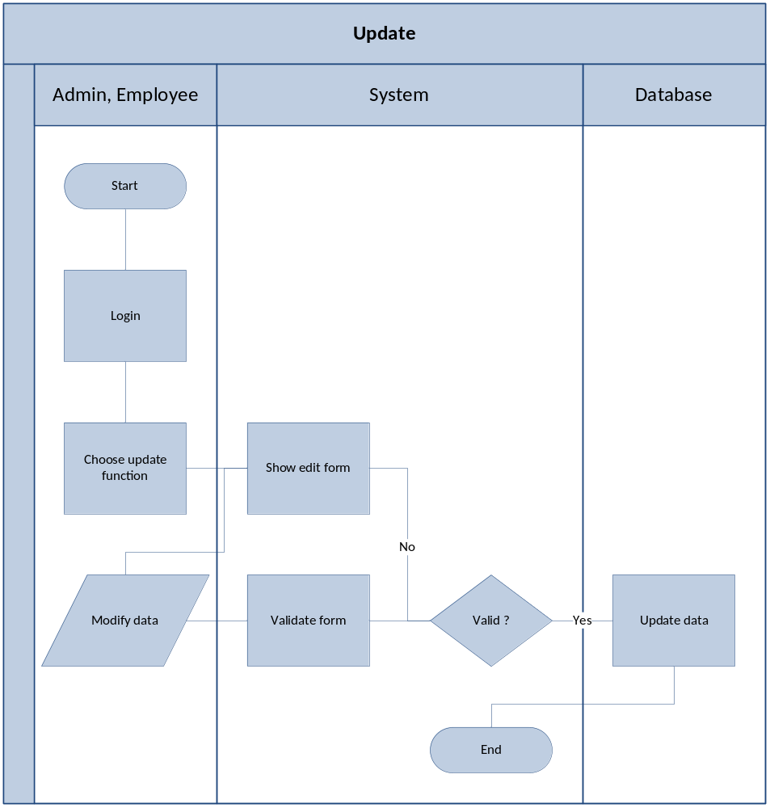

Register
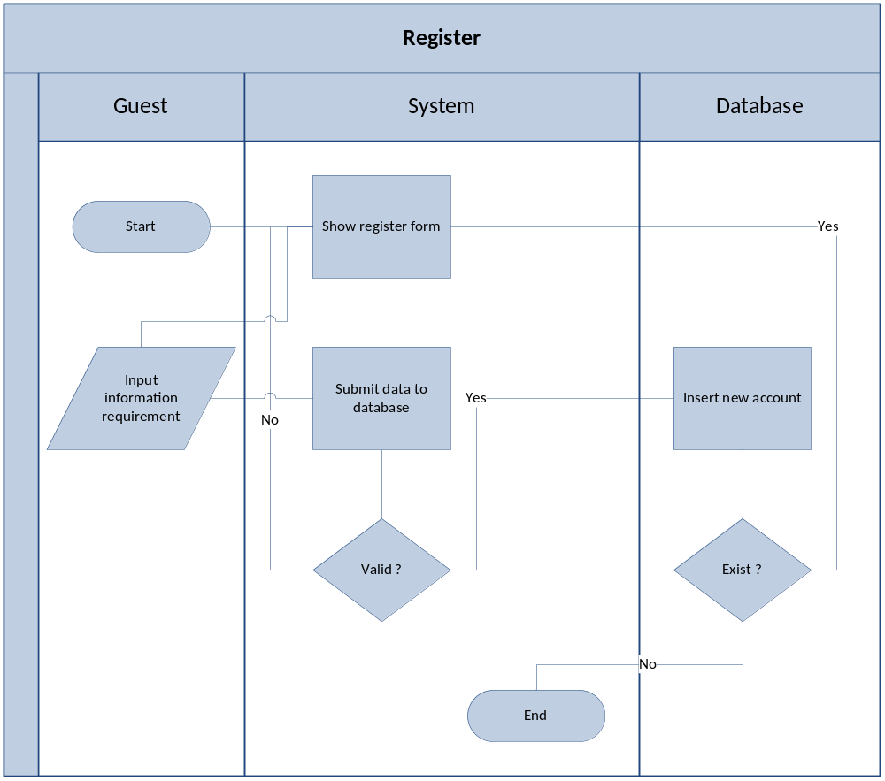

Login
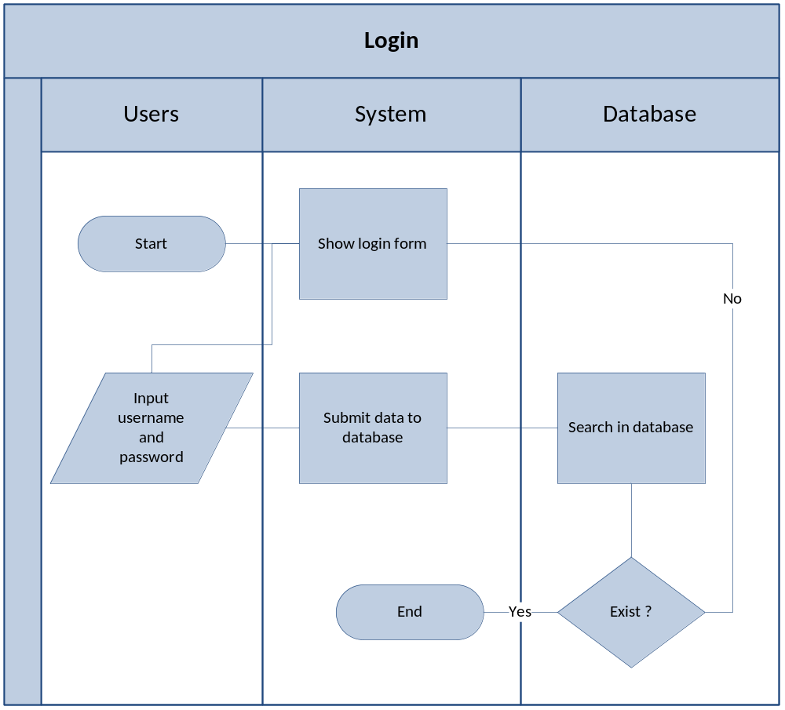

Change password
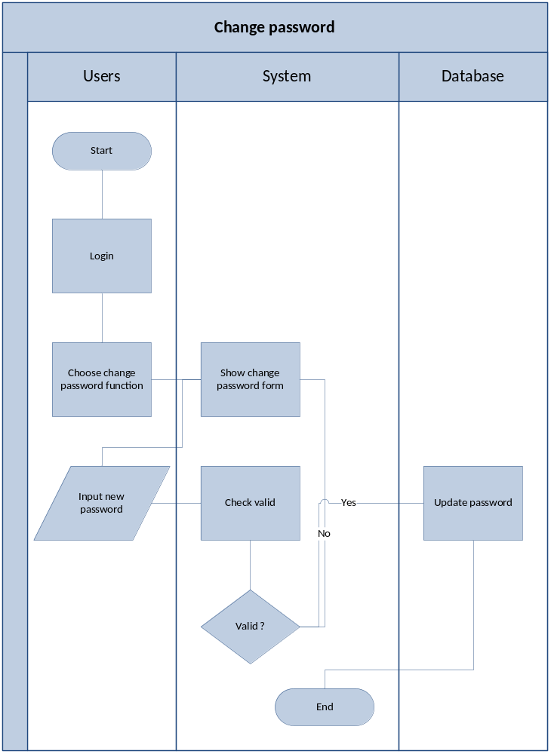

Search
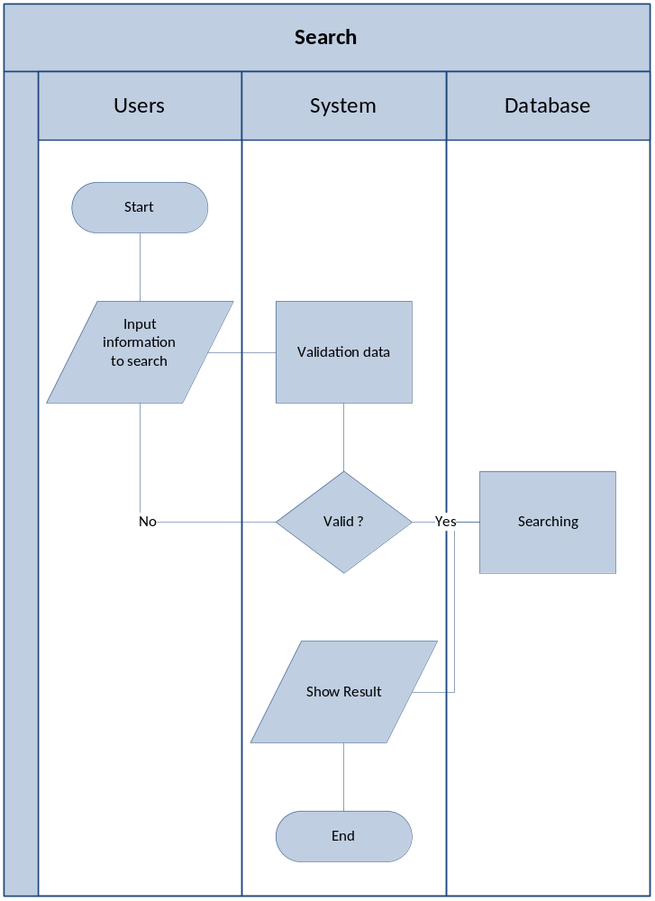

Design

4.1. System Architecture
The application will be made of a Web-based distributed three-tier architecture to support multiple user transaction at the same time.

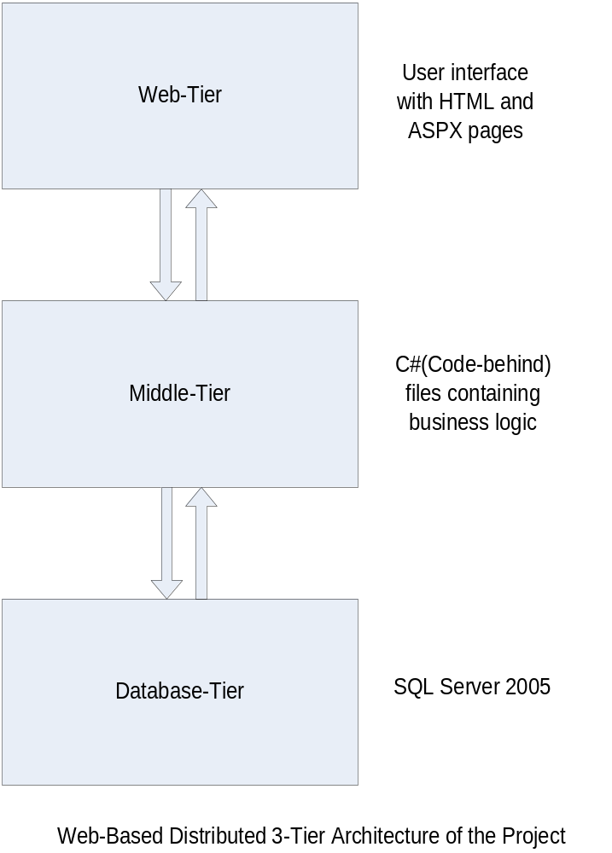

4.2. Class Diagram
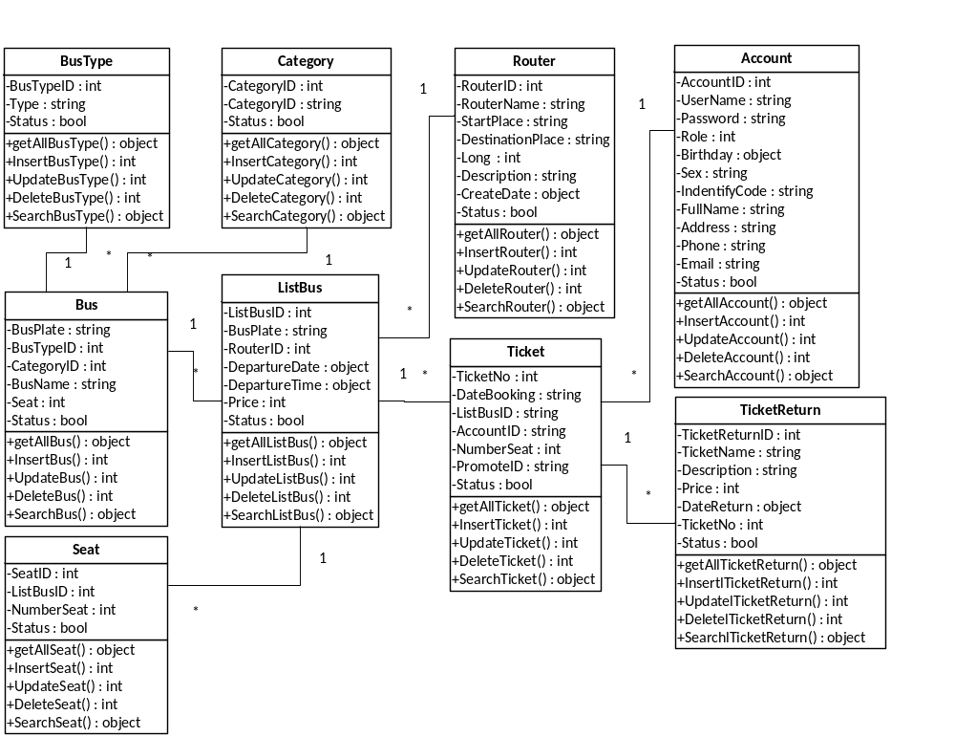

4.3. Entity Relationship diagram
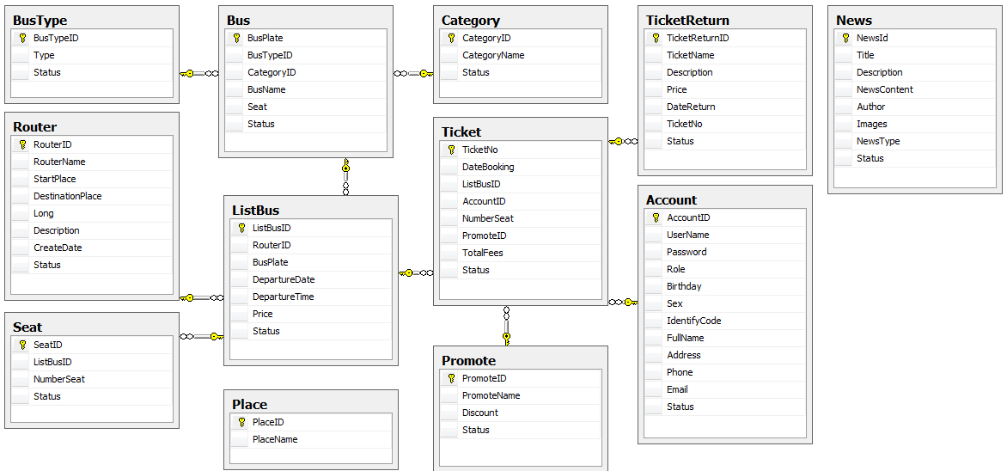

4.4. Database Design
Table : Account
Field Name | Data Type | Null | Description
AccountID | Int | No | PK
UserName | Nchar(10) | Yes
Password | Nchar(10) | Yes
Role | Int | Yes
Birthday | Datetime | No
Sex | Nvarchar(50) | Yes
IndentifyCode | Nvarchar(50) | No
FullName | Nvarchar(50) | Yes
Address | Nvarchar(MAX) | No
Phone | Varchar(50) | Yes
Email | Varchar(50) | No
Status | Bit | Yes

Table: BusType
Field Name | Data Type | Null | Description
BusTypeID | Int | No | PK
Type | Nvarchar(50) | Yes
Status | Bit | Yes

Table: Category
Field Name | Data Type | Null | Description
CategoryID | Int | No | PK
CategoryName | Nvarchar(50) | Yes
Status | Bit | Yes

Table : Ticket
Field Name | Data Type | Null | Description
TicketNo | Int | No | PK
DateBooking | DateTime | No
ListBusID | Int | No | FK
AccountID | Int | No | FK
NumberSeat | Int | No
PromoteID | Int | No
Status | Bit | Yes

Table : Bus
Field Name | Data Type | Null | Description
BusPlate | Nvarchar(50) | No | PK
BusTypeID | Int | No | FK
CategoryID | Int | No | FK
BusName | Nvarchar(50) | No
Seat | Int | No | FK
Status | Bit | Yes

Table : TicketReturn
Field Name | Data Type | Null | Description
TicketReturnID | Int | No | PK
TicketName | Nvarchar(50) | Yes
Description | Nvarchar(50) | Yes
Price | Int | Yes
DateReturn | Int | Yes
TicketNo | Int | Yes | FK
Status | Bit | Yes

Table : Promote
Field Name | Data Type | Null | Description
PromoteID | Int | No | PK
PromoteName | Nvarchar(50) | Yes
Discount | Int | Yes
Status | Bit | Yes

Table : Router
Field Name | Data Type | Null | Description
RouterID | Int | No | PK
RouterName | Nvarchar(50) | No
StartPlace | Nvarchar(50) | No
DestinationPlace | Nvarchar(50) | No
Long | Int | No
Description | Ntext | Yes
CreateDate | DateTime | No
Status | Nvarchar(50) | Yes

Table : Place
Field Name | Data Type |  | Null | Description
PlaceID | Int |  | No | PK
PlaceName | Nvarchar(50) |  | Yes
Table : Seat
Field Name |  | Data Type | Null | Description
SeatID |  | Int | No | PK
ListBusID |  | Int | No | FK
NumberSeat |  | Int | No
Status |  | Nvarchar(50) | Yes

Table : News
Field Name | Data Type | Null | Description
NewID | Int | No | PK
Title | Nvarchar(MAX) | Yes
Description | Ntext | Yes
NewsContent | Ntext | Yes
Author | Nvarchar(50) | Yes
Images | Nvarchar(200) | Yes
NewsType | Int | Yes
Status | Bit | Yes

Table : ListBus
Field Name | Data Type | Null | Description
ListBusID | Int | No | PK
BusPlate | Nvarchar(50) | No | FK
RouterID | Int | No | FK
DepartureDate | DateTime | Yes
DepartureTime | DateTime | Yes
Status | Int | Yes
Price | Int | Yes

