
FPT-aptech computer education
ONLINE BUS TICKET RESERVATION SYSTEM

Group Member | Đặng Ngọc Tuyền  Nguyễn Khải Hoàn  Lê Hữu Trung  Vũ Ngọc Sơn
Instructor | Đỗ Quốc Bình
Batch | C0812i
Semester | 3

1. Introduction
SRC Travel Agencies is a domestic privatized transportation company that runs the vehicles all over the country. They have several branches at different locations of the country, so that they can provide the transportation facilities between the places. They want an online application to be developed, where the details of the bookings done and the customer will be updated from time to time and one can track the details of the available seats immediately.

2. Problem Definition

Problem Abstraction
a. Purpose:
SRC Travel Agencies is a domestic privatized transportation company that runs the vehicles all over the country. They have several branches at different locations of the country, so that they can provide the transportation facilities between the places. They ant an online application to be developed, where the details of the bookings done and the customer will be updated from time to time and one can track the details of the available seats immediately
b. Range of document:
This is a ticket management program for central ticketing company, is a system connected to a database including user staff, management, and customer bookings. Including car and bus routes are important components of the program.
The Current System
System management bus ticket missing so focused company has realized that need a management system best car have a common database management center bus ticket in many places.
The Proposed System
Scope:
- The details of the buses, Price list, and Employee details are to be maintained and controlled solely by the (Manager) Admin alone.
- The Employer can change alone the password assigned to him.
- Also first the employer needed to login first in order to perform the booking actions.
- Calculations of the charges and the reimbursements are to be implemented by the application alone as designated by the Admin.
- The details of the buses and seats available are to be maintained and can be updated regularly (ofcourse only by the admin)
- Enquiry form, Booking form and the pricing list are to be maintained in separate pages.
- There should be new, update, cancel and search options available.
Overall description:
Non-Financial:
An online application needed to be developed which is to be solely used and maintained by the booking department alone (regarding the bookings like booking, Enquiry and Updating and canceling). It is implemented so as to automate the process. Also the total authority is taken care of by the admin (Employee, Buses and charges) Also for booking or to perform other actions one has to login with the username and the password assigned.
There will be a new, Update, Cancel, search buttons available on each page with which the employee details
The customer needed to visit to the booking to enquire or book the tickets and he can collect the tickets in the bus alone.
It also maintains a database that consists of the list of buses along with the five digit code that will be assigned to each bus for easy reference.
Also the application should develop a unique six digit code whenever a new employee detail is entered.
Employee s personal, contact, age, qualifications etc are needed to be collected.
There will be an Enquiry form, Booking Form, and the also a page where the search options will be available. Also the Price list is to be maintained separately, where one can access the details of the price by entering the details of the Place of starting and destination, age, number of seats, etc.
The charges are as per the age, bus type and the distance and are to be maintained by the application alone.
Financial:
The charges vary depending on the type of the bus opted, distance of travel and as well the age of the customer, which is to be calculated by the application alone. The price list can be updated by the Admin alone. Also the Reimbursement of the amount will also be as defined by the admin and is calculated by the application alone by considering the above parameters.
Boundaries of the System
This online application management, it will apply for employee and admin of offices at different cities can be connected through a single application. The customers can check the status of tickets through this application.

3.Requirements and Business Flow
3.1. Customer Requirement Specification
3.1.1.1. System Login
Purpose:
Allow to certify accounts together with checking the authorities of accounts.
Users:
Super Administrator, Administrator, Super Mod, Mod
Fuctions :
- Allow users to enter Username, password
- The system will check account’s authorize and limitation.
- Display “log in success” announcement or errors announcement.
3.1.1.2.Authorise
Purpose:
Manage customers, Bus’s information (routine, bus code, number plate), ticket price, promotion’s information, transfers, drivers.
Users:
Super Administrator, Administrator, Super Mod, Mod
Functions :
Super Administrator
- Can add more, fix, or totally delete all database of the system : user accounts (Administrator, Super Mod, Mod, Customer), all database of the system (Bus’s information, orders …)
Administrator s:
- Add, fix, delete (temporally) of users: super Mod, Mod
- Add, fix, delete (temporally) information about bus (routine, bus code, number’s plate), orders, customer’s feedbacks.
- Restore all temporally deleted database.
Super Mods:
- Have the authorize to lock / unlock user accounts.
Add, fix, delete (temporally) information about bus (routine, bus code, number’s plate), orders, customer’s feedbacks
Mods:
- Have the authorize to lock / unlock user accounts.

- Add, fix, delete (temporally) information about bus (routine, bus code, number’s plate), orders, customer’s feedbacks
3.1.1.3.Ticket management
Purpose:
Allow to manage orders, ticket’s place, promotions, types of tickets.
Users:
Super Administrator, Administrator, Super Mod
Function:
- Create, fix, delete information of tickets, prices, promotions
- Tickets information searching.
Implementing conditions :
- User must log in to use.
3.1.1.4. Bus management
Purpose:
Allow to add, fix, delere information about bus (routine, bus code…)
Users:
Super Administrator, Administrator, Super Mod
Functions:
Add, fix, delete information of buses (routine, bus code…)
- Bus, bus’s routines searching.
Implementation conditions :
- User must log in to use.
3.1.1.5. Customers’ management
Purpose:
Manage all information of customers.
Func tion :
Checking customers’s account information.
- Lock/unlock customer’s account.
- Add, fix, delete customer’s account information
- Searching for customers.
Implementation conditions:
- Users must log in to use.
3.1.1.5. Ticket transfer management
Purpose:
Allow to mange customers’ trade (transfer)
Users
Super Administrator, Administrator, Super Mod,Mod
Functions:
- Add, fix, delete transfer’s information.
- Checking detailed transfer information: transfer date, transfer information, customer’s information.
- Transfer’s information searching.
Implementation conditions:
- Users must log in to use.
3.1.1.6. Drivers management
Purpose:
Manage all personal’s data , labor contracts, assigned bus.
Function:
- Check, add, fix, delete personal’s data.
- Create assigned bus.
- Personal’s data searching.
Implementation conditions:
- Users must log in to use.

3.1.2 Website
3.1.2.1 Register
Purpose:
Allow customers to register accounts to transfer.
User
Customer
Functions:
- Allow customers to enter their personal’s data to register.
- The system will check the validities of the registered information
- Display “ register success” or “erros”
Implementing conditions:

3.1.2.2Log in
Purpose:
Allow user to log in to transfer
Users:
Users
Function:
- Allow users to enter username, password
- The system will check the validties of accounts.
- Display “ log in success” or “erros”
Implementing condition

3.1.2.3 Cheking routines’ information
Purpose:
Allow customers to view detailed information of bus routines, ticket prices, departure time.
Users :
Super Administrator, Administrator, Super Mod,Mod, Users
Function :
- Display information of routines: bus code, departure time, ticket prices, bus stop, available seats
- Booking through available seats.
- Searching for bus code, departure time, bus stops.
Implementing conditions :
- Users must log in to use.

3.1.3 System requirements
3.1.3.1 software requirements
3.1.3.1.1 To admins
- System must ensure the simplify of interacting database
- Highly sercured.
- Only Super Administrator can change the authorities.
3.1.3.1.2 To website
- Website template must be easy for customers to interact
- Atractive themes but not difficult for customers.
- Website must be stable.

3.1.3.2.1 Hardware Requirements:
- A minimum computer system that will help you access all the tools inthe courses is a Pentium 166 or better
- 64 Megabytes of RAM or better
- Windows 98 (or higher if possible)
- Java Virtual Machine
3.1.3.2.2 Software Requirements
- .NET Framework 2.0
- IIS Version 6.0
- Microsoft SQL Server 2005
- Visual studio 2005
- Internet Explorer 7.0
- Flash 8

3.2 Active Diagram

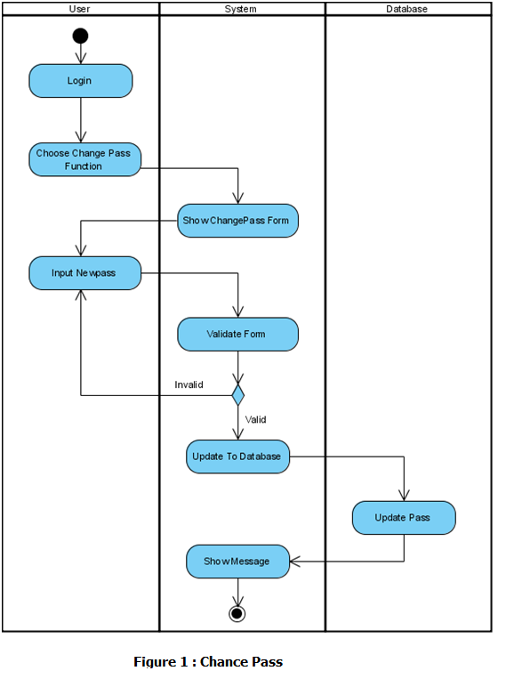
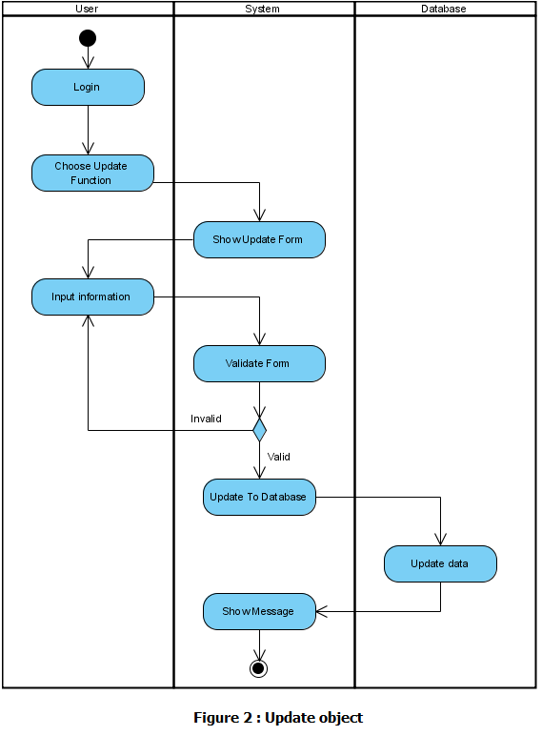
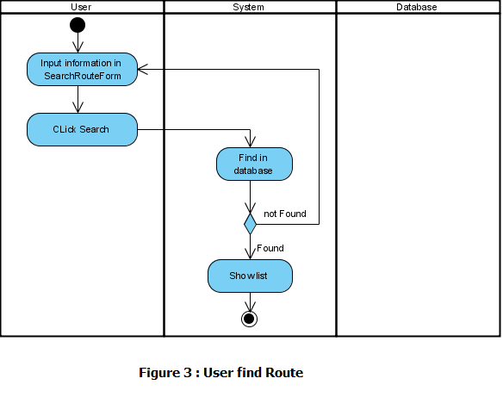
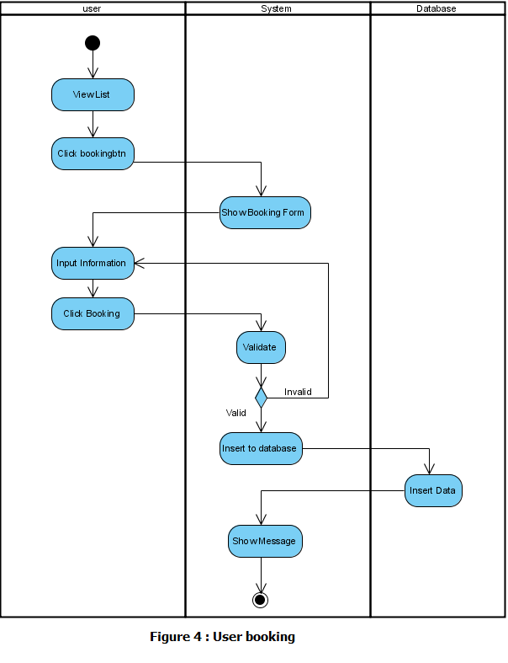
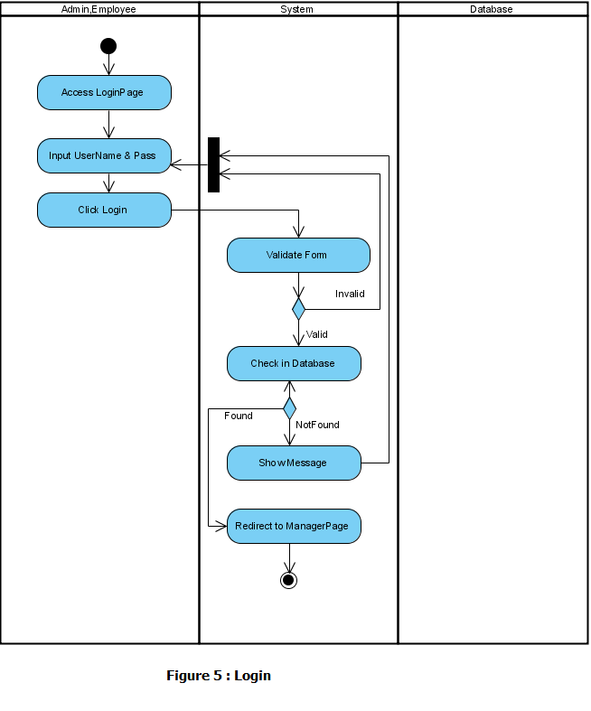
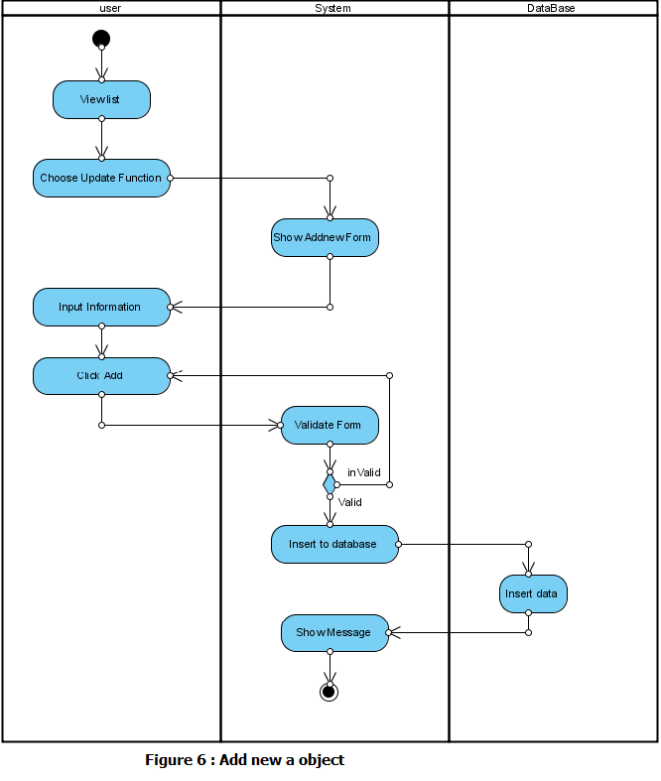
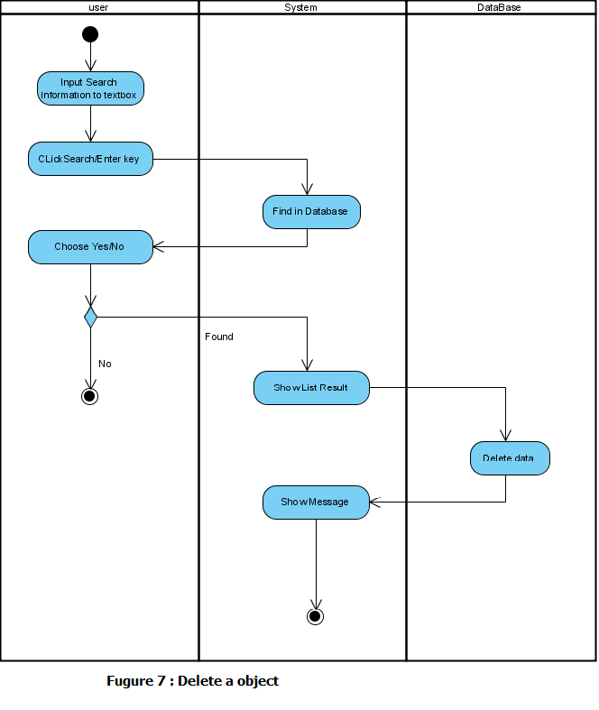
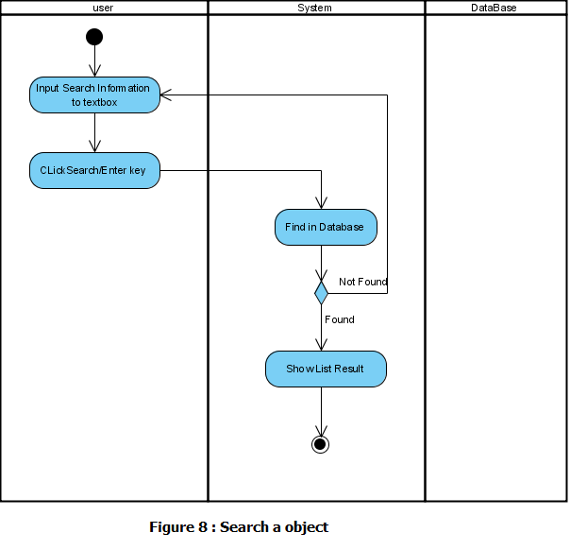

Use Case Diagram
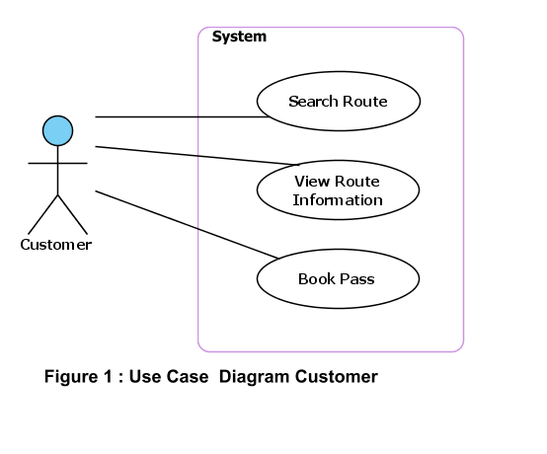
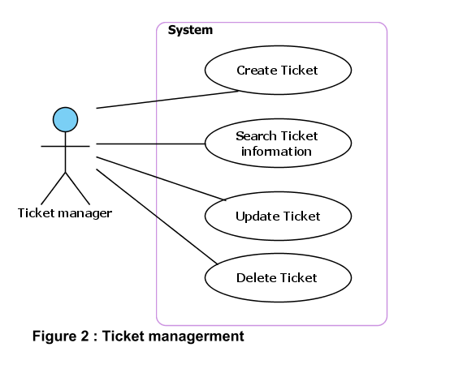
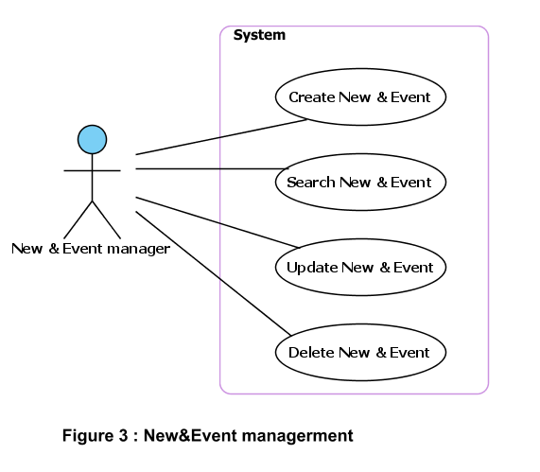
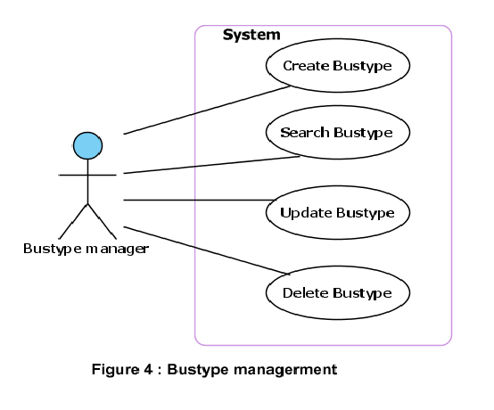
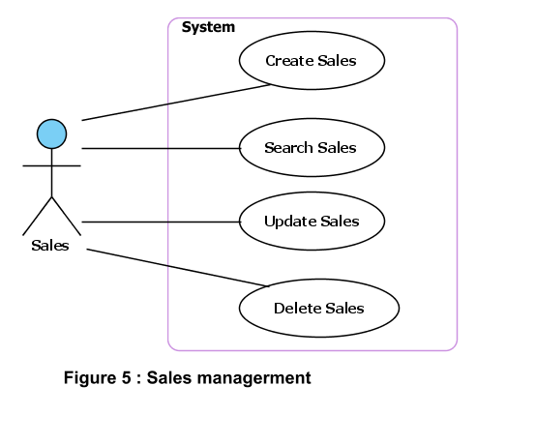
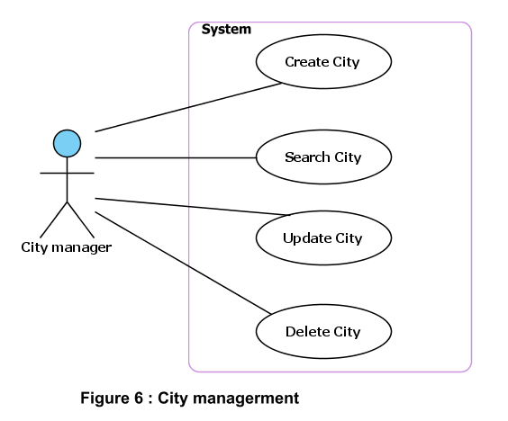
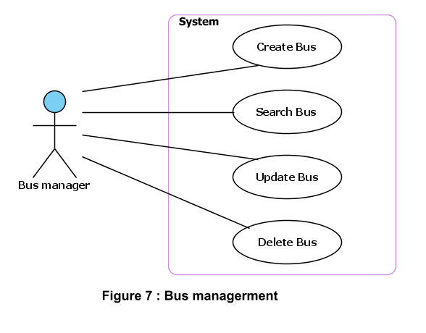
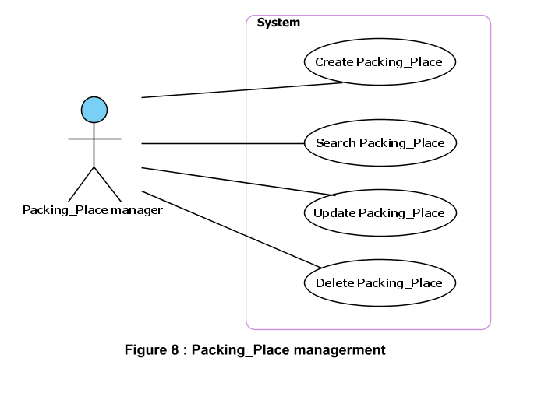
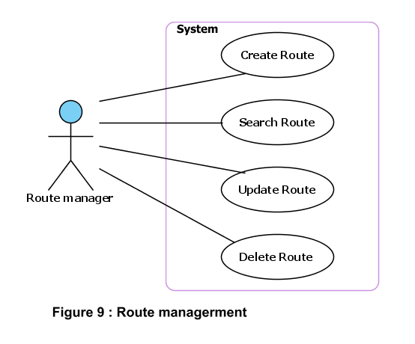
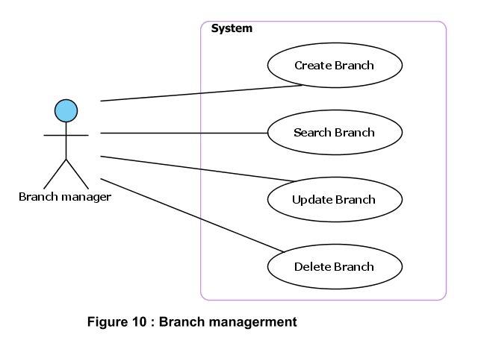
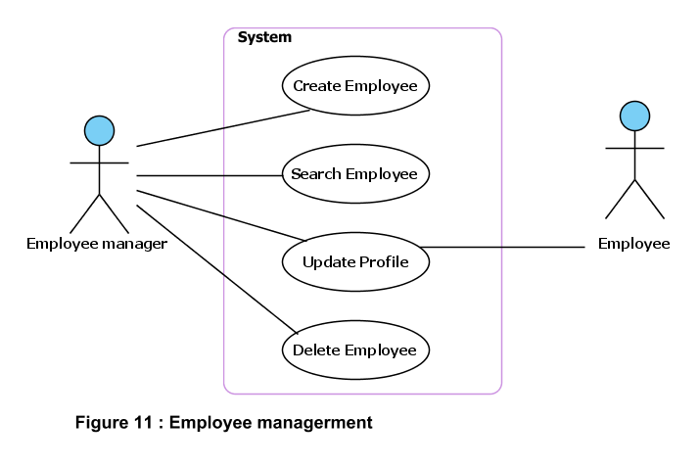
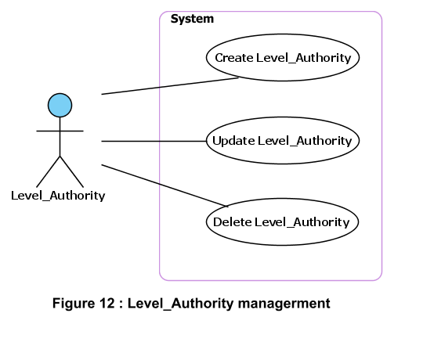

Use Case Specification
USE CASE SPECIFICATION

Use-case No. | UC001 | Use-case Version |  | 1.0
Use-case Name | Search Route
Author
Date |  | Priority | Normal
Actor:
Customer
Summary:
Visited and search Route information.
Goal:
Customers can find detailed information about the trip of their choice.Customers can book online through the company's website.
Triggers
Preconditions:
Customer don’t need register but customer can direct book online.
PostConditions:
Main Success Scenario:
1. Customer choose start place,endplace,start date of trip
2. System display details information about trip
3. Customer input account information into form register.
4. System confirm information
5. Insert the customerinformation to database
Alternative Scenario:
Exceptions:
Relationships:
Business Rules:

USE CASE SPECIFICATION

Use-case No. | UC002 | Use-case Version |  | 1.0
Use-case Name | CreateTicket
Author
Date |  | Priority | Normal
Actor:
Ticket manager
Summary:
Create new the ticket information for the Customer
Goal:
Ticket manager can create the ticket for the customer
Triggers
Preconditions:
Ticket manager must login to the system
PostConditions:
After Ticket manager created ticket, customers can use to join trip.
Main Success Scenario:
1. Ticket manager enters information of trip (customer information and bus information)
2. Ticket managercreate new the ticket.
3. System determines the validity of customer information
4. System confirm action
5. Insert the new the ticket to database
Alternative Scenario:
Exceptions:
Relationships:
Ticket manager
Business Rules:

USE CASE SPECIFICATION

Use-case No. | UC003 | Use-case Version |  | 1.0
Use-case Name | SearchTicket
Author
Date |  | Priority | Normal
Actor:
Ticket manager
Summary:
Find information related to tickets
Goal:
Find information related to tickets to easily manage the status of customer bookings
Triggers
Preconditions:
Ticket manager must login to the system
PostConditions:
After Ticket manager created ticket, Ticket manager can use to find information..
Main Success Scenario:
1. Ticket managerview information of trip (customer information and bus information)
2. Ticket managerenter customer name or ticket number into text box.Then click button search.
3. System to verify the information entered and compare to list tickets in the database to provide details of the ticket to find.
4. Ticket manager can process of ticket and customer(issue ticket or )
Alternative Scenario:
Exceptions:
Relationships:
Ticket manager
Business Rules:

USE CASE SPECIFICATION

Use-case No. | UC004 | Use-case Version |  | 1.0
Use-case Name | UpdateTicket
Author
Date |  | Priority | Normal
Actor:
Ticket manager
Summary:
Update information of ticket (ticket and customer).
Goal:
Edit and update information of the trip.Allocation of tickets to active status
Triggers
Preconditions:
Ticket manager must login to the system
PostConditions:
After Ticket manager created ticket, Ticket manager can use to update information for ticket.
Main Success Scenario:
1. Ticket managerview information of trip (customer information and bus information)
2. Then ,ticket managercan edit and update information each ticket.
3. Inspection systems and update information on the database.
Alternative Scenario:
Exceptions:
Relationships:
Ticket manager
Business Rules:

USE CASE SPECIFICATION

Use-case No. | UC005 | Use-case Version |  | 1.0
Use-case Name | DeleteTicket
Author
Date |  | Priority | Normal
Actor:
Ticket manager
Summary:
Delete ticket.
Goal:
Ticket manager can delete ticket of your choice.
Triggers
Preconditions:
Ticket manager must login to the system
PostConditions:
After Ticket manager created ticket, Ticket manager can use to delete information for ticket.
Main Success Scenario:
1. Ticket managerview information of trip (customer information and bus information)
2. Then ,ticket managercan search and delete information each ticket.
3. Inspection systems and update information on the database.
Alternative Scenario:
Exceptions:
Relationships:
Ticket manager
Business Rules:

USE CASE SPECIFICATION

Use-case No. | UC006 | Use-case Version |  | 1.0
Use-case Name | CreateNew and Event
Author
Date |  | Priority | Normal
Actor:
New and Event manager
Summary:
Create new the New and Event
Goal:
New and Event manager can create New and Event.
Triggers
Preconditions:
New and Event manager must login to the system
PostConditions:
After New and Event manager created New and Event, customers can use to view information of company.
Main Success Scenario:
1. New and Event manager enters information of New and Event.
2. New and Event managercreate new the New and Event.
3. System determines the validity of New and Event information
4. System confirm action
5. Insert the new the New and Event to database
Alternative Scenario:
Exceptions:
Relationships:
New and Event manager.
Business Rules:

USE CASE SPECIFICATION

Use-case No. | UC007 | Use-case Version |  | 1.0
Use-case Name | SearchNew and Event
Author
Date |  | Priority | Normal
Actor:
New and Event manager
Summary:
Find information related to New and Event.
Goal:
Find information related to New and Event to easily manage the status of New and Event
Triggers
Preconditions:
New and Event manager must login to the system
PostConditions:
After New and Event manager created New and Event, New and Event manager can use to find information..
Main Success Scenario:
1. New and Event managerview information of New and Event
2. New and Event managerenter date register new into text box.Then click button search.
3. System to verify the information entered and compare to list New and Event in the database to provide details of the New and Event to find.
4. Ticket manager can process of New and Event.
Alternative Scenario:
Exceptions:
Relationships:
New and Event manager.
Business Rules:

USE CASE SPECIFICATION

Use-case No. | UC008 | Use-case Version |  | 1.0
Use-case Name | UpdateNew and Event
Author
Date |  | Priority | Normal
Actor:
New and Event manager
Summary:
Update information of New and Event
Goal:
Edit and update information of the New and Event.Allocation of New and Event to active status
Triggers
Preconditions:
New and Event manager must login to the system
PostConditions:
After New and Event manager created New and Event, New and Event manager can use to update information for New and Event.
Main Success Scenario:
1. New and Event managerview information New and Event
2. Then ,ticket managercan edit and update information each ticket.
3. Inspection systems and update information on the database.
Alternative Scenario:
Exceptions:
Relationships:
New and Event manager
Business Rules:

USE CASE SPECIFICATION

Use-case No. | UC009 | Use-case Version |  | 1.0
Use-case Name | DeleteNew and Event
Author
Date |  | Priority | Normal
Actor:
New and Event manager
Summary:
Delete ticket.
Goal:
New and Event manager can delete ticket of your choice.
Triggers
Preconditions:
Ticket manager must login to the system
PostConditions:
After New and Event manager created ticket, New and Event manager can use to delete information for New and Event.
Main Success Scenario:
1. New and Event managerview information New and Event.
2. Then , New and Event managercan search and delete information each New and Event.
3. Inspection systems and update information on the database.
Alternative Scenario:
Exceptions:
Relationships:
New and Event manager
Business Rules:

