 

|  |
| --- |
| **FPT-aptech computer education** |
| eProject Document |
| Online Bus Ticket Reservation System |
|  |
| |  |  | | --- | --- | | **Group 2** | | | **Group Member** | Đặng Ngọc Tuyền < 4548 >  Nguyễn Khải Hoàn< 4573 >  Lê Hữu Trung < 4118 >  Vũ Ngọc Sơn < 2758 >  Nguyễn Trung Thành < 4564 > | | **Instructor** | Đỗ Quốc Bình | | **Batch** | C0812i | | **Semester** | 3 | |
|  |

|  |
| --- |
| - Hanoi, 1/2011 - |

Table of Contents

1. Introduction 3

2. Problem Definition 3

2.1. Problem Abstraction 3

2.2. The Current System 3

2.3. The Proposed System 3

2.4. Boundaries of the System 5

2.5. Development Environment 6

3. Requirements and Business Flow 6

3.1. Customer Requirement Specification 6

3.1.1. System administrator 6

3.1.2. Website 8

3.1. Use Case Diagram 9

3.1.1. Use case customer 9

3.1.2. Use case Ticket Management 10

3.1.3. Use case News & Event management 10

3.1.4. Use case bus type management 11

3.1.5. Use case sales management 11

3.1.6. Use case city management 12

3.1.7. Use case Bus management 12

3.1.8. Use case Packing place management 13

3.1.9. Use case Route management 13

3.1.10. Use case branch management 14

3.1.11. Use case Employee Management 14

3.1.12. Use case level authority management 15

3.2. Use Case Specification 15

# Introduction

SRC Travel Agencies is a domestic privatized transportation company that runs the vehicles all over the country. They have several branches at different locations of the country, so that they can provide the transportation facilities between the places. They want an online application to be developed, where the details of the bookings done and the customer will be updated from time to time and one can track the details of the available seats immediately.

# Problem Definition

## Problem Abstraction

SRC Travel Agencies is a domestic privatized transportation company that runs the vehicles all over the country. They have several branches at different locations of the country, so that they can provide the transportation facilities between the places. They want an online application to be developed, where the details of the bookings done and the customer will be updated from time to time and one can track the details of the available seats immediately.

## The Current System

SRC Travel Agencies is the agency that provides the transportation facility to the

customers based on their requirements. They provide different buses like Express,

Luxury, and Volvo (Has two types A/C and Non A/C). The charges are different for

different buses. The charges are in the below mentioned format.

Express < Luxury < Volvo (Non A/C) < Volvo (A/C)

The charges also depend on the distance the customer wants to travel and as well on

the age of the customer. The charges also depends on the age, i.e., up to the age of 5 years

there will not be any charges, in between 5 12 there will be half charges and for above

twelve the charges will be full till the age of 50 and for the age above fifty they will get a

discount of 30%. They implement this in order to attract the customers.

They maintain all the records of the bus reservation counter through Online service

itself but the application is only accessed by the Admin and the Employers Alone. Until

now they used to issue the tickets in the buses alone as it is difficult to track the details of

the bookings done as it provides the service allover the country.

## The Proposed System

They want incorporate an online service application where they can maintain the

records of the buses along with the details of the customers. The customer can now book

the tickets by visiting the booking counters at their place (nearby) to the respective

destination as required. They want the application to be linked with the database, so that

whatever details are entered like the details of the customers, buses, and bookings can be

viewed by the other centers as well as it is an online application.

They also want to incorporate some feature which performs the tasks that they actually

perform, and an application where the customer can register with the site and then book

the tickets online instead of visiting the booking counter

A database should be maintained where the bus details along with the bus number,

route, the places it covers through out the distance and also the timings are needed to be

maintained. Also the details of the customers that are entered at the time of booking the

tickets are needed to be gathered in the database. So that they can track the details of the

customer at any time using the search option based on the starting place, age, name,

destination place and Date and Time and even based on the bus they had chosen.

The database should also maintain the list of the Employers as they alone book the

tickets with the username and password. The list that is to be maintained is personal

details, contact details, location, qualification, age, etc are needed to be gathered.

There should be buttons like New, Update and Cancel are to be included. Based on the

button chosen the respective action is needed to be performed. Also if the Employee

record is entered (The Employee details will be maintained by the Admin alone), it

should automatically generate a six digit code, and it will ask for the username and the

password (the password can be changed by the Employee) through which he can login in

to the a/c so as to perform the booking tasks.

Also for canceling the ticket, there is a limit like, if cancelled before 2 days then the

whole money will be returned, and if done one day before, then 15% is debited from the

total amount and the remaining amount is returned and if done on that day 30% is debited

from the total amount and the remaining is to be returned back. This action is also to be

performed by the application alone.

They want the application to be maintained in different details like the buses and the

bookings information. When they try to book a ticket it should ask for the customer

details like the name of the customers for whom the tickets are booked, Date and Time,

Starting and Destination place and the age ( as the charges depends on the age). Also the

Bus no. and the seat no. for which the ticket (s) booked are to be entered so that they can

keep track of the bookings done.

Whenever a customer enquires for the availability they can check through the Enquiry

form where the details like Destination Place, Starting Place, Date and Time are asked,

by entering these details (all fields are not mandatory) the availability details should be

displayed. Also there should be a search option through which the records of the

customers and the buses can be known easily with the same above options.

After the ticket is booked, one should be able to print the ticket, including the details

like age, name, Date and time for which the ticket is booked and as well the destination

and Starting locations and the charges for the ticket including the taxes.

The application alone should be able to calculate the payments as per the age criteria

and the distance. Also it has to be updated in the site.

**Note :**

*i. To book the ticket or to fetch the details (Search and Enquiry) first they need to*

*Login and only then they will be able to perform such actions.*

*ii. This application is solely for the booking department to book the tickets and is*

*purely maintained by them. It is not applicable for the customers and they*

*(customers) cannot book the tickets online by themselves.*

*iii. The Admin maintains the list of the buses and as well the Employees which*

*cannot be accessed by the Employee. The Employee can alone change his*

*Password from the booking window)*

## Boundaries of the System

**Non-Financial:**

An online application needed to be developed which is to be solely used and maintained by the booking department alone (regarding the bookings like booking, Enquiry and Updating and canceling). It is implemented so as to automate the process. Also the total authority is taken care of by the admin (Employee, Buses and charges) Also for booking or to perform other actions one has to login with the username and the password assigned.

There will be a new, Update, Cancel, search buttons available on each page with which the employee details

The customer needed to visit to the booking to enquire or book the tickets and he can collect the tickets in the bus alone.

It also maintains a database that consists of the list of buses along with the five digit code that will be assigned to each bus for easy reference.

Also the application should develop a unique six digit code whenever a new employee detail is entered.

Employee s personal, contact, age, qualifications etc are needed to be collected.

There will be an Enquiry form, Booking Form, and the also a page where the search options will be available. Also the Price list is to be maintained separately, where one can access the details of the price by entering the details of the Place of starting and destination, age, number of seats, etc.

The charges are as per the age, bus type and the distance and are to be maintained by the application alone.

**Financial**:

The charges vary depending on the type of the bus opted, distance of travel and as well the age of the customer, which is to be calculated by the application alone. The price list can be updated by the Admin alone. Also the Reimbursement of the amount will also be as defined by the admin and is calculated by the application alone by considering the above parameters.

## Development Environment

**Hardware:**

A minimum computer system that will help you access all the tools in the courses is a Pentium IV or better, 256 Megabytes of RAM or better, Windows XP (or higher if possible)

**Software :**

Net 3.5, SQL Server 2005, Visual studio 2008

# Requirements and Business Flow

## Customer Requirement Specification

### 3.1.1. System administrator

#### 3.1.1.1. System Login

* *Purpose:*
* Allow use declared identification to used application.
* *Object used:*
* Administrator, Employee, Customer, Visiter
* *Functional request:*
* Allow user input username and password and validate information.
* The program will display error if username or password is invalid.
* *Execute condition:*

#### 3.1.1.2. Ticket management

* *Purpose:*
* Allows managers manage employees, bus routes and bus.
* *Object used:*
* Administrator
* *Functional request:*
* Application for the search has not set ticket, the fare was set, the online car, truck and control staff.
* Application for additional car online, the location of the vehicle, creating tickets, canceled tickets, booking.
* The application allows managers tickets, sell tickets, to cancel tickets and staff created tickets but not controlled cars and car routes.
* *Execute condition:*
* Administrator and employee have to login system.

#### 3.1.1.3. Bus management

* *Purpose:*
* Vehicles and vehicle routes to allow only administrators manage; the list will cover details of online marketing vehicles and vehicle. The administrator has the right to cancel or continue to allow the car trip activities.
* *Object used:*
* System manager: admin.
* *Functional request:*
* This application allows administrators to use.
* This application allows administrators to add, edit, delete and update bus, route of bus.
* *Execute condition:*
* Administrator has to login system.

#### 3.1.1.4. Employee management

* *Purpose:*
* The administrator has the right to delete, update, create or continue to allow the employee.
* *Object used:*
* System manager: admin.
* *Functional request:*
* This application allows administrators to use.
* This application allows administrators to add, edit, delete and update employee.
* *Execute condition:*
* Administrator has to login system.

### 3.1.2. Website

#### 3.1.2.1. View Services information routes of bus

* *Purpose:*
* This system is mainly used for management and employees, users visiting the bus ticket. Visitors are not booking.
* Visitors also need an account on the website.
* *Object used:*
* Employee and Users or visitor
* *Functional request:*
* Allowing customers to visit, view tickets and information related to the center bus ticket.
* Detailed coverage of the address bus ticket center.
* Allows search other bus, the bus right on the site.
* *Execute condition:*
* Users or visitor goes to website view bus and route bus.
* Client: Web site User.

#### 3.1.2.2. Business/Project objective

* Create a Website using ASP.NET and MS SQL Server 2005. The website authenticates the existing user by his user name and password. The website has a registration page where a new user can enter his persional details in the given field. The user details get stored in the database and the database containing details of existing users gets updated.
* For the purpose of storing information of Administrator, Employees, Customers, details of bus ticket…

#### 3.1.2.3. Input provide by client

* Inputs for the Web-based application.
* Outputs from the Web-based application.
* Process involed in the Web-based application.
* Expected delivery dates.
* List of delieverables.
* Data Constraints / Triggers / Validation Tables.

## Use Case Diagram

### Use case customer

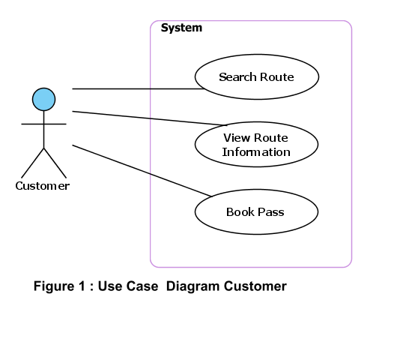

### Use case Ticket Management

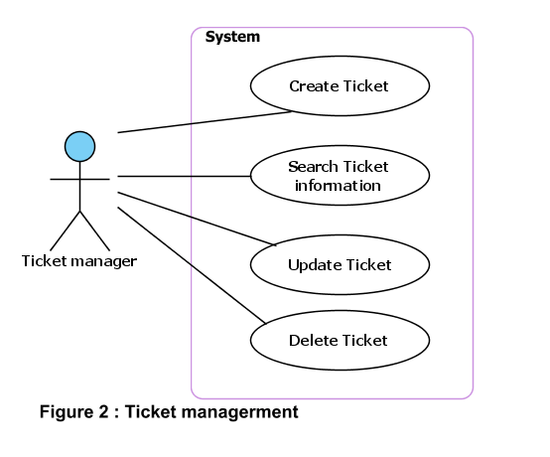

### Use case News & Event management

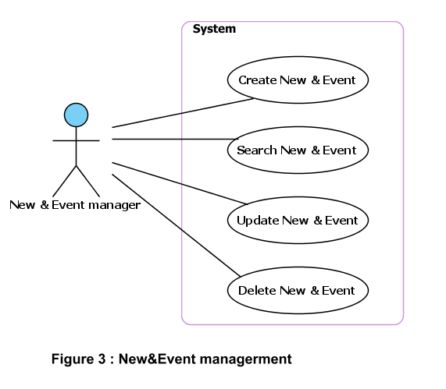

### Use case bus type management

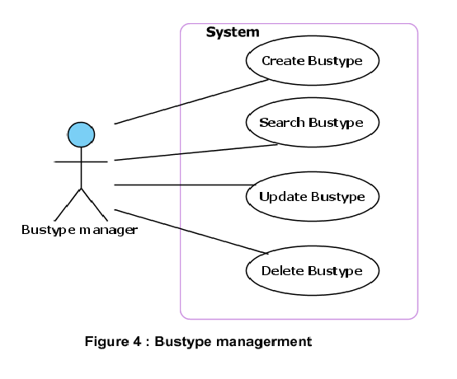

### Use case sales management

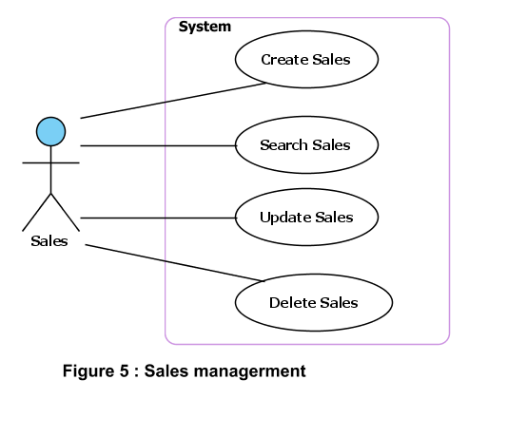

### Use case city management

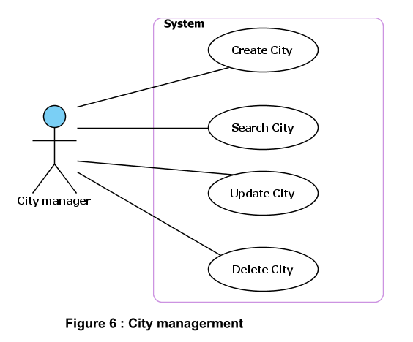

### Use case Bus management

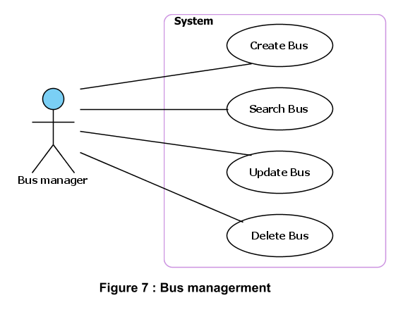

### Use case Packing place management

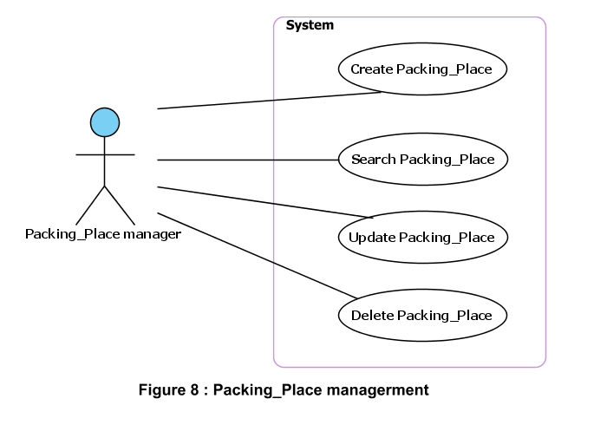

### Use case Route management

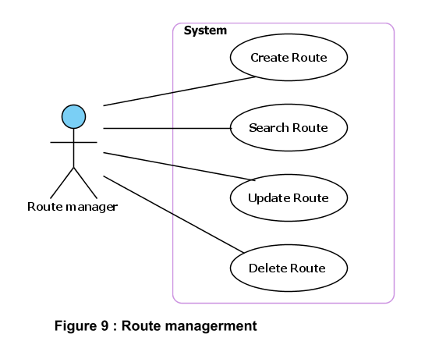

### Use case branch management

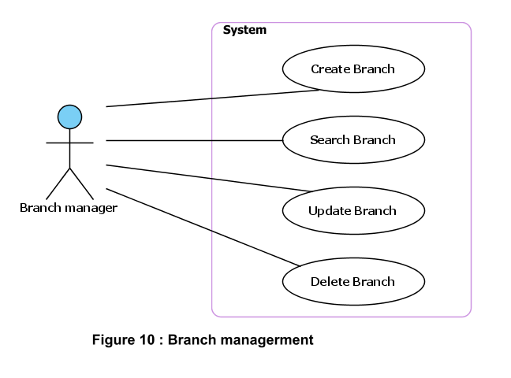

### Use case Employee Management

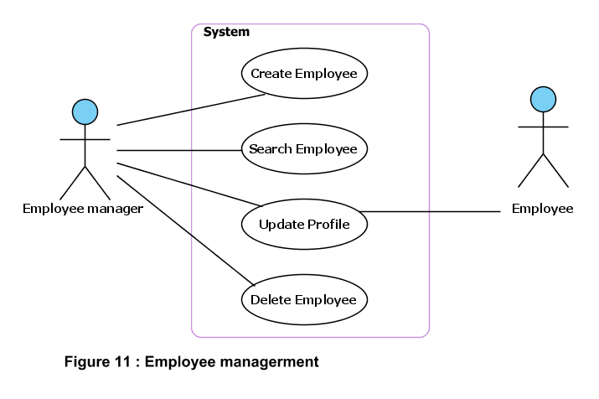

### Use case level authority management

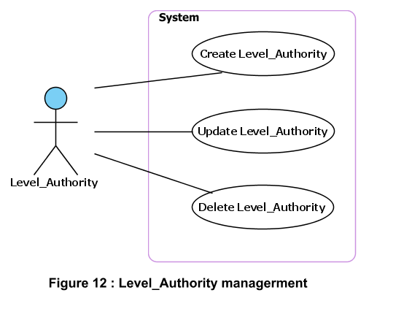

## Use Case Specification

|  |  |  |  |  |
| --- | --- | --- | --- | --- |
| **USE CASE SPECIFICATION** | | | | |
| **Use-case No.** | UC001 | **Use-case Version** | | 1.0 |
| **Use-case Name** | Search Route | | | |
| **Author** |  | | | |
| **Date** |  | **Priority** | Normal | |
| **Actor:**  Customer  **Summary:**  Visited and search Route information**.**  **Goal:**  Customers can find detailed information about the trip of their choice. Customers can book online through the company's website.  **Triggers**  **Preconditions:**  Customer don’t need register but customer can direct book online.  **Post Conditions:**  **Main Success Scenario:**  1. Customer choose start place, end place, start date of trip  2. System display details information about trip  3. Customer input account information into form register.  4. System confirm information   5. Insert the customer information to database  **Alternative Scenario:**  **Exceptions:**  **Relationships:**  **Business Rules:** | | | | |

|  |  |  |  |  |
| --- | --- | --- | --- | --- |
| **USE CASE SPECIFICATION** | | | | |
| **Use-case No.** | UC002 | **Use-case Version** | | 1.0 |
| **Use-case Name** | Create Ticket | | | |
| **Author** |  | | | |
| **Date** |  | **Priority** | Normal | |
| **Actor:**  Ticket manager  **Summary:**  Create new the ticket information for the Customer  **Goal:**  Ticket manager can create the ticket for the customer  **Triggers**  **Preconditions:**  Ticket manager must login to the system  **Post Conditions:**  After Ticket manager created ticket, customers can use to join trip.  **Main Success Scenario:**  1. Ticket manager enters information of trip (customer information and bus information)  2. Ticket manager create new the ticket.  3. System determines the validity of customer information  4. System confirm action   5. Insert the new the ticket to database  **Alternative Scenario:**  **Exceptions:**  **Relationships:**  Ticket manager  **Business Rules:** | | | | |

|  |  |  |  |  |
| --- | --- | --- | --- | --- |
| **USE CASE SPECIFICATION** | | | | |
| **Use-case No.** | UC003 | **Use-case Version** | | 1.0 |
| **Use-case Name** | Search Ticket | | | |
| **Author** |  | | | |
| **Date** |  | **Priority** | Normal | |
| **Actor:**  Ticket manager  **Summary:**  Find information related to tickets  **Goal:**  Find information related to tickets to easily manage the status of customer bookings  **Triggers**  **Preconditions:**  Ticket manager must login to the system  **Post Conditions:**  After Ticket manager created ticket, Ticket manager can use to find information..  **Main Success Scenario:**  1. Ticket manager view information of trip (customer information and bus information)  2. Ticket manager enter customer name or ticket number into text box. Then click button search.  3. System to verify the information entered and compare to list tickets in the database to provide details of the ticket to find.  4. Ticket manager can process of ticket and customer(issue ticket or )  **Alternative Scenario:**  **Exceptions:**  **Relationships:**  Ticket manager  **Business Rules:** | | | | |

|  |  |  |  |  |
| --- | --- | --- | --- | --- |
| **USE CASE SPECIFICATION** | | | | |
| **Use-case No.** | UC004 | **Use-case Version** | | 1.0 |
| **Use-case Name** | Update Ticket | | | |
| **Author** |  | | | |
| **Date** |  | **Priority** | Normal | |
| **Actor:**  Ticket manager  **Summary:**  Update information of ticket (ticket and customer).  **Goal:**  Edit and update information of the trip. Allocation of tickets to active status  **Triggers**  **Preconditions:**  Ticket manager must login to the system  **Post Conditions:**  After Ticket manager created ticket, Ticket manager can use to update information for ticket.  **Main Success Scenario:**  1. Ticket manager view information of trip (customer information and bus information)  2. Then, ticket manager can edit and update information each ticket.  3. Inspection systems and update information on the database.  **Alternative Scenario:**  **Exceptions:**  **Relationships:**  Ticket manager  **Business Rules:** | | | | |

|  |  |  |  |  |
| --- | --- | --- | --- | --- |
| **USE CASE SPECIFICATION** | | | | |
| **Use-case No.** | UC005 | **Use-case Version** | | 1.0 |
| **Use-case Name** | Delete Ticket | | | |
| **Author** |  | | | |
| **Date** |  | **Priority** | Normal | |
| **Actor:**  Ticket manager  **Summary:**  Delete ticket.  **Goal:**  Ticket manager can delete ticket of your choice.  **Triggers**  **Preconditions:**  Ticket manager must login to the system  **Post Conditions:**  After Ticket manager created ticket, Ticket manager can use to delete information for ticket.  **Main Success Scenario:**  1. Ticket manager view information of trip (customer information and bus information)  2. Then, ticket manager can search and delete information each ticket.  3. Inspection systems and update information on the database.  **Alternative Scenario:**  **Exceptions:**  **Relationships:**  Ticket manager  **Business Rules:** | | | | |

|  |  |  |  |  |
| --- | --- | --- | --- | --- |
| **USE CASE SPECIFICATION** | | | | |
| **Use-case No.** | UC006 | **Use-case Version** | | 1.0 |
| **Use-case Name** | Create New and Event | | | |
| **Author** |  | | | |
| **Date** |  | **Priority** | Normal | |
| **Actor:**  New and Event manager  **Summary:**  Create new the New and Event  **Goal:**  New and Event manager can create New and Event.  **Triggers**  **Preconditions:**  New and Event manager must login to the system  **Post Conditions:**  After New and Event manager created New and Event, customers can use to view information of company.  **Main Success Scenario:**  1. New and Event manager enters information of New and Event.  2. New and Event manager create new the New and Event.  3. System determines the validity of New and Event information  4. System confirm action   5. Insert the new the New and Event to database  **Alternative Scenario:**  **Exceptions:**  **Relationships:**  New and Event manager.  **Business Rules:** | | | | |

|  |  |  |  |  |
| --- | --- | --- | --- | --- |
| **USE CASE SPECIFICATION** | | | | |
| **Use-case No.** | UC007 | **Use-case Version** | | 1.0 |
| **Use-case Name** | Search New and Event | | | |
| **Author** |  | | | |
| **Date** |  | **Priority** | Normal | |
| **Actor:**  New and Event manager  **Summary:**  Find information related to New and Event.  **Goal:**  Find information related to New and Event to easily manage the status of New and Event  **Triggers**  **Preconditions:**  New and Event manager must login to the system  **Post Conditions:**  After New and Event manager created New and Event, New and Event manager can use to find information..  **Main Success Scenario:**  1. New and Event manager view information of New and Event  2. New and Event manager enter date register new into text box. Then click button search.  3. System to verify the information entered and compare to list New and Event in the database to provide details of the New and Event to find.  4. Ticket manager can process of New and Event.  **Alternative Scenario:**  **Exceptions:**  **Relationships:**  New and Event manager.  **Business Rules:** | | | | |

|  |  |  |  |  |
| --- | --- | --- | --- | --- |
| **USE CASE SPECIFICATION** | | | | |
| **Use-case No.** | UC008 | **Use-case Version** | | 1.0 |
| **Use-case Name** | Update New and Event | | | |
| **Author** |  | | | |
| **Date** |  | **Priority** | Normal | |
| **Actor:**  New and Event manager  **Summary:**  Update information of New and Event  **Goal:**  Edit and update information of the New and Event. Allocation of New and Event to active status  **Triggers**  **Preconditions:**  New and Event manager must login to the system  **Post Conditions:**  After New and Event manager created New and Event, New and Event manager can use to update information for New and Event.  **Main Success Scenario:**  1. New and Event manager view information New and Event  2. Then ,ticket manager can edit and update information each ticket.  3. Inspection systems and update information on the database.  **Alternative Scenario:**  **Exceptions:**  **Relationships:**  New and Event manager  **Business Rules:** | | | | |

|  |  |  |  |  |
| --- | --- | --- | --- | --- |
| **USE CASE SPECIFICATION** | | | | |
| **Use-case No.** | UC009 | **Use-case Version** | | 1.0 |
| **Use-case Name** | Delete New and Event | | | |
| **Author** |  | | | |
| **Date** |  | **Priority** | Normal | |
| **Actor:**  New and Event manager  **Summary:**  Delete ticket.  **Goal:**  New and Event manager can delete ticket of your choice.  **Triggers**  **Preconditions:**  Ticket manager must login to the system  **Post Conditions:**  After New and Event manager created ticket, New and Event manager can use to delete information for New and Event.  **Main Success Scenario:**  1. New and Event manager view information New and Event.  2. Then , New and Event manager can search and delete information each New and Event.  3. Inspection systems and update information on the database.  **Alternative Scenario:**  **Exceptions:**  **Relationships:**  New and Event manager  **Business Rules:** | | | | |