Outline:

BAB II TINJAUAN PUSTAKA

Bab ini menjelaskan tentang definisi dan teori-teori yang digunakan sebagai landasan penelitian yang berasal dari hasil publikasi dan penelitian dan/atau buku yang relevan.

AKSARA JAWA

CITRA DIGITAL

CITRA BERWARNA

PENGOLAHAN CITRA DIGITAL

RESCALE/RESIZE

AUGMENTASI

NORMALISASI atau STANDARDISASI

DEEP LEARNING

LAYERS

ACTIVATION

DROP OUT

POOLING

CNN

OPTIMIZER

LOSS FUNCTION

METRICS

TRANSFER LEARNING

*PRE-TRAINED MODEL*

XCEPTION

INCEPTION-V3?

VGG?

CONFUSION MATRIX

ALBUMENTATIONS (library)

TENSORFLOW (library)

**TINJAUAN PUSTAKA**

[review paper](https://sesar-d.notion.site/Research-Table-2a6533eedcd345c497ce192ce5d7e51b)

**LANDASAN TEORI**

**AKSARA JAWA**

DEFINISI

CONTOH DATA

**CITRA DIGITAL**

**CITRA BERWARNA**

BELOM

**PENGOLAHAN CITRA DIGITAL**

image processing, set of computational techniques for analyzing, enhancing, compressing, and reconstructing images. Its main components are importing, in which an image is captured through scanning or digital photography; analysis and manipulation of the image, accomplished using various specialized software applications; and output (e.g., to a printer or monitor). Image processing has extensive applications in many areas, including astronomy, medicine, industrial robotics, and remote sensing by satellites.

“Digital Image Processing” by Rafael C. Gonzalez and Richard E. Woods.

**RESCALE/RESIZE (BILINEAR INTERPOLATION)**

Source: [Image Processing – Bilinear Interpolation | TheAILearner](https://theailearner.com/2018/12/29/image-processing-bilinear-interpolation/) <https://i0.wp.com/theailearner.com/wp-content/uploads/2018/10/Bilinear_interpolation.png?w=423&ssl=1>

Resizing images is a critical pre-processing step in computer vision. Principally, deep learning models train faster on small images. A larger input image requires the neural network to learn from four times as many pixels, and this increase the training time for the architecture [30].

**DATA AUGMENTATION**

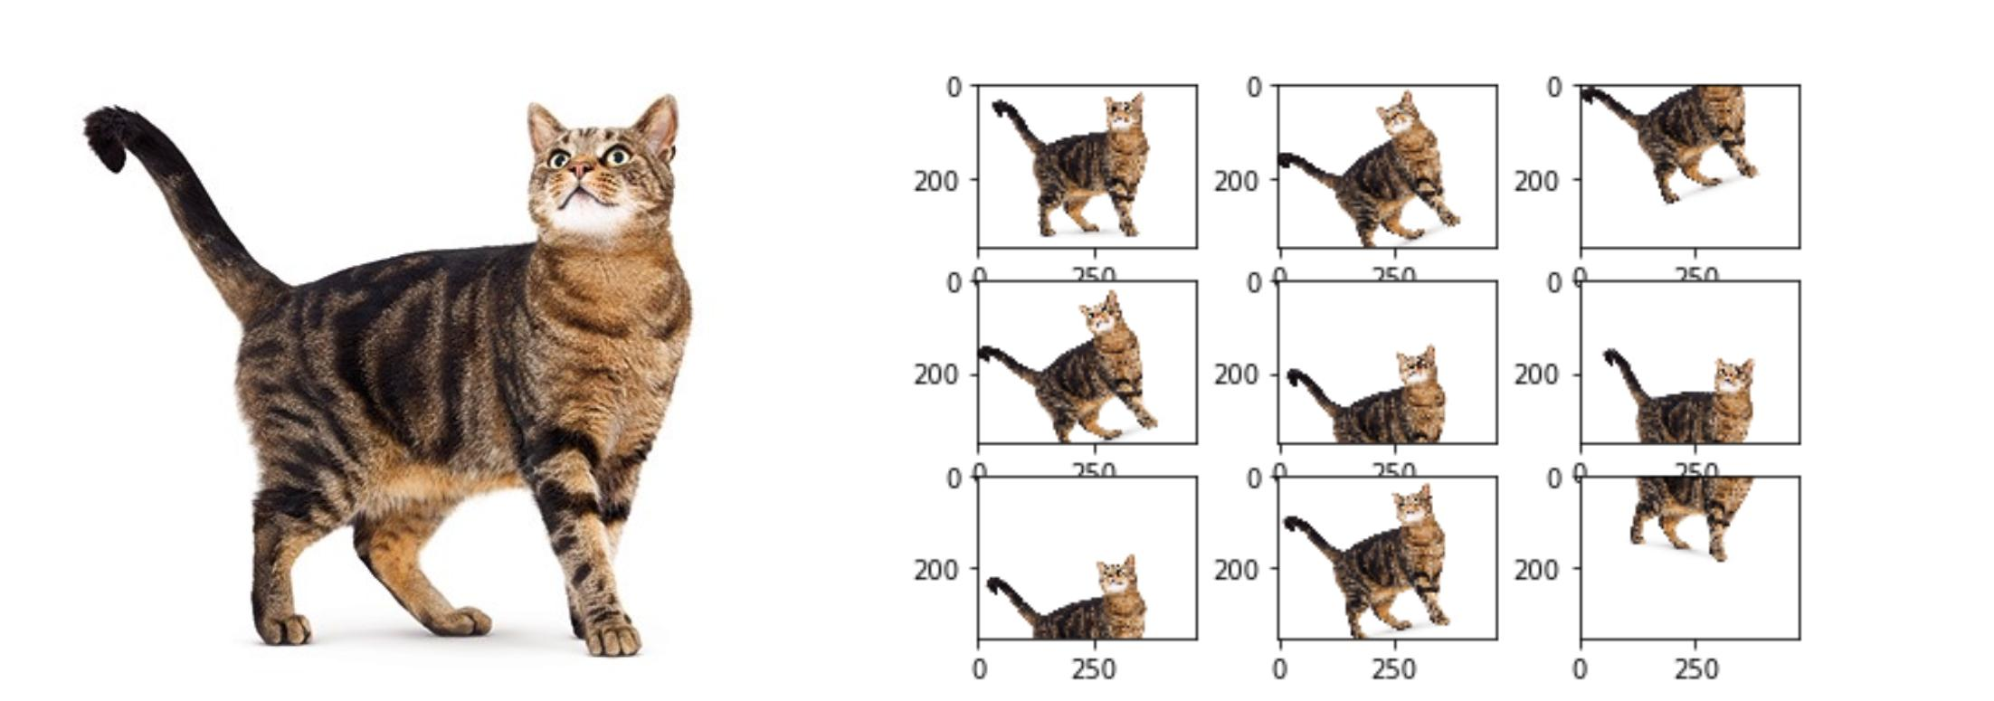

Source: <https://149695847.v2.pressablecdn.com/wp-content/uploads/2020/08/UKwFg.jpg>

[How Data Augmentation Impacts Performance Of Image Classification (analyticsindiamag.com)](https://analyticsindiamag.com/image-data-augmentation-impacts-performance-of-image-classification-with-codes/)

Data augmentation goal is to add new data points to the input space by modifying training images while preserving semantic information and target labels. Thus, it is used to reduce overfitting [29].

Our results confirm the importance of data augmentation in both training and testing and show that it can lead to more performance gains than obtaining new images [29].

**NORMALISASI atau STANDARDISASI**

Image normalization or standardization ensures optimal comparisons across data acquisition methods and texture instances. The normalization of pixel values (intensity) is recommended for imaging modalities that do not correspond to absolute physical quantities [31, 32].

**ACTIVATION FUNCTIONS**

Untuk memungkinkan jaringan saraf mempelajari batas keputusan yang kompleks, kami menerapkan fungsi aktivasi non-linier pada beberapa lapisannya. Fungsi yang umum digunakan meliputi tanh, ReLU, softmax, dan varian dari fungsi-fungsi tersebut. Secara teknis, setiap neuron menerima sinyal masukan yang merupakan jumlah terbobot dari bobot sinaptik dan nilai aktivasi dari neuron yang terhubung [34].

**RELU ACTIVATION FUNCTIONS**

[34]

**SOFTMAX ACTIVATION FUNCTIONS**

Secara umum, pada level terakhir dari FFNN, fungsi softmax diterapkan sebagai batas keputusan. Ini adalah kasus umum, terutama ketika menyelesaikan masalah klasifikasi. Sebaliknya, kita tidak perlu menggunakan fungsi aktivasi sama sekali untuk masalah regresi [34].

Dalam Matematika, fungsi softmax adalah generalisasi dari fungsi logistik, yang “menekan” vektor K-dimensi dari nilai-nilai real sembarang menjadi vektor K-dimensi σ(z) dari nilai-nilai real dalam rentang [0, 1] yang jumlahnya sama dengan 1 [34].

[34]

**DROPOUT**

Dropout adalah teknik yang digunakan untuk mengurangi overfitting dalam jaringan dengan banyak lapisan dan/atau neuron. Secara umum, lapisan dropout ditempatkan setelah lapisan yang memiliki sejumlah besar neuron yang dapat dilatih [34].

**TRANSFER LEARNING**

*Transfer learning* adalah peningkatan pembelajaran dalam tugas baru melalui transfer pengetahuan dari tugas terkait yang sudah dipelajari [33]. Pembelajaran transfer terdiri dari mengambil jaringan yang sudah dibangun dan membuat perubahan yang sesuai pada parameter dari berbagai lapisan sehingga dapat menyesuaikan dengan dataset lain [34].

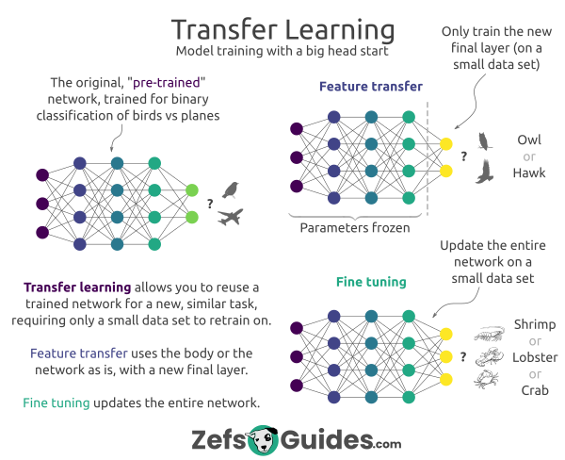

Source: <https://preview.redd.it/4p3j8qej1nn91.png?auto=webp&s=8de0945c56138ede9a0067be28e505a3bca1dc17>

**TRANSFER LEARNING APPROACHES**

**XCEPTION**

Xception adalah arsitektur jaringan saraf konvolusional yang sepenuhnya didasarkan pada lapisan konvolusi terpisah secara mendalam (depthwise separable convolution layers). Arsitektur ini diusulkan sebagai perpanjangan dari arsitektur Inception, di mana modul Inception telah digantikan dengan konvolusi terpisah secara mendalam. Arsitektur Xception adalah tumpukan linier lapisan konvolusi terpisah secara mendalam dengan koneksi residual [35].

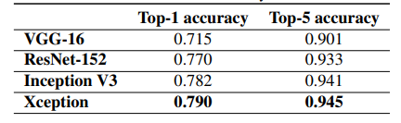

Benchmark table [35]

**ARSITEKTUR XCEPTION**

**CONFUSION MATRIX**

The confusion matrix is a table that summarizes how successful the classification model is at predicting examples belonging to various classes. One axis of the confusion matrix is the label that the model predicted, and the other axis is the actual label. In a binary classification problem, there are two classes [32].

**ALBUMENTATIONS**

Albumentations adalah *library* Python untuk augmentasi gambar yang cepat dan fleksibel. Albumentations secara efisien mengimplementasikan berbagai operasi transformasi gambar yang kaya dan dioptimalkan untuk kinerja, sambil memberikan antarmuka augmentasi gambar yang ringkas namun kuat untuk berbagai tugas visi komputer, termasuk klasifikasi objek, segmentasi, dan deteksi [36].

Contoh lebih banyak: [Defining a simple augmentation pipeline for image augmentation - Albumentations Documentation](https://albumentations.ai/docs/examples/example/), [Image augmentation for classification - Albumentations Documentation](https://albumentations.ai/docs/getting_started/image_augmentation/)

**TENSORFLOW**

TensorFlow adalah salah satu *library* yang dapat digunakan untuk implementasi *machine learning*. *Library* ini terkenal dengan penggunaan terkait *Deep Learning* [37].

[TensorFlow](https://www.tensorflow.org/)

[API Documentation  |  TensorFlow v2.12.0](https://www.tensorflow.org/api_docs)

BAB I

13: Implementation of Optical Character Recognition using Tesseract with the Javanese Script Target in Android Application, Urbanization and Regional Imbalances in Indonesia, Rancang Bangun Aplikasi Pembelajaran Aksara Jawa Berbasis Android

14: Implementation of Optical Character Recognition using Tesseract with the Javanese Script Target in Android Application, Urbanization and Regional Imbalances in Indonesia, Rancang Bangun Aplikasi Pembelajaran Aksara Jawa Berbasis Android

15: [Kurdish Handwritten character recognition using deep learning techniques - ScienceDirect](https://www.sciencedirect.com/science/article/abs/pii/S1567133X22000485)

16: [Sci-Hub | Deep learning. Nature, 521(7553), 436–444 | 10.1038/nature14539](https://sci-hub.se/https:/www.nature.com/articles/nature14539)

17: [(PDF) A Comprehensive Study on Deep Image Classification with Small Datasets (researchgate.net)](https://www.researchgate.net/publication/331728350_A_Comprehensive_Study_on_Deep_Image_Classification_with_Small_Datasets)

18: K. He, X. Zhang, S. Ren, and J. Sun, "Deep residual learning for image recognition," arXiv preprint arXiv:1512.03385, 2015.

19: [Sci-Hub | A Survey of Convolutional Neural Networks: Analysis, Applications, and Prospects. IEEE Transactions on Neural Networks and Learning Systems, 1–21 | 10.1109/TNNLS.2021.3084827](https://sci-hub.se/https:/ieeexplore.ieee.org/abstract/document/9451544)

23: J. Yosinski, J. Clune, Y. Bengio, and H. Lipson, "How transferable are features in deep neural networks?," in Advances in neural information processing systems, pp. 3320-3328, 2014.

24: J. Deng, W. Dong, R. Socher, L. J. Li, L. Kai, and F.-F. Li, "Image{N}et: {A} large-scale hierarchical image database," in Proceedings of the Computer Vision and Pattern Recognition (CVPR), pp. 248-255, 2009

25: [Javanese Script Text Image Recognition Using Convolutional Neural Networks | IEEE Conference Publication | IEEE Xplore](https://ieeexplore.ieee.org/abstract/document/9888527)

26: [TRANSFER LEARNING IMPLEMENTATION ON SUNDANESE SCRIPT RECOGNITION USING CONVOLUTIONAL NEURAL NETWORK (ugm.ac.id)](http://etd.repository.ugm.ac.id/penelitian/detail/213204)

BAB II

27: [A survey of transfer learning | Journal of Big Data | Full Text (springeropen.com)](https://journalofbigdata.springeropen.com/articles/10.1186/s40537-016-0043-6)

28: [A Comprehensive Survey on Transfer Learning | IEEE Journals & Magazine | IEEE Xplore](https://ieeexplore.ieee.org/abstract/document/9134370)

29: [Our results confirm the importance of data augmentation in both training and testing and show that it can lead to more performance gains than obtaining new images. - Consensus](https://consensus.app/details/results-confirm-importance-data-augmentation-training-perez/7309cabc177d5f9a85722a741270e505/)

30: [Impact of Image Resizing on Deep Learning Detectors for Training Time and Model Performance | SpringerLink](https://link.springer.com/chapter/10.1007/978-3-030-95498-7_2#:~:text=Resizing%20images%20is%20a%20critical,training%20time%20for%20the%20architecture.)

31: [Fundamentals of Texture Processing for Biomedical Image Analysis: A General Definition and Problem Formulation - ScienceDirect](https://www.sciencedirect.com/science/article/abs/pii/B9780128121337000016)

32: [The Hundred-Page Machine Learning Book by Andriy Burkov (themlbook.com)](https://themlbook.com/)

33: [torrey.handbook09.pdf (wisc.edu)](https://ftp.cs.wisc.edu/machine-learning/shavlik-group/torrey.handbook09.pdf)

34: buku: Expert Insight Deep Learning with Tensorflow

35: [Xception: Deep Learning With Depthwise Separable Convolutions (thecvf.com)](https://openaccess.thecvf.com/content_cvpr_2017/papers/Chollet_Xception_Deep_Learning_CVPR_2017_paper.pdf)

36: [Albumentations: fast and flexible image augmentations](https://albumentations.ai/)

37: [TensorFlow](https://www.tensorflow.org/)

# References

|  |  |
| --- | --- |
| [1] | A. R. G., A. Tandra, I. Susanto, J. Harefa and A. Chowanda, "Implementation of Optical Character Recognition using Tesseract with the Javanese Script Target in Android Application," *Procedia Computer Science,* pp. 499-505, 2019. |