Outline:

BAB III METODE PENELITIAN

**3.1 DATA**

**3.2 ALAT DAN BAHAN**

**ALAT**

SPESIFIKASI PERANGKAT KERAS

*LIBRARIES*

**BAHAN**

PENGUMPULAN DATA

PREPROCESSING

ARSITEKTUR MODEL XCEPTION DKK

TRAIN MODEL

EVALUASI

- Akurasi

- Confusion Matrix

**3.3 SKENARIO PENGUJIAN**

* DARI AWAL SAMPE AKHIR
* COBA AUGMENTASI (BANDINGKAN)
* COBA FINE TUNING DENGAN FREEZE LAYER

**METODE PENELITIAN**

**DATA**

Data yang peneliti gunakan diambil dari *kaggle*. *Kaggle* adalah sebuah platform komunitas *data science* yang berisi berbagai sumber dataset, notebook, kompetisi, dan lain sebagainya. Terdapat dua sumber dataset yang saya ambil yaitu,

* [Aksara Jawa | Kaggle](https://www.kaggle.com/datasets/phiard/aksara-jawa) (2659): sebagai sumber utama
* [Aksara Jawa / Hanacaraka | Kaggle](https://www.kaggle.com/datasets/vzrenggamani/hanacaraka?select=ya) (1583): sebagai sumber tambahan
* Buku tulis belajar Aksara Jawa: sebagai sumber tambahan lainnya???

Contoh data:

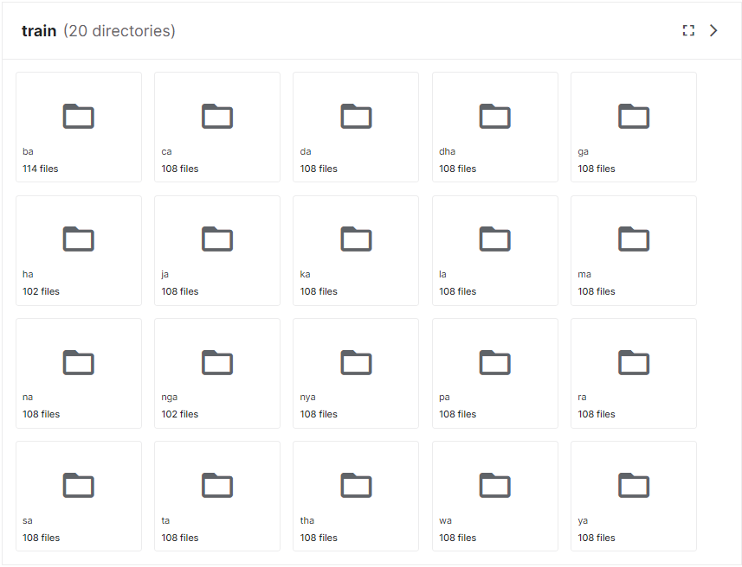

[INSERT CONTOH DATA DARI CODING] - RANDOM

**ALAT DAN BAHAN**

SPESIFIKASI PERANGKAT KERAS

Perangkat yang digunakan pada penelitian ini diambil dari platform notebook *kaggle*. *Kaggle* menyediakan jupter notebook yang bisa digunakan untuk menjalankan kode dengan menggunakan GPU, CPU, dan RAM yang cukup. Berikut detail spesifikasinya:

20 GB of auto-saved disk space

1 Nvidia Telsa P100 GPU

2 CPU cores

13 Gigabytes of RAM

Lebih lengkapnya dapat dilihat di [dokumentasi *kaggle* notebook](https://www.kaggle.com/docs/notebooks)

LIBRARIES

* Tensorflow
* Albumentation
* Numpy
* Pandas
* Matplotlib
* Plotly
* Sklearn

**PREPROCESSING**

RESCALE/RESIZE

[INSERT CONTOH DARI CODING]

NORMALIZATION

[INSERT CONTOH DARI CODING]

AUGMENTATION

CONFIG

[INSERT CONTOH GAMBAR DARI DATA SY (CODING)]

ARSITEKTUR MODEL TRANFSER LEARNING

XCEPTION

Dalam transfer learning, peneliti mengubah input layer dari model Xception dan menambahkan global average pooling, dropout, dan dense setelah arsitektur dari model Xception [35].

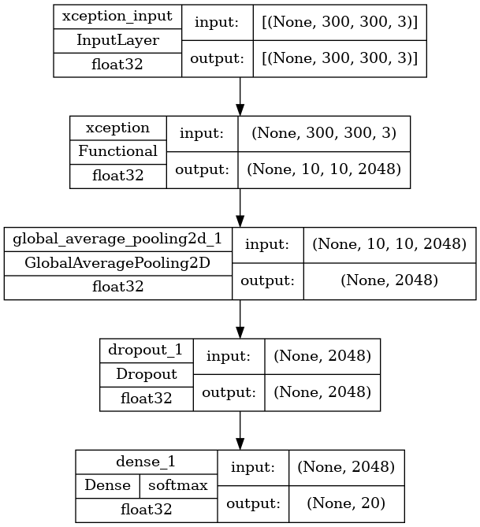

*TRAIN MODEL*

EVALUASI

* Akurasi
* Confusion Matrix
* Test new data

BAB I

13: Implementation of Optical Character Recognition using Tesseract with the Javanese Script Target in Android Application, Urbanization and Regional Imbalances in Indonesia, Rancang Bangun Aplikasi Pembelajaran Aksara Jawa Berbasis Android

14: Implementation of Optical Character Recognition using Tesseract with the Javanese Script Target in Android Application, Urbanization and Regional Imbalances in Indonesia, Rancang Bangun Aplikasi Pembelajaran Aksara Jawa Berbasis Android

15: [Kurdish Handwritten character recognition using deep learning techniques - ScienceDirect](https://www.sciencedirect.com/science/article/abs/pii/S1567133X22000485)

16: [Sci-Hub | Deep learning. Nature, 521(7553), 436–444 | 10.1038/nature14539](https://sci-hub.se/https:/www.nature.com/articles/nature14539)

17: [(PDF) A Comprehensive Study on Deep Image Classification with Small Datasets (researchgate.net)](https://www.researchgate.net/publication/331728350_A_Comprehensive_Study_on_Deep_Image_Classification_with_Small_Datasets)

18: K. He, X. Zhang, S. Ren, and J. Sun, "Deep residual learning for image recognition," arXiv preprint arXiv:1512.03385, 2015.

19: [Sci-Hub | A Survey of Convolutional Neural Networks: Analysis, Applications, and Prospects. IEEE Transactions on Neural Networks and Learning Systems, 1–21 | 10.1109/TNNLS.2021.3084827](https://sci-hub.se/https:/ieeexplore.ieee.org/abstract/document/9451544)

23: J. Yosinski, J. Clune, Y. Bengio, and H. Lipson, "How transferable are features in deep neural networks?," in Advances in neural information processing systems, pp. 3320-3328, 2014.

24: J. Deng, W. Dong, R. Socher, L. J. Li, L. Kai, and F.-F. Li, "Image{N}et: {A} large-scale hierarchical image database," in Proceedings of the Computer Vision and Pattern Recognition (CVPR), pp. 248-255, 2009

25: [Javanese Script Text Image Recognition Using Convolutional Neural Networks | IEEE Conference Publication | IEEE Xplore](https://ieeexplore.ieee.org/abstract/document/9888527)

26: [TRANSFER LEARNING IMPLEMENTATION ON SUNDANESE SCRIPT RECOGNITION USING CONVOLUTIONAL NEURAL NETWORK (ugm.ac.id)](http://etd.repository.ugm.ac.id/penelitian/detail/213204)

BAB II

27: [A survey of transfer learning | Journal of Big Data | Full Text (springeropen.com)](https://journalofbigdata.springeropen.com/articles/10.1186/s40537-016-0043-6)

28: [A Comprehensive Survey on Transfer Learning | IEEE Journals & Magazine | IEEE Xplore](https://ieeexplore.ieee.org/abstract/document/9134370)

29: [Our results confirm the importance of data augmentation in both training and testing and show that it can lead to more performance gains than obtaining new images. - Consensus](https://consensus.app/details/results-confirm-importance-data-augmentation-training-perez/7309cabc177d5f9a85722a741270e505/)

30: [Impact of Image Resizing on Deep Learning Detectors for Training Time and Model Performance | SpringerLink](https://link.springer.com/chapter/10.1007/978-3-030-95498-7_2#:~:text=Resizing%20images%20is%20a%20critical,training%20time%20for%20the%20architecture.)

31: [Fundamentals of Texture Processing for Biomedical Image Analysis: A General Definition and Problem Formulation - ScienceDirect](https://www.sciencedirect.com/science/article/abs/pii/B9780128121337000016)

32: [The Hundred-Page Machine Learning Book by Andriy Burkov (themlbook.com)](https://themlbook.com/)

33: [torrey.handbook09.pdf (wisc.edu)](https://ftp.cs.wisc.edu/machine-learning/shavlik-group/torrey.handbook09.pdf)

34: buku: Expert Insight Deep Learning with Tensorflow

35: [Xception: Deep Learning With Depthwise Separable Convolutions (thecvf.com)](https://openaccess.thecvf.com/content_cvpr_2017/papers/Chollet_Xception_Deep_Learning_CVPR_2017_paper.pdf)

36: [Albumentations: fast and flexible image augmentations](https://albumentations.ai/)

37: [TensorFlow](https://www.tensorflow.org/)

BAB III

38: [Sci-Hub | Xception Architecture Transfer Learning for Garbage Classification. 2020 4th International Conference on Informatics and Computational Sciences (ICICoS) | 10.1109/icicos51170.2020.9299017](https://sci-hub.se/https:/ieeexplore.ieee.org/abstract/document/9299017) (BUAT VGG DAN XCEPTION)

39: [Deep Generalized Max Pooling | IEEE Conference Publication | IEEE Xplore](https://ieeexplore.ieee.org/document/8978110)

# References

|  |  |
| --- | --- |
| [1] | A. R. G., A. Tandra, I. Susanto, J. Harefa and A. Chowanda, "Implementation of Optical Character Recognition using Tesseract with the Javanese Script Target in Android Application," *Procedia Computer Science,* pp. 499-505, 2019. |