A. Showing both canonical and current center options

A.1. Use transparency and superimpose the two views

A.2. When the user moves the cursor over, or clicks, dynamically move the canonical view from a superimposed view to below the current center

A.3. Use arrows to expand the canonical center view; start with canonical not visible by default

A.4. Use left side for current and right side for canonical. (probably not feasible due to real estate issues)

B. Showing differences

B.\*. All options below can be done one of three ways: mouse over a section to show difference, click a button to show, or show always

B.1. Use a different background under boxes and arrows.

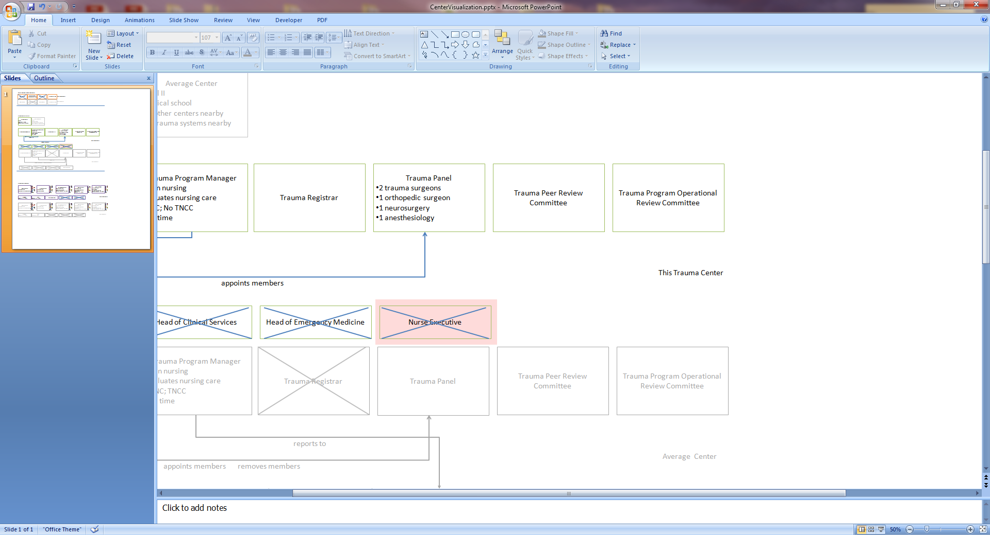

B.2. Use a highlight circle. Can be done on the labels of the arrows or boxes.

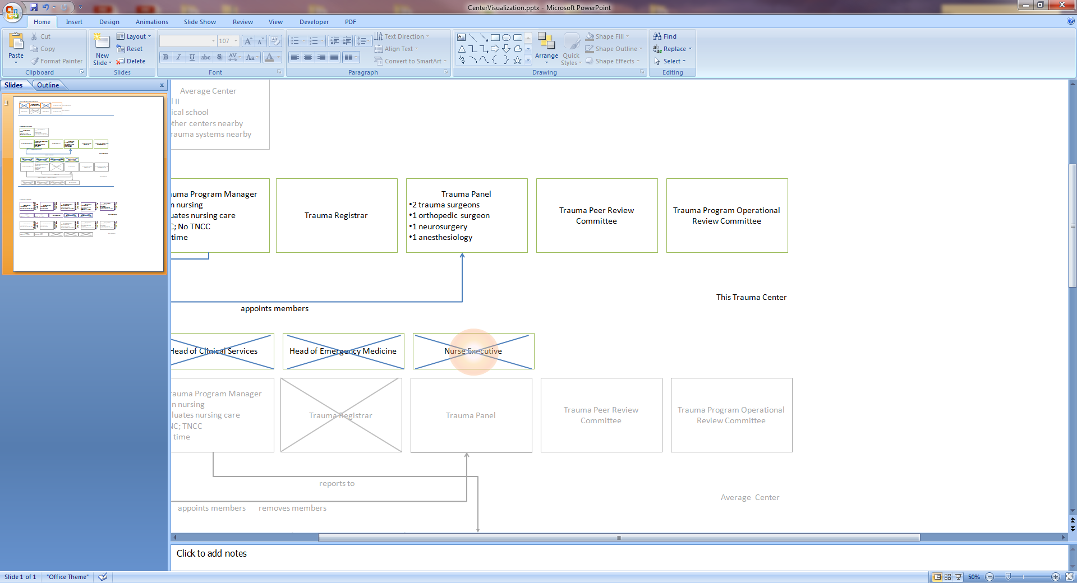

B.3. Use a bold font and heavy lines

B.4. Use a dynamically pulsating color or boldness (probably not going to work well).