## Understanding the microscopic simulation mechanism using GMNS and DTALite v0.51

Data set

[DLSim/release at main · asu-trans-ai-lab/DLSim · GitHub](https://github.com/asu-trans-ai-lab/DLSim/tree/main/release)

## Learning Goal:

Levels of modeling elements:

|  |  |  |  |
| --- | --- | --- | --- |
| Category | Elements | GMNS file names | Learning Goals |
| A | Network | Node.csv, link.csv | Free-flow speed, capacity, multiresolution network |
| b | Demand | demand.csv | Zone structure, OD demand matrix mapping to road network |
| c | Signal | Timing in link.csv | Micro |
| D | Scenario | Setting |  |
| E1 | Link output | link_performance.csv, | Macro |
| E2 | Route assignment output | Route_assignment.csv | Macro |
| E3 | Agent output | agent.csv, | Agent |
| E4 | Trajectory output | trajectory.csv, trace.csv | Micro |

## 1. Network Generation

## 2. Demand Generation

## 3. Traffic Signal

## 4. Traffic assignment and simulation

Work on cell-based path. Use 0.1 sec as simulation interval and simple spatial queue (CA). in addition, we also need a simple strategy to determine reaction time tau to consider time-dependent speed reduction.

Run DTALite.exe

We could obtain some key information about traffic assignment simulation, such as assignment mode, agent types, link types, simulation time period, input file name, file format and so on in setting.csv

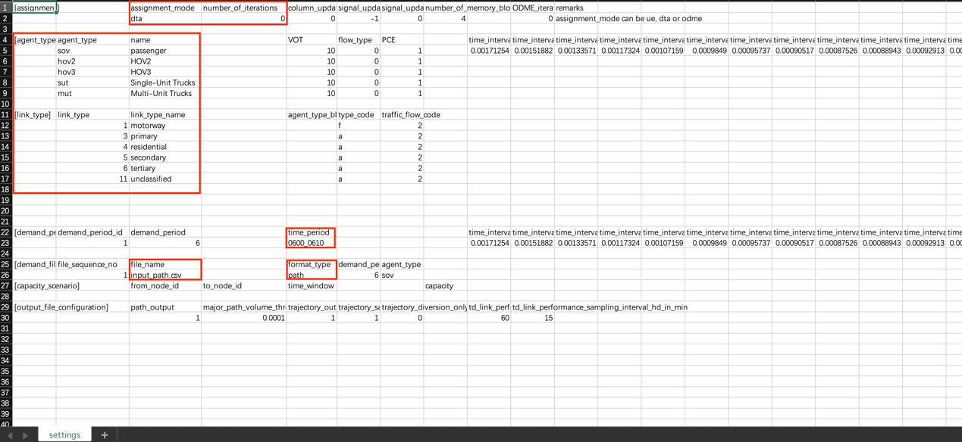

## 5. Check different levels of input and output

The following input and output files need to be checked systematically.

a. node.csv, link.csv.

b. input_path.csv, timing.csv, settings.csv

c. link_performance.csv, TD_link_performance.csv (link volume, aggregated speed and so on).

d. path.csv (assignment or given input file, both of them need to be visualized in Nexta ->agent diaglog)

e. agent.csv (with different vehicles with different departure times from simulation step (visualized in nexta ->agent dialog)

f. trajectory.csv

## 6. Load node.csv in Nexta