# 

[**www.codet.com**](http://www.codet.com)

Ez-Park Business Plan

CODET (yazılım ürün geliştirme) LTD. ŞTİ.

Cihangir Mah. Şirketler Sk. No:21

Beyoğlu/İstanbul 34767

Phone: +90 (212) 999 90 65

Fax: +90 (212) 999 90 66

Cafer S. Yükseloğlu

+90(531)853 44 02

Melike Avşar

Sercan Varan

Sena Uluçam

Oğuzhan Karabey

Tamer Ünal

Beyza Kurşun

07/02/2021

# TABLE OF CONTENTS

Ecevutive Summary iii

Industry Analysis iii

**1.** **INTRODUCTION** 1

**1.1** **Company Description** 1

**1.2****Market Analysis** 1

**2.** **DEFINITION OF THE MARKET** 2

**2.1** **Economics of Our Business** 2

**2.2** **Marketing Plan** 2

**3.** **THE APP COMPONENTS** 3

**3.1** **Product (or Service) Design** 3

**3.2****Development Plan** 3

**3.3****Challenges & Risks** 3

**4.** **PROJECT FLOW** 4

**4.1** **Where are we now?** 4

**5.** **COST & CHALLANGES** 5

**5.1** **What Will It Coast in Development?** 5

**5.2** **What Will It Coast in Development?.............................................................................**5

**5.3****Operations Plan …………………...................................................................................**5

**6.** **MANAGEMENT TEAM AND COMPANY STRUCTURE** 6

**7.****OVERALL & FINANCIAL**  7

**7.1****Overall Schedule** 3

**7.2****Financial Projections** 3

**8.****APPENDIX**  7



*“Comfortable parking with a reliable system”*

# Executive Summary

It is a project developed to find a solution to the increasing parking problem in big cities, especially with the increasing population and number of vehicles. Most of us now own smartphones and benefit from the apps inside. In this project, people will be able to download the application to their phones and easily find a place in the parking lot with the QR code there. For this, it is among our plans to make an agreement with the parking lot owners.

# Industry Analysis

Processing of raw materials, creating energy resources, all the tools and methods used in the creation of these resources are industry. It is a definition associated with industry. Although the size and growth rate of the application depends on its sale, the fee received from the customer is initially minimal. However, dividends are taken on the voucher. Thanks to the ads made, the demand for the application increases and the growth of the sector occurs gradually, thus moving sales to an advanced level. For the future, satisfaction and revenue are expected to increase with the increase in services provided. Good advertising is key to achieving this success. For example, ads are displayed in billboards in crowded areas or in-App is used to appeal to large audiences. In this way, access to individuals over the age of 18 who can use the application, which is the desired target audience, becomes easier.

# Company Description

The application has a technological structure and is related to parking services. It has a system showing the occupancy rate of the car parks. Its task is to inform the user about the occupancy rate of the car parks and to place them in suitable car parks. All of the agreed parking lots in the areas where this application is used have been activated. Users do not waste time searching for parking spaces. You can also register your car with the QR code and have online ticket purchases. With the increase in automation in the future, it is planned to develop an automatic parking system worldwide, to pay a fee with QR code and to receive various requests (vehicle repair, paint, maintenance). Customers of the application are parking lots, products are vehicle owners, and the area is determined as automation. The legal status of the agreed parking lots is included in the implementation structure.

# Market Analysis

Ez-Park is designed for the people who want to reduce their parking problems and want to have a comfortable journey. That’s why target market of application can be defined as individuals over the age of 18 who have a driving license and vehicle. These reasons describe the application’s market segmentation as demographical. Further, Ez-Park is the first application developed in its market therefore the app has no any competitors. It can be predicted that our application will grow rapidly at the lowest competition and become the pioneer of the field. Since we are creating a new area, it will be difficult to attract people’s attention and increase the use of the application for the first one year. So that we don’t aim for a financial gain until we catch our potential.

# Economics of Our Business

Since our product is an application, we do not need a huge amount financially to start, we will need an initial investment in technical equipment and payment of employee wages. In the next stage, we have to spend a large amount of money for advertising. At this point, the point that requires us to make a big investment will be advertising expenses. As a revenue model, we plan to receive commission fees from the ticket fees at the car park entrances and the services inside the car park.

Marketing Plan

Ez-park's potential customers all vehicle owners who value their time, are compatible with technology and are over 18 years old. Ez-Park differs from the old manual parking ways via mobile application and online services. With these online services and the mobile application Ez-Park is also prevents waste of energy, time and waste of paper documents. Furthermore Ez-Park just like a bridge to connect car owners and the car park owners and Ez-Park just takes a little dividend from advertisements for car parks and the persons that parked on our connected parks via their bills at first Ez-Park aims for bigger car park connections and more users. So, the main spot of the marketing strategy is to be more common between vehicle owners and car parks.

Product Design

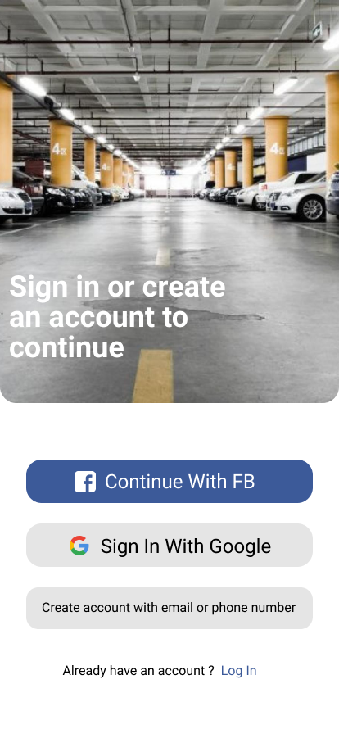Firstly, a user should log in on their accounts, via Google account, phone number, Facebook account, or their mails. Vehicle owner looks up for a proper empty space and the prices on an any car park that they want to park then chooses how much time that would an owner want to park their car on a park for requested time interval. After that the payment phase comes through and user pay instantly or pay after usage via cash, online payment ways. Lastly car parks bill the usage for their selves and the user and Ez-Park and the car park owners take their shares.

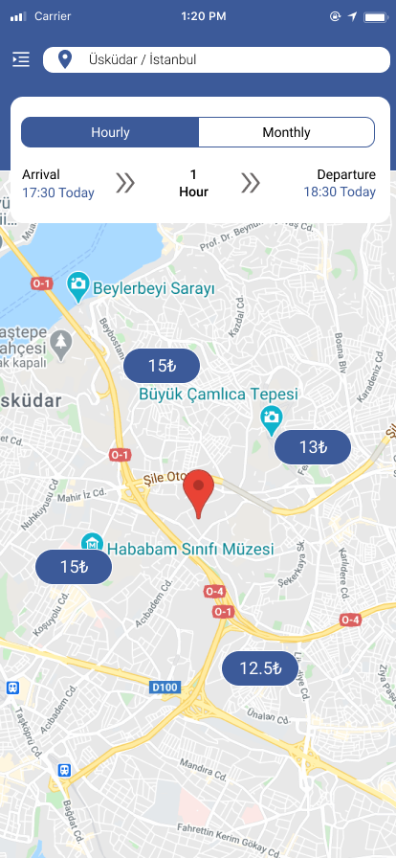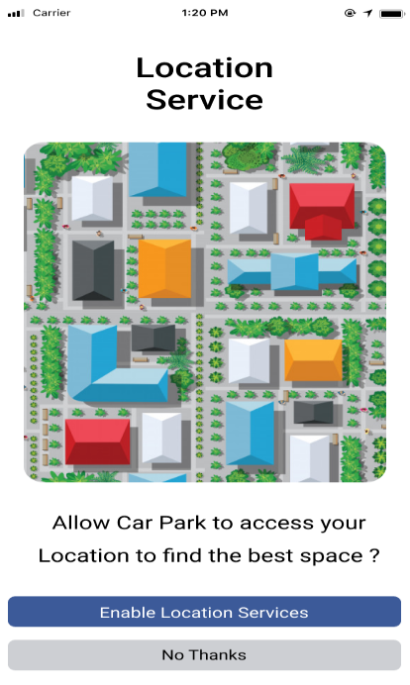This is the way how the sale process works for vehicle owner and car park owners.

# Development Plan

Ez-Park has been completely ready to be coded and by Ez-Park members can be coded in a very short time. About the coding side, firstly front-end developer and graphic designer has going to design proper way via firebase and another apps. After then that, back-end developers going to create data structures and class diagrams. Then we going to create main functions of the Ez-Park like main page, booking page, online map functions and structures. So, we will publish our app in a very short time like 5 months.

# Challenges & Risks

If the time to market time increase it will get harder to get users. So Ez-Park has to release on time for users. Furthermore, there can be another parking product as Ez-Park can be released while Ez-Park does or another parking product with high financial budget would be a risk for the position of Ez-Park. On the other hand, while getting users, the product has to be attractive for users via designs. Might the designs can be seen unattractive for some possible users. Lastly might the prices and dividend could not accept by the users and car park owners. These are the risks and the challenges for Ez-Park.

# What Will It Coast in Development?

While the count of users increases, the server fees, programming fees, advertising fees and fees of the customer services will increase but at this point it's impossible to say anything certain about the development costs. Because all these development costs, depends on the user count and size of community.

# Operations Plan

We intend to manage our business from a single office. As we are a software company, we don't need a huge office. We will be releasing good software with a limited number of personnel and will update it regularly. We need computers and internet connection for these. The selection of our application server will do the turkey's leading companies. Security is as important as speed. We will add all alternative payment systems to our application.

**Office**

* First of all, we will rent a small office in Istanbul's leading districts.
* Approximately 150 square meters is enough.
* Utilities (water, electricity, gas, internet, telephone) are estimated at 500 TL per month.

**Staff**

* We will recruit 1 front-end and 3 back-end personnel, excluding front-end and back-end developers in the management team.
* Bonus / profit sharing system will be put into use to increase employee loyalty.
* Back end developers will be one part time and two full time.

**Equipment**

* Computer and Computer Accessories
* Office tables and chairs
* Office decorations

*Maintenance contracts for the equipment will be deal with local dealers.

# Management Team and Company Structure

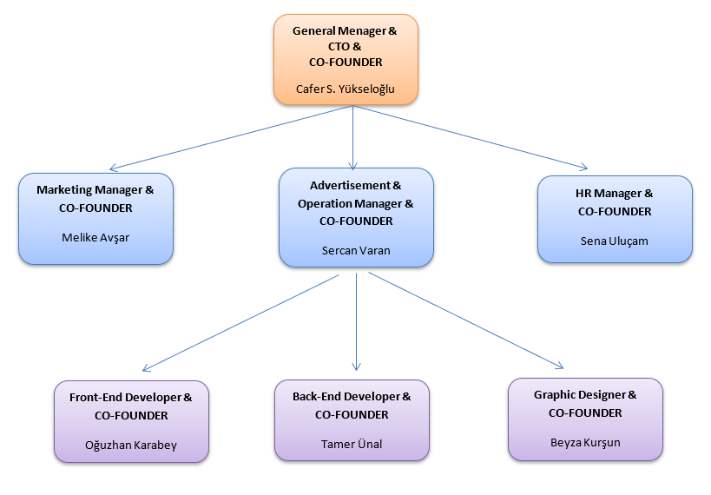

# Overall Schedule

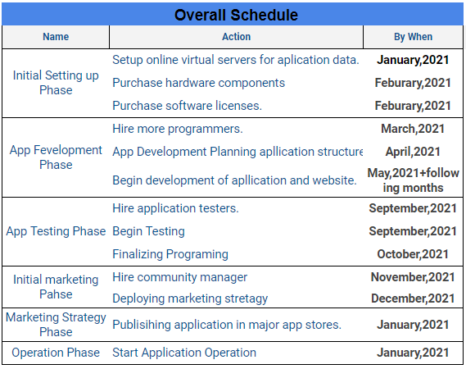

# Financial Projections

We do not aim for a financial gain until we catch our potential, we are using financial power to reach more users via design advertisement and more available program.

There are the fees that required to keep our project effective and useful. One of them is design fee which is that we pay to make our program more attractive via designs, graphics.

Programming fee which is one of our biggest expenses, is the fee that we give to the programmer for the software of our product. Also, we will host our application on a server. We have to pay regular server fees. There is also office rent that we have to pay. Since we will manage our business from an office, we must rent an office. For this reason, we need to have an office rental fee.

Moreover, company set-up fees which covers entire taxes and legal fees required for the establishment of the company. One of the most important is the advertising fee which budget allocated for the promotion of the product to consumers in different media.

Beside this, one of the biggest expenses of a software company is hardware expenses because the, computer and internet are used for this project.

As we mentioned above, we do not have the aim to earn big money in the first place, together with the ads, and as this application is used and grows, we can start to make a profit in a short time.

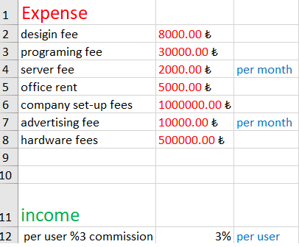

# Appendix

