Individual project – Final idea

AI For Society

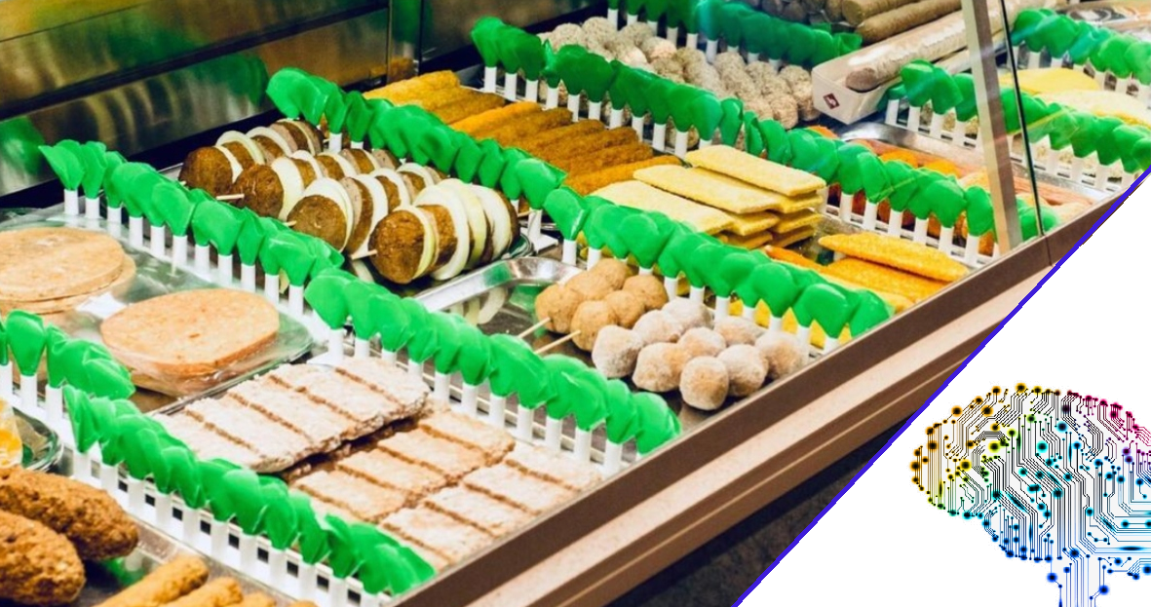

Calvin Hong - 431518

# Introduction

For the minor AI For Society, students have to work on a individual and group project. This document will be used to further explain the individual project idea of the student by giving more information. Since this is the first time working with AI, the student is not sure what is realistic or too simple. Despite this, the created idea has been thought out by answering predefined questions created by the teachers.

# Final Idea

The parents of the student run a snack bar, which is a unique advantage that could be used for this project. There are multiple points that could be improved during the process of preparing an order. One of the major bottlenecks is gathering the items of the order.

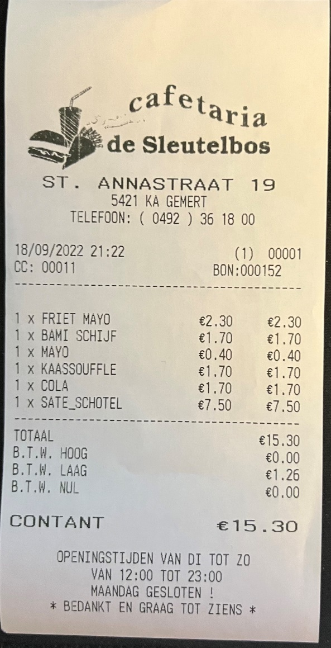For example, see the following medium sized example order:  
  
In this order, the employee has to get:

1X Bami schijf

1X kaassoufle

After gathering the snacks, the employee then has to vocally shout to the fries station how much should be thrown into the frying pan.  
In this example:  
Friet mayo + Sate schotel = 2 portions.

This is not that difficult with one or two orders, but during rush hours the receipts quickly pile up. Keeping focus and remembering every item you have to gather gets difficult quickly combined with the noise and chaos that comes in these hours.

The items on the printed receipts are not efficiently organized. This results in wasted time as the gatherer needs to count and organize the items in their head. Due to this, the chance of human mistakes in this process is drastically increased. Having an assistant who reads all the receipts and organizes the key information to the employee who is gathering the items would be a great help.

Employees have to prepare up to 3 receipts at a time. Doing this fast is important, so that the flow will not get disturbed and the customers do not have to wait a long time.

Doing this with the example below, you can see how difficult it can quickly become.

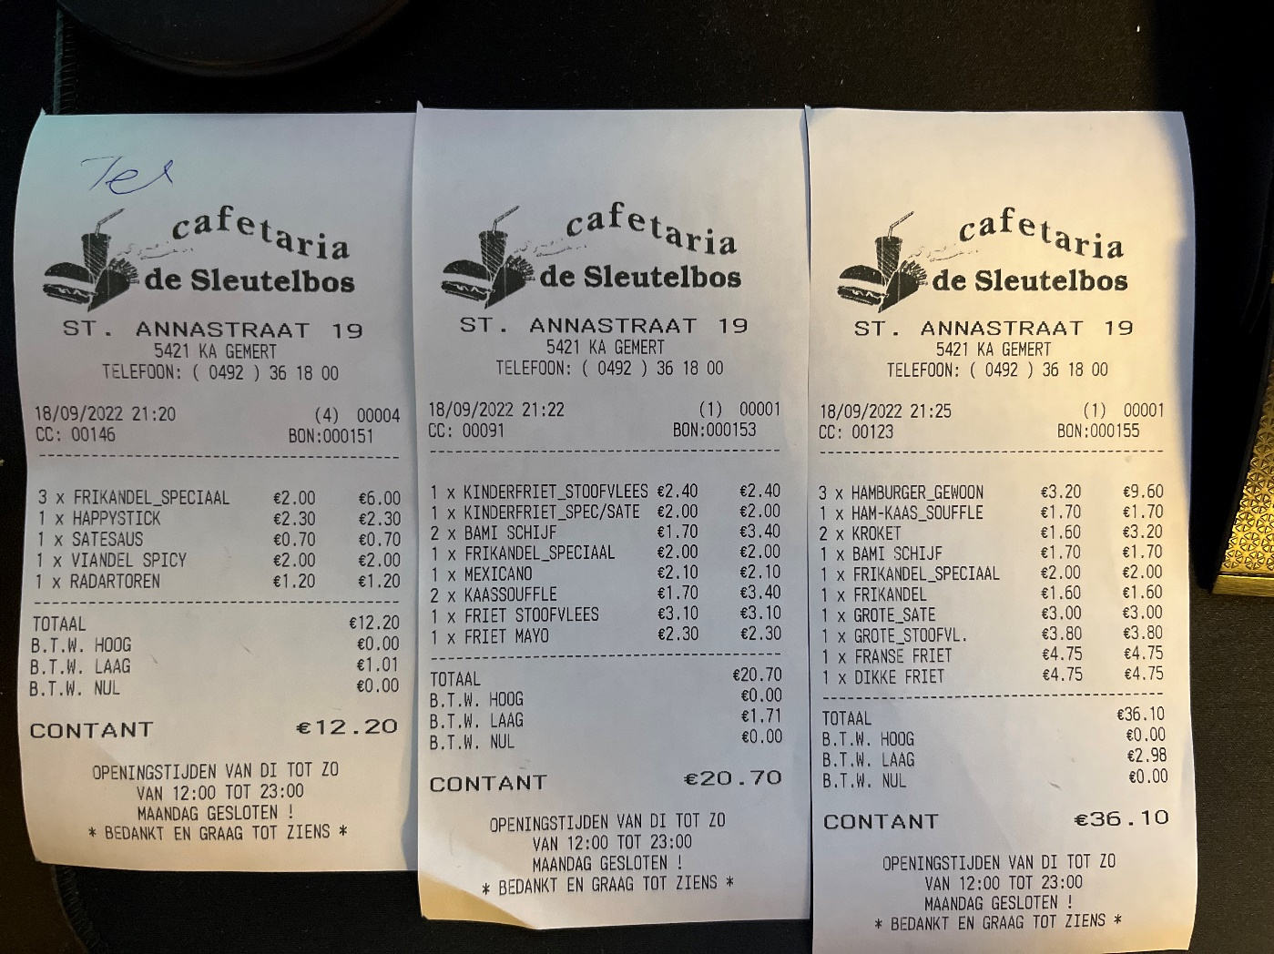

The final idea: **Snack bar preparation assistant**

The assistant AI will scan the receipts as soon as they get ordered and show the employee what items should be prepared first. This should help with the time efficiency, since not all the items cook in the same amount of time. For example, a hamburger takes around 10 minutes, while a frikandel takes around 5. Having a screen that shows you what you should prepare in order of time should make the process more time efficient.

Some items are also not in the deli case at the work station. To get these items the employee has to go to the back. This sometimes results in having to make multiple trips because it is difficult to remember all the items listed. The assistant can group these items together in an overview so that it is clearer for the employee.

There is not an infinite amount of snacks in the deli case and it is often hard to track availability during rush hours. Due to this, it would be useful if the assistant can also keep track of this and tell the employee when a snack is running out of stock so they can refill this.

## What problem does it solve?

This idea solves the bottleneck that occurs during the preparation of an order. The cashier prints the receipt and hands it to the person who prepares the orders. However, because the amount of orders printed within a certain amount of time surpasses that of orders prepared, there is a bottleneck in this process. This is a problem because it causes a backlog of receipts that still need to be tended to, which increases customer waiting time and subsequently lowers customer satisfaction. Even though it is manageable right now, the efficiency of making an order can be improved by developing and using this assistant.

## How does it solve it?

By tracking the orders and its items, employees will have a clear overview of what needs to be prepared first, what items needs to be gathered, and how many orders of fries should be passed along to the fries station.

## Who is it for?

This assistant is mainly for the employee that is tasked with preparing the items for an order. Though it can still be expanded to other stations like the fries station.

## Why is your solution the best?

There is currently no solution to this problem, the prepper has to memorize the order items, which is difficult to do in large quantities. This idea should make the preparation stage of the order more efficient, making the waiting time for customers lower.

## How is AI/DATA used?

Artificial intelligence will be used to keep track of the orders and to display the items that should be prepared first. The AI will also keep track of the stock in the shopwindow, so the employee will get a notification when an item is running out.

## What data(sets) does it use?

This idea will use the data received from the orders. It will also have the data on the item stocks.

## What is the possible positive AND negative impact?

+ More insight on item stock

+ Employees do not have to struggle remembering items

+ Employees can focus on gathering items, and the assistant can keep track of the rest.

+ More efficient process, which ultimately results in customers having to wait less and improves customer satisfaction.

- This changes the process of making an order, which the employees will have to adapt to.

- This will cost money.