Semester 7 – AI for Society

Personal Development Report

Calvin Hong - 431518

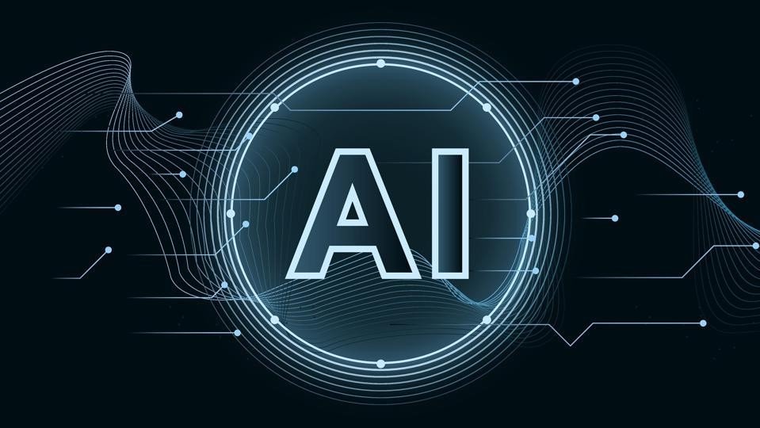

**Versioning**

|  |  |  |
| --- | --- | --- |
| Version | Description | Date |
| 0.1 | Start PDR | 18-09-2022 |
| 0.2 | Second version | 16-10-2022 |
| 0.3 | Third version | 27-11-2022 |
|  |  |  |

# Introduction

The 7th semester of the ICT & Software Engineering course at Fontys is on a minor or specialization that students had to pick themselves. Among the minors, one stood out: **AI for Society**. I was picked in this minor because I have not explored it that much. I am interested in the possibilities and I want to create a project using AI that is actually useful.

# Contents

Introduction 3

1. Societal Impact 5
2. Investigative Problem Solving 6
3. Data Preparation 7
4. Machine Teaching 8

5 Data Visualization 9

1. Reporting 10
2. Personal Leadership 11
3. Personal Goal 12

Reflection 13

Conclusion 14

Appendix 15

Learning outcomes

## Societal Impact

*“The student is able to approach the context and impact of their own AI project(s) from different perspectives in a sustainable way. In addition, the student is able to reflect on their own choices, taking into account data legislation and the (possible) impact on society.”*

This learning outcome focusses on societal impact. The student should be able to recognize their influence and reflect on choices made.

### Development (undefined, orienting, beginning, proficient, advanced)

|  |  |  |
| --- | --- | --- |
| **ID** | **Description** | **Level** |
| 0 | Week 4 | Undefined |
| 1 | Week 7 | Orienting |
| 2 | Week 12 | Beginning |

**Substantiation**

0: Week 4

This first period was mainly used for getting to know the minor, making groups, and setting up the work environments.

1: Week 7

The student has looked at the influence their individual project has to society. The project should be beneficial for the catering industry that fall behind in their technological aspects (in this case snack bars in particular). The student also followed lectures about the legal points of AI and software. This resulted in the student looking at how the data is handled and where legal problems could occur. Since the data is anonymous and sensitive information is not saved, the project should not fall in the scope of GDPR.

2: Week 12

This period, the student has looked into societal impact by finishing an exercise recommended by a teacher. This exercise focused on contemporary philosophy. In the group project, the students have created a TICT quick scan document.

### Reflection on my progress

0: Week 4

This learning outcome has not progressed yet, so the level is: **Undefined.**

1: Week 7

This learning outcome has progressed. The student has gained more knowledge and this should result in a better implementation of the application. The amount progressed is between orienting and beginning, but after reconsidering the progress done and to be done, the level is set to: **Orienting.**

2: Week 12

The student has looked into societal impact and is close to proficient level, but can still improve. The level is set to: **Beginning.**

## Investigative Problem Solving

*“The student is able to critically look at their own AI project(s) from different perspectives, recognize problems and come up with appropriate solutions.”*

This learning outcome focuses on recognizing problems in the project and being able to fix them appropriately.

### Development (undefined, orienting, beginning, proficient, advanced)

|  |  |  |
| --- | --- | --- |
| **ID** | **Description** | **Level** |
| 0 | Week 4 | Undefined |
| 1 | Week 7 | Orienting |
| 2 | Week 12 | Beginning |

**Substantiation**

0: Week 4

This first period was mainly used for getting to know the minor, making groups, and setting up the work environments.

1: Week 7

The student has followed multiple lectures varying from practice exercises to presentations about important information. By following the exercises, the student gained practical experience with adjusting AI under the guidance of a teacher. The presentations from the teachers also played an important part in the progressing the student as an AI developer. The student is currently busy collecting their own dataset, so their own AI has not been tested yet.

2: Week 12

The student is able to solve problems in the project. One of the biggest problems was how to collect the data from the receipts printed. The student was able to solve this problem by using a camera mounted above the printer. Other smaller hurdles have been solved as well.

### Reflection on my progress

0: Week 4

This learning outcome has not progressed yet, so the level is: **Undefined.**

1: Week 7

This learning outcome has progressed. Just like the last learning outcome, the student has gained more knowledge from lectures. Unfortunately, their own AI has not been tested yet, so the level is set to: **Orienting.**

2: Week 12

This period has shown improvements in this learning outcome. The level is set to: **Beginning.**

## Data Preparation

*“The student is able to collect data and estimate its quality and usability. The student is also able to adjust the data if necessary for proper usage in their project(s).”*

This learning outcome focusses on gathering data and being able to decide which data is usable and the quality of it.

### Development (undefined, orienting, beginning, proficient, advanced)

|  |  |  |
| --- | --- | --- |
| **ID** | **Description** | **Level** |
| 0 | Week 4 | Undefined |
| 1 | Week 7 | Beginning |
| 2 | Week 12 | Proficient |

**Substantiation**

0: Week 4

This first period was mainly used for getting to know the minor, making groups, and setting up the work environments.

1: Week 7

The student is currently collecting their own dataset from a live environment. The data collection system is a Raspberry PI 4 connected to a camera that scans receipts and sends them to a back office. In this back office, entries can be adjusted (so outliers can be removed and edited).

1: Week 12

This period, the parts of the system has been connected to each other. The data received from the scanned receipts are sent to the back office. In this back office, all orders and items can be shown and adjusted if necessary. These orders can also be interacted with on the dashboard by an employee.

### Reflection on my progress

0: Week 4

This learning outcome has not progressed yet, so the level is: **Undefined.**

1: Week 7

This learning outcome has progressed. The student has created their own system to collect their dataset. This system sends the data to a back office where the data can be shown in an overview. From here, the outliers in the dataset can be edited or removed. Since the learning outcome has progressed a lot, the new level is set to: **Beginning.**

2: Week 12

This learning outcome has progressed. Instead of getting data from the internet, the student created his own device to scan the receipts. These receipts are then scanned and sent to a back office for further adjustments or visualizations. For these reasons, the level is set to: **Proficient.**

## Machine Teaching

*“The student is able to use data to train models in a way that fits the intended purpose. The student is also able to test whether the models have been adequately trained”*

This learning outcome focusses on training models using data. It should also be tested to see if the model is working properly.

### Development (undefined, orienting, beginning, proficient, advanced)

|  |  |  |
| --- | --- | --- |
| **ID** | **Description** | **Level** |
| 0 | Week 4 | Undefined |
| 1 | Week 7 | Orienting |
| 2 | Week 12 | Beginning |

**Substantiation**

0: Week 4

This first period was mainly used for getting to know the minor, making groups, and setting up the work environments.

1: Week 7

The student is currently collecting their own dataset from a live environment, so their AI has not been used yet. However, during lectures, there has been practice assignments using test datasets to train an AI.

2: Week 12

This period, the student mainly worked on the scanning of receipts part. The technology used for getting the images are a raspberry pi and a webcam. The image gets processed in Python by using the packages Opencv and tesseract.

### Reflection on my progress

0: Week 4

This learning outcome has not progressed yet, so the level is: **Undefined.**

1: Week 7

This learning outcome has not progressed as much as the student wanted to, but there was some practice in training AI during lectures. There are still quite some steps to take, so the level is set to: **Orienting.**

2 Week 12

This learning has progressed by one level. The student has collected their data themselves, but can still improve on other levels. The steps to be taken have lessened, but there are still some left. The level is set to: **Beginning.**

## 5 Data Visualization

*“The student is able to use data to create an interesting, informative and compelling story in an (interactive) data visualization product, tailored to the right target group.”*

This learning outcome focusses on displaying results in an interesting and informative way.

### Development (undefined, orienting, beginning, proficient, advanced)

|  |  |  |
| --- | --- | --- |
| **ID** | **Description** | **Level** |
| 0 | Week 4 | Undefined |
| 1 | Week 7 | Orienting |
| 2 | Week 12 | Beginning |

**Substantiation**

0: Week 4

This first period was mainly used for getting to know the minor, making groups, and setting up the work environments.

1: Week 7

The student is currently working on a back office, where the dataset can be displayed and/or edited. This back office should get the data live from the receipt scanning system, so the graphs will also update real time. Alongside this back office, there will also be a dashboard for the employee with the items that came out of the results of the AI. This display will most likely be a list view with buttons.

2: Week 12

The page to visualize the data has been created in the back office. All the orders can be shown in a table, and individual orders can also be adjusted. The next step is to make the data prettier by using graphs and colors.

### Reflection on my progress

0: Week 4

This learning outcome has not progressed yet, so the level is: **Undefined.**

1: Week 7

This learning outcome has progressed. The back office and dashboard is currently being worked on, so it is not finished yet. The student has practiced with graphs during lectures. The level of this learning outcome is: **Orienting.**

2: Week 12

This learning outcome has progressed. The back office and dashboard are functional and connected to each other. The student has been working with graphs during his part time job at a software company. These skills can be taken to the individual project. The level of this learning outcome is: **Beginning.**

## Reporting

*“The student is able to report in a methodologically sound manner on (the outcome of) own AI projects (project proposal, process documentation, reporting of final results, etc.).”*

This learning outcome focusses on reporting and documenting progress in a professional way.

### Development (undefined, orienting, beginning, proficient, advanced)

|  |  |  |
| --- | --- | --- |
| **ID** | **Description** | **Level** |
| 0 | Week 4 | Undefined |
| 1 | Week 7 | Orienting |
| 2 | Week 12 | Beginning |

**Substantiation**

0: Week 4

This first period was mainly used for getting to know the minor, making groups, and setting up the work environments.

However, the student already had to make a couple of documents which have been submitted on canvas.

1: Week 7

The student has needed to document their progress for both the individual project and group project. The student also has made simple diagrams to show what the final system looks like.

2: Week 12

The student has been keeping track of his documents in a separate GitHub repository inside the project organization. The documents inside this repository range from this PDR to 3D models used for mounting the scanned above the receipt printer.

### Reflection on my progress

0: Week 4

This learning outcome has progressed a little bit, but not enough to change the level. The level is:

**Undefined.**

1: Week 7

This learning outcome has progressed. Although the documents are done, the styling could use some more attention. The level is: **Orienting.**

2: Week 12

This learning outcome has progressed. The student has kept up their documents and added more. The level is: **Beginning.**

## Personal Leadership

*“The student shows an entrepreneurial mindset regarding their own AI project(s) and personal development, while being aware of their own learning capacity and keeping in mind professional ambitions in their future work field.”*

This learning outcome focusses on personal development. Being able to see where you stand and how much can still be learned.

### Development (undefined, orienting, beginning, proficient, advanced)

|  |  |  |
| --- | --- | --- |
| **ID** | **Description** | **Level** |
| 0 | Week 4 | Undefined |
| 1 | Week 7 | Orienting |
| 2 | Week 12 | Beginning |

**Substantiation**

0: Week 4

This first period was mainly used for getting to know the minor, making groups, and setting up the work environments.

1: Week 7

The student is currently a little bit behind track, with the focus on the receipt scanner. The scanner is currently about halfway done, but ideally a first version should’ve been completed which would start collecting the data set.

In regards of the future work field, the student has updated their cv and LinkedIn. The student has been looking for companies and has written down a couple interesting ones.

2: Week 12

The student is currently looking for a graduation internship. The cv, LinkedIn and personal website have been updated. Besides this, the student has been keeping up schoolwork and the part time job at a software company. This part time job is also helping the personal development by building up experience in a real company and improving their coding capabilities.

### Reflection on my progress

0: Week 4

This learning outcome has not progressed yet, so the level is: **Undefined.**

1: Week 7

This learning outcome has progressed. Even though the student is a little bit behind track, the project should still be fine. The progress lost can still be gained back in the coming holidays or during extra hours after lectures. The student will start applying to companies soon after talking to their mentor. The current level is set to: **Orienting.**

2: Week 12

This learning outcome has progressed. The student has caught up a bit and is progressing well. The student is currently also focusing on their graduation internship. The current level is set to: **Beginning.**

## Personal Goal

*“<With this learning outcome, the student can set its own goal in relation to their future field of work. Describe this Learning Outcome in your PDR.>”*

The student can improve an already existing system or progress by adding AI or replacing components with AI.

### Development (undefined, orienting, beginning, proficient, advanced)

|  |  |  |
| --- | --- | --- |
| **ID** | **Description** | **Level** |
| 0 | Week 4 | Undefined |
| 1 | Week 7 | Orienting |
| 2 | Week 12 | Beginning |

**Substantiation**

0: Week 4

This first period was mainly used for getting to know the minor, making groups, and setting up the work environments.

1: Week 7

The student has looked at the bottlenecks in the flow of the snack bar. The student found the biggest bottleneck that could be solved by using AI that is big enough for a semester project. A project proposal was submitted to canvas which was accepted. The student is currently working on the implementation of the system.

2: Week 12

The system has been tested a couple times in a real environment, but not at the busy stages. It is not ready yet for rush hours, but the feedback of the employees has been positive.

### Reflection on my progress

0: Week 4

This learning outcome has not progressed yet, so the level is: **Undefined.**

1: Week 7

This learning outcome has progressed. The plan has been set, but the system itself is not done yet. The level is set to: **Orienting.**

2: Week 12

This learning outcome has progressed. The system has been testing live in a snack bar, but due to some problems, it did not work perfectly. The level is set to: **Beginning.**

# Reflection

# Conclusion

# Appendix

https://fhict.instructure.com/courses/12677/assignments/209183