Project Proposal

Snack bar preparation assistant - AI For Society

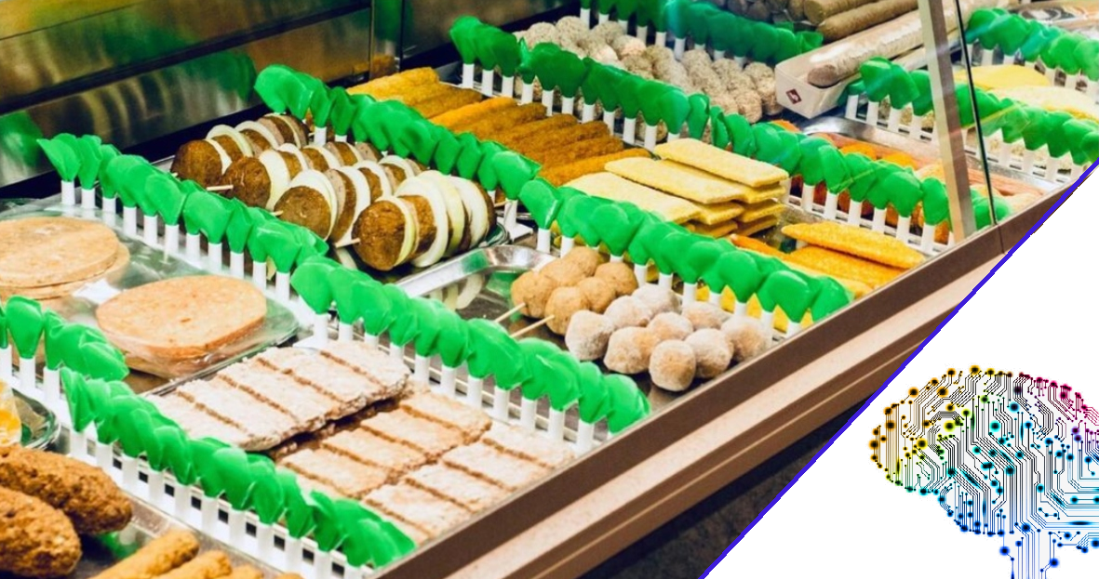

Calvin Hong - 431518

# Introduction

For the minor AI For Society, students have to work on a individual and group project. This document will be used to further explain the individual project idea of the student by giving more information. Since this is the first time working with AI, the student is not sure what is realistic or too simple. Despite this, the created idea has been thought out by answering predefined questions created by the teachers.

# 2.Project assignment

## 2.1 Context

When a customer orders food, a whole process starts. Below, you can see a simplified flowchart.

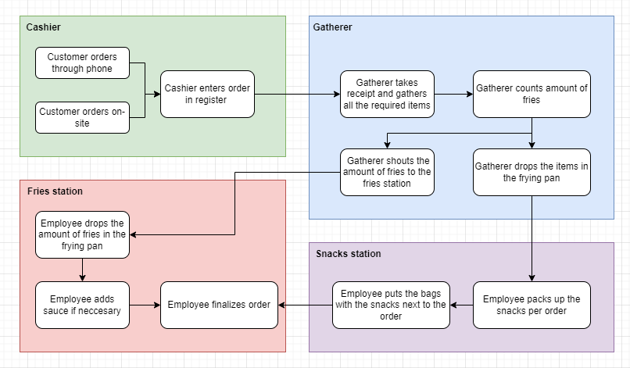

There are multiple points that could be improved during the process of preparing an order. One of the major bottlenecks is the blue field: gathering the items of the order.

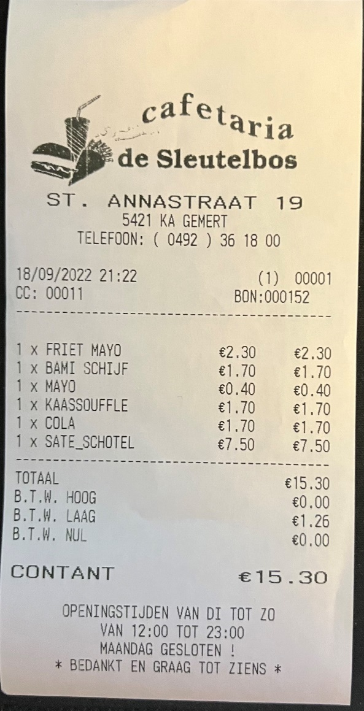For example, see the following medium sized example order:  
  
In this order, the employee has to get:

1X Bami schijf

1X kaassoufle

1X Sate schotel

After gathering the snacks, the employee then has to vocally shout to the fries station how much should be thrown into the frying pan.  
In this example:  
Friet mayo + Sate schotel = 2 portions.

This is not that difficult with one or two orders, but during rush hours the receipts quickly pile up. Keeping focus and remembering every item you have to gather gets difficult quickly combined with the noise and chaos that comes in these hours.

The items on the printed receipts are not efficiently organized. This results in wasted time as the gatherer needs to count and organize the items in their head. Due to this, the chance of human mistakes in this process is drastically increased. Having an assistant who reads all the receipts and organizes the key information to the employee who is gathering the items would be a great help.

Employees have to prepare up to 3 receipts at a time. Doing this fast is important, so that the flow will not get disturbed and the customers do not have to wait a long time.

Doing this with the example below, you can see how difficult it can quickly become.

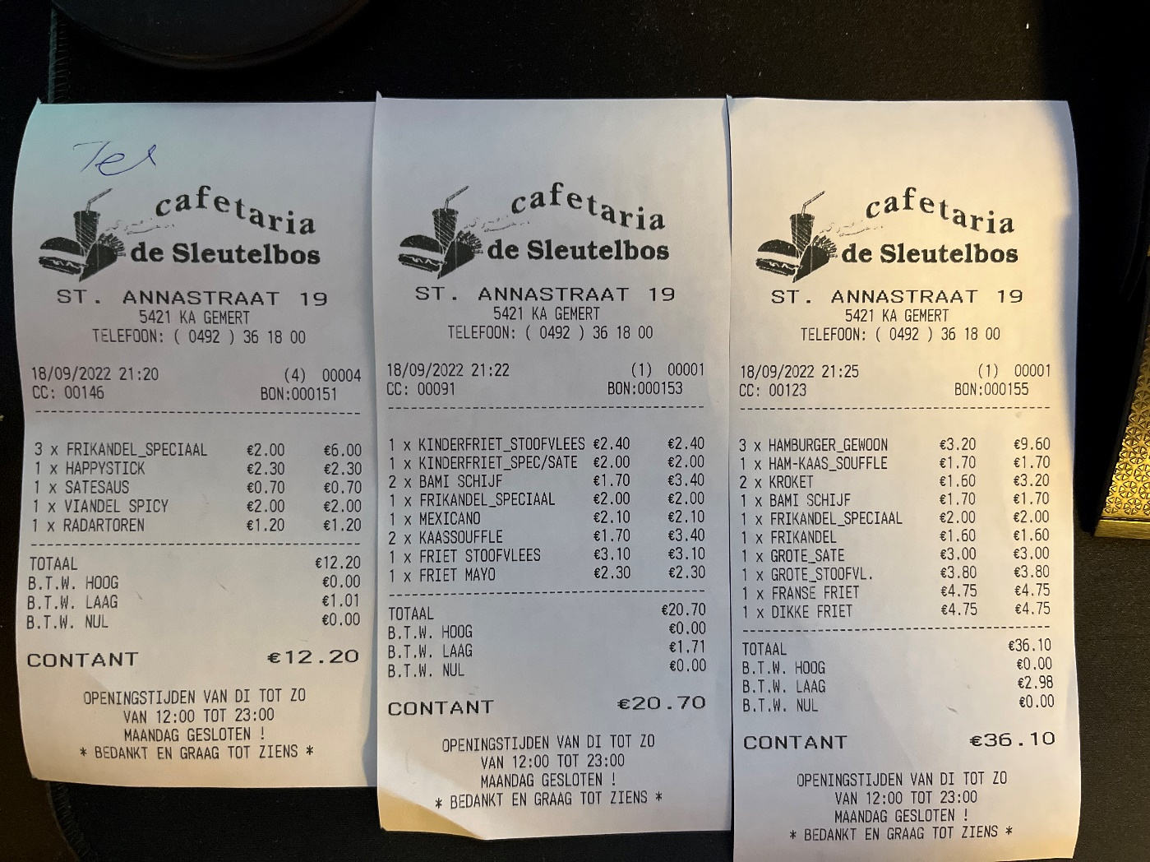

## 

## 2.2 Goal of the project

The goal of this project is to decrease the waiting time of customers in a snack bar by using artificial intelligence to make the gathering process more efficient.

The assistant AI will scan the receipts as soon as they get ordered and show the employee what items should be prepared first. This should help with the time efficiency, since not all the items cook in the same amount of time. For example, a hamburger takes around 10 minutes, while a frikandel takes around 5. Having a screen that shows you what you should prepare in order of time should make the process more time efficient.

Some items are also not in the deli case at the work station. To get these items the employee has to go to the back. This sometimes results in having to make multiple trips because it is difficult to remember all the items listed. The assistant can group these items together in an overview so that it is clearer for the employee.

There is not an infinite amount of snacks in the deli case and it is often hard to track availability during rush hours. Due to this, it would be useful if the assistant can also keep track of this and tell the employee when a snack is running out of stock so they can refill this.

## 2.3 Scope

|  |  |
| --- | --- |
| **Inside Scope** | **Outside Scope** |
| Receipt scanner | Permanent deployment |
| Backoffice to add the items and duration | Testing in other snack bars /environments |
| AI that assists the gatherer |  |
| Dashboard for the gatherer |  |
| Gatherer can interact with dashboard (buttons to go next, increase time, etc.) |  |

## 2.4 Research questions and methodology

Research has to be done to make an AI that works properly, in particular the actual problems of the gatherer.

## 2.5 End products

The end products of this project will be a system that helps improve the process of preparing an order for a customer in a snack bar. This system exists out of a receipt scanner, back office, and gatherer dashboard.

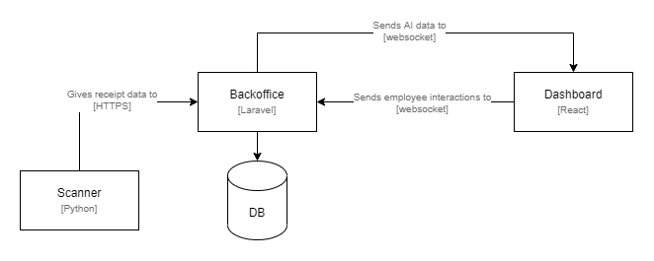

## 2.6 Risks

|  |  |  |
| --- | --- | --- |
| **Risk** | **Prevention activities** | **Mitigation activities** |
| The student does not have enough time to implement all the items planned for the sprint. | Estimate difficulty and time of tasks. Clearly plan out the tasks in a planning tool. | Bring task to next sprint. See what went wrong and plan accordingly. |