RC Car Development

1. IDEA
We would like to develop a remote control car, which should be controlled via an Java application using a regular computer/laptop with a Wi-Fi chip.

2. REQUIREMENTS ENGINEERING
- The RC car shall be controlled by a process defined in the Control-Developer GUI
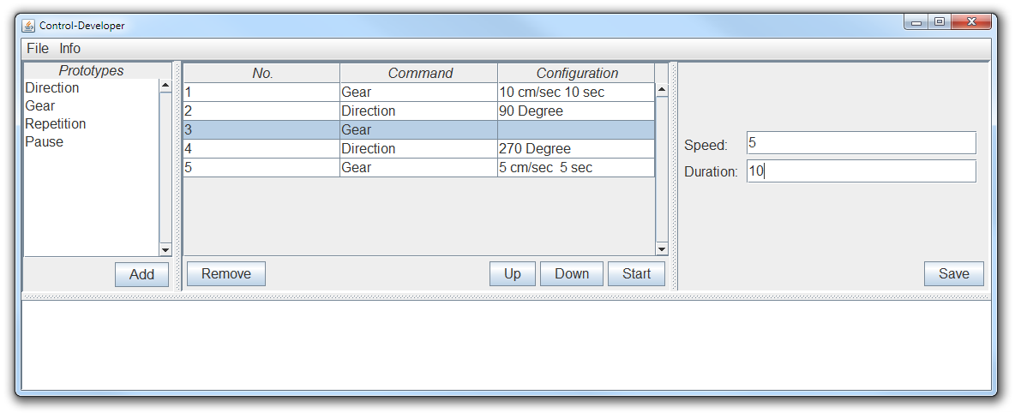

- The connection between the Java GUI and the RC car shall be based on WiFi.

- The Control-Developer GUI has to be expanded by setting up the connection out of a set of connections

- The functionality for transmitting the data to the RC car shall be integrated into the overall Control-Developer GUI framework by extending the existing framework.

- After pressing the “Start” button the RC-car shall start moving regarding the selected command; commands are
  - Gear drive for x sec. with the speed of y
  - Direction turn x degrees (x < 0: turn left; x>= 0: turn right)
  - Pause do not move for x sec.

- The commands shall executed sequentially.

- The RC car receives one command, executes it and sends a response after finishing execution.

- The movement of the car shall be such precise, that you can take a “ruler” and the car shall follow the polygon.

- There should be an error handling regarding the connection to the RC car (time out regarding feedback of the RC car). Possible answers from the RC car would be
  - Command Successfully Received
  - Command Successfully Executed

3. ANALYSIS

a. Logical structure

The logic of the whole system works as shown in the following diagram:

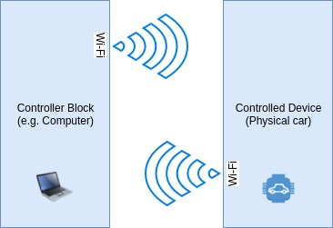

The system consists of two main logical blocks:
- Controller Block;
- Controlled Device [Block];

The communication established between those two blocks is full-duplex, this mean that both blocks will be able to send and receive data at the same time. Master-Slave principe is used.

The protocol which will used in order to establish a communication channel between main two blocks is Wi-Fi. In this case we have two options rgarding Wi-Fi frequency: 2.4GHz and 5GHz:

Protocol | Range | Bandwidth | Interferences | Compatib. | Costs
2.4GHz | High | Low | High | High | Normal
5GHz | Low | High | Low | Normal | >Normal

Data amount exchanged by our system is fairly low; further more, we want the range to be as high as possible so 2.4GHz Wi-Fi protocol will be used in the designed system.

The format of data exchanged and conventions will be defined in implementation chapter.

1. Controller block
This block is represented by a device which acts like a master in the system. It can be a computer or any other device wich is able to run the designated Java application and has a Wi-Fi chip.

From this block all commands are send to the car; also this is the block which listen to the response from car; whenever a command is send, two responses are expected: confirmation of command received and confirmation of command executed.

The very last layer of this his block also contain the GUI used by a user to send commands to the car.

2. Controlled Device [Block];
This block is also divided in other hardware modules placed on the car, like in the following diagram:

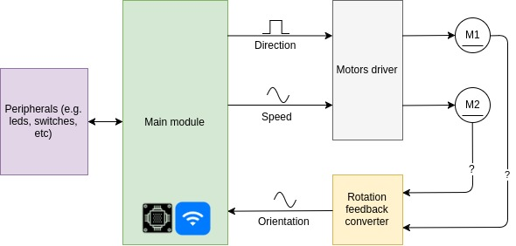
Main module is the „brain“ of the car. This module process the command received from the Java application then it translate is for motors. The calculations regarding direction correcting are processed here.

The following logical blocks are implemented at this level:
- Main module (C&C);
- Motors driver;
- Rotation feedback converter (data used in order to detect angular velocity);
- Peripherals

1. Main module

This module has the microcontroller used to process data and it also contain the Wi-Fi communication module and a Bluetooth module. One of the strengths of using this kind of module is that we don't worry about Wi-Fi and TCP/IP suit implementation.

Commands from the computer (controller) arrive here though Wi-Fi. In this block all commands and informations are processed and then routed to their destinations. Also some data integrity checks can be performed here.

2. Motors driver

This module have 4 inputs (connected to main block) and two high power outputs (connected to motors) organised as the following:

Inputs:
- Motor1:
- Speed (Analogic signal);
- Direction (Digital – Usually, 1 = forward and 0 = backward);
- Motor2:
- Speed (Analogic signal);
- Direction (Digital – Usually, 1 = forward and 0 = backward);
Outputs:
High power output ports in order to supply and command motors.

3. Rotation feedback converter

Rotation feedback block provide provide data related to current orientation or motors position. This data is used as a feedback for main module in order to execute commands with high level of accuracy.

Pins mode:
- 2 Inputs (connected to motors) – Signals: motors current value;
- 2 Outputs (connected to main block) – Current value converted to analogic unit supported by main block;

4. Peripherals

Basically all auxiliar components or devices such as led, battery level indicator, etc;

b. Hardware components

1. Main module

The main module consists of an Espressif ESP32 ESP-WROOM-32 WiFi/WLAN+Bluetooth Module.

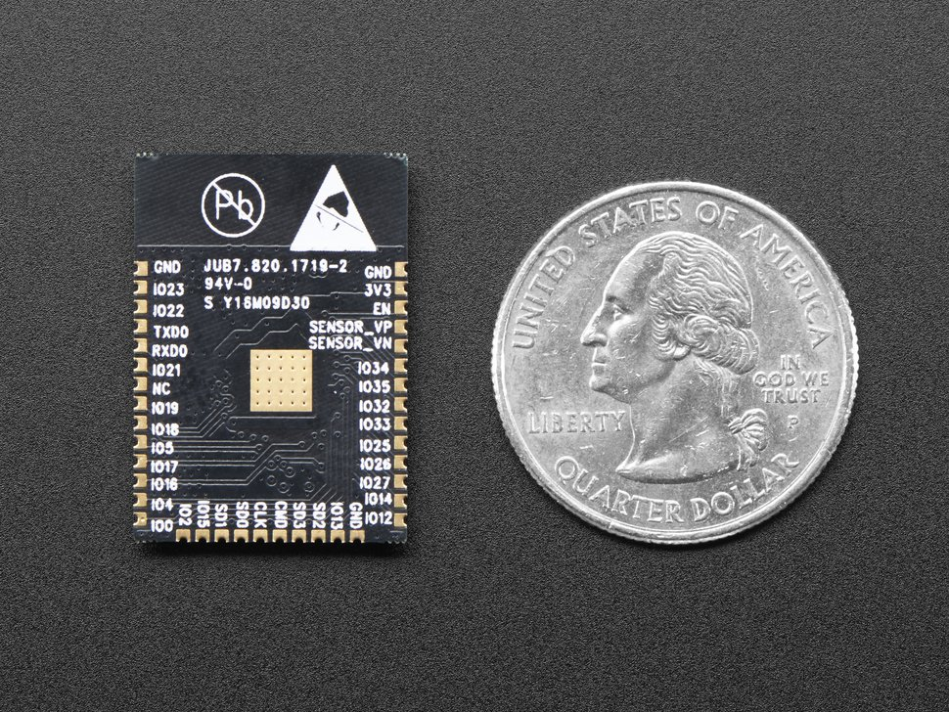

As previously said, this module include the communication Wi-Fi and Bluetooth communication chips and also a uC which can be used to process our data and commands. This module alse come with

Also a bunch of GPIOs pins are provided in order to interact with our controlled device.

2. Motors driver

To control motors is relative simple, because DC motors are used. Basically, varying tension, the speed and direction will also vary. Because we need a high amount of power on the motors, we can't connect them directly to uC. To achieve this, a H bridge for every motos is required. However, a better option would be to just buy a driver as it will be smaller and reliable.

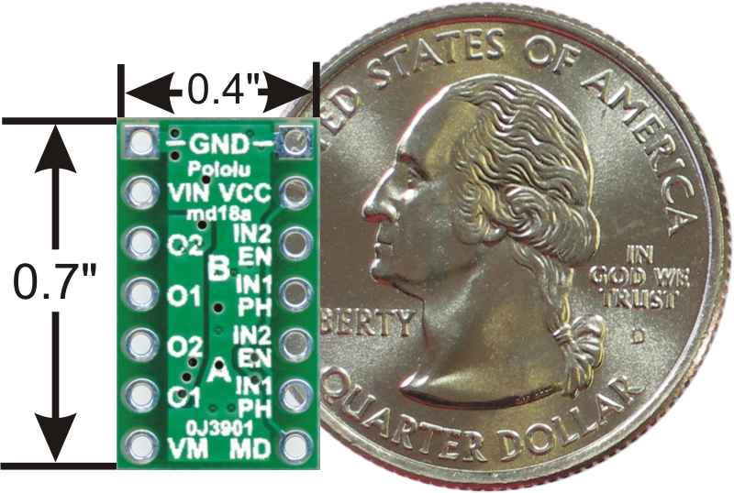
The chip used is Pololu DRV8835 Dual Motor Driver Carrier. Is support booth two motors.

The chip is also commanded by main microcontroller, which is integrated by communication module.

3. Rotation feedback converter

The name of this block looks like a generic name and it is as we have few options in order to achieve goal of accuracy rotations.

Method | Costs | Complexity | Space required | Efficenty
Motors encoder | Normal | Normal | High | Low
9-DOF IMU | High | Normal | Normal | High
Ampermeter | Low | Low | Normal | Low
Gyro+Acc | Normal | High | Normal | Normal

The highlighted method will be used.

For ampermeter method, basically, the current consumed by every motor is measured then converted into analogic unit in order to be send to uC. On microcontroller, both values of the motors are compared. Form those values the direction can be calculated. Now that we know actual direction of car, all we have to do is to compare that with the direction required by user; if it is not the same, the uC will try to correct it.

c. Context diagram
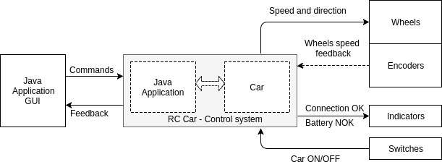

d. Dataflow diagram

Main processes
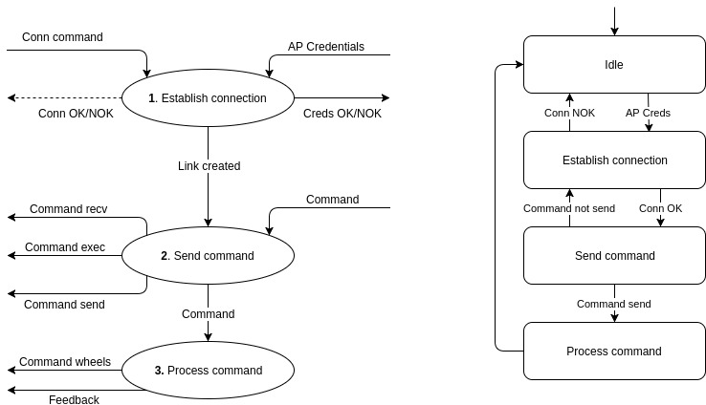

2. Logical model of processes
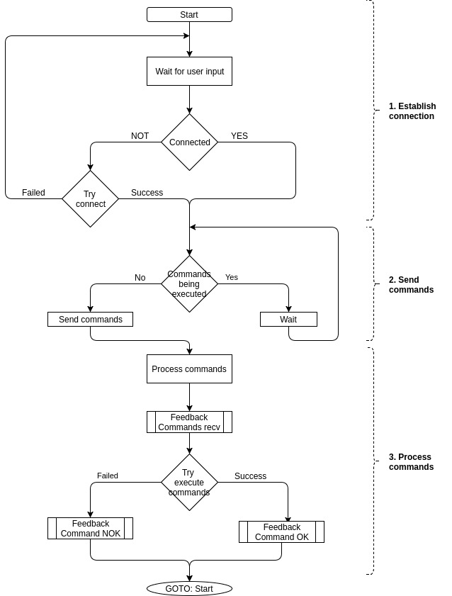

4. Design

To be continued...

