Modeling Caffeine in the Human Body

Lindsay Crowl
Math 164 - Scientific Computing
Friday, May 2, 2003
Prof de Pillis
ppt @ http://www.cs.hmc.edu/~lfletche/files.html

Abstract

I have created a dynamic system of continuous differential equations that models the effects of caffeine in the human body over time. In this paper I incorporated parameters for sleep deprivation, body mass, as well as the interaction of other chemicals in the body into my model from data taken from various studies involving the use of caffeine as a stimulant. In addition, I modeled levels of alertness in terms of energy level, reaction time, and probability of errors on simple-task tests.

Introduction

Caffeine has been a necessity for me during my time at Harvey Mudd College and it is widely used by most college students across America to help them stay awake all night studying. About 90% of Americans consume caffeine every day of their lives, and about half of American adults take in about 300mg of caffeine per day, making it America’s most popular drug. Caffeine is well known for helping people stay awake and improving cognitive performance, but it also causes insomnia and irritability in excess.
Caffeine is medically known as trimethylxanthine, and its chemical formula is C₈H₁₀N₄O₂³. Caffeine is useful as a cardiac and a central nervous system stimulant. It can provide a boost of energy and a feeling of alertness and focus. However caffeine is an addictive drug; it operates using the same mechanisms that amphetamines, cocaine and heroin use to stimulate the brain³. Caffeine works as a stimulant in the brain by inhibiting the binding of adenosine to its receptor sites, which prevents the sleep inducing feeling⁶.
The average cup of coffee contains 100mg of caffeine; the average cola contains about 70mg. The average half life of caffeine is 5 hours, but this depends upon body weight and a number of other factors, including how often it is consumed. Although experimental studies have shown that caffeine has a positive effect on alertness, it is unclear which mental processes are influenced by this chemical. The most likely mental process that caffeine affects is arousal and perceptual sensitivity.

Questions to Address

How can a person use caffeine for peak performance over a long period of sleep deprivation without feeling irritable or shaky? What factors are involved in caffeine absorption and how it affects the brain? What is the optimal strategy for pulling an all-nighter? These are all questions I hoped to answer with my caffeine model by numerical computation of experimental data, analysis of caffeine level curves, and verification from a study done for the USA military.

Basic Equations

For my analysis, I modeled the amount of caffeine in the bloodstream in order to approximate overall alertness and irritability over a time span of ten hours. My modeling approach is using a dynamic system of ODES for which I seek to minimize fluctuations in the system over time.
Once in the human body, caffeine experiences exponential decay in the liver. I formulated my model using the half life equation for caffeine, which is

A = A_{o}e^{-ln(2) * t / H1/2}, (1)

where A is the amount of caffeine in the body at any time t, A_{o} is the initial amount consumed at t = 0 and H_{1/2} is the half-life of caffeine. This equation models the amount of caffeine in the body after it has been consumed. However, what I am interested in the level of caffeine in the blood that is affecting the brain, which brings about a system of two differential equations,

dA/dt = -(ln(2)/H_{1/2}) × A (2)
dB/dt = -k₁B+k₂A,

where B is the amount of caffeine in bloodstream at any time t. The first DE is simply another way of writing the half life equation. The second DE is the change in caffeine in the blood that is getting to the brain and directly affecting an individual’s level of alertness. The average half life of caffeine is 4.5, with a range of 1.5 to 9.5 hours. Experimental studies have shown that peak absorption level of caffeine occurs between 15 and 120 minutes, after which 99% is absorbed after ingestion⁵. I have used this information to estimate the values for k₁, the constant for caffeine metabolism, and k₂, the constant for caffeine absorption from the stomach to the blood, to be 2.5(1/hr) and 2.7(1/hr) respectively. This system of equations is shown in Figure 1.

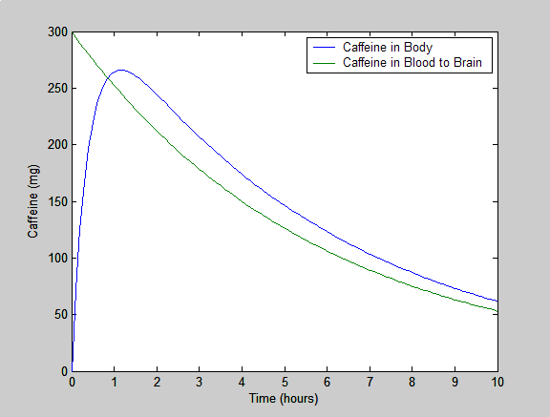
Figure 1: This graph displays the amount of caffeine in the body as it decays as well as how it is absorbed into the blood stream.

From this simple equation, the first thing I chose to manipulate is the time intervals of caffeine dosage over the same 10 hour period. Studies show that the optimal level of caffeine in the blood is somewhere between 200-300mg⁵. Irritability, dehydration, and anxiousness occur when there is an excess of caffeine getting sent to the brain. Mood swings may also occur if the level of caffeine fluctuates too much. Therefore, I sought to create a model where a healthy level of caffeine is present in the brain over a long period of time, so that a college student can be focused on work when need be. In order for caffeine to have a long lasting positive effect, we seek a constant curve at an optimal level of caffeine in the blood. In Figures 2-5 I have tested the number of increments needed to sustain as even of a caffeine level as possible.

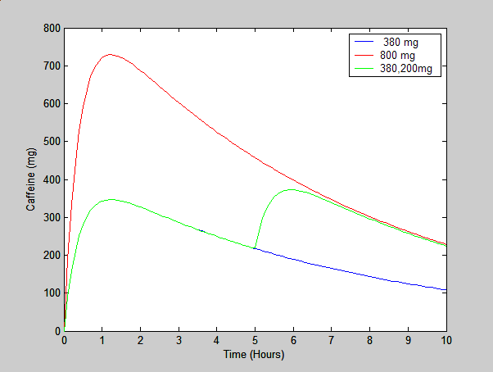
Figure 2: This plot shows the difference caffeine intervals make, compare 800mg to 580mg, which leave a person at the same caffeine level after 10 hours.

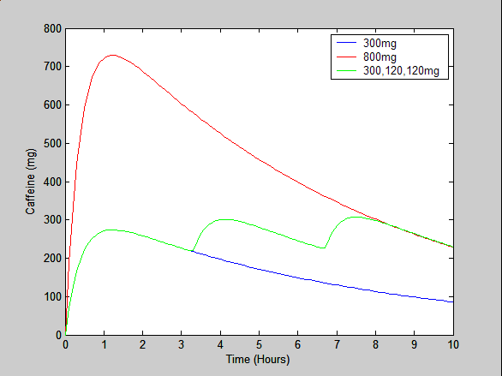
Figure 3: With 3 increments, 800mg is equivalent to 540 after 10 hours.

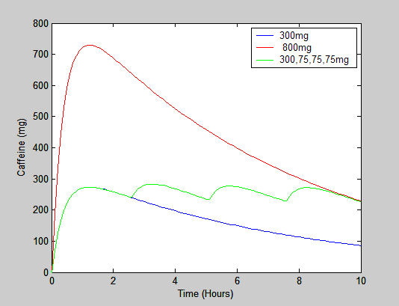
Figure 4: With 4 increments, 800mg is equivalent to 525mg

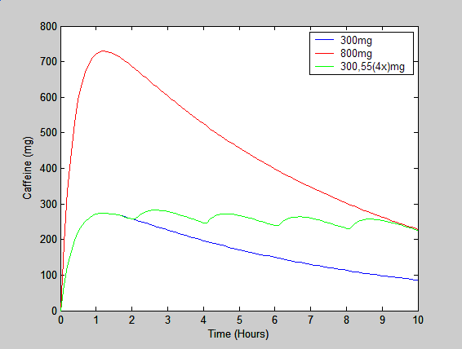
Figure 5: After 5 increments, the amount of caffeine needed to stay up 10 hours levels off at 500mg.

Over a ten hour period, these four graphs show the effects of caffeine increments that achieve steady state equilibrium somewhere between 200 and 300 mg and have the same effect as one 800mg dosage of caffeine. The most feasible of these plots is displayed in Figure 4. Here the time increments are not small enough to bother a focus worker or make them consume half a soda, but the intervals are also not large enough to cause more than a mild fluctuation in caffeine level. This scenario would be a student drinking a venti cappuccino at Starbucks before beginning work, and then having three additional sodas later on through the night every 2.5 hours.
It must be noted here that the analysis so far has only examined the level of caffeine in the blood. There are many other factors that should be inspected in order to model an individual’s overall cognitive alertness. This might be measured in terms of reaction time, fatigue level, mood, judgment, or alertness. Alertness, mood, and judgment are arbitrary and subjective terms that can be scaled however we chose, so there is no real experimental evidence of this sort. However studies have been done that take note of reaction time to stimuli and errors on simple computer tasks with and without caffeine. These studies helped me determine parameter values for my caffeine model.

Parameters

Many factors influence how caffeine works in the body. Specifically, the half life of caffeine is not constant. According to research, half life varies between people depending on certain chemicals in their bodies: mainly those from smoking, which decrease the half life of caffeine, or oral contraceptives and pregnancy, both which approximately double its half life⁵. Another important factor to consider that affects the half life of caffeine is body mass. On a general basis, smaller individuals metabolize caffeine slower since smaller bodies come with smaller livers. From this of information, I created a tentative half life equation,

H_{1/2} = C(280-W)/26 (3)

where W is body weight in pounds and C is a chemical constant such that under normal circumstances we set C =1. If the individual smokes, C is between 0.5 and 0.9 and if the person uses oral contraceptives, C ≈ 2. Logically, simply multiply C values if the person both smokes and takes birth control (Ex 0.6×2 = 1.2). Figure 6 shows how this affect on half life changes the level caffeine in the brain. Figure 7 examines how body mass alters the caffeine level; however this graph is more of an estimation since I was unable to find data on the relationship between weight and half life. Research shows that gender does not have a significant effect on caffeine level. I did not consider additional factors that change the half life, for instance the amount of food in the stomach, but it is difficult to find an adequate parameter for food and find experimental data on this.

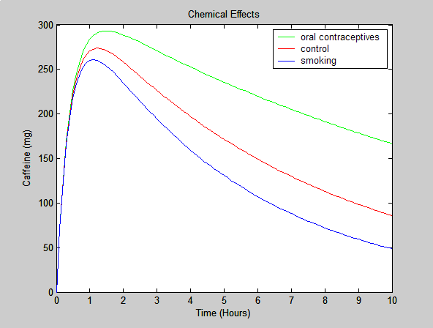
Figure 6: Chemical Effects

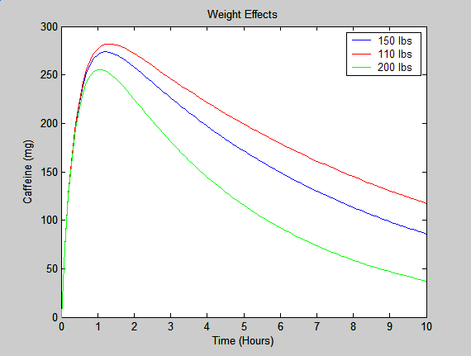
Figure 7: Testing the Parameters and Visualizing Body Mass Factor
Measuring Alertness

In order to measure alertness, I must consider factors other than the amount of caffeine in the blood. Since eventually even when caffeine is preventing fatigue from occurring, the body will still become physically depleted over time. Obviously, one cannot use caffeine as a substitute for sleep; it is merely a method of enduring a long period without sleep. A major factor to consider when modeling alertness is the individual’s sleep deprivation level. Studies show that caffeine works better the less sleep a person has had; however, their initial state of alertness is not very high in comparison to a person who is well rested.

dE/dt = c₁dB/dt – c₂(S+t-c₃)² (4)

where dE/dt is the change in energy level, dB/dt is the change in blood-caffeine level, S is the number of hours the person has been awake prior to caffeine consumption, and the constants c values can be manipulated and adjusted to match those of experimental values. In addition to this, I have created an equation to model reaction time and percent of commission errors on a simple computer test in the same situation to see if I can get the same relationship between alertness and fatigue level. Therefore, I created these two equations in a similar fashion,

dRT/dt = - n₁dB/dt + n₂(S+t-n₃)² (5)

dEr/dt = - m₁dB/dt + m₂(S+t-m₃)² (6)

where dRT/dt is the change in reaction time and dEr/dt is the change in error percentage. Both of these variables increase as energy level deplete. I took data from a study of the influences of caffeine on information processing in well rested and fatigue stages⁶, and used this information to determine the constants for equations 5 and 6. Figure 8 displays my model for these three variables in the absence of caffeine. Time equaling zero correlates to an initial awake period of approximately seven hours, a time at which caffeine may be necessary to keep energy levels up further on during the day. There are many more variables related to alertness that are affected by caffeine, including fatigue level, mood, judgment, and decision making dependability. I chose to model the factors for which I could find adequate experimental data to support.
By averaging data from a study of 30 subjects, data was taken for four subgroups: a control group of well rested people who took a placebo, a fatigued group that had been awake for approximately 13 additional hours who took a placebo, a rested group, and a second fatigued group who all had 200mg of caffeine in the form of coffee prior to the experiment, which took place 45 minutes after caffeine ingestion. Two types of alertness measurements were taken for this test. The first I studied was a reaction time test, and the second was a measure of errors simple task test on a computer⁶. By comparing the measurements of the four subgroups, I determined the values of n₁ and n₂ to be 0.18 and 0.36 respectively. Similarly I determined m₁ and m₂ to be 0.007 and 0.004 respectively. The two addition time constants, n₃ and m₃ I estimated to be 6 hours, which correlates to a time interval of six hours of wakefulness before energy levels begin to drop during the course of a day. Figure 9 shows the effects of both fatigue and caffeine on these variables.
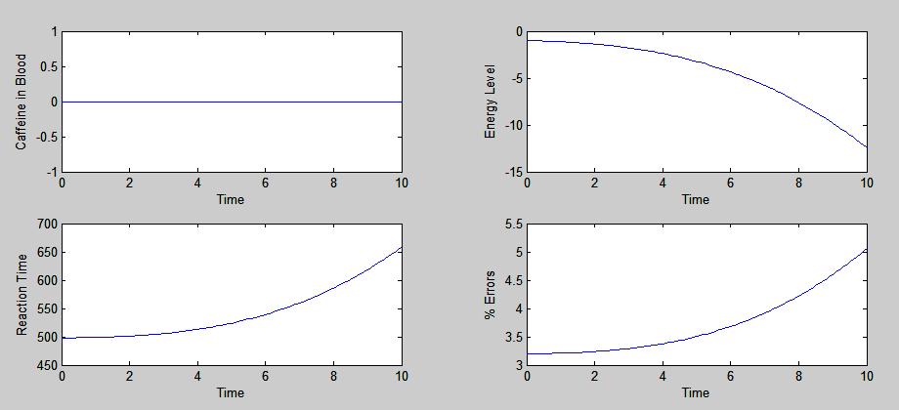
Figure 8: Measuring fatigue levels with experimental data

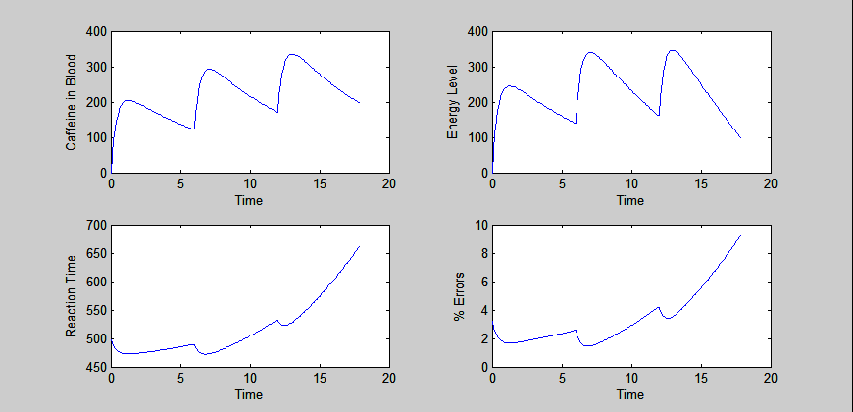
Figure 9: Measuring fatigue levels under the influence of caffeine with experimental data

Military Study

In 1992 the U.S. Army asked the Committee on Military Nutrition Research to assess the potential of caffeine, in addition to many other chemicals, to enhance performance⁵. My all-nighter caffeine model correlates closely to a few particular findings on cognitive performance under stress and severe sleep deprivation of military personal. These military studies focused on maximizing the positive effects of caffeine after performance is degrading from exhaustion. This analysis recommended doses of 300-600 mg of caffeine for a 150lbs person. They also concluded in their research that over long periods of time, caffeine in the amount of 300mg every six hours is the best option. This data I have displayed using my model in Figure 9. It appears that the caffeine level has fairly large dips and tends to increase up to 500mg in the system at once. This option is border-line on unhealthy behavior; however it makes sense for this to be necessary in the military where caffeine is not constantly available during a sustained vigilance. Intakes every three hours may be tedious in this situation; however I believe that I would be beneficial for a long study session to have caffeine more often in smaller doses. The second graph in Figure 9 shows the energy level over a 30 hour time period. Even though caffeine level is increasing, it becomes clear after 20+ hours that the body is drained.

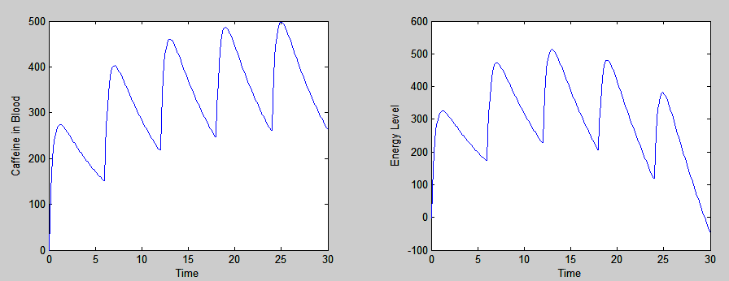
Figure 9: 300mg every 6 hours, on a very long term level

Conclusions

Many factors effect how caffeine influences the complex networking in the brain. Some of which include body mass, amount of sleep during the past 24 hours, chemicals present in the body, the amount of food in the stomach, the amount of exercise, whether or not one is a habitual caffeine user. No matter how much caffeine one has, it cannot replace sleep in the long run. Therefore, energy levels will eventually drop even if caffeine is kept at an optimal level. Caffeine is safe and when used properly can be very beneficial for pulling all-nighters (specifically useful for college students), although for longer periods of time, caffeine without sleep is detrimental to an individual’s health.

Acknowledgments

I would like to thanks Prof de Pillis for finding a good cold medicine¹ example for my caffeine model, Les Fletcher for helping me get my Powerpoint presentation on the web, Andy DeCampo for helping me set up Matlab on my laptop, David Gleich for convincing me that modeling caffeine is a feasible idea, the Huntley bookstore for actually having books on caffeine and sleep deprivation experiments, and of course to Starbucks for its energy-giving power.
References

1) Borelli, Robert L. and Courtney S. Coleman. Differential Equations: a Modeling Percpective.

2) Debry, Gerard. Coffee and Health. Paris: John Libbey Eurotext, 1994.

3) Erowid. “Caffeine.” The Vaults of Erowid. 9 Feb 2003. <http://www.erowid.org/chemicals/caffeine/caffeine.shtml>.

4) “How Caffeine Works.” How Stuff Works Inc. 2003. <http://home.howstuffworks.com/caffeine.htm>.

5) Institute of Medicine (U.S.). Committee on Military Nutrition Research. Caffeine for the sustainment of mental task performance : formulations for military operations / Committee on Military Nutrition Research, Food and Nutrition Board, Institute of Medicine. Washington DC: National Academy Press, 2001.

6) Lorist, Monicque M. Caffeine and Human Processing. Amsterdam: Universiteteit van Amsterdam, 1995.

7) Rees, Katy, David Allen, and Malcolm Lader. “The Influences of age and caffeine on psychomotor and cognitive function.” Psychopharmacology (1999) 145:181-8. <http://clem.mscd.edu/~bashamm/resmeth/caffeine%20article%202.pdf>.

8) “Tea and Caffeine.” <http://www.teahealth.co.uk/th/facts/pdf/Caffeine%20fact%20sheet%20.pdf>.

Appendix

Matlab Code:

% Coffee Function
function dy = coffee(t,y)
dy = zeros(5,1);
W = 150; % Body Weight (lbs)
C = 1; % Norm=1 OralCon=2 Smoking=0.7+/-.2
H = C*(280-W)/26; % Half Life in Hours
S = 7; % Hours awake
Yo = -abs(S-6)*abs(S-8);
ka = log(2)/H;
kb = 2.5;
kc = 2.7;
kd = 1/30;
ke = 1.2;
dy(1) = -ka*y(1); %Half Life Eq. Caf in Body
dy(2) = -kb*y(2)+kc*y(1); % Caffeine in Brain
dy(3) = ke*dy(2)-kd*(S+t-5)^2; % Energy Level
dy(4) = -(38/214)*dy(3)+(1/2.8)*(S+t-6)^2; % Reaction Time
dy(5) = -(0.8/107)*dy(3)+(1/250)*(S+t-6)^2; % % Errors

% Caffeine
A = 300; % Initial Amount of caffeine (mg)
S = 7; % Hours Awake
Yo = [A 0 -abs(S-6)*abs(S-8) 498 3.2]; % Initial Conditions
ti = 0; % Time of Consumption
tf = 30; % Time of 2nd Cup (Hours)
h = 1; % Integration Step
[t1,y1] = ode23(@coffee, [0:1/10:5.9], Yo);
[t2,y2] = ode23(@coffee, [6:1/10:11.9], [300+y1(60,1) y1(60,2) y1(60,3) y1(60,4) y1(60,5)]);
[t3,y3] = ode23(@coffee, [12:1/10:17.9], [300+y2(60,1) y2(60,2) y2(60,3) y2(60,4) y2(60,5)]);
[t4,y4] = ode23(@coffee, [18:1/10:23.9], [300+y3(60,1) y3(60,2) y3(60,3) y3(60,4) y3(60,5)]);
[t5,y5] = ode23(@coffee, [24:1/10:30], [300+y4(60,1) y4(60,2) y4(60,3) y4(60,5) y4(60,5)]);
t = [0:1/10:tf];
Ymother1 = [y1(:,1)' y2(:,1)' y3(:,1)' y4(:,1)' y5(:,1)'];
Ymother2 = [y1(:,2)' y2(:,2)' y3(:,2)' y4(:,2)' y5(:,2)'];
Ymother3 = [y1(:,3)' y2(:,3)' y3(:,3)' y4(:,3)' y5(:,3)'];
Ymother4 = [y1(:,4)' y2(:,4)' y3(:,4)' y4(:,4)' y5(:,4)'];
Ymother5 = [y1(:,5)' y2(:,5)' y3(:,5)' y4(:,5)' y5(:,5)'];
%[tx,yx] = ode23(@coffee, [0:1/10:10], Yo);
%[txx,yxx] = ode23(@coffee, [0:1/10:10], [800 0 0-abs(S-6)*abs(S-8) 658 5]);
%plot(t, yx(:,5)); %yxx(:,2), 'r', t, Ymother2, 'g');
%subplot(2,2,1), plot(t, yx(:,2));
%xlabel('Time');
%ylabel('Caffeine in Blood');
%subplot(2,2,2), plot(t, yx(:,3));
%xlabel('Time');
%ylabel('Energy Level');
%subplot(2,2,3), plot(t, yx(:,4));
%xlabel('Time');
%ylabel('Reaction Time');
%subplot(2,2,4), plot(t, yx(:,5));

