Experiment: 9

Student Name: Jagrath UID:24BDA70365
Branch: CSE Section/Group: AIT-KRG-GP2
Semester: 4th Date of Performance:17/04/2026
Subject Name: DBMS

- Aim of the practical: To create and implement PL/SQL packages by developing a package specification and package body containing procedures and shared cursors, in order to achieve modular, reusable, and efficient database programming.

2. Tool Used:

● Database Management System:

○ PostgreSQL

● Database Administration Tool:

○ pgAdmin

- Objective:

To design and implement a PL/SQL package that includes procedures and shared cursors for structured and modular program development.

- Practical / Experimental Steps

Step 1 :Create the base table (Employee) with appropriate attributes such as employee ID, name, department, and salary.

Step 2 : Insert sample data into the table to simulate real-world employee records.

Step 3: Design a package-like structure by creating a schema (in PostgreSQL) or package specification (in Oracle) to declare procedures/functions.

Step 4: Implement procedures/functions to fetch and display employee details.

Step 5: Define and use a shared cursor (or cursor logic) to retrieve employee records efficiently within the procedures.

Step 6: Execute the created procedures/functions to display all employee records and filtered results (e.g., by department).

- I / O Analysis

CREATE TABLE employee (

emp_id INTEGER PRIMARY KEY,

emp_name VARCHAR(50),

department VARCHAR(50),

salary NUMERIC

);

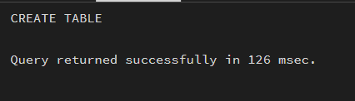

INSERT INTO Employee VALUES (101, 'Amit', 'HR', 30000);

INSERT INTO Employee VALUES (102, 'Riya', 'IT', 50000);

INSERT INTO Employee VALUES (103, 'Karan', 'Finance', 45000);

INSERT INTO Employee VALUES (104, 'Neha', 'IT', 55000);

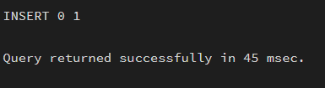

CREATE SCHEMA emp_package;

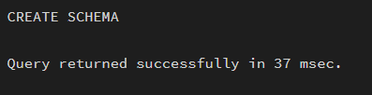

CREATE OR REPLACE FUNCTION emp_package.get_all_employees()

RETURNS VOID AS $$

DECLARE

emp_rec RECORD;

BEGIN

FOR emp_rec IN

SELECT * FROM employee

LOOP

RAISE NOTICE '% % % %',

emp_rec.emp_id,

emp_rec.emp_name,

emp_rec.department,

emp_rec.salary;

END LOOP;

END;

$$ LANGUAGE plpgsql;

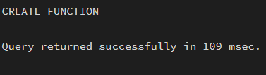

CREATE OR REPLACE FUNCTION emp_package.get_emp_by_dept(p_dept VARCHAR)

RETURNS VOID AS $$

DECLARE

emp_rec RECORD;

BEGIN

FOR emp_rec IN

SELECT * FROM employee

LOOP

IF emp_rec.department = p_dept THEN

RAISE NOTICE '% % % %',

emp_rec.emp_id,

emp_rec.emp_name,

emp_rec.department,

emp_rec.salary;

END IF;

END LOOP;

END;

$$ LANGUAGE plpgsql;

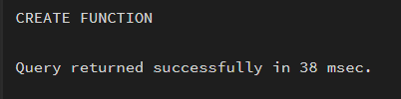

OUTPUT

SELECT emp_package.get_all_employees();

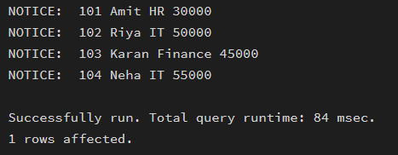

SELECT emp_package.get_emp_by_dept('IT');

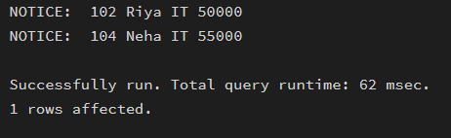

- Learning outcomes (What I have learnt):
- Understand the concept and working of materialized views in a database system.
- Differentiate between simple views, complex views, and materialized views.
- Create and refresh materialized views in PostgreSQL.
- Measure and compare query execution time for different types of views.
- Analyze performance benefits of materialized views in data-intensive applications.
- Apply materialized view concepts in real-world company scenarios such as SanDisk, JTG, and PayPal.

