Student Name: Samridh Srivastava UID: 24BDA70208
Branch: AIT-CSE (DS) Section/Group: 24AIT_KRG-G2
Semester: 5
Subject Name: Computer Network Subject Code: 24CSH-337

Experiment 06
Implementation of VLAN and VLAN Trunking Protocols
Aim
To implement VLAN and VLAN Trunking protocols in Cisco Packet Tracer and understand how VLANs provide logical separation of networks and how trunk links carry traffic belonging to multiple VLANs between switches.
Objective
- To understand the concept of VLANs.
- To understand the difference between Layer 2 and Layer 3 switches.
- To configure VLANs on Cisco switches.
- To configure access ports and assign them to VLANs.
- To understand the concept of VLAN trunking.
- To configure a trunk link between two switches.
- To understand IEEE 802.1Q VLAN tagging.
- To verify communication between devices belonging to the same VLAN.
- To verify that devices in different VLANs cannot communicate without Layer 3 routing.
Software Requirements
- Cisco Packet Tracer
Hardware (Virtual)
- Cisco 2960 Switches
- PCs
- Copper Straight-Through Cables
Theory
A Layer 2 switch primarily operates at the Data Link Layer and uses MAC addresses to forward Ethernet frames. A Layer 3 switch can perform both Layer 2 switching and Layer 3 routing and can therefore perform Inter-VLAN Routing.
VLAN stands for Virtual Local Area Network. It allows a single physical switch to be logically divided into multiple separate networks. For example, VLAN 10 can be assigned to one department and VLAN 20 to another department. Devices belonging to different VLANs are logically separated and normally require Layer 3 routing to communicate with each other.
VLANs help reduce broadcast traffic, provide logical separation between departments, improve network organization, and allow multiple logical networks to use the same physical switch infrastructure.
An access port normally belongs to one VLAN and is generally used to connect end devices such as PCs, printers, and servers.
A trunk port carries traffic belonging to multiple VLANs over a single physical link, and is generally used between network devices such as switches.
When VLAN traffic crosses a trunk, VLAN information is carried using VLAN tagging. The commonly used standard is IEEE 802.1Q, which allows the receiving switch to identify the VLAN to which a frame belongs.
Practical / Experiment Steps
- Open Cisco Packet Tracer.
- Place two Cisco 2960 switches and four PCs in the workspace.
- Connect the devices using Copper Straight-Through cables:
  - PC1 → SW1 Fa0/1
  - PC2 → SW1 Fa0/2
  - PC3 → SW2 Fa0/1
  - PC4 → SW2 Fa0/2
- Connect the two switches:
  - SW1 Gi0/1 → SW2 Gi0/1
- Assign IP addresses to the PCs:
PC1
  - IP Address: 192.168.10.11
  - Subnet Mask: 255.255.255.0
PC3
  - IP Address: 192.168.10.12
  - Subnet Mask: 255.255.255.0
PC2
  - IP Address: 192.168.20.11
  - Subnet Mask: 255.255.255.0
PC4
  - IP Address: 192.168.20.12
  - Subnet Mask: 255.255.255.0
- Configure VLAN 10 and VLAN 20 on SW1.
- Assign Fa0/1 of SW1 to VLAN 10.
- Assign Fa0/2 of SW1 to VLAN 20.
- Repeat the VLAN and access-port configuration on SW2.
- Configure Gi0/1 on SW1 as a trunk port.
- Configure Gi0/1 on SW2 as a trunk port.
- Test communication between PC1 and PC3. Both devices belong to VLAN 10, so the ping should be successful.
- Test communication between PC2 and PC4. Both devices belong to VLAN 20, so the ping should be successful.
- Test communication between PC1 and PC4. Since they belong to different VLANs and no Layer 3 routing is configured, the ping should fail.
VLAN Configuration Commands
On each switch:
enable
configure terminal

vlan 10
name STUDENTS
exit

vlan 20
name FACULTY
exit
Access Port Configuration
For Fa0/1:
interface fa0/1
switchport mode access
switchport access vlan 10
exit
For Fa0/2:
interface fa0/2
switchport mode access
switchport access vlan 20
exit
Trunk Configuration
On both switches:
interface gigabitEthernet 0/1
switchport mode trunk
exit
These configurations correspond to the complete SW1 and SW2 configurations provided in the experiment.
Verification Commands
To view the configured VLANs:
show vlan brief
To verify the trunk configuration:
show interfaces trunk
To view the MAC address table:
show mac address-table
Output
Screenshot 1 – Complete network topology
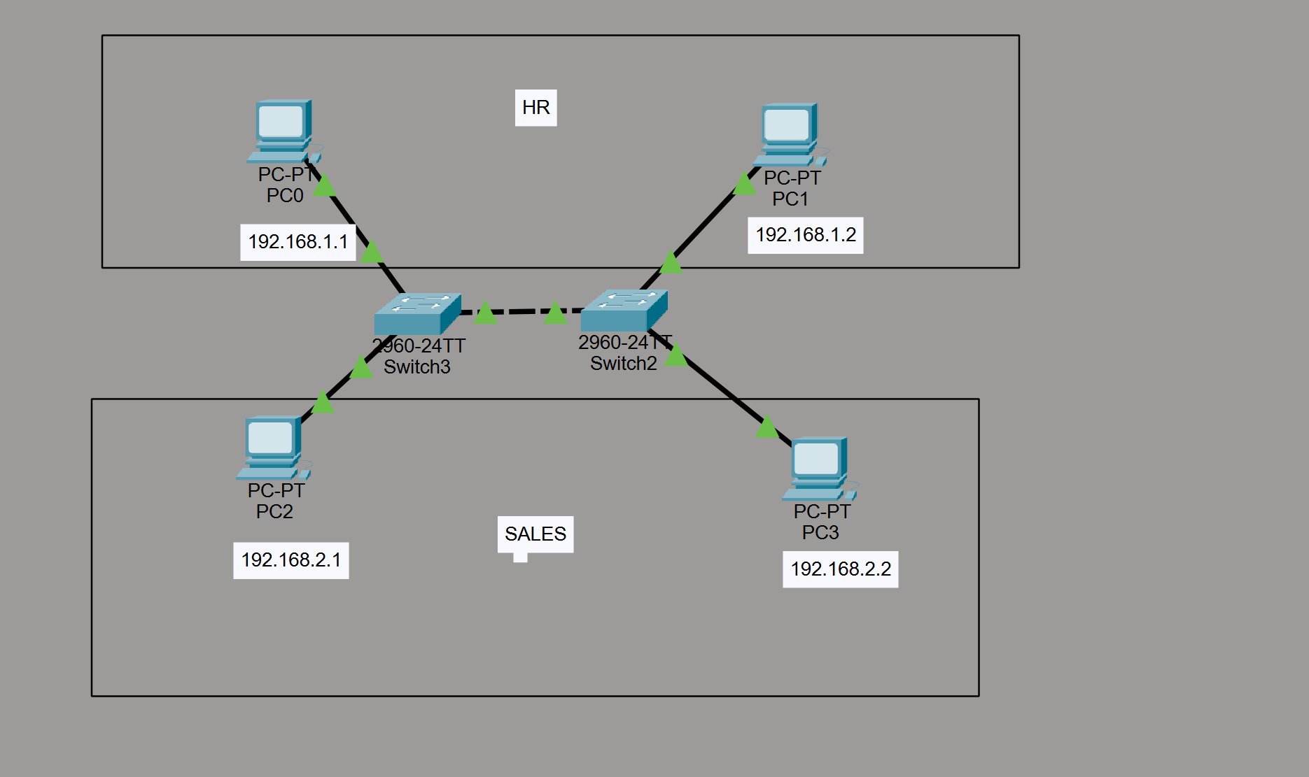
Screenshot 2 – VLAN configuration on Switch 1
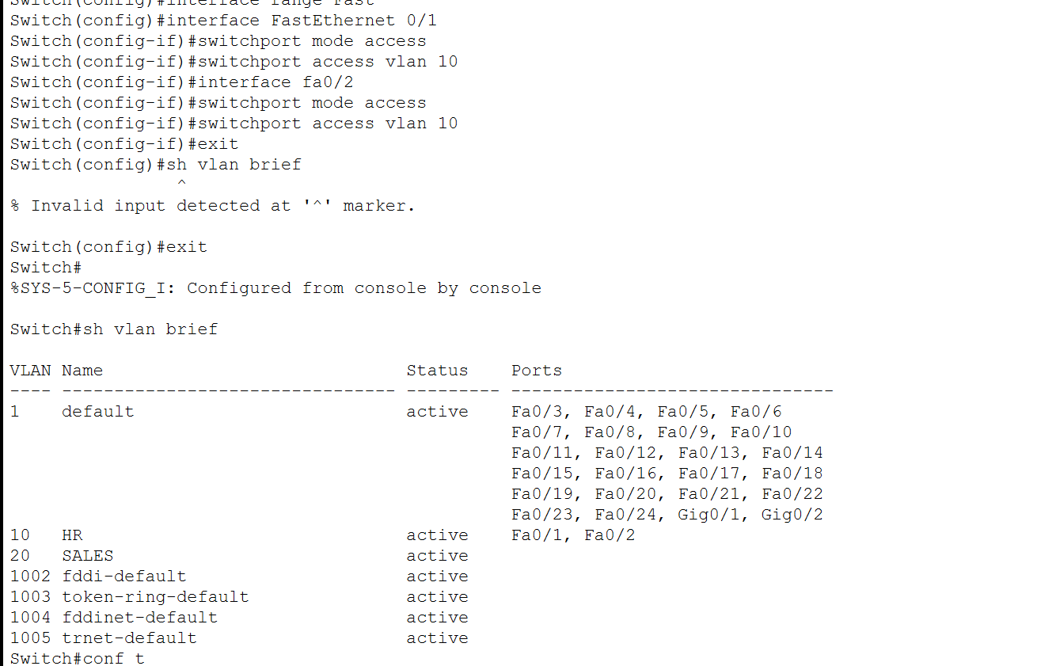
Screenshot 3 – VLAN configuration on Switch 2
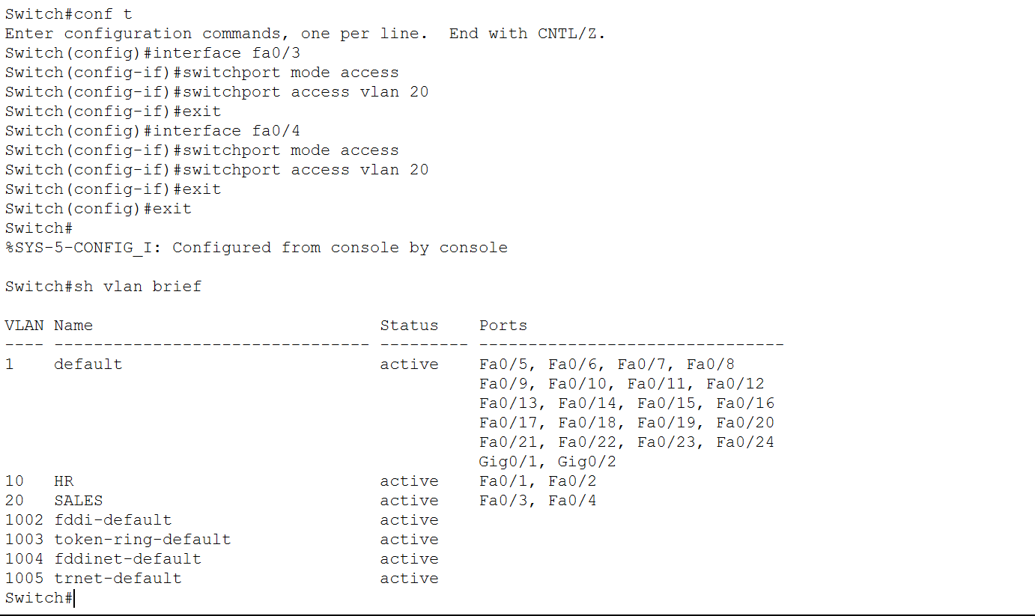
Screenshot 4 – Trunk configuration
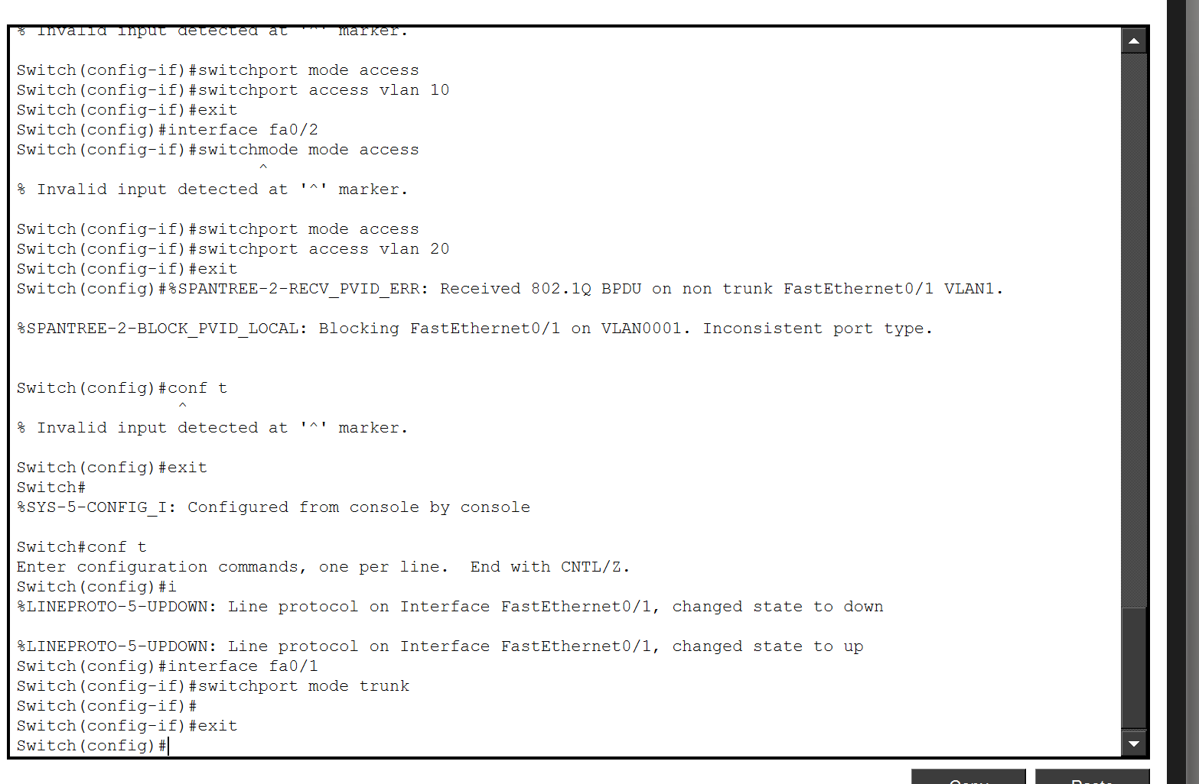
Screenshot 5 – VLAN and MAC address verification
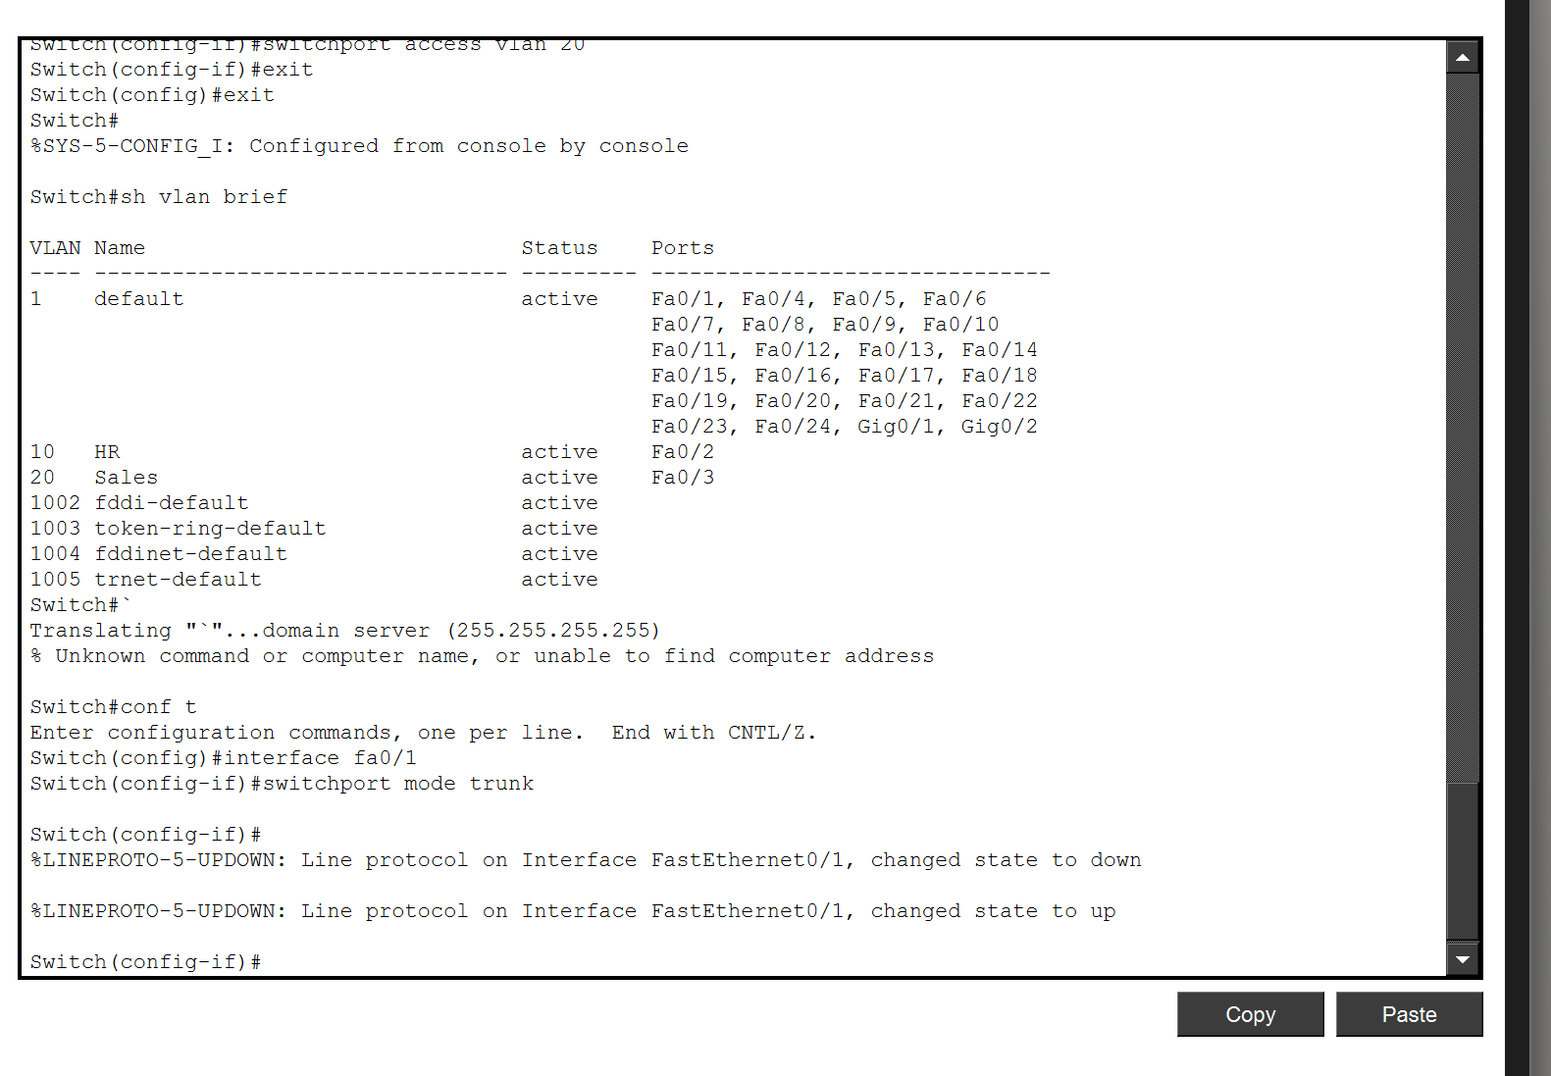
Screenshot 6 – Successful Ping between devices in the same VLAN
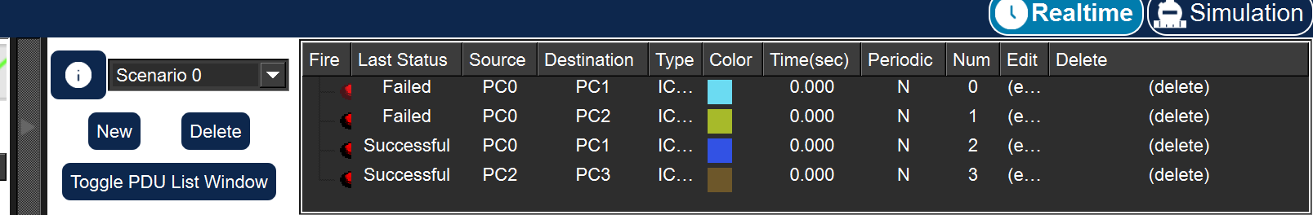
Learning Outcome
After completing this experiment, I was able to:
- Understand the concept and purpose of VLANs.
- Understand the difference between Layer 2 and Layer 3 switches.
- Configure VLANs on Cisco switches.
- Configure access ports and assign them to specific VLANs.
- Understand the concept of VLAN trunking.
- Configure a trunk link between two switches.
- Understand the purpose of IEEE 802.1Q VLAN tagging.
- Verify VLAN and trunk configurations using Cisco IOS commands.
- Verify communication between devices belonging to the same VLAN.
- Understand why devices in different VLANs require Layer 3 routing for communication.

