Cybersecurity isn’t just for hackers. It’s for everyone!
Whether you’re curious about cybersecurity, switching careers, or just getting started — we’re here to guide you step-by-step, from beginner to job-ready.
Explore Learning Paths

IMAGE
Why Cybersecurity is the Smartest Career Move You Can Make Right Now?
Future-Proof Your Career
AI, Cloud, Remote work-cybersecurity is no longer optional.

High Pay, Real Impact
High demand = strong salaries + job security
3.5M+ Open Roles
Massive global talent gap – no tech background? No problem.

$500+ Billion Industry
Booming market, projected to hit $538B by 2030

It’s not just a job. It’s your edge in the digital world.
Infographic representation (for developer) :
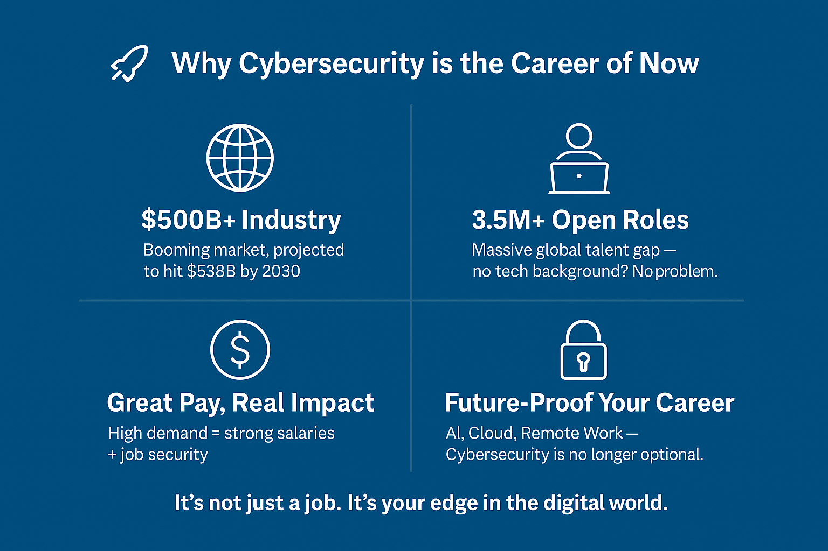

Why Alangh Academy?
Cybersecurity feels confusing. We make it simple.
Most people don’t know where to begin with cybersecurity —and that’s not their fault. The industry hasn’t made it easy.
At Alangh Academy, we’ve built a better way—We offer clear, structured learning paths designed to take you from beginner to job-ready —no fluff, no confusion, just real skills and step-by-step support. Whether you’re exploring tech for the first time, switching careers, or sharpening your IT toolkit, we’re here to help you make it happen.
We don’t just teach. We guide.
From curiosity to career —we bridge the gap.
Who is this For?

Where Should I Start?

No matter your background — we’ll meet you where you are.

Pick what sounds most like you, and we’ll guide you to the right path:

Infographic representation (for developer):
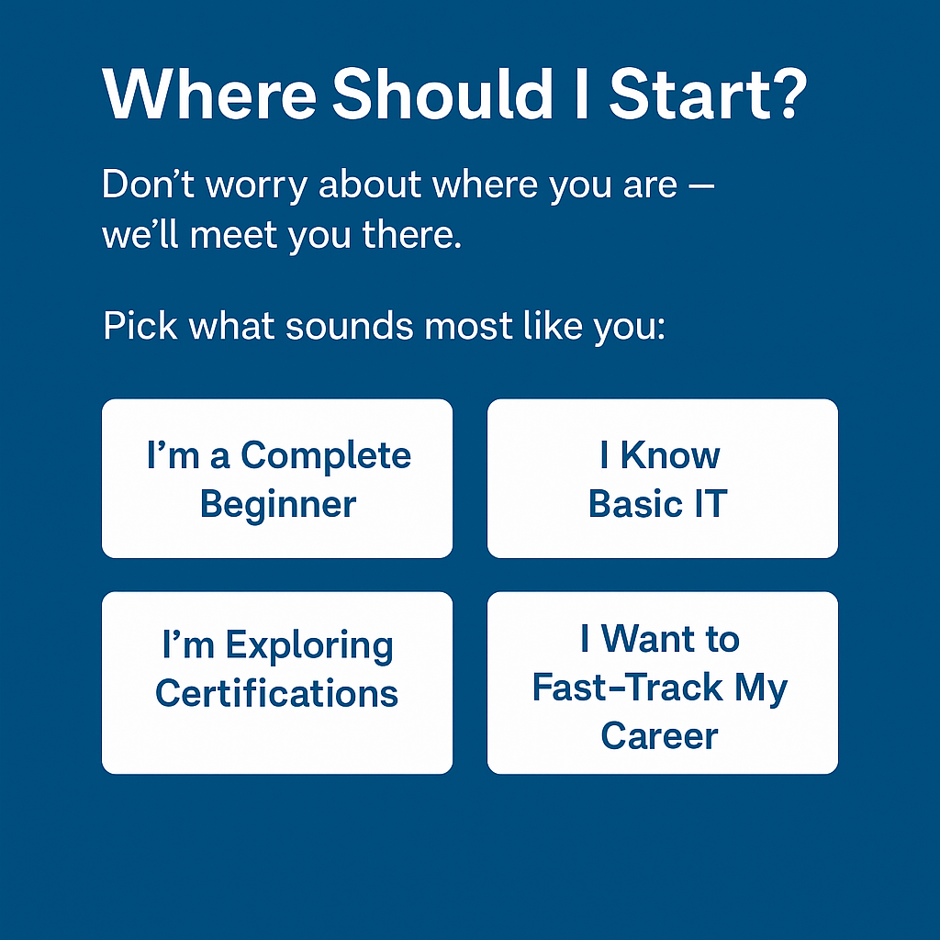
Testimonials
TBD

Cybersecurity is Not Just for Tech Geniuses - FAQ for Beginners

- Do I need a computer science degree to get into cybersecurity?

No. Most entry-level roles in cybersecurity do not require a formal degree. Skills, certifications, and hands-on experience matter more. Many professionals enter the field with backgrounds in commerce, arts, or unrelated domains.

- Do I need to know how to code?

It depends.
• For roles like SOC Analyst, GRC, or Compliance, no coding is needed.
• For penetration testing or threat hunting, basic scripting (Python, Bash) is helpful.

- Can I switch into cybersecurity from a non-technical background?

Yes. Cybersecurity has many roles that don’t require technical expertise, like:
• Governance, Risk & Compliance (GRC)
• Security Awareness & Training
• Policy Writing & Auditing

With the right training and project exposure, a career switch is very possible and common.

- How long will it take to become job-ready?

6–9 months on average, depending on:
• Your current knowledge level
• The track you choose (Beginner / Intermediate / Advanced)
• How much time you can dedicate weekly (5–10 hrs/week is typical)

- What kinds of jobs can I get after this?

Entry-level roles include:
• Security Operations Center (SOC) Analyst
• Information Security Analyst
• IT Security Support
• GRC Associate

These roles exist across banking, IT, healthcare, e-commerce, and government sectors.

- Is this course only for students or freshers?

No. We train:
• Students
• Working professionals
• Career switchers
• Homemakers re-entering the workforce
Anyone can join — as long as they’re willing to learn.

- Is this aligned with global standards or certifications?

We do not offer certification prep (like CEH, CISSP, etc.) right now.
Instead, we help you break into cybersecurity. Our focus is on practical, project-based learning that builds foundational and intermediate skills applicable in real-world jobs.

- What makes Alangh Academy different?
• Structured learning paths (Beginner → Intermediate → Advanced)
• Real-world projects and labs
• Industry-relevant role-based training
• Personalized mentorship and career guidance

Ready to Start Your Cybersecurity Journey?
This is your launchpad. Let’s build your future.

